**"Sentiment Analysis on Movie Reviews"**

Authors: Sarjakkumar Kothiya, Abhikumar Patel

Student IDs: U01882769, U01883041

Prof. Buchi Okoli

**Table of Contents**

* Introduction....................................................................[4]

1. Explaining the concept of sentiment analysis
2. Importance in movie reviews
3. Project goals and significance

* Problem Statement/Definition...................................................[6]

1. Problem being addressed
2. Scope and expected outcomes

* Tools/Technologies..............................................................[8]

1. Detailed descriptions of tools and tech used

* Module Development/Implementation.............................................[11]

1. Data collection
2. Preprocessing
3. Algorithm implementation
4. Model training and evaluation

* Application Development........................................................[14]

1. Overview of the web application
2. Interface and functionality
3. Technology stack
4. User experience

* Images and Visualizations.......................................................[15]
* Conclusion......................................................................[18]

1. Key findings and results
2. Challenges and limitations
3. Future research directions

**Introduction**

**Understanding Sentiment Analysis**

Sentiment Analysis, also known as opinion mining, is a field of Natural Language Processing (NLP) that focuses on identifying and categorizing opinions expressed in text. It aims to determine the attitude or emotional tone of a writer or speaker with respect to some topic or the overall contextual polarity of a document. The sentiments can typically be classified into categories like positive, negative, and neutral.

In today's digital era, where vast amounts of text data are generated daily, sentiment analysis has become an invaluable tool for understanding public opinion. It is widely used in various domains such as marketing, customer service, product analytics, and social media monitoring.

**Importance in Movie Reviews**

The application of sentiment analysis in movie reviews holds significant importance. Movies, being a major part of entertainment and culture, evoke strong emotional responses from audiences. Reviews and ratings are common ways for viewers to express their opinions and experiences. Analysing these reviews provides insights into general audience sentiments, which can be pivotal for filmmakers, marketers, and moviegoers alike.

For filmmakers and production companies, sentiment analysis helps gauge public reception, informing future projects and marketing strategies. For moviegoers, sentiment analysis of reviews can offer a quick understanding of the general consensus, aiding in decision-making.

**Project Goals and Significance**

The goal of this project is to apply sentiment analysis techniques to movie reviews with the aim of accurately predicting whether the sentiments expressed are positive or negative. This involves processing and analysing text data from movie reviews, applying machine learning and deep learning models, and evaluating their effectiveness.

The significance of this project lies in its potential to enhance the understanding and application of sentiment analysis in a real-world context. By comparing various NLP models, the project aims to contribute to the broader field of sentiment analysis, providing insights into the effectiveness of different approaches. Additionally, it serves as a practical tool for those in the film industry to assess audience sentiments and tailor their strategies accordingly.

Through this project, we aim to demonstrate the practical application of sentiment analysis, its challenges, and its potential impact on the film industry and beyond.

**Problem Statement/Definition**

**Defining the Problem**

The primary problem that this project addresses is the automated analysis and classification of sentiments in movie reviews. Movie reviews, whether professional critiques or audience opinions, are rich in subjective information and express diverse feelings, opinions, and experiences related to films. However, manually sifting through and interpreting this vast amount of text data is impractical and time-consuming. The challenge, therefore, lies in accurately and efficiently analysing these tests to determine the overall sentiment: whether the reviewer perceives the movie positively or negatively.

This task is complex due to the nuances of human language, including sarcasm, idioms, and varying contexts. Additionally, movie reviews can be highly subjective, with different individuals expressing their sentiments in unique ways. Thus, the problem extends beyond simple keyword analysis and requires a deeper understanding of language semantics.

**Scope of the Project**

**The scope of this project encompasses several key areas:**

**Data Collection and Preprocessing:** Gathering a large dataset of movie reviews from reliable sources, such as the IMDB database, and preparing the data for analysis. This includes cleaning the text, removing irrelevant information, and standardizing the format.

Model Development and Training: Implementing and training various sentiment analysis models, including traditional machine learning models like Naive Bayes and advanced deep learning models like BERT (Bidirectional Encoder Representations from Transformers).

Performance Evaluation: Comparing the effectiveness of different models in accurately classifying sentiments in movie reviews. This involves assessing various performance metrics such as accuracy, precision, recall, and F1 score.

Analysis and Interpretation: Analysing the results to understand model performance and the characteristics of movie review sentiments.

**Expected Outcomes**

**The project aims to achieve the following outcomes:**

**Effective Sentiment Classification**: Develop a robust sentiment analysis model capable of accurately classifying movie reviews into positive or negative sentiments.

**Insights into Sentiment Analysis Techniques:** Gain insights into the strengths and limitations of different NLP models when applied to sentiment analysis, particularly in the context of movie reviews.

**Practical Application:** Provide a tool that can be used by the film industry, critics, and movie enthusiasts to gauge public opinion and sentiment trends.

**Contribution to Research and Education:** Enhance the academic and practical understanding of sentiment analysis, serving as a case study for future research in NLP and sentiment analysis applications.

**Tools/Technologies**

**Overview**

In this project, we employed a range of tools and technologies, each contributing uniquely to different aspects of sentiment analysis. The primary tools and technologies include the Natural Language Toolkit (NLTK), Naive Bayes classifiers, and the BERT model. Below is a detailed description of each, highlighting their functionalities and contributions to the project.

**NLTK (Natural Language Toolkit)**

Functionality: NLTK is a leading platform for building Python programs to work with human language data. It provides easy-to-use interfaces to over 50 corpora and lexical resources, along with a suite of text processing libraries for classification, tokenization, stemming, tagging, parsing, and semantic reasoning.

Contribution: In this project, NLTK was instrumental for preprocessing tasks such as tokenization, stopword removal, and feature extraction. It provided a foundational framework for handling linguistic data, enabling efficient manipulation and analysis of the movie review texts.

**Naive Bayes Classifier**

Functionality: The Naive Bayes classifier is a probabilistic machine learning model based on Bayes' Theorem with the assumption of independence among predictors. It is particularly effective for large datasets and is widely used in text classification due to its simplicity, efficiency, and ability to handle high-dimensional data.

Contribution: We utilized the Naive Bayes classifier for its proficiency in text classification tasks. Its implementation, via libraries like Scikit-learn, provided a baseline model for sentiment analysis, allowing us to benchmark performance against more complex models.

**BERT (Bidirectional Encoder Representations from Transformers)**

Functionality: BERT is a transformer-based machine learning technique for natural language processing pre-training. It represents a significant leap forward in the ability to understand the context of a word in a sentence, using bidirectional training and handling a wide range of NLP tasks.

Contribution: BERT's advanced capabilities were harnessed to develop a more nuanced sentiment analysis model. Its ability to understand the context and subtleties of language helped in accurately classifying sentiments in movie reviews, surpassing traditional models in performance.

**Additional Tools and Libraries**

**Scikit-learn:** Used for implementing traditional machine learning algorithms and for model evaluation metrics.

**TensorFlow/PyTorch**: Utilized for implementing and training the BERT model, providing a robust framework for deep learning tasks.

**Pandas and NumPy:** Essential for data manipulation and numerical computations during preprocessing and analysis.

**Module Development/Implementation**

**Data Collection**

**Process:** The initial phase involved collecting a substantial dataset of movie reviews. We sourced our data from the IMDB database, which provided a comprehensive collection of movie reviews, including both user-generated and critic reviews.

Scope: The dataset comprised metadata for 50,000 movies, with additional information like cast, crew, budget, and ratings. This extensive collection allowed for a diverse range of sentiments and expressions to be analyzed.

**Data Preprocessing**

**Conversion to Lowercase:** To maintain uniformity, all text data was converted to lowercase. This step is crucial in text processing to ensure that the model treats words like "Good" and "good" identically.

**HTML Tag Removal:** Given that some reviews contained HTML tags, these were removed to clean the text data. This step was essential to focus the analysis solely on the content of the reviews.

**Tokenization and Stopword Removal:** Employing NLTK, the text was tokenized (split into individual words), and stopwords (common words with little semantic value) were removed.

**Label Encoding:** Sentiments were labeled as 'positive' or 'negative' and encoded into binary values (1 for positive, 0 for negative) to facilitate classification.

**Algorithm Implementation**

**Naive Bayes Classifier**: As a traditional machine learning approach, the Multinomial Naive Bayes algorithm was used. This classifier is known for its simplicity and effectiveness in text classification tasks, particularly when dealing with high-dimensional datasets.

**TF-IDF Vectorization:** Term Frequency-Inverse Document Frequency (TF-IDF) was employed to transform textual data into numerical vectors. This method highlights the importance of less frequent words, providing a more nuanced feature set for the classifiers.

**Model Training and Evaluation**

**NLTK Sentiment Analysis:** Using NLTK, we extracted features based on word frequencies, selected the top 2000 common words, and trained a Naive Bayes classifier on these features. The model's performance was evaluated based on accuracy, precision, recall, and F1-score.

**BERT Model Implementation:** We utilized the pre-trained BERT model for more advanced sentiment analysis. The model was fine-tuned on our dataset, involving tokenization, data formatting, and employing PyTorch datasets for training and evaluation. BERT's deep contextual understanding was crucial for capturing nuanced sentiments.

**Model Comparison and Analysis**

Performance Comparison: The performance of traditional machine learning models was compared against the advanced BERT model. Metrics like accuracy, precision, recall, and F1-score were used to assess each model's effectiveness in sentiment classification.

**Insights and Interpretation:** The comparison provided valuable insights into the strengths and limitations of each approach, enhancing our understanding of sentiment analysis methodologies.

Application Development

Overview

As an integral part of the "Sentiment Analysis on Movie Reviews" project, we developed a user-friendly web application that enables users to perform sentiment analysis on movie reviews in real-time. This application provides immediate feedback on the sentiment of the inputted text, categorizing it as positive, negative, or neutral.

**Application Interface**

**The application features a minimalistic design with an intuitive user interface, making it accessible for both technical and non-technical users. The main components of the interface include:**

**Input Field:** Users can enter the text of a movie review.

**Analysing Button:** Upon clicking, the application processes the input text to determine the sentiment.

**Visualization:** The sentiment analysis results are displayed as a bar chart, showing the probabilities of each sentiment category.

**Functionality**

**Sentiment Analysis Engine:** The core of the application is powered by the models developed during the project. It leverages the BERT model for its advanced NLP capabilities.

Real-time Analysis: The application analyses the sentiment of the review text in real-time, providing immediate visual feedback.

**Multi-sentiment Visualization**: The probability scores for positive, negative, and neutral sentiments are visualized, offering a comprehensive view of the sentiment analysis.

**Technology Stack**

**Streamlit:** The application was built using Streamlit, a powerful open-source app framework for Machine Learning and Data Science projects.

**Python:** All backend operations, including the sentiment analysis algorithms and data processing, were implemented using Python.

**Machine Learning Models:** The application utilizes the sentiment analysis models trained on the IMDB movie reviews dataset.

**Images and Visualizations**

1. A heatmap illustrating precision, recall, and F1-score for each class.
2. A bar plot representing the support for each class.

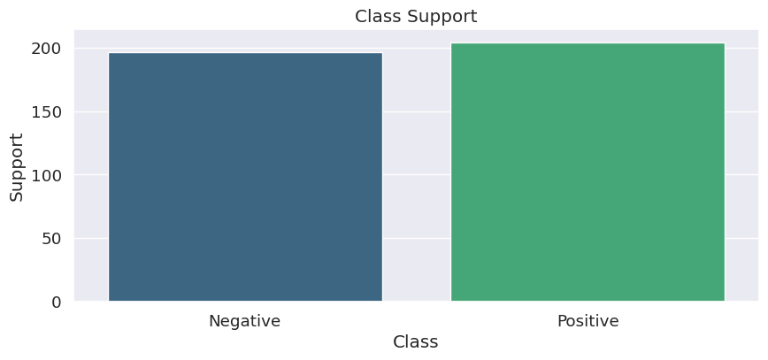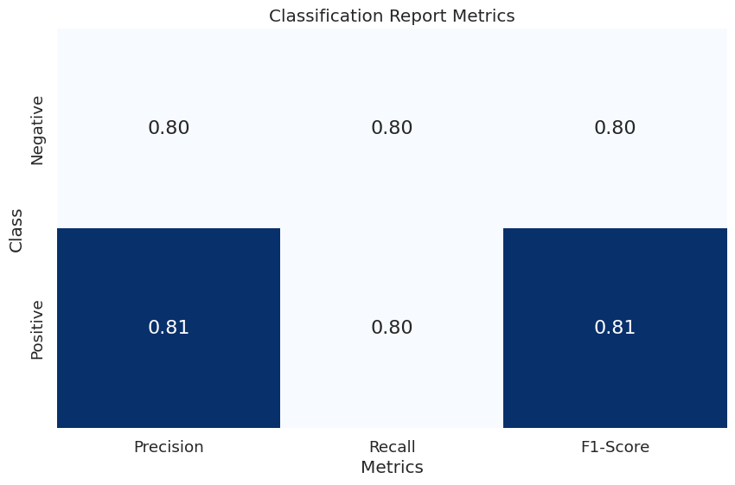

1. 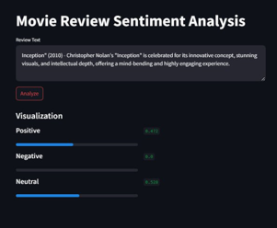 The results of the sentiment analysis determine whether the review expresses a positive or negative sentiment:

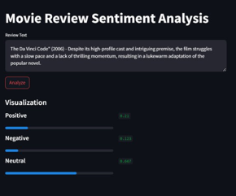

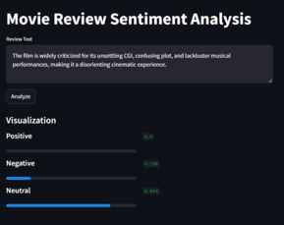

**Conclusion**

**Key Findings and Results**

**Effective Sentiment Classification:** The project successfully applied various sentiment analysis techniques on the IMDB movie reviews dataset. Traditional machine learning methods like the Naive Bayes classifier demonstrated moderate accuracy in classifying sentiments. In contrast, the BERT model, utilizing deep learning techniques, showed superior performance, particularly in understanding context and nuanced expressions in text.

**Insights into Sentiment Analysis Techniques:** The project revealed the strengths of different NLP models in sentiment analysis. While traditional models provided a solid baseline, advanced models like BERT offered a more profound understanding and classification capability due to their deep contextual learning.

**Practical Application:** The results of this project hold significant potential for practical applications, particularly for stakeholders in the film industry to gauge audience sentiments and for platforms that aggregate movie reviews.

**Challenges and Limitations**

**Data Preprocessing Intricacies**: Handling the intricacies of data preprocessing, such as HTML tag removal and converting all text to lowercase, posed initial challenges. Ensuring data cleanliness was crucial for the accuracy of the models.

**Model Complexity and Resources:** Implementing and interpreting complex models like BERT required significant computational resources. The complexity of these models also presented challenges in fine-tuning and optimization.

**Handling Subjectivity in Language:** One of the intrinsic challenges of sentiment analysis is the subjective nature of language. Capturing subtle nuances, especially in diverse movie reviews, remained a challenging aspect.

**Future Prospects and Research**

**Ensemble Methods:** Future work could explore the integration of ensemble methods, combining the strengths of various models for improved accuracy and robustness in sentiment prediction.

**Advanced Deep Learning Architectures:** Beyond BERT, there's potential to explore other advanced deep learning architectures, which might offer enhanced accuracy and efficiency in sentiment analysis.

**Fine-Tuning and Optimization Techniques:** Further research could focus on fine-tuning techniques to optimize model performance, particularly in handling the nuances and variability of language in movie reviews