

American International University-Bangladesh (AIUB)

**Department of Computer Science and Engineering**

**Faculty of Science & Technology (FST)**

**Fall 2023 – 2024**

**SOFTWARE REQUIREMENT ENGINEERING**

**Software Requirement Specifications**

**Section: E**

**Group-05**

**Project Title: Hospital Management System (Medi-Care)**

**Submitted By:**

SARJAT AZIZ RUMI(19-40595-1)

S. S. M. AFSAN SANI (19-39332-1)

Submitted To

MD. ANWARUL KABIR

ASSOCIATE PROFESSOR

DEPARTMENT OF COMPUTER SCIENCE

FACULTY OF SCIENCE & TECHNOLOGY

**Table of Contents**

1. **Introduction …………………………………………………………… 1-6**
   1. **Purpose ………………………………………………………… 1-1**
   2. **Definition, Acronyms, and Abbreviations …………………… 1-2**
   3. **Overview of the System ………………………………………. 2-3**
   4. **Business Context ……………………………………………… 3-6**
2. **The Overall Description ………………………………………………. 6-10** 
   1. **Product Perspective …………………………………………… 6-7**
   2. **Product Functions …………………………………………….. 7-8**
   3. **User Characteristic ……………………………………………. 8-9**
   4. **Use Case Diagram …………………………………………….. 9-10**
3. **Justification: Benefits of the System ………………………………… 11-12**
4. **Stakeholder Analysis …………………………………………………. 12-13**
5. **Product Vision and Scope …………………………………………… 13-14**
6. **Diagrams for the system …………………………………………….. 14-18**
7. **Components or Modules of the System …………………………….. 19-20**
8. **Functional Requirements ……………………………………………. 20-28**
9. **Non-Functional Requirements for the System ……………………... 28-29**
10. **System Requirements ………………………………………………... 29-30**
    1. **Technological Requirements ………………………………… 29-29**
    2. **Infrastructure Requirements …………………………………. 29-30**
    3. **Software Requirements ……………………………………….. 30-30**
    4. **Security Requirements ………………………………………... 30-30**
    5. **User Interface Requirements …………………………………. 30-30**
    6. **Version Compatibility …………………………………………. 30-30**
11. **Manpower Requirement for Implementation ………………………. 30-31**
12. **Budget ………………………………………………………………… 31-32**
13. **Constraints of this Document ……………………………………….. 30-33**
    1. **General Constraints …………………………………………… 33-34**
    2. **Scope Flexibility ………………………………………………. 34-34**
    3. **Resource Constraints …………………………………………. 34-34**
    4. **Technology Adoption Constraints …………………………… 34-34**
    5. **Data Security Constraints …………………………………….. 34-34**
    6. **Adaptability Constraints ……………………………………… 34-35**
14. **Conclusion ……………………………………………………………. 35-35**

**1. Introduction**

**1.1 Purpose**

The purpose of the Software Requirements Specification (SRS) for the hospital management system is to provide a detailed description of the functionality of the Medi-Care platform. This hospital management system (HMS) platform is designed to revolutionize healthcare service accessibility and delivery by connecting patients with the right doctors, services, and resources at every stage of their health journey. This Medi-Care HMS enables patients to quickly identify and connect with the most suitable healthcare providers based on their location, insurance, and specific needs by providing a comprehensive list of specialists and services.

Our platform's main objective is to facilitate the effortless sharing of patient data between physicians, clinics, and hospitals to support the continuity of treatment and informed decisions. With the help of the website, patients may make accurate financial decisions about their healthcare by receiving estimated breakdowns of their medical bills. The platform allows patients to easily schedule appointments for medical care, lodging, checkups, and other services, eliminating the need for time-consuming phone calls or physical visits. All patients can actively participate in their well-being thanks to the platform's practical elements like pharmaceutical product lists, health advice, educational materials, etc.

Producing comprehensive reports and analytics provides valuable insights into resource utilization, patient trends, and treatment outcomes, helping healthcare institutions make informed decisions about staffing, service expansion, and resource allocation. The HMS platform stands as a bridge between patients, healthcare providers, and resources, aiming to create a patient-centric, efficient, and accessible healthcare experience for all.

**1.2 Definition, Acronyms, and Abbreviations:**

a. **SRS - Software Requirements Specification:**

* **Definition:** A comprehensive document outlining the functional and non-functional requirements of the software system. It serves as a foundational guide for software development, encompassing design, implementation, and testing phases.
* **Purpose:** The SRS ensures a shared understanding among stakeholders, including clients, developers, and testers, concerning the software's features, capabilities, and constraints.

b. **HMS - Hospital Management System:**

* **Definition:** A web-based platform designed to streamline and enhance various healthcare-related processes within a hospital or medical facility. It typically includes modules for patient management, appointment scheduling, billing, and resource optimization.
* **Purpose:** The HMS aims to improve overall healthcare service delivery, optimize resource utilization, and provide a centralized platform for managing patient information and administrative tasks.

c. **Medi-Care:**

* **Definition:** A trademarked name for the HMS platform.
* **Purpose:** Represents the brand identity and recognition of the Hospital Management System developed under this name.

d. **EMR - Electronic Medical Records:**

* **Definition:** A digital version of a patient's paper chart, containing their medical history, diagnoses, medications, treatment plans, immunization dates, allergies, radiology images, and laboratory test results.
* **Purpose:** Facilitates efficient record-keeping and retrieval of patient information, enhancing healthcare providers' ability to deliver coordinated and high-quality care.

e. **CPOE - Computerized Physician Order Entry:**

* **Definition:** A system that allows medical practitioners to enter medication orders or other physician instructions electronically, eliminating the need for handwritten orders and reducing errors.
* **Purpose:** Improves the accuracy and efficiency of the order entry process, contributing to patient safety and streamlined healthcare workflows.

f. **HL7 - Health Level Seven:**

* **Definition:** A set of international standards for the exchange, integration, sharing, and retrieval of electronic health information. It defines protocols for the interchange of clinical and administrative data between software applications.
* **Purpose:** Ensures interoperability and seamless communication between different healthcare information systems, promoting standardized and efficient data exchange in the healthcare industry.

**1.3 Overview of the System**

**The Medi-Care Hospital Management System is a comprehensive, web-based platform meticulously crafted to enhance the interconnected experience among patients, medical professionals, and various health-related services. This user-centric platform is a dynamic hub, empowering individuals with extensive features designed to streamline healthcare interactions.**

**This sophisticated system facilitates a seamless booking experience for medical services, appointments, health checkups, hospital visits, and pharmaceutical product orders. Users navigate effortlessly through an intelligently designed interface, choosing from predefined options or describing symptoms to access a comprehensive list of doctors, hospitals, and tests. By utilizing sophisticated algorithms and medical databases, the platform proposes potential illnesses, suggested testing, and appropriate healthcare providers, thereby assisting individuals in making sensible choices regarding their healthcare journey.**

**The software offers consumers clear and detailed cost breakdowns for medical expenses, helping them with financial planning by addressing their financial concerns. With personalized suggestions based on users' choices, they can make their healthcare experience unique.**

**The platform ensures swift emergency response through automated confirmations and manual processes, guaranteeing prompt handling of medical requests and critical situations.**

**The robust database infrastructure of the platform establishes international connectivity with extensive disease databases abroad. This connection enhances disease control measures, generates accurate reports for special research sections, and contributes to global healthcare knowledge. The platform accommodates various account types, including patient accounts, Medi-Care staff, and professionals from different hospitals, ambulance services, and emergency response teams, creating a holistic healthcare ecosystem.**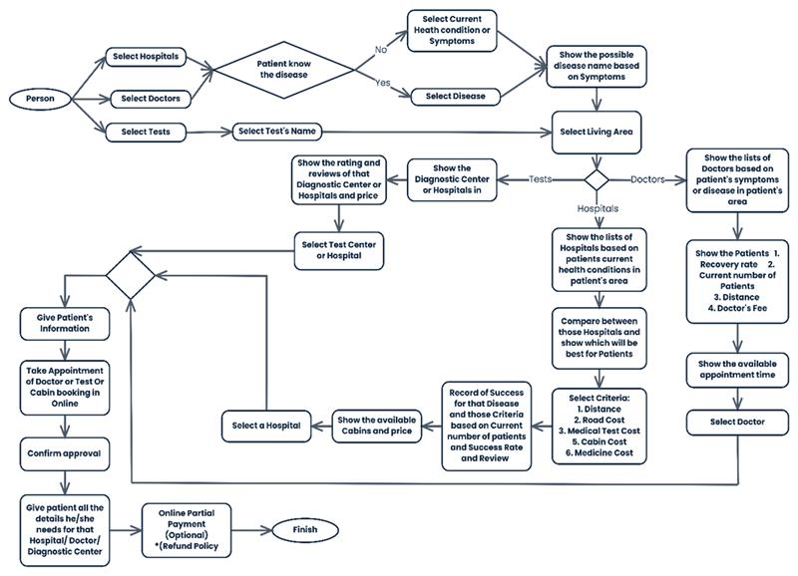

**1.4 Business Context**

The healthcare industry faces significant challenges characterized by information gaps, operational inefficiencies, and limited accessibility. Patients frequently need help navigating healthcare services, resulting in delayed diagnoses, insufficient treatment, and financial burdens. The transformative Medi-Care Hospital Management System (HMS) has been designed as a service-oriented platform to address these issues comprehensively.

The Medi-Care HMS is poised to revolutionize healthcare delivery by comprehensively addressing challenges, offering innovative solutions, and catering to a broad range of users, ensuring a more empowered, efficient, and accessible healthcare experience for all stakeholders.

The platform's ambition extends to unifying the healthcare ecosystem by integrating providers across hospitals, clinics, and diagnostic centers onto a single platform. Leveraging advanced algorithms and medical knowledge bases, the system aims to provide intelligent recommendations for relevant doctors, tests, treatments, and medications.

The anticipated benefits of the Medi-Care HMS are extensive. Patients can expect an improved healthcare experience with increased convenience, reduced stress, and greater control over their healthcare journeys. Enhanced healthcare quality is anticipated through more accurate diagnoses, faster treatment decisions, and personalized care options, ultimately leading to better health outcomes.

Efficiency gains and cost-effectiveness are projected outcomes, with reduced administrative burdens, improved resource utilization, and minimized errors translating to lower healthcare costs for patients and providers. The system also envisions fostering a more robust healthcare infrastructure by providing a unified platform that promotes collaboration and data sharing within the healthcare ecosystem.

**1.4.1 Challenges in the Healthcare Landscape**

**The existing healthcare challenges include:**

**Information Asymmetry:** Patients face challenges in accessing clear and accurate information about healthcare providers, services, and costs, impacting their ability to make informed decisions about their health.

**Inefficiency:** Fragmented systems, paper-based processes, and poor communication contribute to delays, errors, and administrative burdens for patients and healthcare providers.

**Lack of Accessibility:** Difficulty locating qualified healthcare providers, navigating complex medical services, and managing healthcare expenses creates barriers to timely and effective care.

**1.4.2 Addressing the Challenges with Medi-Care HMS**

**The Medi-Care HMS aims to revolutionize healthcare delivery by:**

**Empowering Patients:** Providing a user-friendly portal for scheduling appointments, accessing medical records, managing bills, and taking control of their healthcare journey.

**Bridging Communication Gaps:** Enabling seamless communication between patients and healthcare providers, ensuring prompt responses and efficient care coordination, especially during emergencies.

**Unifying the Healthcare Ecosystem:** Integrating healthcare providers across hospitals, clinics, and diagnostic centers onto a single platform eliminates fragmentation and facilitates seamless patient care.

**Leveraging Data and Intelligence:** Utilizing advanced algorithms and medical knowledge bases to provide intelligent recommendations for relevant doctors, tests, treatments, and medications.

**Promoting Transparency and Financial Planning:** Offering price transparency by providing upfront cost estimates for medical services, enabling patients to plan their healthcare expenses confidently.

**Supporting Personalization and Choice:** Empowering patients to personalize their healthcare experience by selecting preferred doctors, facilities, tests, and treatments based on individual needs and preferences.

**Optimizing Care Continuity:** Providing a comprehensive overview of patient medical history to enable better-informed decisions and ensure continuity of care.

**Advancing Research and Global Collaboration:** Securely sharing patient data with international disease databases, contributing to global healthcare knowledge and facilitating research for complex cases.

**1.4.3 Expected Benefits of Medi-Care HMS**

**The anticipated benefits of the Medi-Care HMS include:**

**Improved Patient Experience:** Increased convenience, reduced stress, and greater control over healthcare journeys.

**Enhanced Healthcare Quality:** More accurate diagnoses, faster treatment decisions, and personalized care options improve health outcomes.

**Increased Efficiency and Cost-Effectiveness:** Reduced administrative burdens, improved resource utilization, and minimized errors, leading to lower healthcare costs.

**More robust Healthcare Infrastructure:** A unified platform promoting collaboration and data sharing within the healthcare ecosystem, resulting in a more resilient and responsive system.

**1.4.4 Target Audience**

**Medi-Care HMS caters to a diverse range of stakeholders within the healthcare ecosystem, including:**

**Patients:** Individuals seeking accessible, efficient, and personalized healthcare services.

**Healthcare Professionals:** Doctors, nurses, and other providers seeking improved communication, streamlined workflows, and comprehensive patient data.

**Healthcare Administrators:** Organizations aiming to optimize operations, reduce administrative costs, and improve patient satisfaction.

**Ambulance Services and Emergency Responders:** Teams requiring swift access to patient information and efficient coordination with healthcare providers during emergencies.

**Medi-Care Staff:** Platform administrators responsible for system maintenance, data security, and user support.

1. **The Overall Description**

**2.1 Product Perspective**

The product perspective for the Medi-Care Hospital Management System (HMS) SRS involves defining the boundaries, interfaces, and some essential functions. The document highlights a few critical points:

1. The backend database holding electronic health records, connections with other healthcare IT systems, and the HMS online and mobile platforms are all included in the system scope.
2. Healthcare personnel, hospital administrators, physicians, and patients are all catered to by user-friendly interfaces. Productivity is increased through processes, AI support, and customized dashboards.
3. Core features include clinical recording, computerized physician order entry, billing/reporting, analytics, and appointment scheduling.

Connectivity with medical equipment, health wearables, payment systems, etc., is made possible by interoperability and open APIs. The relational database oversees several aspects of patient information, including demographics, drugs, diagnoses, imaging reports, and treatment plans. Modular architecture allows deploying components incrementally. On-premise and cloud-based delivery models provide flexibility. Compatibility with global healthcare standards and regulations is ensured. An essential requirement is scalability to expand from hospitals to national-level public health systems. With clearly articulated specifications around the system landscape, UX needs, feature scope, and data structure, the HMS project aims to transform healthcare delivery with optimal efficiency.

Medi-Care HMS will be an integrated digital hub connecting critical stakeholders across the healthcare ecosystem to provide a seamless, personalized care experience. At its core, Medi-Care HMS is a cloud-based healthcare IT solution replacing fragmented paper-based and legacy systems with a unified architecture. The product encompasses clinical systems such as EMRs and CPOE and administrative systems for scheduling, billing, and reporting. The modular design integrates third-party healthcare IT systems like pharmacy, labs, imaging, and medical devices through advanced interoperability and HL7 standards. The responsive web interface, mobile apps, and patient portal deliver an omnichannel user experience tailored to the specialized needs of patients, clinicians, healthcare administrators, and support staff. Intuitive dashboards, workflows, alerts, and AI-assisted decision-making enable healthcare providers to improve productivity and patient outcomes.

In the broader aspect of the ecosystem, Medi-Care HMS may interface with wearables, remote patient monitoring devices, external healthcare databases, payment systems, and health information exchanges. Offering open APIs allows third-party application integration to extend functionality over time.

The initial release focuses on hospitals and large clinic chains, although the platform can ultimately scale to public health systems like community health centers to national scale healthcare administrators. With a cloud-native architecture, Medi-Care HMS aims for ubiquitous access, enabling seamless continuity of care across any care setting.

**2.2 Product Functions**

The Medi-Care Hospital Management System (HMS) is designed to perform various essential functions to deliver a seamless and comprehensive healthcare management experience. These functions are organized for clarity and presented below:

The Medi-Care Hospital Management System (HMS) is designed to perform a wide range of functions that can be broadly categorized into the following areas:

**Patient-Facing Functions:**

* **Smart Selection for Healthcare Services:**
  + Allow patients to input their location, disease or symptoms, and current condition.
  + Present a list of hospitals, doctors, and diagnostic centers based on factors like distance, road cost, medical test cost, doctor’s fee, cabin cost, and medicine cost.
* **Rating and Information:**
  + Display hospital ratings based on the success of treating specific diseases.
  + Provide a list of doctors for a given disease, fees, the number of current patients, the best diagnostic center in their location, and test costs.
* **Booking and Price Transparency:**
  + Showcase available cabins, appointment times, tests, and prices.
  + Collect patient information securely.
* **Online Appointment Booking:**
  + Enable patients to appoint a doctor and book cabins online using the software.
* **Partial Payment Option:**
  + Provide an optional feature for patients to make partial payments using the software.

**Hospital/Diogenitic canter IT Staff Facing Functions:**

* **Patient Management:**
  + View and manage patient appointments, medical records, and billing information.
  + Send appointment reminders and notifications.
* **Communication with Patients:**
  + Send secure messages to patients.
  + Provide online consultations and advice.
* **Scheduling and Resource Management:**
  + Manage appointment schedules and optimize resource allocation.
  + Track patient flow and waiting times.

**Administrative Functions:**

* **User Account Management:**
  + Create, manage, and delete user accounts for patients, healthcare providers, and administrators.
* **System Configuration:**
  + Manage system settings, preferences, and security measures.
* **Data Analysis and Reporting:**
  + Generate reports on patient demographics, appointment statistics, billing trends, and resource utilization.
  + Track key performance indicators (KPIs) to measure system effectiveness.

**2.3 User Characteristic**

There are three types of roles in this software.

1. **Admin:** The administration is the primary owner of this Medi-Care software. One must understand computers and the internet and know how to operate this software. The administration is responsible for maintaining the software and its requirements. The administration can perform the following functions:

* Add or change the price of the cost, fees, cabin no., doctor/hospital/ diogenitic canter name, test name, etc. Moreover, the admin can delete those if needed.

1. **Patients:**The patient is the primary user of this software. They must have at least a basic knowledge of the internet. The users/patients should be able to perform the following functions:

* View, browse, and select a category on the home page.
* View, add, and update min/max cost, fees, and other requirements.
* Please create a profile and be able to update it whenever users want to.
* Check out the Hospitals/Doctors/Diagnostic Centers list and choose whatever users want.
* Patients can sign in/log in using a username and password.
* Patients can comment and review listed hospitals/doctors/diagnostic centers.

1. **Hospital/Diogenitic canter IT Staff:**This role is from the listed hospital, doctor chamber, and diagnostic centers. Staff must understand computers and the internet and know how to operate this software. This role should be able to perform the following functions:

* View the patient’s appointment, confirm it, and list it in their database.
* View and reply to Users’/Patients’ comments.
* Give basic information to patients.
* Can inform to change their requirement to the administration.

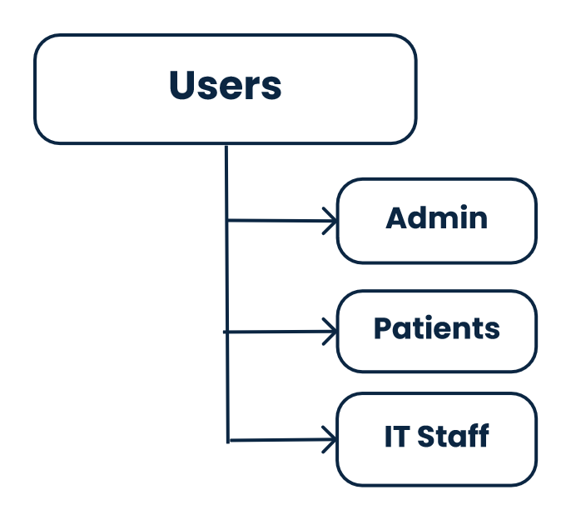

* 1. **Use Case Diagram**

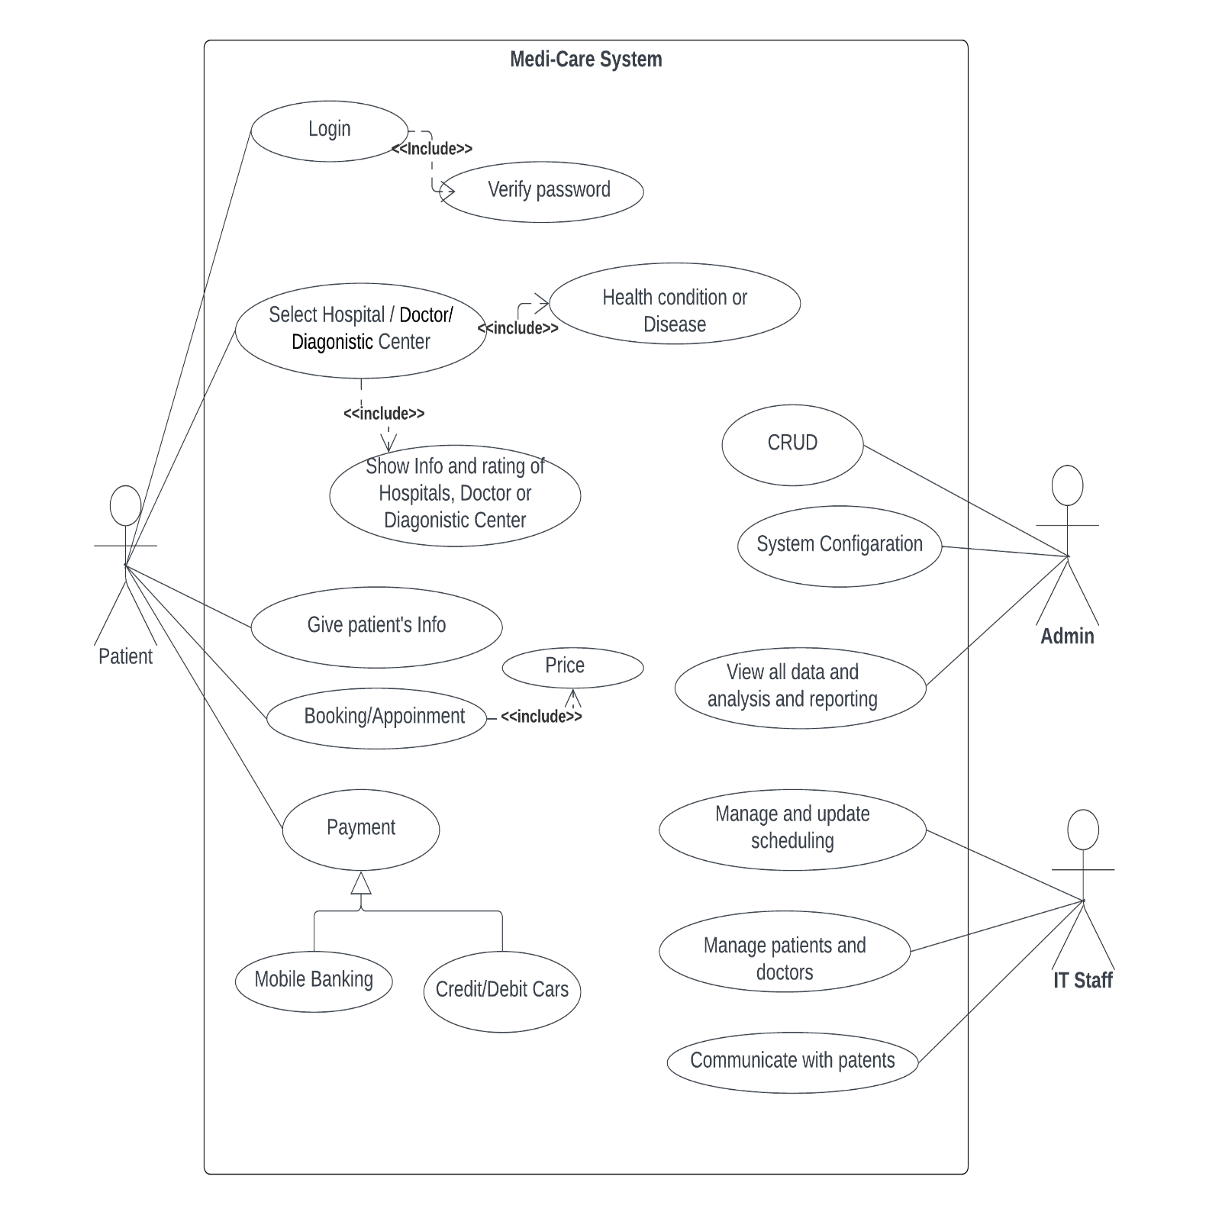

**3. Justification: Benefits of the System**

Implementing the Medi-Care Hospital Management System (HMS) is justified by many benefits that positively impact patients and healthcare providers. These benefits encompass various healthcare delivery aspects and enhance the healthcare ecosystem.

1. **Enhanced Healthcare Accessibility:**
   * Facilitates access to healthcare services, especially in remote and rural areas where physical accessibility is challenging.
   * Connects patients with suitable healthcare providers: Overcomes geographical barriers, ensuring that individuals receive timely and appropriate care.
2. **Cost Reduction for Patients:**
   * Streamlines the healthcare process, reducing patient treatment costs by minimizing inefficiencies.
   * Enables informed decisions: Empowers patients to make well-informed choices, preventing unnecessary expenses and promoting cost-effective healthcare.
3. **Efficient Appointment Management:**
   * Offers a seamless and user-friendly appointment booking process: Enhances the patient experience and ensures timely access to healthcare services.
   * Minimizes waiting times: Optimizes the utilization of healthcare resources and improves the efficiency of service delivery.
4. **Comprehensive Healthcare Information:**
   * Provides a centralized repository of healthcare information: Equips patients with data on hospitals, doctors, and diagnostic centers, facilitating informed decision-making.
   * Empowers users: By offering comprehensive information, empowering them to take charge of their healthcare journey.
5. **Improved Patient Experience:**
   * Improve patients' general experience by addressing problems that patients have with their healthcare journey and emphasizing ease of access and convenience.
   * Providing that the healthcare system is customized to fulfill the requirements and anticipations of patients.
6. **Optimized Resource Allocation for Providers:**
   * Assists healthcare providers in managing patient appointments and resources efficiently, reducing administrative burdens and allowing a focus on delivering quality healthcare services.
   * Reduces administrative burdens: Creating a more streamlined and effective healthcare service provision.
7. **Data-Driven Healthcare Decisions:**
   * Healthcare demand trends and patterns are being analyzed to help stakeholders make smart decisions. Creating the efficient execution of healthcare services.
8. **Technology-Driven Healthcare Management:**
   * Harnesses the power of technology: Streamlines healthcare processes and ensures the system remains modern and efficient.
   * Keeps pace with advancements: Adapting to changes and advancements in the healthcare industry to provide state-of-the-art solutions.
9. **Community Health Improvement:**
   * Contributes to overall community health By addressing healthcare gaps in underserved areas and promoting preventive healthcare measures through information dissemination.
   * Promotes preventive healthcare measures: Encouraging healthier communities through proactive healthcare practices.
10. **Scalable and Adaptable System:**
    * Provides a scalable solution: Adapting to evolving healthcare needs and accommodating technological advancements.

Ensures long-term viability and relevance: In the dynamic healthcare landscape, ensuring that the system remains effective and valuable over time.

**4. Stakeholder Analysis**

Medi-Care success depends on many people, including their jobs, interests, and expectations. Conducting a comprehensive stakeholder analysis is essential for comprehending their needs and guaranteeing that the system fulfills their demands. Stakeholders can be roughly divided into two groups: primary and secondary.

**4.1 Primary Stakeholders:**

1. **Patients:**
   * User Needs to book appointments, view test results, and manage bills.
   * Expectations: User-friendly platform accessible on any device.
2. **Healthcare Providers (Doctors, Hospitals, Diagnostic Centers):**
   * User Needs: Quick access to patient records, efficient workflows, and quality care delivery.
   * Expectations: Tools for streamlined operations and effective communication.
3. **Insurance Companies:**
   * User Needs: Integrated systems for claims processing.
   * Expectations: Patient access visit details and medical records data.

**4.2 Secondary Stakeholders:**

1. **Government Agencies:**
   * Interest: Improved healthcare data for policy development.
   * Expectations: Enhanced data collection and analysis capabilities.
2. **Technology Companies:**
   * Interest: Providing technical support and infrastructure.
   * Expectations: Seamless operation and integration capabilities.

This stakeholder analysis is a foundation for understanding the diverse needs and expectations of those developing and utilizing the Medi-Care HMS. Regular engagement and proactive communication with these stakeholders are essential for the system's successful implementation and sustained value delivery.

**5. Product Vision and Scope**

**Product Name:** Medi-Care (HMS)

**Vision:** To revolutionize healthcare delivery by seamlessly connecting patients, doctors, hospitals, and healthcare services through a user-friendly, intelligent, and comprehensive platform. Our vision is to empower patients to take control of their healthcare journeys, enhance the efficiency of healthcare providers, and foster a more accessible, transparent, and data-driven healthcare ecosystem.

**Scope:**

**What the system will do:**

1. **Patient-facing features:**
   * Enable patients to book appointments, manage medical records, view bills, communicate with providers, access health information, and receive personalized recommendations.
   * Facilitate emergency response and coordination.
2. **Provider-facing features:**
   * Assist providers in managing patient appointments, medical records, communication, and resource allocation.
   * Enable efficient scheduling, resource optimization, and streamlined workflows.
3. **Administrative features:**
   * Manage user accounts, system settings, data analysis, and reporting.
   * Track key performance indicators to measure system effectiveness.
4. **Unify healthcare services:**
   * Integrate healthcare providers across various facilities onto a single platform.
   * Break down silos and facilitate seamless care coordination.
5. **Leverage data and intelligence:**
   * Utilize advanced algorithms and medical knowledge bases to provide intelligent recommendations for patients and providers.
   * Support data-driven decision-making and personalized care.
6. **Facilitate research and collaboration:**
   * Securely share patient data with authorized researchers and organizations.
   * Connect with international disease databases to contribute to global health advancements.

**What the system will not do:**

* Provide direct medical diagnosis or treatment.
* Replace the role of healthcare professionals in clinical decision-making.
* Conduct physical exams and give people medicine as part of their physical care.

**Key benefits and objectives:**

* Enhanced patient experience through convenience, accessibility, and personalization.
* Improved healthcare quality through data-driven decisions, intelligent recommendations, and streamlined processes.
* Increased efficiency for healthcare providers, reducing administrative burdens and optimizing resource utilization.
* Reduced healthcare costs through streamlined processes, informed decision-making, and error prevention.
* Increased accessibility to healthcare services in underserved areas.
* Enhanced collaboration and knowledge sharing within the healthcare ecosystem.
* Contribution to global healthcare advancements through research and data sharing.

This vision and scope align with the higher-level specifications, emphasizing a holistic approach to healthcare improvement. It encapsulates the core objectives of the Medi-Care HMS, ensuring consistency with the overarching mission to enhance healthcare services.

**6. Diagrams for the system**

**Class Diagram**

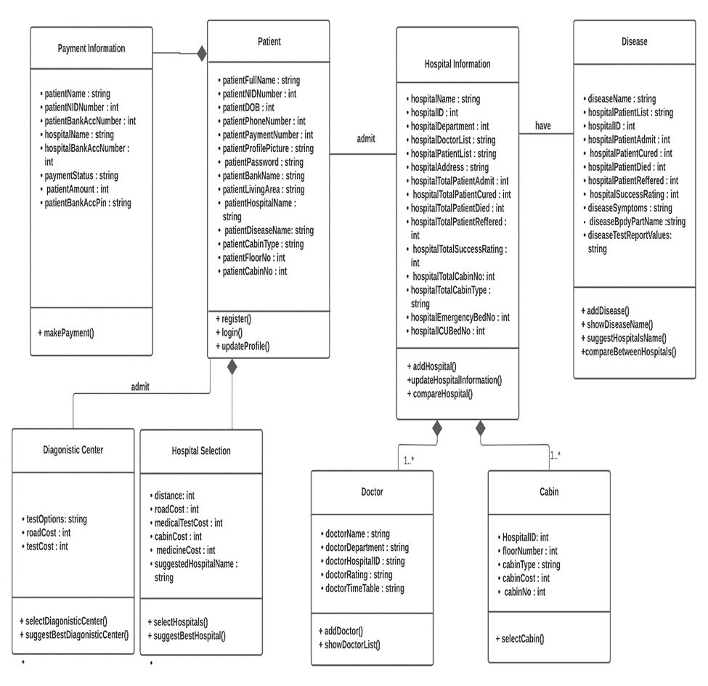

**Sequence Diagram**

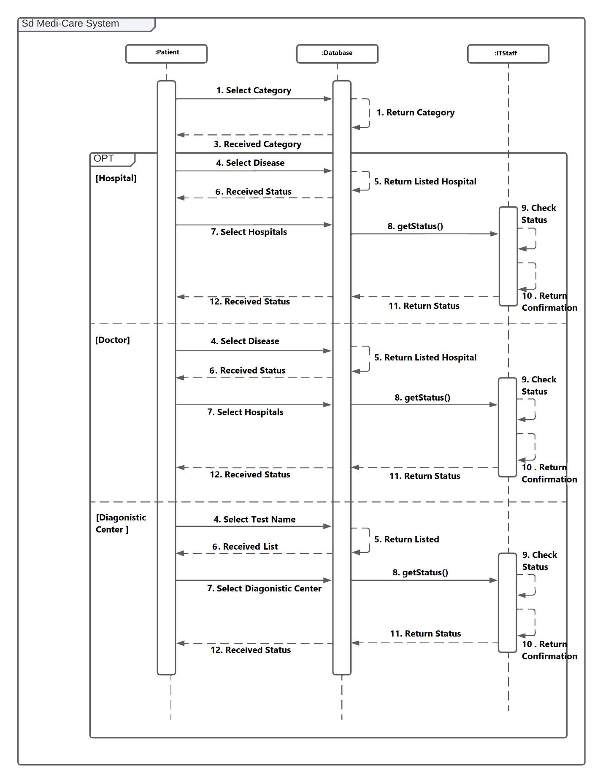

**State Diagram**

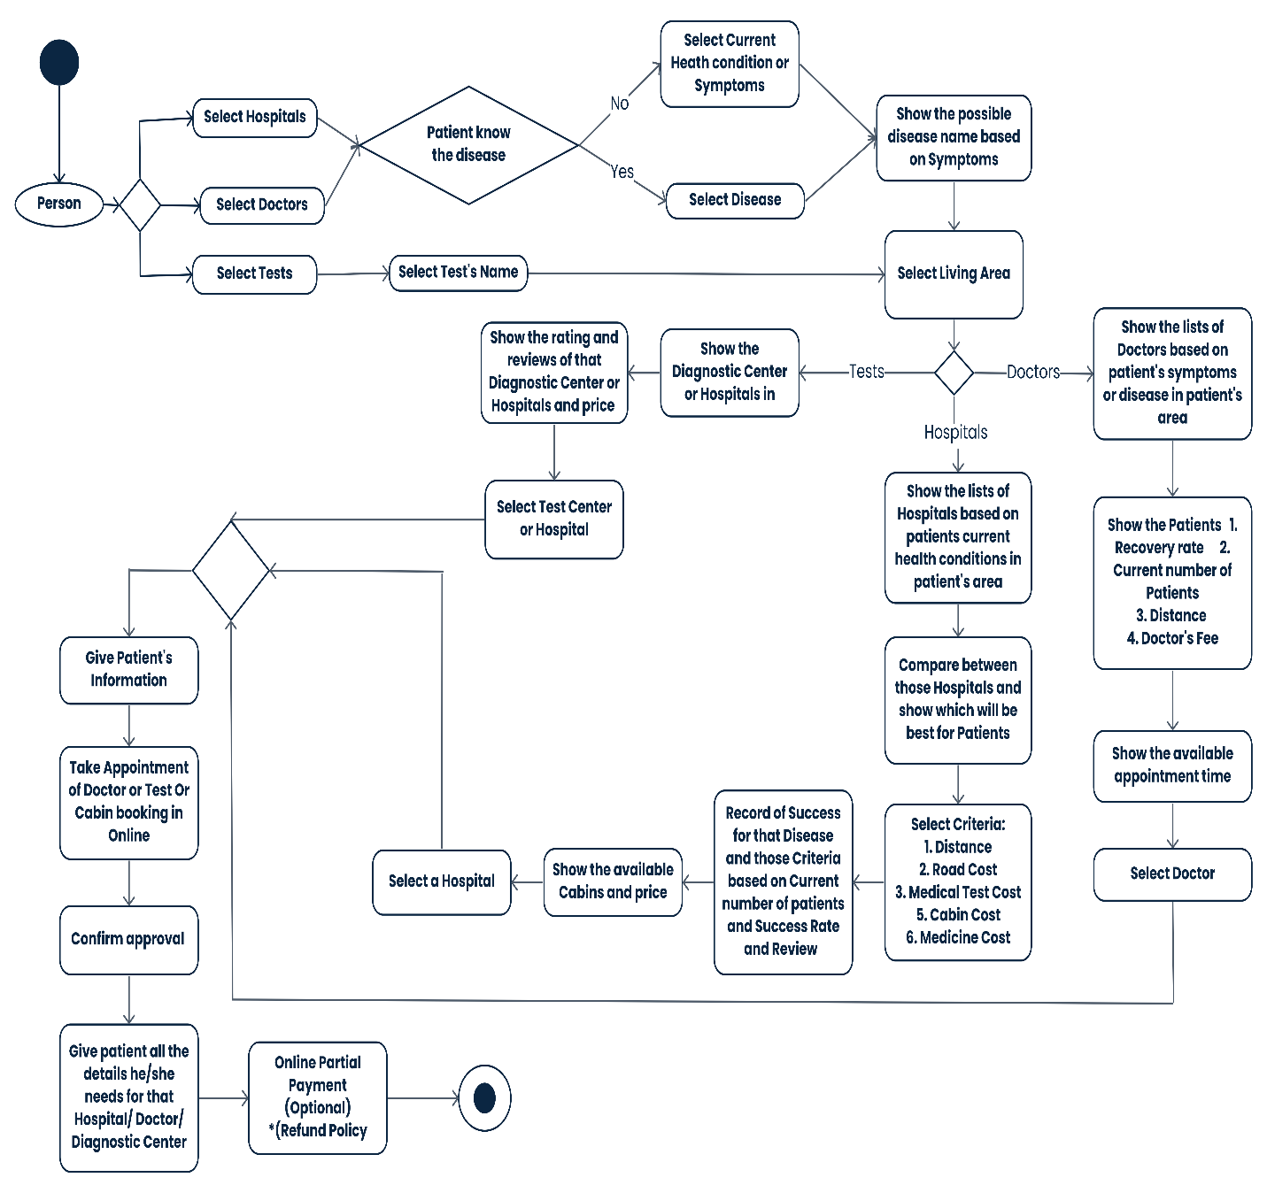

**Activity Diagram**

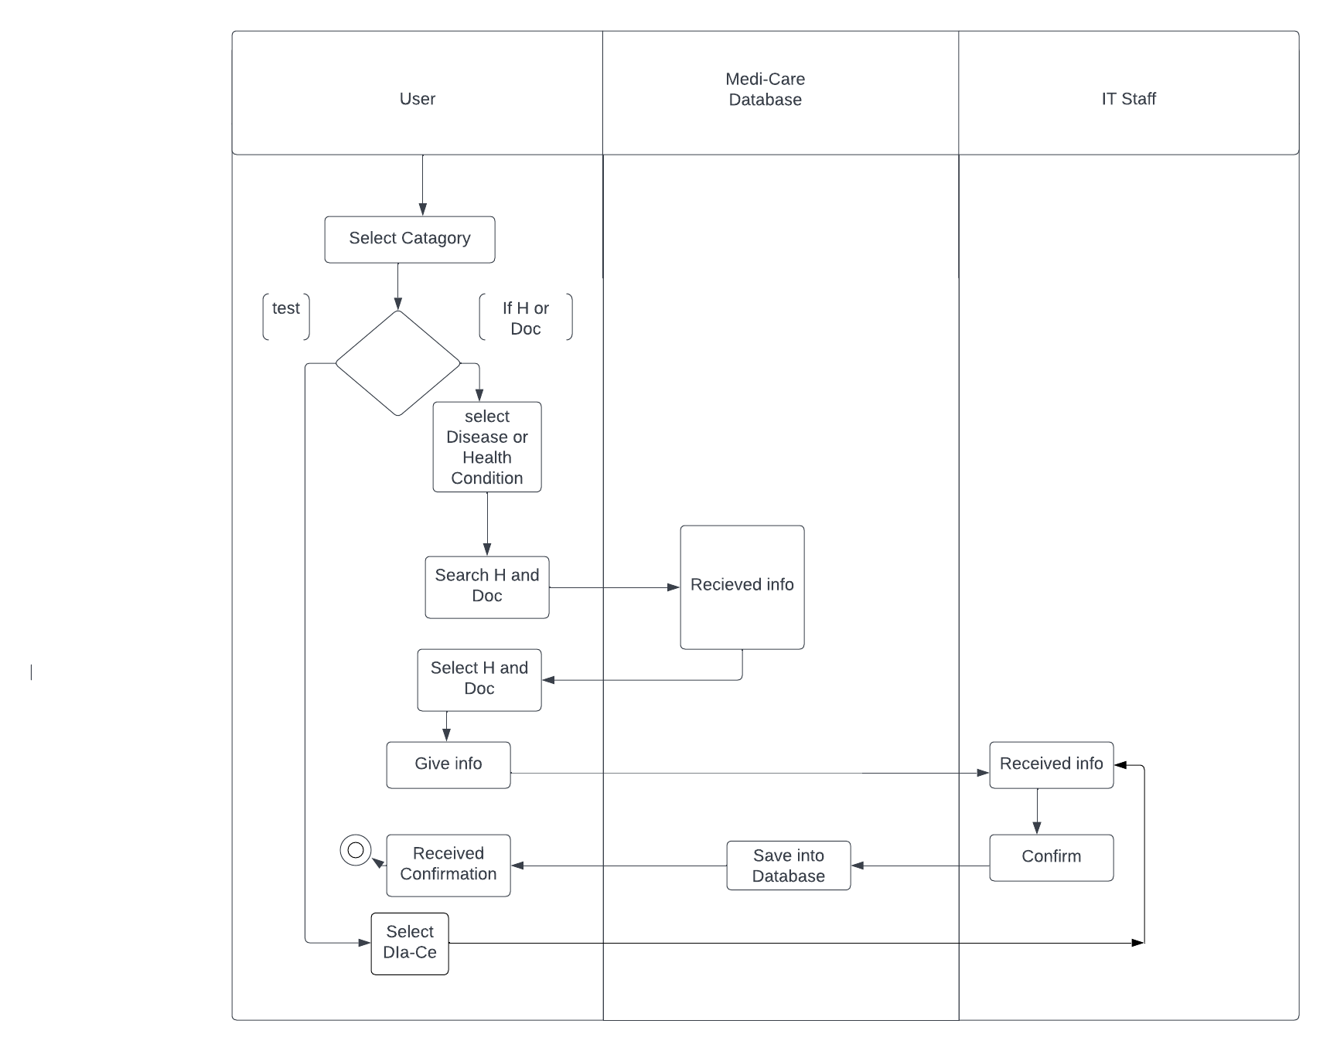

**7. Components/Modules of the System**

1. **User Management (UM):**
   * **Module Functionality:** Manages user registration, login, and profile information.
2. **Search and Recommendation (SR):**
   * **Module Functionality:** Enables users to search for healthcare providers and receive recommendations.
3. **Information Management (IM):**
   * **Module Functionality:** Allows admin to manage information about hospitals, doctors, and diagnostic centers.
4. **Health Condition/Symptoms (HC):**
   * **Module Functionality:** Deals with user input regarding their health condition or symptoms.
5. **Hospital Selection (HS):**
   * **Module Functionality:** Involves selecting hospitals based on various criteria.
6. **Doctor Selection (DS):**
   * **Module Functionality:** Involves selecting doctors based on various criteria.
7. **Tests Selection (TS):**
   * **Module Functionality:** Involves selecting tests based on health conditions or specific test names.
8. **Selecting Living Area (SLA):**
   * **Module Functionality:** Allows users to refine their search for healthcare providers based on location.
9. **Select Test Center (STC):**
   * **Module Functionality:** Allows users to choose dedicated test centers for their selected test.
10. **Doctor Selecting (DS):**
    * **Module Functionality:** Allows users to search and select doctors based on various criteria.
11. **Show Reviews and Price (RP):**
    * **Module Functionality:** Displays user reviews and price information for chosen hospitals or diagnostic centers.
12. **Show Filtered Hospitals and Diagnostic Center (FHD):**
    * **Module Functionality:** Displays a list of hospitals or diagnostic centers filtered by health condition or selected test name and location.
13. **Show Provider Details (PD):**
    * **Module Functionality:** Displays additional information about chosen healthcare providers.
14. **Recommend Providers (RC):**
    * **Module Functionality:** Based on the user's needs and preferences, shows the most suitable healthcare provider for them.
15. **Show Appointment Times (AT):**
    * **Module Functionality:** Displays available appointment slots for chosen doctors or tests.
16. **Booking Appointment/Cabin (AB):**
    * **Module Functionality:** Allows users to book appointments and cabins online.
17. **Provide Booking Details (BD):**
    * **Module Functionality:** Provides users with a summary of their chosen healthcare provider, appointment details, and any additional booking information.
18. **IT Staff Management (ISM):**
    * **Module Functionality:** IT staff can manage patient information and help IT.
19. **Data Backup and Recovery (DBR):**
    * **Module Functionality:** Ensures regular data backups and recovery processes.

**8.** **Functional Requirements**

**Module-1: User Management:**

|  |  |  |  |  |  |
| --- | --- | --- | --- | --- | --- |
| **Req ID** | **Date** | **Requirement Description** | **Dependencies** | **Originator** | **Testing Criteria** |
| UM1 | 01/12/2023 | Users can login using valid information. | None | User | Successful registration redirects to user profile. |
| UM2 | 01/12/2023 | Users can log in using valid credentials. | UM1 | User | Successful login redirects to the dashboard. |
| UM3 | 01/12/2023 | Users cannot login with incomplete or invalid information. | UM2 | User | Error message displayed for invalid login attempts. |
| UM4 | 01/12/2023 | Users can create and update their profiles. | UM2 | User | Profile updates reflect in the user's dashboard. |

**Module-2: Search and Recommendation:**

|  |  |  |  |  |  |
| --- | --- | --- | --- | --- | --- |
| **Req ID** | **Date** | **Requirement Description** | **Dependencies** | **Originator** | **Testing Criteria** |
| SR1 | 02/12/2023 | Users can search for hospitals, doctors, and diagnostic centers | None | User | Search results display relevant healthcare providers. |
| SR2 | 02/12/2023 | Users can filter search results based on cost, distance, and facilities | SR1 | User | Filtered results match user criteria. |
| SR3 | 02/12/2023 | Users receive recommendations based on their health condition or disease. | None | User | Recommended providers match user's needs. |

**Module-3: Information Management:**

|  |  |  |  |  |  |
| --- | --- | --- | --- | --- | --- |
| **Req ID** | **Date** | **Requirement Description** | **Dependencies** | **Originator** | **Testing Criteria** |
| IM1 | 03/12/2023 | Admin can add, update, delete hospitals, doctors, and diagnostic center. | None | Admin | Changes reflect on the platform in real-time. |
| IM2 | 03/12/2023 | Admin can update costs, fees, and other relevant information. | IM1 | Admin | Update information is accurate and reflects in search results. |
| IM3 | 03/12/2023 | Admin can respond to user and IT staff messages via the chat system. | None | Admin | Responses are timely and visible in the chat interface. |

**Module-4: Health Condition/Symptoms:**

|  |  |  |  |  |  |
| --- | --- | --- | --- | --- | --- |
| **Req ID** | **Date** | **Requirement Description** | **Dependencies** | **Originator** | **Testing Criteria** |
| HC1 | 04/12/2023 | Users can enter their current health condition or describe symptoms using free text or pre-defined keywords. | None | User | System accurately parses user input and identifies relevant keywords. |
| HC2 | 04/12/2023 | Users can refine their symptom description by selecting from a list of suggested conditions or body parts. | HC1 | User | Suggested options are accurate and relevant to user input. |
| HC3 | 04/12/2023 | Users can choose to skip selecting a specific condition and navigate directly to browsing hospitals or doctors. | None | User | System allows bypassing this step without requiring a condition selection. |

**Module-5: Hospital Selection:**

|  |  |  |  |  |  |
| --- | --- | --- | --- | --- | --- |
| **Req ID** | **Date** | **Requirement Description** | **Dependencies** | **Originator** | **Testing Criteria** |
| HS1 | 05/12/2023 | Users can select hospitals based on location, specialty, user ratings, or other available filters. | HC1 | User | Search results display relevant hospitals based on selected criteria. |
| HS2 | 05/12/2023 | Users can view details of each hospital, including address, contact information, facilities, and available doctors. | HS1 | User | Hospital details are accurate and up-to-date. |
| HS3 | 05/12/2023 | Users can compare multiple hospitals side-by-side based on key criteria. | HS1 | User | Comparison feature displays information accurately and clearly. |

**Module-6: Doctor Selection;**

|  |  |  |  |  |  |
| --- | --- | --- | --- | --- | --- |
| **Req ID** | **Date** | **Requirement Description** | **Dependencies** | **Originator** | **Testing Criteria** |
| DS1 | 06/12/2023 | Users can choose doctors based on hospital, specialty, experience, user ratings, or other filters. | HS1 | User | Search results display relevant doctors based on chosen hospital and additional filters. |
| DS2 | 06/12/2023 | Users can view details of each doctor, including their profile, qualifications, experience, and patient reviews. | DS1 | User | Doctor details are accurate and up-to-date. |
| DS3 | 06/12/2023 | Users can filter doctors who are currently accepting new patients. | DS1 | User | Filter displays only doctors available for new appointments. |

**Module-7: Tests Selection**

|  |  |  |  |  |  |
| --- | --- | --- | --- | --- | --- |
| **Req ID** | **Date** | **Requirement Description** | **Dependencies** | **Originator** | **Testing Criteria** |
| TS1 | 06/12/2023 | Users can choose tests based on their health condition, doctor's recommendation, or specific test name search. | HC1 | User | Search results display relevant tests based on user input. |
| TS2 | 06/12/2023 | Users can refine their test selection by filtering by test type, purpose, or cost. | TS1 | User | Filters accurately narrow down available tests based on chosen criteria. |
| TS3 | 06/12/2023 | Users can view details of each test, including its purpose, duration, preparation requirements, and potential side effects. | TS1 | User | Test details are accurate and informative. |
| TS4 | 06/12/2023 | Users can specify the exact name of the test they wish to book an appointment to the center. | TS1 | User | System accurately identifies and displays the chosen test. |
| TS5 | 06/12/2023 | If the exact test name is not found, the system suggests similar or alternative tests. | TS4 | User | Suggested tests are relevant and helpful for users who cannot find the specific test which is given. |

**Module-8: Selecting Living Area**

|  |  |  |  |  |  |
| --- | --- | --- | --- | --- | --- |
| **Req ID** | **Date** | **Requirement Description** | **Dependencies** | **Originator** | **Testing Criteria** |
| SLA1 | 06/12/2023 | Users can refine their search for healthcare providers by specifying their geographical location. | None | User | Search results are adjusted based on user's chosen location. |
| SLA2 | 06/12/2023 | The system displays the distance to each healthcare provider from the user's chosen location. | SLA1 | User | Distance information is accurate and updated. |
| SLA3 | 06/12/2023 | Users can save their preferred location for future searches. | SLA1 | User | Saved location is stored and automatically applied to subsequent searches. |

**Module-9: Select Test Center (or, Diagnostic Center)**

|  |  |  |  |  |  |
| --- | --- | --- | --- | --- | --- |
| **Req ID** | **Date** | **Requirement Description** | **Dependencies** | **Originator** | **Testing Criteria** |
| STC1 | 06/12/2023 | Users can choose dedicated test centers for their selected test. | TS1 | User | System clearly displays test centers. |
| STC2 | 06/12/2023 | Users can view available locations for each test center or its branch. | STC1 | User | Location information for each provider is accurate and accessible. |
| STC3 | 06/12/2023 | User can view rating and review of selected diagnostic center (Test Center). | STC1 | User | System clearly display the rating and review were given. |

**Module-10: Doctor Selecting**

|  |  |  |  |  |  |
| --- | --- | --- | --- | --- | --- |
| **Req ID** | **Date** | **Requirement Description** | **Dependencies** | **Originator** | **Testing Criteria** |
| DS1 | 07/12/2023 | User can search and select doctors or get suggestion from patients’ symptoms and also based on living area. | None | User | System navigates directly to the chosen doctors’ details and available services. |
| DS2 | 07/12/2023 | User know the disease and get the doctors’ list of suggestion based on disease and living area. | None | User | System clearly display the doctor’s lists are accurate and available services. |

**Module-11: Show Reviews and Price**

|  |  |  |  |  |  |
| --- | --- | --- | --- | --- | --- |
| **Req ID** | **Date** | **Requirement Description** | **Dependencies** | **Originator** | **Testing Criteria** |
| RP1 | 07/12/2023 | Users can see user reviews and price information for chosen hospitals or diagnostic centers. | HS1, DS1 & TS1 | STC1, HS1 | Reviews and prices are up-to-date and clearly displayed for each provider. |
| RP2 | 07/12/2023 | Users can filter reviews by criteria like date, rating, or specific keywords. | RP1 | User | Review filters function accurately and allow for targeted review exploration. |
| RP3 | 07/12/2023 | The system displays price information transparently, including any potential additional fees or charges. | RP1 | User | Price information is accurate, detailed, and easily understandable. |

**Module-12: Show Filtered Hospitals and Diagnostic Center**

|  |  |  |  |  |  |
| --- | --- | --- | --- | --- | --- |
| **Req ID** | **Date** | **Requirement Description** | **Dependencies** | **Originator** | **Testing Criteria** |
| FHD1 | 08/12/2023 | Users can see a list of hospitals or diagnostic centers filtered by both their health condition or selected test name and location. | HC1 | SLA1 | Filtered list accurately reflects user's specific needs and location. |
| FHD2 | 08/12/2023 | The system prioritizes hospitals and diagnostic centers equipped to handle the user's selected health condition or selected test name within their chosen location. | FHD1 | User | Filtered list prioritizes relevant healthcare providers first. |
| FHD2 | 08/12/2023 | Users can save their preferred filter combinations for future searches. | FHD1 | User | Saved filters are stored and readily accessible for subsequent use. |

**Module-13: Show Provider Details**

|  |  |  |  |  |  |
| --- | --- | --- | --- | --- | --- |
| **Req ID** | **Date** | **Requirement Description** | **Dependencies** | **Originator** | **Testing Criteria** |
| PD1 | 09/12/2023 | Users can see additional information about chosen healthcare providers, including patient recovery rates, patient volume, distance, and doctor's fees. | HS1 | STC1 | Information is accurate and updated for each chosen provider. |
| PD2 | 09/12/2023 | The system clearly differentiates and displays data specific to hospitals vs. test centers when showing provider details. | PD1 | User | Information presented matches the chosen provider type (hospital or test center). |
| PD3 | 09/12/2023 | Users can filter displayed provider details based on specific criteria like insurance acceptance or available amenities. | PD1 | User | Filters accurately narrow down providers based on chosen criteria. |

**Module-14: Recommend Providers**

|  |  |  |  |  |  |
| --- | --- | --- | --- | --- | --- |
| **Req ID** | **Date** | **Requirement Description** | **Dependencies** | **Originator** | **Testing Criteria** |
| RC1 | 10/12/2023 | The system recommends the most suitable healthcare provider for the user based on their needs and preferences. | PD1 | HS1 | Recommended provider aligns with user's health condition, location, and desired features. |
| RC2 | 10/12/2023 | Users can adjust the weighting of different factors influencing the recommendation algorithm such as price, distance, ratings, recover rats, etc. | RC1 | User | Recommendation customization based on user preferences is functional and effective. |
| RC3 | 10/12/2023 | The system provides transparent explanations for the chosen recommendation, highlighting the key factors influencing the decision. | RC1 | User | Recommendation rationale is clearly explained and understandable. |

**Module-15: Show Appointment Times**

|  |  |  |  |  |  |
| --- | --- | --- | --- | --- | --- |
| **Req ID** | **Date** | **Requirement Description** | **Dependencies** | **Originator** | **Testing Criteria** |
| AT1 | 11/12/2023 | Users can see available appointment slots for chosen doctors or tests at their preferred healthcare provider. | DS1 | TC1 & HS1 | System displays accurate and up-to-date appointment availability. |
| AT2 | 11/12/2023 | Users can filter available appointments by date, time, doctor (for hospitals), or specific test name (for test centers). | AT1 | User | Appointment filters function accurately and allow for targeted booking options. |
| AT3 | 11/12/2023 | The system highlights any appointment slots considered urgent or high-priority based on user's health condition. | AT1 | HC1 | Urgent appointment highlighting accurately reflects the user's selected health condition. |

**Module-16: Booking Appointment/Cabin**

|  |  |  |  |  |  |
| --- | --- | --- | --- | --- | --- |
| **Req ID** | **Date** | **Requirement Description** | **Dependencies** | **Originator** | **Testing Criteria** |
| AB1 | 12/12/2023 | Users can book appointments and cabins online for chosen doctors, tests, or healthcare providers. | AT1 | User | Successful booking updates user's profile, provider's schedule, and confirms the appointment. |
| AB2 | 12/12/2023 | Users can choose and book specific cabins or rooms within the chosen healthcare facility (optional). | AB1 | User | Cabin booking functionality is available and integrated with appointment selection. |
| AB3 | 12/12/2023 | Users can choose various payment methods for appointment booking, including online payments or insurance coverage verification (optional). | AB1 | User | Payment options are secure and available based on user preferences and provider capabilities. |

**Module-17: Provide Booking Details**

|  |  |  |  |  |  |
| --- | --- | --- | --- | --- | --- |
| **Req ID** | **Date** | **Requirement Description** | **Dependencies** | **Originator** | **Testing Criteria** |
| BD1 | 13/12/2023 | Users receive a summary of their chosen healthcare provider, appointment details, and any additional booking information after successful booking. | AB1 | User | Booking summary accurately reflects all confirmed details about the appointment. |
| BD2 | 13/12/2023 | The booking summary includes provider name, location, date and time of appointment, chosen test or doctor, cabin/room number (if applicable), and payment confirmation. | BD1 | User | All relevant booking information is clearly displayed and accessible. |
| BD3 | 13/12/2023 | Users can choose to receive the booking summary via email, SMS, or both for future reference. | BD1 | User | Preferred delivery method for booking confirmation is functional and reliable. |
| BD4 | 13/12/2023 | The system allows users to easily access and re-view their booking details from their profile or dedicated booking history section. | BD1 | User | Past and upcoming booking information is readily available and easily accessible within the user interface. |

**Module-18: IT Stuff Management**

|  |  |  |  |  |  |
| --- | --- | --- | --- | --- | --- |
| **Req ID** | **Date** | **Requirement Description** | **Dependencies** | **Originator** | **Testing Criteria** |
| ISM1 | 14/12/2023 | IT staff can view and manage patient information, including medical history, appointments, and test results. | UM1 | IM1 | IT staff can successfully access, view, and update patient information within their designated access levels. |
| ISM2 | 14/12/2023 | IT staff can provide IT help to patients and staff through a communication channel. | UM1 | IM1 | IT staff can receive, respond to, and resolve IT-related queries from patients and staff within a reasonable timeframe. |

**Module-19: Data Backup and Recovery**

|  |  |  |  |  |  |
| --- | --- | --- | --- | --- | --- |
| **Req ID** | **Date** | **Requirement Description** | **Dependencies** | **Originator** | **Testing Criteria** |
| DBR1 | 15/12/2023 | The system regularly performs data backups to prevent data loss. | None | System | Data can be successfully restored after a simulated data loss scenario. |

**9.** **Non-Functional Requirements for the System**

1. **Performance:**

* The System should respond to the user queries within 1.0 seconds.
* The System should provide responsive and swift user interactions.

1. **Scalability:**

* The platform should be able to handle a growing number of users, healthcare providers, and data without compromising the performance.
* Simultaneous can handle 1000 users.

1. **Reliability:**

* The System should have minimal downtime, ensuring accessibility for users at all times.

1. **Security:**

* User data should be encrypted using industry-standard encryption algorithms.
* Access controls should be implemented to ensure only authorized personnel can make changes.

1. **Usability:**

* The user interface should adhere to accessibility standards.
* User training should not exceed 30 minutes for basic functionalities.

1. **Technological Requirements:**

* The System should be accessible via the latest versions of major web browsers (Chrome, Firefox, Safari).
* It should be responsive for all devices.

1. **Integration Requirements:**

* Integration with reputable payment gateways for secure online transactions.

1. **Data Requirements:**

* Secure storage and retrieval of user and healthcare provider data.
* Regular data backups to prevent data loss.

1. **Interoperability:**

* The System should be capable of integrating with external databases, healthcare systems, and international standards.

1. **Availability:**

* Users can use the platform every week at any time.

1. **Maintainability:**

* If any problem is faced from using this application, be able to solve it in a few hours.

1. **Serviceability:**

* Users can request any problem and get any solution they need.

**10.** **System Requirements**

**10.1** **Technological Requirements**

* **10.1.1 Development Frameworks:** Modern web development frameworks for web applications such as React, Agular for the Backend and HTML, CSS, and JavaScript for the front end.
* **10.1.2 Third-Party API Integration:** Secure APIs for payment gateways and international databases.
* **10.1.3 Database System:** Secure and efficient database system to store and manage user and healthcare provider data. In this platform, MongoDB is going to be used.

**10.2** **Infrastructure Requirements**

* **10.2.1 Web Hosting:** Reliable and secure web hosting with sufficient bandwidth for user traffic.
* **10.2.2 Server Maintenance:** Regular server maintenance for performance and security.

**10.3** **Software Requirements**

* **10.3.1 Browser Compatibility:** Latest versions of popular web browsers (Chrome, Firefox, Safari).

**10.4** **Security Requirements**

* **10.4.1 Data Encryption:** Robust encryption algorithms for data security in transit and at rest.
* **10.4.2 Security Audits and Assessments:** Regular security audits and vulnerability assessments.
* **10.4.3 Regulatory Compliance:** Adherence to healthcare data protection regulations and data privacy laws.

**10.5** **User Interface Requirements**

* **10.5.1 Intuitive Interface:** User-friendly interface for easy navigation and accessibility features for disabled users.

**10.6** **Version Compatibility:**

For optimal performance and access to all features, users are recommended to use the following versions:

* **Web Browsers:**
  + Google Chrome: The latest version
  + Mozilla Firefox: Latest version
  + Apple Safari: The latest version

**11.** **Manpower Requirement for Implementation**

1. **Development Team:**
   * 1. **Project Manager:** 
        + Number Needed: 1.
     2. **Software Developers:** 
        + Fronted: 2
        + Backend: 2
     3. **UI/UX Designer:**
        + Number Needed: 1
2. **IT Stuff:**
   * 1. **Database Administrator:**
        + Number Needed: 1
     2. **System Administrator:**
        + Number Needed: 1
3. **Administrative Staff:**
   * 1. **Administrator:**
        + Number Needed: 1
4. **Medical Experts:**
   * 1. **Medical Professionals:**
        + Number Needed: 2

**Total Manpower Needed: 11.**

**12.** **Budget**

#### **Effort Estimation:**

We are utilizing COCOMO, a static model for quick and rough software development effort estimation, primarily based on the number of lines of code (SLOC).

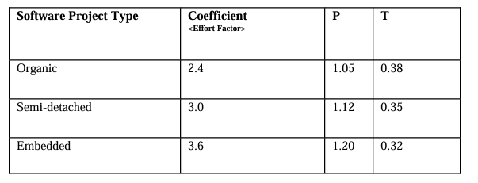

The formula used for estimation is as follows:

Effort (PM) = Coefficient x (SLOC / 1000) ^P

Where:

* Coefficient = 3.0 (for our Semi-detached project)
* SLOC = 600,000 (Lines of Code)
* P = Project Complexity = 1.12

**Calculating Effort:**

Effort (PM) = 3.0 x (600,000 / 1000) ^1.12 = 2,316.195 person-months

**Development Time (DM):**

Development Time (DM) = 2.50 x Effort ^T = 2.50 x 2,316.195 ^0.35 = 2.50×13.890

= 34.725 months

#### **Budget Estimation:**

#### **Development Costs:**

* **Personnel Expenses:**
  + Project Manager: 1 x 100,000 BDT monthly x 4 months = 400,000 BDT
  + Frontend Developers: 2 x 50,000 BDT monthly x 4 months = 400,000 BDT
  + Backend Developers: 2 x 50,000 BDT monthly x 4 months = 400,000 BDT
  + UI/UX Designer: 1 x 30,000 BDT monthly x 4 months = 120,000 BDT

**Total Development Costs:** 1,320,000 BDT

#### **Infrastructure Costs:**

* Required Hardware & Training: 250,000 BDT

**Total Infrastructure Costs:** 250,000 BDT

#### **Maintenance & Server Costs:**

* Server: 2 x 200,000 = 400,000 BDT
* Maintenance (for 6 months): 6 x 10 x 2,500 = 150,000 BDT

**Total Maintenance & Server Costs:** 550,000 BDT

#### **Marketing Costs:**

* Short-term Marketing Plan: 80,000 + 20,000 + 45,000 = 145,000 BDT
* Long-term Marketing Plan: 240,000 + 100,000 = 340,000 BDT
* Continuous Marketing Plan: 240,000 + 100,000 + 100,000 = 440,000 BDT

**Total Marketing Costs:** 925,000 BDT

#### **Other Costs:**

#### Requirement Analysis Cost: 50,000 BDT

#### Others (including Electricity bill & Internet bill & Transportation, Food):

#### 60,000 x 4 months = 240,000 BDT

**Total Other Costs:** 290,000 BDT

#### **Grand Total Budget (in BDT):**

#### Grand Total Budget = 1,320,000 BDT + 250,000 BDT + 550,000 BDT + 925,000 BDT + 290,000 BDT = 3,335,000 BDT

#### **Profit Margin (10% of Total Budget):**

* Profit Margin = 0.1 x 3,335,000 BDT = 333,500 BDT

#### **Including Profit (in BDT):**

#### Total Budget (including profit) = 3,335,000 BDT + 333,500 BDT = 3,668,500 BDT

**Total Budget (including profit) = 3,668,500 BDT**

**13.** **Constraints of this Document**

This Software Requirements Specification (SRS) for the Medi-Care Hospital Management System (HMS) acknowledges the following constraints to ensure realistic expectations and effective project management:

**13.1** **General Constraints**

* **Evolution of Healthcare Standards:** The dynamic nature of healthcare regulations and best practices might necessitate updates to maintain compliance and adapt to best practices.
* **Technological Advancements:** Rapid advancements in technology may impact the compatibility and scalability of the system, requiring regular reviews and potential future upgrades.
* **Budgetary Limitations:** Development and maintenance of the HMS are subject to budget constraints, potentially affecting the scope of features and planned enhancements.
* **Data Privacy and Security Regulations:** Keeping up with changing privacy and security rules for data, like HIPAA and GDPR, may limit how data is handled and shared, which means that it needs to be constantly checked and possibly changed.
* **User Adoption:** Successful implementation relies on user acceptance. Training programs and change management strategies will be crucial to overcome potential resistance and ensure effective utilization.
* **Interoperability Challenges:** Integrating with existing healthcare systems and technologies may pose challenges, requiring collaboration with external entities and careful planning.
* **External Dependencies:** Reliance on third-party services or data sources, such as insurance providers, diagnostic centers, and government databases, may impact system functionality and stability.
* **Global Health Landscape:** External factors, such as pandemics or global health crises, may introduce unforeseen deployment and operation challenges.

**13.2** **Scope Flexibility**

The system functionalities described in this SRS are based on the current understanding of project requirements and stakeholder needs. However, the document acknowledges the following possibilities:

* **Additional Features:** As the project grows and changes based on ongoing feedback, new features or improvements not planned initially may be added.
* **Scope Adjustments:** The system's capabilities can be increased to ensure it completes its goals and changes to fit the project's needs.

**13.3** **Resource Constraints**

* **Resource Availability:**Implementation timelines and feature prioritization are subject to resource availability, including staffing, funding, and technology resources. Unforeseen technical challenges or dependencies could impact resource allocation and project timelines.

**13.4** **Technology Adoption Constraints**

* **User Adoption:**Successful deployment depends on the rate of technology adoption among target users, including patients, healthcare providers, and administrative staff. Resistance to change within existing healthcare workflows could potentially hinder adoption. Strategies for change management and user training will be crucial for successful implementation.

**13.5** **Data Security Constraints**

* **Data Privacy and Security:**The system must follow regulations about data protection and security. Continual evaluation and possible revisions will be necessary to guarantee consistent compliance with changing requirements. Data security steps must be implemented to keep private patient data safe from people who should not have access to it, breaches, or misuse.

**13.6** **Adaptability Constraints**

* **Evolving Healthcare Landscape:**The healthcare landscape constantly changes due to new regulations, technological advancements, and evolving patient needs. The system must adapt to these changes through ongoing maintenance, updates, and potential feature enhancements. A flexible and adaptable system architecture will be essential to accommodate future changes and maintain system relevance.

By acknowledging and addressing these constraints, the development team can navigate challenges effectively, ensuring the successful delivery and sustained effectiveness of the Medi-Care HMS.

**14.** **Conclusion**

In conclusion, the Software Requirements Specification (SRS) for the Medi-Care Hospital Management System (HMS) is a comprehensive guide for developing a transformative healthcare platform. The main functional requirements outlined in the SRS emphasize the system's capacity to empower patients, streamline healthcare processes, and enhance communication and collaboration among stakeholders.

The anticipated benefits of the Medi-Care HMS are multifaceted. Patients can expect enhanced accessibility, personalized care, and improved healthcare experiences. Healthcare providers stand to gain from increased efficiency, optimized resource allocation, and data-driven decision-making. The broader healthcare ecosystem is poised to benefit from improved collaboration, data sharing, and advancements in global healthcare research.

It is essential to keep getting feedback, evaluating, and making changes as we move on to the following stages of development, such as planning, development, testing, and application. Our dedication to adaptation and response to changing technologies, standards, and user needs is essential due to the dynamic nature of the healthcare industry.

The immediate next steps involve collaborative efforts in the design phase to create an intuitive and user-friendly interface, followed by meticulous development, rigorous testing, and seamless implementation. Stakeholder engagement and active participation throughout these phases are paramount to ensure the successful delivery of the Medi-Care HMS.

We encourage all stakeholders, including patients, healthcare providers, administrators, and technology partners, to actively participate in the development and implementation process. Your insights, feedback, and collaboration will be instrumental in shaping a healthcare solution that not only meets current needs but evolves to meet future challenges. We can usher in a new era of connected, intelligent, and patient-centric healthcare services with the Medi-Care HMS.