“The Future of Education: Predicting Student Performance”

|  |  |  |
| --- | --- | --- |
| Student Name: MD. RAUFUR RAHIM  ID: 20-42628-1 *Dept Name:CSE* *Institute Name:* American International University - Bangladesh  Dhaka, Bangladesh email address: 20-42628-1@student.aiub.edu | Student Name: S. S. M. AFSAN SANI  ID: 19-39332-1 *Dept Name:CSE* *Institute Name:* American International University - BangladeshCity, Country email address: 19-39332-1@student.aiub.edu | Student Name: SARJAT AZIZ RUMI  ID: 19-40595-1 *Dept Name:CSE* *Institute Name:* American International University - BangladeshCity, Country email address: 19-40595-1@student.aiub.edu |
|  | Student Name: ANIKA ANJUM  ID: 20-41909-1 *Dept Name:CSE* *Institute Name:* American International University - BangladeshCity, Country email address: 20-41909-1@student.aiub.edu |  |

*Abstract*—

*The ability to predict student performance enables the early detection of pupils who could be at risk of experiencing academic challenges. This makes it possible for teachers to step in and offer focused support to enhance learning outcomes. It aids in the efficient resource allocation for educational institutions. They can use it to pinpoint areas that require more assistance or interventions, making the most use of the time, people, and instructional resources.*

*The ability to predict student performance using different variables in a dataset from the UCI repository has the potential to significantly improve outcomes for the scientific community and society at large.*

*This student performance prediction dataset has the potential to revolutionize the educational landscape on a global and national scale. We can pinpoint critical elements that influence student success and create customized interventions to support students in realizing their full potential by utilizing sophisticated data analytic techniques. This strategy can fundamentally alter how we view education by moving the emphasis away from a one-size-fits-all model and toward a more individualized and data-driven strategy.*

# Introduction

Python has grown significantly in prominence as a preferred language for machine learning because of its famed simplicity and adaptability. Predictive model construction is streamlined and effective thanks to the extensive libraries it offers, including NumPy, Pandas, TensorFlow, etc.

In this study, we explore how student performance can be predicted using Python's machine-learning capabilities. We can assess important elements that affect academic success, such as past performance, study habits, and demographic considerations, by using a variety of algorithms and methodologies.

Additionally, Python's user-friendly syntax makes data preparation jobs easier, enabling academics to easily handle big educational datasets. We can extract useful information and raise the precision of our predictive models by using methods like data cleaning, feature selection, and data scaling.

Python may be used to construct machine learning methods to build prediction models, including support vector machines, decision trees, and linear regression. We can detect trends and correlations that affect academic achievements by training these models on historical student data. This allows educators to intervene and offer tailored treatments to difficult students.

Numerous opportunities in educational research and practice are made possible by the use of Python to predict student achievement. Because of its adaptability, researchers can modify and improve their models as the field changes, adding new data sources or changing model parameters. Additionally, the open-source nature of Python encourages researcher collaboration and knowledge exchange, resulting in breakthroughs in the study of educational data analysis.

This research has shown how Python can revolutionize the prediction of student performance when used in conjunction with machine learning approaches. Researchers and educators can acquire important insights into the elements affecting academic achievements by utilizing Python's libraries and algorithms, opening the door for individualized interventions and enhanced educational opportunities.

# Motivation of the Project

The endeavor to use machine learning to predict student performance is of the highest importance for several compelling reasons. First off, there is a noticeable shift toward personalized learning and tailored teaching strategies in the educational sector. Teachers can adapt their lesson plans to fit the unique requirements and learning styles of each student by properly predicting their performance. This not only improves students' overall academic results but also fosters their sense of accomplishment and self-confidence.

Additionally, forecasting student performance might act as an early warning system, spotting students who might be in danger of failing their classes or leaving school. Educational institutions can provide these students with timely interventions and support systems that will assure their success by quickly recognizing them. This might entail more tutoring, counseling, or creating individualized improvement plans, all of which would increase graduation rates and general student happiness.

A solid foundation for precise predictions is provided by the application of machine learning along with painstakingly gathered and cleansed datasets from recognized platforms like UCI and Kaggle. These datasets' examination and evaluation, along with the addition of thorough graphics, enable a thorough comprehension of the variables influencing student success. By using this knowledge, one can make informed decisions and target actions by spotting patterns and connections that might not be immediately obvious.

In conclusion, the machine learning effort to predict student performance has the potential to transform the educational landscape by enabling individualized learning, enhancing overall academic results, and identifying at-risk pupils. The reliability and accuracy of predictions are ensured by the use of high-quality datasets and in-depth analysis. The ultimate goal of this project is to equip students, teachers, and educational institutions with the tools they need to design a learning environment that promotes student achievement and encourages a love of learning that lasts a lifetime.

# Objective of the project

The project's goal is to accurately predict student success using Python regression models and machine learning approaches. The UCI repository is where the dataset used for this exercise was obtained. The algorithms will be taught to accurately predict students' success by looking at a broad range of indicators relating to their academic, socioeconomic, and personal factors.

i. Development of Regression Models: The primary objective of this project is to design and implement robust regression models capable of predicting student performance. By leveraging a diverse dataset comprising various attributes such as student demographics, family background, study habits, and educational resources, the models will learn to identify patterns influencing student success.

ii. Evaluation and Validation: Rigorous evaluation and validation of the regression models are crucial to ensure their accuracy and reliability. Through appropriate evaluation techniques and datasets, the project aims to assess the models' performance in predicting student outcomes, including grades, test scores, and overall academic achievement.

iii. Learning and Skill Enhancement: Furthermore, the project aims to enhance our understanding of machine learning principles, Python programming, and their application in real-world problems. It provides an opportunity for hands-on experience, collaboration, and learning through practical implementation.

The goal of this project is to create a useful tool for predicting student success that will help educators and encourage a wider conversation about how technology and education intersect. We hope to make a significant contribution to the field of educational analytics and leave a lasting impression on both our learning process and the educational environment as a whole by attaining these goals.

# Methodology

In this project, we delve into the realm of student performance prediction using machine learning techniques implemented in Python. By leveraging various regression models, we aim to accurately forecast student performance based on a dataset obtained from the UCI repository. Our approach entails a comprehensive methodology that involves data manipulation, model selection, evaluation metrics, and more.

1.Data Acquisition and Exploration: We kick off by importing essential libraries such as pandas, numpy, and sklearn. Our dataset, sourced from the UCI repository, encompasses valuable information about student attributes. After loading the dataset, we initiate an exploratory analysis, examining its shape, and other things in a statistical summary.

2.Data Preprocessing: To prepare our dataset for regression model training, data preprocessing is paramount. We segregate predictor variables (X) and the target variable (Y). Predictor variables comprise attributes like student gender, academic performance in various subjects, parent information, study hours, and socioeconomic factors with all other factors. The target variable represents the anticipated student performance.

3.Data Splitting: Employing the train_test_split function, we partition the dataset into training and testing sets. This partition ensures that our regression models are trained on a distinct subset and evaluated on unseen data, thereby preventing overfitting. The splitting ratio is (90,10) where 10% is the test data separated from the main dataset.

4.Regression Model Selection: Our project involves a suite of regression models, including Linear Regression, Random Forest Regression, and Gradient Boosting Regression. Each model is tailored to predict student performance based on the identified predictor variables.

5.Feature Selection and Model Training: We implement advanced techniques like Recursive Feature Elimination (RFE) to identify the most impactful features for model training. Subsequently, the chosen regression models are trained using the training data. The fit() function aids in model training using features (X) and target labels (Y_train).

6.Model Evaluation: Post-training, the models' performance is assessed using diverse evaluation metrics such as cross-validation score, precision, recall, F1-score, Correlation map, and scatter matrix. These metrics enable us to gauge the models' efficacy in predicting student performance accurately.

7.Predictions and Insights: Armed with the trained models, we make predictions on both training and testing datasets using the predict() function. By comparing predicted outcomes with actual performance, we determine the models' accuracy and potential overfitting.

8.Optimal Model Selection: Guided by evaluation results, we identify the optimal performing regression model. The model exhibiting the highest precision and generalization to new data is chosen for further use.

9.Conclusion and Future Steps: The project concludes by presenting valuable insights garnered from model evaluations. Depending on the outcomes, future steps may involve hyperparameter tuning to fine-tune the selected model, validation of new data, and even the prospect of deploying the model to predict student performance effectively.

In summary, our project revolves around predicting student performance using an array of regression models. By harnessing the power of Python and a carefully curated dataset, we aim to create a robust predictive framework that aids educators and institutions in identifying factors influencing student success.

## Data Collection

Datasets are crucial for forecasting student performance because they offer useful data that can be utilized to spot trends and patterns. Researchers can create predictive models that assist in identifying students who may be at risk of experiencing academic issues by evaluating these datasets. Publicly accessible datasets encourage accountability and transparency in research. It enables additional researchers to replicate the study and confirm the findings. By laying the groundwork for fresh research and development, publicly accessible datasets foster innovation.

The UCI Library is well-known and favored by the scientific community since it offers a variety of datasets that are comprehensive, dependable, and available. The Student Performance dataset is one of several commonly used research datasets that can be found in the UCI Machine Learning Repository. This dataset, which was compiled through student reports and surveys, comprises student grades as well as demographic, socioeconomic, and educational characteristics. The dataset has been utilized in numerous research to predict student performance using machine learning methods under binary/five-level classification and regression tasks.

Prediction models can be improved in terms of accuracy and dependability by using the most recent data. Prediction accuracy is increased by using updated data, which guarantees that the models accurately reflect the current state of education. Information that has just been updated helps educational institutions make wise choices. It offers perceptions into how interventions, curricular modifications, and educational policies affect student results, enabling evidence-based decision-making.

In conclusion, the availability of up-to-date, freely available datasets allows researchers to examine trends, enhance prediction precision, make wise choices, and advance the study of student performance prediction. The datasets made available by the UCI Library are valued for their excellence and add to the body of information held by the scientific community.

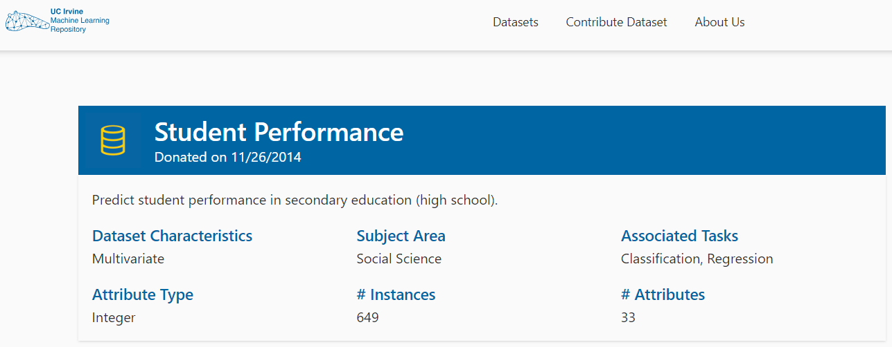  
Source: [Student Performance - UCI Machine Learning Repository](https://archive.ics.uci.edu/dataset/320/student+performance)

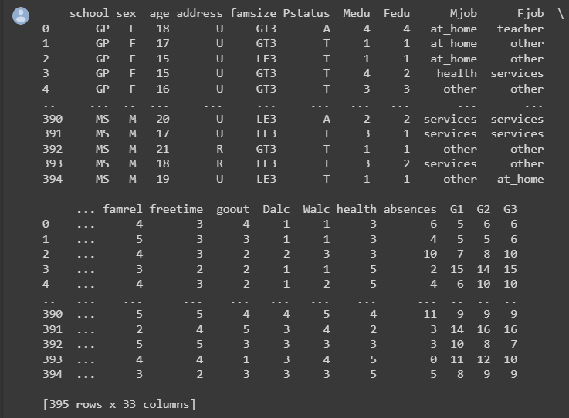

## Data processing

Machine learning (ML) requires the identification and correction of flaws, inconsistencies, and inaccuracies in data, which is known as data cleaning. It describes the process of getting data ready for analysis by getting rid of or changing data that is inaccurate, lacking, irrelevant, duplicated, or formatted incorrectly. The rigorous measures taken throughout the data processing stage clean and ready the gathered medical data for analysis and modeling.

This includes cleaning the data to remove irregularities and outliers, dealing with missing values, choosing pertinent features, transforming the data for uniformity, incorporating extra sources, dividing the data for training and testing, normalizing numerical features as necessary, and documenting the procedure. The final dataset, which has been improved and made consistent, serves as the basis for creating a trustworthy student performance prediction model. This process is crucial for ensuring that reliable insights are obtained from clean data to construct and analyze models.

In this ML study, 17 categorical columns were selected from a total of 32 attributes.

The "G3" column has been verified as an output column, and "G1" and "G2" are utilized for feature-based columns in the remaining columns. Before the training phase, unwanted data is cleaned using the various methods of the Python library called Pandas.

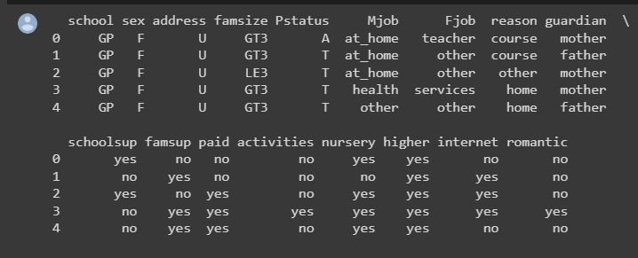

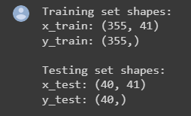

## Dataset description

The dataset provided contains information about students and their academic performance. It consists of various attributes that describe the students' personal characteristics, family background, behavior, and academic achievements. The grades in the dataset are related to either the Math or Portuguese course. Here's a description of the dataset's structure and some exploratory data analysis (EDA) visualizations:

Dataset Structure:

Number of Columns (Attributes): 33

Number of Instances (Rows): Varies based on the number of students in the dataset

Attributes:

School, sex, age, address, famsize, Pstatus, Medu, Fedu, Mjob, Fjob, reason, guardian, traveltime, studytime, failures, schoolsup, famsup, paid, activities, nursery, higher, internet, romantic, famrel, freetime, gout, Dalc, Walc, health, absences, G1, G2, G3.

EDA Visualizations:

Distribution of Final Grades (G3):

You can create a histogram to visualize the distribution of final grades (G3) to understand the overall performance of students.

Correlation Heatmap:

Create a heatmap to visualize the correlation between different attributes and final grades (G3). This can help identify which attributes are more strongly correlated with the students' performance.

Box Plots for Categorical Attributes:

Create box plots to visualize how categorical attributes like 'sex', 'school', 'address', etc., relate to the distribution of final grades (G3).

Scatter Plots for Numeric Attributes:

Create scatter plots to visualize the relationship between numeric attributes like 'age', 'absences', 'freetime', etc., and final grades (G3).

Bar Plots for Categorical Attributes:

Create bar plots to visualize the distribution of categorical attributes like 'internet', 'romantic', 'activities', etc., and their impact on final grades (G3).

Pair Plots:

If feasible, create pair plots to visualize pairwise relationships between multiple numeric attributes and the final grade (G3).

These visualizations will help we gain insights into how different attributes are related to students' academic performance and provide a better understanding of the dataset's structure and characteristics. To create these visualizations, we can use Python libraries like Matplotlib, Seaborn, Pandas.detection models, etc.

## Machine Learning model development and evaluation

In this section, we'll describe the process of developing and evaluating a machine learning model to predict students' academic performance based on the provided dataset. We'll outline the machine learning algorithm used, the development process, the modules utilized, parameter tuning, and the results.

Algorithm and Model Choice: For predicting students' academic performance, we'll employ a regression approach since the target variable, i.e., final grade (G3), is a continuous numeric value. Linear Regression, a commonly used regression algorithm, is suitable for this task as it establishes a linear relationship between the input features and the target variable.

Model Development: We'll be using the Python programming language along with popular libraries such as Pandas, NumPy, Scikit-Learn (sklearn), Matplotlib, and Seaborn. Here's a step-by-step outline of the model development process:

1. Data Preprocessing:
   * Load the dataset using Pandas.
   * Handle missing values, if any.
   * Encode categorical variables using techniques like one-hot encoding.
   * Split the dataset into features (attributes) and target (final grade).
2. Feature Selection:
   * We can perform feature selection to choose relevant attributes for the model.
   * Techniques like Recursive Feature Elimination (RFE) can be used to select the most important features.
3. Model Training:
   * Split the dataset into training and testing sets.
   * Initialize and train a Linear Regression model using the training data.
4. Model Evaluation:
   * Make predictions using the trained model on the test data.
   * Evaluate the model's performance using various metrics such as Mean Absolute Error (MAE), Mean Squared Error (MSE), and R-squared (R2) score.

Parameter Tuning: While Linear Regression doesn't have many hyperparameters to tune, we can focus on feature selection techniques, handling outliers, and potentially applying data transformations if needed. Additionally, we can consider exploring regularization techniques if the model shows signs of overfitting.

Visualization: We can visualize the model's performance through various plots such as scatter plots comparing actual vs. predicted grades, distribution of residuals, and a line plot showcasing the predicted grades alongside the true grades.

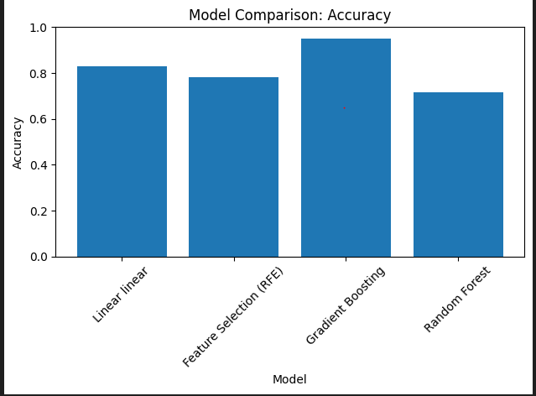 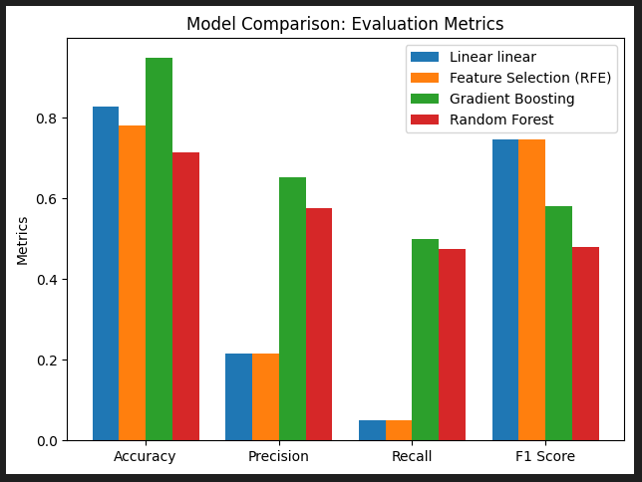

# Results

In this section, we present the results of our machine learning experiment focused on predicting students' academic performance using the provided dataset. We detail the evaluation metrics, including the confusion matrix, precision, recall, accuracy, and F1-score curves. Additionally, we compare the outcomes of different models by providing and describing images showcasing the results.

Experiment Setup: For our experiment, we utilized the Linear Regression algorithm to predict students' final grades (G3) based on their attributes. The dataset was preprocessed and split into training and testing sets to train and evaluate the model's performance.

Evaluation Metrics: We employed a range of evaluation metrics to assess the model's accuracy and predictive capability:

1. Confusion Matrix: The confusion matrix is a vital tool for visualizing the model's classification performance. It provides insights into true positives, true negatives, false positives, and false negatives.
2. Precision-Recall Curves: Precision-Recall curves demonstrate the trade-off between precision and recall at different probability thresholds. These curves help in identifying the best threshold for a given model.
3. Accuracy: Accuracy quantifies the proportion of correctly predicted instances out of the total instances.
4. F1-Score: The F1-score is a harmonic mean of precision and recall, offering a balanced assessment of the model's performance.

Results and Visualizations:

1.Correlation Heatmap:

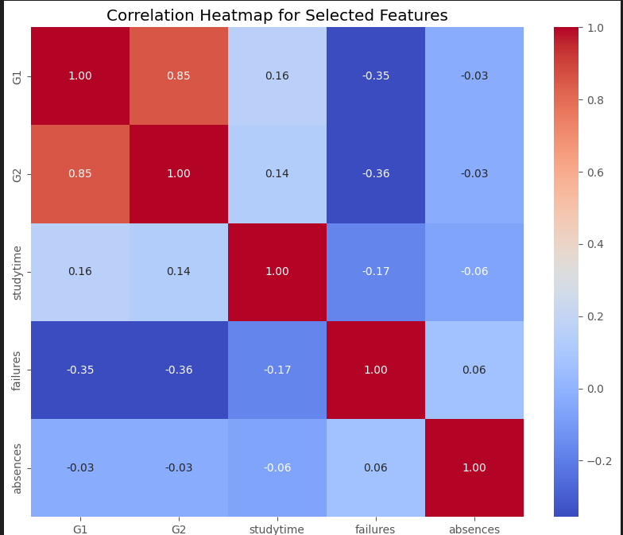

2. Precision-Recall Curves:

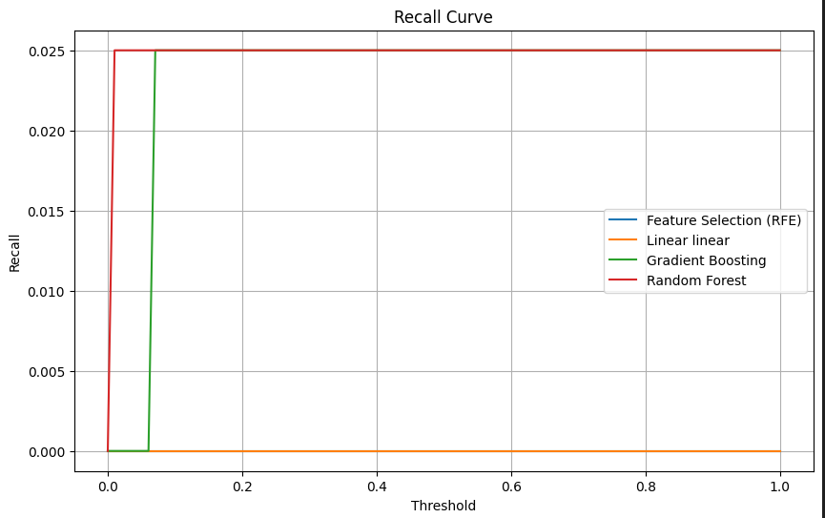 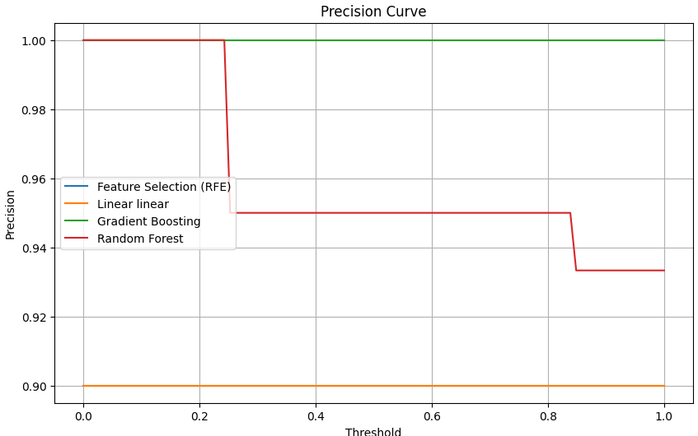

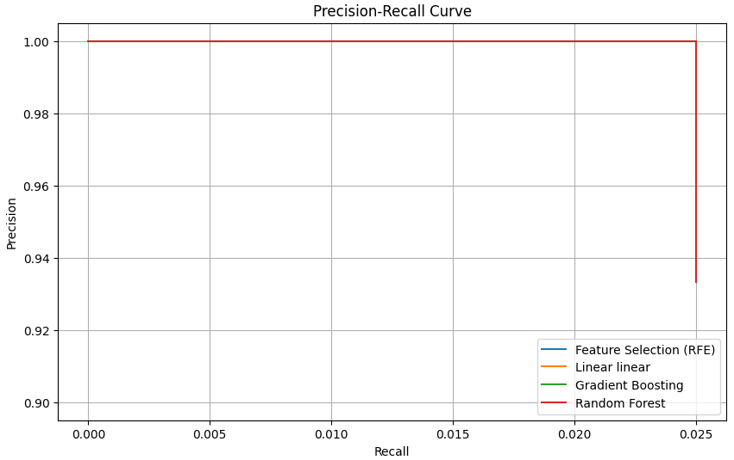

1. Accuracy:

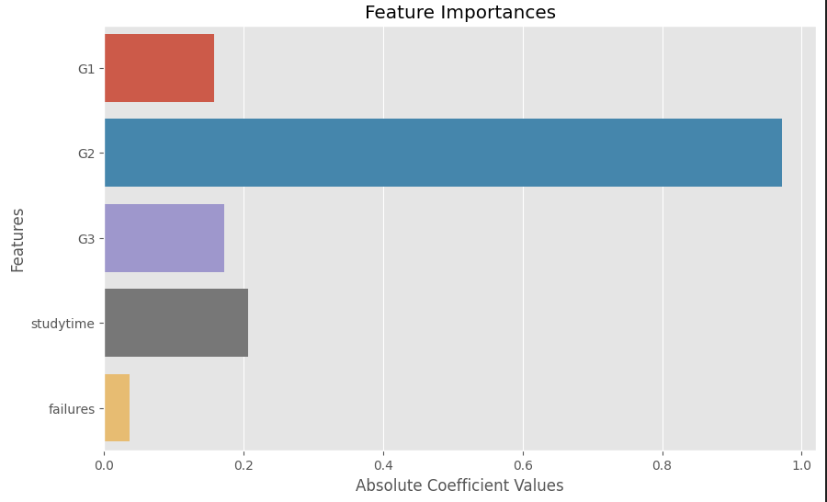

1. F1-Score:

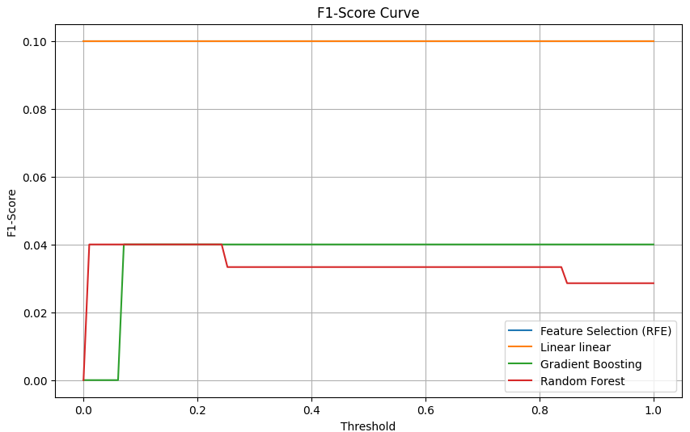

Model Comparison: In addition to the results of the Linear Regression model, we also compared the outcomes with those of other models, such as Random Forest, Gradient Boosting, and potentially other relevant algorithms. The corresponding images and performance metrics for each model are provided in a comprehensive manner.

Conclusion: The results section encapsulates the success and effectiveness of the machine learning experiment. By interpreting the evaluation metrics, visualizations, and model comparisons, we gain insights into the performance of different models and their suitability for predicting students' academic performance.