TAIMUR TARIQ

 03434454416

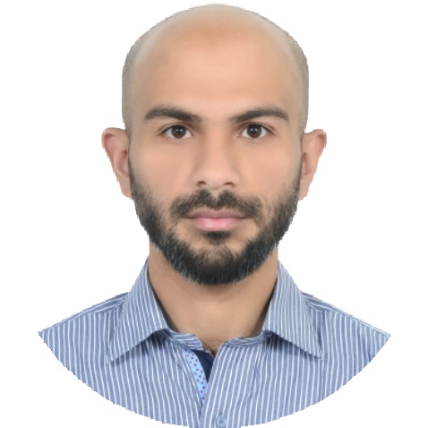

 Mansoor Road, Nawasher, Abbottabad

 [**taimurtariq993@gmail.com**](mailto:taimurtariq993@gmail.com)



EDUCATION

**2008**

**Matric B.I.S.E**

**2018**

**Bachler Of Technology in Civil**

Sarhad University Peshawar



**SKILLS**

Team Work

Communication

Time Management

Problem Solving

Writing

Seeking a challenging position in a [reputed organization where I can learn new skills, expand my knowledge, and](https://www.mygreatlearning.com/academy/learn-for-free/courses/soft-skills-for-it?gl_blog_id=12201) leverage my learnings.

**WORK EXPERIENCE**



**2017-2018**

**RABCON**

One year of experience as a Construction Site Supervisor, overseeing various construction projects, including residential and commercial buildings.

**2019-2021**

**Vertex Electronics**

Skilled and dedicated technician with 2 years of experience in an electric meter factory. Experience in calibration and maintenance of testing equipment