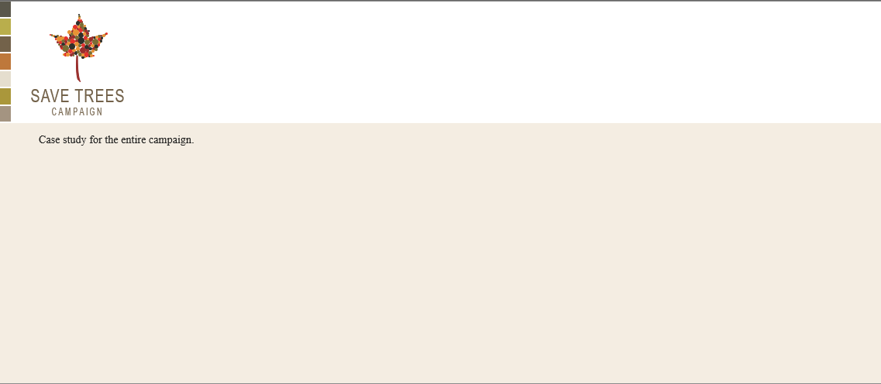1

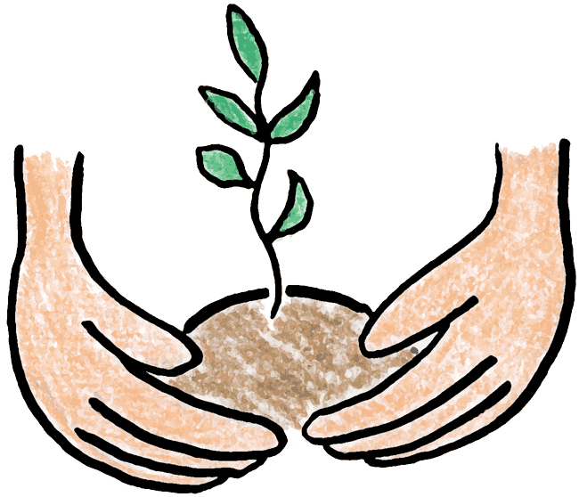

**Aim**: "Save tree Campaign" is a campaign that includes various campaign elements, including campaign details, volunteers, tree information, events, government agencies, environmental NGOs, suppliers, planting sites, sponsors, social media engagement, and donor contributions. People having same motto of saving our earth and believing in the slogan “Green Earth!” come together and join hands in this campaign to save and plant trees.

Through this initiative, the case study aims to enhance the campaign's operational efficiency, promote transparency in its activities, and provide a valuable platform for monitoring the progress of tree planting initiatives. Additionally, the database will facilitate engagement with stakeholders, optimize resource allocation, and support data-driven decision-making to maximize the impact of the "Save Tree Campaign" in its mission to protect and preserve the environment.

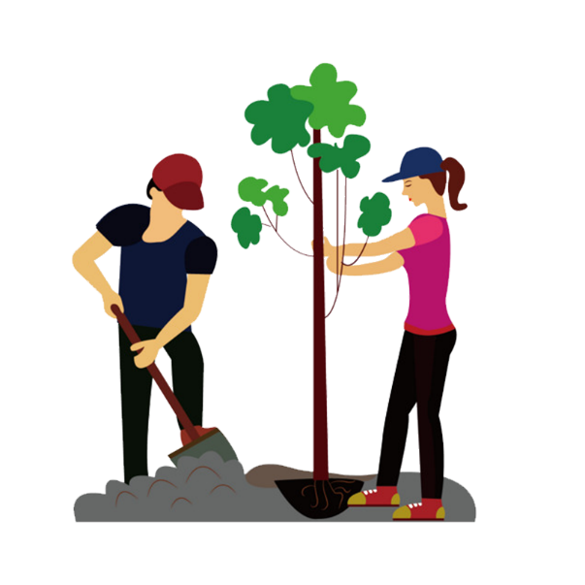**Description:**  
In our saving environmental initiative campaign, we have several key components and processes. The system encompasses various entities, including Campaigns, Organizations, Volunteers, Trees, Events, Government Agencies, Environmental NGOs, Suppliers, Tree Planting Sites, Sponsors, Social Media Posts, and Donors. Participants can create new campaigns with details such as a unique Campaign ID, name, start date, end date, and description. Organisers can be registered with a unique Org ID, name, contact information, and description. Volunteers can sign up with a unique Volunteer ID, specifying their role and contact information, and associate themselves with specific campaigns. The system tracks tree data, including a unique Tree ID, species, age, location, and status, monitoring their growth over time. Events linked to campaigns can be organized with a unique Event ID, name, date, location, and description.

Government agencies and environmental NGOs can be added, recording their Agency ID or NGO ID, name, contact details, and personnel. Suppliers can be managed, with a unique Supplier ID, name, contact details, and email, for sourcing campaign materials. Tree planting sites can be created with a Site ID, name, location. Sponsors can be registered with a Sponsor ID, name, contact information, and email. The system also tracks social media posts related to campaigns with a Post ID, tracking likes, content, and posting date. Donors are recorded with a unique Donor ID, name, phone, and email.

**Table Description:**

Following are the tables along with constraints used in *Saving Tree Campaign* database.

1. **CAMPAIGN**: This table stores information related to campaigns. It includes attributes such as CampaignId (a unique identifier for each campaign), Name (the name of the campaign), StartDate (the start date of the campaign), Description (a brief description of the campaign), and EndDate (the end date of the campaign).

*Constraint*: The CampaignId is designated as the primary key, ensuring its uniqueness for each campaign.

1. **ORGANIZATIONS**: This table is used to store data about various organizations. It consists of OrgID (a unique identifier for each organization), OrganizationName (the name of the organization), Description (a brief description of the organization), ContactPerson (the contact person's phone number), and ContactEmail (the contact person's email address). *Constraint*: The OrgID is set as the primary key to ensure uniqueness.
2. **VOLENTEERS**: This table records information about volunteers participating in campaigns. It includes attributes like VolenteersId (a unique identifier for each volunteer), CampaignId (a foreign key referencing the Campaign table to associate volunteers with specific campaigns), Name (the volunteer's name), Role (the role of the volunteer), and PhoneNo (the volunteer's phone number).

*Constraint*: The VolenteersId serves as the primary key, and campaignID is a foreign key.

1. **TREES**: This table contains details about trees, including TreeID (a unique identifier for each tree), Location (the tree's location), Age (the age of the tree), Species (the species of the tree), and Status (the status of the tree).

*Constraint*: The TreeID is the primary key.

1. **EVENTS**: This table manages information related to events associated with campaigns. It includes EventID (a unique identifier for each event), CampaignID (a foreign key referencing the Campaign table to link events to specific campaigns), EventName (the name of the event), EventDate (the date of the event), Location (the event's location), and Description (a brief description of the event).

*Constraint*: EventID serves as the primary key, campaign id is the foreign key.

1. **GOVERNMENT_AGENCY**: This table stores data about government agencies involved in environmental initiatives. It comprises Agency_id (a unique identifier for each agency), Agency_name (the name of the agency), Contact_phoneNo (the agency's contact phone number), Contact_mail (the agency's contact email address), and Contact_person_name (the name of the agency's contact person).

*Constraint*: Agency_id is set as the primary key.

1. **ENVIRONMENTAL_NGO**: This table holds information about environmental NGOs. It includes NGO_id (a unique identifier for each NGO), NGO_name (the name of the NGO), NGO_phone (the NGO's phone number), and NGO_email (the NGO's email address).

*Constraint*: NGO_id serves as the primary key.

1. **SUPPLIER**: This table manages supplier data. It includes Supplier_id (a unique identifier for each supplier), Supplier_name (the name of the supplier), Supplier_phone (the supplier's phone number), and Supplier_email (the supplier's email address).

*Constraint*: Supplier_id is designated as the primary key.

1. **TREE_PLANTING_SITES**: This table records information about tree planting sites. It comprises Site_id (a unique identifier for each site), Site_name (the name of the site), and Location (the location of the site).

*Constraint*: Site_id is set as the primary key.

1. **SPONSOR**: This table stores data about sponsors. It includes Sponsor_id (a unique identifier for each sponsor), Sponsor_name (the name of the sponsor), Sponsor_phone (the sponsor's phone number), and Sponsor_email (the sponsor's email address).

*Constraint*: Sponsor_id is the primary key.

1. **SOCIAL_MEDIA_POST**: This table manages social media posts related to campaigns. It consists of Post_id (a unique identifier for each post), Like_count (the number of likes on the post), Content (the content of the post), and Posted_date (the date when the post was posted).

*Constraint*: Post_id serves as the primary key.

1. **DONAR**: This table stores data about donors. It includes Donar_id (a unique identifier for each donor), Donar_name (the name of the donor), Donar_phone (the donor's phone number), and Donar_email (the donor's email address).

*Constraint*: Donar_id is designated as the primary key.

**ER DIAGRAM :**

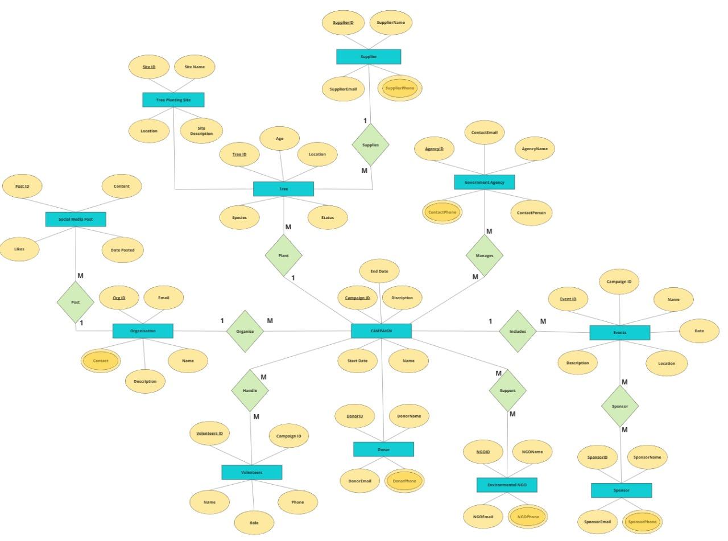

**Relationships:**

1. **One**organisation organises **many** campaigns.
2. **One** organisation can manage **many** social media posts(platforms).
3. **One** campaign can include **many** events.
4. **Many** sponsors can sponsor **many** events.
5. **Many** volunteers can handle one or **many** campaigns.
6. **Many** environmental NGOs supports **many** campaigns.
7. Government agencies manages **many** campaigns.
8. **One** campaign plants **many** trees.
9. **One** supplier can supply **many** trees.

**Schema**

CAMPAIGN_1

|  |  |  |  |  |
| --- | --- | --- | --- | --- |
| CampaignId | Name | StartDate | Description | EndDate |

Organizations_

|  |  |  |  |  |
| --- | --- | --- | --- | --- |
| OrgID | OrganizationName | Description | ContactPerson | ContactEmail |

Volenteers_

|  |  |  |  |  |
| --- | --- | --- | --- | --- |
| VolenteersId | CampaignId | Name | Role | PhoneNo |

Trees_

|  |  |  |  |  |
| --- | --- | --- | --- | --- |
| TreeID | Location | Age | Species | Status |

Events_

|  |  |  |  |  |  |
| --- | --- | --- | --- | --- | --- |
| EventID | CampaignID | EventName | EventDate | Location | Description |

Goverment_Agency_

|  |  |  |  |  |
| --- | --- | --- | --- | --- |
| Agency_id | Agency_name | Contact_phoneNo | Contact_mail | Contact_person_name |

Enviromental_NGO_

|  |  |  |  |
| --- | --- | --- | --- |
| NGO_id | NGO_name | NGO_phone | NGO_email |

Supplier_

|  |  |  |  |
| --- | --- | --- | --- |
| Supplier_id | Supplier_name | Supplier_phone | Supplier_email |

Tree_Planting_Sites_

|  |  |  |
| --- | --- | --- |
| Site_id | Site_name | Location |

Sponsor_

|  |  |  |  |
| --- | --- | --- | --- |
| Sponsor_id | Sponsor_name | Sponsor_phone | Sponsor_email |

Social_Media_Post_

|  |  |  |  |
| --- | --- | --- | --- |
| Post_id | Like_count | Content | Posted_date |

Donar_

|  |  |  |  |
| --- | --- | --- | --- |
| Donar_id | Donar_name | Donar_phone | Donar_email |

**Table data and Tables**

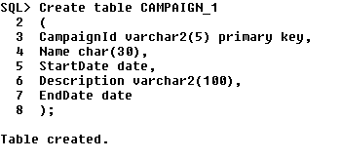





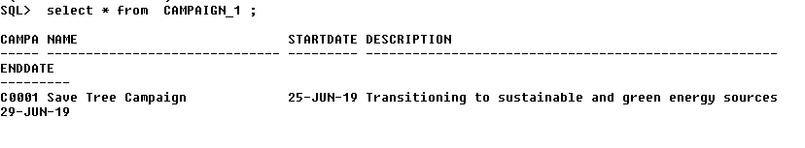

1. 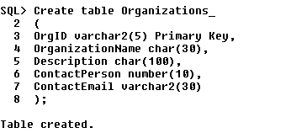



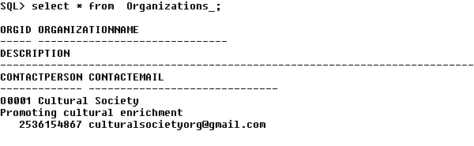

1. 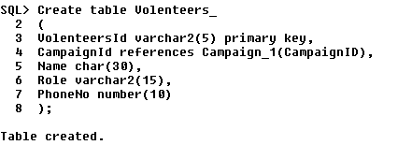

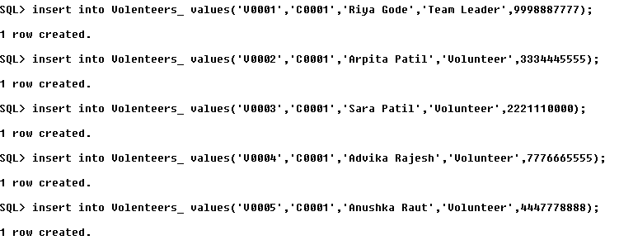

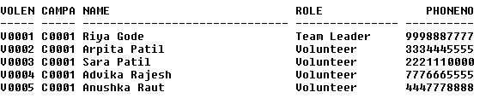

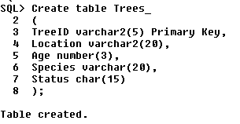



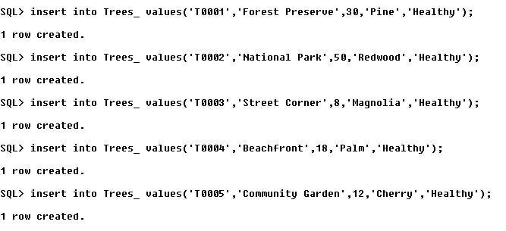

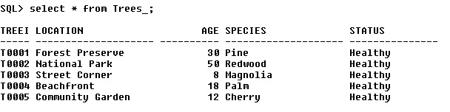

1. 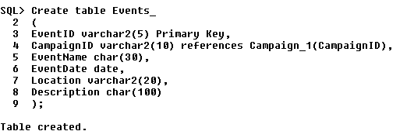

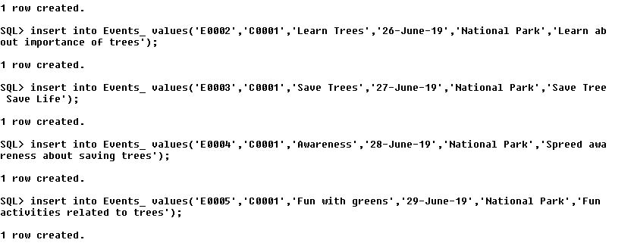

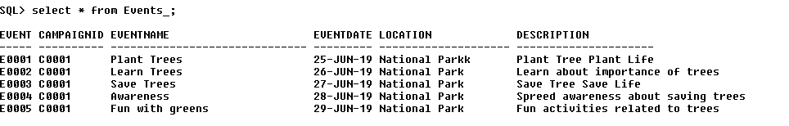

1. 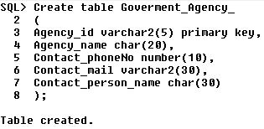

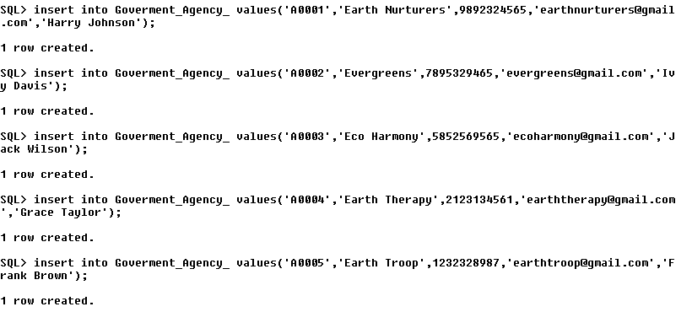

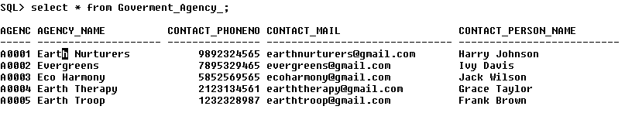

1. 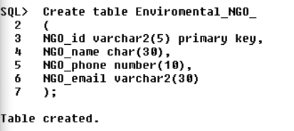

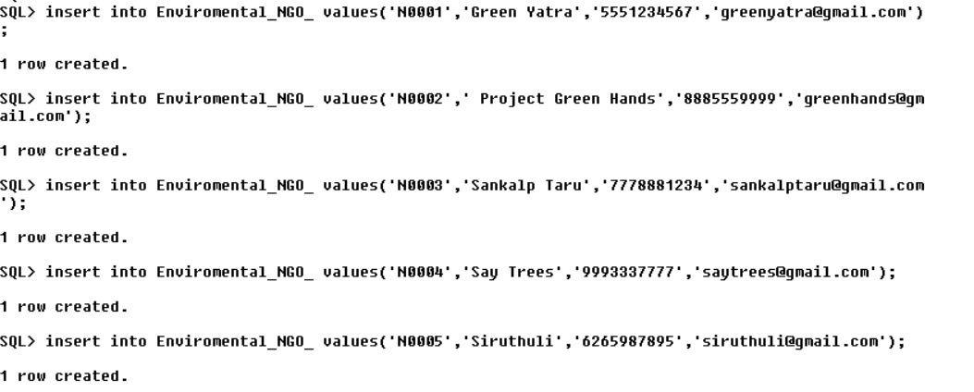

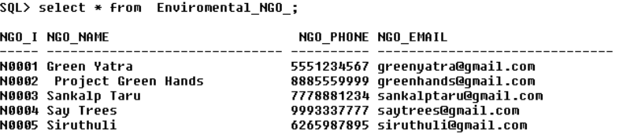

1. 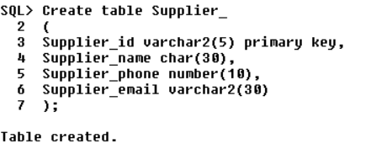

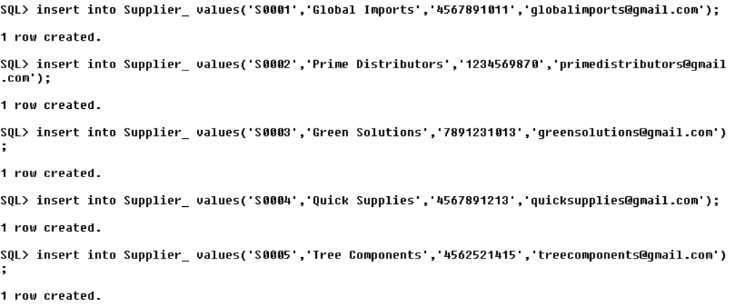

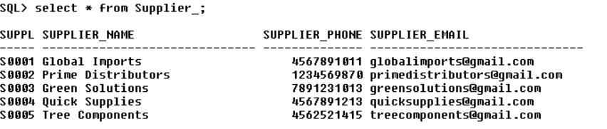

1. 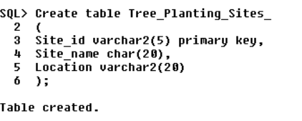

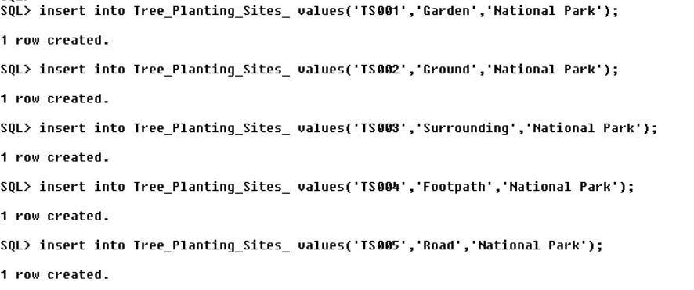

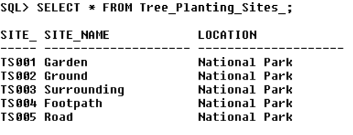

1. 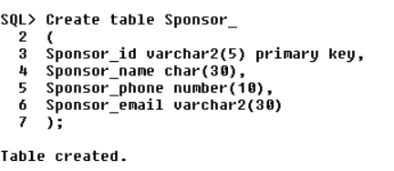

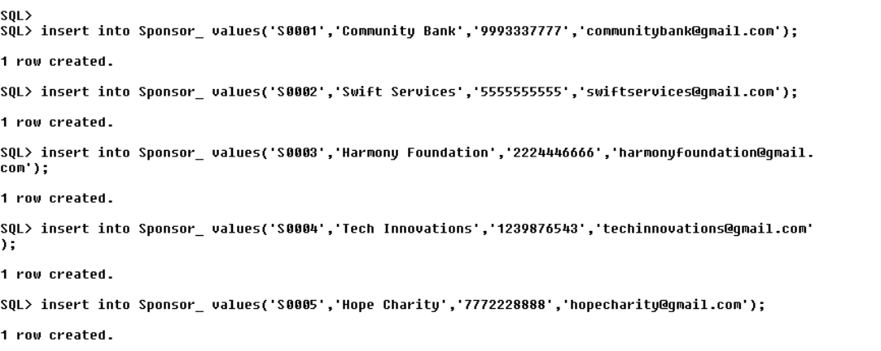

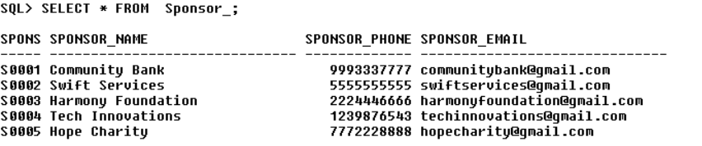

1. 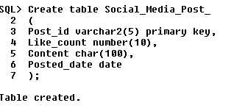

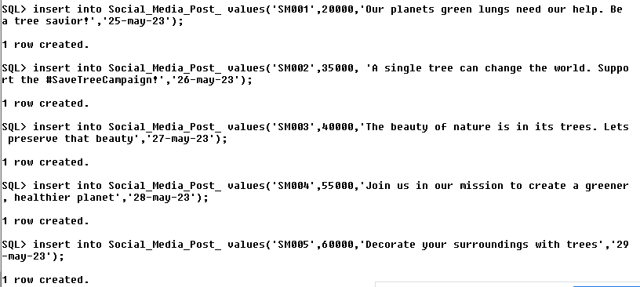

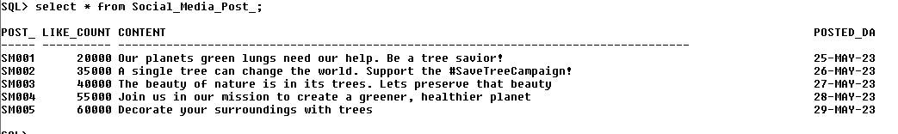

1. 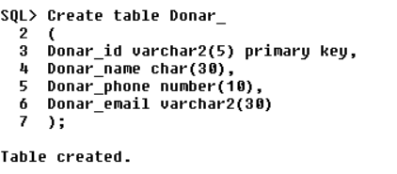

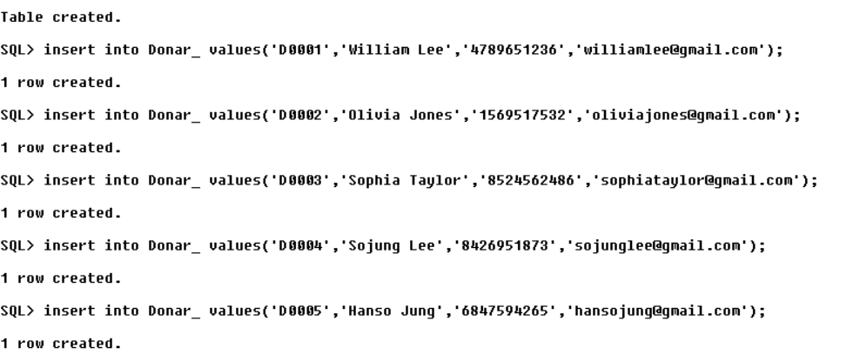

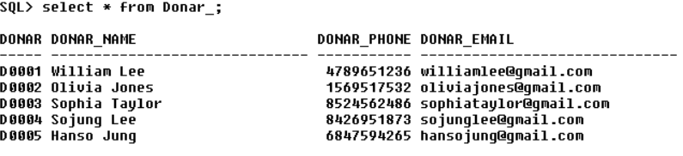

QUERIES

1. 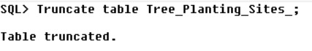

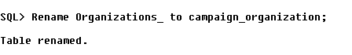



2. 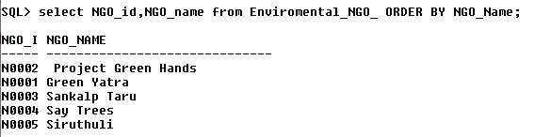

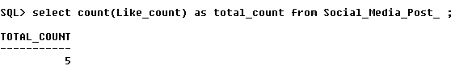

2. 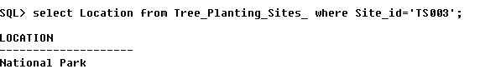

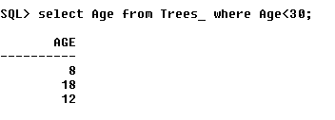



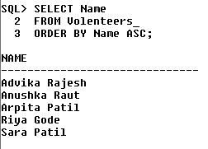



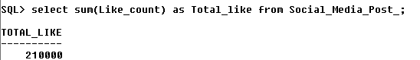

2. 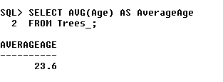

PROCEDURES

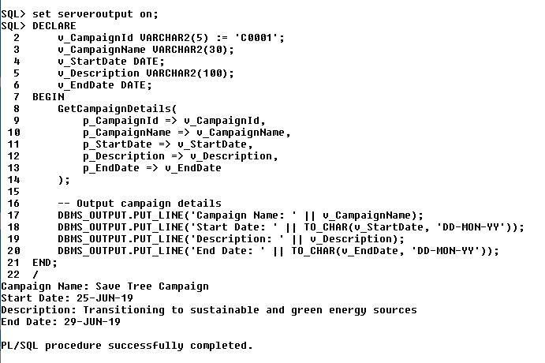

FUNCTIONS

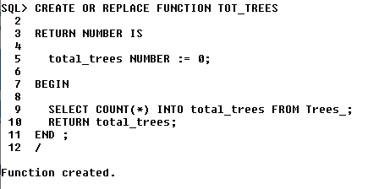

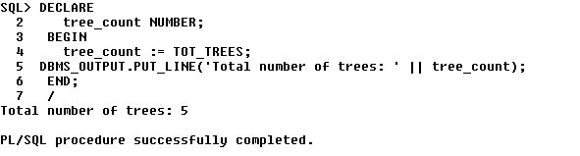

TRIGGERS

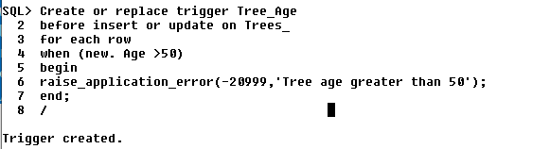

Tested data

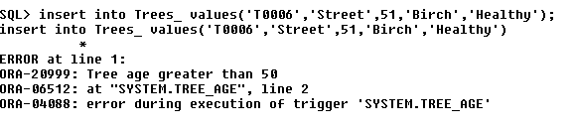



**TEAM CONTRIBUTION**

Schema : Jagveer , Manasvi ,Disha

Table Description : Manasvi , Jagveer

ER Diagram : Manasvi , Sahil , Disha , Jagveer , Bharath , Prachi (each gave 2 entities )

Tables creation and data insertion: Manasvi , Sahil , Disha , Jagveer , Bharath , Prachi (each two tables )

Queries : Bharath

Functions : Jagveer , Sahil

Procedure : Disha , Prachi

Triggers : Manasvi