Assignment 1

# How to run

1. The attached has a project/solution of Microsoft Visual Studio 2022. So, this project can be imported to Visual Studio 2022, or the executable file is available in: WindowsFormsApp1\bin\Debug\WindowsFormsApp1.exe  
   (The application is a little slow to load, you will have to wait a bit for it load)
2. The code of execution is in WindowsFormsApp1\Form1.Designer.cs and WindowsFormsApp1\Form1.cs
3. Upon starting execution the window first looks like this:  
   Graphical user interface, application, PowerPoint

   Description automatically generated
4. Select image and select Intensity Method or Colour Code Method.  
   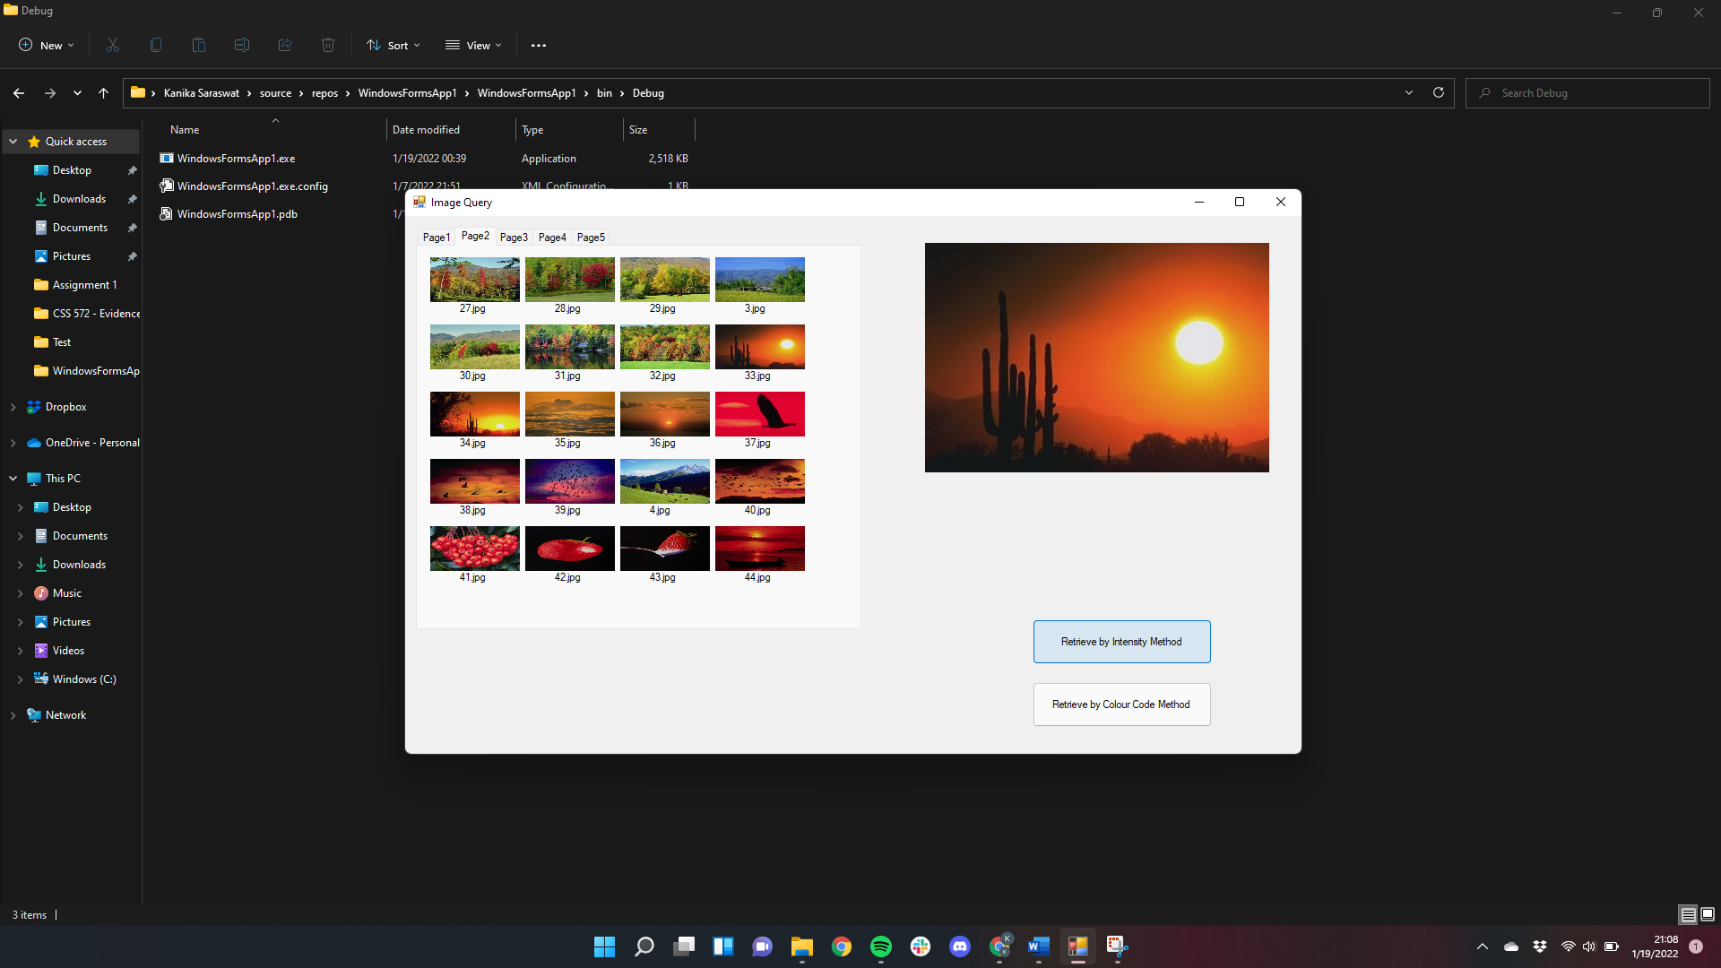
5. Results are shown on the next page:  
   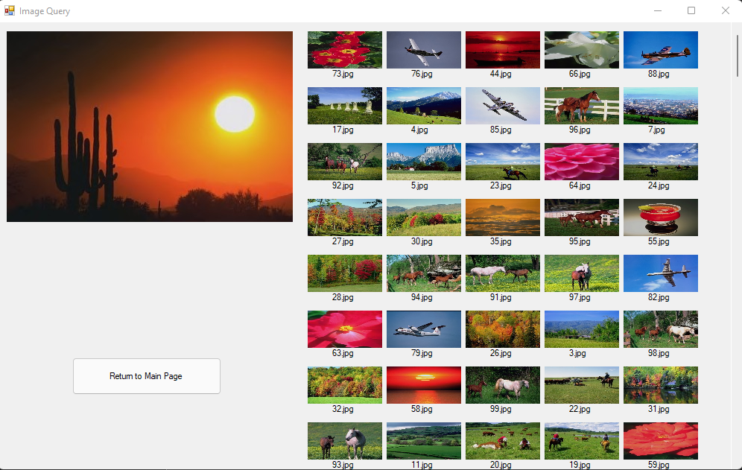
6. You can click to return on the previous page and try again with another image.

# Retrieval results of given query images

Query Image: 33.jpg

Colour Intensity Method:

Colour-Code Method:

Query Image: 93.jpg

Colour Intensity Method:

Colour Code Method:

# Further Analysis

**What are the advantages (what aspects that you like as a system designer and a user) and limitations?**

Advantages:

* The image query application requires to select an image as a query and print the closest matching images. The color intensity method does not seem to yield results as expected, but we were able to get better results using the color code method.
* We are able to get good results without training the machine to get similar looking images, only by histogram difference.

Limitations:

* Even with color code method the first 4-5 images might be correct, but we can still see some images that might be a match are a bit lower in the results.
* Since we are making a comparison using pixel-by-pixel color interpretation, the interpretation of color could be different on different platforms (OS, computing language).
* I used C# to perform this application, which has only a limited number of libraries to interpret images: *System.Drawing*.

**How would you do to overcome these limitations? Please conduct literature review and cite the paper(s) in your report.**

C# might not be the best computing language for image processing, maybe we could get better results using Python.

We may have to use more refined method to overcome the limitations of the methods that we have used, like incorporating the use of Machine Learning and other techniques like histogram intersections:

**Lee, Xin, J. H., & Westland, S. (2005). Evaluation of image similarity by histogram intersection. Color Research and Application, 30(4), 265–274.** [**https://doi.org/10.1002/col.20122**](https://doi.org/10.1002/col.20122)

**Barla, Odone, F., & Verri, A. (2003). Histogram intersection kernel for image classification. Proceedings 2003 International Conference on Image Processing (Cat. No.03CH37429), 3, III–513. https://doi.org/10.1109/ICIP.2003.1247294**