Environment Setup:

1. Create new java project name PizzaShop_Selenium_Test in Ecliepese Ide.
2. Download selenium-java-3.141.59 and add in add my project external JARS.

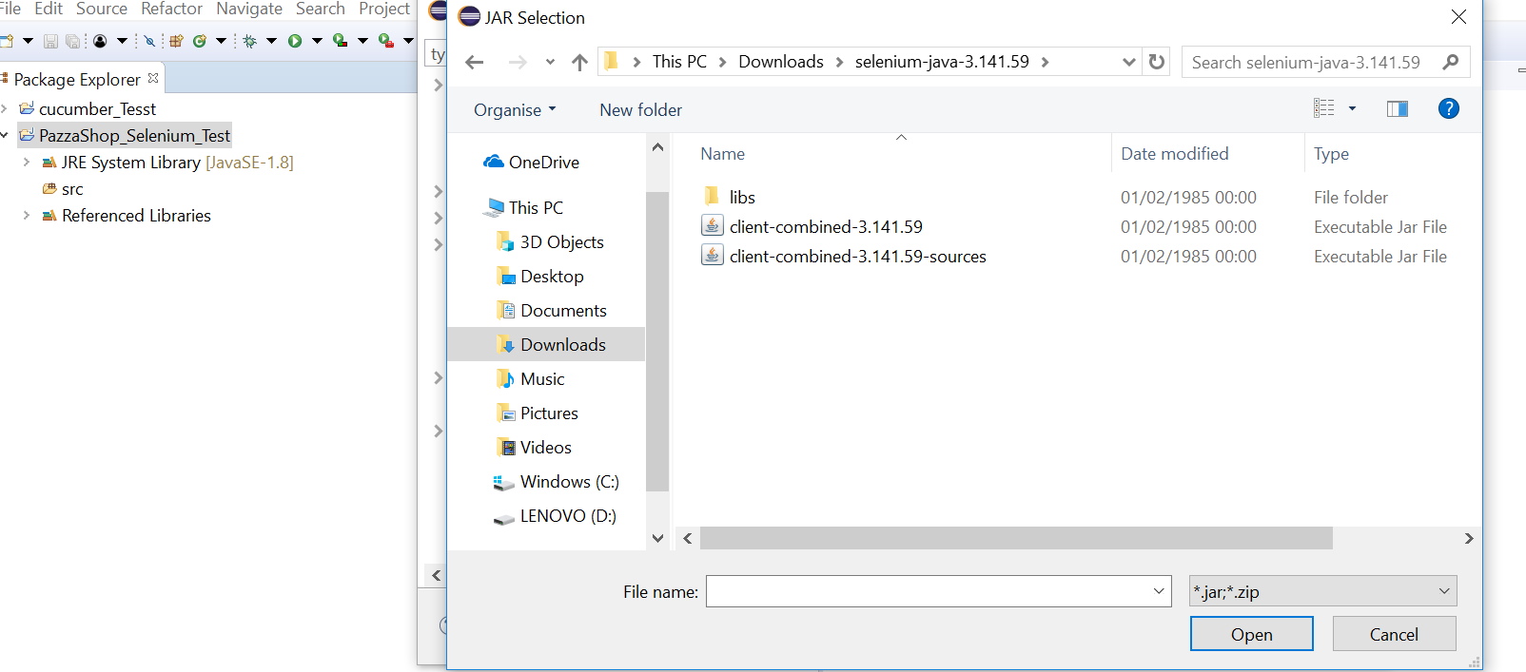

1. Download and place chromedriver in C drive.
2. Create new package name net.pizzashop.automation.
3. Under net.pizzashop.automation create new class name Base.
4. For setup driver write the following code

**public** static WebDriver getDriver() {

System.*setProperty*("webdriver.chrome.deive","C:\\chromedriver.exe");

WebDriver driver = **new** ChromeDriver();

driver.manage().timeouts().implicitlyWait(10,TimeUnit.***SECONDS***);

**return** driver;

}

When I set driver findElement(By.*id*("loginLink")) and click its shows logIn page.

