Testing_Assignment09

Nonfunctional Testing Assignment

Jmeter is an open source testing software. Jmeter is design to cover various categories of test such as load testing, functional testing, performance testing, regression testing, etc. Jmeter is open source and freely available.

Set up thread group:

1. Thread group elements are the beginning points of test plan. We can also control via thread group:

* Setting the number of threads
* Setting the ramp-up time
* Setting the number of test iterations-

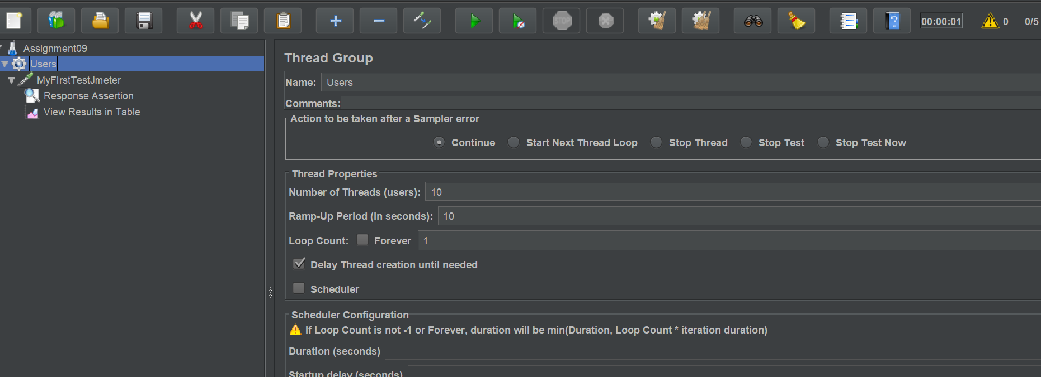

1. For testing purpose i have use [www.bikroy.com](http://www.bikroy.com) web site.

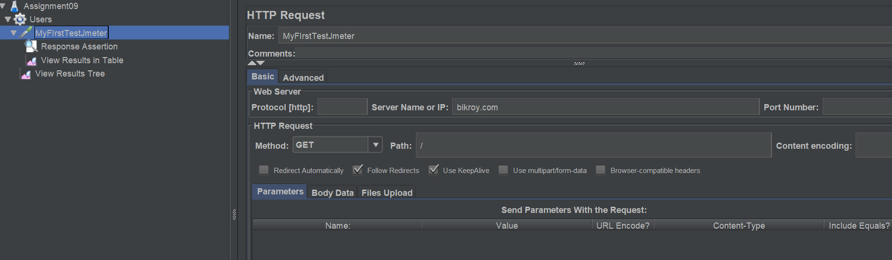

1. When I execute test plan for 10 user I have got following result.

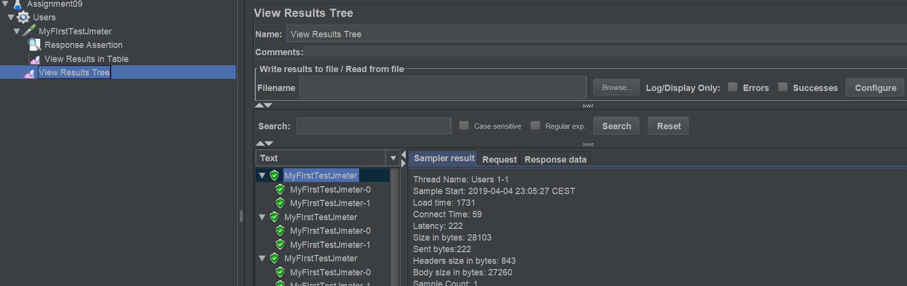

1. If I will use response code = 200 then all test will pass but for example but response code = 301 the all test fail.

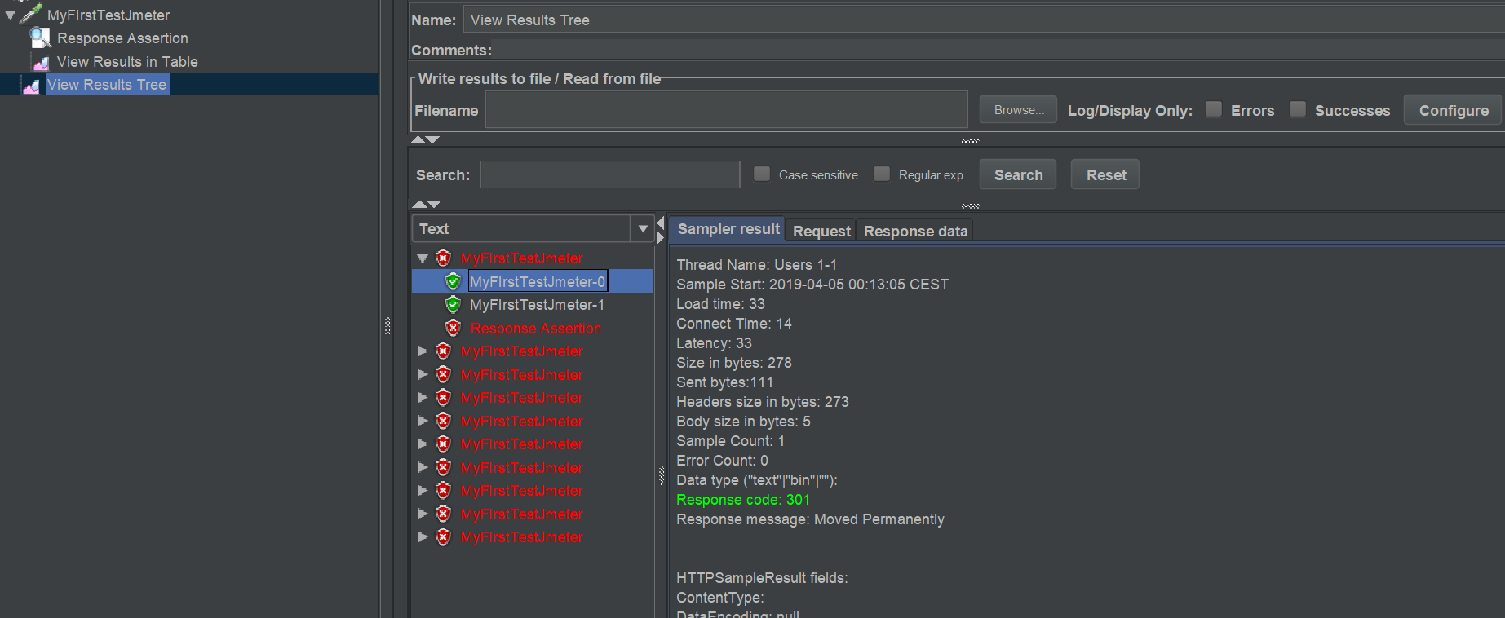

1. If I will use text response= How to Plan Right ? then I will get assertion pass.

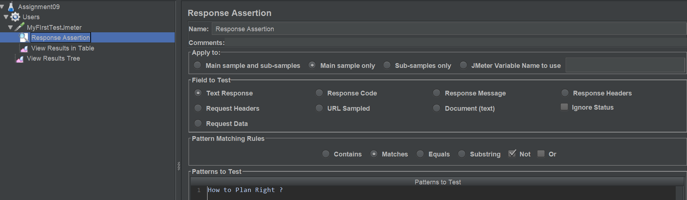

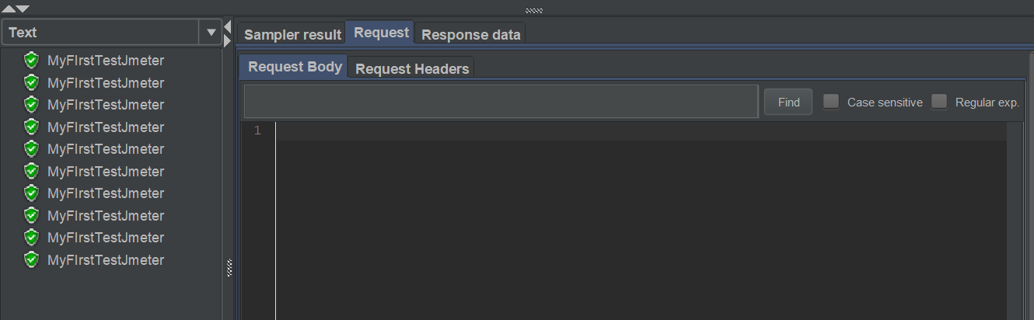

1. Jason Assertion:

The Jason assertion is checked or test a statement or condition and result will be true of false. If result gets true test will pass else test will fail. For test Jason assertion I have to use website [www.reqres.in/api/users?page=2](http://www.reqres.in/api/users?page=2).

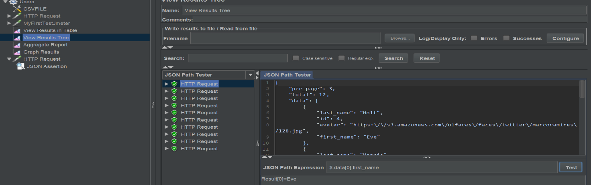

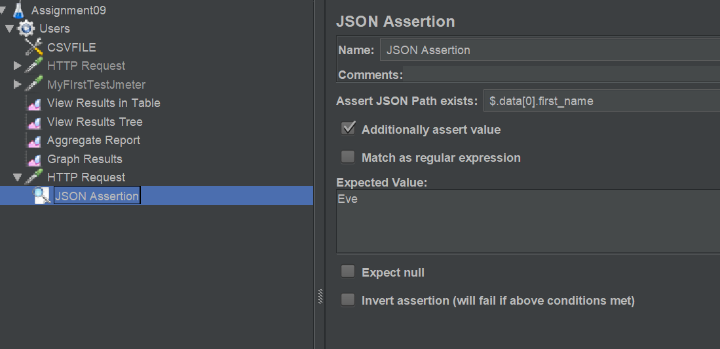

Graph Result:

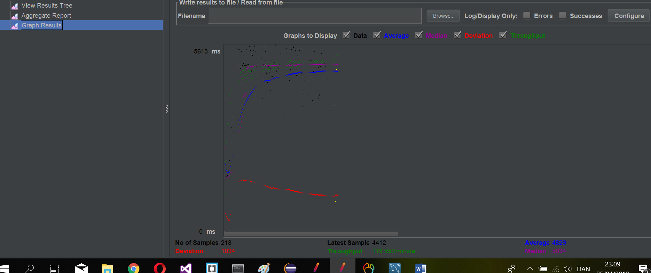

Parameterize test input data from CSV file:

In parameterization testing the input values for the test are fetched from data files. My input data files name Data-csv.csv. A test containing several sets of hard hard coded values will be rather difficult manage.

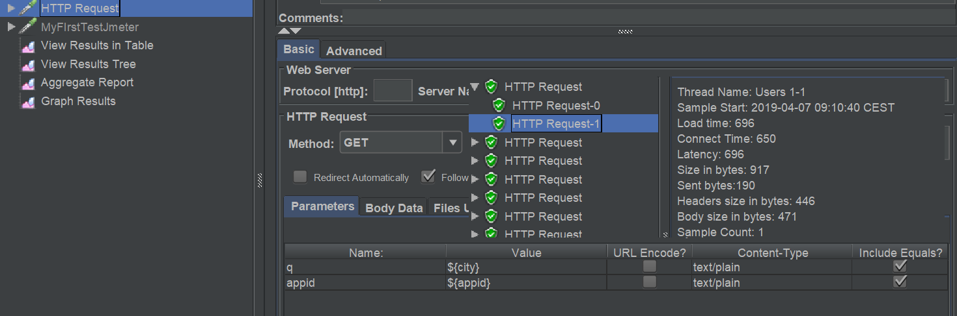

Create parameterization table in .csv format:

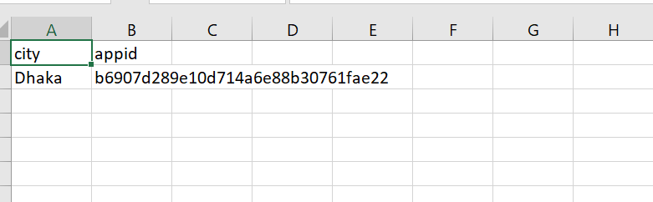

Import test plan BlazeMeter and run with the test with 50 users and for 20 minutes from the location Asia Pacific Mumbai.

