
AHMADU BELLO UNIVERSITY, ZARIA
FACULTY OF ENGINEERING
DEPARTMENT OF COMPUTER ENGINEERING
COEN838: ADVANCED SOFTWARE ENGINEERING
Project Examination, Question 4
OFFLINE-FIRST CRYPTOGRAPHIC QR IDENTITY WALLET
FOR RURAL PUBLIC SERVICES
USER MANUAL AND INSTALLATION GUIDE
Document QRW-USR-06 · Version 1.0
BY
ALIYU SARKI ILIYASU
P25EGCP8040
November 2026
DOCUMENT CONTROL
Document details
Item | Detail
Document | User Manual and Installation Guide (QRW-USR-06)
Project | Offline-First Cryptographic QR Identity Wallet for Rural Public Services
Course | COEN838 Advanced Software Engineering, Ahmadu Bello University, Zaria
Author | Aliyu Sarki Iliyasu (P25EGCP8040)
Version / date | 1.0 · November 2026
Source code | https://github.com/sarki94/qr-identity-wallet
Related documents | QRW-SRS-01 Requirements · QRW-SDD-02 Design · QRW-TST-04 Test Plan & Report

Revision history
Version | Date | Change
1.0 | 4 Nov 2026 | First complete user manual and installation guide

TABLE OF CONTENTS
1. INTRODUCTION 1
1.1 Purpose and Audience 1
1.2 The System at a Glance 1
1.3 Roles and Screens 1
1.4 Conventions 2
2. SYSTEM REQUIREMENTS 3
3. INSTALLATION 4
3.1 Step 1: Install the Tools 4
3.2 Step 2: Get the Code 4
3.3 Step 3: Install the Python Packages 4
3.4 Step 4: Install and Build the Web Application 5
3.5 Alternative: Run the Services with Docker 5
3.6 Configuration 5
3.7 Demonstration Accounts and Test Data 5
4. STARTING AND STOPPING 7
4.1 One-Click Start on Windows 7
4.2 Manual Start (Any Operating System) 7
4.3 Using Real Phones 7
4.4 Checking the Installation 8
5. QUICK TOUR: THE GUIDED DEMO 9
6. USER GUIDE BY ROLE 10
6.1 Enrolment Officer: Issuer Portal 10
6.1.1 Enrol a farmer and issue a credential 10
6.1.2 Revoke a credential 11
6.2 Farmer: Wallet 11
6.2.1 Set up (at the LGA office) 12
6.2.2 Present at the distribution point 12
6.3 Redemption Agent: Verifier 12
6.3.1 Before the distribution day (with a signal) 13
6.3.2 Checking each farmer (no signal needed) 13
6.3.3 Keeping the list fresh 14
6.4 Auditor: Audit Screen 14
6.5 Administrator: Staff Accounts 15
7. VERDICTS AND MESSAGES 16
8. TROUBLESHOOTING 17
9. RUNNING THE TESTS 18

1. INTRODUCTION

1.1 Purpose and Audience
This manual explains how to install, start and use the Offline-First Cryptographic QR Identity Wallet. Part one (Sections 2 to 4) is the installation guide, written for whoever sets the system up: an examiner, a developer or an IT officer. Part two (Sections 5 to 7) is the user guide, organised by role, for the people who use the screens: enrolment officers, farmers, redemption agents, auditors and administrators. Section 8 helps when something goes wrong.

1.2 The System at a Glance
A farmer's identity is issued once, at the LGA office, as a digitally signed QR code kept in a wallet app on the farmer's phone (or printed on paper for farmers without a smartphone). At the fertiliser distribution point the agent's phone checks that code with no network at all: it confirms the signature, asks the farmer's wallet to prove it holds the matching key, checks that the credential is not revoked or expired, and asks the agent to compare the farmer's face with the details shown. Each check is recorded and uploaded to a tamper-evident audit log when the phone next has a signal.

1.3 Roles and Screens
The web application has one screen per role (Table 1.1). All screens are in the same application; each device simply opens the screen its user needs.
Table 1.1: Roles and their screens
Role | Screen | Device | Network needed
Enrolment officer | Issuer Portal | Laptop at the LGA office | Yes
Farmer | Wallet | Farmer's phone (can be shared by a family) | Never
Redemption agent | Verifier | Agent's phone at the distribution point | Once a week, to sync
Auditor (M&E officer) | Audit | Laptop | Yes
Administrator | API documentation pages | Laptop | Yes
Examiner or trainer | Guided Demo | One laptop or a projector | Services running locally

1.4 Conventions
Text you type or commands you run are shown in a shaded box. Buttons and labels on screen are written in quotation marks, for example "Sign and issue". All names and NINs used in this manual are fictional.

2. SYSTEM REQUIREMENTS
Table 2.1: Requirements for the server laptop
Item | Minimum | Notes
Operating system | Windows 10 or 11, macOS, or Linux | The one-click launcher is for Windows
Processor and memory | Any dual-core laptop, 4 GB RAM | All five services together use well under 1 GB
Disk space | 1 GB free | Mostly the Node packages
Python | 3.11 or newer (3.12 recommended) | From python.org; tick "Add Python to PATH"
Node.js | 20 LTS or newer | From nodejs.org; includes npm
Git | Any recent version | From git-scm.com
Docker Desktop | Optional | Only for the container option (Section 3.4)

Table 2.2: Requirements for phones
Item | Requirement
Phone | Android phone with Chrome (a recent version), camera for scanning
Connection for setup | Same Wi-Fi network as the server laptop, to open the app the first time and to sync
Connection at the distribution point | None. The Wallet never needs one; the Verifier needs one only to sync
Feature-phone users | No phone needed: a printed paper wallet (L1) is issued instead

3. INSTALLATION
The installation is done once. It takes about 10 to 15 minutes, most of it downloading packages.

3.1 Step 1: Install the Tools
- Install Python from python.org. On the first installer screen, tick "Add python.exe to PATH".
- Install Node.js (the LTS version) from nodejs.org, accepting the defaults.
- Install Git from git-scm.com, accepting the defaults.
- Open a new PowerShell window and check each tool answers with a version number:

python --version
node --version
git --version

3.2 Step 2: Get the Code
In PowerShell, go to the folder where you keep projects and clone the repository:
cd $HOME\Documents
git clone https://github.com/sarki94/qr-identity-wallet.git
cd qr-identity-wallet
If you received the project as a ZIP file instead, extract it and open PowerShell in the extracted folder.

3.3 Step 3: Install the Python Packages
Create a virtual environment (a private folder of packages for this project), activate it, and install the core library and the services:
python -m venv .venv
.venv\Scripts\Activate.ps1
pip install -e ./core -e "./services[dev]"
On Linux or macOS, activate with source .venv/bin/activate instead. If PowerShell refuses to run the activation script, run Set-ExecutionPolicy -Scope CurrentUser RemoteSigned once and try again. When the environment is active, the prompt starts with (.venv).

3.4 Step 4: Install and Build the Web Application
cd web
npm install
npm run build
cd ..
The build creates the web/dist folder, which the launcher and the preview server use.

3.5 Alternative: Run the Services with Docker
If Docker Desktop is installed, the five services can be started as containers instead of Steps 3 and 5. A one-off container creates the keys in a shared volume first:
docker compose up --build
The web application is still started with npm as in Section 4.2.

3.6 Configuration
The services read their settings from environment variables (Table 3.1). The defaults suit a demonstration on one laptop; the last column shows what to change for any real deployment.
Table 3.1: Configuration settings
Variable | Default | Meaning | Production
QRW_KEY_PASSWORD | dev-only-change-me | Password that encrypts the private keys on disk | Set a long secret
QRW_SEED_DEMO | 1 | Create the demo accounts on first start | 0
QRW_API_DOCS | 1 | Serve the /docs API pages and /openapi.json | 0
QRW_CORS_ORIGINS | localhost:5173 and 127.0.0.1:5173 | Web origins allowed to call the services | The real app origin
QRW_DATA_DIR | data | Folder for the SQLite databases | Use PostgreSQL instead
QRW_<SERVICE>_DATABASE_URL | (SQLite file) | Database for one service, e.g. QRW_ISSUER_DATABASE_URL | PostgreSQL URL
QRW_SECRETS_DIR | .secrets | Folder for keys and the service key | Protected volume or HSM

3.7 Demonstration Accounts and Test Data
On first start the services create the demonstration accounts in Table 3.2. They exist for examination and training only and are switched off with QRW_SEED_DEMO=0.
Table 3.2: Demonstration accounts
Username | Password | Role
officer1 | Officer#2026! | Enrolment officer
agent1 | Agent#2026! | Redemption agent at point KURA-01
agent2 | Agent#2026! | Redemption agent at point KURA-02
auditor1 | Auditor#2026! | Auditor
admin | Admin#2026! | Administrator

The mock NIMC service holds six fictional records. Use NIN 12345678901 (Musa Ibrahim, Kura Ward) or 23456789012 (Hauwa Garba); the others are 34567890123, 45678901234, 56789012345 and 67890123456.

4. STARTING AND STOPPING

4.1 One-Click Start on Windows
Double-click start-demo.bat in the project folder. It opens two windows, one running the services and one running the web application (keep both open), and then opens the Guided Demo in the browser at http://localhost:4173/demo. To stop, close the two windows.

4.2 Manual Start (Any Operating System)
Open two terminals in the project folder, with the virtual environment active in the first:
# Terminal 1: the five services
python services/scripts/run_local.py

# Terminal 2: the web application
cd web
npm run preview
Then open http://localhost:4173 in the browser. Stop each terminal with Ctrl+C.

4.3 Using Real Phones
Phones need HTTPS to use the camera and the browser's cryptography, so the web application has a phone mode with a self-signed certificate:
- Connect the laptop and the phones to the same Wi-Fi network (a phone hotspot works).
- Find the laptop's address with ipconfig (Windows) and note the IPv4 address, for example 192.168.0.12.
- In Terminal 2 run npm run phone instead of npm run preview.
- On each phone open Chrome and go to https://<laptop-address>:4173, for example https://192.168.0.12:4173.
- Chrome warns that the connection is not private, because the certificate is self-signed. Tap "Advanced" then "Proceed". This is needed once per phone for the demonstration; a real deployment uses a proper certificate.
- Optionally use Chrome's "Add to Home screen" so the app opens like an installed app, even with no network.

4.4 Checking the Installation
Each service answers at /health. With the services running, these addresses should each show "status": "ok": http://127.0.0.1:8001/health (Auth), 8002 (Issuer), 8003 (Trust), 8004 (Audit) and 8005 (Mock NIMC). For a full check, run the automated tests (Section 9).

5. QUICK TOUR: THE GUIDED DEMO
The Guided Demo shows the whole distribution day on one screen, with the officer's laptop, the farmer's phone and the agent's phone side by side (Figure 5.1). Each press of "Next step" performs one real action against the running services, using the same code as the real screens, and explains what happened and which requirements it demonstrates. It is the quickest way to see the system work and is designed for the oral defence.
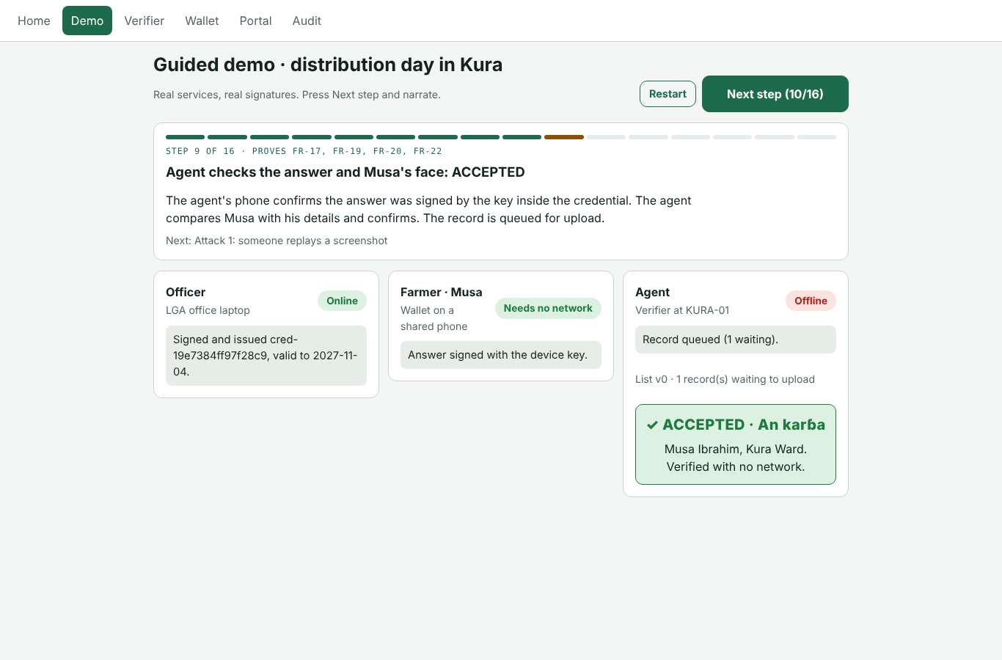
Figure 5.1: Guided Demo, step 9: the farmer is accepted with the agent offline
The sixteen steps are: the farmer sets up the wallet; the officer looks Musa up at NIMC and issues the credential; the wallet saves it; the agent syncs and then loses the network; Musa presents, answers the challenge and is accepted after the face check; a replayed screenshot and an edited QR are both rejected; the officer revokes Musa's credential after his phone is stolen; the offline agent still accepts it (the honest gap, explained on screen); the agent syncs and uploads; the stolen credential is now refused; and the auditor confirms the audit chain is intact. "Restart" begins again.

6. USER GUIDE BY ROLE

6.1 Enrolment Officer: Issuer Portal
The officer works at the LGA office with a network connection. Open the "Portal" tab and sign in with your officer account.

6.1.1 Enrol a farmer and issue a credential
- Under "1 · Enrol farmer", type the farmer's 11-digit NIN and press "Look up at NIMC". The farmer's name, ward and LGA appear. Only a masked NIN is kept (for example 123*****901).
- Under "2 · Issue credential", choose the level: "L2 · smartphone wallet" if the farmer has an Android phone, or "L1 · paper wallet" if not.
- For L2, ask the farmer to open the Wallet, create a profile and show the binding code. Scan it with "Open camera" (or paste it). The binding code contains only the wallet's public key.
- Optionally take or choose a photo. It is stored, small, inside the signed credential and shown to the agent at the face check.
- Press "Sign and issue". The signed credential QR appears. For L2, the farmer scans it into the wallet; for L1, press "Print" and hand over the paper wallet.

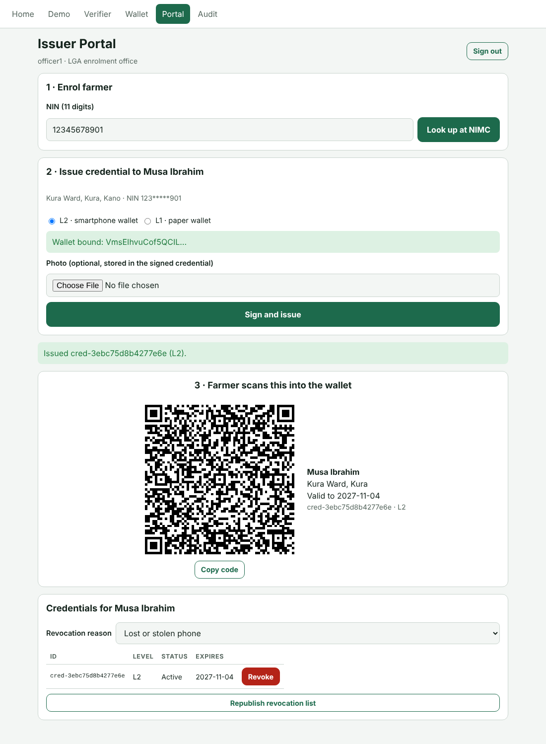
Figure 6.1: Issuer Portal after issuing a credential
If the farmer already has an active credential, issuing a new one revokes the old one automatically in the same step, so a farmer never has two valid credentials.

6.1.2 Revoke a credential
When a phone is lost or stolen, or fraud is suspected, find the farmer's credentials in the list under the issue form, choose the "Revocation reason" (lost or stolen phone, death, fraud, possible cloning, other) and press "Revoke". The signed revocation list is published to the Trust service at once; agents receive it at their next sync. If the Trust service was unreachable, the portal says so, and "Republish revocation list" sends it again.

6.2 Farmer: Wallet
The Wallet works with no network at any time. One phone can hold several family members, each with their own profile and PIN. Figure 6.2 shows the main screens.
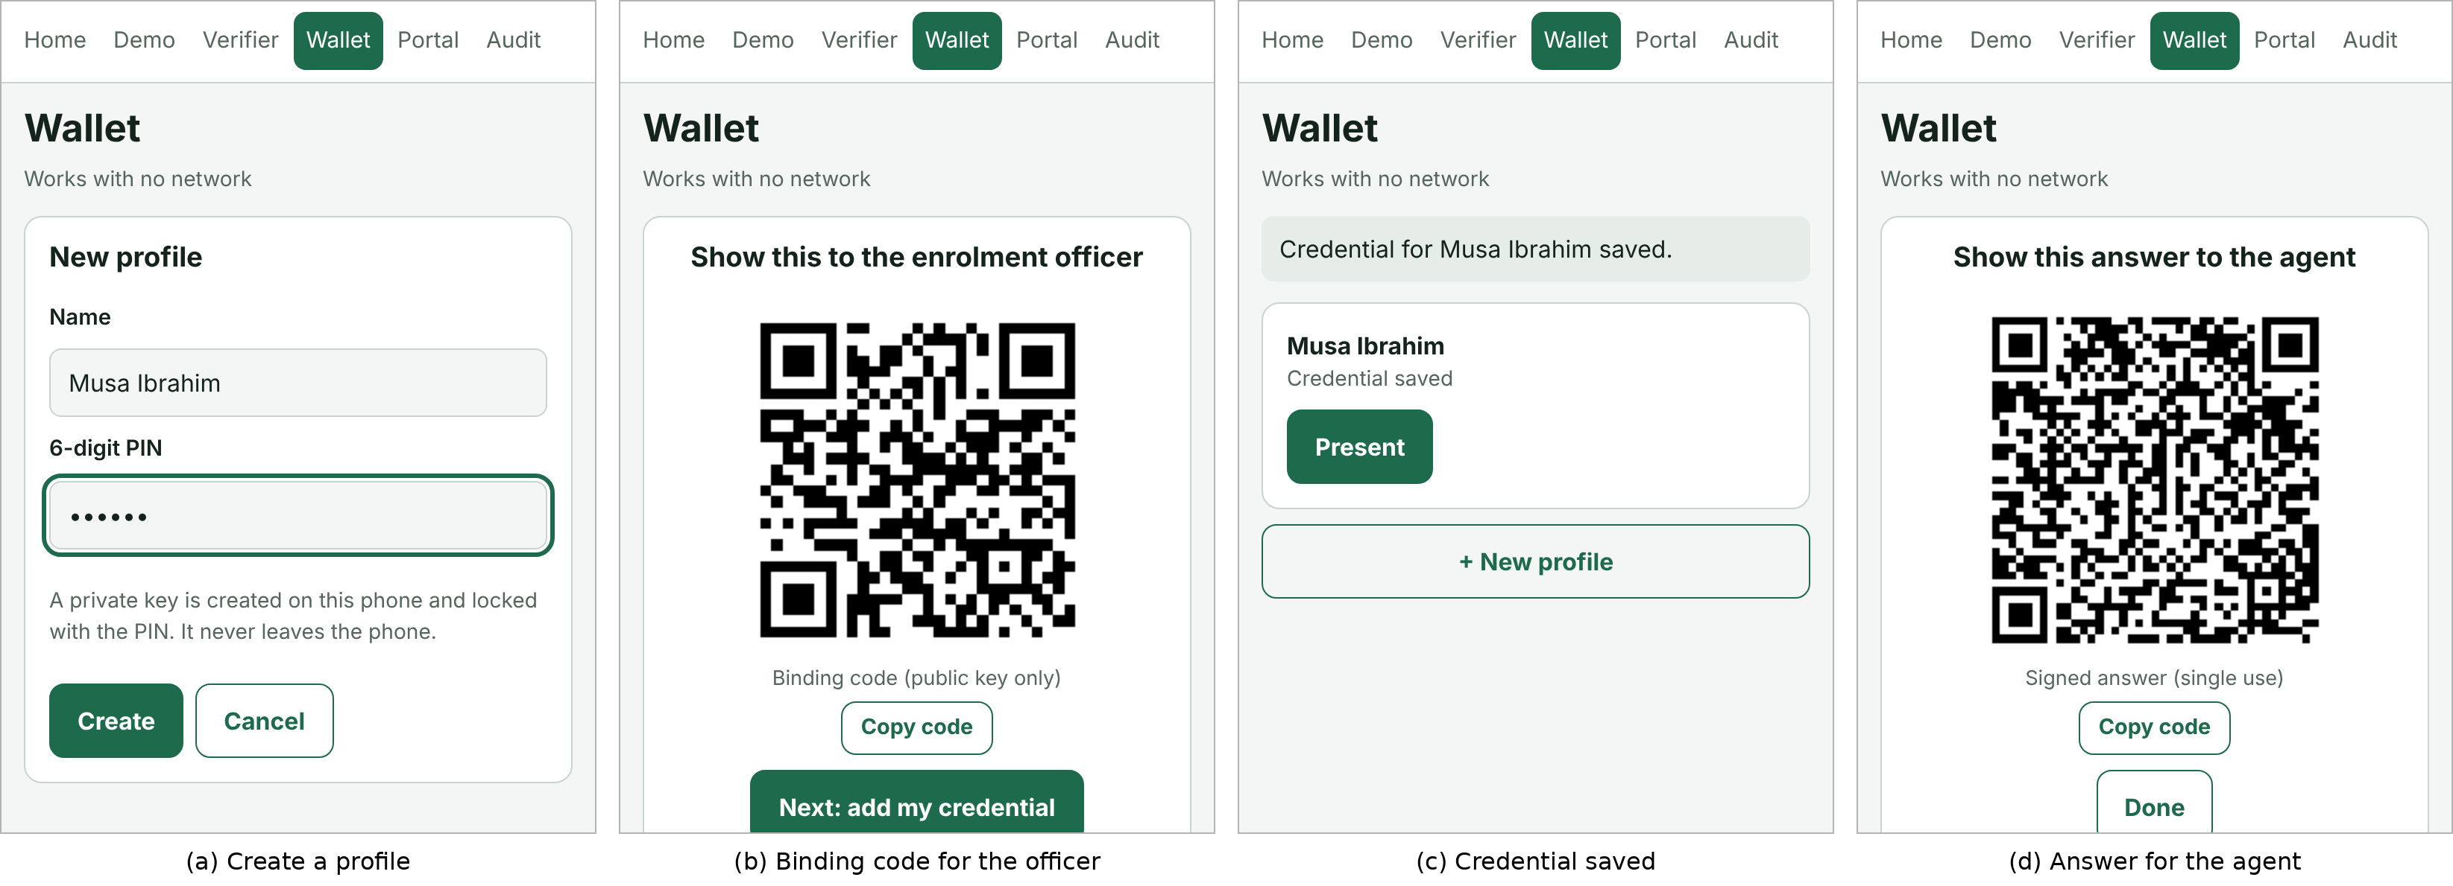
Figure 6.2: Wallet: creating a profile, binding, saving and answering

6.2.1 Set up (at the LGA office)
- Open the "Wallet" tab and press "+ New profile". Type your name and choose a 6-digit PIN, then press "Create". A private key is created on the phone and locked with the PIN; it never leaves the phone.
- Show the binding code to the officer, then press "Next: add my credential".
- Scan the credential QR the officer shows (or paste it) and press "Add credential". The profile now shows "Credential saved".

6.2.2 Present at the distribution point
- Press "Present" on your profile and enter your PIN. Your credential QR appears; the agent scans it.
- Press "Agent shows a challenge" and scan the challenge code on the agent's phone.
- Your wallet signs an answer. Show it to the agent and press "Done" when the agent has scanned it.

Keep your PIN private: it is what stops another family member from using your profile. After five wrong PINs the profile locks for five minutes. If your phone is lost or stolen, report it to the enrolment officer so the credential is revoked.

6.3 Redemption Agent: Verifier
The Verifier works offline once it has synced. Figure 6.3 shows the steps.
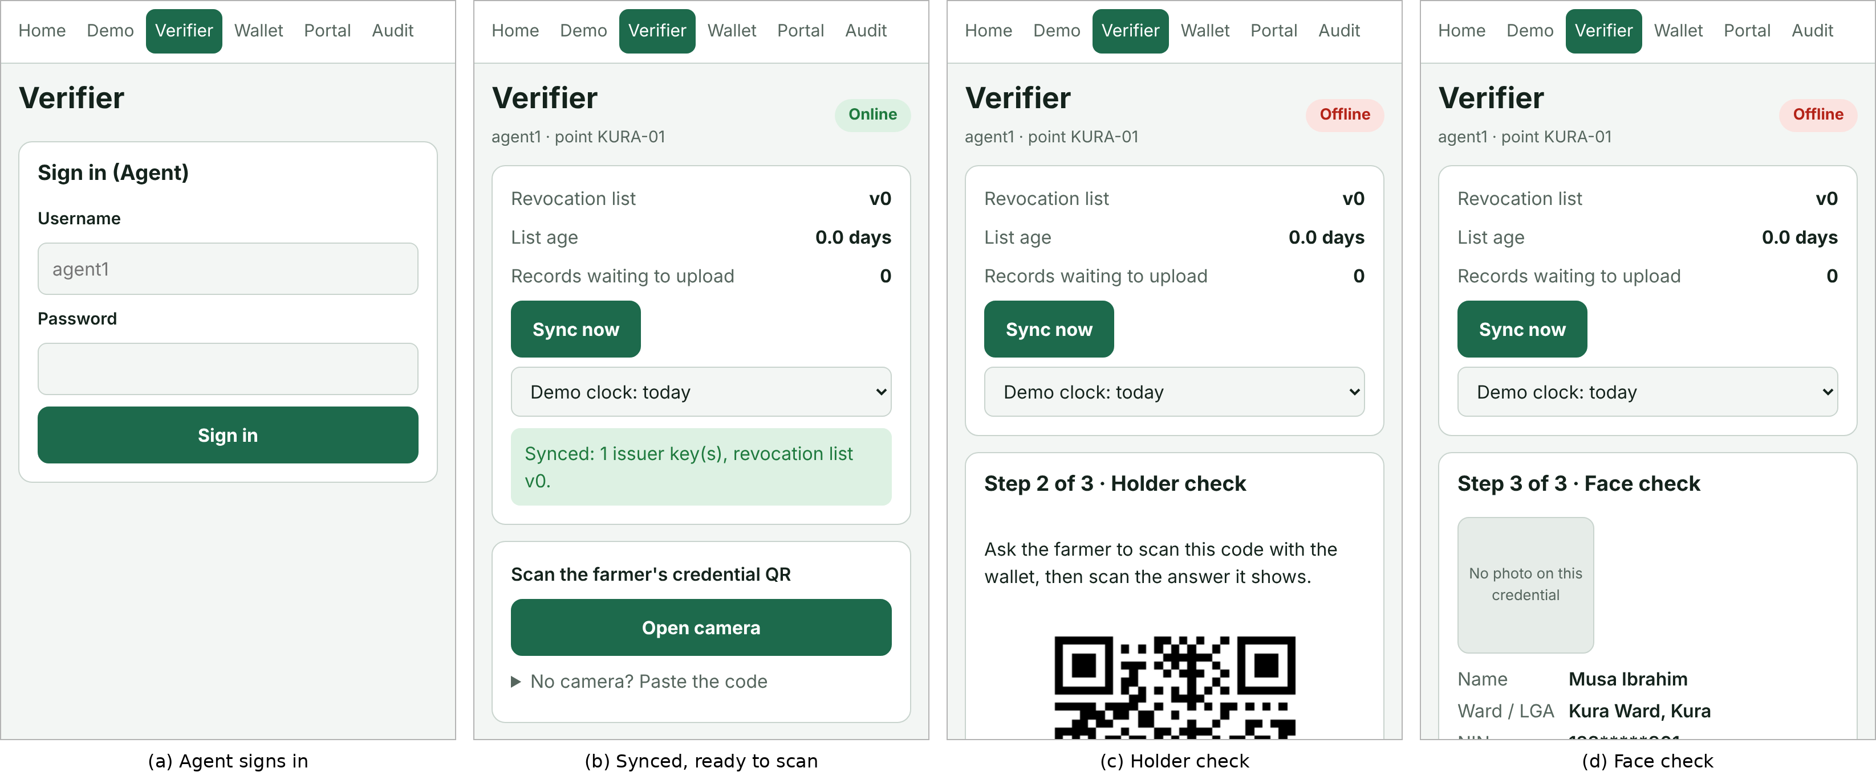
Figure 6.3: Verifier: signing in, ready to scan, holder check and face check

6.3.1 Before the distribution day (with a signal)
- Open the "Verifier" tab and sign in with your agent account. The sign-in lasts seven days, so you can work offline for a week.
- Press "Sync now". The phone downloads the issuer keys and the latest revocation list, and uploads any queued records. The card shows the list version, its age and the number of records waiting.

6.3.2 Checking each farmer (no signal needed)
- Press "Open camera" and scan the farmer's credential QR (wallet or paper). If the camera cannot be used, open "No camera? Paste the code".
- For a wallet (L2) credential, the phone shows a challenge code: let the farmer's wallet scan it, then scan the answer the wallet shows.
- Compare the person in front of you with the photo and details shown, and answer "Yes, same person" or "No".
- Read the verdict, then press "Next farmer". Every check, accepted or rejected, is recorded and queued for upload.

The verdicts and what to do about each are listed in Section 7. Figure 6.4 shows four of them.
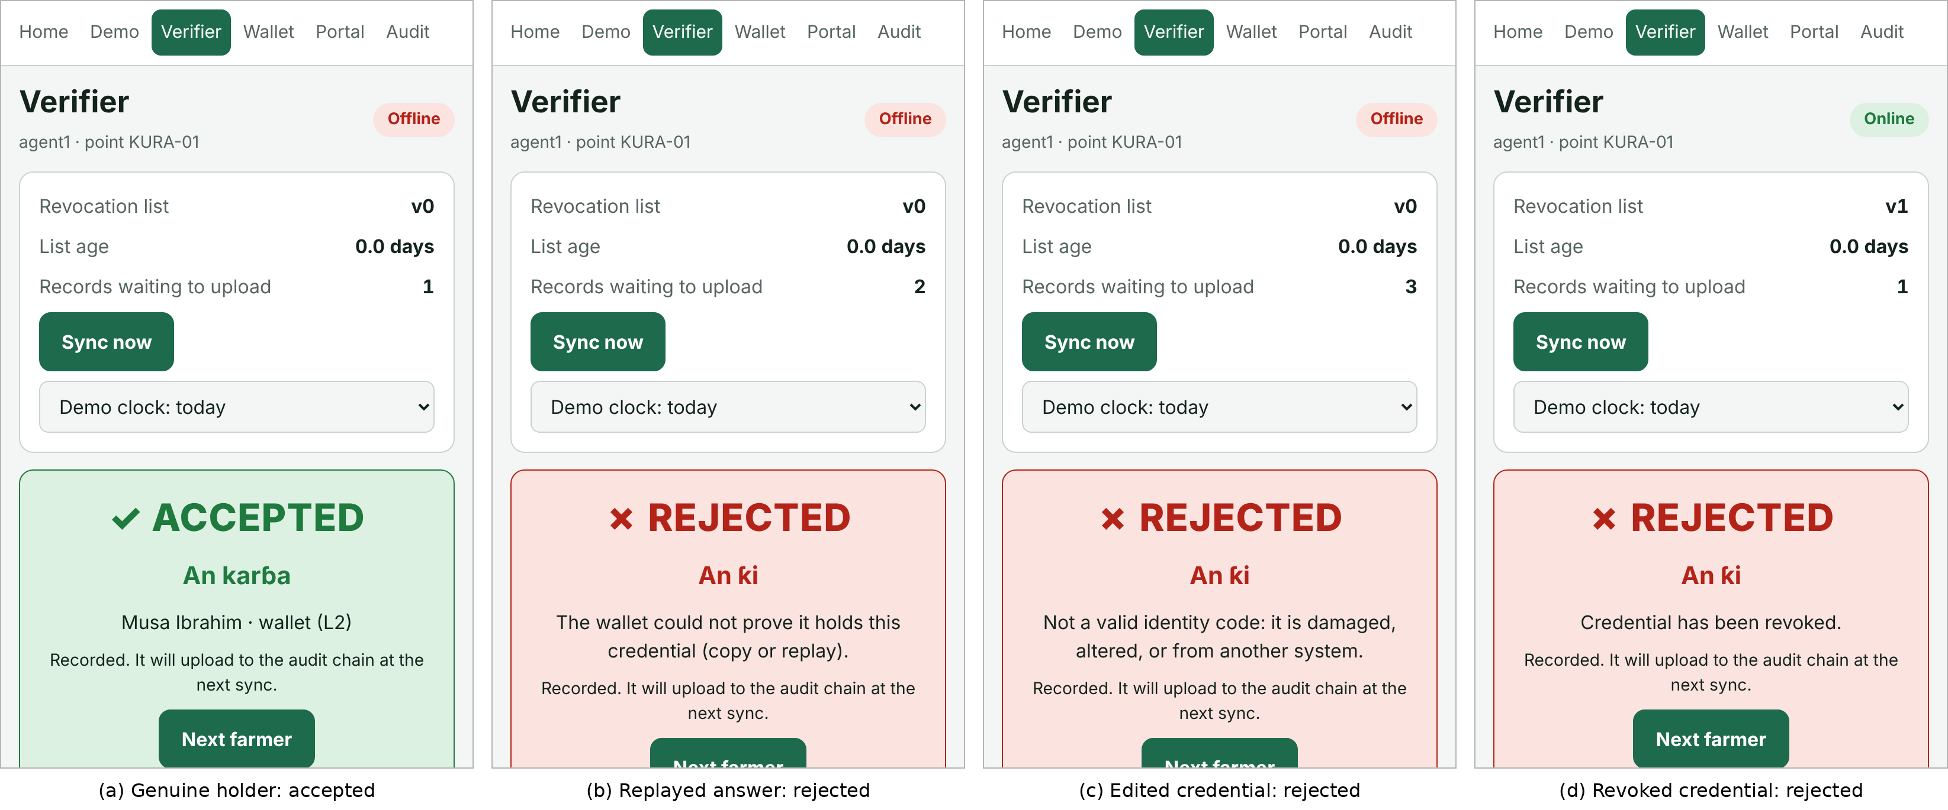
Figure 6.4: Verifier verdicts

6.3.3 Keeping the list fresh
Sync whenever you have a signal. If the list is more than 7 days old the Verifier warns you; after 30 days it refuses to accept anyone until you sync, because revoked credentials could otherwise pass.

6.4 Auditor: Audit Screen
Open the "Audit" tab and sign in with the auditor account. The top card shows whether the audit chain is intact: every record is linked by hash to the one before it, so any change, deletion or reordering in the database is detected. Below it, the verification records show the time, point, agent, credential, result, level and reason for each check. "Refresh" reloads the records.
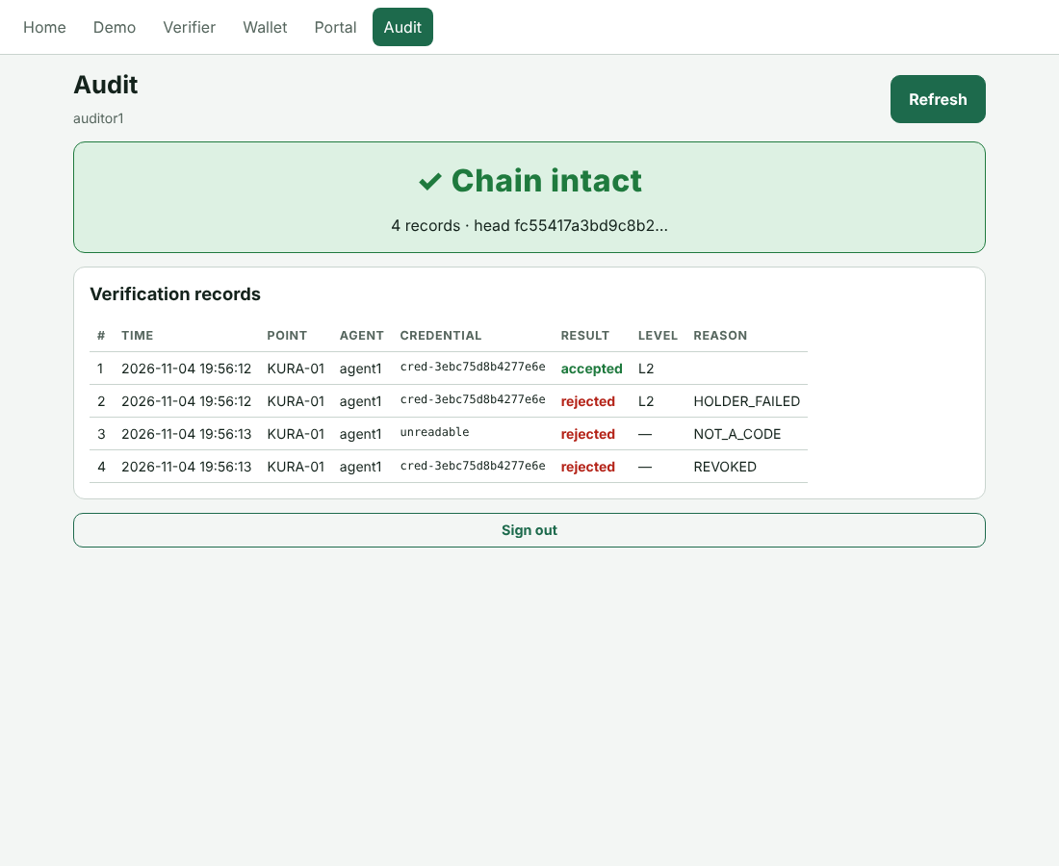
Figure 6.5: Audit screen with an intact chain
The anomaly report (the same credential checked at two different points within 24 hours) is available from the Audit service at /anomalies.

6.5 Administrator: Staff Accounts
Staff accounts are managed through the Auth service's API documentation page at http://127.0.0.1:8001/docs. Sign in with POST /token to obtain a token, press "Authorize" and paste it, then use:
- POST /users to create an account (username, password, role, and for agents the distribution point);
- GET /users to list accounts;
- PATCH /users/{id} to disable or re-enable an account, unlock it after five failed logins, or move an agent to another point.

In production the documentation pages are switched off (QRW_API_DOCS=0) and these calls are made from an administration tool.

7. VERDICTS AND MESSAGES
Table 7.1 explains every verdict the Verifier can give and what the agent should do.
Table 7.1: Verifier verdicts and actions
Message on screen | Meaning | What to do
ACCEPTED (An karɓa) | Signature, holder, revocation, expiry and face all passed | Proceed with the distribution
The wallet could not prove it holds this credential (copy or replay) | A screenshot, photocopy or recorded answer was used | Refuse; ask for the farmer's own phone
Not a valid identity code: it is damaged, altered, or from another system | The QR was edited, damaged or is not ours | Refuse; refer to the LGA office
Signature does not match: the code was altered or forged | The credential's content was changed | Refuse; report as possible fraud
Credential has been revoked | The officer withdrew it (lost phone, fraud, death) | Refuse; refer to the LGA office
Credential has expired / is not valid yet | Outside its validity dates | Refuse; refer for re-issue
Issued by an unknown authority | Signed by a key the Verifier does not trust | Refuse; sync if keys may be outdated
The agent judged the person does not match | Face check answered "No" | Refuse; recorded for the auditor
That is the wallet's binding code / a challenge code / a wallet answer | The wrong kind of code was scanned | Ask the farmer to press "Present" and enter the PIN
List is N days old | More than 7 days since the last sync | Sync as soon as there is a signal
Revocation list older than 30 days. Sync before accepting anyone | Too stale to trust | Sync before continuing
This phone has never synced | No keys or list yet | Sync once with a signal

8. TROUBLESHOOTING
The problems in Table 8.1 were met during development and testing; each has a known fix.
Table 8.1: Troubleshooting
Problem | Cause | Fix
The .venv folder is missing (launcher message) | One-time setup not done | Do Section 3, Steps 3 and 4
pip says the requirement is not a valid editable path | Older pip on Windows | Use the ./ paths exactly as shown, or install core and services separately
Verifier or Portal shows a connection error; the web window shows ECONNREFUSED | The services are not running | Start Terminal 1 (or use start-demo.bat) and keep it open
The camera does not open on a phone | The page is not on HTTPS | Use npm run phone and an https:// address
"Your connection is not private" on the phone | Self-signed demo certificate | Tap Advanced, then Proceed (demo only)
"Account locked" when signing in | Five wrong passwords | Ask the administrator to unlock the account
"Too many requests" | More than 20 sign-in attempts in a minute | Wait one minute
Wallet says the profile is locked | Five wrong PINs | Wait five minutes
Port already in use when starting | An earlier copy is still running | Close the old windows or restart the laptop
Git asks "Unlink of file ... failed. Should I try again? (y/n)" | Windows file lock during Git housekeeping | Answer n; run git config gc.auto 0 once
PowerShell will not run Activate.ps1 | Script execution policy | Set-ExecutionPolicy -Scope CurrentUser RemoteSigned

9. RUNNING THE TESTS
With the virtual environment active, from the project folder:
cd core
pytest --cov=qrw_core # 53 unit and property tests
cd ../services
pytest --cov=qrw_services # 49 integration, security, E2E
cd ../web
npm run coverage # 16 browser-library tests
cd ..
python tools/rtm.py # all suites + regenerate RTM
The browser system tests need the services and the web preview running, and Playwright installed (npm install -g playwright, then npx playwright install chromium):
cd web
node e2e/distribution-day.mjs # TC-SYS-002, 11 checks
node e2e/guided-demo.mjs # TC-SYS-003, 16 steps
The same Python and browser-library tests, static analysis and dependency scans run automatically on GitHub for every push.

