AHMADU BELLO UNIVERSITY, ZARIA
FACULTY OF ENGINEERING
DEPARTMENT OF COMPUTER ENGINEERING
COEN838: ADVANCED SOFTWARE ENGINEERING
Project Examination, Question 4
OFFLINE-FIRST CRYPTOGRAPHIC QR IDENTITY WALLET
FOR RURAL PUBLIC SERVICES
SOFTWARE DESIGN DOCUMENT
Document QRW-SDD-02 · Version 1.0
BY
ALIYU SARKI ILIYASU
P25EGCP8040
November 2026
DOCUMENT CONTROL
Document details
Item | Detail
Document | Software Design Document (QRW-SDD-02)
Project | Offline-First Cryptographic QR Identity Wallet for Rural Public Services
Course | COEN838 Advanced Software Engineering, Ahmadu Bello University, Zaria
Author | Aliyu Sarki Iliyasu (P25EGCP8040)
Version / date | 1.0 · November 2026
Source code | https://github.com/sarki94/qr-identity-wallet
Related documents | QRW-SRS-01 Requirements · QRW-SEC-03 Security · QRW-TST-04 Test Plan & Report

Revision history
Version | Date | Change
1.0 | 4 Nov 2026 | First complete design document

TABLE OF CONTENTS
1. INTRODUCTION 1
1.1 Purpose 1
1.2 Scope 1
1.3 Design Stakeholders and Concerns 1
1.4 References 1
2. DESIGN CONSIDERATIONS 3
2.1 Architectural Drivers 3
2.2 Design Decisions 3
3. ARCHITECTURAL DESIGN 5
3.1 Architectural Style and Justification 5
3.2 Component View 5
3.3 Deployment View 6
3.4 Inter-Component Communication 7
3.5 Offline-First Design 8
4. DATA DESIGN 10
4.1 Data Model 10
4.2 Data Dictionary 10
4.3 Credential and Message Formats 11
5. COMPONENT DESIGN 13
5.1 Cryptographic Core Library 13
5.1.1 Verification algorithm 13
5.1.2 Atomic re-issue and publication 13
5.2 Back-End Services 14
5.3 Web Application 14
6. INTERFACE DESIGN 15
7. SCALABILITY AND RESILIENCE 16
7.1 Scalability 16
7.2 Resilience 16
8. SECURITY DESIGN SUMMARY 18
9. DESIGN TRACEABILITY 19

1. INTRODUCTION

1.1 Purpose
This Software Design Document (SDD) describes how the Offline-First Cryptographic QR Identity Wallet is built to satisfy the requirements in QRW-SRS-01. It records the architectural style and the reasons for choosing it, the components and their responsibilities, the data model, the communication patterns between components, the detailed design of the security-critical algorithms, and the provisions for scalability and resilience. Its structure follows the viewpoint approach of IEEE 1016, the standard for software design descriptions (IEEE, 2009).

1.2 Scope
The design covers the cryptographic core library, the four back-end services and the mock NIMC service, and the Progressive Web App with its Verifier, Wallet, Issuer Portal and Audit screens. Security design is summarised in Section 8 and treated fully in QRW-SEC-03.

1.3 Design Stakeholders and Concerns
Table 1.1 lists who reads this design and what each needs it to answer.
Table 1.1: Design stakeholders and concerns
Stakeholder | Concern | Addressed in
Examiners | Is the architectural style justified? Are communication patterns, data model and scalability considered? | Sections 3, 4, 7
Programme sponsor | Will it work where the network fails? Can it be trusted? | Sections 3.5, 7, 8
Developer / maintainer | Where does each responsibility live? How do the parts talk? | Sections 3, 5, 6
Security reviewer | Where are the keys? What does each component trust? | Sections 5.1, 8; QRW-SEC-03

1.4 References
Fältström, P., Ljunggren, F., & van Gulik, D.-W. (2022). The Base45 data encoding (RFC 9285). Internet Engineering Task Force. https://doi.org/10.17487/RFC9285
IEEE. (2009). IEEE standard for information technology — Systems design — Software design descriptions (IEEE Std 1016-2009). Institute of Electrical and Electronics Engineers.
Josefsson, S., & Liusvaara, I. (2017). Edwards-curve digital signature algorithm (EdDSA) (RFC 8032). Internet Engineering Task Force. https://doi.org/10.17487/RFC8032
Newman, S. (2021). Building microservices (2nd ed.). O'Reilly Media.
Sommerville, I. (2016). Software engineering (10th ed.). Pearson.

2. DESIGN CONSIDERATIONS

2.1 Architectural Drivers
Four drivers from the requirements shaped the design more than any others:
- Verification must work with no network (problem statement; FR-13, FR-16 to FR-22, NFR-P3). The trust decision therefore has to be computable on the agent's phone from data downloaded earlier.
- Credentials must be unforgeable and uncopyable (FR-16, FR-17, FR-23; STRIDE spoofing and tampering). This rules out database look-ups as the basis of trust and points to digital signatures with holder binding.
- The signing key is the most valuable asset (NFR-S1). Whatever the architecture, only one small component may hold it.
- A solo developer must deliver a working, tested system in days. Every extra moving part (broker, orchestrator, separate codebases) costs time without earning marks.

2.2 Design Decisions
The main decisions, with their rationale, are summarised in Table 2.1. The full log with defence notes is kept in the project repository.
Table 2.1: Key design decisions
ID | Decision | Rationale
D2a | Two assurance levels on one credential format: L2 smartphone wallet, L1 paper wallet | Elicitation found shared phones and feature phones (F2, F3); one format keeps one verifier code path.
D3 | Four services: Auth, Issuer, Trust & Revocation, Audit & Sync, plus a mock NIMC | Split on trust and availability boundaries, not on screens.
D4 | FastAPI services; one React PWA for every screen | Reuses the developer's existing stack; a PWA runs offline and installs on phones.
D6 | No proxy or delegated presentation | Programme policy observed in Kura (F1).
D8 | Atomic re-issue in one database transaction | A farmer never has two active credentials, nor none.
D9 | Sign the exact payload bytes; QR = "QRW1:" + Base45(zlib(signature ‖ payload)); typed messages | No canonicalisation mismatch between Python and the browser; dense QR alphanumeric mode; domain separation.
D11 | Issuer signs the revocation list; Trust only verifies and publishes it | Keeps the signing key in one place; Trust cannot forge or roll back a list.
D12 | Database per service; EdDSA-signed staff tokens verified with Auth's public key | No service reads another's data; services can check tokens but not mint them.
D13 | Store NINs only as a keyed hash plus a masked copy | A stolen Issuer database reveals no NIN.
D14 | Strict RFC 8032 verification in the browser; one HTTPS origin via a proxy | Browser and server accept exactly the same signatures; phones need HTTPS for the camera.

3. ARCHITECTURAL DESIGN

3.1 Architectural Style and Justification
The system combines three styles: an offline-first edge client for verification, a set of service-oriented back-end services each owning its own data, and asynchronous store-and-forward synchronisation between them. Table 3.1 compares this with the alternatives considered.
Table 3.1: Architectural alternatives
Style | Strengths | Weaknesses for this problem | Decision
Single monolith with a central database | Simplest to build and deploy | Verification would need the server, which is exactly what fails in rural areas; one breach exposes the signing key and all data | Rejected
Online microservices with a message broker (e.g. Kafka) and orchestrator | Industry-scale throughput and decoupling | Still requires connectivity at verification time; broker and orchestration add days of work and operational burden without serving any requirement | Rejected
Federated, per-state deployments | Local autonomy | Duplicates issuance and trust management; verifiers would need many trust anchors | Deferred (future scaling path)
Offline-first edge verification + service-oriented back end (chosen) | Verification needs no network; trust boundaries isolate the key; services stay small and testable | Revocation reaches offline points only on their next sync (managed as a risk) | Adopted

The decisive argument is that the problem statement makes network failure the normal case. Any architecture that consults a server at the moment of verification fails the requirement, however well it scales. Signatures move the trust decision to the edge: the server's role shrinks to issuing, publishing and collecting, which can all tolerate delay.

3.2 Component View
Figure 3.1 shows the components and how they connect, and Table 3.2 lists their responsibilities.
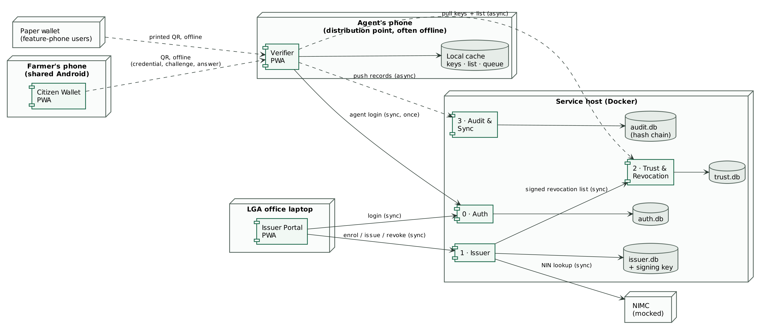
Figure 3.1: Component and connector view
Table 3.2: Component responsibilities
Component | Responsibility | Owns data | Holds secrets
Auth (8001) | Staff login, password hashing (scrypt), lockout, EdDSA tokens, staff administration | auth.db: users | Auth private key
Issuer (8002) | NIMC look-up, enrolment, credential signing, atomic re-issue, revocation, signing and publishing the revocation list | issuer.db: farmers, credentials, revocation_state | Issuer signing key; NIN pepper; service key
Trust & Revocation (8003) | Publishes issuer public keys and the latest signed revocation list; verifies pushed lists and refuses rollback | trust.db: published_list | Service key only
Audit & Sync (8004) | Receives queued verification records, chains them by hash, verifies the chain, flags anomalies | audit.db: records | None
Mock NIMC (8005) | Returns fictional NIN records (stand-in for NIMC) | Bundled JSON | None
Web app (PWA) | Verifier, Wallet, Issuer Portal, Audit and Guided Demo screens; offline verification in the browser | Browser storage on each device | Wallet: PIN-sealed device keys
qrw_core (library) | Pure functions: signing, verification, encoding, challenge–response, revocation list, hash chain | None | None

3.3 Deployment View
The deployment is shown in Figure 3.2. All five services are built from one Docker image and started as five containers by Docker Compose; a one-off container creates the key material in a shared, encrypted volume. Each service has its own data volume. The web application is a static build served over HTTPS by a server that also proxies /api/<service> to the services, so phones talk to a single origin. For laptops without Docker, a launcher script starts the same five services as local processes.
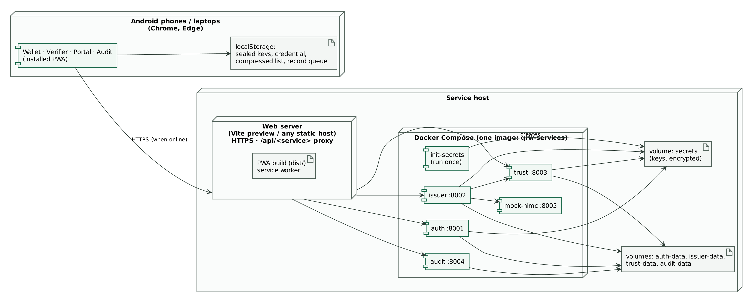
Figure 3.2: Deployment view
For production the same structure would sit behind a TLS-terminating reverse proxy, with PostgreSQL databases (selected by setting QRW_<SERVICE>_DATABASE_URL) and the issuer key held in a hardware security module (assumption AS2 in QRW-SRS-01).

3.4 Inter-Component Communication
Each interaction uses the pattern that matches its timing needs. Table 3.3 justifies each choice; the sequence diagrams in QRW-SRS-01 (Figures 4.2 to 4.4) show them in detail.
Table 3.3: Communication patterns
Interaction | Pattern | Protocol | Why
Portal → Auth, Portal → Issuer | Synchronous request–response | HTTPS REST/JSON | The officer is online and needs an immediate answer to continue enrolment.
Issuer → Mock NIMC | Synchronous | HTTP (internal) | Enrolment cannot proceed without the NIN record.
Issuer → Trust (publish list) | Synchronous with retry | HTTP + service key | Publication should be immediate, but a Trust outage must not block revocation; the Issuer records the unpublished version and republishes later.
Wallet ↔ Verifier | Offline, device to device | QR codes (four formats) | No network exists at the distribution point.
Trust → Verifier (keys, list) | Asynchronous pull | HTTPS GET, gzip | The verifier fetches whenever it has a signal; freshness is managed by list-age rules.
Verifier → Audit (records) | Asynchronous push, store-and-forward, batched | HTTPS POST | Records accumulate offline and upload in one batch; idempotent by record ID so retries are safe.
Any service ← token | Stateless verification | JWT (EdDSA) | No call to Auth is needed per request; services verify tokens locally with Auth's public key.

3.5 Offline-First Design
The Verifier is designed so that its core task has no network dependency at all:
- What is cached: the issuer public keys, the latest revocation list (compressed, NFR-C3) with its download time, the agent's seven-day token, and the queue of verification records.
- Freshness rules (FR-21): the verifier warns when its list is older than seven days and refuses acceptances after 30 days. These rules bound the revocation gap.
- No conflicts by construction: verification records are append-only facts, each with a unique random record ID. Upload is idempotent, so a batch interrupted half-way can simply be resent; duplicates are ignored. There is nothing to merge.
- Application shell: the service worker caches the built application, so the screens open with no network after the first visit.
- Fail securely when the cache is unreadable: the verifier treats itself as never synchronised and refuses to accept anyone until it syncs.

4. DATA DESIGN

4.1 Data Model
Figure 4.1 shows the entity–relationship diagram. Each service owns its own database; relationships that cross a service boundary are logical (by identifier), never foreign keys, which keeps the services independently deployable.
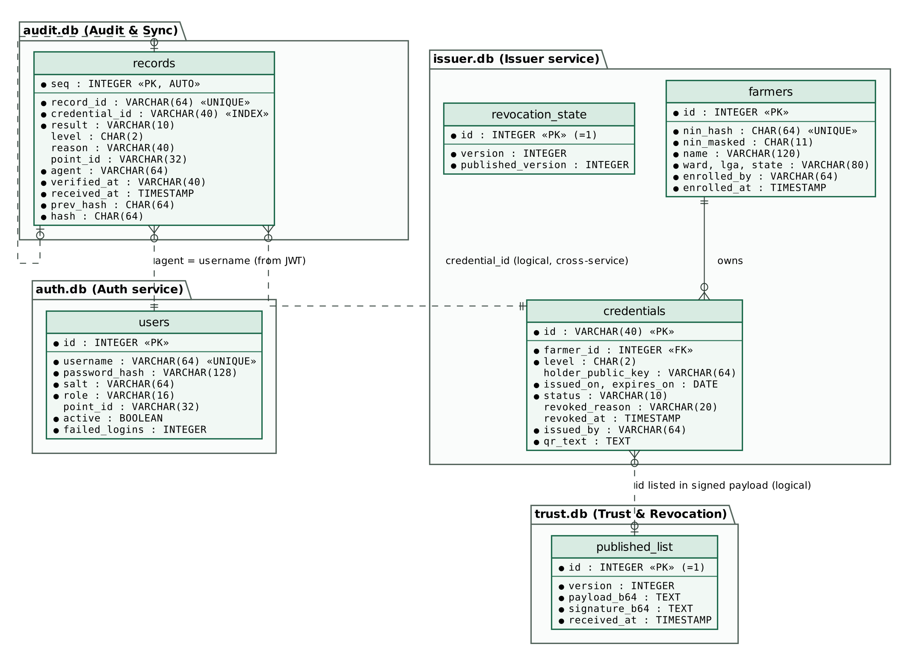
Figure 4.1: Entity–relationship diagram, one database per service
Three integrity rules are enforced in the Issuer: a credential is created only for an enrolled farmer (foreign key); at most one credential per farmer is Active (enforced in the issuing transaction); and an L2 credential carries a valid 32-byte holder public key (validated on input). The audit table enforces append-only integrity by hash chaining rather than by database constraints, so that tampering by someone with database access is still detectable.

4.2 Data Dictionary
The most important fields are described in Table 4.1.
Table 4.1: Data dictionary (selected fields)
Entity.field | Type | Meaning and rules
farmers.nin_hash | CHAR(64), unique | HMAC-SHA256 of the NIN under a secret pepper; detects duplicate enrolment without storing the NIN (D13)
farmers.nin_masked | CHAR(11) | First and last three digits only, e.g. 123*****901 (NFR-S4)
credentials.id | VARCHAR(40), PK | "cred-" + 16 random hex digits; also the ID inside the signed credential
credentials.status | VARCHAR(10) | Active, Revoked or Expired (state machine in QRW-SRS-01 Figure 3.2)
credentials.qr_text | TEXT | The exact signed QR string issued, kept for reprinting a paper wallet
revocation_state.version | INTEGER | Increases on every revocation; published_version shows whether Trust has the latest
published_list.payload_b64 | TEXT | The Issuer-signed list exactly as received; Trust never re-signs it
records.record_id | VARCHAR(64), unique | Random ID created on the phone; makes uploads idempotent
records.agent, point_id | VARCHAR | Taken from the uploader's signed token, never from the request body (STRIDE R1)
records.prev_hash, hash | CHAR(64) | hash = SHA-256(prev_hash ‖ "|" ‖ canonical JSON of the record); the first record uses 64 zeros
users.password_hash, salt | VARCHAR | scrypt (N = 2^14, r = 8, p = 1) with a per-user 128-bit salt

4.3 Credential and Message Formats
The signed credential is compact JSON with short field names to keep the QR small (Table 4.2). The Issuer signs the exact bytes; the verifier checks the signature over those same bytes before it reads any field.
Table 4.2: Credential payload fields
Field | Meaning | Example
typ | Message type (domain separation) | QRW1-CRED
id | Credential ID | cred-1422ba201c77b4bf
kid | Issuer key ID (first 12 hex digits of SHA-256 of the public key) | iss-06933dde2eff
lvl | Assurance level | L2
nin | Masked NIN | 123*****901
nm, wd, lga, st | Name, ward, LGA, state | Musa Ibrahim, Kura Ward, Kura, Kano
iat, exp | Issue and expiry dates (ISO 8601) | 2026-11-03, 2027-11-03
hpk | Holder public key, base64url (L2 only) | PZD6hj0z…
ph | Optional photo thumbnail, base64url JPEG ≤ 1,400 characters | /9j/4AAQ…

The QR text is built in four steps: (1) concatenate the 64-byte Ed25519 signature and the payload bytes; (2) compress with zlib; (3) encode with Base45 (RFC 9285), which fits the QR alphanumeric mode; (4) prefix "QRW1:". A typical credential without a photo is 362 characters. Decoding reverses these steps and refuses any payload that inflates beyond 8 KB, which defeats decompression-bomb codes. The other signed messages are distinguished by their own types: the revocation list ("QRW1-REVOCATIONS") and the challenge message, which is the JSON array ["QRW1-CHALLENGE", nonce, credential ID]. A signature over one type can therefore never be replayed as another.

5. COMPONENT DESIGN

5.1 Cryptographic Core Library
The core library holds every security decision as pure functions with no network or database access, which is what made it possible to build it test-first and to prove its properties with property-based tests. Its modules are listed in Table 5.1.
Table 5.1: qrw_core modules
Module | Main functions | Responsibility
encoding | b45encode/decode, b64url, canonical_json | Wire encodings (RFC 9285 test vectors)
keys | key_id, public_key_b64, save/load_private_key | Ed25519 key handling; issuer key encrypted at rest
credential | issue_credential, verify_credential, mask_nin | Signing and fail-secure verification
qr | encode_qr, decode_qr | QR text format with size guard
challenge | new_challenge, sign_challenge, verify_challenge_response | Offline holder binding
revocation | sign_revocation_list, verify_revocation_list | Signed, versioned revocation list
audit | append_record, record_hash, verify_chain | Tamper-evident hash chain

5.1.1 Verification algorithm
The verification function is the heart of the system. It is written so that every path that is not a complete success ends in a rejection, and so that no field is trusted before the signature has been checked:
verify_credential(signed, trusted_keys, revoked_ids, today):
body ← parse JSON(signed.payload) fail → REJECT MALFORMED
key ← trusted_keys[body.kid] none → REJECT UNKNOWN_ISSUER
Ed25519.verify(key, signature, payload) bad → REJECT BAD_SIGNATURE
payload ← strict schema check(body) fail → REJECT MALFORMED
reasons ← []
if today < payload.issued_on: add NOT_YET_VALID
if today > payload.expires_on: add EXPIRED
if payload.id in revoked_ids: add REVOKED
return ACCEPT(payload) if reasons empty, else REJECT(reasons)
The browser implementation (web/src/lib/qrw.ts) follows the same steps and is checked against vectors produced by the Python implementation, including byte-identical challenge signatures.

5.1.2 Atomic re-issue and publication
When a farmer who already has an active credential is issued a new one, the Issuer revokes the old credential, increments the revocation version and saves the new credential inside one database transaction. Only after the transaction commits does it sign the full revocation list and push it to Trust. If Trust is unreachable, the issuance still succeeds, the response reports that publication is pending, and the list is republished on the next revocation or on request. The database is therefore always consistent, and the published list catches up.

5.2 Back-End Services
Each service is a FastAPI application created by a factory function that receives its settings and, for the Issuer, its HTTP clients. This lets the tests start all five services in one process with temporary databases and keys, and wire the Issuer to in-process copies of NIMC and Trust. Shared concerns live in one package: settings, database setup, token verification and role checks, rate limiting, security headers, compression and the safe error handler.

5.3 Web Application
The web application is one React and TypeScript code base with a minimal internal router for its fixed screens. Its main design elements are:
- Verifier: implements the verification state machine (QRW-SRS-01 Figure 3.1) as explicit steps; stores its cache through a compact, compressed form; enforces list-age rules; queues records.
- Wallet: each profile's 32-byte Ed25519 seed is sealed with AES-GCM under a key derived from the PIN by PBKDF2 with 210,000 iterations; five wrong PINs lock the profile for five minutes.
- Shared library: the same verification library is used by the Verifier, the Wallet and the Guided Demo, so the demonstration exercises the production code path.
- Scanner: camera scanning with a paste fallback, so the system can be demonstrated and tested on a single laptop.

6. INTERFACE DESIGN
All services use REST with JSON bodies; each publishes OpenAPI documentation at /docs. Errors use standard HTTP status codes, summarised in Table 6.1; error bodies contain only a short message, never internal details.
Table 6.1: Error responses
Status | Meaning in this system
401 | Missing, forged or expired token; wrong password; missing service key
403 | Valid token but the role is not permitted
404 | NIN or credential not found
409 | Conflict: credential already revoked; revocation list rollback refused; username taken
422 | Input failed validation (for example a NIN that is not 11 digits, an oversized photo or batch)
423 | Account locked after five failed logins
429 | Rate limit exceeded
500 | Internal error (generic message only; details logged on the server)

Staff tokens carry the claims in Table 6.2.
Table 6.2: Token claims
Claim | Content
iss | qrw-auth
sub | Username
role | Officer, Agent, Admin or Auditor
pt | Distribution point (agents only)
iat, exp | Issue and expiry time: 8 hours for staff, 7 days for agents

7. SCALABILITY AND RESILIENCE

7.1 Scalability
- Verification scales with the number of phones, not the server. Each check runs locally in about 5 ms in the browser library (measured). Adding distribution points adds no verification load to the services.
- Server load is driven by synchronisation, which is batched and infrequent: one list download and one record upload per phone per sync. A 100,000-entry revocation list is 0.94 MB compressed (measured), and a 2,000-record batch is accepted in one request.
- Read-mostly data is cacheable. The public keys and the signed revocation list are the same for every verifier and are signed, so they can be served from any cache or content delivery network without trusting it.
- Services are stateless apart from their databases and can be run as several instances behind a load balancer once SQLite is replaced by PostgreSQL. The in-memory login rate limiter would then move to a shared store.
- Future growth path: delta revocation lists instead of full lists, and federated issuers per state, each with its own key ID in the same key set.

7.2 Resilience
Table 7.1 lists the failure modes considered and how the design responds.
Table 7.1: Failure modes and responses
Failure | Effect | Design response
No network at a distribution point | None on verification | Offline-first; records queued and uploaded later
Trust service down | Verifiers cannot refresh | Verifiers use their cached list within the age limits; Issuer republishes when Trust returns
Audit service down | Records cannot upload | Records stay queued on the phone; idempotent retry
Upload interrupted part-way | Some records stored | Re-send the whole batch; duplicates ignored by record ID
NIMC unreachable | No new enrolments | Officer is told to retry; existing credentials unaffected
Stale revocation list offered | Could re-admit revoked credentials | Trust and verifier refuse older versions (anti-rollback)
Malformed or malicious QR | Could crash a verifier | Size guard and fail-secure parsing; property-tested on random input
Service crash | Request fails | Container restart policy; generic error message; no partial transactions

8. SECURITY DESIGN SUMMARY
Security is designed in, not added. The main measures are summarised here; the threat model and test evidence are in QRW-SEC-03.
- Least privilege: only the Issuer reads the signing key; services hold only public keys for tokens; each endpoint names the roles allowed.
- Defence in depth: four independent checks on every credential (issuer signature, holder challenge, revocation and expiry, human face check).
- Fail securely: every malformed, unknown or expired input is a rejection; server errors return a generic message.
- Data minimisation: masked NIN in credentials; keyed hash in the database; no BVN or telephone number anywhere.

9. DESIGN TRACEABILITY
Table 9.1 maps each requirement group to the design elements that realise it. Requirement-level traceability to code and tests is in the RTM (QRW-SRS-01, Appendix A).
Table 9.1: Requirements to design elements
Requirements | Design elements
FR-01 to FR-07 | Issuer service; credential and revocation_state tables; atomic re-issue (Section 5.1.2)
FR-08, FR-09 | Trust service; signed revocation list format; anti-rollback
FR-10 to FR-13 | Wallet screen; PIN vault; challenge signing
FR-14 to FR-23 | Verifier screen and cache; verification algorithm (Section 5.1.1); QR formats
FR-24 to FR-26 | Audit service; hash chain; anomaly query
FR-27 to FR-29 | Auth service; token claims; role checks
NFR-P1 to NFR-P3 | Edge verification; asynchronous synchronisation; failure-mode responses
NFR-S1 to NFR-S8 | Security design summary; QRW-SEC-03
NFR-C1 to NFR-C4 | Compact credential encoding; compressed list; batch cap

