**Tallinna Tööstushariduskeskus**

**Text Game**

project

Sandra Sark, Thomas-Henry Pärt,

Mihkel Ploompuu ja Trevor Metsmaaker

**Tallinn 2025**

Sisukord

1. Introduction 3

1.1 Purpose 3

2.Class 3

**Front-Endi Detailid** 4

# 1. Introduction

Text game is game for people who like reading and free will in the game.

* 1. Purpose

The Purpose of this document is to outline the requirements for the Text Game console app. Ltd. This document will be used by developers and testers.

# 2.Class

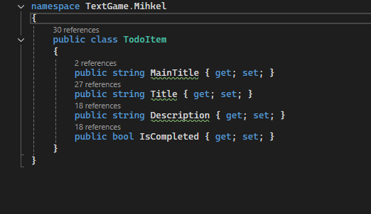

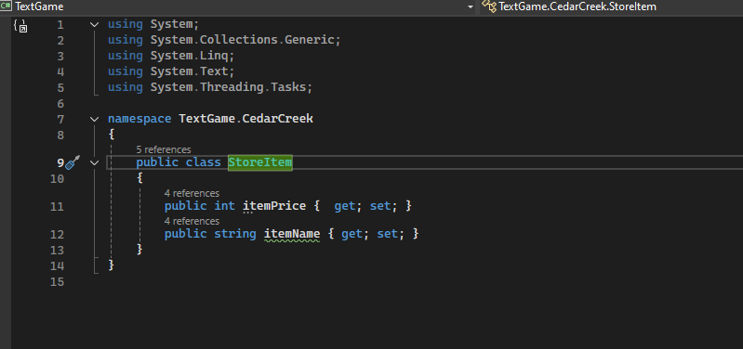

# 3. Front-Endi Detailid

**TOdoitem**

* **MainTitle**
* **Title**
* **Description**
* **IsComplited**

**StoreItem**

* **itemPrice**
* **itemName**

# 4.User Story

User

If user press one then open ToDo list.

* If user perse one on the ToDolist user can open markItem
* If user perse two on the ToDolist user can open ViewList
* If user perse Three on the ToDolist user can exit

If user press two then open Game1

* If user press one he can start the game
* If user press two then it can exit the game

If user perse three then open Game 2

* If user press one he can start the game
* If user press two then it can exit the game