TRAVEL MANAGEMENT SYSTEM (C++ PROJECT REPORT)
1. FUNCTIONAL REQUIREMENTS
Project Name:
Travel Management System (C++ Console Application)
Submitted To:
Sir Laeeq
Roll Number:
2026(S)-CS-87
University Name:
UET Lahore
Functional Requirements:
Admin Functionalities:
- Login as admin
- Manage users (view/delete)
- Manage destinations (add/view/delete)
- Manage bookings (view/delete)
- View statistics (users/bookings)
- Logout
User Functionalities:
- Register account
- Login account
- View dashboard
- View profile
- View booking history
- Change password
- View destinations
- Search destination
- Book trip
- Cancel booking
- Logout
2. WIREFRAMES
--General Structure
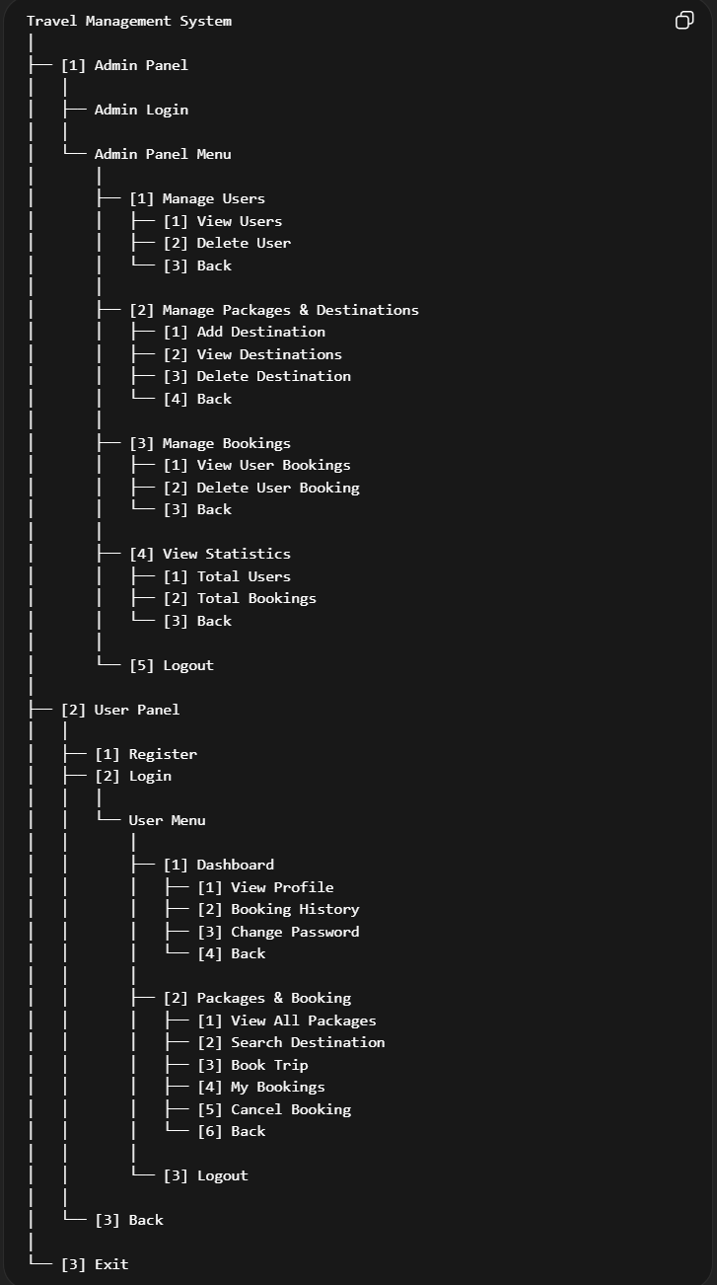
(Main UI Screenshots to be inserted manually)
1. Main Menu - shows admin/user/exit options
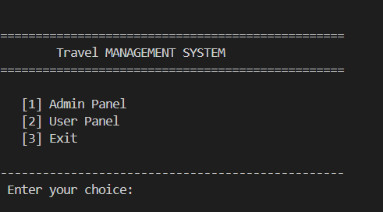
2. Admin login screen
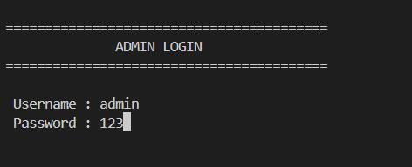
3. Admin dashboard menu
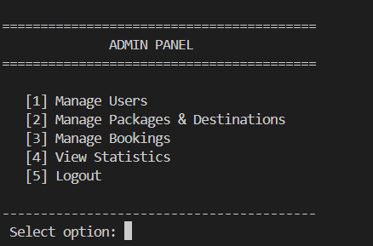
4. User Login
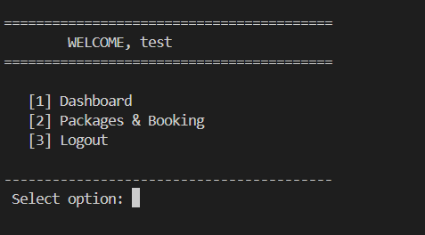
5. User dashboard
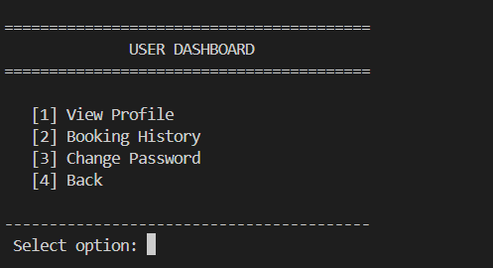
5. Booking & packages menu
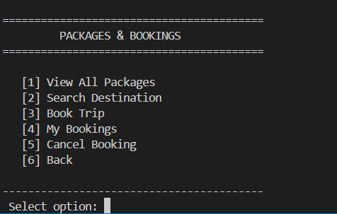
3. DATA STRUCTURES
User Data:
string Username[100]
string User_Password[100]
Destination Data:
string Destination[100]
int Des_Price[100]
Booking Data:
string Booking[100][100]
int Booki_Price[100][100]
Deleted Bookings:
string Deleted[100][100]
int Del_Price[100][100]
Control Variables:
int user_count
int des_count
int current_user
int booking_count[100]
4. SOURCE CODE
#include <iostream>
#include <string>
#include <conio.h> // for getch()
using namespace std;

int main()
{
const int total = 100;

// ===== USERS =====
string Username[total] = {"ali", "ahmed", "sara"};
string User_Password[total] = {"111", "222", "333"};
int user_count = 0;

// ===== DESTINATIONS =====
string Destination[total] = {"Pakistan", "Turkey", "Saudi", "Dubai", "Malaysia"};
int Des_Price[total] = {100, 200, 300, 400, 500};
int des_count = 0;

// ===== BOOKINGS =====
string Booking[total][total] = {""};
int Booki_Price[total][total] = {0};

// ===== DELETED BOOKINGS =====
string Deleted[total][total] = {""};
int Del_Price[total][total] = {0};

// ===== OTHER =====
int booking_count[total] = {0};
int current_user = 0;
int k = 0;

// ===== PRE-FILLED BOOKINGS =====

// ali bookings
Booking[0][0] = "Pakistan";
Booki_Price[0][0] = 100;

Booking[0][1] = "Dubai";
Booki_Price[0][1] = 400;

// ahmed bookings
Booking[1][0] = "Saudi";
Booki_Price[1][0] = 300;

// sara bookings
Booking[2][0] = "Turkey";
Booki_Price[2][0] = 200;

// sara cancelled booking
Deleted[2][0] = "Malaysia";
Del_Price[2][0] = 500;

for (int i = 0; i < total; i++)
{
if (Username[i] != "")
{
user_count++;
}
}
for (int i = 0; i < total; i++)
{
if (Destination[i] != "")
{
des_count++;
}
}
while (true) // Travel Management System main menu
{

system("CLS");
cout << "\n";
cout << "=================================================\n";
cout << " Travel MANAGEMENT SYSTEM\n";
cout << "=================================================\n\n";

cout << " [1] Admin Panel\n";
cout << " [2] User Panel\n";
cout << " [3] Exit\n\n";

cout << "-------------------------------------------------\n";
cout << " Enter your choice: ";

string userOption;
cin >> userOption;

if (userOption == "1") // admin menu options
{

int loginAttemp = 0;
for (int i = 0; i < 3; i++) // limiting login attempts
{

system("CLS");
cout << "\n=========================================\n";
cout << " ADMIN LOGIN\n";
cout << "=========================================\n\n";

string username, password;
cout << " Username : ";
cin >> username;
cout << " Password : ";
cin >> password;

if (username == "admin" && password == "123") // credential validation
{
cout << "Login successful!\n";

while (true) // shows admin menu
{
system("CLS");
cout << "\n=========================================\n";
cout << " ADMIN PANEL\n";
cout << "=========================================\n\n";

cout << " [1] Manage Users\n";
cout << " [2] Manage Packages & Destinations\n";
cout << " [3] Manage Bookings\n";
cout << " [4] View Statistics\n";
cout << " [5] Logout\n\n";

cout << "-----------------------------------------\n";
cout << " Select option: ";
string adminOption;
cin >> adminOption;
if (adminOption == "1") // Users
{
while (true)
{
system("CLS");
cout << "\n=========================================\n";
cout << " USER MANAGEMENT\n";
cout << "=========================================\n\n";

cout << " [1] View Users\n";
cout << " [2] Delete User\n";
cout << " [3] Back\n\n";

cout << "-----------------------------------------\n";
cout << " Select option: ";
string Manage_UserOption;
cin >> Manage_UserOption;
if (Manage_UserOption == "1")
{
k = 0;
for (int i = 0; i < user_count; i++)
{
if (Username[i] != "")
{
k++;
cout << "User " << k << ": " << Username[i] << endl;
cout << "Password for " << Username[i] << ": " << User_Password[i] << endl;
}
}
cout << "\nPress any key to continue...";
getch();
}
else if (Manage_UserOption == "2")
{
k = 0;
for (int i = 0; i < user_count; i++)
{
if (Username[i] != "")
{
k++;
cout << "User " << k << ": " << Username[i] << endl;
}
}
cout << "Enter the user name you want to delete: ";
string user_name;
cin >> user_name;
for (int i = 0; i < total; i++)
{
if (user_name == Username[i])
{
Username[i] = "";
User_Password[i] = "";
}
}
cout << "User Deleted Successfully!";
cout << "\nPress any key to continue...";
getch();
}
else if (Manage_UserOption == "3")
{
break;
}
}
}
else if (adminOption == "2") // Manage Packages & Destinations
{
while (true)
{
system("CLS");
cout << "\n=========================================\n";
cout << " DESTINATIONS & PACKAGES MANAGER\n";
cout << "=========================================\n\n";

cout << " [1] Add Destination\n";
cout << " [2] View Destinations\n";
cout << " [3] Delete Destination\n";
cout << " [4] Back\n\n";

cout << "-----------------------------------------\n";
cout << " Select option: ";
string Manage_UsersOption;
cin >> Manage_UsersOption;
if (Manage_UsersOption == "1")
{
cout << "Enter the number of Destinations to add: ";
int add_count;
cin >> add_count;
for (int i = 0; i < add_count; i++)
{
cout << "Enter the destination name and price: ";
cin >> Destination[des_count] >> Des_Price[des_count];
des_count++;
}
cout << "Added successfully!";

cout << "\nPress any key to return to previous menu!";
getch();
}
else if (Manage_UsersOption == "2")
{
k = 0;
for (int i = 0; i < total; i++)
{
if (Destination[i] != "")
{
k++;
cout << k << ". " << Destination[i] << " " << Des_Price[i] << endl;
}
}

cout << "\nPress any key to return to previous menu!";
getch();
}
else if (Manage_UsersOption == "3")
{
k = 0;
for (int i = 0; i < total; i++)
{
if (Destination[i] != "")
{
k++;
cout << k << ". " << Destination[i] << " " << Des_Price[i] << endl;
}
}
cout << "Enter the Destination name to delete or to exit enter -1: ";
string del_dest;
cin >> del_dest;
if (del_dest != "-1")
{
for (int i = 0; i < total; i++)
{
if (del_dest == Destination[i])
{
Destination[i] = "";
Des_Price[i] = 0;
}
}
cout << "Destination Deleted Successfully!";
}

cout << "\nPress any key to return to previous menu!";
getch();
}
else if (Manage_UsersOption == "4")
{
break;
}
}
}
else if (adminOption == "3") // manage bookings
{
while (true)
{
system("CLS");
cout << "\n=========================================\n";
cout << " BOOKING MANAGEMENT\n";
cout << "=========================================\n\n";

cout << " [1] View User Bookings\n";
cout << " [2] Delete User Booking\n";
cout << " [3] Back\n\n";

cout << "-----------------------------------------\n";
cout << " Select option: ";
string Manage_PackagesOption;
cin >> Manage_PackagesOption;
if (Manage_PackagesOption == "1")
{
k = 0;
for (int i = 0; i < total; i++)
{
for (int j = 0; j < total; j++)
{
if (Username[i] != "")
{
if (Booking[i][j] != "")
{
k++;
cout << "User " << k << ": " << Username[i] << endl;
cout << "Bookings for " << Username[i] << ":" << Booking[i][j] << endl;
}
}
}
}
cout << "\nPress any key to continue...";
getch();
}
else if (Manage_PackagesOption == "2")
{
k = 0;
for (int i = 0; i < user_count; i++)
{
for (int j = 0; j < user_count; j++)
{
if (Username[i] != "")
{
if (Booking[i][j] != "")
{
k++;
cout << "User " << k << ": " << Username[i] << endl;
cout << "Bookings for " << Username[i] << ": " << Booking[i][j] << endl;
}
}
}
}

cout << "Enter user name followed by the booking naeme you want to delete: ";
string temp_user;
string temp_booking_name;
cin >> temp_user >> temp_booking_name;

int user, booking_name;
for (int i = 0; i < total; i++)
{
if (temp_user == Username[i])
{
user = i;
}
}
for (int i = 0; i < total; i++)
{
if (temp_booking_name == Booking[user][i])
{
booking_name = i;
}
}
Booking[user][booking_name] = "";
Booki_Price[user][booking_name] = 0;
cout << "Successfully removed";

cout << "\nPress any key to continue...";
getch();
}
else if (Manage_PackagesOption == "3")
{
break;
}
}
}
else if (adminOption == "4") // view stats
{
while (true)
{
system("CLS");
cout << "\n=========================================\n";
cout << " STATISTICS PANEL\n";
cout << "=========================================\n\n";

cout << " [1] Total Users\n";
cout << " [2] Total Bookings\n";
cout << " [3] Back\n\n";

cout << "-----------------------------------------\n";
cout << " Select option: ";
string statsOption;
cin >> statsOption;
if (statsOption == "1")
{
cout << "Total Users: " << user_count;
cout << "\nPress any key to continue...";
getch();
}
else if (statsOption == "2")
{
int total_bookings = 0;
for (int i = 0; i < total; i++)
{
for (int j = 0; j < total; j++)
{
if (Booking[i][j] != "")
{
total_bookings++;
}
}
}
// for (int i = 0; i <= user_count; i++)
// {

// total_bookings += booking_count[i];
// }
cout << "Total Bookings: " << total_bookings << endl;
// cout << "Total Bookings: " << booking_count[current_user]<<endl;
cout << "\nPress any key to continue...";
getch();
}
else if (statsOption == "3")
{
break;
}
}
}
else if (adminOption == "5") // logout admin
{
cout << "Logout Success!\n";
cout << "Press any key to return to main menu...\n";
getch(); // pause
break;
}
}
}
else // retry login
{
cout << "Invalid credentials.\n";
cout << "Press any key to try again...\n";
getch(); // pause
}
loginAttemp++;
break;
}
}
else if (userOption == "2") // user registration options
{
while (true)
{
system("CLS");
cout << "\n=========================================\n";
cout << " USER PORTAL\n";
cout << "=========================================\n\n";

cout << " [1] Register\n";
cout << " [2] Login\n";
cout << " [3] Back\n\n";

cout << "-----------------------------------------\n";
cout << " Select option: ";
string Register_UserOption;
cin >> Register_UserOption;
if (Register_UserOption == "1")
{ // register user
cout << "Register username: ";
cin >> Username[user_count];
cout << "Register Password: ";
cin >> User_Password[user_count];

cout << "User " << Username[user_count] << " registered successfully!\n";
user_count++;
cout << "\nPress any key to return to previous menu!";
getch();
}
else if (Register_UserOption == "2")
{ // login user
cout << "Enter username: ";
string username;
cin >> username;
cout << "Enter Password: ";
string user_password;
cin >> user_password;
for (int i = 0; i < user_count; i++)
{
if (username == Username[i] && user_password == User_Password[i])
{
current_user = i;
cout << "Login Successful! \n";
cout << "Press any key to continue...";
getch();

while (true) // shows user menu
{
system("CLS");
cout << "\n=========================================\n";
cout << " WELCOME, " << Username[i] << "\n";
cout << "=========================================\n\n";

cout << " [1] Dashboard\n";
cout << " [2] Packages & Booking\n";
cout << " [3] Logout\n\n";

cout << "-----------------------------------------\n";
cout << " Select option: ";
string UserOption;
cin >> UserOption;
if (UserOption == "1") // show User Dashboard
{
while (true)
{
system("CLS");
cout << "\n=========================================\n";
cout << " USER DASHBOARD\n";
cout << "=========================================\n\n";

cout << " [1] View Profile\n";
cout << " [2] Booking History\n";
cout << " [3] Change Password\n";
cout << " [4] Back\n\n";

cout << "-----------------------------------------\n";
cout << " Select option: ";
string DashboardOption;
cin >> DashboardOption;
if (DashboardOption == "1")
{
cout << "Username: " << Username[current_user] << endl;
cout << "Password: " << User_Password[current_user] << endl;
int j = 0;
for (int i = 0; i < total; i++)
{
if (Booking[current_user][i] != "")
{
j++;
booking_count[current_user] = j;
}
}
cout << "Total Bookings " << booking_count[current_user] << endl;

cout << "\nPress any key to return to previous menu!";
getch();
}
else if (DashboardOption == "2")
{
cout << "Current Bookings:-------------\n";
k = 0;
for (int i = 0; i < total; i++)
{
if (Booking[current_user][i] != "")
{
k++;
cout << k << ". " << Booking[current_user][i] << " " << Booki_Price[current_user][i] << endl;
}
}

cout << "\nCanceled Bookings:-------------\n";
k = 0;
for (int i = 0; i < total; i++)
{
if (Deleted[current_user][i] != "")
{
k++;
cout << k << ". " << Deleted[current_user][i] << " " << Del_Price[current_user][i] << endl;
}
}

cout << "\nPress any key to return to previous menu!";
getch();
}
else if (DashboardOption == "3")
{
cout << "Enter current password: ";
string temp_pass;
cin >> temp_pass;
if (temp_pass == User_Password[current_user])
{
string new_pass;
cout << "Enter new password: ";
cin >> new_pass;
User_Password[current_user] = new_pass;
}
cout << "\nPress any key to return to previous menu!";
getch();
}
else if (DashboardOption == "4")
{
break;
}
}
}
else if (UserOption == "2") // Packages and Booking
{
while (true)
{
system("CLS");
cout << "\n=========================================\n";
cout << " PACKAGES & BOOKINGS\n";
cout << "=========================================\n\n";

cout << " [1] View All Packages\n";
cout << " [2] Search Destination\n";
cout << " [3] Book Trip\n";
cout << " [4] My Bookings\n";
cout << " [5] Cancel Booking\n";
cout << " [6] Back\n\n";

cout << "-----------------------------------------\n";
cout << " Select option: ";
string Browse_PackageOption;
cin >> Browse_PackageOption;
if (Browse_PackageOption == "1")
{ // View All Packages
k = 0;
for (int i = 0; i < total; i++)
{
if (Destination[i] != "")
{
k++;
cout << k << ". " << Destination[i] << " " << Des_Price[i] << endl;
}
}

cout << "\nPress any key to return to previous menu!";
getch();
}
else if (Browse_PackageOption == "2")
{ // Search Destinations
k = 0;
string dest_name;
cout << "Enter the name of the destination: ";
cin >> dest_name;
for (int i = 0; i < total; i++)
{
if (dest_name == Destination[i])
{
k++;
cout << k << ". " << Destination[i] << " " << Des_Price[i] << endl;
}
}
cout << "\nPress any key to return to previous menu!";
getch();
}
else if (Browse_PackageOption == "3")
{ // Book Trip
k = 0;
for (int i = 0; i < total; i++)
{
if (Destination[i] != "")
{
k++;
cout << k << ". " << Destination[i] << " " << Des_Price[i] << endl;
}
}
int empty_slot = -1;
for (int i = 0; i < total; i++)
{
if (Booking[current_user][i] == "")
{
empty_slot = i;
break;
}
}
int select_pack;
cout << "Enter the package number: ";
cin >> select_pack;
Booking[current_user][empty_slot] = Destination[select_pack - 1];
Booki_Price[current_user][empty_slot] = Des_Price[select_pack - 1];

cout << "\nPress any key to return to previous menu!";
getch();
}
else if (Browse_PackageOption == "4")
{ // View My Bookings
k = 0;
for (int i = 0; i < total; i++)
{
if (Booking[current_user][i] != "")
{
k++;
cout << k << ". " << Booking[current_user][i] << " " << Booki_Price[current_user][i] << endl;
}
}

cout << "\nPress any key to return to previous menu!";
getch();
}
else if (Browse_PackageOption == "5")
{ // Cancel My Bookings
k = 0;
for (int i = 0; i < total; i++)
{
if (Booking[current_user][i] != "")
{
k++;
cout << k << ". " << Booking[current_user][i] << " " << Booki_Price[current_user][i] << endl;
}
}
string del_pack;
cout << "Enter the name of the Booking to delete or to exit enter -1: ";
cin >> del_pack;
if (del_pack != "-1")
{
int empty_slot = 0;
for (int i = 0; i < total; i++)
{
if (Deleted[current_user][i] == "")
{
empty_slot = i;
break;
}
}
for (int i = 0; i < total; i++)
{
if (del_pack == Booking[current_user][i])
{
cout << "Booking for " << Booking[current_user][i];
Deleted[current_user][empty_slot] = Booking[current_user][i];
Booking[current_user][i] = "";
Del_Price[current_user][empty_slot] = Booki_Price[current_user][i];
Booki_Price[current_user][i] = 0;
cout << " Cancelled Successfully! ";
}
}
}

cout << "\nPress any key to return to previous menu!";
getch();
}
else if (Browse_PackageOption == "6")
{
break;
}
}
}
else if (UserOption == "3") // logout user
{
cout << "Logout Success!\n";
cout << "Press any key to return to main menu...\n";
getch(); // pause
break;
}
}
}
}
}
else if (Register_UserOption == "3")
{ // back
break;
}
}
}
else if (userOption == "3") // exit loop
{
// cout << "Thanks for using this software!\n";
break; // exit loop
}
else // option invalidity
{
cout << "Invalid option. Press any key to Try again.\n";
getch();
}
}

cout << "Thanks for using this software!";
return 0;
}

