Software Design Specifications

***Homemade food service***

**Version: 1.01**

|  |  |
| --- | --- |
| **Project Code** | CS-491 |
| **Supervisor** | Ms. Saeeda Kanwal |
| **Co Supervisor** | Sir. Abdul Rehman |
| **Project Team** | K173769 – Shahzad Hussain  K173891 –Mudasir Akhtar  K173632 –Fahad Ali |
| **Submission Date** |  |

**Document History**

|  |  |  |  |
| --- | --- | --- | --- |
| Version | Name | Date | Description of change |
|  |  |  |  |
| 1.02 | Shahzad Hussain | 20/11/20 | Edited whole SDS |

**Distribution List**

|  |  |
| --- | --- |
| **Name** | **Role** |
| **Ms. Saeeda Kanwal** | Supervisor |
| Sir. Abdul Rehman | Co Supervisor |
|  |  |

**Document Sign-Off**

*[Following table will contain sign-off details of document. Once the document is prepared and revised, this should be -off by the sign-off authority.*

*Any subsequent changes in the document after the first sign-off should again get a formal sign-off by the authorities.]*

|  |  |  |  |  |
| --- | --- | --- | --- | --- |
| **Version** | **Sign-off Authority** | **Project Role** | **Signature** | **Sign-off Date** |
|  |  |  |  |  |
|  |  |  |  |  |
|  |  |  |  |  |
|  |  |  |  |  |
|  |  |  |  |  |
|  |  |  |  |  |

**Document Information**

|  |  |
| --- | --- |
| **Category** | **Information** |
| Customer | FAST-NU |
| Project | Home Food Service |
| Document | Software Design Specification |
| Document Version | 1.01 |
| Status | Draft |
| Author(s) | Shahzad hussain, Mudasir Akhtar, Fahad Ali |
| Approver(s) |  |
| Issue Date |  |
| Document Location |  |
| Distribution | Advisor  Project Coordinator’s Office (through Advisor) |

**Definition of Terms, Acronyms and Abbreviations**

|  |  |
| --- | --- |
| **Term** | **Description** |
| ASP | Active Server Pages |
| DD | Design Specification |
|  |  |
|  |  |
|  |  |
|  |  |
|  |  |
|  |  |

**Table of Contents**

**Introduction……………………………………………………………………………………… 8**

Purpose of Document…………………………………………………………………………… 8

Intended Audience………………………………………………………………………………. 8

Document Convention…………………………………………………………………………… 8

Project Overview…………………………………………………………………………………. 8

Scope……………………………………………………………………………………………… 8

**Design Considerations………………………………………………………………………… 9**

Assumptions and Dependencies………………………………………………………………..9

Risks and Volatile Areas………………………………………………………………………… 9

**System Architecture………………………………………………………………………….. 10**

System Level Architecture…………………………………………………………………….. 10

Software Architecture……………………………………………………………………………11

**Design Strategy………………………………………………………………………………… 1****2**

**Detailed System Design……………………………………………………………………… 1****3**

Class Diagram………………………………………………………………………………….. 13

Database Design………………………………………………………………………………. 14

**Data Dictionary………………………………………………………………………………… 1****5**

1. Customer…………………………………………………………………………………… 15
2. Order-details……………………………………………………………………………….. 15
3. Product………………………………………………………………………………………. 16
4. Cart………………………………………………………………………………………….. 16
5. Comments/Reviews……………………………………………………………………….. 17
6. Category…………………………………………………………………………………….. 17
7. Sub- Category ……………………………………………………………………………… 17
8. Admin……………………………………………………………………………………….. 17
9. Chef…………………………………………………………………………………………. 18
10. Address…………………………………………………………………………………….. 18
11. Message……………………………………………………………………………………..18
12. Favourite…………………………………………………………………………………….19

**Application Design…………………………………………………………………………… 17**

**Sequence Diagram…………………………………………………………………………… 17**

1. Registration for Users………………………………………………………………………...20

[2.. Create an account……………………………………………………………………………](#_2bn6wsx)..21

3. Food ordering system…………………………………………………………………………22

**State Diagram 2**3

1. User Registration……………………………………………………………………………. 23

2. Rating and Reviews…………………………………………………………………………………. 23

**References…………………………………………………………………………………….. 2**4

# Introduction

There are many restaurants out there as the craze for food is increasing day by day but however the quality of food is questionable. There are lot of unhealthy food in restaurants which exerts negative influence on people. Although there are several food inspectors who are trying to regulate these restaurants in a healthy way but due to wide range of restaurants, they are unable to do so. Homemade food service is a food service that provides Homemade food to their consumers in order to save them from unhealthy toxic foods. It is essential to develop a website for people to order online healthy Homemade food. Not only health is most neglected aspect of our life, but we have tons of unhealthy toxic food choices around us, making it hard to live a healthy life. Our service is also offering feature to gain a customer interest, as if someone is diagnosing from diabetes, heart patient, stomach problem in this case we will offer food as per their need.

## Purpose of Document

The purpose of this document is to describe briefly about our project which is a Home food service web-site and mobile app. This document will provide an overview of website and mobile application purpose, and what problem it is solving, what are the requirements of this website and mobile application. It also identifies the framework and a technology used for the development and tries to define the system architecture. And design strategies use to build this website and mobile application.

## Intended Audience

This document is intended for a varied set of audiences including Team Lead, Supervisors, Juries and Externals.

## 

## Document Convention

The font size of this document is 12 pt.

**Project Overview**

A homemade food ordering application which is developed with the means of providing working people with the option of having home cooked healthy food. It also serves as a platform where home cooks can exhibit their culinary skills and even get employment opportunities. It is developed using html, php and bootstrap making it a cross platform for mobile application and web application both are applicable.

**Scope**

Homemade food service website and mobile application both are responsive. Both are easy to use with an attractive interface for customers, chef and admin. Where customers will search dishes, add dishes to cart checkout and review on the dishes. Whereas customers order dishes on their own recipes, add dishes to the wish list, update dishes, see and ship orders and see reviews on dishes and total bill.

# 

# Design Considerations

## Assumptions and Dependencies

These assumptions are based on Hardware requirements for:

* 2.1 GHz of Processor
* 4 GB RAM
* 20 GB of HDD Space Required
* Keyboard and Mouse for Input
* Dedicated GPU of 1 GB Video Memory (optional)
* Broadcom 802.11b Network Adapter
* Android platform (Version > 5.0 Lolipop)
* Mobile Ram =>2 GB
* App Size <= 30 MB

## Risks and Volatile Areas

We have added some versatile type of menu items i.e. Preparation of food on customer’s choice.

If there remains extra food at the end of the day, then we shall distribute it to needy people.

Whereas there are also some risks to be considered i.e. there might be a delay in payment made by customer through debit/credit card, so he might not get food on time

# System Architecture

Users order food from their android app or web application request will be further proceeded to server and from server to application server and fetches the desired output of request from database. Server and application server will communicate with each other and also our payment method is connected to the server.

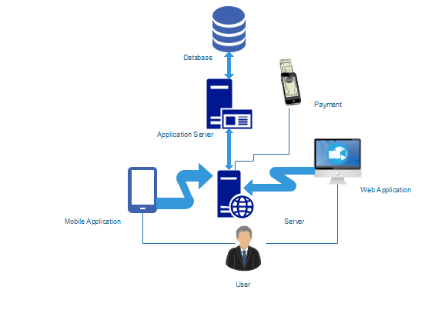

**Figure 1. (Architecture Diagram)**

**System Module**

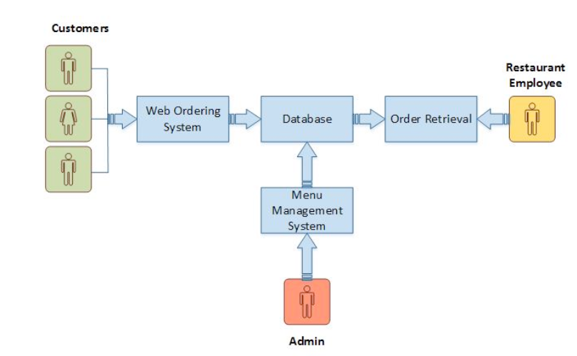

## Figure 2. (System Module)

## System Level Architecture

## Software Architecture

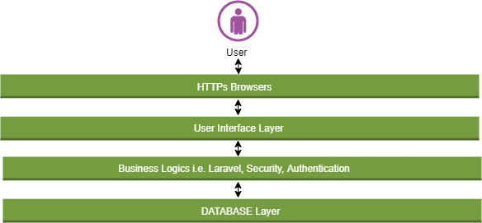

## Figure 3.(Software level architecture)

# Design Strategy

# 1. Future system extension or enhancement:

# The system will be built using the latest edition of framework and incase a new updates occurs in technology we must be ready.

# Stay updated by tracking orders with customized alerts and resolve issues proactively.

# Track real-time, Optimize routes and schedules and resource allocation in one centralized view.

# 2. User interface paradigms:

# The user interface is very reliable and understandable to the user, the interface designed in such a way that every age of people can easily learned and understand that what happens if i click this option ,interface is very effective and efficient to increase the usability of users.

# 3. Data Management:

# The traditional way to collect the data of the kitchen’s customers has been through feedback forms, conducting surveys, and asking for signups. Over the years, technology has grown by leaps and bounds and has made the collection of data in a kitchens, both customer and internal data management for kitchen much easier. Simple, everyday activities such as browsing the internet, or placing an order online generate different sets of data which can reveal the eating habits, purchase preferences, travel habits, etc of the users.

# *An online order typically collects the following data:*

# Name

# E-mail Id

# Phone number

# Location and address

# Food preferences/Ordering habits

# Over time, a profile of each customer can be created which tell about their behavior

# how much do they spend on an average, most ordered dish, etc.

# Thus restaurant data collection must not be limited to customers frequenting the restaurant. In today’s day and age where online food delivery has taken over the restaurant industry, customer data collected online is just as important as data collected in the premises of the restaurant and must also be managed.

# Design strategy:

# 1-Android Studio

# 2-MYSQl

# 3-Google maps

# 4-Connectivity

# Detailed System Design

## Class Diagram

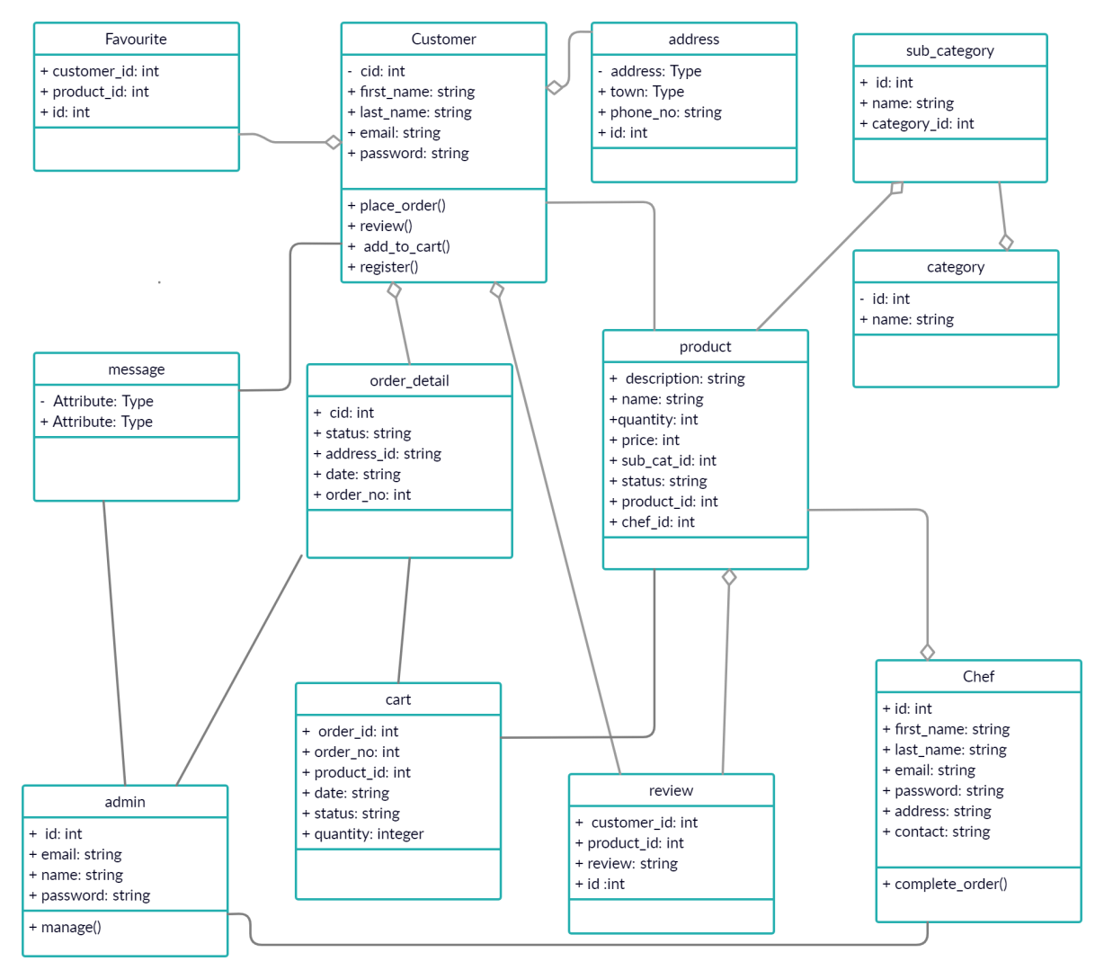

***Figure 4***.**(Class diagram)**

## Database Design

### 

### ER Diagram

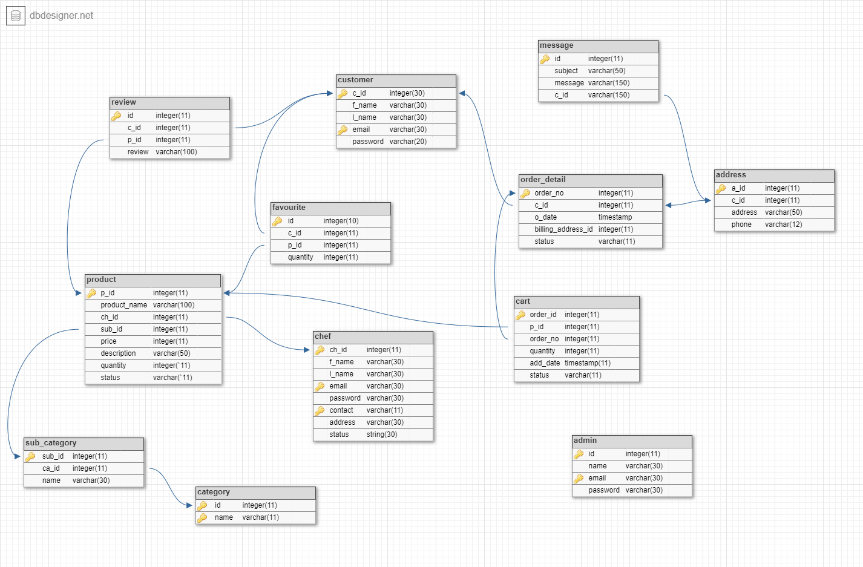

***Figure 5.(ER Diagram)***

## Data Dictionary

**Table-1: Customer**

|  |  |  |  |
| --- | --- | --- | --- |
| **Attributes** | **Datatype** | **Constraints** | **Description** |
| First name | Varchar | None | First name of a customer |
| Last name | Varchar | None | Last name of a customer |
| Customer_ID | Integer | Primary key | Unique no given to all customer |
| Email | Varchar | None | Email of customer |
| Password | Varchar | None | Passwsord of the username |

**Table-2:order-detail**

|  |  |  |  |
| --- | --- | --- | --- |
| **Attributes** | **Datatype** | **Constraints** | **Description** |
| Order_no | Integer | Primary key | Unique no given to all orders |
| Customer_ID | Integer | Foreign key | Taken from customer table to check whose order belongs to. It give access of that customer table |
| Product_Id | Integer | Foreign key | Taken from product table to check which product is that. |
| Order date | timestamp | none | Date of order |
| Quantity | Integer | none | Tells the no of produces. |
| Billing_address_id | integer | none | Address will be taken from address table through id |
| Status | varchar | none | Shows status of product |

**Table-3: Product**

|  |  |  |  |
| --- | --- | --- | --- |
| **Attributes** | **Data type** | **Constraints** | **Description** |
| ProductID | Integer | Primary key/Unique | Unique no given to all products |
| Product name | Varchar | none | Name of the product |
| Chef id | Integer | Foreign key | Provides details about chef |
| Sub id | Integer | none | Belongs to which category |
| Product price | Integer | none | Price of the product |
| Product description | Varchar | none | Details of the product |
| Quantity | Integer | none | Quantity of product |
| Status | String | none | Shows availability of product |

**Table-4: Cart**

|  |  |  |  |
| --- | --- | --- | --- |
| **Attributes** | **Data type** | **Constraints** | **Description** |
| Id | Integer | Unique | Unique no given to all carts. |
| Product id | Integer | Foreign key | From product table this attribute is taken to know the details of the product. |
| Quantity | Integer | None | To know how much items does the product adds. |
| Order no | Integer | Foreign key | From customer table to see the record of the customer through this. |
| Add date | Timestamp | None | Add date to order |
| Status | Varchar | None | Shows status of product |

**Table 5: Comment/reviews**

|  |  |  |  |
| --- | --- | --- | --- |
| **Attributes** | **Data type** | **Description** | **Constraint** |
| Id | Integer | Id of reviews | Primary key |
| Product_id | Integer | To know which comment is belong to which product. | Foreign_key |
| C_id | integer | To know which customer reviewed | None |
| Review | Varchar | Like/dislike | None |

**Table 6:- categories**

|  |  |  |  |
| --- | --- | --- | --- |
| **Attributes** | **Constraint** | **Description** | **Datatype** |
| Category _id | unique | Unique no given to all category | Int |
| Category_name | none | Name of category. | None |

**Table 7:- sub- categories**

|  |  |  |  |
| --- | --- | --- | --- |
| **Attributes** | **Constraint** | **Description** | **Datatype** |
| sub _id | unique | Unique no given to all category | Int |
| Category_id | None | Take details of category from category through ca_id. | Foreign |
| Category_name | None | Name of category. | None |

**Table 8:- Admin**

|  |  |  |  |  |
| --- | --- | --- | --- | --- |
| **Attributes** | | **Datatype** | **Description** | **Constraint** |
| Admin_Id | Integer | | Unique no given to all users | Unique |
| Name | Varchar | | Name of the admin | None |
| Email | Varchar | | Email of the admin | None |
| Password | Varchar | | Password of the admin | None |

**Table 9:- Chef**

|  |  |  |  |
| --- | --- | --- | --- |
| **Attrisbutes** | **Datatype** | **Constraints** | **Description** |
| First_name | Varchar | None | First name of a customer |
| Last_name | Varchar | None | Last name of a customer |
| Chef-ID | Integer | Primary key | Unique no given to all customer |
| Email | Varchar | Primary key | Email of customer |
| Password | Varchar | None | Password of the username |
| Contact | varchar | Primary key | Contact Number of chef |
| Address | varchar | none | Address of chef |
| Status | varchar | None | Availability of chef |

**Table 10:- Address**

|  |  |  |  |
| --- | --- | --- | --- |
| **Attributes** | **Datatype** | **Description** | **Constraint** |
| Address_Id | Integer | Unique not given to all customer | Unique |
| C_id | Integer | To link with customer | Foreign key |
| Address | Varchar | Address of customer | None |
| Phone | Varchar | To Contact | None |

**Table 11:- Message**

|  |  |  |  |
| --- | --- | --- | --- |
| **Attributes** | **Datatype** | **Description** | **Constraint** |
| Message Id | Integer | Unique not given to all messages | Unique |
| C id | integer | To link with customer | Foreign key |
| Subject | Varchar | Subject of message | None |
| Message | Varchar | message | None |

**Table 12:- Favorite**

|  |  |  |  |
| --- | --- | --- | --- |
| **Attributes** | **Datatype** | **Description** | **Constraint** |
| Id | Integer | Id of reviews | Primary key |
| Product id | Integer | To know which comment is belong to which product. | Foreign key |
| C id | integer | To know which customer reviewed | Foreign key |
| Quantity | integer | To know how much items does the product adds. | None |

# 

# Application Design

## Sequence Diagram

### Login

### 

## 

## Figure 6.(Login sequence diagram)

## 

## 

## 2- Create an account

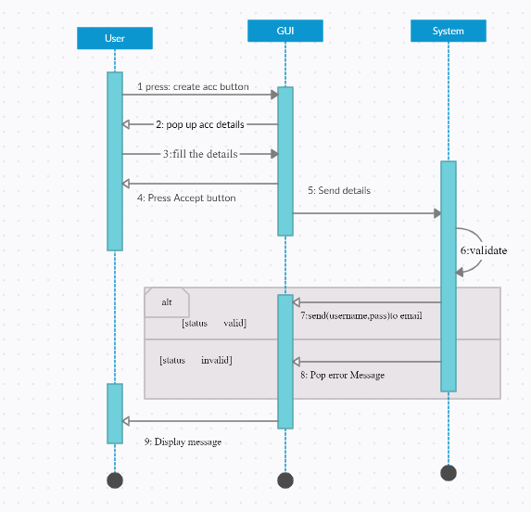

### 

## Figure 7.(Register sequence diagram)

## 3- Food ordering system

.

.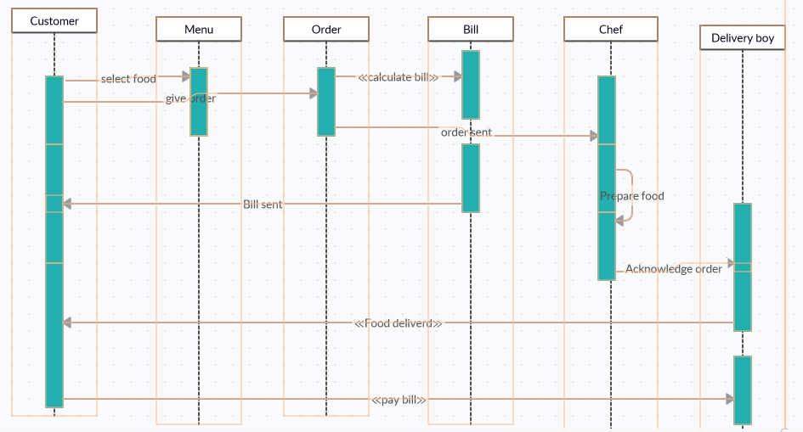

## Figure 8.(order system sequence disgram)

### 4- Rating and reviews

## Untitled Document (2).jpgFigure 9.(Rating and reviews sequence diagram)

## State Diagram

### 1. User Registration

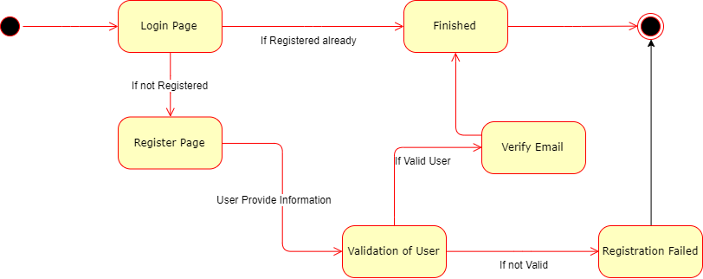

## Figure 10.(Registration state diagram)

### Rating and reviews

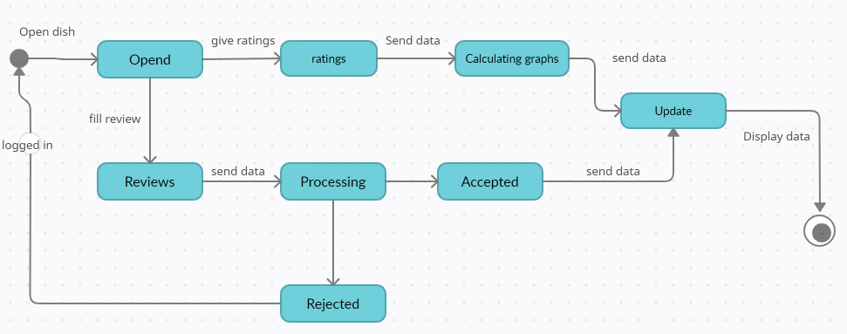

## Figure 11.(Rating and reviews state diagram)

# 

# References

1. Impact of Online Food Delivery on Customers: https://www.irjet.net/archives/V7/i4/IRJET-V7I4455.pdf
2. Kedah, Zulkarnain & Ismail, Yusof & Ahasanul, A & Ahmed, Selim. (2015). Key Success Factors of Online Food Ordering Services: An Empirical Study. Malaysian Management Review. 50.
3. The Study of Interest of Consumers In Mobile Food Ordering Apps: https://ijrar.com/upload_issue/ijrar_issue_20542895.pdf
4. Kimes, S,E. 2011, Consumer perceptions of online food ordering, Center for Hospitality Research Publications, Vol. 11, page no: 4-12
5. Consumer Perception of Online Food Delivery Apps in Kochi: https://www.ijitee.org/wpcontent/uploads/papers/v8i7s2/G10520587S219.pdf
6. 10. See-Kwong G., Soo-Ryue N., 2017, Outsourcing to online food delivery services : perspective of F&B business owners, Journal of Internet Banking and Commerce, 2, Vol no. 22, page no. 5-7
7. Rashmi, 2018, SWOT Analysis of online food industry in India, Internationl Research Journal of Management and Commerce, 1, Vol no. 5, page no. 503-507

**THANK YOU!**