# DB PROJECT REPORT

MEMBERS:

SARMAD JAMAL (K19-1116)

KHIZER JILANI (K19-1057)

MANSOOR BUTT(K19-1114)

**Problem Statement**

## Problem Definition

Following are commonly faced problems:

* Many times, we have to wait in long queues for the orders, which in return waste a lot of time and requires greater level of patience.
* Sometimes an order can be missed.
* Many human errors occur when we deal with information manually.
* There are many benefits for online restaurant management including customer satisfaction, better product quality and fast service.

## Objective

*The software we are proposing have many enhance features than other RMS(Restaurant Management Software), as we propose a system which would help every member of the restaurant to do his task with less effort and time,When talking about restaurants, there are many problems faced by people in restaurants but typical restaurant management website helps customers to carry out their tasks and ignore restaurant staff. This system will provide every restaurant staff with a help and an easy way to carry out their tasks without wasting time and efforts.*

There is also a monitoring system for reserving tables and adding orders. Orders can be accepted, viewed and its status can be tracked. People had to wait in a long queue to order which was a big problem and effected customer satisfaction, through this system, orders can be taken online saving both customer and admin's efforts and also increase usability of the system.

ERD

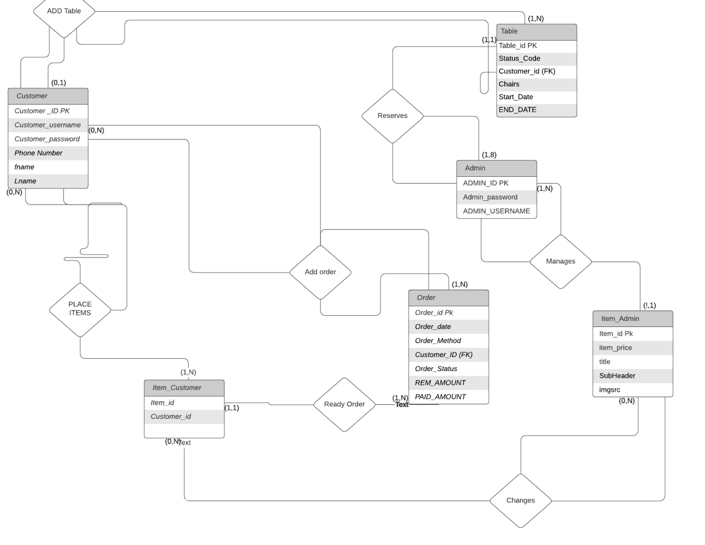

RELATION AND LOGICAL MODEL USING DATA MODELER

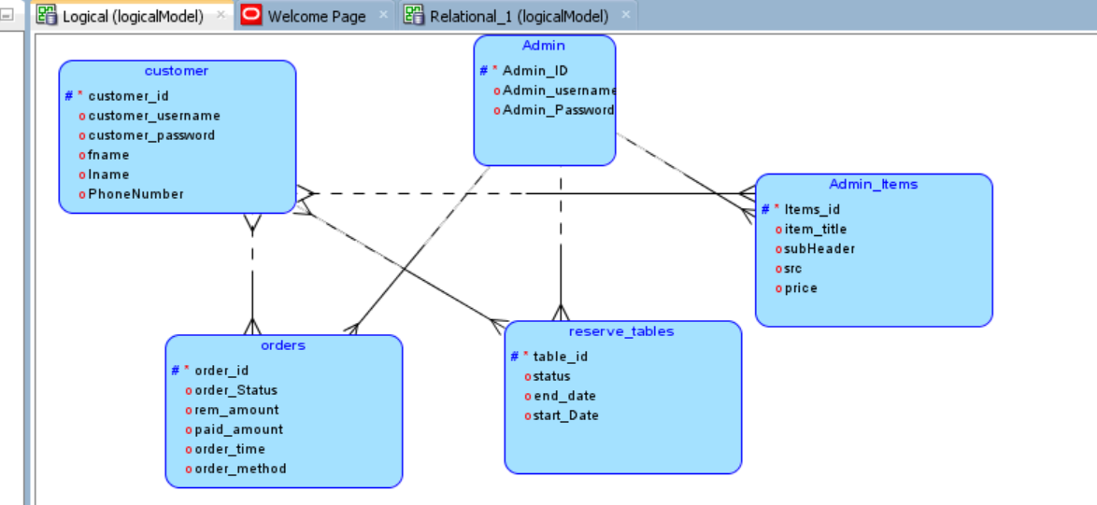

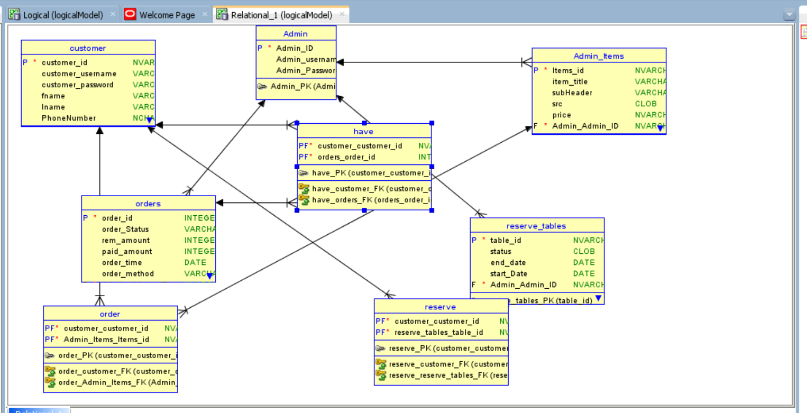

GENERATED DDL

CREATE TABLE admin (

admin_id NVARCHAR2(1) NOT NULL,

admin_username VARCHAR2(10),

admin_password VARCHAR2(10)

);

ALTER TABLE admin ADD CONSTRAINT admin_pk PRIMARY KEY ( admin_id );

CREATE TABLE admin_items (

items_id NVARCHAR2(1) NOT NULL,

item_title VARCHAR2(10),

subheader VARCHAR2(10),

src CLOB,

price NVARCHAR2(1),

admin_admin_id NVARCHAR2(1) NOT NULL

);

ALTER TABLE admin_items ADD CONSTRAINT admin_items_pk PRIMARY KEY ( items_id );

CREATE TABLE customer (

customer_id NVARCHAR2(1) NOT NULL,

customer_username VARCHAR2(10),

customer_password VARCHAR2(500),

fname VARCHAR2(10),

lname VARCHAR2(10),

phonenumber NCHAR(11)

);

ALTER TABLE customer ADD CONSTRAINT customer_pk PRIMARY KEY ( customer_id );

CREATE TABLE have (

customer_customer_id NVARCHAR2(1) NOT NULL,

orders_order_id INTEGER NOT NULL

);

ALTER TABLE have ADD CONSTRAINT have_pk PRIMARY KEY ( customer_customer_id,

orders_order_id );

CREATE TABLE "order" (

customer_customer_id NVARCHAR2(1) NOT NULL,

admin_items_items_id NVARCHAR2(1) NOT NULL

);

ALTER TABLE "order" ADD CONSTRAINT order_pk PRIMARY KEY ( customer_customer_id,

admin_items_items_id );

CREATE TABLE orders (

order_id INTEGER NOT NULL,

order_status VARCHAR2

,

rem_amount INTEGER,

paid_amount INTEGER,

order_time DATE,

order_method VARCHAR2(10),

admin_admin_id NVARCHAR2(1) NOT NULL

);

ALTER TABLE orders ADD CONSTRAINT orders_pk PRIMARY KEY ( order_id );

CREATE TABLE reserve (

customer_customer_id NVARCHAR2(1) NOT NULL,

reserve_tables_table_id NVARCHAR2(1) NOT NULL

);

ALTER TABLE reserve ADD CONSTRAINT reserve_pk PRIMARY KEY ( customer_customer_id,

reserve_tables_table_id );

CREATE TABLE reserve_tables (

table_id NVARCHAR2(1) NOT NULL,

status CLOB,

end_date DATE,

start_date DATE,

admin_admin_id NVARCHAR2(1) NOT NULL

);

ALTER TABLE reserve_tables ADD CONSTRAINT reserve_tables_pk PRIMARY KEY ( table_id );

ALTER TABLE admin_items

ADD CONSTRAINT admin_items_admin_fk FOREIGN KEY ( admin_admin_id )

REFERENCES admin ( admin_id );

ALTER TABLE have

ADD CONSTRAINT have_customer_fk FOREIGN KEY ( customer_customer_id )

REFERENCES customer ( customer_id );

ALTER TABLE have

ADD CONSTRAINT have_orders_fk FOREIGN KEY ( orders_order_id )

REFERENCES orders ( order_id );

ALTER TABLE "order"

ADD CONSTRAINT order_admin_items_fk FOREIGN KEY ( admin_items_items_id )

REFERENCES admin_items ( items_id );

ALTER TABLE "order"

ADD CONSTRAINT order_customer_fk FOREIGN KEY ( customer_customer_id )

REFERENCES customer ( customer_id );

ALTER TABLE orders

ADD CONSTRAINT orders_admin_fk FOREIGN KEY ( admin_admin_id )

REFERENCES admin ( admin_id );

ALTER TABLE reserve

ADD CONSTRAINT reserve_customer_fk FOREIGN KEY ( customer_customer_id )

REFERENCES customer ( customer_id );

ALTER TABLE reserve

ADD CONSTRAINT reserve_reserve_tables_fk FOREIGN KEY ( reserve_tables_table_id )

REFERENCES reserve_tables ( table_id );

ALTER TABLE reserve_tables

ADD CONSTRAINT reserve_tables_admin_fk FOREIGN KEY ( admin_admin_id )

REFERENCES admin ( admin_id );

NORMALIZED TABLES UPTO 3NF

* admin (admin_id ,admin_username ,admin_password)
* Customer(*customer_id* ,customer_username ,customer_password ,fname ,lname ,phonenumber)
* reserve_tables (table_id ,status ,end_date ,start_date,customer_id)
* item_admin (*item_id* ,item_price , item_title ,item_subHeader,item _src);
* item_customer (*item_id* ,customer_id );
* Orders (order_id, order_status, rem_amount,paid_amount, order_time, order_method );

# Snap shots

->HOMEPAGE

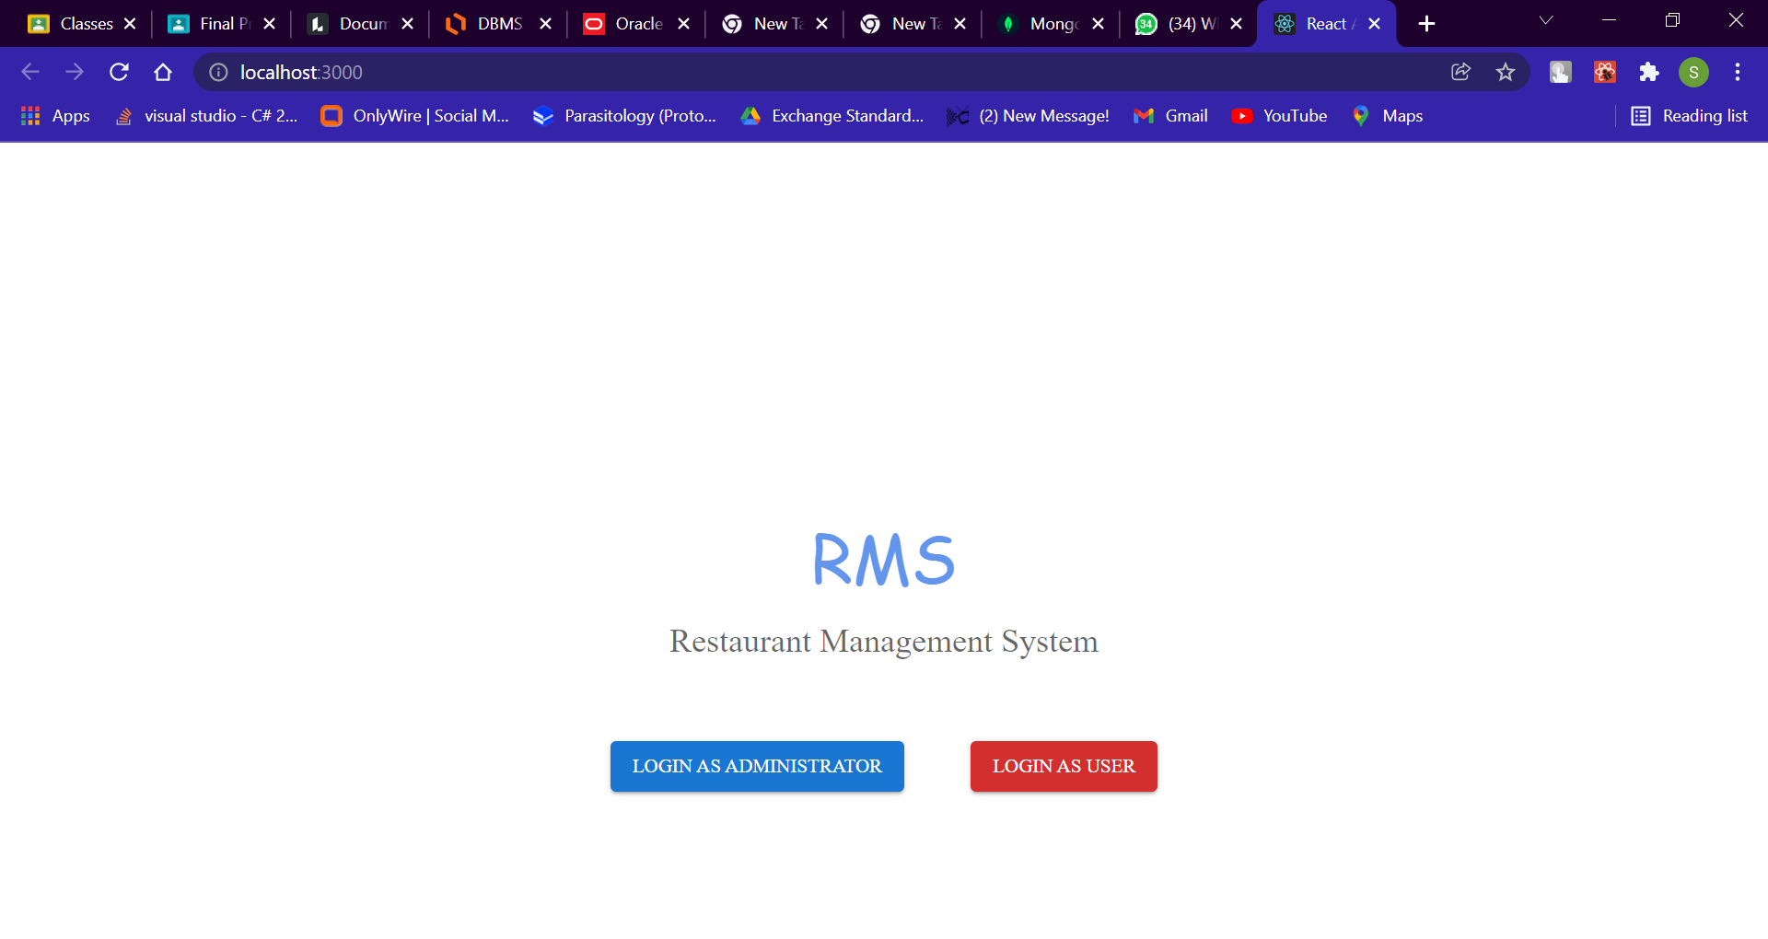

->Admin login Page

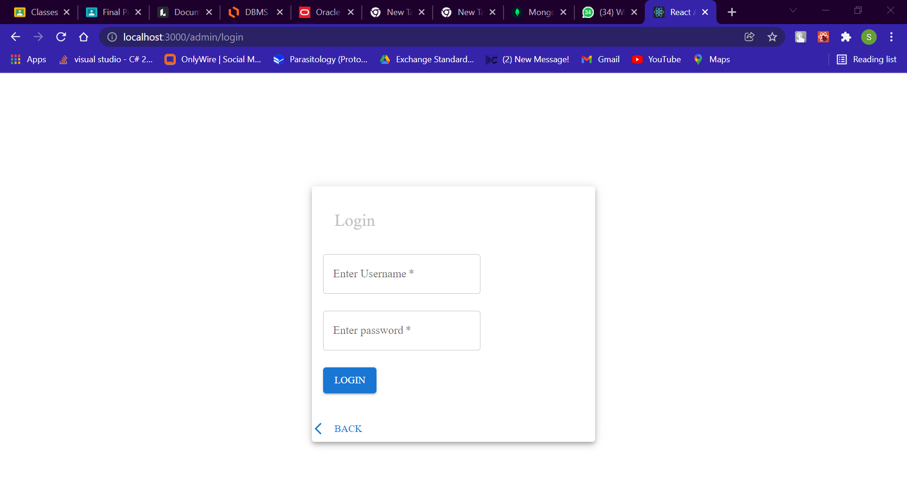

->Admin Adding tables

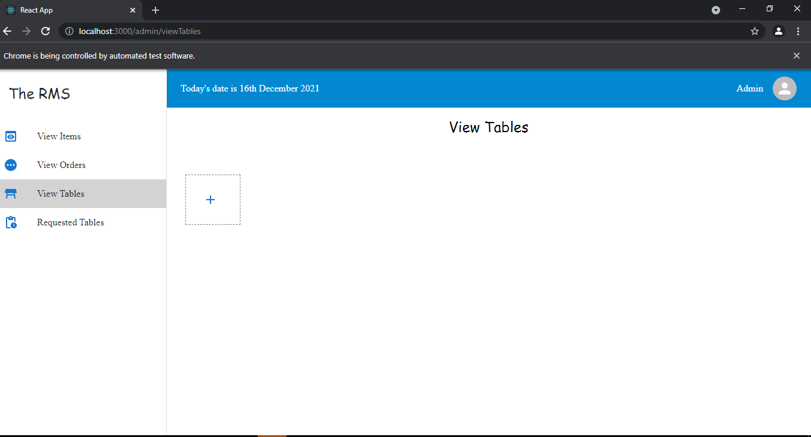

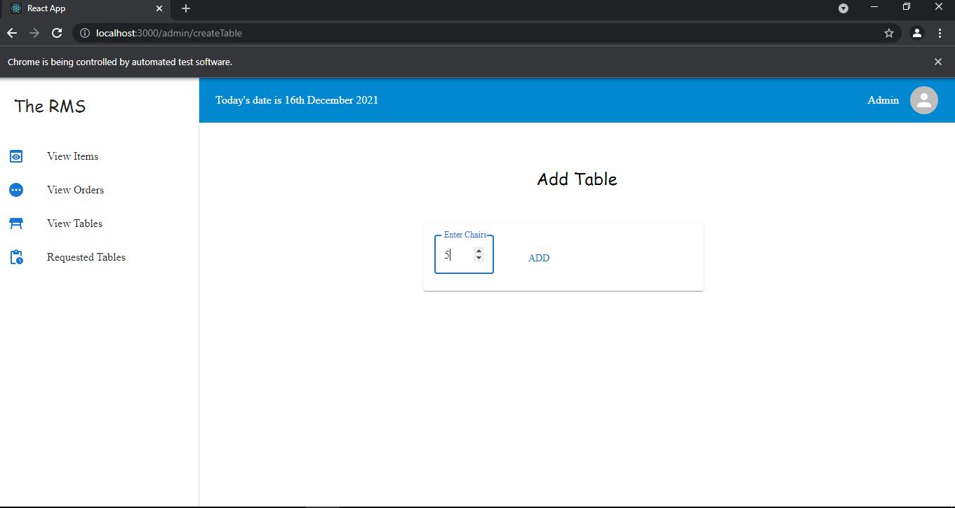

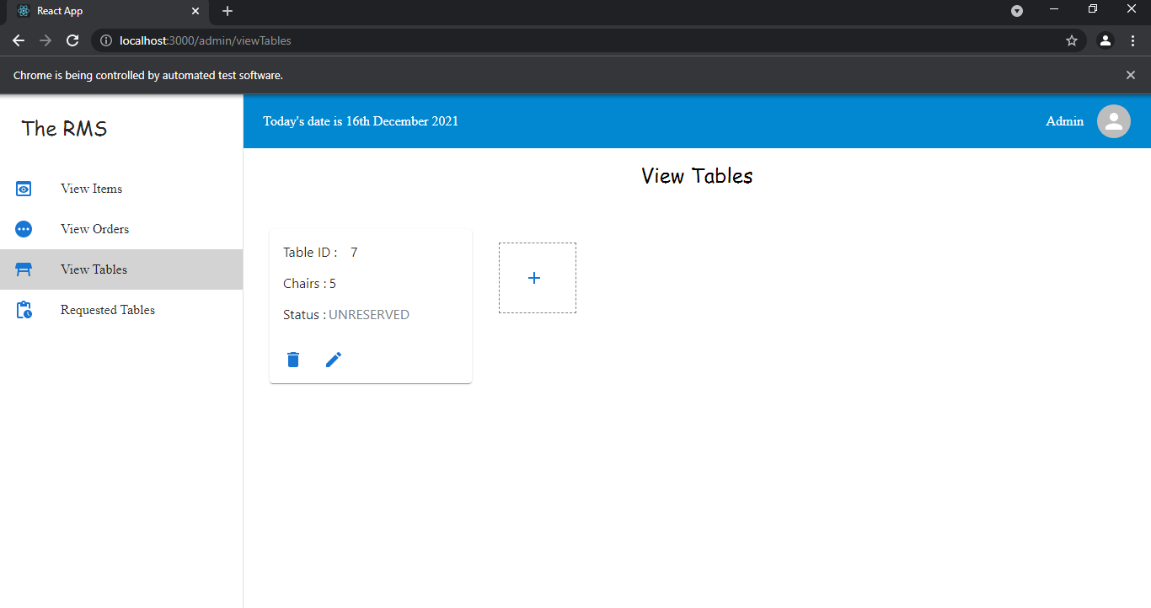

->Admin Updating Chairs

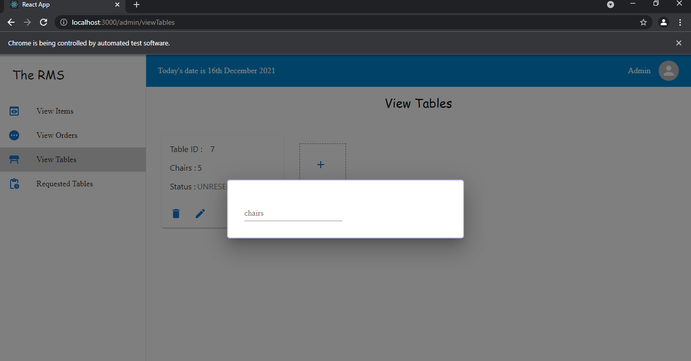

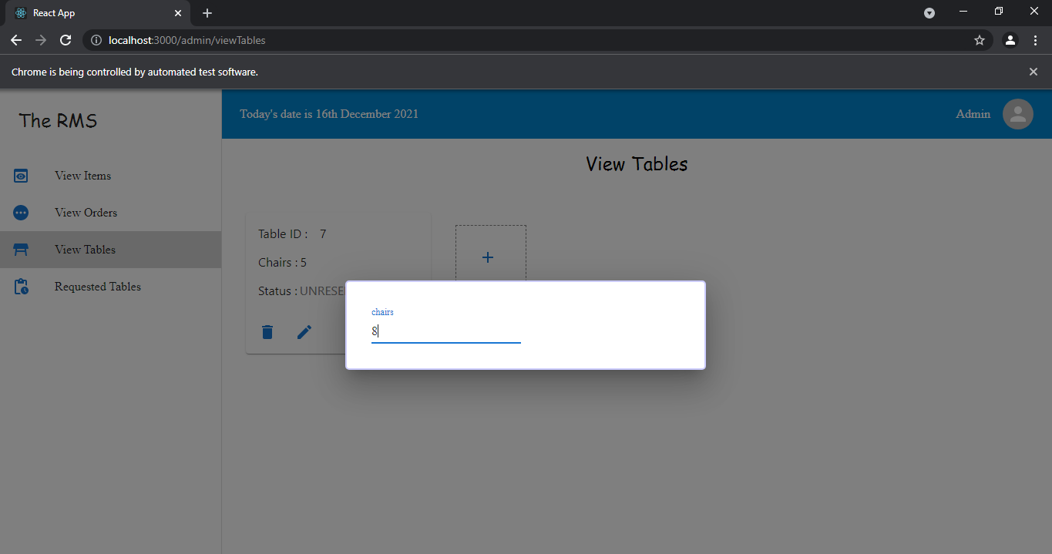

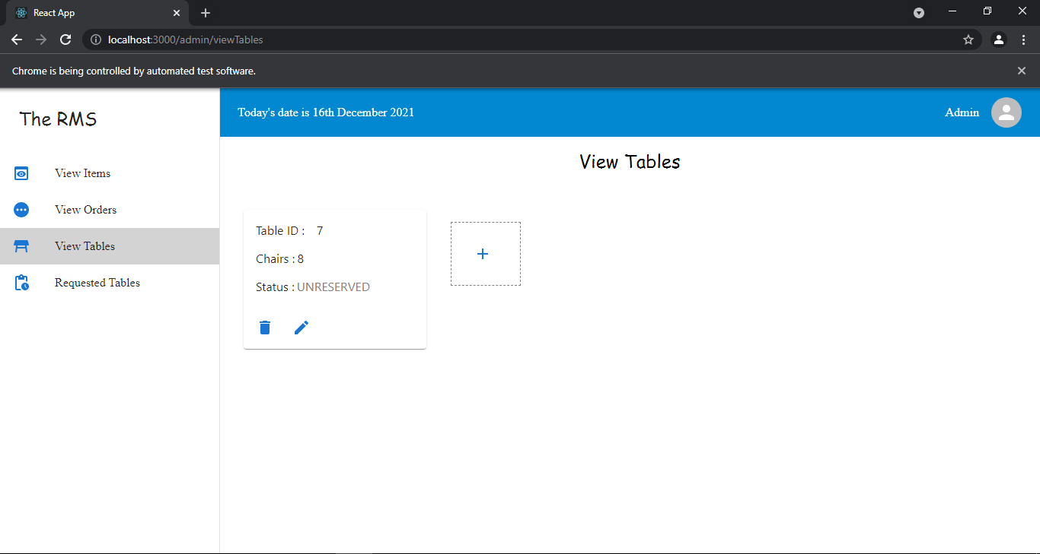

->Admin Deleting tables

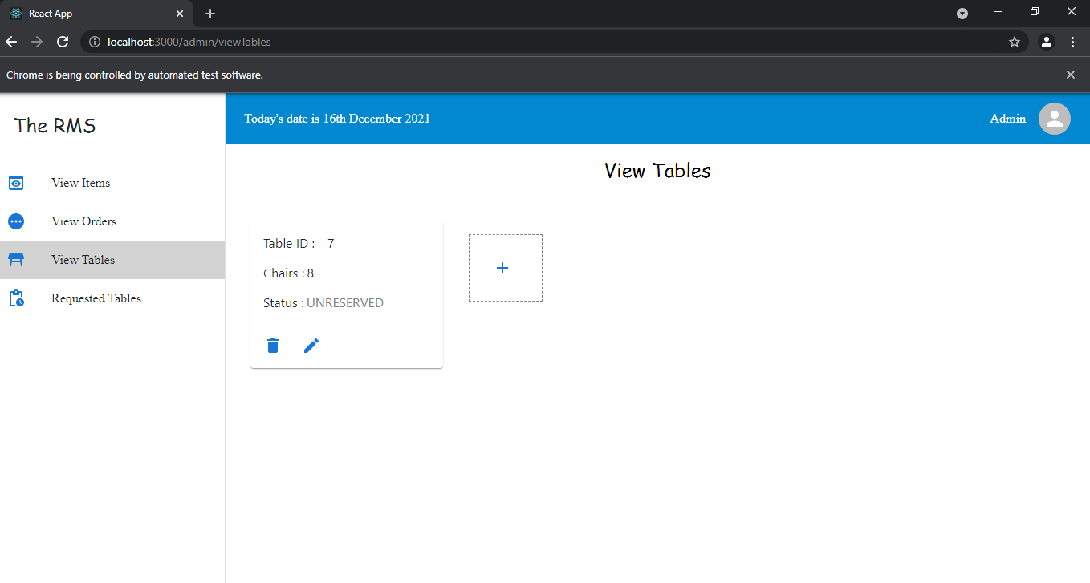

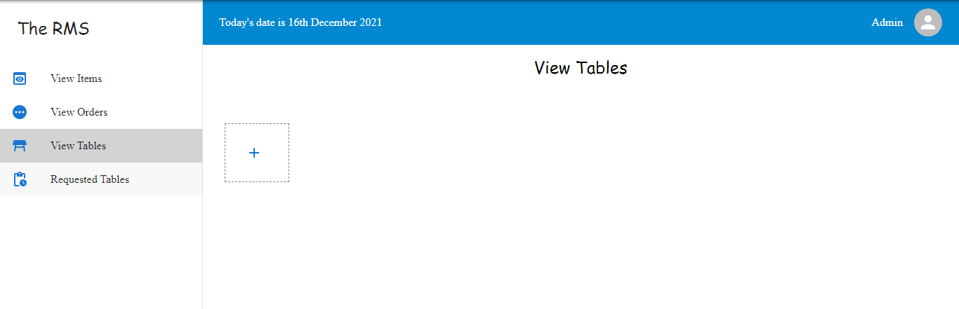

->Admin modifying Items price

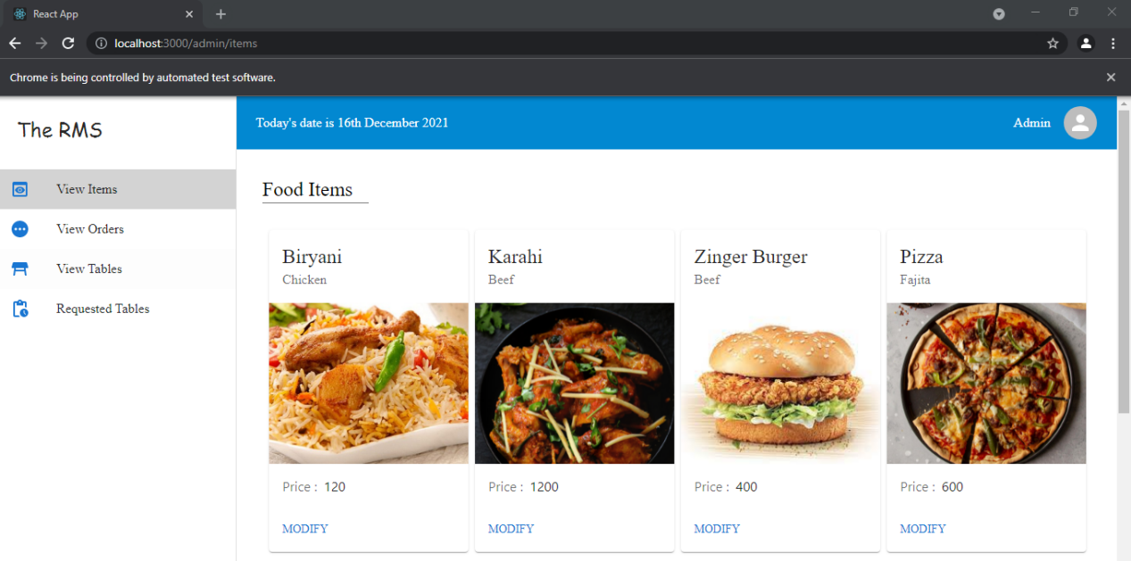

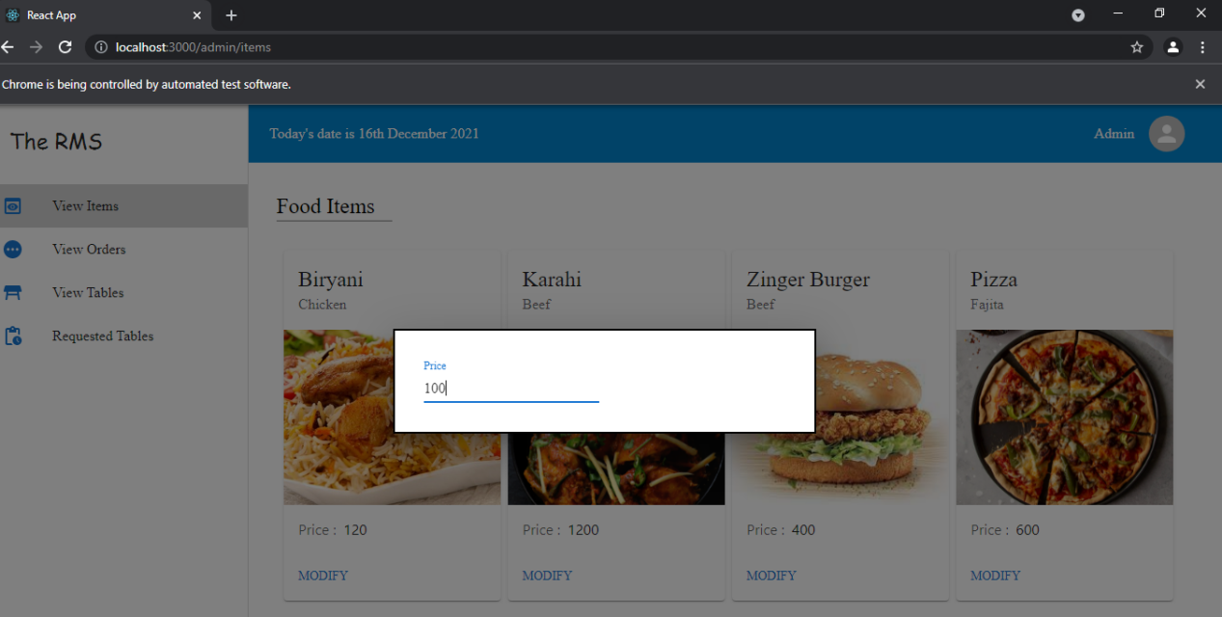

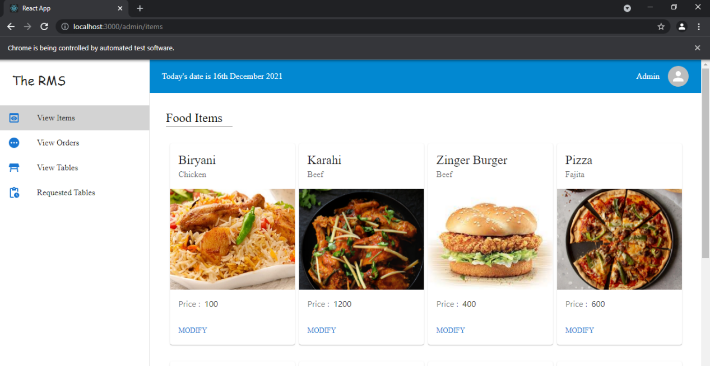

->admin approving Orders

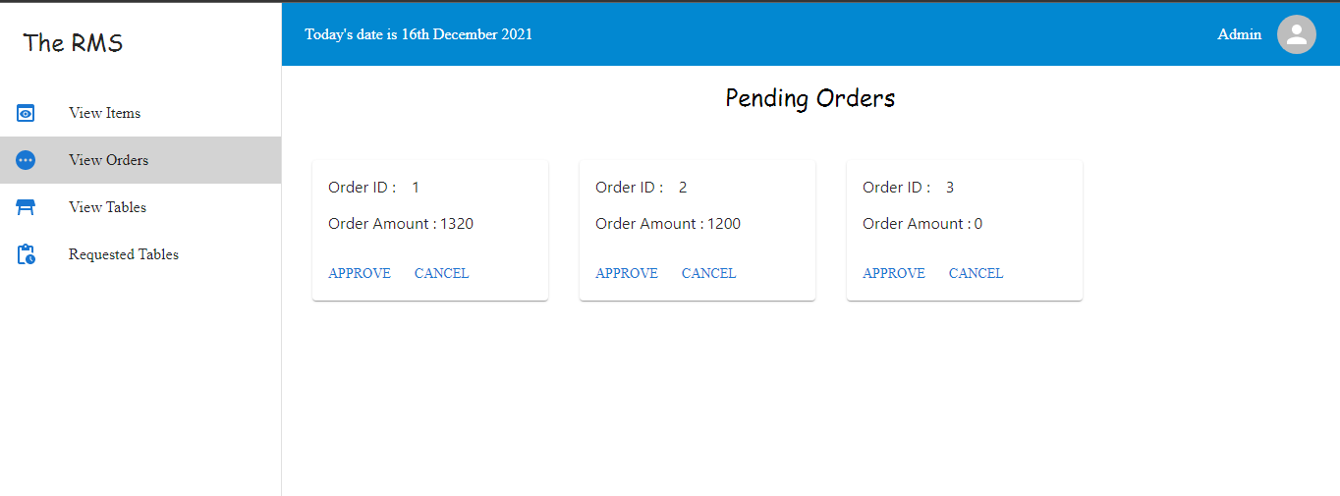

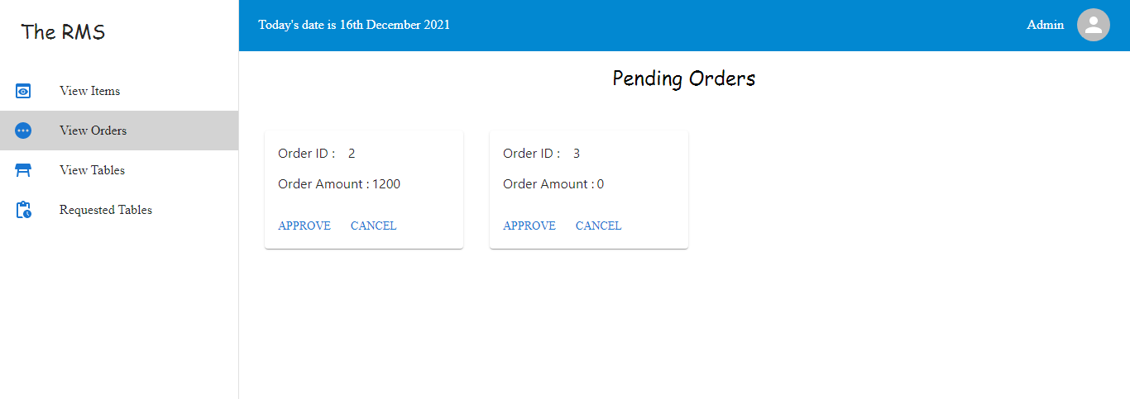

->Customer Flow of adding order



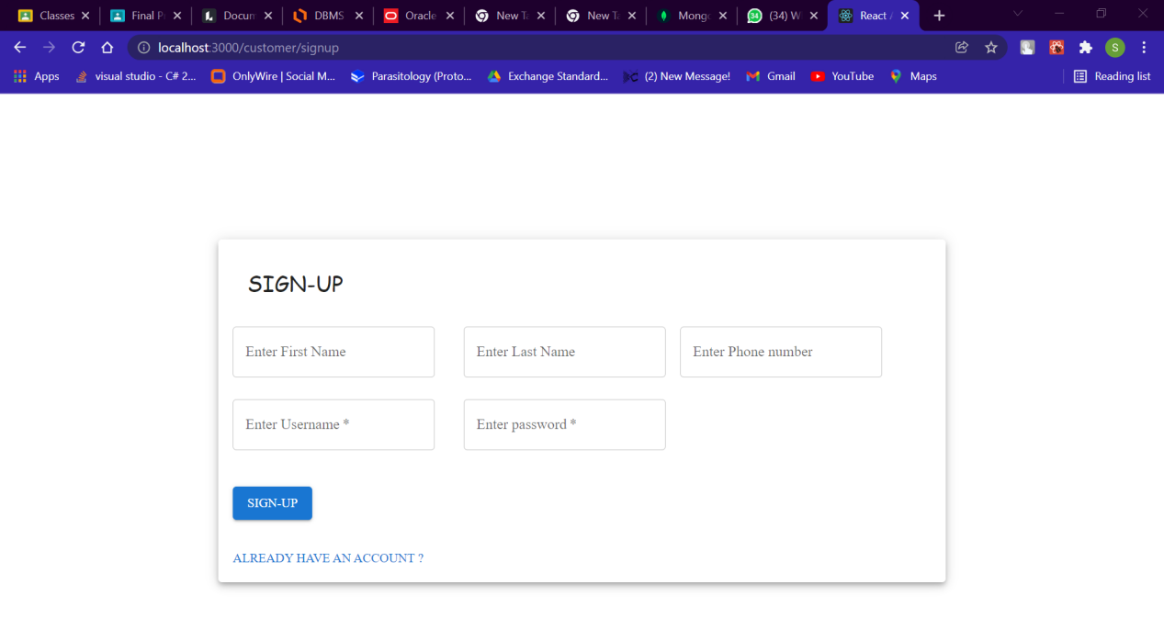

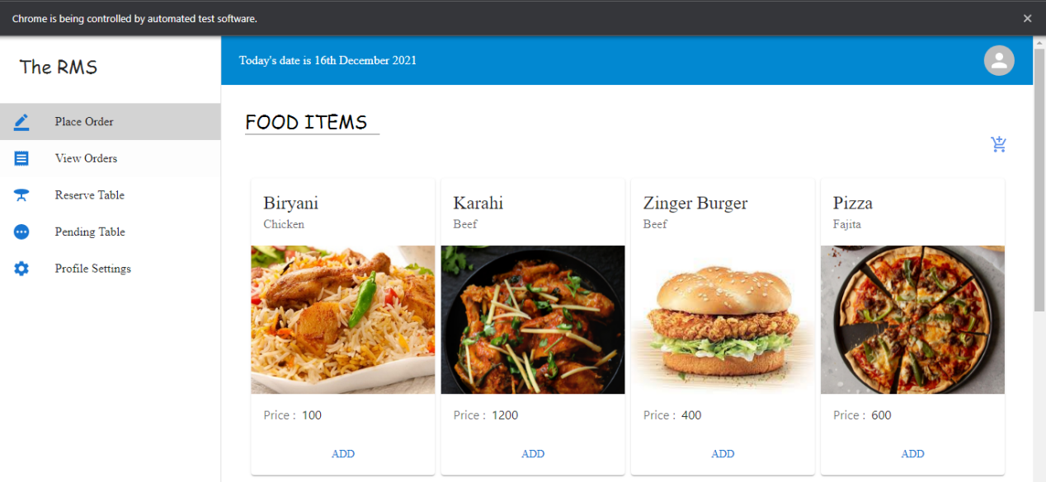

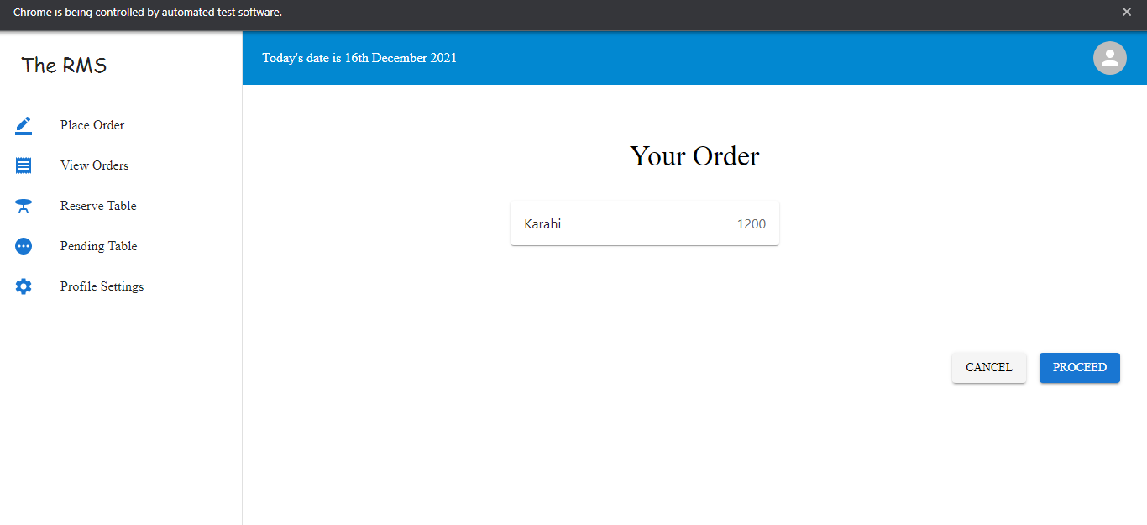

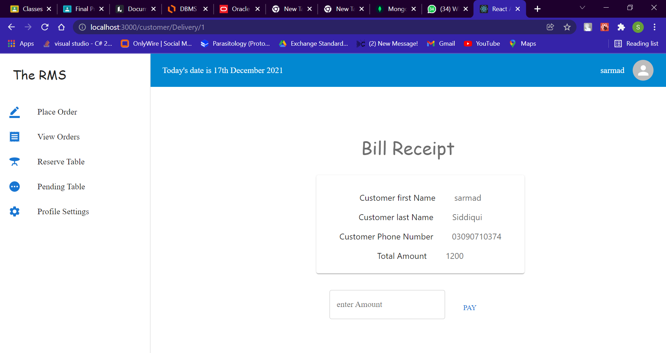

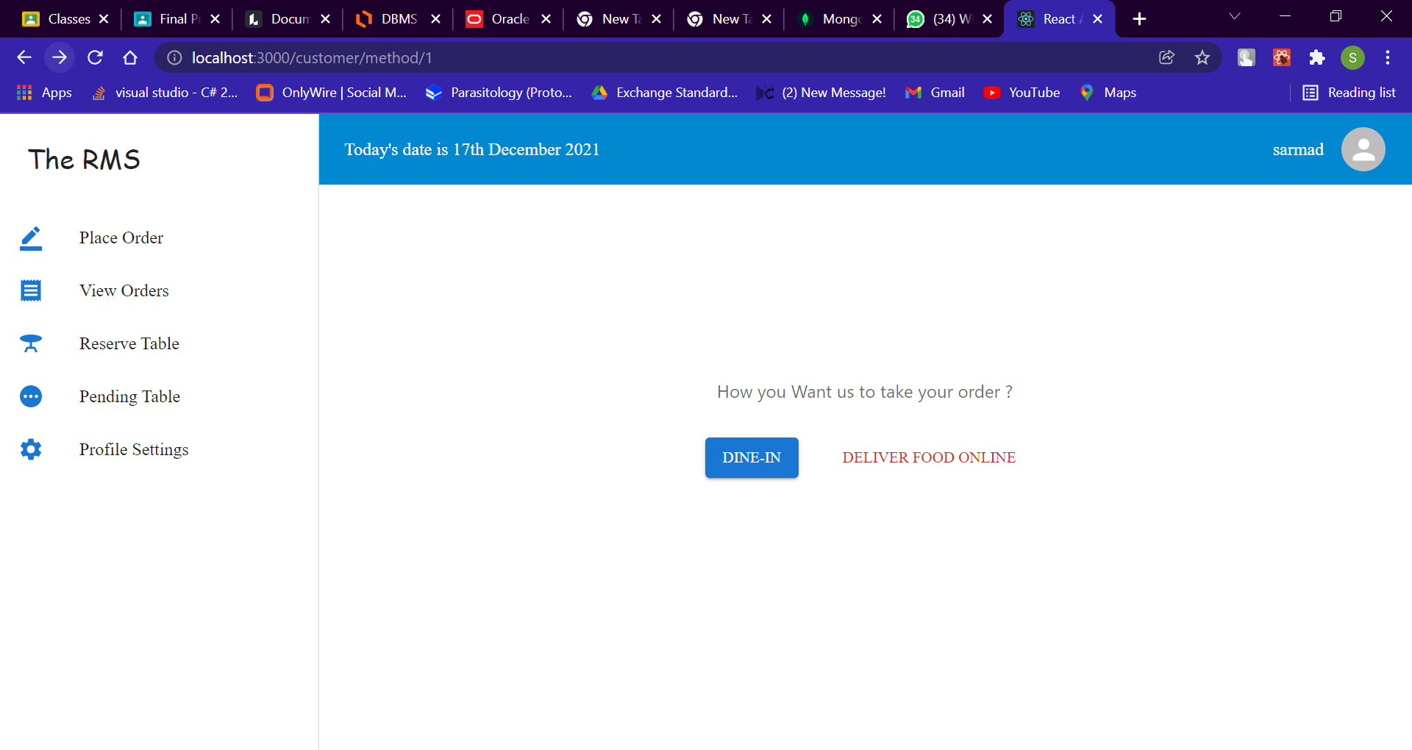

->Order is pending since admin has not approved it

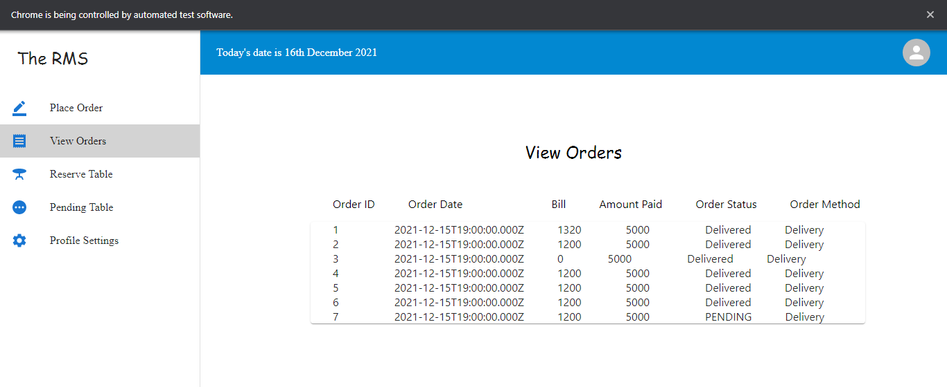

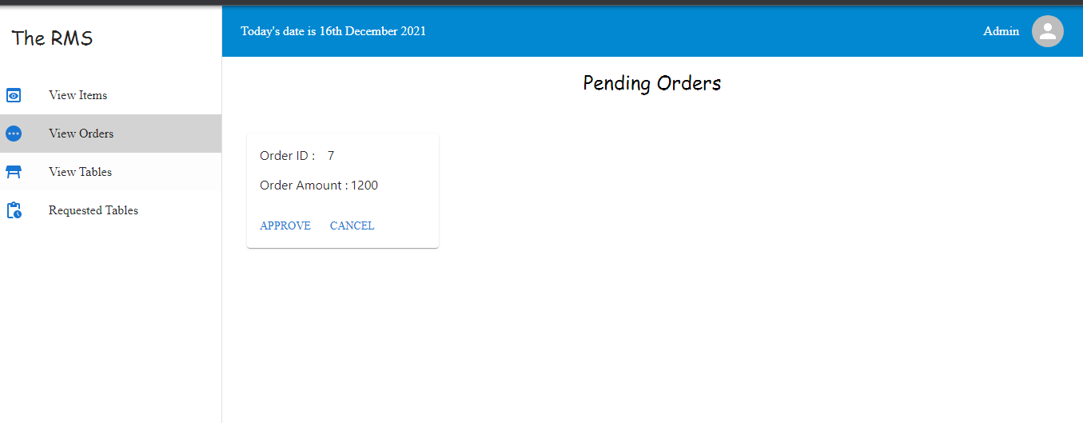

->Order is delivered since admin has approved it

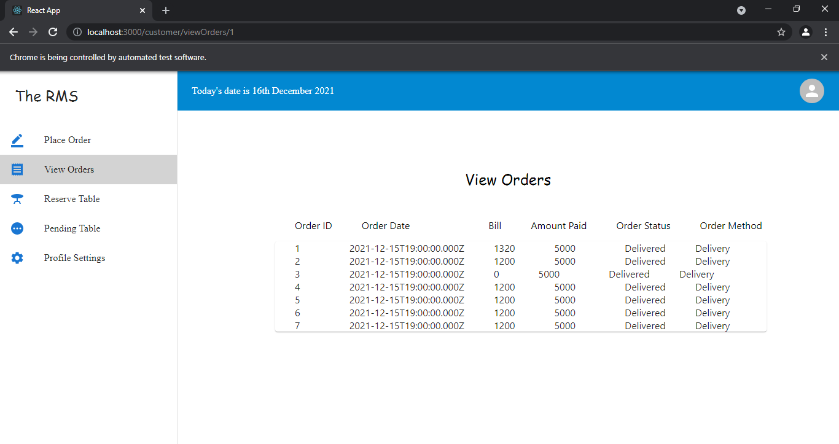

-> Customer Profile

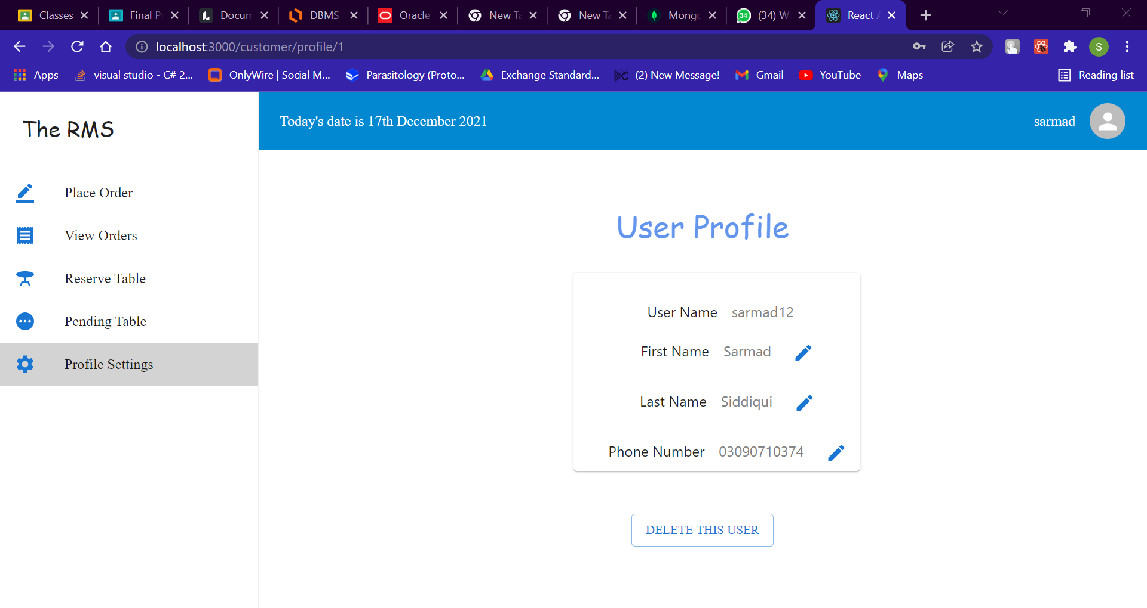

**RMS Core Features:**

1. View Order (ADMIN)
2. Accept Order (ADMIN)
3. Status of Order (ADMIN/CUSTOMER)
4. Home Delivery (CUSTOMER)
5. Reservation (CUSTOMER)
6. Changing profile data (CUSTOMER)
7. Adding tables for customers (ADMIN)
8. Reserving/Canceling Table Reservations (Admin)
9. Updating Chairs in a Table(Admin)
10. Dine-IN option for customers
11. Viewing previous orders
12. Generating Bill according to the items
13. Changing food Items price for every item(Admin)

SETTING UP PROJECT

**Step 1: Download workbench**

**Step 2:Create a connection as we have created**

**Step 3: create database xyz(we have named it rms)**

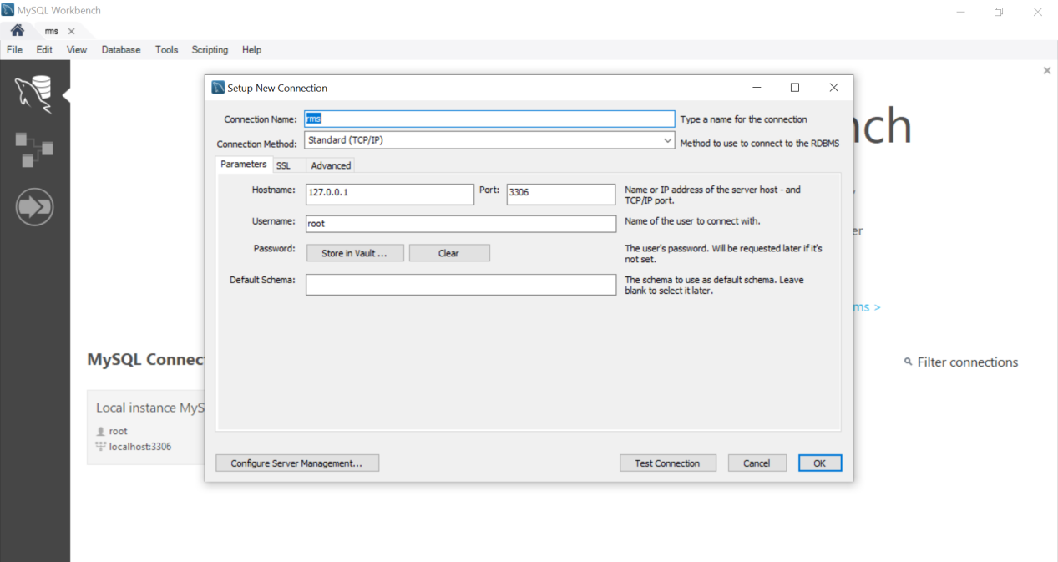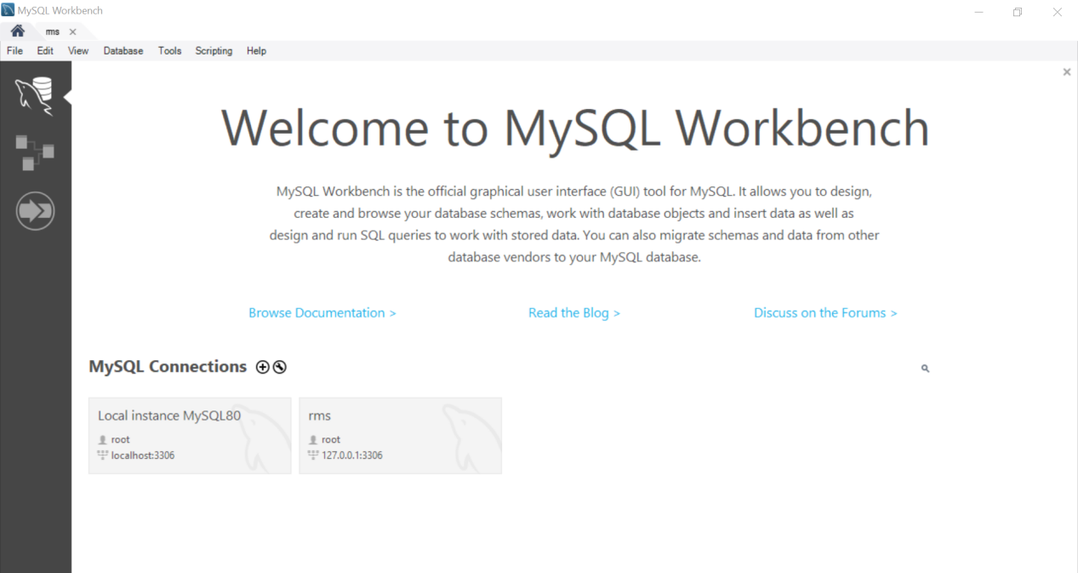

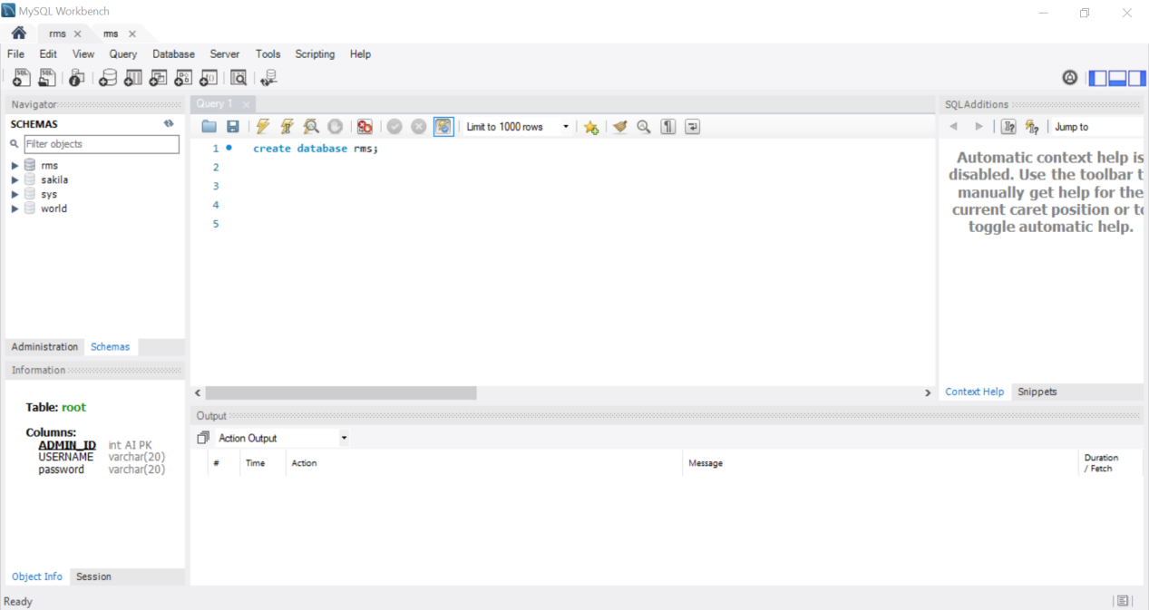

**Step 4: In your Project download npm pkg mysql**

**Step 5: Create connection as we have created(username,password can vary )**

**Step 6: change directory to server**

**Step 7: run npm start**

**Step 8: change directory to rms/client**

**Step 9:run npm start**

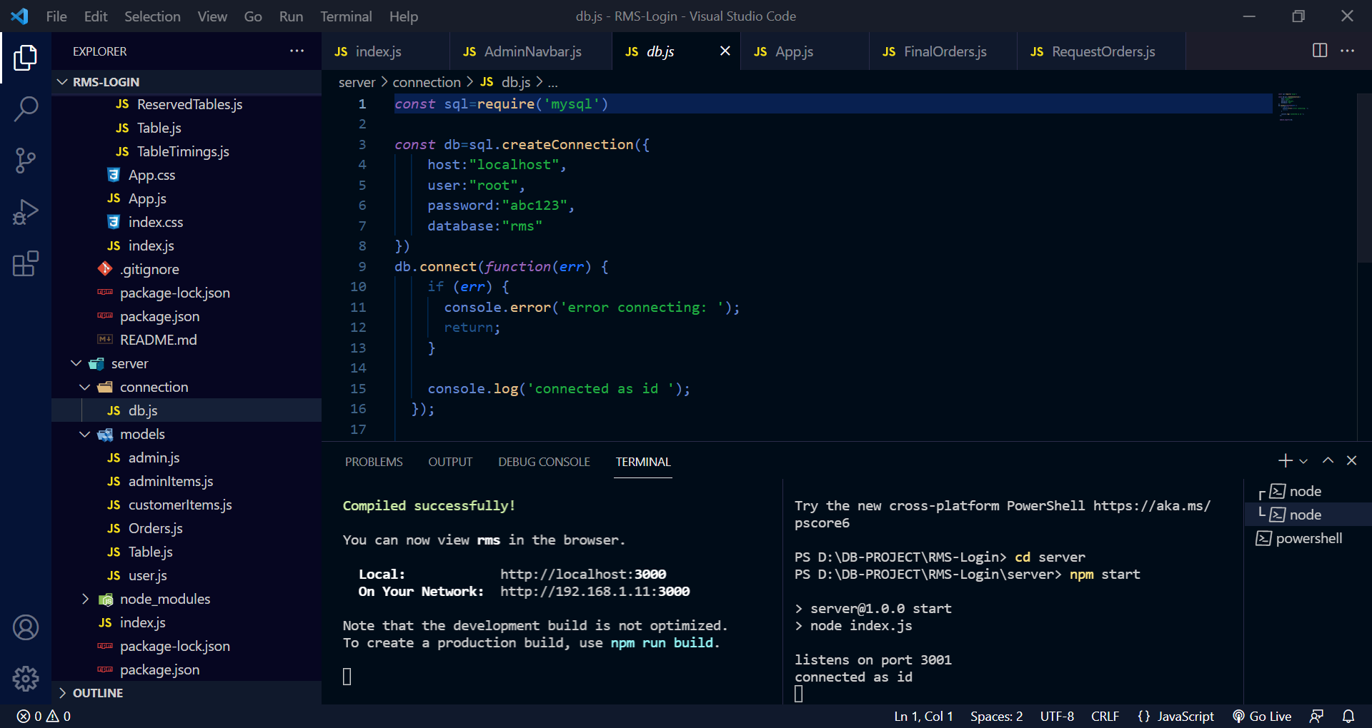**11**