BOLINAO SCHOOL OF FISHERIES
STUDENT E-VOTING SYSTEM
APPENDIX H – USER MANUAL
This user manual provides step-by-step instructions for setting up, administering, and using the Bolinao School of Fisheries Student E-Voting System. The system provides secure role-based access control, DepEd Learner Reference Number (LRN) voter authentication, automated DepEd School Form 1 (SF1) roster importation, digital ballot casting with real-time auditability, and instant canvassing.
1. SYSTEM REQUIREMENTS
Before deploying and using the system, prepare the following hardware and software components:
• Server Host or Local Precinct Computer (Node.js v20.x or higher runtime)
• Client Voting Terminals / Kiosks (Desktop PC, Laptop, or Tablet)
• Google Chrome or Microsoft Edge (Latest version recommended)
• Local Area Network (LAN) router or active Internet connection
• Official DepEd School Form 1 (SF1) student masterlist spreadsheet (.xls or .xlsx)
• Registered System Accounts (Administrator, Teacher/Proctor, and Student Voters)
Make sure the host server is active and client terminals can communicate over the network before commencing election operations.
2. STARTING THE SYSTEM
Step 1: Turn on the server computer and start the CivicFlow backend service.
Step 2: Power on the client voting terminals in the designated polling room.
Step 3: Connect each workstation to the election Local Area Network or Wi-Fi.
Step 4: Open Google Chrome or Microsoft Edge browser.
Step 5: Navigate to the designated application URL (e.g., http://localhost:3000 or the school portal address).
Step 6: The Bolinao School of Fisheries Student E-Voting System Login Page will appear.
[Insert Screenshot – System Login Page (Desktop View)]
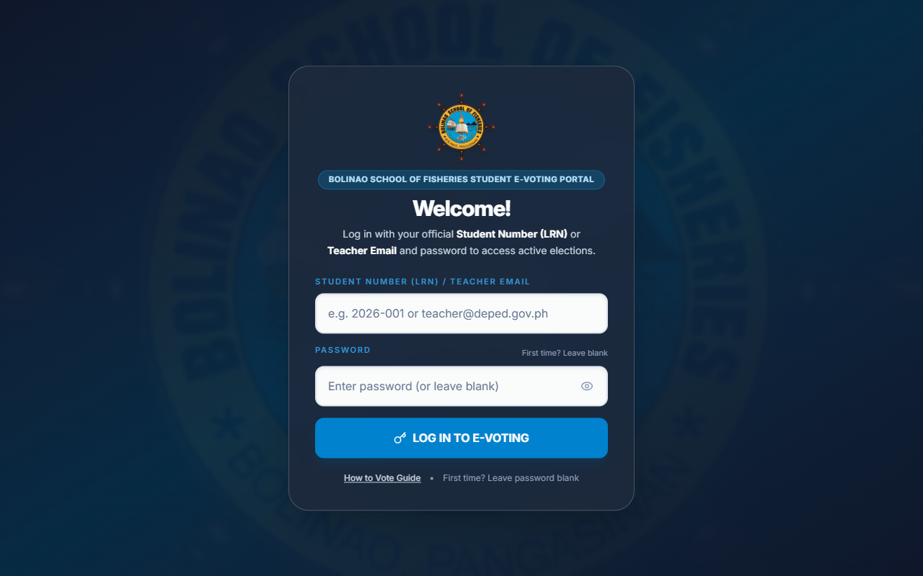
Figure: System Login Page (Desktop View)
3. LOGGING IN
Authorized users access the system using their assigned credentials based on role.
A. Student Voter Login Procedure
Step 1: Enter your 12-digit Learner Reference Number (LRN) into the Student Number field.
Step 2: Enter your personal account password.
Step 3: Click the 'Sign In to Ballot' button.
Step 4: The system will authenticate your session and automatically load the Active Ballot Page.
B. First-Time Password Setup for Imported Students
Students imported via the DepEd SF1 roster without passwords will be prompted upon their first login to establish credentials:
Step 1: Enter your Student LRN into the login field and click Sign In.
Step 2: The 'First-Time User Password Setup' window will appear displaying your full name.
Step 3: Enter your desired password in the 'New Password' field (minimum 6 characters).
Step 4: Re-type your password in the 'Confirm Password' field.
Step 5: Click 'Create Password & Continue' to finalize your credentials and proceed to the ballot.
C. Administrator and Faculty Login
Step 1: Enter your administrative username (e.g., ADMIN).
Step 2: Enter your secure administrative password.
Step 3: Click 'Sign In'.
Step 4: The system will verify administrative authorization and load the Administrator Dashboard.
D. How to Cast Your Ballot Guidance
Voters unfamiliar with digital voting can click the 'How to Vote' link on the login card to review the three-step voting overview before signing in.
[Insert Screenshot – How to Cast Your Ballot Informational Modal]
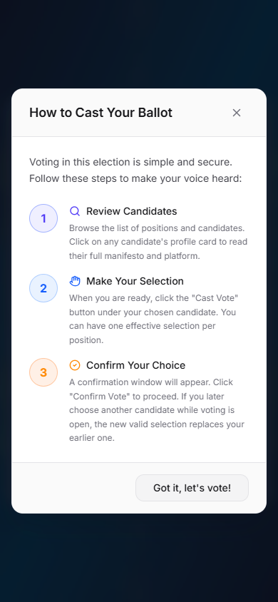
Figure: How to Cast Your Ballot Informational Modal
If Login Fails:
• Verify that the Student LRN contains exactly 12 digits without spaces or dashes.
• Check that the keyboard Caps Lock key is turned off.
• Check with the precinct poll clerk if your name is listed on the official DepEd SF1 enrollment roster.
• If your password is forgotten, request a password reset from the Election Administrator.
4. REGISTERING A USER AND BULK SF1 IMPORT
Only authorized administrators can register voter accounts and manage system credentials.
A. Manual User Creation
Step 1: Log in as an Administrator.
Step 2: Click 'Users' on the navigation drawer menu.
Step 3: Click the '+ Add User' button.
Step 4: Enter the user's details: Student Number (LRN), Full Name, Grade Level (7–12), Section (e.g., Glassfish, Sailfish), and designated Room.
Step 5: Select the user role: Student, Teacher/Proctor, or Admin.
Step 6: Verify the information and click 'Save User'.
Step 7: The user will appear in the active user roster.
B. Bulk Importing from DepEd School Form 1 (SF1) Excel Files
The system provides a built-in parser for rapid importation of complete class rosters directly from standard Department of Education SF1 spreadsheets:
Step 1: Open the Users tab and click 'Bulk Import'.
Step 2: Select the 'Upload File' tab or click the drag-and-drop zone.
Step 3: Choose the target DepEd SF1 spreadsheet (e.g., SF1_2026_Grade 7 (Year I) - GLASSFISH (1).xls).
Step 4: The system automatically parses student LRNs, full names, year levels, and sections.
Step 5: Review the validation preview table to ensure no duplicate LRNs exist.
Step 6: Click 'Import Students'. The system registers all accounts without passwords, allowing students to set their own password on their first login.
[Insert Screenshot – Bulk User Registry Import (DepEd SF1 Parser)]
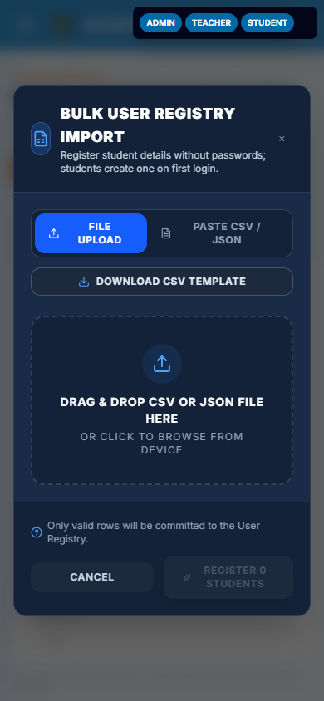
Figure: Bulk User Registry Import (DepEd SF1 Parser)
[Insert Screenshot – User Directory and Voter Roster Table]
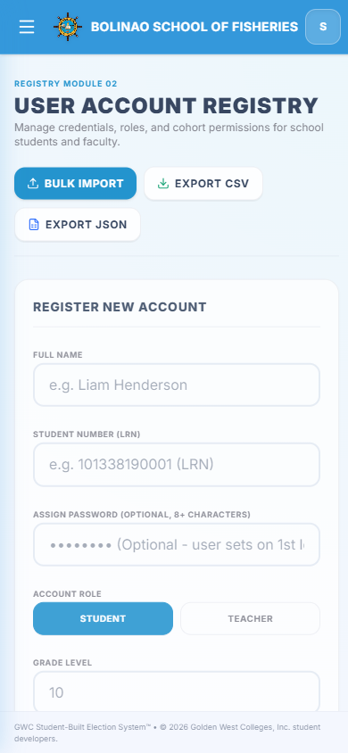
Figure: User Directory and Voter Roster Table
5. CONFIGURING AN ELECTION EVENT
Before students can vote, an election event must be configured and scheduled.
Step 1: Navigate to the 'Elections' tab in the Administrator portal.
Step 2: Click '+ Create Election'.
Step 3: Enter the Election Title (e.g., Supreme Secondary Learner Government General Election 2026).
Step 4: Enter a detailed description of the election rules and purpose.
Step 5: Set the Start Date and Time (when voting officially opens).
Step 6: Set the End Date and Time (when voting automatically closes).
Step 7: Select the Election Scope: 'All Students' for general elections, or filter by specific Grade Level, Section, or Voting Room.
Step 8: Toggle 'Support Party-Lists' if political parties are contesting the election.
Step 9: Click 'Save Election'. The election status will reflect as 'Upcoming' until the start time is reached.
[Insert Screenshot – Elections Management and Scheduling Tab]
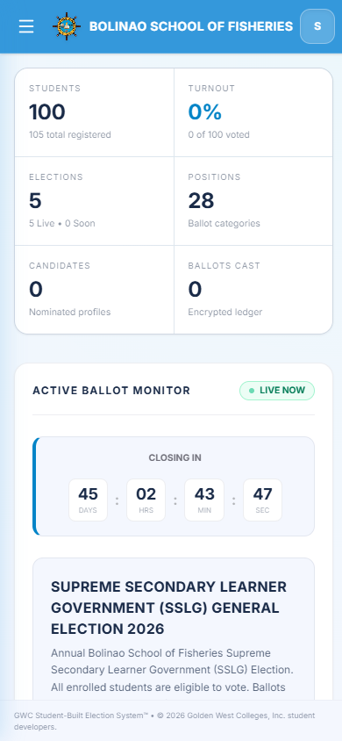
Figure: Elections Management and Scheduling Tab
6. MANAGING ELECTORAL POSITIONS AND QUOTAS
Positions define the offices contested on the ballot.
Step 1: Click 'Positions' on the navigation drawer menu.
Step 2: Select the target election from the dropdown menu.
Step 3: Click '+ Add Position'.
Step 4: Enter the official Position Name (e.g., President, Vice President, Secretary, Treasurer, Auditor, Public Information Officer, Grade 7 Representative).
Step 5: Set the Ballot Order number to arrange positions from highest to lowest executive rank.
Step 6: Specify the maximum allowable votes (1 for single-winner executive positions; 2 or more for multi-seat councilors).
Step 7: Click 'Save Position'.
[Insert Screenshot – Positions Management and Ballot Quotas Tab]
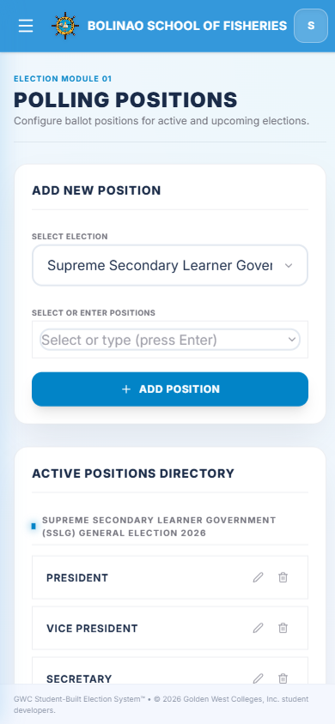
Figure: Positions Management and Ballot Quotas Tab
7. REGISTERING CANDIDATES AND PARTY-LISTS
Candidate profiles display photos, party affiliations, and platforms on the voting ballot.
Step 1: Click 'Candidates' on the navigation menu.
Step 2: Click '+ Add Candidate'.
Step 3: Select the target Election and Position.
Step 4: Enter the candidate's Full Name or link their enrolled student account.
Step 5: Assign their Party-List affiliation (or select 'Independent').
Step 6: Upload the candidate's portrait photo. Use the built-in Image Cropping tool to zoom, pan, and ensure uniform headshot proportions.
Step 7: Enter the candidate's platform or advocacy statement.
Step 8: Click 'Save Candidate'. The candidate profile is published to the ballot.
[Insert Screenshot – Candidates Management Tab]
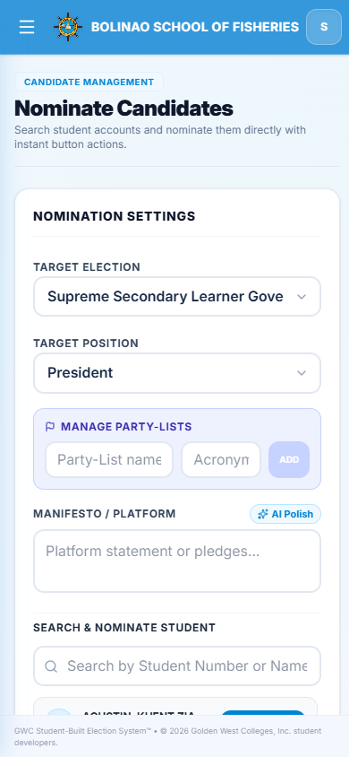
Figure: Candidates Management Tab
[Insert Screenshot – Candidate Profile and Manifesto Modal]
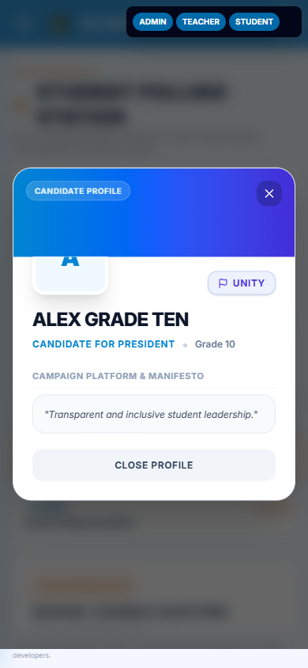
Figure: Candidate Profile and Manifesto Modal
8. CHECKING THE USER AND VOTER ELIGIBILITY
Before students are permitted to cast their ballots, verify that voter registration is complete.
Make sure the voter has:
☑ Active Student Account with verified 12-digit DepEd LRN
☑ Correct Grade Level, Section, and Room assignment
☑ Established account password (or ready for first-time setup)
☑ Unvoted status (Has Voted = False)
Voter Readiness Flow:
Identity Verification → Roster Check → Terminal Login → Active Ballot Access
If all checks pass, the student is authorized to cast their vote.
9. CASTING A VOTE (STUDENT VOTER MANUAL)
This is the standard digital voting procedure for students:
Step 1: Log in using your Student Number (LRN) and password at the polling terminal.
Step 2: The Active Election Ballot opens, featuring a live countdown timer indicating the time remaining.
Step 3: Scroll through the electoral positions in constitutional order.
Step 4: Click on any candidate's profile card to review their campaign photo, party-list, and full manifesto.
Step 5: Click the 'Cast Vote' button under your chosen candidate. The selected card will be highlighted with a checkmark badge.
Step 6: Continue selecting candidates for each position. The system will prevent exceeding the maximum allowable vote quota per position.
Step 7: Once all selections are made, click 'Review Ballot' at the bottom of the screen.
Step 8: The Vote Confirmation Modal will appear, displaying a complete summary of all your selections.
Step 9: Review your ballot carefully. If you wish to change a selection, click 'Cancel' to return to the ballot.
Step 10: If satisfied, click 'Confirm Vote'.
Step 11: The system executes an animated ballot drop celebration confirming that your vote has been securely recorded.
Step 12: A tamper-evident digital receipt confirmation is generated. Click 'Finish & Log Out' to clear the terminal for the next student.
[Insert Screenshot – Student Digital Voting Ballot]
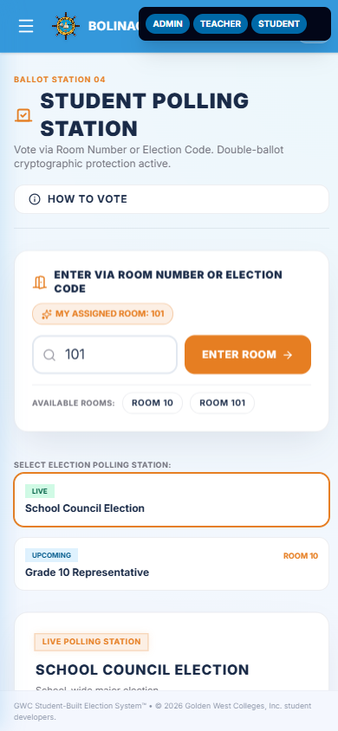
Figure: Student Digital Voting Ballot
[Insert Screenshot – Ballot Review and Confirmation Modal]
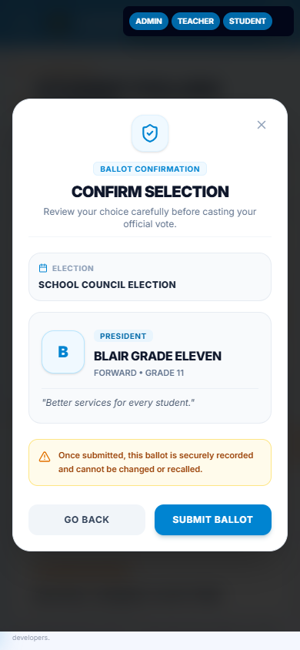
Figure: Ballot Review and Confirmation Modal
10. REAL-TIME MONITORING AND UNVOTED VOTER TRACKING
Election officials can monitor turnout and track voter participation in real time:
Step 1: Log in to the Administrator Dashboard.
Step 2: Review the live summary tiles displaying Total Users, Total Votes Cast, Total Positions, and Total Candidates.
Step 3: Inspect turnout percentage progress bars across Grade Levels and Sections.
Step 4: Navigate to the 'Results' tab and click the 'Unvoted Students' sub-tab.
Step 5: Use the search bar to locate specific sections or students who have not yet voted.
Step 6: Coordinate with classroom advisers and proctors to dispatch pending voter batches to the polling booths.
[Insert Screenshot – Administrator Dashboard Overview]
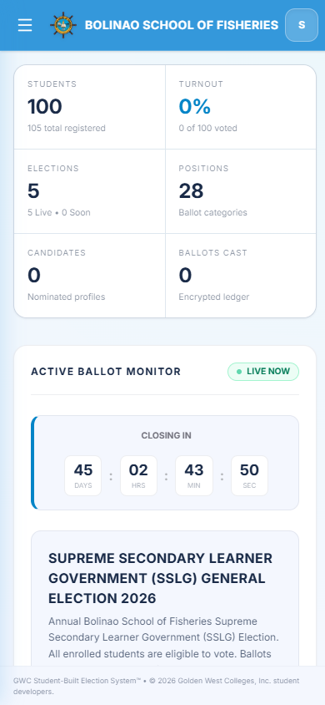
Figure: Administrator Dashboard Overview
11. CANVASSING AND VIEWING ELECTION RESULTS
The system performs instant, automated canvassing and vote tallying:
Step 1: Click 'Results' on the main navigation menu.
Step 2: Select the target election from the election filter dropdown.
Step 3: Observe the live vote tally per position.
Step 4: Review the Winner Podium highlighting the leading candidates with Gold, Silver, and Bronze badges.
Step 5: Examine the interactive Donut Charts illustrating percentage distributions of votes cast.
Step 6: When the scheduled voting window concludes, the election status transitions to 'Ended', permanently locking the vote counts.
[Insert Screenshot – Live Canvassing, Podium Leaderboard, and Results Charts]
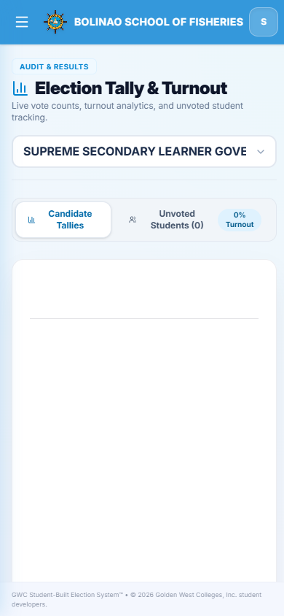
Figure: Live Canvassing, Podium Leaderboard, and Results Charts
12. GENERATING A REPORT
Official election documents can be generated for institutional records and certification:
Step 1: Open the Results tab.
Step 2: Click 'Generate Official Certificate of Canvass'.
Step 3: Verify the generated report containing total registered voters, total ballots cast, turnout percentage, and candidate rankings.
Step 4: Click 'Export Report' to save or print the document in PDF or spreadsheet format.
Step 5: Present the Certificate of Canvass to the School Election Committee, Head Teacher, and Principal for official signing.
13. WHEN A STUDENT CANNOT LOG IN
If a student encounters authentication issues:
Step 1: Check that the student is typing their correct 12-digit DepEd LRN.
Step 2: Ensure no accidental leading or trailing spaces are present in the student number.
Step 3: Verify that the keyboard Caps Lock is disabled.
Step 4: If the student forgot their created password, have an authorized Administrator locate the user in the User Management tab and click 'Reset Password'.
Step 5: If the system reports 'Account Not Found', verify whether the student was included in the uploaded DepEd SF1 masterlist.
Step 6: If the student was recently enrolled, the administrator may manually add their record.
14. WHEN A VOTE CANNOT BE CAST
If the voting portal blocks a student from submitting a ballot:
Step 1: Check the Election Status. Voting is only permissible during the 'Live' election phase.
Step 2: Verify the Election Scope. If an election is scoped to a specific Grade Level or Section, ensure the student's profile matches the targeted cohort.
Step 3: Check the 'Has Voted' status. The system strictly enforces a one-student, one-vote policy. Once a ballot is submitted, subsequent attempts are automatically rejected.
Step 4: Ensure that selections do not violate ballot quotas (e.g., attempting to select multiple candidates for a single-winner position).
15. MANUAL VERIFICATION PROCEDURES
When automated verification requires human intervention:
Step 1: The student reports to the Election Committee Polling Precinct Desk.
Step 2: The poll clerk verifies the student's identity using their physical DepEd School ID card.
Step 3: The poll clerk cross-references the student's name against the printed DepEd SF1 enrollment roster.
Step 4: The poll clerk checks the system directory to confirm the voter's active eligibility.
Step 5: Follow the approved manual verification procedure and assist the voter to an available terminal.
Step 6: Never create duplicate voter records for a student who has already voted.
16. COMMON PROBLEMS
The following matrix summarizes common operational issues and recommended resolutions:
Problem | What to Do
Cannot log in | Check 12-digit Student LRN and password; turn off Caps Lock.
First-time login prompt appears | Enter and confirm a secure new personal password (min. 6 characters).
Student account not found | Check LRN spelling; cross-reference DepEd SF1 enrollment roster; contact administrator.
System reports 'Already Voted' | Voters can only cast a ballot once. Duplicate voting is mathematically prohibited.
Election status shows 'Upcoming' | Voting has not commenced yet. Await the scheduled election start time.
Election status shows 'Ended' | The election deadline has elapsed. The voting window is permanently closed.
Positions missing on ballot | Verify election scope settings; some positions are restricted to specific grade levels.
Candidate photo fails to upload | Ensure image format is PNG, JPG, or WEBP and file size is below 5 MB. Re-crop using image tool.
DepEd SF1 bulk import error | Ensure file is in .xls or .xlsx format with LRN and Student Name column headers.
Ballot submission is slow or hangs | Check precinct Wi-Fi or LAN connection; do not close browser until confirmation receipt appears.
Turnout percentage not updating | Click the browser refresh button or check connection to the central server.
Tablet screen distorted or clipped | Update browser to the latest version of Chrome or Edge; rotate tablet to landscape orientation.

17. SECURITY AND PRIVACY
All operators, proctors, and voters must strictly observe the following security and data privacy reminders:
☑ Keep your username, LRN, and account password private at all times.
☑ Do not use another student's account or LRN to access the system.
☑ Observe absolute ballot secrecy: selections are cryptographically decoupled from voter identities.
☑ Adhere to Republic Act No. 10173 (Data Privacy Act of 2012): student masterlists and LRNs must never be exposed or shared outside authorized election activities.
☑ Do not disclose or copy confidential election audit trails without formal COMELEC approval.
☑ Only authorized administrative personnel may access the User Management and Canvassing tabs.
☑ Always log out immediately after casting a vote or completing an administrative task.
18. LOGGING OUT
After completing your voting session or administrative duties:
Step 1: Click your User Profile / Avatar icon in the upper right header.
Step 2: Click 'Log Out'.
Step 3: Wait until the system terminates the session token and redirects to the clean Login Page.
Step 4: Ensure the terminal is reset to the login standby state for the next voter.
[Insert Screenshot – System Ready for Next Voter (Standby Login Page)]
Figure: System Ready for Next Voter (Standby Login Page)

