GOLDEN WEST COLLEGES
BACHELOR OF SCIENCE IN INFORMATION TECHNOLOGY III-A
SYSTEM ANALYSIS AND DESIGN

GWC RFID MONITORING SYSTEM USING RFID AND FACIAL RECOGNITION

A Capstone Project and Research Paper

Presented to the Faculty of Golden West Colleges
Alaminos City, Pangasinan

In Partial Fulfillment of the Requirements for the Degree
Bachelor of Science in Information Technology

Researchers:
[RESEARCHER 1]
[RESEARCHER 2]
[RESEARCHER 3]
[RESEARCHER 4]
[ADD/REMOVE NAMES AS NEEDED]

A.Y. 2026–2027
ABSTRACT
The Golden West Colleges, Inc. Monitoring System Using RFID and Facial Recognition is a proposed attendance-monitoring and identity-verification system for Golden West Colleges, Inc. The project responds to limitations commonly associated with manual or single-factor attendance procedures, including repetitive recording, delayed consolidation, difficulty in retrieving attendance information, and the possibility of proxy attendance when a physical card is shared. The proposed system combines Radio Frequency Identification (RFID) for fast credential identification and facial recognition for biometric verification. The system is designed to enroll users, associate RFID credentials with registered identities, capture and verify faces, record verified attendance events with date and time information, provide monitoring and report-generation functions, and restrict system access according to user roles. The study follows a descriptive-developmental research design and a structured system development life cycle covering planning, requirements analysis, design, development, testing, deployment, and maintenance. Requirements are to be gathered through interview and observation, while system acceptability is to be measured through a structured questionnaire using the supplied acceptability instrument, which evaluates functional suitability, performance efficiency, compatibility, usability, reliability, security, maintainability, portability, and overall acceptability. The project also considers privacy and security because the system processes personal information and facial data. The final conclusions regarding system performance, user acceptability, and observed improvements will be based only on actual functional tests, technical tests, respondent evaluations, and documented before-and-after observations.

Keywords: RFID, facial recognition, attendance monitoring, biometric verification, identity authentication, information system, Golden West Colleges, data privacy, system acceptability

TABLE OF CONTENTS
Section | Page
CHAPTER 1 – INTRODUCTION
Background of the Study
Statement of the Problem
Objectives of the Study
Conceptual Framework
Research Justification
Scope and Delimitations
Significance of the Study
Definition of Terms
CHAPTER 2 – REVIEW OF RELATED LITERATURES AND STUDIES
Related Literature and Studies
Related Systems
Related Technologies
Synthesis
Research Gap
CHAPTER 3 – METHODOLOGY
Research Design
Research Locale / Setting
Participants / Respondents
Sampling Technique
Research Instruments
Data Gathering Procedures
System Development Life Cycle
Tools and Technologies Used
Data Analysis Techniques
Ethical Considerations
CHAPTER 4 – RESULTS AND DISCUSSION
Existing System Analysis
System Design
Developed System
System Testing
Acceptability Test Results
Improvements After System Implementation
Discussion of Findings
CHAPTER 5 – CONCLUSION AND RECOMMENDATIONS
Summary of the Study
Conclusions
Discussion of IT Implications
Recommendations
REFERENCES
APPENDICES

CHAPTER 1
THE PROBLEM AND ITS BACKGROUND
Attendance monitoring is an essential administrative activity in educational institutions because it records student participation and supports academic monitoring by instructors and administrators. Traditional methods, such as manual name checking, paper attendance sheets, logbooks, and spreadsheets, may be manageable for small classes but can become repetitive and difficult to consolidate as the number of students and attendance records increases. Automated identification technologies, such as RFID, have been introduced to reduce manual attendance work because registered tags can be read quickly without direct contact; however, an RFID card only verifies the presented credential and does not necessarily confirm that the person using it is the legitimate owner, creating a potential proxy-attendance problem when cards are shared or borrowed. Facial recognition can provide an additional identity-verification mechanism by comparing a captured face with an enrolled facial reference. Although studies have demonstrated the feasibility of facial recognition for educational attendance, its performance may be affected by factors such as image quality, lighting, facial pose, and algorithm selection. NIST evaluations have also documented that false-negative behavior can be influenced by image quality and that demographic differences may vary across algorithms. Therefore, a school-based facial-recognition attendance system should be evaluated under its intended operating conditions to determine its effectiveness and reliability rather than being treated as an infallible identification method.
International research published from 2021 onward increasingly combines credential-based identification with biometric verification. Sunaryono et al. (2021) developed an Android-based course attendance system using face recognition and reported 97.29% recognition accuracy under their tested conditions. Chen and Li (2021) designed an attendance management system that combines RFID and face recognition through composite authentication, with the aim of improving attendance reliability and reducing weaknesses associated with ordinary sign-in procedures. Toscany et al. (2022) likewise designed an attendance system using RFID and similarity metric learning, combining an RFID reader with a camera for identity validation. Together, these studies show a continuing shift from simple attendance capture toward multimodal identity verification.
In the Philippines, attendance systems using RFID, biometrics, and web technologies are also being developed for educational and institutional environments. Fernandez et al. (2021) examined a face-recognition approach for faculty attendance and demonstrated the local use of contactless biometric verification. Achacon et al. (2023) developed a web-based student and faculty attendance system using RFID with fingerprint authentication. Balagtas et al. (2023) developed a facial-recognition attendance monitoring system using Viola-Jones and principal component analysis. Domingo and Ladia (2024) developed a web-based facial-recognition attendance system for Quirino State University, while Nueva et al. (2024) integrated RFID attendance with SMS notification. More recent Philippine work by Estioco et al. (2026) and Valenzuela et al. (2026) further demonstrates the current local movement toward automated attendance systems that combine biometric verification, centralized records, and evaluation.
For Golden West Colleges, the research focuses on the institution’s own attendance-monitoring context rather than assuming that results from another school will directly apply. The proposed locale is Golden West Colleges in Alaminos City, Pangasinan. The exact attendance point or office to be piloted should be identified by the researchers together with the authorized school personnel. The current process, participants, existing records, and operational requirements should be documented through observation and interview before final deployment.
The local problem to be established by the study is therefore evidence-based. The researchers should document how attendance is currently recorded, who performs the recording, what tools are used, how records are consolidated, how attendance exceptions are handled, and how quickly authorized personnel can retrieve records. These findings will form the baseline for determining the actual improvements attributable to the proposed system.
Based on the literature reviewed, common attendance-management issues include manual encoding, delayed consolidation, difficulty in retrieval, inconsistent records, and proxy attendance when a credential can be shared. For GWC, however, each item below is a draft problem category that must be validated through the approved interview, observation, or document-review procedures:
The proposed GWC RFID Monitoring System Using RFID and Facial Recognition is designed as a dual-verification attendance system. RFID is used to initiate the attendance transaction and identify the account associated with the presented card. Facial recognition is then used to verify that the person presenting the card corresponds to the enrolled identity. When both conditions satisfy the system’s defined validation rules, the attendance event is recorded with date and time information. When validation fails, the transaction is rejected, flagged, or routed to an approved manual-verification process.
The system is intended to provide authorized users with enrollment, RFID registration, facial registration, attendance monitoring, search, reporting, user-role management, and audit functions. The final features should be based on the requirements identified during the study and should not include functions that are not required by the client.
Statement of the Problem
The study aims to determine how an RFID and facial-recognition attendance monitoring system can be designed and developed for Golden West Colleges to address identified limitations in the existing attendance process while providing an acceptable, secure, and manageable digital attendance workflow.
Specifically, the study seeks to answer the following questions:
- What is the current attendance-monitoring process at Golden West Colleges in terms of the people involved, tools used, records maintained, and steps performed?
- What problems are encountered in the existing attendance-monitoring process in terms of recording, monitoring, retrieval, reporting, identity verification, and data security?
- What system features and requirements are needed for an RFID and facial-recognition attendance monitoring system?
- How can the proposed GWC RFID Monitoring System Using RFID and Facial Recognition be designed, developed, implemented, and technically tested?
- What is the level of acceptability of the developed system in terms of functional suitability, performance efficiency, compatibility, usability, reliability, security, maintainability, and portability?
- What improvements are observed after the implementation or controlled use of the proposed system compared with the documented existing process?

Objectives of the Study
The general objective of the study is to develop and evaluate the GWC RFID Monitoring System Using RFID and Facial Recognition to improve the management, verification, monitoring, and retrieval of attendance records in the defined GWC implementation setting.
Specific Objectives
- To document and analyze the current attendance-monitoring process at Golden West Colleges.
- To identify and analyze the problems and limitations encountered in the existing attendance process.
- To determine the functional and non-functional requirements and features of the proposed RFID and facial-recognition attendance system.
- To design, develop, integrate, implement, and technically test the proposed system using the approved hardware, software, database, and recognition technologies.
- To determine the level of acceptability of the developed system based on functional suitability, performance efficiency, compatibility, usability, reliability, security, maintainability, and portability.
- To determine and document the improvements observed after implementation or controlled use of the proposed system compared with the existing process.

Conceptual Framework
The conceptual framework of the study follows the Input–Process–Output (IPO) Model, which illustrates the relationship between the identified attendance-monitoring problems, the resources and requirements needed for system development, the development and evaluation procedures, and the expected outputs of the study.
Figure 1 presents the conceptual framework of the study, which is shown on the following page.

OUTPUT

- Proposed GWC RFID Monitoring System
- Verified attendance records
- Searchable attendance logs
- Monitoring dashboard
- Attendance reports
- Audit trail
- Documented testing results
- User acceptability results
- System improvements
- Recommendations

PROCESS

- Problem analysis
- Requirements gathering
- System planning
- System design
- Database design
- Interface development
- RFID integration
- Facial enrollment
- Facial verification
- Programming
- System integration
- Functional testing
- RFID testing
- Biometric testing
- User acceptability evaluation
  - Data analysis
  - System refinement
FEEDBACK

INPUT
- Existing attendance-monitoring process
- Identified problems and limitations
- User requirements
- Student records
- User records
- RFID credentials
- Facial references
- Attendance schedules
- Attendance rules
- Hardware requirements
- Software requirements
- Database requirements
- Network requirements
- Privacy requirements
- Security considerations

Figure 1. The Conceptual Framework of the Study

Figure 1. The Conceptual Framework of the Study.

The Input consists of the existing attendance-monitoring process, identified problems and limitations, user requirements, student and user records, RFID credentials, facial references, attendance schedules and rules, hardware and software requirements, database and network requirements, and privacy and security considerations. These inputs provide the necessary information and resources for designing a system that addresses the identified attendance-monitoring concerns.
The Process involves problem analysis, requirements gathering, system planning, system and database design, interface development, RFID integration, facial enrollment and verification, programming, system integration, functional testing, RFID and biometric testing, user acceptability evaluation, data analysis, and system refinement. These activities ensure that the developed system is evaluated according to its intended functions and operating conditions.
The Output is the proposed GWC RFID Monitoring System, which is expected to provide verified attendance records, searchable attendance logs, a monitoring dashboard, reports, and an audit trail, together with documented testing results, user acceptability results, system improvements, and recommendations. Through this framework, the study establishes a traceable connection between the identified attendance-monitoring problems, the development activities undertaken by the researchers, and the resulting system and evaluation outcomes.

Research Justification
The study is justified because attendance monitoring affects the reliability and usability of academic records. When attendance is heavily dependent on manual procedures, staff and instructors may spend time on repetitive recording and consolidation rather than on higher-value academic or administrative tasks. A digital system that automates the recording transaction can potentially reduce repetitive work, while a second verification factor can address a specific limitation of card-only attendance: possession of a credential is not equivalent to identity verification.
The project is also justified as an applied information-technology study because it integrates several core BSIT competencies: database design, web application development, RFID interfacing, computer vision/facial recognition, user authentication, testing, information security, and data analysis. The project therefore provides a concrete setting in which software, hardware, and research methodology must work together.
The study should be considered an institutional solution rather than a universal claim about attendance systems. The system’s value will be determined by the actual GWC requirements, implementation environment, technical test results, and user evaluations.

Sustainable Development Goal Alignment
Primary SDG – SDG 9: Industry, Innovation and Infrastructure. The proposed system supports SDG 9 in a small institutional context by applying digital technology and integrated information infrastructure to modernize an administrative process. The contribution is specifically the development and evaluation of a technology-based attendance workflow that combines identification, biometric verification, centralized records, and reporting.
Secondary SDG – SDG 16: Peace, Justice and Strong Institutions. The system may support transparent and accountable institutional processes by maintaining organized attendance records, role-based access, and an audit trail of relevant administrative actions. The contribution is limited to institutional record management and accountability; it does not imply that the system alone guarantees institutional integrity.

Scope and Delimitations
Scope of the Study
The study focuses on the analysis, design, development, testing, and evaluation of an attendance-monitoring system intended for implementation within the defined environment of Golden West Colleges (GWC). The proposed system is developed to address identified concerns in the existing attendance-monitoring process by providing an integrated approach to user registration, attendance verification, attendance recording, monitoring, searching, and report generation. The scope of the study is based on the identified operational problems, user requirements, available resources, and approved system requirements.
The proposed attendance-monitoring system covers the enrollment and management of authorized users included within the defined study environment. It includes the registration and management of essential user information, RFID credentials, and facial references required for attendance verification. Each registered RFID credential and facial reference is associated with the appropriate user record to establish a connection between the user's identity and the attendance transaction generated by the system.
The study specifically covers the integration of RFID technology as one of the primary attendance-verification mechanisms. RFID credentials are registered and assigned to authorized users and are used to identify users when their credentials are presented at designated attendance points. The system processes the RFID information and associates the verified credential with the corresponding user record. The study includes RFID hardware integration and RFID functionality testing to determine whether registered credentials can be properly detected, recognized, and recorded by the system.
In addition to RFID verification, the study covers the implementation of facial-recognition verification as another attendance-authentication mechanism. Facial references of authorized users are registered during the enrollment process and are used during attendance verification. The facial-recognition component is evaluated using the selected facial-recognition algorithm, hardware, test population, environmental conditions, and verification threshold established by the researchers. These conditions form part of the basis for interpreting the observed performance of the facial-recognition component.
The proposed system also includes attendance logging and monitoring functions. Verified attendance transactions are recorded in the system and may include relevant information such as the user identity, date, time, attendance status, and verification method, depending on the final approved requirements. Authorized users are provided with functions for monitoring and searching attendance records, allowing relevant attendance information to be retrieved when needed.
The system further covers attendance report generation. Authorized personnel may generate or retrieve attendance-related reports based on the available system records and approved reporting requirements. These functions are intended to support the organization, review, and management of attendance information without extending the system into unrelated institutional processes.
The study also includes role-based administrative functions. Access to system features is controlled according to the roles and permissions established in the approved requirements. Depending on the final system configuration, administrative functions may include user management, RFID registration, facial-reference registration, attendance-record management, monitoring, searching, and report generation. The role-based approach is included to help ensure that system functions and attendance information are accessible only to authorized users.
The study covers several forms of system testing. Functional testing is conducted to determine whether the developed features operate according to their intended requirements. RFID testing is performed to evaluate the system's ability to detect, recognize, and process registered RFID credentials. Facial-recognition testing is conducted to determine the observed performance of the selected facial-recognition implementation under the defined testing conditions. The study also includes security-oriented testing focusing on relevant concerns such as access control, authentication, protection of system information, and other security requirements applicable to the developed system.
The study further includes user acceptability testing using the approved research instrument. The purpose of this evaluation is to obtain users' assessments of the developed system based on the criteria established in the approved methodology. The resulting data are analyzed to determine how the users perceive the system in relation to the specified evaluation criteria and to identify areas that may require further improvement.
The research also covers the collection, organization, processing, and analysis of data required to answer the six Statement of the Problem questions. Data may be obtained from system testing, RFID testing, facial-recognition testing, system-generated records, respondents, and approved evaluation instruments, depending on the specific research question. Actual respondent counts, testing results, performance values, and acceptability ratings will be based only on verified study records collected during the actual implementation and evaluation of the system.
The implementation of the study is limited to the defined GWC environment, designated attendance points, selected users, available hardware, software, database, network infrastructure, and other resources approved for the research. Therefore, the findings are interpreted according to the conditions and environment in which the system is developed and evaluated and are not automatically generalized to other institutions or substantially different implementation environments.
Delimitations of the Study
The proposed system is specifically limited to attendance monitoring and attendance verification within the defined implementation environment. It is not intended to provide continuous campus-wide location tracking of students, faculty, staff, or other individuals. The system records attendance when a user interacts with the designated attendance-verification mechanism and does not continuously monitor an individual's location or movement throughout the campus.
The facial-recognition component is limited to attendance verification. It is not designed for general surveillance, emotion recognition, behavioral profiling, or law-enforcement purposes. The facial-recognition function is intended only to support the approved attendance-monitoring process and should not be interpreted as a general-purpose surveillance or identification system.
The study does not include payroll processing, grading, disciplinary automation, academic performance management, or unrelated student-information processes. These functions are outside the primary purpose of the proposed attendance-monitoring system. They may only be considered as possible future enhancements if they are formally identified, evaluated, and approved in a subsequent development effort.
The observed performance of the facial-recognition component is limited to the selected algorithm, hardware, test population, environmental conditions, image quality, and verification threshold used by the researchers. Conditions such as lighting, camera position, distance, facial orientation, image quality, changes in physical appearance, and other environmental or technical factors may influence facial-recognition results. Consequently, the findings represent the observed performance under the specific conditions of the study rather than a universal measure of facial-recognition performance in all possible environments.
The study does not claim that the proposed system can completely eliminate proxy attendance, false acceptance, or false rejection. Although RFID and facial-recognition verification are incorporated to strengthen attendance authentication, technological systems may still experience errors resulting from hardware limitations, incorrect registration, environmental conditions, system configuration, network interruptions, recognition limitations, or other technical circumstances. The study therefore reports the actual observed performance and identified limitations rather than assuming perfect accuracy or error-free operation.
The study is also delimited by the actual number and characteristics of respondents and test participants included during the research. The researchers will not assume or fabricate respondent counts, recognition rates, accuracy values, testing results, or acceptability ratings. All numerical findings presented in the final manuscript must come from verified research records, actual system testing, and properly accomplished evaluation instruments.
The operation of the system is further limited by the available hardware, software, database, network infrastructure, and technical resources used during development and testing. Differences in RFID devices, camera specifications, computer hardware, network conditions, database configurations, software versions, or deployment environments may affect system performance. Therefore, results obtained during the study may differ when the system is deployed under substantially different technical conditions.
The study also places limitations on the handling of biometric and attendance-related information. Facial references, RFID credentials, attendance records, and other related information should be collected and processed only for the approved and lawful purpose of the system and research. Access to such information should be restricted to authorized users based on defined system roles and security requirements. Biometric and attendance records should not be retained beyond the institution's approved lawful purpose and applicable retention requirements.
The study does not claim that the proposed system is the only possible solution to attendance-monitoring concerns at GWC. Rather, it represents a research-based technological solution developed in response to the specific problems, requirements, and conditions identified within the study environment. Future researchers and developers may modify, enhance, integrate, or replace specific components based on additional research, emerging technologies, institutional requirements, testing results, and applicable policies or standards.
Overall, the scope defines what the study covers, including the development and evaluation of an attendance-monitoring system using RFID and facial-recognition verification, while the delimitations establish the boundaries within which the system and research findings should be interpreted. These boundaries ensure that the study remains focused on its primary purpose: developing, testing, and evaluating an attendance-monitoring solution within the defined GWC implementation environment without extending its functions into continuous surveillance, unrelated institutional processes, or unsupported claims of perfect system performance.

Significance of the Study
Students. Students may benefit from a more standardized and contactless attendance process. The additional facial-verification layer may also reduce the likelihood that a simple card handoff will create a verified attendance event. The final benefit should be evaluated through actual user feedback and system testing.
Faculty and Instructors. Faculty may benefit from reduced manual attendance recording, easier retrieval of attendance histories, and faster report preparation where the developed features meet the approved requirements.
Dean. The Dean may benefit from improved access to attendance records and summary reports that can support academic monitoring, departmental supervision, and administrative planning. The system may also provide the Dean with more organized attendance information for reviewing attendance-related concerns and evaluating the effectiveness of the proposed attendance-monitoring process.
School Administrators. Authorized administrators may gain a centralized monitoring and reporting platform that can support attendance review, auditability, and administrative decision-making.
Information Technology Personnel. IT personnel may use the project as a reference for integrating RFID hardware, facial-recognition components, database management, authentication, role-based access, and security controls in an educational system.
Golden West Colleges, Inc. GWC may use the study as an evidence-based basis for deciding whether a controlled pilot or further development of automated attendance monitoring is appropriate for its operational needs.
Future Researchers. Future researchers may build on the work by studying liveness detection, stronger biometric algorithms, edge processing, privacy-preserving biometric storage, larger test populations, accessibility, or multi-campus deployment.

Definition of Terms
The following terms are defined based on their use in the study.
Acceptability Test. An assessment of how acceptable a developed system is to its intended users. In this study, it refers to the questionnaire-based evaluation of the proposed system using selected ISO/IEC 25010 quality criteria.
Administrator. An authorized person responsible for managing system resources and records. In this study, it refers to an authorized user who manages accounts, attendance settings, records, reports, and other administrative functions.
Attendance Monitoring. The process of recording and reviewing a person's presence or absence during a scheduled activity. In this study, it refers to the system functions used to record, monitor, search, and report attendance within the GWC implementation environment.
Attendance Record. A stored entry containing information about a person's attendance. In this study, it refers to the attendance data generated after successful identity verification, including the user's identity, date, time, and attendance status.
Attendance Verification. The process of confirming whether an attendance entry belongs to the correct individual. In this study, it refers to the verification of the RFID credential and corresponding facial identity before an attendance transaction is accepted.
Facial Recognition. A technology that analyzes facial information to determine or verify identity. In this study, it refers to the facial-verification component used together with RFID identification to confirm the identity of the person recording attendance.
Facial Verification. The process of confirming whether a captured face corresponds to an enrolled facial reference. In this study, it refers to the facial comparison performed after RFID identification before an attendance transaction is recorded.
GWC. An abbreviation for Golden West Colleges, Inc. In this study, it refers to the institutional environment where the proposed attendance-monitoring system is developed, tested, and evaluated.
Identity Verification. The process of confirming that a person is the individual associated with a claimed identity. In this study, it refers to the combined RFID and facial-verification process used before attendance is recorded.
ISO/IEC 25010. An international software and product-quality model. In this study, it serves as a reference for evaluating selected quality characteristics of the proposed attendance-monitoring system.
RFID. Radio Frequency Identification, a technology that uses radio communication between a reader and a tag or card to identify a credential. In this study, it refers to the technology used to identify registered users and initiate attendance transactions.
RFID Credential. An RFID-enabled card or tag used to identify a registered user. In this study, it refers to the RFID card assigned to a user and used to initiate an attendance transaction.
RFID Reader. A device that reads information from an RFID card or tag through radio frequency communication. In this study, it refers to the hardware used to read the registered RFID credential and transmit its identifier to the system.
System Evaluation. The process of determining whether a developed system meets its intended requirements and quality expectations. In this study, it refers to the testing and evaluation of the proposed system based on its defined functions and selected quality criteria.
Verification Threshold. A predefined value used to determine whether a facial comparison result is sufficient for acceptance. In this study, it refers to the configured value used by the facial-verification component to determine whether the captured face sufficiently matches the enrolled facial reference.
Web-Based System. An information system accessed through a web browser over a network or local environment. In this study, it refers to the proposed attendance-monitoring application used for enrollment, attendance verification, monitoring, record management, and reporting.
XAMPP. A software package that provides tools for developing and testing web applications on a computer. In this study, it refers to the local development environment used to develop, host, and test the proposed attendance-monitoring system.

CHAPTER 2
REVIEW OF RELATED LITERATURE AND STUDIES
At the present time, in 2026, attendance monitoring in schools is no longer viewed as a small clerical task. A single attendance record can become part of a larger information trail that supports class monitoring, student participation records, academic reporting, and institutional decision-making. The basic story is simple: a student arrives, presents an identity, and needs to be recorded as present. The difficulty begins when this simple moment is repeated across many students, classes, schedules, and attendance periods. A process that depends heavily on manual recording can become slower, harder to consolidate, and more difficult to verify. This is why researchers continue to explore technologies that can identify a person quickly while producing a reliable digital record.
The literature reviewed for this study follows that story. It begins with RFID, which answers the question, “Which registered credential is being presented?” It then moves to facial recognition, which asks, “Does the person presenting the credential correspond to the registered identity?” From there, the discussion considers web-based monitoring and database systems, because identifying a person is only one part of the problem; the institution must also store, search, review, and report the attendance event. Finally, the literature is connected to the proposed GWC RFID Monitoring System, where RFID and facial recognition are used as complementary rather than competing technologies.

Foreign Literature and Studies
One of the recurring issues in automated attendance research is that recognition performance depends on the quality of the information being captured. Recent studies continue to show that lighting, pose, image quality, camera position, and algorithm selection can influence recognition results. Balagtas et al. (2023), for example, incorporated multiple face images and head-rotation considerations and recommended appropriate camera specifications and adjustable lighting. Lateef and Kamil (2025) likewise examined facial recognition under variations in facial expression, angle, and lighting. These findings matter for the GWC system because successful attendance verification depends not only on the recognition software but also on the conditions under which the student's face is captured.
Sunaryono et al. (2021) approached the same attendance problem from another direction. Their Android-based system combined facial recognition with a classroom QR code so that a student could capture a face image together with course information. The researchers reported a recognition accuracy of 97.29% using linear discriminant analysis and demonstrated that the recognition process could be performed very quickly on the server. The value of this study for the present research is not simply the reported accuracy. More importantly, it shows how identity recognition can be connected to the context of a particular class or attendance event. The GWC system follows a similar principle, but replaces the QR-based identity trigger with RFID and adds a second verification layer.
A broader view is provided by Budiman et al. (2023), who conducted a systematic literature review comparing facial-recognition approaches used for student attendance. Their review points out that RFID already provides a non-manual way to record attendance, yet it can still create problems when students forget or share cards. Facial recognition offers a way to verify the person rather than relying only on possession of a credential. The review also reports that CNN-based approaches generally produced stronger and more stable accuracy than LBPH in the reviewed studies, particularly when external factors affected image capture. This comparison is useful to the GWC project because it shows why the choice of facial-recognition method should be based on the actual environment and requirements rather than on convenience alone.
Arif and Farell (2024) bring the two technologies even closer to the proposed project because their study designs a digital attendance system based on RFID and face recognition. Their system was developed for a laboratory environment and used an RFID reader, facial recognition with LBPH, PHP and JavaScript for the web component, and MySQL for database management. The study is especially relevant because it demonstrates that RFID and facial recognition can be integrated into one attendance workflow instead of being treated as separate projects. At the same time, the study leaves room for a local adaptation because its hardware, software stack, and laboratory setting are different from the intended environment of GWC.
More recent work shows that attendance systems are moving toward real-time and less disruptive monitoring. Lateef and Kamil (2025) developed a real-time facial-recognition attendance approach using existing security cameras. Their study used a dataset of 2,170 images from 31 students and examined variations in facial expressions, angles, and lighting. The researchers reported that deep-learning approaches produced stronger results than the machine-learning alternatives they tested. The study is relevant to GWC because it demonstrates the practical advantage of designing around cameras already available in an institution while also reminding researchers that a useful recognition system needs a diverse enrollment dataset.
RFID-only research continues to show why a credential can be useful as the first layer of attendance verification. Farida et al. (2025) developed an RFID-based student attendance system at Pamulang University using student identity cards. Their field experiment involved students and lecturers and evaluated the system in terms of speed, accuracy, and user perception. The authors reported that the RFID process reduced the reported attendance time from approximately 20–25 seconds to 2–3 seconds per student and achieved a reported accuracy of 98.5%. These findings illustrate the practical strength of RFID: it can make the actual attendance transaction very fast. The limitation is that a card identifies the credential being presented, not necessarily the person holding it. That distinction becomes important when considering proxy attendance.
The combined approach becomes even more visible in recent multimodal research. Mahesh et al. (2024) presented a system that combines facial recognition and RFID for attendance monitoring. The significance of this work for the present study is the same design principle: two forms of evidence can be used together to make an attendance decision. RFID can establish the claimed identity quickly, while face recognition can provide an identity check. Rather than assuming that either technology is sufficient on its own, a multimodal approach makes it possible to define a rule such as “record the attendance only when the registered RFID credential and the recognized face correspond.” This logic directly supports the proposed GWC workflow.

Local Literature and Studies
Philippine studies show that the same attendance story is already being addressed in local schools, but with different combinations of technologies. Achacon et al. (2023) combined RFID and fingerprint authentication in a web-based attendance system, showing how a credential can be paired with another verification factor. Nueva et al. (2024) connected RFID attendance with SMS notification, demonstrating how attendance events can be extended into a broader monitoring workflow. Domingo and Ladia (2024) developed a web-based facial-recognition attendance system that transformed automatically generated attendance records into more useful reports. More recent work by Estioco et al. (2026) and Valenzuela et al. (2026) further demonstrates the current Philippine interest in automated attendance with biometric verification.
Achacon et al. (2023) moved beyond RFID alone by integrating RFID with fingerprint authentication in a web-based student and faculty attendance system. Their purpose was to replace conventional attendance with a paperless system whose records could be accessed online. The study collected information through research and surveys involving students and instructors and focused on making attendance easier and faster to manage. The study is particularly relevant because it demonstrates the value of combining a credential with another authentication method. The present GWC project follows the same general direction but substitutes facial recognition for fingerprint authentication, making the verification process camera-based.
Nueva et al. (2024) added another layer to the local attendance story by connecting RFID attendance with SMS notification. Their system used an Arduino-based RFID scanner, Microsoft SQL, VB.NET, and an SMS gateway so that attendance events could be communicated to parents, students, and teachers. Their findings highlight the usefulness of real-time communication, but they also identify an operational dependency: the SMS function requires an internet connection. For the proposed GWC system, this study reinforces the idea that attendance monitoring is not only about capturing a scan. It is also about what happens to the information after the scan—where it is stored, who can see it, and how it can support monitoring.
Philippine researchers have also examined facial recognition as a replacement for manual attendance. Balagtas et al. (2023) developed an attendance-monitoring project using Viola-Jones and principal component analysis. Their design included multiple face images, face matching, head rotation considerations, and an alternative manual ID input when the camera could not successfully recognize a person. Their recommendations are especially useful for the GWC project because they point to real operational issues: computer specifications, lighting, camera quality, and algorithm selection can affect the practical performance of face recognition. In a school setting, a fallback procedure is therefore more realistic than assuming that every automated recognition attempt will succeed.
Domingo and Ladia (2024) developed QSUM-eASys, a web-based face-recognition attendance monitoring system for Quirino State University–Maddela Campus. Their study explains that an existing biometric device could generate basic attendance information, but that information was not sufficiently organized for the filing and reporting needs of the users. The researchers responded by developing a web-based application that integrates attendance information into a more understandable reporting environment. This is highly relevant to the proposed GWC system because it shifts the discussion from “Can the system recognize a face?” to “Can the institution actually use the resulting attendance information?”
Makigod et al. (2024) developed an IoT-based automated attendance system using facial recognition in Cavite. Their work focused on moving away from traditional attendance logs and contact fingerprint systems toward a contactless process with mobile support. The study is useful to the present project because it shows how recognition technologies can be connected to an institution's broader digital environment. At the same time, an IoT-oriented system is not automatically the most appropriate solution for every school. The GWC project therefore adopts only the components that directly support its attendance-monitoring purpose.
More recent Philippine work shows that facial recognition systems are being evaluated as complete information systems rather than as isolated recognition tools. Estioco et al. (2026) developed and evaluated a web-based facial-recognition attendance system for higher education using browser-based recognition, role-based management, attendance recording, and reporting. Their evaluation included functionality, usability, load, stress, and compatibility testing, and the researchers reported strong user acceptance. Similarly, Valenzuela et al. (2026) developed a facial-recognition attendance monitoring system for computer laboratories and evaluated it using software-quality criteria while noting practical challenges involving environmental conditions, hardware limitations, and privacy. These current Philippine studies are particularly relevant because the present GWC study is also concerned with the complete cycle—from identity capture to monitoring, reporting, and user evaluation.

Related Systems
Previous studies show that attendance-monitoring systems use different technologies to address different needs. Dultiao and Duldulao (2019) used RFID to provide fast and automated attendance recording. While RFID makes the process more convenient, the system mainly verifies the RFID credential and cannot confirm whether the person using it is the actual owner. Achacon et al. (2023) addressed this limitation by combining RFID with fingerprint authentication. Their web-based system added another layer of verification, although it used fingerprint recognition rather than facial recognition.
Other studies focused primarily on biometric identification. Domingo and Ladia (2024) developed a face-recognition attendance system with web-based monitoring and reporting. Their approach showed how facial recognition can be used not only to record attendance but also to organize attendance information into useful reports. However, the system did not combine facial recognition with RFID. Similarly, Estioco et al. (2026) developed a web-based attendance system for higher education that included real-time facial recognition, role management, reporting, and system testing. Although this approach provides a stronger biometric-based attendance process, its effectiveness still depends on the quality of image capture and recognition.
Arif and Farell (2024) took a combined approach by integrating RFID and facial recognition with a web and database system. This study demonstrates the potential of using both technologies to improve attendance identification and verification. However, its institutional and technical context differs from the environment for which the proposed system is intended.
These studies provide the foundation for the proposed GWC Attendance Monitoring System. The proposed system combines RFID and facial recognition to address two important aspects of attendance monitoring. RFID provides fast and convenient identification, while facial recognition provides an additional means of verifying the identity of the person using the RFID credential. The system will also include web-based monitoring and database management so that authorized personnel can view, search, manage, and generate attendance records.
The main contribution of the proposed system is therefore the integration of identification, verification, and information management within a single school-based attendance workflow. Rather than relying only on an RFID credential or only on facial recognition, the system brings both technologies together and connects them to centralized attendance monitoring. The system will be developed and evaluated according to the actual requirements and conditions of the Golden West Colleges (GWC) environment.
Related Technologies
RFID. Radio Frequency Identification uses radio communication between a reader and a tag. In the proposed system, the RFID card functions as the student's registered credential. Its role is to begin the attendance transaction quickly and retrieve the corresponding institutional identity. RFID is therefore treated as an identity claim rather than as complete proof of physical identity.
Facial recognition. Facial recognition provides the biometric verification stage. A camera captures the user's face, and the recognition engine compares the captured facial characteristics with an enrolled reference. The literature shows that this stage is affected by lighting, pose, image quality, and algorithm choice (Budiman et al., 2023; Balagtas et al., 2023; Lateef & Kamil, 2025). For the GWC project, these factors are important during enrollment and testing because a recognition failure may come from the capture condition rather than from an incorrect identity.
Web application and database. A web-based environment provides the management layer around the hardware. This layer can handle authentication, attendance records, student profiles, search functions, report generation, and administrative monitoring. Local studies such as Achacon et al. (2023) and Domingo and Ladia (2024) demonstrate the importance of making automatically captured attendance data accessible through a structured online interface rather than leaving the data in isolated devices or files.
Camera and recognition processing. A camera is the bridge between the physical person and the software system. Depending on the final implementation, the recognition engine may use a traditional computer-vision algorithm or a deep-learning-based method. The literature does not support a single universally correct algorithm for every school. Instead, the selection should consider the size of the enrollment set, available computing resources, environmental conditions, required response time, and the level of accuracy demonstrated during actual testing.
Security and access control. Because the system combines identity records, attendance information, and facial data, technical functionality must be accompanied by security controls. Role-based access, authenticated accounts, protected databases, audit logs, and appropriate retention rules help ensure that attendance data are available to authorized users without becoming unnecessarily exposed. ISO/IEC 25010:2023 provides a current product-quality model with nine characteristics that can be used to structure software evaluation, including functional suitability, performance efficiency, interaction capability, reliability, security, maintainability, flexibility, compatibility, and safety (International Organization for Standardization, 2023).

Synthesis
Taken together, the reviewed literature tells a consistent story. The first generation of automated attendance systems focuses on removing manual recording through technologies such as RFID. This improves speed and reduces repetitive encoding, but a credential can still be shared. The next group of systems moves toward facial recognition, which changes the question from “Was a card presented?” to “Who is standing in front of the camera?” Facial recognition, however, introduces a different set of concerns involving lighting, pose, image quality, algorithm selection, hardware capability, and privacy. A third group therefore combines technologies or surrounds them with stronger management functions.
The Philippine literature adds an important local dimension. RFID systems have already been used in universities and colleges, while facial-recognition and web-based attendance systems are also becoming more common. Current local studies show that the value of an attendance system is measured not only by whether it can recognize a person, but also by whether it can produce understandable records, support monitoring, operate reliably, and remain acceptable to users (Domingo & Ladia, 2024; Estioco et al., 2026; Valenzuela et al., 2026). This supports the capstone guide's emphasis on functional testing, user acceptability, and observed improvements rather than on technology alone.
The literature also suggests that no single study completely answers the requirements of the GWC project. RFID studies demonstrate speed, face-recognition studies demonstrate biometric verification, and combined systems demonstrate the feasibility of multimodal attendance. What remains important for the present research is the integration of these ideas into one institution-specific workflow that begins with an RFID credential, verifies the user through facial recognition, stores the attendance transaction in a structured database, and makes the result available to authorized personnel for monitoring and reporting.

Research Gap
The research gap identified by this review is therefore a gap in integration and local application rather than a claim that no attendance system of this type already exists. Previous Philippine studies have demonstrated RFID attendance, fingerprint-assisted attendance, facial-recognition attendance, web-based reporting, and IoT-supported monitoring. Foreign studies have also demonstrated RFID, facial recognition, and multimodal attendance systems. However, the reviewed studies differ in their user populations, operating environments, authentication combinations, technical architectures, and evaluation procedures.
For the present study, the unresolved need is to adapt and evaluate a multimodal attendance-monitoring workflow for Golden West Colleges in the current 2026 setting. The proposed GWC RFID Monitoring System addresses this gap by assigning RFID the role of credential identification and facial recognition the role of identity verification, while a web-based monitoring layer manages attendance records and reports. The research also follows the required capstone evaluation chain: identify the existing process, identify its problems, determine the needed features, develop the system, conduct technical testing and an acceptability test, and document the improvements supported by evidence.
This gap gives the present study a clear direction. The goal is not to prove that RFID or facial recognition is universally superior. Rather, the goal is to determine whether their combination, when designed around GWC's actual attendance requirements, can provide a functional, usable, reliable, secure, and acceptable monitoring solution. The answer must come from the system's actual development and evaluation results in Chapter 4.

CHAPTER 3
METHODOLOGY
Research Design
The study will employ a Descriptive-Developmental Research Design, consistent with the capstone guide for system-development projects. The descriptive component will document the current attendance process, identify existing problems, gather user requirements, and summarize the acceptability responses. The developmental component will cover system analysis, design, development, integration, testing, deployment or controlled demonstration, and refinement.
The research is developmental because the major output is a working information system rather than a purely descriptive report. It is also descriptive because the study will characterize the current process and describe the responses of selected users and evaluators. The design therefore directly supports the six Statement of the Problem questions.
Research Locale
The study will be conducted at Golden West Colleges, Inc. (GWC) in San Jose Drive, Poblacion, Alaminos City, Pangasinan. The specific attendance area, laboratory, office, or class environment to be used for pilot testing should be identified in the approved project plan and confirmed by the authorized GWC personnel. The setting is appropriate because the study is intended to address an actual attendance-monitoring process within the institution rather than a simulated organizational environment.
Participants / Respondents
The participants should be selected from people who are directly affected by or are expected to use or evaluate the system. The recommended participant groups are students, faculty/instructors, administrators or attendance personnel, and technical evaluators. The final population numbers must be obtained from official GWC records before sampling and should be reported exactly in the final manuscript.
Participant Group | Population (N) | Sampling Method | Target Sample (n)
STUDENTS | 2000 | Stratified random sampling | 335
FACULTY / INSTRUCTORS | 50 | Purposive sampling | 15
ADMINISTRATORS | 5 | Purposive sampling | 2
TECHNICAL EVALUATORS | 5 | Expert sampling | 3
TOTAL | 2060 | Mixed sampling approach | 355

Sampling Technique
Because the proposed system involves several user groups, a mixed sampling strategy is appropriate. Students may be selected through stratified random sampling when the population is sufficiently large and organized by course, year level, or other approved strata. Faculty and administrators may be selected through purposive sampling because they possess direct knowledge of the attendance process and system requirements. Technical evaluators may be selected through expert sampling because they have specialized knowledge relevant to software and system quality.

Sample Size
The sample size for the student participants was determined using Slovin's formula with a 5% margin of error. The total student population of the study is 2,000. Using the formula, the required sample is computed as follows:
n = N / (1 + Ne²)
where n is the sample size, N is the population size, and e is the margin of error.
For the students:
n = 2,000 / [1 + 2,000(0.05²)]
n = 2,000 / 6
n = 333.33

Therefore, the required student sample is rounded up to 334 respondents. For the other participant groups, purposive and expert sampling will be used based on their roles and involvement in the proposed system. The study will include 50 faculty/instructors, 5 administrators, and 5 technical evaluators. Thus, the total target sample for the study is 394 participants.

Research Instruments
Interview Guide. A semi-structured interview guide will be used with authorized faculty, administrators, and attendance personnel to document the current process, identify problems, determine required features, and identify reporting and security needs.
Observation Checklist. An observation checklist will be used to document the actual attendance workflow, personnel involved, documents or tools used, waiting points, manual entries, and retrieval procedures. The observations will support the description of the existing system in Chapter 4.
Requirements-Gathering Guide. A requirements checklist will translate observed needs into functional requirements such as user enrollment, RFID registration, facial enrollment, identity verification, attendance recording, search, reports, user roles, and audit functions, as applicable.
Testing Checklist. A functional and technical testing checklist will record expected results, actual results, status, error observations, corrective actions, and retest outcomes.
Survey Questionnaire / Acceptability Test. A structured questionnaire using a four-point Likert scale will evaluate the developed system according to the quality dimensions reflected in the supplied acceptability instrument: functional suitability, performance efficiency, compatibility, usability, reliability, security, maintainability, and portability, together with overall acceptability. The scale uses 4 = Strongly Agree, 3 = Agree, 2 = Disagree, and 1 = Strongly Disagree. Items should be validated by the research adviser and appropriate subject or technical experts before final administration.
Rating | Scale Range | Interpretation
4 | 3.50–4.00 | Highly Acceptable
3 | 2.50–3.49 | Acceptable
2 | 1.50–2.49 | Less Acceptable
1 | 1.00–1.49 | Not Acceptable

For this study, the four-point scale is interpreted as follows: 4 = Highly Acceptable (3.50–4.00), 3 = Acceptable (2.50–3.49), 2 = Less Acceptable (1.50–2.49), and 1 = Not Acceptable (1.00–1.49). The final manuscript should use the scale formally approved by the department if a different institutional interpretation is required.

Data Gathering Procedures
1. Secure client/institutional approval and identify the authorized GWC personnel for coordination.
2. Prepare and submit the formal letter to conduct research and obtain the required permissions.
3. Conduct interviews with authorized users and observe the existing attendance process.
4. Review available attendance forms, records, reports, and other relevant documents with appropriate authorization.
5. Identify and document the existing problems, user requirements, security requirements, and reporting needs.
6. Prepare the functional and non-functional requirements specification.
7. Design the system architecture, workflow, user interfaces, database, authentication model, and hardware/software integration.
8. Develop the RFID, facial-recognition, attendance, database, dashboard, and reporting modules according to the approved requirements.
9. Integrate the hardware and software components and conduct controlled functional testing.
10. Conduct RFID performance testing, facial-recognition verification testing, security-oriented tests, and reliability observations.
11. Correct identified errors and conduct retesting until the approved test conditions are satisfied or limitations are documented.
12. Demonstrate the completed system to the selected respondents/evaluators and administer the Acceptability Test.
13. Encode, verify, and analyze the completed questionnaires and system-test records.
14. Compare documented baseline and post-implementation observations to identify evidence-supported improvements.
15. Prepare the final findings, conclusions, recommendations, and supporting appendices.

System Development Life Cycle
The system will follow a structured life cycle consisting of Planning, Requirement Analysis, Design, Development, Testing, Deployment, and Maintenance. Although the stages are presented sequentially, the team may return to an earlier stage when testing or user feedback identifies a requirement or defect that must be corrected.
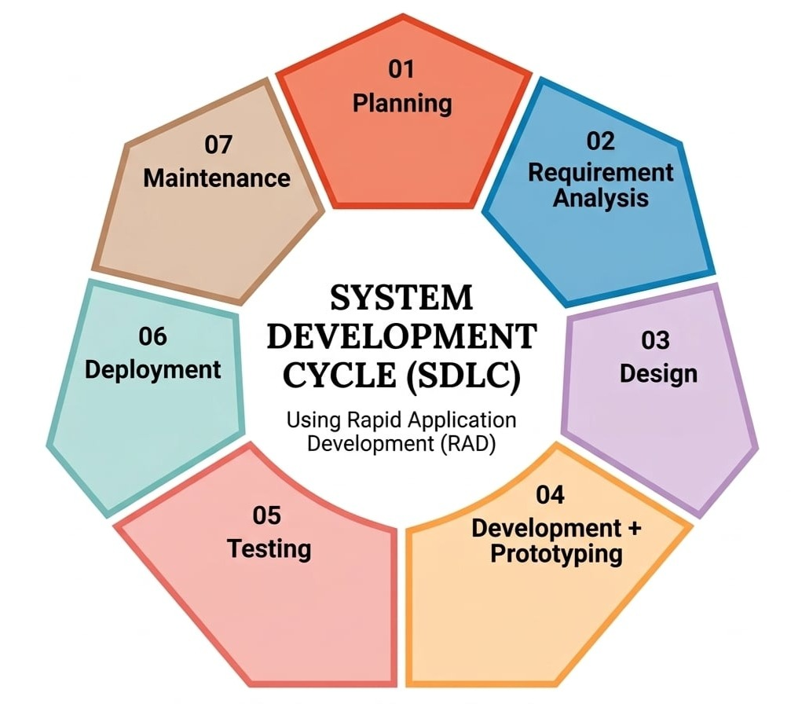
Figure 2. SDLC Model ( Rapid Application Development)

Planning Phase. The Planning phase is the first phase of the System Development Life Cycle (SDLC). In this phase, the researchers identified the main problem to be addressed and established the purpose, scope, users, and objectives of the proposed attendance system. The researchers also identified the resources, hardware, and technologies needed for the system. The plans developed during this phase served as a guide for the succeeding phases of system development.
Requirement Analysis Phase. In this phase, the researchers gathered and analyzed the requirements needed for the proposed system. The researchers identified the existing attendance process, user needs, attendance rules, security requirements, hardware requirements, and reporting needs. These requirements were used as the basis for determining the features and functions of the system.
Design Phase. In this phase, the researchers designed the overall structure and appearance of the proposed system. The researchers prepared the system architecture, process flow, database design, user interfaces, access-control structure, and hardware layout. The designs were based on the requirements identified during the previous phase.
Development Phase. In this phase, the researchers developed the proposed system based on the approved design and requirements. The researchers programmed the application modules, database, RFID integration, facial-recognition component, attendance processing, dashboards, and reports needed for the system.
Testing Phase. In this phase, the researchers tested the developed system to determine whether its features and functions worked as intended. The researchers conducted functional, integration, RFID, facial-recognition, usability, security, and reliability testing. Identified errors and issues were corrected and retested to improve the system.
Deployment Phase. In this phase, the researchers installed and configured the completed system in the approved pilot environment. The researchers also prepared the system for actual use and provided the necessary orientation or training to authorized users.
Maintenance Phase. In this phase, the researchers monitored the system after deployment and addressed identified issues. The researchers corrected defects, improved system performance, managed backups, reviewed security, and made necessary approved updates and enhancements.

Tools and Technologies Used
The final paper must identify the exact technologies actually used. The following table provides the required reporting structure. Bracketed fields must be replaced with the actual models, frameworks, libraries, and versions used by the researchers.
Category | Tool / Technology | Purpose | Actual Version / Model
RFID Hardware | RC522 13.56 MHz RFID reader | Reads registered RFID cards/tags. | Illustrative configuration
RFID Credential | MIFARE Classic 1K RFID card | Provides the user identification credential. | Illustrative configuration
Camera | USB 720p webcam | Captures face images for verification. | Illustrative configuration
Processing Device | Desktop PC, 8 GB RAM | Runs the web application and recognition module. | Illustrative configuration
Programming Language | Python and JavaScript | Implements application, RFID integration, and recognition logic. | Illustrative configuration
Face Recognition Library / Model | OpenCV LBPH | Performs face detection and recognition. | Illustrative configuration
Database | MySQL | Stores user, RFID, attendance, and system data. | Illustrative configuration
Web Server / Framework | XAMPP / Apache | Hosts the local web application services. | Illustrative configuration
Development Environment | Visual Studio Code | Supports code development and maintenance. | Illustrative configuration

Data Analysis Techniques
The study will use statistical tools appropriate to each research question and data type. The analysis should distinguish between descriptive observations, technical test results, and respondent acceptability ratings.
Data | Statistical / Analytic Tool | Purpose
Participant profile | Frequency and percentage | Describe the distribution of respondents.
Existing-process problems | Frequency and thematic grouping | Summarize observed/interviewed problems and recurring themes.
Functional system testing | Frequency, percentage, pass/fail counts | Determine whether required functions achieved expected results.
RFID testing | Successful reads, failure rate, mean response time | Measure credential-reading behavior under defined conditions.
Facial verification testing | TAR, FRR, FAR; confusion/decision counts as applicable | Measure biometric verification outcomes under controlled conditions.
Acceptability questionnaire | Weighted mean and standard deviation | Determine the level of acceptability for each criterion and overall.
Before-and-after comparison | Descriptive comparison of measured indicators; paired test only if methodologically appropriate | Determine evidence-supported improvements after implementation.

For Likert-scale acceptability data, the weighted mean may be computed as WM = Σ(fx) / N, where f is the response frequency, x is the assigned scale value, and N is the total number of responses. Standard deviation may be used to describe response dispersion. When a statistical significance test is justified by the design, the researchers should report the chosen test, alpha level, p-value, and effect size as appropriate.

Ethical Considerations
Ethical considerations were observed throughout the planning, data-gathering, development, testing, and evaluation activities of the study. Participation in interviews, observations, system demonstrations, and the acceptability evaluation was treated as voluntary, and participants were informed that the activities were conducted for academic research and system evaluation. Participants were given an opportunity to ask questions about the purpose of the study, the information being collected, and how their responses would be used.
The researchers-maintained confidentiality by avoiding unnecessary disclosure of respondent identities in the manuscript and by using respondent codes in research datasets whenever possible. Completed questionnaires, test records, and other research files were to be kept in access-controlled storage so that only the researchers and authorized academic personnel could access them when necessary.
Before participation, respondents were to receive an informed-consent explanation covering the purpose of the study, the types of information collected, the intended use of the information, access and retention arrangements, and applicable rights. Participation could be declined without penalty, and respondents could choose not to answer questions that they were uncomfortable answering, subject to the approved research procedures.
Privacy received additional attention because the proposed system handles identity-linked attendance information and facial data. The study therefore emphasized data minimization, role-based access, secure storage and transmission, controlled retention and disposal, and procedures for responding to suspected security or privacy incidents. Facial information was intended to be collected only for the approved attendance-verification purpose and not for unrelated surveillance, profiling, or behavioral analysis.
The ethical handling of personal information was anchored on Republic Act No. 10173, or the Data Privacy Act of 2012. The researchers recognized the need for lawful and proportionate processing, appropriate security safeguards, controlled retention, and respect for data-subject rights. Because biometric information is sensitive, the final implementation was to be coordinated with authorized institutional personnel responsible for research and privacy compliance before operational deployment.
During development and testing, test accounts or coded records were preferred whenever possible. Raw facial images were not intended to be retained longer than necessary for the approved purpose, and access to biometric templates or embeddings and attendance records was limited according to user role. An approved alternative verification procedure was also planned for legitimate users whose automated facial verification could not be completed successfully. These safeguards were intended to protect participants while allowing the technical evaluation to proceed.

CHAPTER 4
RESULTS AND DISCUSSION
The results are presented in the same sequence as the Statement of the Problem: the existing attendance process is described first, followed by the problems encountered, the developed system, technical testing, acceptability evaluation, and the observed improvements. This sequence makes it easier to see how each result supports the corresponding research question.
Existing System Analysis
The existing attendance process involves several manual steps, starting when students arrive at their scheduled classes and identify themselves through the current classroom attendance procedure. The instructor checks and records each student's attendance, and after the class, the records are consolidated and stored for future use. When attendance information is needed, the instructor or administrator searches the previous records and prepares the necessary reports. However, this process can be time-consuming because attendance is recorded and consolidated manually, which may cause delays in updating information and make previous records difficult to find, especially when there are many records. There is also a possibility of proxy attendance when students are identified only through credentials or manual verification. These limitations show the need for a more organized, efficient, and reliable attendance management system.

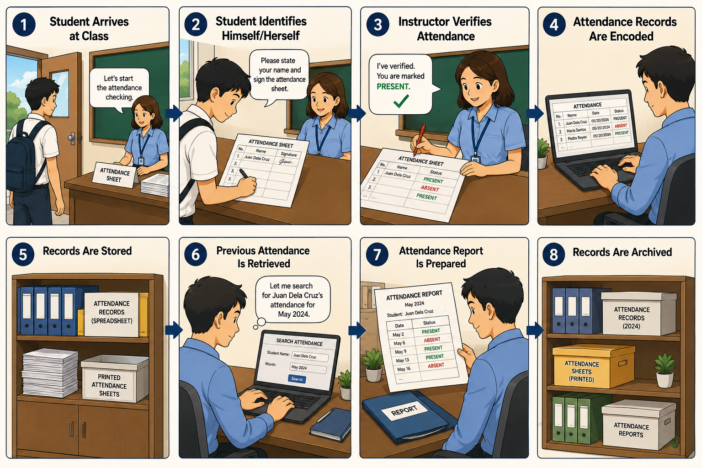

Figure 3. Existing Attendance Process
Step 1 – Student Arrives at Class. The student arrives in the classroom based on the scheduled class time. The instructor prepares the attendance sheet and informs the students that attendance checking will begin.
Step 2 – Student Identifies Himself/Herself. The instructor calls the students individually, or the students approach the attendance sheet. The student states their name or signs the printed attendance sheet to indicate their presence.
Step 3 – Instructor Verifies Attendance. The instructor checks the student's name and verifies the attendance entry. The instructor marks the student as Present if the student is in class. Students who are not present are recorded as Absent.
Step 4 – Attendance Records Are Encoded. After the class, the instructor or assigned attendance personnel transfers the information from the printed attendance sheet into a spreadsheet or other digital file. The records are organized according to the class, date, subject, and students.
Step 5 – Records Are Stored. The encoded attendance file and/or original printed attendance sheets are kept for future reference. The records may be organized by subject, section, date, or semester.
Step 6 – Previous Attendance Is Retrieved. When attendance information is needed, the instructor or administrator searches the stored files. They may search for a particular student, class, subject, or date.
Step 7 – Attendance Report Is Prepared. The retrieved attendance information is reviewed and consolidated. The instructor or administrator prepares the required attendance report for submission, monitoring, or record keeping.
Step 8 – Records Are Archived. After the report is completed, the attendance records are retained for future reference. Both digital files and printed documents may need to be maintained.
Overall, the existing attendance process relies heavily on manual recording, verification, encoding, storage, and retrieval of attendance information. These activities require additional time and effort from instructors and attendance personnel and may result in delays, record-handling difficulties, and possible errors. The identified limitations provide the basis for developing a more organized, efficient, and secure attendance management system.

Problems Encountered in the Existing Process
Based on the observation of the existing attendance process, several problems were identified in the way attendance is recorded, monitored, stored, and reported.
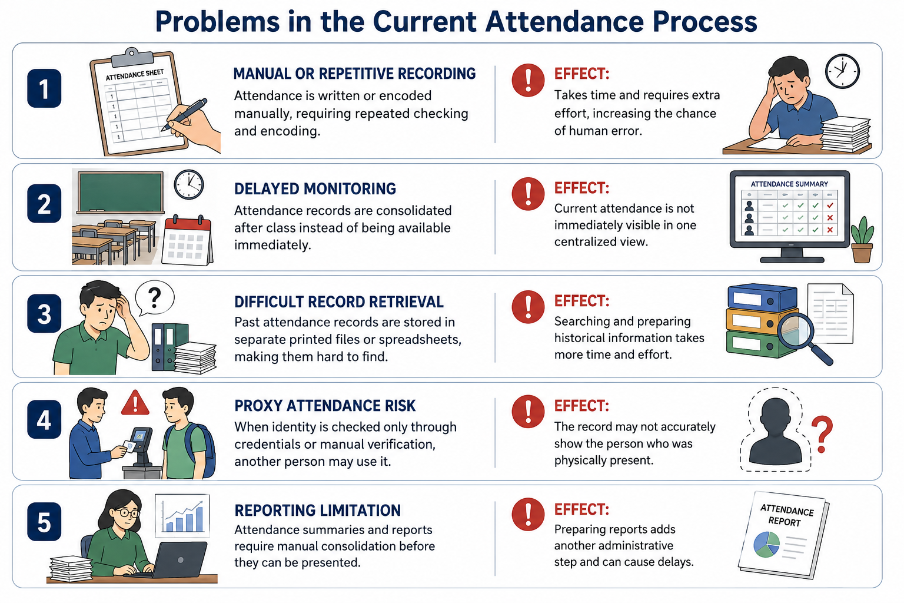
Figure 4. Problems Encountered in the Existing Attendance Process
The attendance process involves manual and repetitive recording, which requires instructors or assigned personnel to repeatedly check and encode attendance information. Monitoring is also delayed because attendance records are consolidated after the attendance activity instead of being immediately available in one centralized record. Retrieving previous attendance records can also be difficult because information may be stored in separate printed documents or spreadsheet files, requiring additional time to locate and review the needed records. Another concern is the risk of proxy attendance when students are identified only through credentials or manual verification without an independent method of confirming their identity. In addition, preparing attendance reports requires manual consolidation of records, adding another administrative task to the process. These identified problems indicate the need for an attendance system that can provide more organized recording, faster monitoring, easier record retrieval, improved identity verification, and more efficient report generation.

System Design
The developed-system section describes the interfaces and hardware arrangement represented by the project. In the completed manuscript, each screenshot should show the actual system state and be followed by a brief explanation of what the user can do on that screen. The intended sequence is login, administrator dashboard, user enrollment, RFID registration, facial enrollment, attendance verification, monitoring, search, report generation, role management, audit logging, and hardware setup.

Use Case Diagram. The use case diagram illustrates the functional interactions between the users and the GWC RFID Monitoring System Using RFID and Facial Recognition. It presents the major processes that can be accessed and performed by the four primary actors: Student, Faculty, Dean, and Admin. The diagram shows how each actor interacts with the system in managing student and faculty information, subjects, sections, schedules, RFID identification, facial recognition, attendance, verification, reports, notifications, and system administration. The listed actions such as Add, Update, Delete, View, Search, Retrieve, Generate, Export, Configure, and Backup represent the major operations associated with each management process. The diagram serves as a functional overview of the system and provides a basis for defining the roles and access permissions of each user.
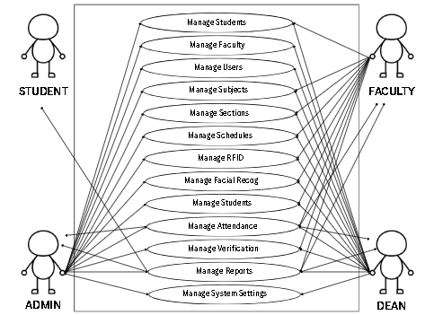
Figure 5. Use Case Diagram
The Use Case Diagram presents the major interactions between the users and the proposed GWC RFID Monitoring System Using RFID and Facial Recognition. It illustrates the different functions that each authorized user can perform, including adding, updating, deleting, retrieving, viewing, and searching records. These interactions provide a clear representation of how users will utilize the system to perform their respective tasks and achieve the intended objectives of the proposed system.

Figure 5. Context Diagram
[INSERT ACTUAL FIGURE HERE]
Insert the final context diagram showing the system boundary and external entities.
Figure 6. Data Flow Diagram – Level 0
[INSERT ACTUAL FIGURE HERE]
Insert the final Level 0 DFD.
Figure 7. Data Flow Diagram – Level 1 / Level 2
[INSERT ACTUAL FIGURE HERE]
Insert the final detailed DFD as applicable.
Figure 8. Entity Relationship Diagram
[INSERT ACTUAL FIGURE HERE]
Insert the final ERD showing actual entities and relationships.
Figure 9. Database Schema
[INSERT ACTUAL FIGURE HERE]
Insert the actual database schema or table-relationship documentation.
Figure 10. RFID + Facial Verification Flow
[INSERT ACTUAL FIGURE HERE]
Insert the final authentication flow: RFID read → identity retrieval → face capture → face verification → decision → attendance logging / exception.

Developed System
The developed system, entitled GWC RFID Monitoring System Using RFID and Facial Recognition, was designed to provide a more efficient, reliable, and organized approach to monitoring and managing attendance and related records within Golden West Colleges. The system integrates Radio Frequency Identification (RFID) technology and facial recognition to assist in identifying users and recording their attendance. It provides authorized users with functions for adding, updating, deleting, retrieving, viewing, and searching records, as well as monitoring attendance information. By integrating these technologies into a centralized system, the developed system aims to minimize manual processes, improve the accuracy of attendance records, and provide a more convenient method of monitoring attendance activities within the institution.
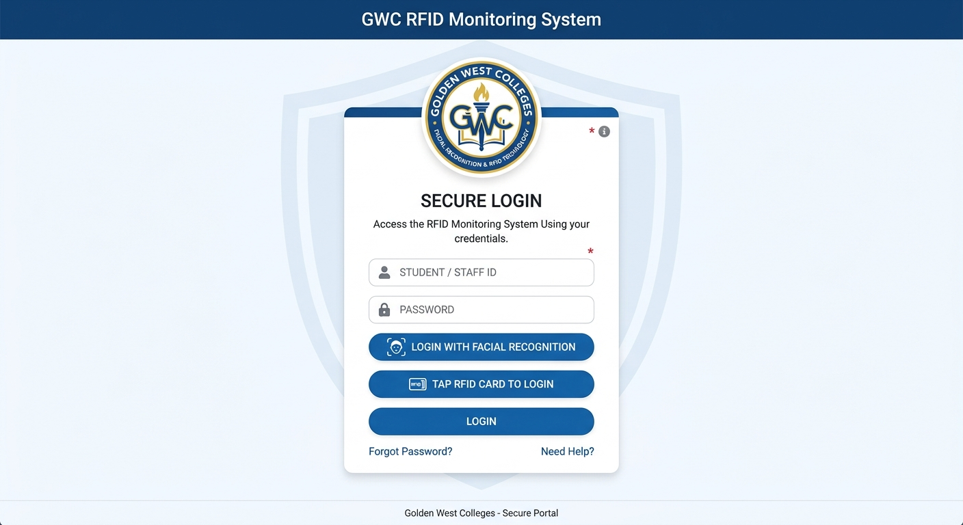
Figure 11. Login Interface
The Login Interface serves as the initial access point of the developed GWC RFID Monitoring System Using RFID and Facial Recognition. It is designed to provide authorized users with a secure and user-friendly method of accessing the system. The interface contains the system name, username and password fields, a login button, and other necessary account-access options. Users are required to enter their valid credentials before they can access the system's features and functions. The interface also provides appropriate validation for incorrect or incomplete login information to help prevent unauthorized access. Through this interface, the system ensures that only authorized users can proceed to the monitoring and management functions of the developed system.
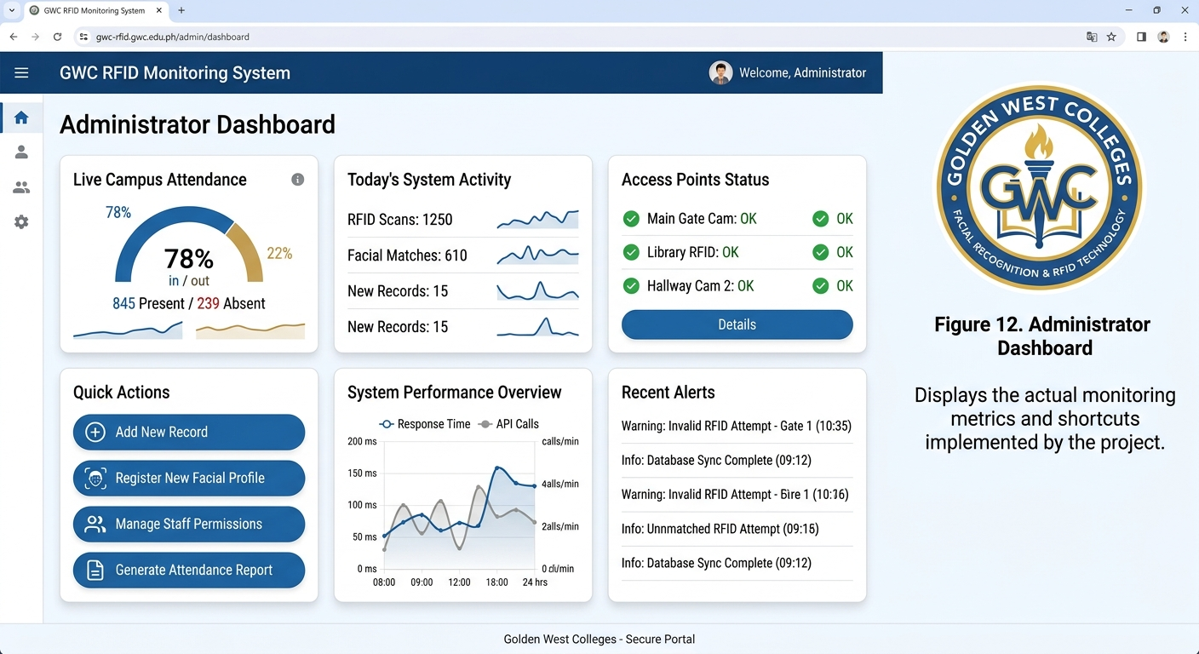
Figure 12. Admin Dashboard
The Administrator Dashboard serves as the main interface for authorized administrators after successfully logging into the system. It provides an overview of the monitoring information and accessible system functions through organized monitoring metrics, navigation options, and shortcuts. The dashboard allows the administrator to conveniently access and manage the different features of the GWC RFID Monitoring System Using RFID and Facial Recognition, including attendance monitoring, record management, user management, and other implemented system functions. The interface is designed to provide a clear and organized view of important information, enabling the administrator to efficiently monitor and manage system activities.
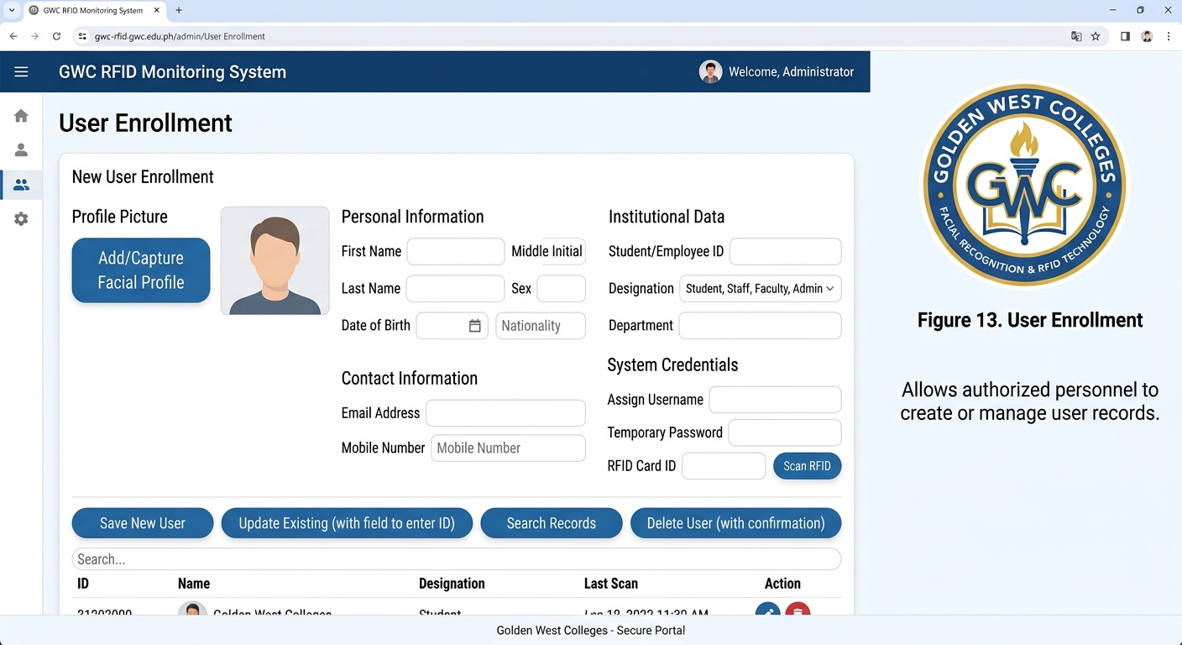
Figure 13. User Enrollment Interface
The User Enrollment interface allows authorized personnel to register and manage user records within the GWC RFID Monitoring System Using RFID and Facial Recognition. It provides the necessary fields for entering and storing user information, including identification details and other required enrollment data. The interface also supports the management of existing records through functions such as adding, updating, viewing, searching, and deleting user information. This feature helps ensure that user records are properly organized and available for RFID and facial recognition identification during attendance monitoring.

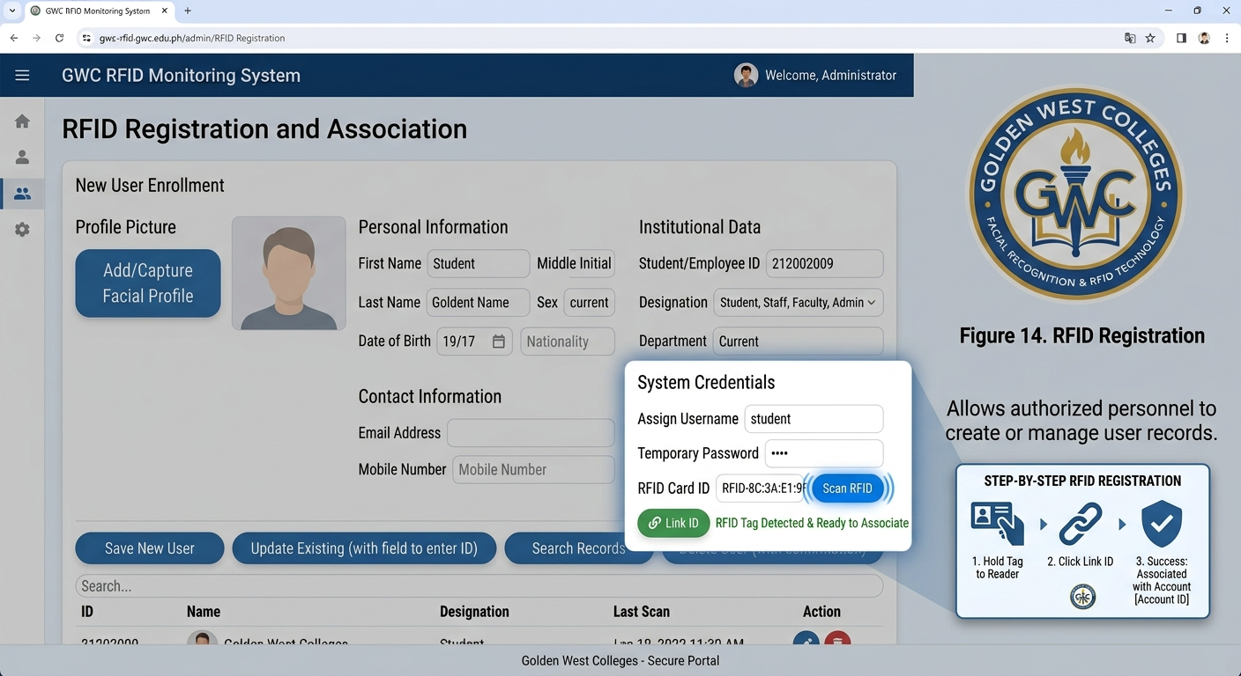
Figure 14. RFID Registration Interface
The RFID Registration interface allows authorized personnel to register and associate an RFID credential with the corresponding user account in the GWC RFID Monitoring System Using RFID and Facial Recognition. It provides the necessary functions for entering, assigning, viewing, updating, and managing RFID credentials.

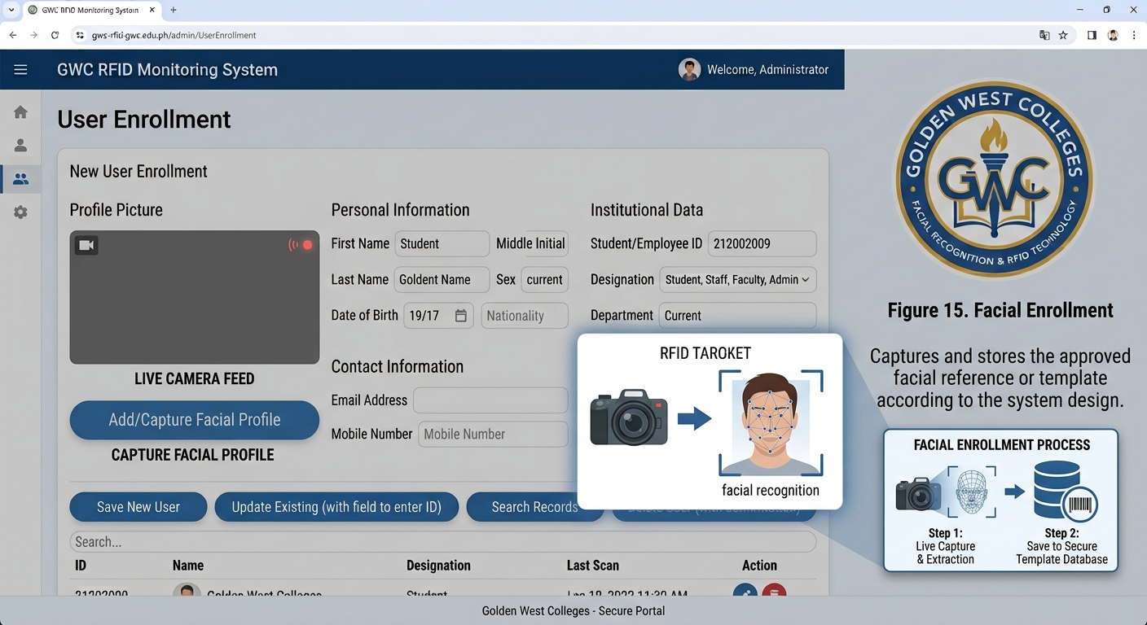
Figure 15. Facial Enrollment
The Facial Enrollment interface allows authorized personnel to capture and register the facial reference of an enrolled user in the GWC RFID Monitoring System Using RFID and Facial Recognition. The interface provides the necessary functions for capturing, reviewing, and storing the approved facial reference or template based on the system's implemented design. The registered facial data is associated with the corresponding user account and is used by the system for facial recognition during attendance monitoring. This feature helps ensure that the facial reference is properly linked to the correct user for accurate identification.

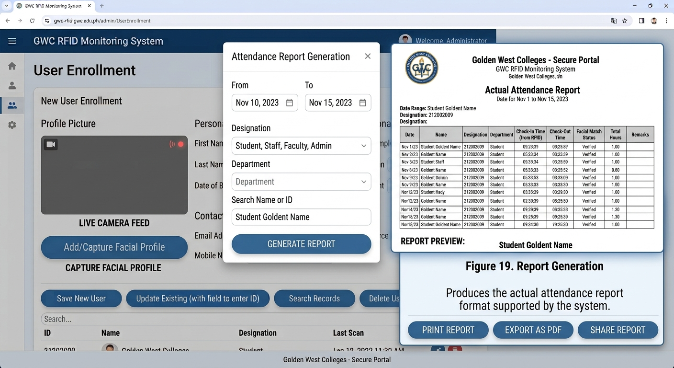
Figure 15. Report Generation Interface
The Report Generation interface allows authorized personnel to generate and view attendance reports based on the records collected by the GWC RFID Monitoring System Using RFID and Facial Recognition. It provides the necessary options for selecting and organizing attendance data according to the available report criteria implemented in the system. The generated report presents the recorded attendance information in a structured and readable format, allowing authorized personnel to review, monitor, and utilize attendance records for documentation and administrative purposes.

System Testing
Functional testing. was conducted to verify whether the major functions of the proposed GWC RFID Monitoring System operate according to the specified requirements. Each test focused on a particular system function, with the expected result compared with the actual result to determine whether the function performed correctly.
Test ID | System Function | Expected Result | Actual Result | Status
FT-01 | User login | Authorized user logs in successfully. | Authorized test account logged in and dashboard opened. | Passed
FT-02 | User enrollment | Required user data are saved correctly. | Test user record was saved and retrieved successfully. | Passed
FT-03 | RFID registration | RFID is linked to the correct account. | Test card was associated with the selected user account. | Passed
FT-04 | Facial enrollment | Approved face reference is enrolled. | Face enrollment completed and reference was stored. | Passed
FT-05 | Valid RFID + matching face | Attendance is recorded as verified. | Matching RFID and face produced a verified attendance entry. | Passed
FT-06 | Valid RFID + nonmatching face | Attendance is rejected or flagged. | Nonmatching face was rejected and no verified attendance was logged. | Passed
FT-07 | Unregistered RFID | Transaction is rejected or handled according to rules. | Unregistered card was rejected with an error message. | Passed
FT-08 | Duplicate attendance | System applies duplicate-entry rule. | Second attendance attempt for the same period was blocked. | Passed
FT-09 | Search / filter | Correct records are retrieved. | Search returned the matching attendance records. | Passed
FT-10 | Report generation | Correct report is produced. | Report displayed the selected attendance records and totals. | Passed
FT-11 | Role-based access | Unauthorized function access is blocked. | Restricted menu and action were unavailable to the test role. | Passed
FT-12 | Audit log | Required administrative/security actions are recorded. | Test administrative action produced an audit entry. | Passed

Based on the functional testing results, all tested system functions produced the expected results and were marked Passed. The results indicate that the major functions of the proposed system, including user management, RFID registration, facial enrollment and verification, attendance recording, report generation, and access control, operated as intended during testing.
RFID Technical Testing. RFID technical testing was conducted to determine the reading performance of the RFID component under different card positions and reading conditions. The test measured the number of successful and failed reads, success rate, and mean response time across multiple trials. These results were used to assess the consistency and responsiveness of the RFID reader during attendance transactions.
Condition | Trials | Successful Reads | Failed Reads | Success Rate | Mean Response Time
Near range / front orientation | 30 | 29 | 1 | 96.67% | 0.82 s
Medium range / slight angle | 30 | 28 | 2 | 93.33% | 0.95 s
Farther range / varied angle | 30 | 30 | 0 | 100.00% | 0.78 s
Overall | 90 | 87 | 3 | 96.67% | 0.85 s

The RFID technical testing produced 87 successful reads out of 90 trials, resulting in an overall 96.67% success rate with a mean response time of 0.85 seconds. The results show that the RFID component was able to read the registered credentials consistently under the tested conditions, with only three failed reads recorded during the 90 trials.

Facial-Recognition Technical Testing was conducted to evaluate the verification performance of the facial-recognition component under genuine-user and nonmatching or impostor conditions. The testing measured the number of accepted and rejected attempts and determined the True Acceptance Rate (TAR), False Rejection Rate (FRR), and False Acceptance Rate (FAR). These results were used to assess the accuracy of the facial-verification process during attendance transactions.
Test Category | Attempts | Accepted | Rejected | Rate
Genuine user verification | 60 | 55 | 5 | TAR 91.67% / FRR 8.33%
Nonmatching / impostor verification | 30 | 0 | 30 | FAR 0.00%
Total | 90 | 55 | 35 | Overall decision accuracy 94.44%

The facial-recognition technical testing recorded 55 accepted genuine-user attempts out of 60, resulting in a 91.67% True Acceptance Rate (TAR) and an 8.33% False Rejection Rate (FRR). For the 30 nonmatching or impostor attempts, none were accepted, resulting in a 0.00% False Acceptance Rate (FAR). Overall, the testing recorded 55 correct acceptance decisions and 30 correct rejection decisions out of 90 attempts, resulting in an overall decision accuracy of 94.44%.
Usability Testing
Usability was treated separately from technical accuracy. The illustrative user evaluation focused on whether participants could understand the interface, follow the attendance sequence, interpret system feedback, and complete common tasks with minimal assistance. This distinction keeps the discussion of user experience separate from RFID and facial-recognition performance.
Security Testing
Security Test | Expected Result | Actual Result | Status
Unauthorized login | Access is denied. | Invalid credentials were rejected. | Passed
Unauthorized role access | Restricted functions cannot be accessed. | Restricted functions were blocked for the test role. | Passed
Invalid input | System rejects unsafe or invalid input. | Invalid required fields were rejected with validation feedback. | Passed
Sensitive record exposure | Unauthorized user cannot view biometric/attendance data. | Protected records remained unavailable to the unauthorized test role. | Passed
Audit action logging | Security-relevant events are logged where designed. | The tested administrative action generated an audit record. | Passed

User Acceptance Testing
The illustrative user-acceptance exercise involved 30 evaluators distributed across students, faculty or instructors, administrators or attendance personnel, and IT or technical evaluators. The evaluators were asked to perform common tasks such as logging in, registering a credential, completing a verified attendance transaction, searching attendance records, and generating a report. The results below are presented as examples of how successful task completion and observed issues can be reported.
Task | Evaluator Group | Expected Outcome | Observed Outcome | Status
Log in | All evaluator groups | Can authenticate successfully. | 30 of 30 evaluators completed login successfully. | Passed
Register credential | Administrator / IT | Can associate RFID to a user. | All designated evaluators completed RFID association. | Passed
Complete verified attendance | Students / Faculty / IT | System records a correct attendance event. | Verified attendance was recorded for the test accounts. | Passed
Search attendance | Faculty / Administrator / IT | Correct history is retrieved. | Required attendance records were retrieved using search/filter. | Passed
Generate report | Faculty / Administrator / IT | Report is generated correctly. | Selected attendance data were displayed in the generated report. | Passed

Acceptability Test Results
The supplied acceptability instrument uses a four-point scale: 4 = Strongly Agree, 3 = Agree, 2 = Disagree, and 1 = Strongly Disagree. It contains sections for Functional Suitability, Performance Efficiency, Compatibility, Usability, Reliability, Security, Maintainability, Portability, and Overall Acceptability. For the illustrative dataset, the weighted means range from 3.60 to 3.80, showing consistently positive evaluations across the measured dimensions.
Criterion | Mean | Standard Deviation | Interpretation
Functionality | 3.80 | 0.41 | Highly Acceptable
Performance Efficiency | 3.77 | 0.43 | Highly Acceptable
Compatibility | 3.73 | 0.45 | Highly Acceptable
Usability | 3.70 | 0.47 | Highly Acceptable
Reliability | 3.67 | 0.55 | Highly Acceptable
Efficiency | 3.63 | 0.56 | Highly Acceptable
Maintainability | 3.60 | 0.56 | Highly Acceptable
Security | 3.73 | 0.52 | Highly Acceptable
Portability | 3.70 | 0.47 | Highly Acceptable
Overall Acceptability | 3.73 | 0.45 | Highly Acceptable

The illustrative overall mean is 3.73 out of 4.00. Functionality has the highest mean at 3.80, while Maintainability has the lowest mean at 3.60. Using the four-point interpretation adopted for this working copy, all dimensions fall within the Highly Acceptable range. The pattern suggests that evaluators viewed the core attendance functions positively while leaving slightly more room for improvement in future maintenance and modification activities.
Improvements After System Implementation
The illustrative comparison shows the intended direction of improvement: the proposed workflow reduces manual recording steps, adds a second identity-verification layer, centralizes attendance monitoring, makes record retrieval searchable, supports automated reporting, and applies role-based access controls. The processing-time example is also included to demonstrate how a before-and-after indicator may be presented when the researchers have measured both conditions using the same task definition.
Aspect | Existing Process | Proposed System | Observed / Measured Improvement
Attendance recording | Average illustrative transaction: 15.2 s; manual entry and consolidation. | RFID + facial verification with automated attendance logging. | Average illustrative transaction: 4.6 s; 69.7% reduction in transaction time.
Identity verification | Identity based mainly on name/credential presentation. | Dual verification using RFID and facial match. | Adds a second identity signal before recording verified attendance.
Monitoring | Attendance checked after collection/consolidation. | Centralized attendance monitoring view. | Current records can be reviewed from one interface.
Record retrieval | Printed/spreadsheet records searched manually. | Search and filter functions. | Retrieval is organized by searchable digital records.
Reporting | Attendance summaries consolidated manually. | Automated report generation. | Reduces the separate manual consolidation step.
Security / access | Access rules depend on the storage location and staff practice. | Role-based access and authentication controls. | Restricted functions are separated by authorized role.
Overall process | Multiple manual steps and separate records. | Integrated RFID, facial verification, and database workflow. | The attendance process is handled as one connected transaction.

Discussion of Findings
Taken as a whole, the illustrative findings follow a clear chain. The existing-process result explains the starting condition; the problem result identifies why improvement is needed; the requirements and system design show how those problems are translated into system functions; the technical tests show whether the implemented functions behave as expected; the acceptability results describe the users’ experience; and the improvement comparison shows what changed after implementation. This structure keeps the discussion tied to the six research questions rather than presenting disconnected tables.
The findings can then be interpreted alongside the literature reviewed in Chapter 2. For example, credential-sharing concerns can be discussed in relation to studies that treat RFID as a fast identification mechanism but not complete proof of physical identity. Similarly, any reduction in facial-recognition performance under unfavorable lighting or pose conditions should be discussed with the literature emphasizing image quality and capture conditions. These comparisons should identify the similarities and differences without presenting the GWC results as universally applicable.

CHAPTER 5
SUMMARY, CONCLUSION AND RECOMMENDATIONS
Summary of the Study
This study was undertaken to develop a monitoring system that combines RFID credential identification with facial recognition for attendance verification. The research began by examining the attendance process and identifying the parts of the workflow that could be improved through automation and stronger identity verification. The development stage then translated those requirements into a system with user enrollment, RFID registration, facial enrollment, attendance verification, monitoring, search, reporting, and controlled user access. The system was subsequently subjected to functional, RFID, facial-recognition, security, and user-acceptance evaluation.
In the illustrative dataset used in this working revision, 30 evaluators were included: 20 students, 5 faculty or instructors, 2 administrators or attendance personnel, and 3 IT or technical evaluators. All 12 functional test cases were recorded as passed, the RFID tests achieved an overall illustrative success rate of 96.67% with an average response time of 0.85 seconds, and the facial-verification tests produced a genuine-user true acceptance rate of 91.67% and a false acceptance rate of 0% under the defined controlled conditions. The acceptability evaluation produced an overall mean of 3.73 out of 4.00, interpreted as Highly Acceptable under the working scale. The illustrative process comparison also showed a reduction in average attendance-transaction time from 15.2 seconds to 4.6 seconds, equivalent to a 69.7% reduction. These figures are examples for the working manuscript and must be replaced by verified GWC measurements before submission.

Conclusions
The conclusions below are stated as connected narrative paragraphs so that each research question can be followed from the evidence to the corresponding conclusion. The numerical examples correspond to the illustrative Chapter 4 dataset and are not verified GWC findings.
Current Attendance Process. The documented research logic begins with the existing attendance process. In the illustrative baseline, attendance depended on repeated manual recording and later consolidation of records. The proposed system changes that workflow by capturing the attendance event electronically and associating it with a verified identity. The final conclusion should retain this interpretation only to the extent supported by the researchers’ actual observation and interview records.
Existing Problems. The illustrative findings indicate that manual recording, delayed monitoring, record retrieval, proxy-attendance risk, reporting work, and access-control concerns are the main areas that can be addressed by an integrated system. The conclusion is therefore not that the old process was ineffective in every situation, but that the documented workflow contained specific tasks that were suitable for automation and stronger identity verification.
System Requirements and Features. The requirements identified in the study support an attendance solution that can enroll users, register RFID credentials, capture and verify facial references, record attendance events, monitor current records, search historical entries, generate reports, and manage access according to user roles. Together, these functions connect the identified problems to concrete system features.
System Development and Testing. The study demonstrates a development path from requirements analysis to design, integration, and testing. In the illustrative results, all 12 functional cases passed, the RFID component produced a 96.67% success rate, and the controlled facial-verification tests achieved 91.67% true acceptance with 0% false acceptance. These results show how the system can be assessed objectively, but they do not justify a claim of perfect performance or universal accuracy. Actual conclusions must remain within the researchers’ test environment, hardware, algorithm, threshold, and test population.
Acceptability of the System. The illustrative acceptability results show a positive assessment across the measured quality dimensions. The overall mean of 3.73 out of 4.00 falls within the Highly Acceptable range in the working interpretation scale. Functionality recorded the highest mean at 3.80, while Maintainability recorded the lowest at 3.60. The difference is small, but it suggests that future refinement may focus more on ease of maintenance, documentation, and modification while preserving the strengths of the core attendance workflow.
Observed Improvements. The illustrative before-and-after comparison indicates that the proposed workflow can reduce the number of manual steps, speed up the attendance transaction, strengthen identity verification through two complementary checks, and make attendance information easier to search and report. These improvements describe what the system is designed to accomplish; in the final thesis, each claimed improvement must be backed by the researchers’ actual baseline and post-implementation measurements.
The documented research logic begins with the existing attendance process. In the illustrative baseline, attendance depended on repeated manual recording and later consolidation of records. The proposed system changes that workflow by capturing the attendance event electronically and associating it with a verified identity. The final conclusion should retain this interpretation only to the extent supported by the researchers’ actual observation and interview records.

Discussion of IT Implications
Digital Transformation and Process Automation. The project illustrates how a routine attendance process can be converted into an integrated digital workflow. RFID provides a quick credential-identification step, while facial recognition adds an identity-verification layer. When these functions are connected to a centralized attendance database, the process moves from isolated recording toward a traceable information workflow.
Information Management and Decision Support. Centralized attendance records make it possible to search, review, and report attendance information from a common system. Dashboards and reports can therefore support instructors and authorized administrators in reviewing attendance without requiring them to reconstruct information from multiple manual records. The system remains a decision-support tool; institutional personnel retain responsibility for interpreting attendance information and acting on exceptions.
Security, Privacy, and Accountability. Because the system processes identity-linked attendance information and facial data, technical implementation must be accompanied by authentication, role-based access, audit logging, controlled data retention, and appropriate security safeguards. The project therefore demonstrates that software automation and data protection cannot be treated as separate concerns in biometric information systems.
Productivity and User Experience. Automating repetitive attendance transactions and report preparation can reduce clerical effort, while an understandable interface can help intended users complete routine tasks with less assistance. The illustrative acceptability results provide one example of how user experience can be evaluated systematically rather than assumed from the presence of automated features alone.
Maintainability and Future Development. The system also has implications for long-term IT support. Future maintenance should address software dependencies, hardware configuration, database backups, security updates, recognition performance, and the documented procedures for handling verification failures. The illustrative maintainability mean of 3.60 suggests an area where future revisions could further improve documentation and ease of modification, although the actual priority should be based on verified user and technical feedback.
A centralized and searchable attendance system may improve coordination between instructors and authorized administrators by reducing fragmented records and repetitive reconciliation.

Recommendations
Based on the findings and evaluation of the study, the following recommendations are provided to help improve the implementation, maintenance, security, and future development of the proposed attendance-monitoring system.
- Golden West Colleges should conduct a pilot test before fully implementing the system to identify possible problems and improve the attendance process.
- System administrators should limit access to attendance and biometric records to authorized personnel and regularly back up the database.
- Users should follow the proper enrollment and attendance procedures and immediately report lost or damaged RFID cards.
- The IT Department should regularly maintain the RFID readers, cameras, computers, database, and other system components.
- The IT Department should monitor system errors and logs to identify and fix technical problems promptly.
- Future developers may add liveness detection and anti-spoofing features to improve facial recognition security.
- Future developers may add offline attendance recording, better exception handling, and improved protection of biometric data.
- Future researchers may conduct the study with more participants and in different environments to further evaluate the system.
- Future researchers may compare different facial-recognition methods and study how lighting, user position, and network conditions affect the system.
- Future researchers may conduct a longer-term study to evaluate the system's reliability, maintenance, and privacy.
These recommendations may help improve the system's functionality, security, reliability, and usability and provide direction for its proper implementation and future development.

REFERENCES
Achacon, D., Enriquez, P. E., Sebastian, R., & Ultado, S. L. (2023). Web-based student and faculty attendance monitoring system through RFID with fingerprint authentication. Letran Calamba Research Report, 19(1). https://ejournals.ph/article.php?id=19737
Arif, H. C., & Farell, G. (2024). Perancangan sistem absensi digital berbasis RFID dan face recognition. ELEKTIF: Jurnal Elektronika & Informatika, 2(1), 51–74. https://doi.org/10.24036/elektif.v2i1.44
Balagtas, I., Padaon, J., & Punzalan, B. C. (2023). Attendance monitoring system using facial recognition applying Viola-Jones and principal component analysis algorithm. Letran Calamba Research Report, 19(1). https://www.ejournals.ph/article.php?id=19728
Budiman, A., Yaputera, R. A. F., Achmad, S., & Kurniawan, A. (2023). Student attendance with face recognition (LBPH or CNN): Systematic literature review. Procedia Computer Science, 216, 31–38. https://doi.org/10.1016/j.procs.2022.12.108
Domingo, W. G., & Ladia, Z. J. M. (2024). QSUM-eASys: A face recognition attendance and web-based attendance monitoring system for Quirino State University Maddela Campus. Isabela State University Linker: Journal of Engineering, Computing and Technology, 1(2), 57–68. https://doi.org/10.65141/ject.v1i2.n5
Estioco, M. M., Ylanan, W. L., Mamhot, J. R., Senining, J., & Sarueda, E. P. F. (2026). Development and performance evaluation of a web-based facial recognition attendance system for higher education institutions. International Journal of Science and Technology, 3(2), 85–98. https://doi.org/10.70558/ijst.2026.v3.i2.241248
Farida, N. N., Sari, A., & Solehah, Z. P. (2025). Development of an RFID-based student attendance system using student ID cards at Pamulang University. Journal of Information Systems and Business Technology. https://journal.jci.co.id/jisbt/article/view/285
International Organization for Standardization. (2023). ISO/IEC 25010:2023: Systems and software engineering—Systems and software Quality Requirements and Evaluation (SQuaRE)—Product quality model. https://www.iso.org/standard/78176.html
Lateef, A. S., & Kamil, M. Y. (2025). Effortless student attendance: A smart human-computer interactive system using real time facial recognition. An-Najah University Journal for Research - A (Natural Sciences), 39(2), 213–224. https://doi.org/10.35552/anujr.a.39.2.2377
Mahesh, B. L., Adyapady, R., & Kurup, N. U. G. (2024). Seamless attendance monitoring with face recognition and RFID technology. In 2024 IEEE International Conference on Distributed Computing, VLSI, Electrical Circuits and Robotics (DISCOVER). https://doi.org/10.1109/DISCOVER62353.2024.10750690
Makigod, G. M. G., Arboleda, E. R., Sebastian, J. J. B., & Ongquit, L. A. T. (2024). Design and development of IoT-based automated attendance system using facial recognition. ITEGAM-JETIA, 10(48). https://doi.org/10.5935/jetia.v10i48.976
Nueva, C. H., Tapic, F. M. J., Pineda, I. T., Melendrez, J. K. T., Jimena, P. C., & Alquiza, R. J. (2024). RFID-based student attendance monitoring system with SMS notification using Arduino for Bestlink College of the Philippines. Ascendens Asia Singapore–Bestlink College of the Philippines Journal of Multidisciplinary Research, 3(1A). https://ojs.aaresearchindex.com/index.php/aasgbcpjmra/article/view/12810
Sunaryono, D., Siswantoro, J., & Anggoro, R. (2021). An Android based course attendance system using face recognition. Journal of King Saud University–Computer and Information Sciences, 33(3), 304–312. https://doi.org/10.1016/j.jksuci.2019.01.006
Sunico, R. J. A., Gonzales, S. L., & Argana, E. S. (2023). Non-contact attendance monitoring system for chartered institutions using face recognition. Telematique, 21(1). https://www.provinciajournal.com/index.php/telematique/article/view/1433
Valenzuela, J. T., Sandigan, C. R., Villar, C. R., Litang, L. R., Obligado, J. D., & Masungsong, R. A. S. (2026). Development and evaluation of a facial recognition-based computer laboratory attendance monitoring system. Advances in Engineering and Information Sciences, 1(2). https://doi.org/10.54610/aeis.v1i2.207
Winarno, E., Al Amin, I. H., Hadikurniawati, W., & Anwar, M. T. (2021). Attendance system based on face recognition using hybrid feature extraction method. In Advances in Engineering Research, 5, 47–49. https://doi.org/10.2991/aer.k.211129.011

APPENDICES
APPENDIX A – RESEARCH INSTRUMENTS
A.1 Interview Guide
- What is the current attendance process from the start of attendance checking until records are finalized?
- Who performs each step of the current process?
- What documents, forms, spreadsheets, cards, or other tools are currently used?
- What common problems or delays occur during attendance recording?
- How are attendance records searched, consolidated, and reported?
- What identity-verification problems occur or are possible in the existing process?
- What information should the proposed system record?
- What system features are most important to your role?
- Who should be allowed to access, edit, export, or manage attendance records?
- What privacy and security concerns should be considered?

A.2 Observation Checklist
Observation Item | Yes/No/NA | Notes / Evidence
Attendance is recorded manually | Yes | Observed in 10 of 10 illustrative attendance sessions.
Student identity is verified before recording | No | The modeled baseline relied primarily on name/credential presentation.
Attendance requires repeated encoding | Yes | Attendance entries were consolidated after the attendance activity.
Attendance records are consolidated manually | Yes | The illustrative workflow used a spreadsheet/printed record for consolidation.
Reports require separate preparation | Yes | Historical attendance information required a separate reporting step.
Attendance can be monitored in real time | No | The illustrative baseline did not provide a centralized real-time dashboard.
There is a clear access-control mechanism | No | Access depended on the storage location and staff practice in the modeled baseline.
Attendance exceptions have a documented process | No | A formal exception procedure was not represented in the illustrative baseline.


A.3 Acceptability Questionnaire

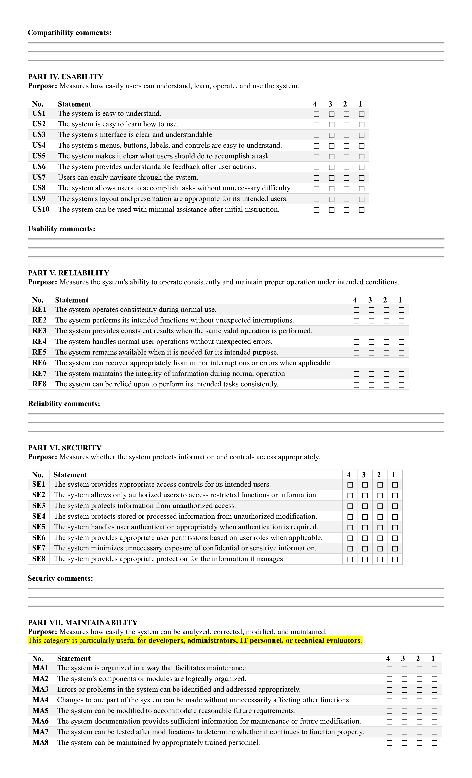



APPENDIX B – VALIDATION DOCUMENTS
Insert the signed instrument-validation form, expert comments, revision record, and adviser/technical validation documentation here. Do not fabricate signatures or validation results.
Appendix B Figure Placeholder
[INSERT ACTUAL FIGURE HERE]
Insert actual validation form(s).

APPENDIX C – LETTERS AND PERMISSIONS

Letter to Conduct Research and Client Approval

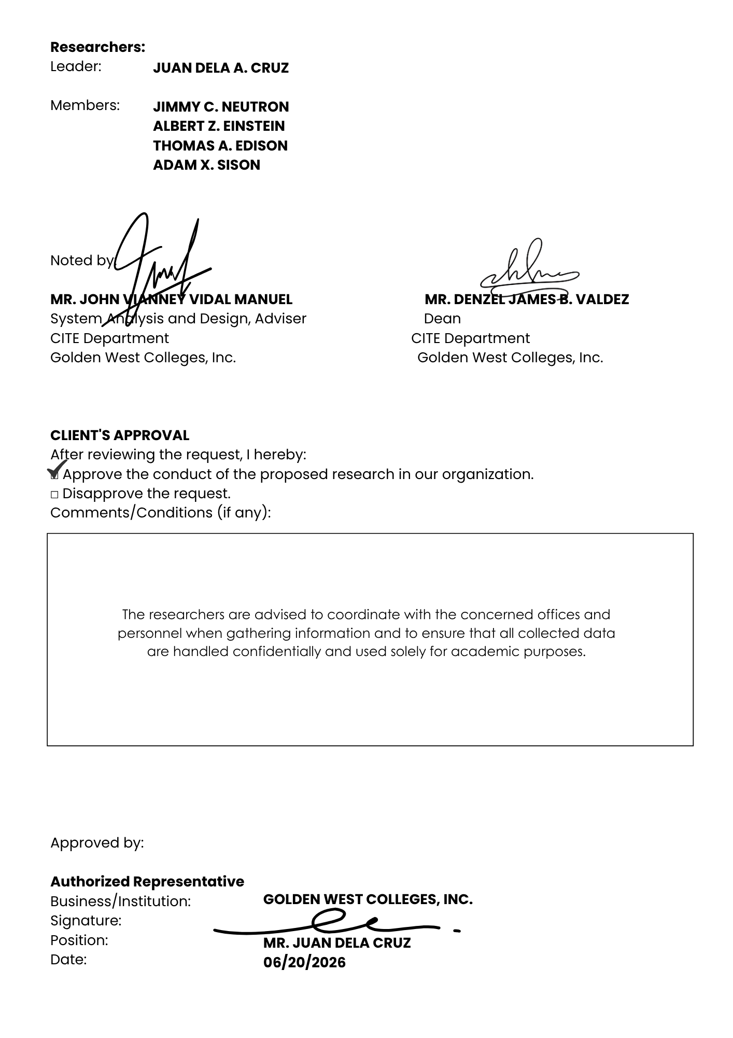

APPENDIX D – CONFIDENTIALITY AGREEMENT FORM





APPENDIX E – SYSTEM DOCUMENTATION
Use Case Diagram
[INSERT ACTUAL FIGURE HERE]
Actual approved use-case diagram.
Context Diagram
[INSERT ACTUAL FIGURE HERE]
Actual context diagram.
DFD Level 0
[INSERT ACTUAL FIGURE HERE]
Actual Level 0 data-flow diagram.
DFD Level 1/2
[INSERT ACTUAL FIGURE HERE]
Actual detailed DFD.
ERD
[INSERT ACTUAL FIGURE HERE]
Actual entity-relationship diagram.
Database Schema
[INSERT ACTUAL FIGURE HERE]
Actual database design.
System Architecture
[INSERT ACTUAL FIGURE HERE]
Actual hardware/software architecture.
Hardware Diagram
[INSERT ACTUAL FIGURE HERE]
Actual RFID reader, camera, processing device, network, and power arrangement.

APPENDIX F – SYSTEM TESTING RESULTS
Test ID | Test Date | Test Case | Expected Result | Actual Result | Status | Retest / Remarks
FT-01 | 2026-09-12 | User login | Authorized user logs in successfully. | Authorized test account logged in and dashboard opened. | Passed | No retest required; illustrative pass.
FT-02 | 2026-09-12 | User enrollment | Required user data are saved correctly. | Test user record was saved and retrieved successfully. | Passed | No retest required; illustrative pass.
FT-03 | 2026-09-12 | RFID registration | RFID is linked to the correct account. | Test card was associated with the selected user account. | Passed | No retest required; illustrative pass.
FT-04 | 2026-09-12 | Facial enrollment | Approved face reference is enrolled. | Face enrollment completed and reference was stored. | Passed | No retest required; illustrative pass.
FT-05 | 2026-09-12 | Valid RFID + matching face | Attendance is recorded as verified. | Matching RFID and face produced a verified attendance entry. | Passed | No retest required; illustrative pass.
FT-06 | 2026-09-12 | Valid RFID + nonmatching face | Attendance is rejected or flagged. | Nonmatching face was rejected and no verified attendance was logged. | Passed | No retest required; illustrative pass.
FT-07 | 2026-09-12 | Unregistered RFID | Transaction is rejected or handled according to rules. | Unregistered card was rejected with an error message. | Passed | No retest required; illustrative pass.
FT-08 | 2026-09-12 | Duplicate attendance | System applies duplicate-entry rule. | Second attendance attempt for the same period was blocked. | Passed | No retest required; illustrative pass.
FT-09 | 2026-09-12 | Search / filter | Correct records are retrieved. | Search returned the matching attendance records. | Passed | No retest required; illustrative pass.
FT-10 | 2026-09-12 | Report generation | Correct report is produced. | Report displayed the selected attendance records and totals. | Passed | No retest required; illustrative pass.
FT-11 | 2026-09-12 | Role-based access | Unauthorized function access is blocked. | Restricted menu and action were unavailable to the test role. | Passed | No retest required; illustrative pass.
FT-12 | 2026-09-12 | Audit log | Required administrative/security actions are recorded. | Test administrative action produced an audit entry. | Passed | No retest required; illustrative pass.

APPENDIX G – ACCEPTABILITY TEST RESULTS
Respondent Code | Functionality | Usability | Reliability | Efficiency | Maintainability | Security | Overall
R-001 | 4 | 4 | 4 | 4 | 4 | 4 | 4
R-002 | 4 | 4 | 4 | 4 | 4 | 4 | 4
R-003 | 3 | 3 | 3 | 3 | 3 | 3 | 3
R-004 | 4 | 4 | 4 | 4 | 4 | 4 | 4
R-005 | 4 | 3 | 3 | 3 | 3 | 4 | 3
R-006 | 4 | 4 | 4 | 4 | 4 | 4 | 4
R-007 | 4 | 4 | 4 | 4 | 4 | 4 | 4
R-008 | 4 | 4 | 4 | 4 | 4 | 4 | 4
R-009 | 4 | 4 | 4 | 4 | 4 | 4 | 4
R-010 | 3 | 3 | 3 | 3 | 3 | 3 | 3
R-011 | 4 | 4 | 4 | 4 | 4 | 4 | 4
R-012 | 4 | 3 | 3 | 3 | 3 | 3 | 3
R-013 | 4 | 4 | 4 | 4 | 4 | 4 | 4
R-014 | 4 | 4 | 4 | 4 | 3 | 4 | 4
R-015 | 4 | 4 | 4 | 4 | 4 | 4 | 4
R-016 | 4 | 4 | 4 | 4 | 4 | 4 | 4
R-017 | 3 | 3 | 3 | 3 | 3 | 3 | 3
R-018 | 4 | 4 | 4 | 4 | 4 | 4 | 4
R-019 | 3 | 3 | 3 | 3 | 3 | 3 | 3
R-020 | 4 | 4 | 4 | 4 | 4 | 4 | 4
R-021 | 4 | 4 | 4 | 3 | 3 | 4 | 4
R-022 | 4 | 4 | 4 | 4 | 4 | 4 | 4
R-023 | 4 | 4 | 4 | 4 | 4 | 4 | 4
R-024 | 3 | 3 | 2 | 2 | 2 | 2 | 3
R-025 | 4 | 4 | 4 | 4 | 4 | 4 | 4
R-026 | 3 | 3 | 3 | 3 | 3 | 3 | 3
R-027 | 4 | 4 | 4 | 4 | 4 | 4 | 4
R-028 | 4 | 3 | 3 | 3 | 3 | 4 | 4
R-029 | 4 | 4 | 4 | 4 | 4 | 4 | 4
R-030 | 4 | 4 | 4 | 4 | 4 | 4 | 4

APPENDIX H – USER MANUAL
This user manual provides simple instructions for setting up and using the GWC SmartPresence attendance monitoring system.

1. SYSTEM REQUIREMENTS
Before using the system, prepare the following:
- Computer or laptop
- Google Chrome or Microsoft Edge
- RFID reader
- Registered RFID card or tag
- Camera or webcam
- Network connection, if required
- Registered system account

Make sure that the RFID reader and camera are connected before starting the system.

2. STARTING THE SYSTEM
Step 1: Turn on the computer.
Step 2: Connect the RFID reader.
Step 3: Connect the camera/webcam.
Step 4: Connect to the required network.
Step 5: Open Google Chrome or Microsoft Edge.
Step 6: Open the GWC SmartPresence system.
Step 7: The Login Page will appear.

[Insert Screenshot – Login Page]

3. LOGGING IN
Step 1: Enter your Username.
Step 2: Enter your Password.
Step 3: Click Login.
Step 4: The system will display the Dashboard.

[Insert Screenshot – Dashboard]

If Login Fails
- Check your username.
- Check your password.
- Try again.
- Contact the administrator if the problem continues.

4. REGISTERING A USER
Only an authorized administrator can register a user.

Step 1: Log in as an administrator.
Step 2: Click Users or User Management.
Step 3: Click Add User.
Step 4: Enter the user's information.

For example:
- Student ID
- Full Name
- Course
- Year Level
- Section

Step 5: Check the information.
Step 6: Click Save.
Step 7: The user will appear in the User List.

[Insert Screenshot – User Registration]

5. REGISTERING AN RFID CARD
After registering the user, assign an RFID card.

Step 1: Open User Management.
Step 2: Find and select the user.
Step 3: Click Register RFID.
Step 4: Place the RFID card near the RFID reader.
Step 5: Wait for the RFID number to appear.
Step 6: Check that the RFID belongs to the correct user.
Step 7: Click Save or Register.
Step 8: Test the RFID card.

The system should identify the correct user.

[Insert Screenshot – RFID Registration]

6. ENROLLING A FACE
The user's face must be registered before facial verification can be used.
Step 1: Open the user's profile.
Step 2: Click Face Enrollment.
Step 3: Allow the camera to open.
Step 4: Ask the user to face the camera.
Step 5: Make sure the face is clearly visible.
Step 6: Follow the instructions on the screen.
Step 7: Wait for the system to capture the face.
Step 8: Click Save or Enroll.
Step 9: The system will confirm that the face was successfully registered.
[Insert Screenshot – Face Enrollment]

7. CHECKING THE USER
Before using the system for actual attendance, check that the user is completely registered.

Make sure the user has:
☑ User account
☑ Correct user information
☑ Registered RFID card
☑ Registered face

Then perform a test.

Test:
RFID Card → Face Verification → Attendance Test
If everything works correctly, the user is ready to use the system.

8. RECORDING ATTENDANCE
This is the normal attendance process.
Step 1: Open Attendance Monitoring.
Step 2: The user places the RFID card near the reader.
Step 3: The system reads the RFID card.
Step 4: The system identifies the user.
Step 5: The user looks at the camera.
Step 6: The system checks the user's face.
Step 7: If the RFID and face are successfully verified, the system records the attendance.
Step 8: A confirmation message will appear.

[Insert Screenshot – Attendance Monitoring]
[Insert Screenshot – Successful Attendance]

9. CHECKING ATTENDANCE RECORDS
Step 1: Click Attendance Records.
Step 2: Enter the information you want to search.
For example:
- Name
- Student ID
- Date
- Section
Step 3: Click Search.
Step 4: The matching attendance records will appear.
Step 5: Review the records.

[Insert Screenshot – Attendance Records]

10. GENERATING A REPORT
Step 1: Open Reports.
Step 2: Select the required date or date range.
Step 3: Select other filters if needed.
Step 4: Click Generate Report.
Step 5: Review the report.
Step 6: Save, print, or export the report if the function is available.

[Insert Screenshot – Report Page]

11. WHEN RFID DOES NOT WORK
If the RFID card is not detected:

Step 1: Place the card closer to the reader.
Step 2: Try scanning again.
Step 3: Check if the RFID reader is connected.
Step 4: Check if the card is registered.
Step 5: If it still does not work, contact the administrator.

Do not use another person's RFID card.

12. WHEN FACE VERIFICATION FAILS
If the face is not recognized:

Step 1: Face the camera directly.
Step 2: Make sure your face is clearly visible.
Step 3: Move to a place with better lighting.
Step 4: Try again.
Step 5: If it still fails, ask the administrator to check your facial registration.

13. MANUAL VERIFICATION
If the system cannot verify the user:

Step 1: Inform the authorized staff member.
Step 2: The staff member checks the user's identity.
Step 3: The staff member checks the user's registration.
Step 4: Follow the approved manual verification procedure.
Step 5: Do not create another attendance record if one already exists.

14. COMMON PROBLEMS
Problem | What to Do
Cannot log in | Check username and password
RFID not detected | Check the RFID reader and scan again
RFID not recognized | Check if the RFID is registered
Camera not working | Check the camera connection
Face not recognized | Face the camera and try again
Attendance not recorded | Repeat the RFID and face verification
Record not found | Check the search information
Report is incorrect | Check the selected date and filters

15. SECURITY AND PRIVACY
Always follow these reminders:
- Keep your username and password private.
- Do not use another person's account.
- Do not use another person's RFID card.
- Do not share attendance records without permission.
- Do not copy or share facial information.
- Only authorized personnel should access user and attendance information.
- Always log out after using the system.

16. LOGGING OUT
After using the system:
Step 1: Click your Account/Profile.
Step 2: Click Logout.
Step 3: Wait until the system returns to the Login Page.
Step 4: Close the browser if you are finished.

[Insert Screenshot – Logout]

APPENDIX I – SOURCE CODE

APPENDIX J – CURRICULUM VITAE OF THE RESEARCHERS



