BOLINAO SCHOOL OF FISHERIES
STUDENT E-VOTING SYSTEM
SYSTEM DESIGN SPECIFICATION
Comprehensive Architectural Design, Data Flow Diagrams, Entity Relationships, Flowcharts, and Schema Data Dictionary
Metadata Attribute | Specification Details
Project Title | Bolinao School of Fisheries Student E-Voting Portal
System Engineering Lead | Golden West Colleges (GWC) Student Development Team
Architecture Version | Release 2.4.0 (Enterprise Scoped Multi-Precinct)
Target Deployment | Appwrite Cloud BaaS + Express/Node.js REST API + Vite Client
Security Standard | Scrypt Key Derivation + HMAC-SHA256 Tokens + ECDH-P256 Offline GCM
Document Classification | Technical System Design & Architectural Blueprint
Status / Verification | Production Verified & Field Tested

1. Executive Summary & System Architecture
The Bolinao School of Fisheries Student E-Voting System is an enterprise-grade digital election portal specifically designed to conduct auditable, tamper-resistant, and highly accessible democratic elections across various administrative boundaries within an educational institution. The system accommodates elections spanning school-wide presidential races, grade-level councils (Grades 1 through 12), specific academic sections, and room-level constituencies.
The architecture is engineered around three fundamental operational tenets:
- Strict Scoped Role-Based Access Control (RBAC): Separating administrative governance, faculty auditing, student voting, and candidate nominations with cryptographic scrypt authentication.
- Multi-Precinct Online & Air-Gapped Offline Resilience: Allowing students to vote through web portals or air-gapped polling kiosks using ECDH-P256 ephemeral key exchange, HKDF key derivation, and AES-256-GCM encryption with anti-replay nonces.
- Strict Idempotency & Mathematical Tamper Detection: Guaranteeing single effective vote guarantees through deterministic composite keys (v_{sha256(election+position+voter)}) and real-time database snapshot verification.
📌 CORE ARCHITECTURAL PHILOSOPHY
The entire data architecture is deployed atop Appwrite Cloud BaaS with strict schema verification and composite indexing, backed by an Express.js orchestration layer enforcing zero-trust API validation on all transactions.

2. System Use Case Diagram & Actor Catalog
The Use Case Diagram defines the interactions between the four primary external actors and the system boundaries. All business processes are grouped within the secure core voting and governance boundary.
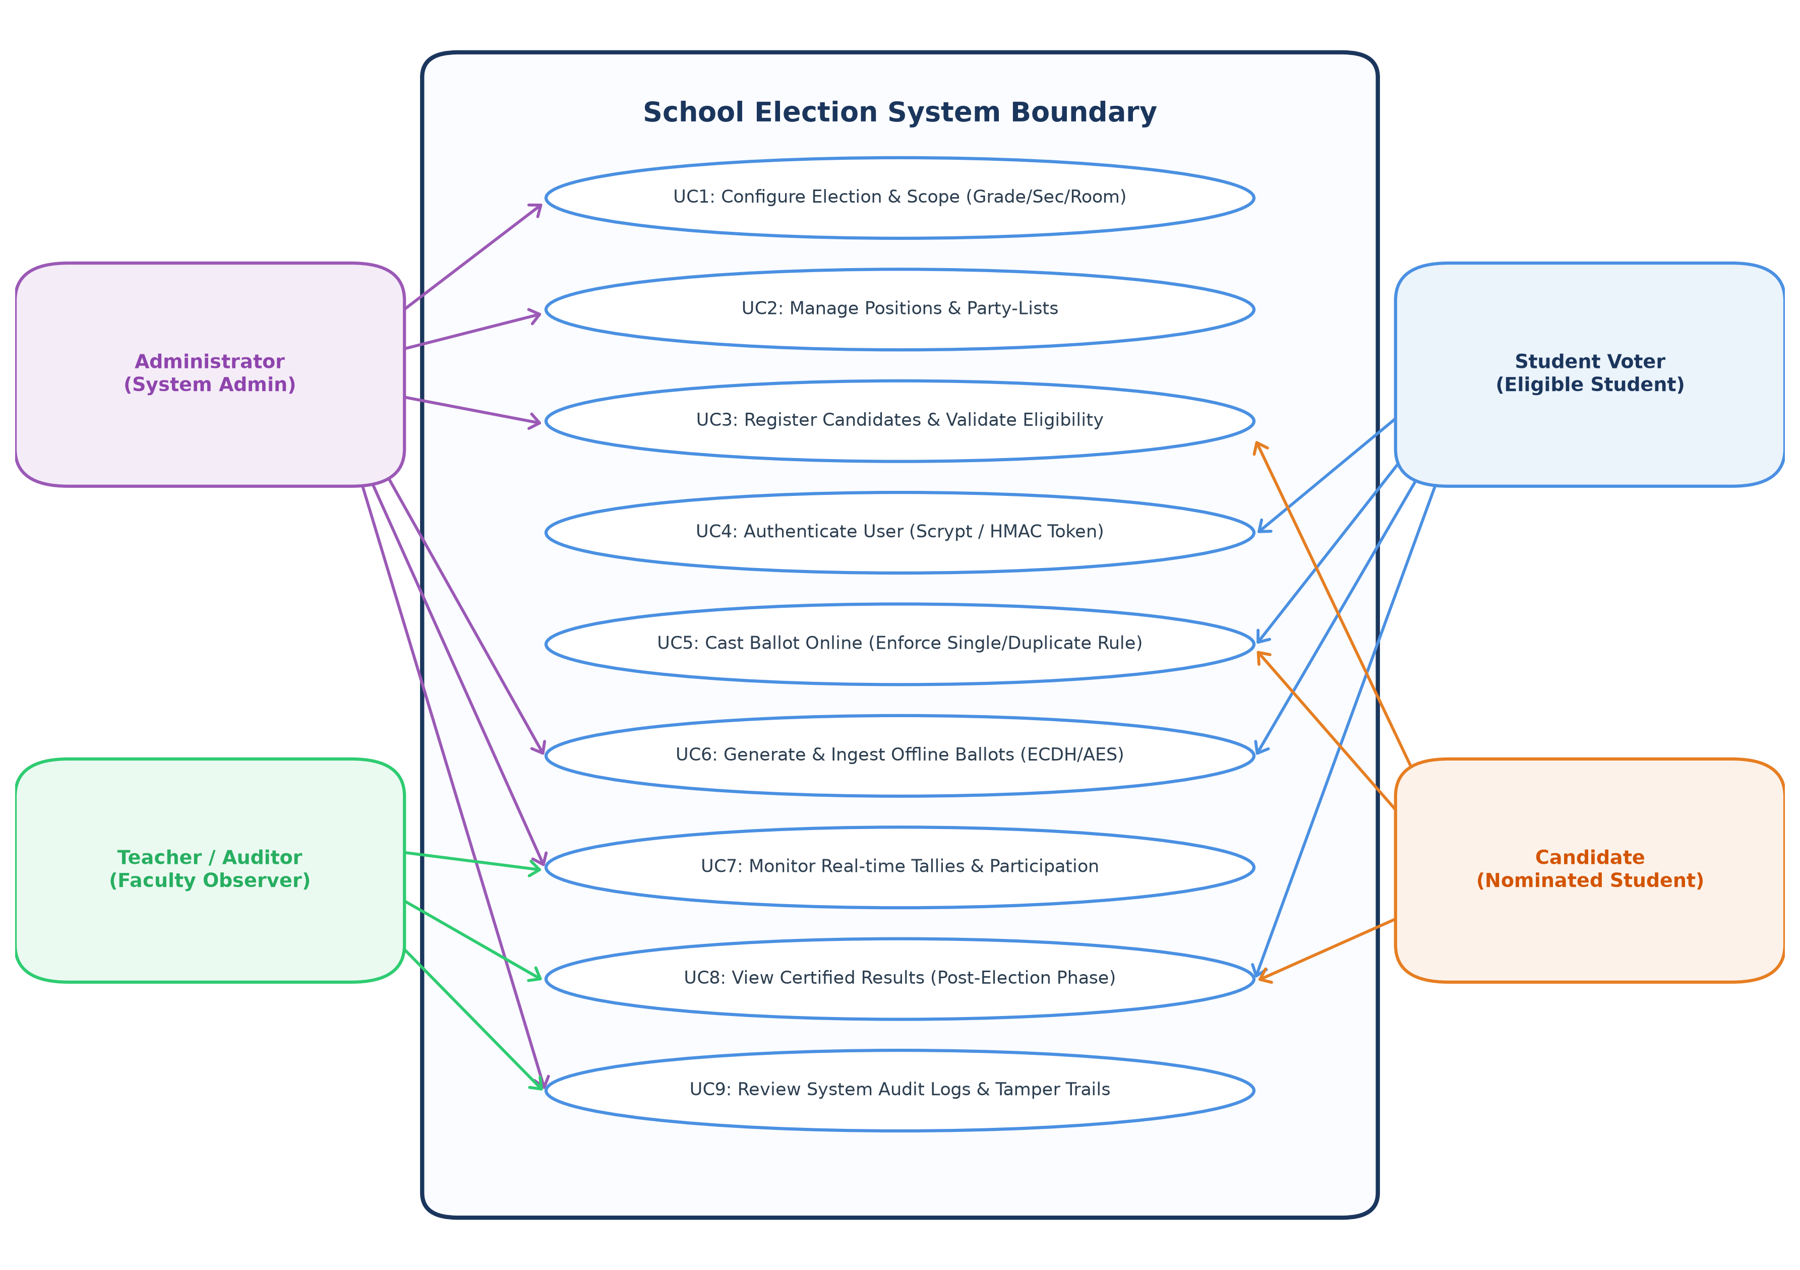
Figure: System Use Case Diagram (Actors & Functional Boundaries)
2.1 Primary Actor Profiles
Actor Role | Classification | System Responsibilities & Entitlements
Administrator | Internal / Privileged | Initializes elections, sets eligibility scoping (grade/sec/room), creates positions, registers party-lists, audits candidates, imports encrypted offline ballots, and inspects tamper audit logs.
Teacher / Auditor | Internal / Observer | Conducts real-time poll monitoring, verifies voter participation percentages without violating secret ballots, and certifies post-election outcomes.
Student Voter | External / End-User | Authenticates via Student Number and scrypt password, retrieves scoped ballots matching academic profile, submits candidate selections, and receives signed cryptographic receipts.
Candidate | External / Specialized | Submits electoral manifesto, photo portfolio, party-list affiliation, and inspects verified certified election results.

2.2 Detailed Use Case Catalog
UC ID | Use Case Title | Primary Actor | Preconditions & Governance Rules | Postconditions
UC-01 | Configure Scoped Election | Admin | Admin authenticated; Start/End timestamps valid; Scope in ['all','grade','section','room']. | Election record created with defined scope attributes.
UC-02 | Manage Positions & Party-Lists | Admin | Target election exists; Position/Party normalized name unique within election. | Positions and affiliated slates persisted in Appwrite.
UC-03 | Nominate Candidate | Admin | Student exists; Student academic profile matches election scope; Single candidacy per position. | Candidate record created with vote count initialized to 0.
UC-04 | Authenticate User | All Users | Valid Student Number; Password verified against scrypt derived hash. | Stateless HMAC-SHA256 session token issued with 12h expiry.
UC-05 | Cast Online Ballot | Student Voter | Active session; Election phase is 'live'; Student eligible for scope; Has not voted. | Votes persisted under composite key; Receipt generated; Duplicate locked.
UC-06 | Issue & Ingest Offline Ballot | Admin / Voter | Admin issues signed permit token; Ballot encrypted using ECDH-P256/AES-GCM; Nonce unused. | Nonce recorded in offlineBallots; Votes decrypted and committed atomically.
UC-07 | Monitor Real-Time Tally | Admin / Teacher | Election phase active; Aggregation query executes over votes collection. | Real-time turnout and candidate tallies displayed without ballot exposure.
UC-08 | Publish Certified Results | All Users | Election phase transitioned to 'ended' (or user is Admin/Teacher). | Official winners determined by rank and published to public portal.
UC-09 | Review Audit Trails | Admin / Teacher | Admin or Teacher role token presented. | Chronological immutable log entries retrieved with actor identity and timestamp.

3. Context Diagram (DFD Level 0)
The Level 0 Context Diagram establishes the highest-level conceptual boundary of the School Election System. It illustrates the fundamental information pipelines traversing between the core software engine and all external entities.
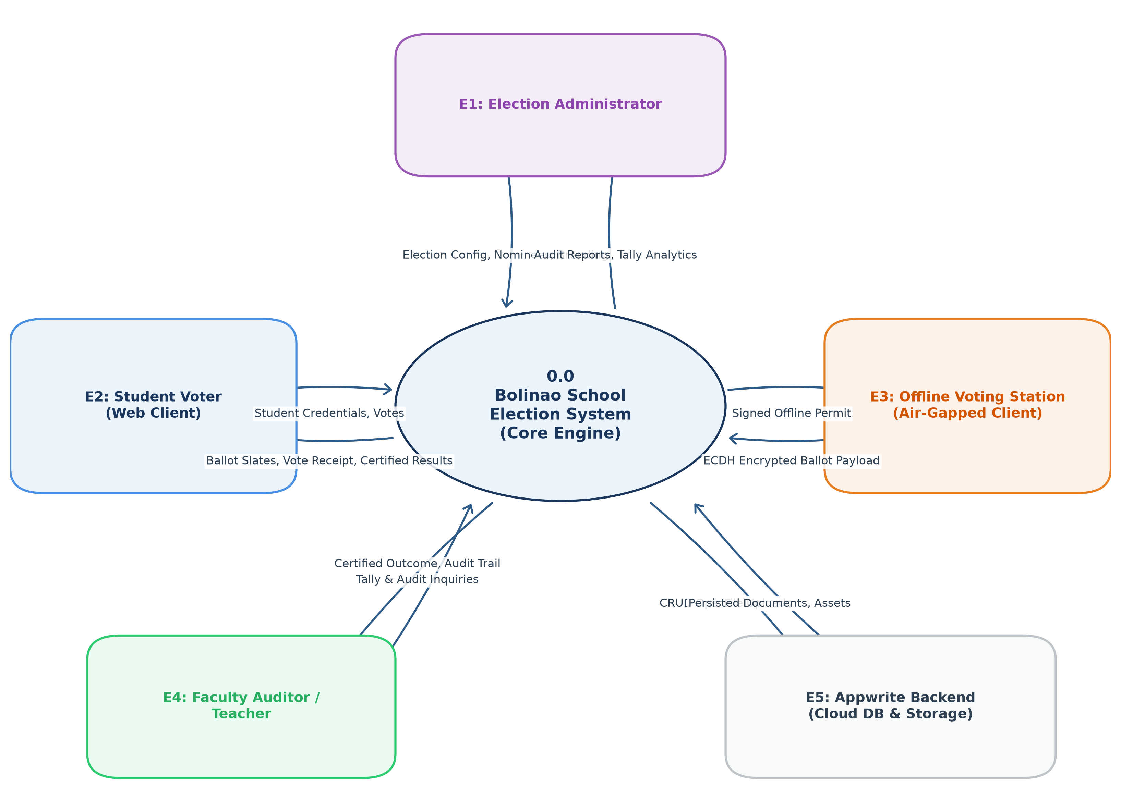
Figure: Context Diagram (DFD Level 0) Highlighting Information Boundaries
3.1 External Entity Interface Matrix
Entity Name | Entity Type | Inbound Data Streams (To System) | Outbound Data Streams (From System)
Election Administrator | Human Entity | Election parameters, position templates, party slates, candidate assets, branding settings, offline envelopes. | System audit logs, turnout statistics, integrity validation alerts, import confirmation.
Student Voter | Human Entity | Student credentials (number & password), candidate choices, password modification requests. | Scoped ballot layouts, cryptographic vote receipt, post-election certified outcomes.
Offline Voting Station | Automated Kiosk | Signed offline voting permits, encrypted ECDH-P256 ballot packages. | Time-stamped station configuration, cryptographic public keys, permit tokens.
Faculty Auditor | Human Entity | Tally requests, certification queries, discrepancy verification inquiries. | Certified winner tallies, voter turnout percentages, chronological audit events.
Appwrite Backend (Cloud) | BaaS Platform | Database document read streams, storage asset blobs, unique index constraints. | Document mutations (CRUD), file uploads (photos/logos), composite queries.

4. Data Flow Diagrams (DFD Level 1 & Level 2)
The Data Flow Architecture breaks down the monolithic system into distinct communicating functional transforms, illustrating exactly how data moves into, through, and out of persisted Appwrite collections.
4.1 DFD Level 1: System Subprocesses & Data Stores
The Level 1 DFD decomposes the system into 7 core operational processes and 8 primary data stores.
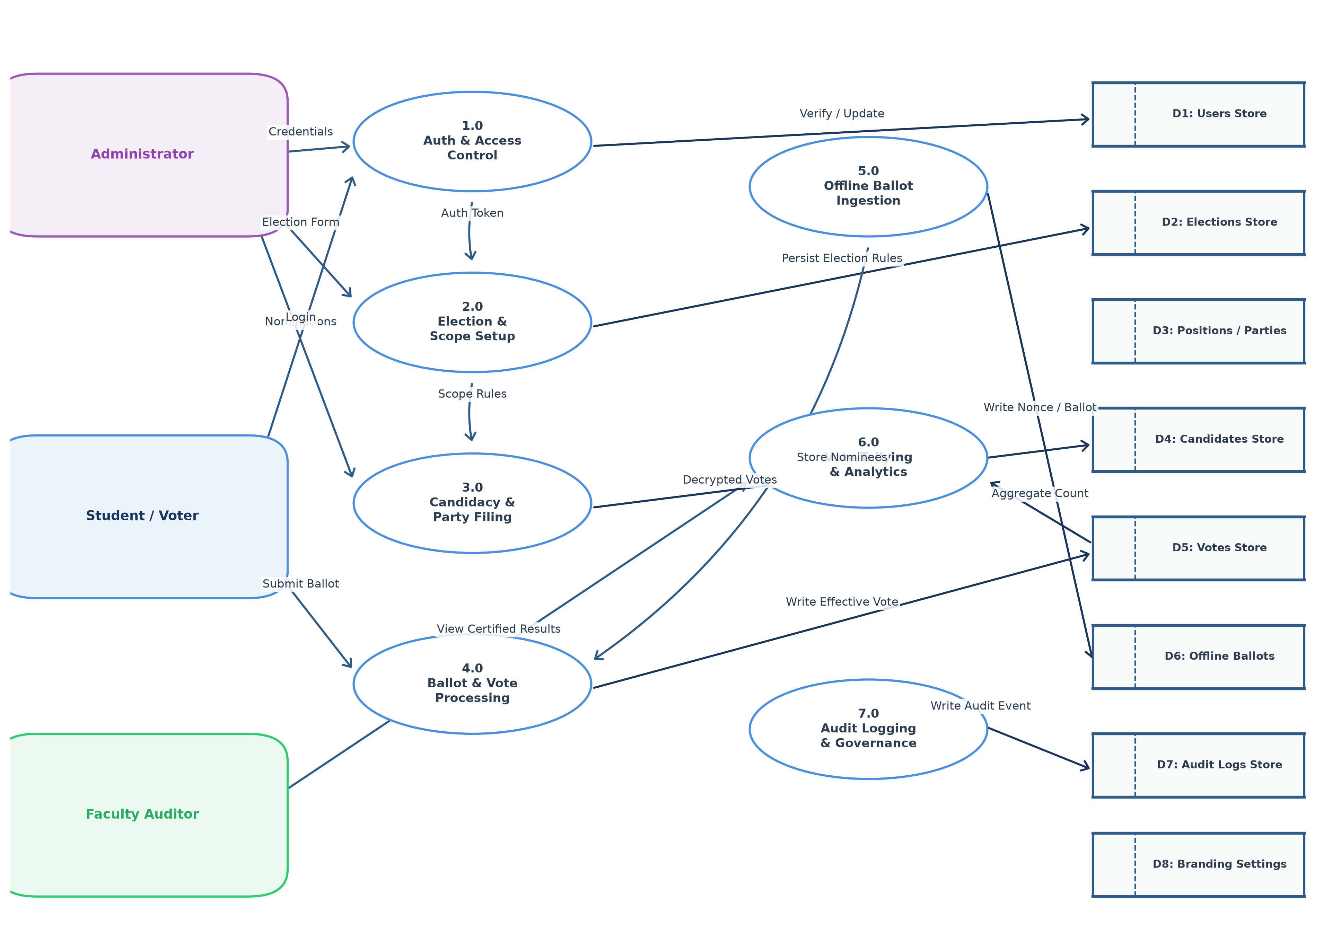
Figure: DFD Level 1: Subprocess Functional Decomposition & Data Stores
4.2 Level 1 Process Description Registry
Proc ID | Subprocess Name | Inputs | Outputs | Governing Data Stores
1.0 | Authentication & Access Control | Student Number, Password, Refresh Token | HMAC-SHA256 Token, Role, User Profile | D1: Users Store
2.0 | Election & Scope Setup | Election Dates, Scope, Grade/Sec/Room | Normalized Election Document | D2: Elections Store
3.0 | Candidacy & Party Filing | Nominee Profile, Manifesto, Party Affiliation | Verified Candidate Record | D3: Positions, D4: Candidates, D5: PartyLists
4.0 | Ballot & Vote Processing | Voter Session Token, Candidate IDs | Effective Vote Records, Digital Receipt | D1: Users, D2: Elections, D5: Votes Store
5.0 | Offline Ballot Ingestion | Encrypted Envelope (ECDH+AES), Admin Auth | Decrypted Votes, Nonce Lock | D5: Votes Store, D6: Offline Ballots Archive
6.0 | Vote Tallying & Analytics | Poll Certification Trigger, Role Token | Turnout Graphs, Candidate Vote Ranks | D5: Votes Store, D4: Candidates Store
7.0 | Audit Logging & Governance | Administrative Mutations, Security Events | Immutable Audit Record | D7: Audit Logs Store

4.3 DFD Level 2: Subprocess 4.0 (Vote Processing Decomposition)
Process 4.0 represents the critical security boundary where democratic integrity is enforced. The Level 2 decomposition maps the micro-steps required to validate, check deduplication, generate deterministic keys, and atomically commit votes.
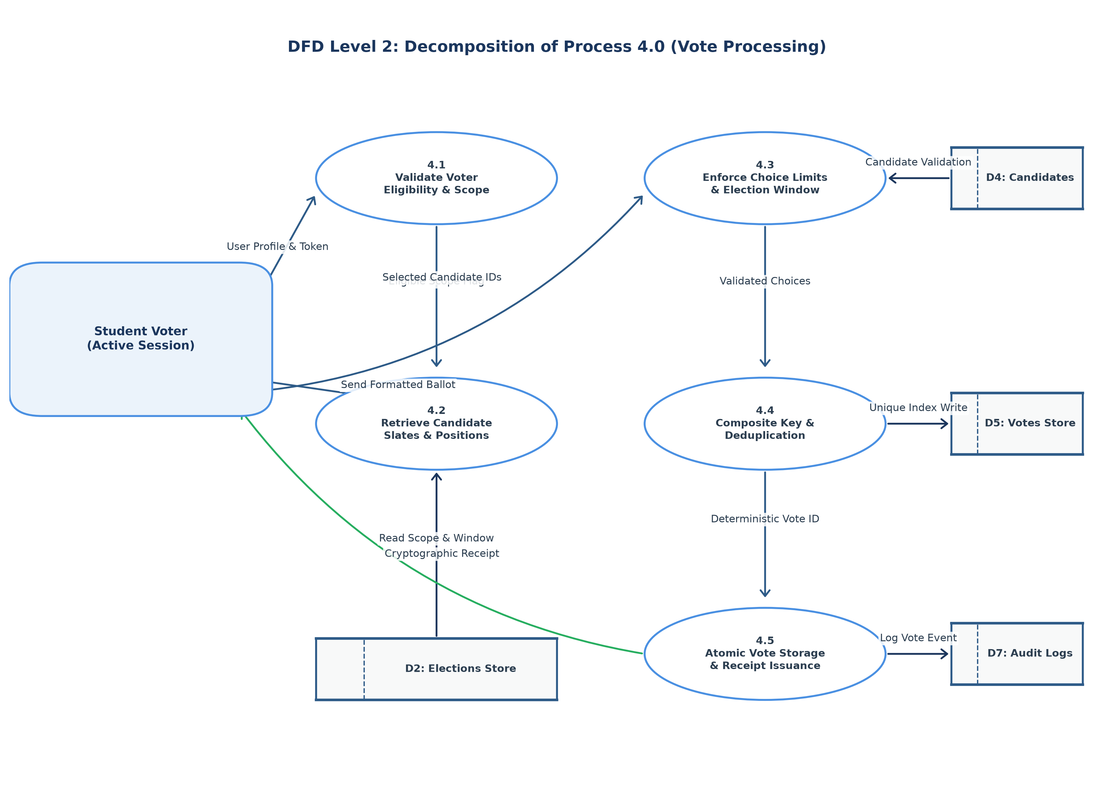
Figure: DFD Level 2: Detailed Decomposition of Process 4.0 (Vote Processing)
Sub-Proc | Action Name | Logical Operation & Security Rule
4.1 | Voter Eligibility & Scope Check | Compares student yearLevel, section, or room against election scope criteria. Rejects ineligible requests.
4.2 | Retrieve Candidate Slates | Queries positions and candidates belonging strictly to target electionId. Returns structured ballot payload.
4.3 | Enforce Choice Limits & Window | Verifies that vote count timestamp falls within [startsAt, endsAt] and validates candidate position IDs.
4.4 | Composite Key Deduplication | Generates deterministic document key v_sha256(electionId + positionId + voterId). Blocks duplicate submissions.
4.5 | Atomic Vote Write & Receipt Issuance | Executes Appwrite database write under unique constraint, increments voteCount, and issues cryptographic confirmation.

5. System Flowcharts (Level 0, Level 1, Level 2)
5.1 Flowchart Level 0: High-Level System Operational Lifecycle
The Level 0 Flowchart models the end-to-end operational stages of the election system from initial platform setup through candidate nomination, live election operation, and final audit certification.
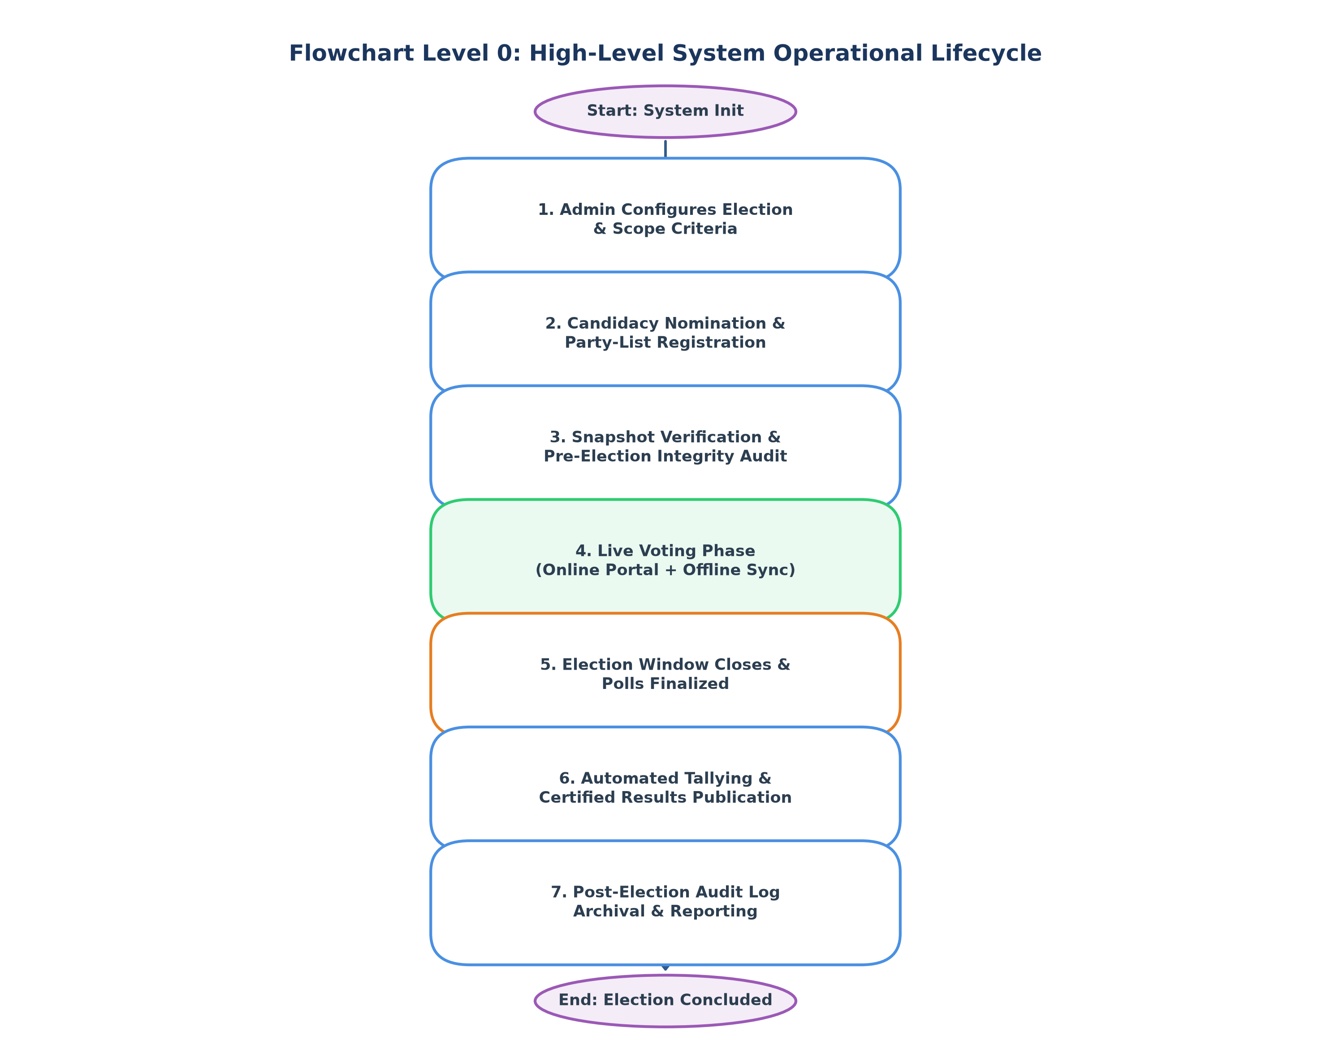
Figure: Flowchart Level 0: Comprehensive System Operating Cycle
5.2 Flowchart Level 1: Student Voter Authentication & Voting Workflow
The Level 1 Flowchart charts the exact decision tree traversed by a student voter during an active polling session.
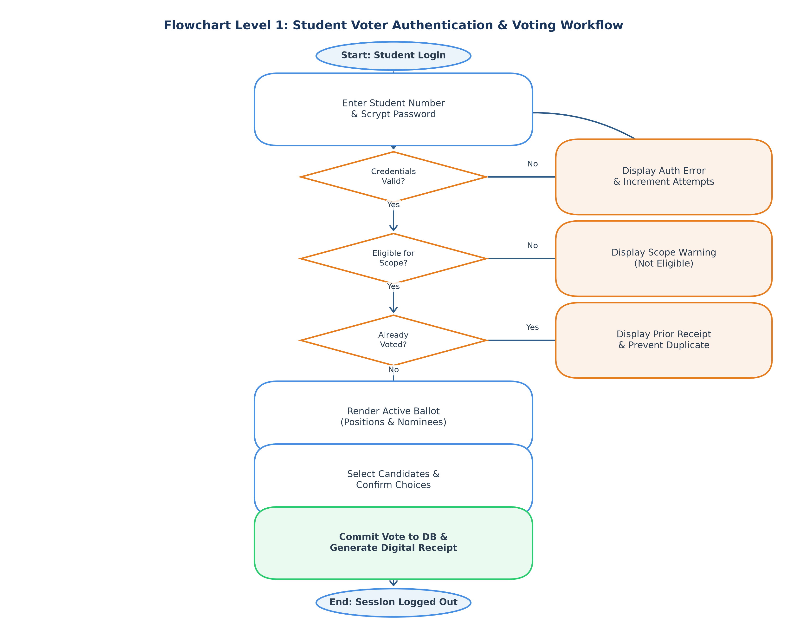
Figure: Flowchart Level 1: Voter Authentication, Eligibility Scoping & Ballot Submission
5.3 Flowchart Level 2: Cryptographic Offline Ballot Ingestion Protocol
The Level 2 Flowchart details the cryptographic security protocol used to execute air-gapped precinct voting and prevent replay, tampering, or double-voting across offline and online environments.
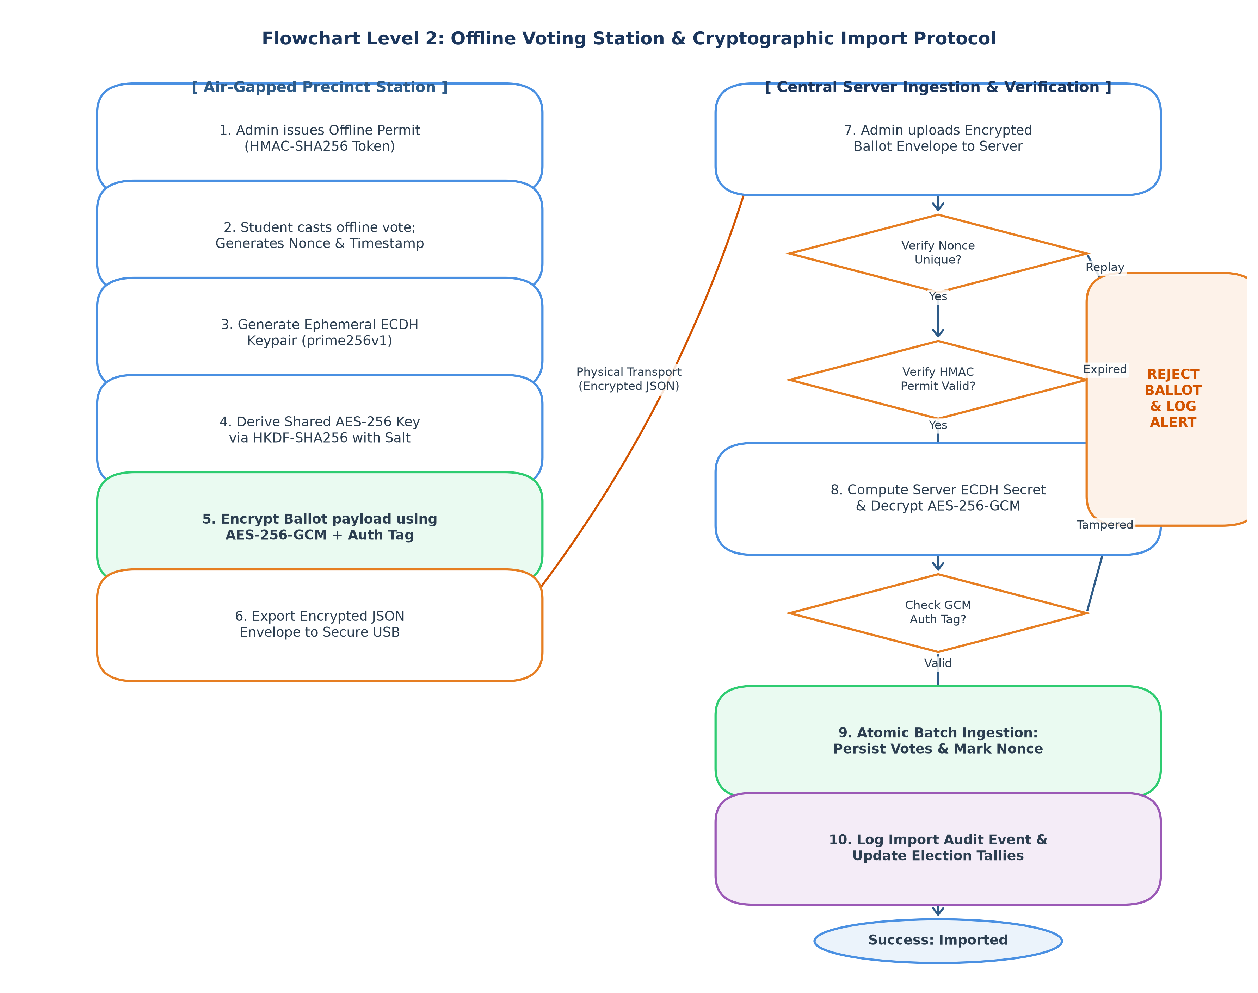
Figure: Flowchart Level 2: Hybrid Cryptographic Offline Voting & Ingestion Verification
6. Entity Relationship Diagram (ERD)
The Entity Relationship Diagram (ERD) formalizes the conceptual and logical schema implemented within Appwrite. It details all primary keys, foreign keys, cardinality relationships, and referential constraints.
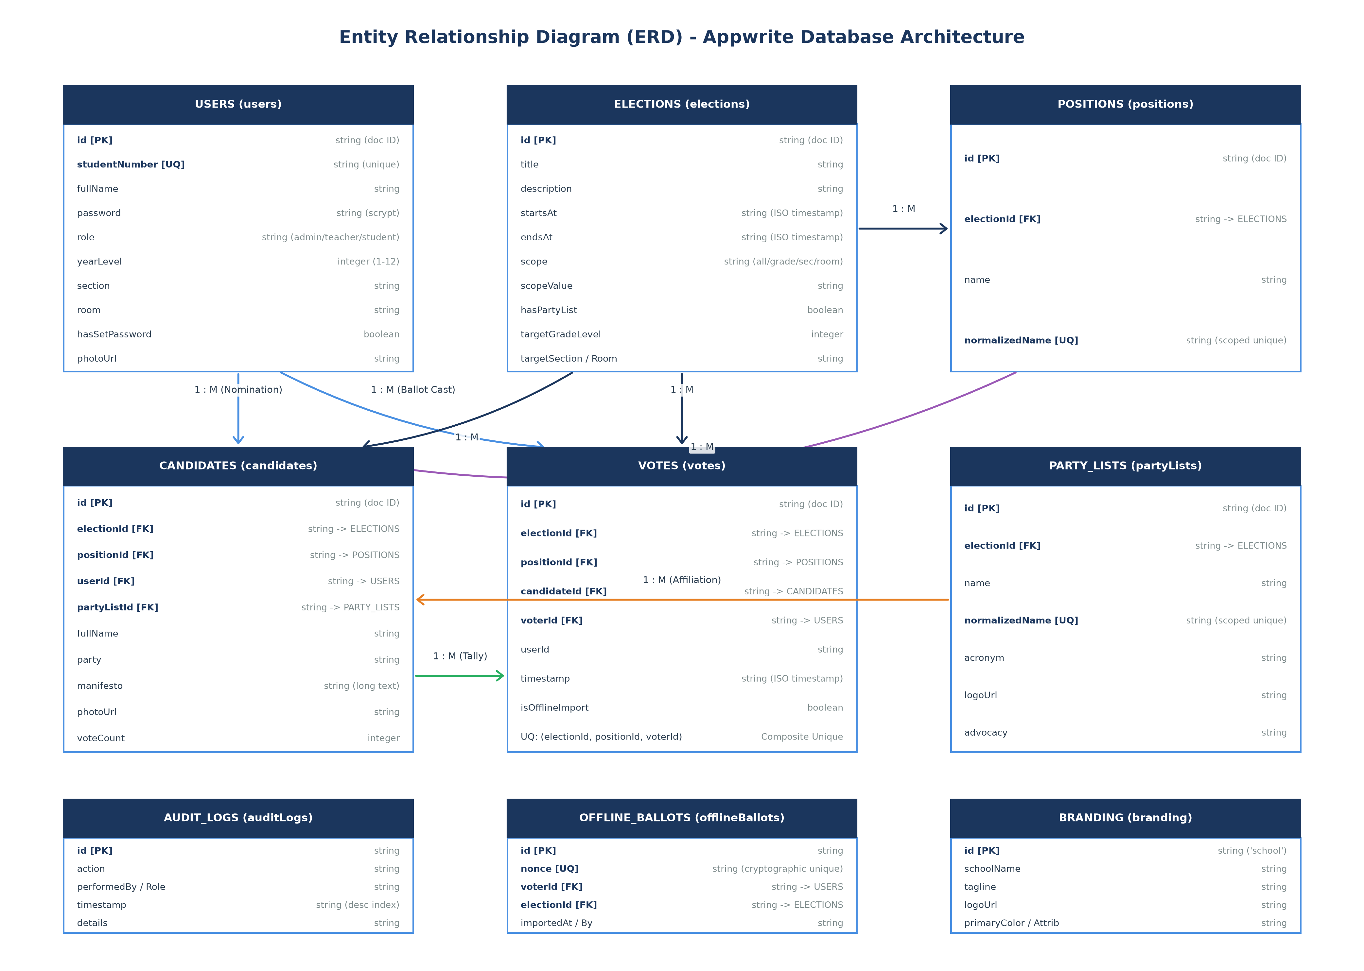
Figure: Entity Relationship Diagram (ERD) with Crow's Foot Cardinalities
6.1 Cardinality & Relationship Specification Matrix
Primary Entity | Related Entity | Cardinality | Foreign Key Mapping | Business Rule & Delete Semantics
ELECTIONS | POSITIONS | 1 : M (One-to-Many) | positions.electionId -> elections.id | Cascade: Deleting election invalidates its positions.
ELECTIONS | PARTY_LISTS | 1 : M (One-to-Many) | partyLists.electionId -> elections.id | Restricted to school-wide elections (scope == 'all').
ELECTIONS | CANDIDATES | 1 : M (One-to-Many) | candidates.electionId -> elections.id | Candidates must match election scope criteria.
ELECTIONS | VOTES | 1 : M (One-to-Many) | votes.electionId -> elections.id | Restricts vote recording to election active time window.
POSITIONS | CANDIDATES | 1 : M (One-to-Many) | candidates.positionId -> positions.id | Unique constraint on (positionId, userId).
PARTY_LISTS | CANDIDATES | 1 : M (One-to-Many) | candidates.partyListId -> partyLists.id | Optional; candidate can run as Independent.
USERS | CANDIDATES | 1 : M (One-to-Many) | candidates.userId -> users.id | Student role required; student grade within scope.
USERS | VOTES | 1 : M (One-to-Many) | votes.voterId -> users.id | Single effective vote per voter per position.
ELECTIONS | OFFLINE_BALLOTS | 1 : M (One-to-Many) | offlineBallots.electionId -> elections.id | Cryptographic nonce deduplication across precincts.

7. Complete Database Schema & Data Dictionary
The following section provides the complete data dictionary for all 9 collections configured in Appwrite Database 'voting_db'. Every attribute, data type, storage size, default value, and index requirement is exhaustively documented.
7.USERS Collection: `users`
Collection Description: Stores identity records, security credentials, and academic demographics for administrators, teachers, and students.
Attribute Key | Type | Size / Range | Req / Null | Index / Key Type | Functional Description & Rules
$id | string | 36 chars | Required | PK (Unique) | Deterministic user document ID (u_{sha256(studentNumber)}).
studentNumber | string | 64 chars | Required | Unique Index | Normalized unique alphanumeric identifier (e.g., 2026-0012).
password | string | 255 chars | Required | None | Scrypt derived key hash format: scrypt${salt}${hash}.
fullName | string | 255 chars | Required | None | Legal complete name of the user.
role | string | 50 chars | Required | Key Index | Authorization role: 'admin' | 'teacher' | 'student'.
yearLevel | integer | 1 to 12 | Optional | None | Grade level for students (required if role == 'student').
section | string | 255 chars | Optional | None | Academic section name (e.g., 'Aquaculture-A').
room | string | 255 chars | Optional | None | Assigned homeroom identifier (e.g., 'Lab-102').
hasSetPassword | boolean | 1 bit | Required | None | Flag indicating whether default bootstrap password has been modified.
photoUrl | string | 1000 chars | Optional | None | Appwrite storage file URL for user avatar.

7.ELECTIONS Collection: `elections`
Collection Description: Contains administrative election configurations, timing parameters, and constituency scoping boundaries.
Attribute Key | Type | Size / Range | Req / Null | Index / Key Type | Functional Description & Rules
$id | string | 36 chars | Required | PK (Unique) | Unique document identifier generated by Appwrite.
title | string | 255 chars | Required | None | Public title of the electoral event (e.g., 'SSG General Election 2026').
description | string | 5000 chars | Optional | None | Comprehensive summary of rules, agenda, and instructions.
startsAt | string | 255 chars | Required | None | ISO-8601 UTC timestamp defining voting commencement.
endsAt | string | 255 chars | Required | None | ISO-8601 UTC timestamp defining poll termination.
scope | string | 50 chars | Required | None | Boundary type: 'all' | 'grade' | 'section' | 'room'.
scopeValue | string | 255 chars | Required | None | Target identifier corresponding to scope parameter.
hasPartyList | boolean | 1 bit | Required | None | Enables slate voting; restricted to school-wide ('all') elections.
targetGradeLevel | integer | 1 to 12 | Optional | None | Explicit numeric grade if scope is 'grade'.
targetSection | string | 255 chars | Optional | None | Explicit section string if scope is 'section'.
targetRoom | string | 255 chars | Optional | None | Explicit room string if scope is 'room'.
hasPartyListSupport | boolean | 1 bit | Optional | None | Legacy parity flag mirroring hasPartyList.

7.POSITIONS Collection: `positions`
Collection Description: Defines available electoral seats belonging to a specific election.
Attribute Key | Type | Size / Range | Req / Null | Index / Key Type | Functional Description & Rules
$id | string | 36 chars | Required | PK (Unique) | Unique position identifier.
electionId | string | 255 chars | Required | Key Index | Foreign key referencing parent election document.
name | string | 255 chars | Required | None | Display title of the seat (e.g., 'President', 'Treasurer').
normalizedName | string | 255 chars | Required | Composite Unique | Lowercase trimmed name; unique per electionId.
title | string | 255 chars | Optional | None | Legacy title alias retained for backward compatibility.

7.CANDIDATES Collection: `candidates`
Collection Description: Represents nominated students contesting for specific positions within an election.
Attribute Key | Type | Size / Range | Req / Null | Index / Key Type | Functional Description & Rules
$id | string | 36 chars | Required | PK (Unique) | Unique candidate identifier.
electionId | string | 255 chars | Required | Key Index | Foreign key referencing elections collection.
positionId | string | 255 chars | Required | Key Index | Foreign key referencing positions collection.
userId | string | 255 chars | Required | Key / Unique | Foreign key referencing users collection; unique per positionId.
fullName | string | 255 chars | Required | None | Nominee name displayed on official ballot.
party | string | 255 chars | Optional | None | Name of political affiliation or 'Independent'.
partyListId | string | 255 chars | Optional | Key Index | Foreign key referencing partyLists collection.
partyListName | string | 255 chars | Optional | None | Denormalized party-list label for fast ballot rendering.
manifesto | string | 10000 chars | Required | None | Comprehensive platform statement and campaign promises.
photoUrl | string | 1000 chars | Optional | None | URL of campaign portrait stored in Appwrite Storage bucket.
voteCount | integer | >= 0 | Required | None | Aggregated tally cache, default initialized to 0.

7.VOTES Collection: `votes`
Collection Description: Stores individual ballot marks cast by eligible voters.
Attribute Key | Type | Size / Range | Req / Null | Index / Key Type | Functional Description & Rules
$id | string | 36 chars | Required | PK (Unique) | Deterministic key format: v_{sha256(electionId+positionId+voterId)}.
electionId | string | 255 chars | Required | Key Index | Foreign key referencing target election.
positionId | string | 255 chars | Required | Key Index | Foreign key referencing contested position.
candidateId | string | 255 chars | Required | Key Index | Foreign key referencing chosen candidate.
voterId | string | 255 chars | Required | Key Index | Foreign key referencing student voter document.
userId | string | 255 chars | Required | None | Legacy alias mirroring voterId for query parity.
timestamp | string | 255 chars | Required | None | ISO timestamp indicating exact moment of vote casting.
isOfflineImport | boolean | 1 bit | Required | None | True if ballot originated from air-gapped offline precinct.

7.PARTYLISTS Collection: `partyLists`
Collection Description: Stores accredited political slates and collective advocacies.
Attribute Key | Type | Size / Range | Req / Null | Index / Key Type | Functional Description & Rules
$id | string | 36 chars | Required | PK (Unique) | Unique party-list document identifier.
electionId | string | 255 chars | Required | Key Index | Foreign key referencing parent school-wide election.
name | string | 255 chars | Required | None | Full legal title of the party-list.
normalizedName | string | 255 chars | Required | Composite Unique | Lowercase trimmed name; unique per electionId.
acronym | string | 50 chars | Optional | None | Shortened party abbreviation (e.g., 'BSF-ALLIANCE').
logoUrl | string | 1000 chars | Optional | None | Appwrite storage URL for party insignia.
advocacy | string | 5000 chars | Optional | None | Detailed organizational principles and legislative agenda.

7.AUDITLOGS Collection: `auditLogs`
Collection Description: Maintains an immutable append-only chronological ledger of all security-sensitive administrative operations.
Attribute Key | Type | Size / Range | Req / Null | Index / Key Type | Functional Description & Rules
$id | string | 36 chars | Required | PK (Unique) | Unique log entry identifier.
action | string | 255 chars | Required | None | Operation type: 'LOGIN', 'ELECTION_CREATE', 'OFFLINE_IMPORT', etc.
performedBy | string | 255 chars | Required | None | Student number or identity of operator.
performedByRole | string | 50 chars | Required | None | Administrative authority level at moment of action.
timestamp | string | 255 chars | Required | Key (Desc) | ISO UTC timestamp; indexed in descending order.
details | string | 5000 chars | Required | None | Detailed JSON or textual description of operation payload.

7.OFFLINEBALLOTS Collection: `offlineBallots`
Collection Description: Cryptographic ledger recording consumed nonces to prevent replay attacks from imported offline precinct envelopes.
Attribute Key | Type | Size / Range | Req / Null | Index / Key Type | Functional Description & Rules
$id | string | 36 chars | Required | PK (Unique) | Unique ingestion record ID.
nonce | string | 255 chars | Required | Unique Index | Cryptographic random nonce embedded in signed ballot.
voterId | string | 255 chars | Required | Key Index | Foreign key referencing voting student.
electionId | string | 255 chars | Required | Key Index | Foreign key referencing target election.
importedAt | string | 255 chars | Required | None | ISO timestamp when server ingested envelope.
importedBy | string | 255 chars | Required | None | Administrator who authorized and uploaded the package.

7.BRANDING Collection: `branding`
Collection Description: Contains institutional presentation assets and contact metadata.
Attribute Key | Type | Size / Range | Req / Null | Index / Key Type | Functional Description & Rules
$id | string | 36 chars | Required | PK (Unique) | Static singleton document ID ('school').
schoolName | string | 255 chars | Required | None | Official academic institution title.
tagline | string | 500 chars | Required | None | Motto displayed on header and landing pages.
logoUrl | string | 1000 chars | Required | None | Storage link to official high-res school seal.
primaryColor | string | 50 chars | Required | None | Hex code for primary user interface elements (e.g., #0284c7).
attributionText | string | 500 chars | Required | None | Permanent developer attribution notice.
contactEmail | string | 255 chars | Optional | None | Official IT support contact address.
address | string | 1000 chars | Optional | None | Physical postal address of the institution.

8. Database Indexing & Uniqueness Constraint Registry
To guarantee sub-millisecond query performance and physically prevent duplicate ballots, the database enforces 18 specialized indexes across collections. The registry below outlines each index definition.
Collection | Index Identifier | Index Type | Target Attributes | Operational Purpose
users | student_number_unique | Unique | studentNumber | Guarantees absolute uniqueness of student numbers across campus.
users | role_index | Key | role | Accelerates filtering of administrative and faculty accounts.
positions | positions_election | Key | electionId | Optimizes retrieval of all positions within an active election.
positions | positions_election_name | Unique | electionId, normalizedName | Prevents duplicate position titles within the same election.
candidates | candidates_election | Key | electionId | Accelerates candidate slate compilation during ballot rendering.
candidates | candidates_election_position | Key | electionId, positionId | Fetches candidate roster for a specific contested office.
candidates | candidates_position_user | Unique | positionId, userId | Strictly prohibits a student from being nominated twice for one seat.
candidates | candidates_user | Key | userId | Validates student candidacy status.
candidates | candidates_party_list | Key | partyListId | Groups candidates by political slate for party voting.
votes | votes_effective_unique | Unique | electionId, positionId, voterId | Core deduplication constraint: physically blocks multi-voting.
votes | votes_election_voter | Key | electionId, voterId | Retrieves complete ballot marks cast by a voter for receipt rendering.
votes | votes_candidate | Key | candidateId | Accelerates real-time count aggregation queries.
partyLists | party_election_normalized_name | Unique | electionId, normalizedName | Guarantees party names cannot be duplicated in an election.
auditLogs | audit_timestamp | Key (Desc) | timestamp (DESC) | Optimizes chronological audit trail pagination.
offlineBallots | offline_nonce_unique | Unique | nonce | Prevents cryptographic replay attacks during offline ballot imports.

9. Security, Cryptography & Audit Architecture
The system incorporates multi-layered cryptographic standards to guarantee non-repudiation, secret ballot privacy, and data durability.
9.1 Password Security via Scrypt Key Derivation
All credentials are protected using the memory-hard scrypt algorithm with a 16-byte random salt and 64-byte derived key length. Passphrases are formatted as `scrypt${salt_b64url}${derived_b64url}`. Constant-time comparison (`crypto.timingSafeEqual`) is strictly enforced to mitigate side-channel and timing attacks.
9.2 Stateless HMAC-SHA256 Session & Permit Tokens
Authentication tokens and offline voter permits utilize HMAC-SHA256 digital signatures with a 256-bit server secret. Each token envelope encapsulates a version tag (`v: 1`), issued timestamp (`iat`), expiration boundary (`exp`), and specific intended purpose, preventing cross-protocol token reuse.
9.3 Air-Gapped Hybrid Cryptosystem (ECDH-P256 + AES-256-GCM)
For precincts operating without active network connectivity, ballots are generated on air-gapped terminals using an ephemeral Elliptic Curve Diffie-Hellman (ECDH over NIST curve prime256v1) keypair. The shared secret is derived via HKDF-SHA256 with a 32-byte salt, and the payload is sealed using AES-256-GCM with a 12-byte IV and 16-byte authentication tag. The server alone possesses the private key capable of decrypting the envelope upon physical return to central headquarters.

