**Submitted By: Shah Sarmad Hamdani**

**Reg. No. fa21-bcs-021**

**Input**: The compiler takes a C source code file as input. Example input files provided in the repository include input1.c, input2.c, input3.c, and input4.c.

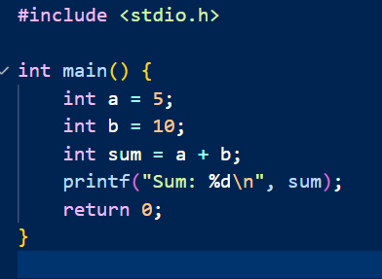

**Output**: The compiler processes the input C code and generates an executable file named a.exe. This executable represents the compiled version of the input C program.

