GitHub Actions and GitHub Pages Workflow Model
From Documentation Source to Published Site with GitHub Actions and GitHub Pages
Visual Documentation Case Study

PREPARED BY: | Jovi Sarmiento
CREATED ON: | DD Month YYYY  (Updated on DD Month YYYY)
VERSION: | Version XX

Table of Contents

1. Overview 1
2. Case Study Fields 2
2.1. Source & Context 2
2.2. Communication Problem 2
2.3. Audience 3
2.4. Design Decisions 3
2.5. Visualization 3
2.6. Source Material 3

List of Figures

Figure 1 GitHub Actions and GitHub Pages Workflow Model 3

List of Tables

Table 1 Case Study Fields 2

Version History

Rev # | System Version | Description | Author | Date | Reviewer | Date
1.0 |  | Initial document publication | J. Sarmiento

- Overview
This visual documentation case study demonstrates how complex technical information can be analyzed, structured, and translated into a purposeful visualization. It presents the context and source material behind the visualization, the communication problem it addresses, the intended audience, and the design decisions used to determine its scope, structure, and level of detail.
The case study includes the resulting visualization and identifies the source material used to understand and represent the subject.
- Case Study Fields
Each case study follows a consistent structure to document the context, communication need, intended audience, visualization approach, and supporting references behind the resulting visual solution.
Table 1 Case Study Fields
Source Field | Description
Source & Context | What information or system was studied and where the visualization originated
Communication Problem | What aspect of the information is difficult to understand or needs clarification
Audience | Who the visualization is intended to help
Design Decisions | Why a particular diagram type, scope, structure, and level of detail were selected
Visualization | The resulting visual solution
Source Material | The authoritative references used to understand and verify the subject
  - Source & Context
This visualization is based on GitHub's documented GitHub Actions and GitHub Pages workflow model. GitHub Actions can automate build and deployment processes in response to repository events, while GitHub Pages can publish static site output produced by a workflow.
  - Communication Problem
Documentation authors working with Docs-as-Code may understand that a repository change eventually appears on a published website without clearly understanding the automated stages between source content and deployment. The visualization explains that technical processing pipeline at a conceptual level.
  - Audience
Documentation specialists, technical writers, and new contributors learning a Docs-as-Code publishing workflow.
  - Design Decisions
A Technical Process Flow was selected to show how documentation source is transformed and moved through an automated build and deployment pipeline. The visualization emphasizes the progression of documentation and generated artifacts through systems, processing stages, and changes in state, while the connections describe the actions and transformations that move the documentation toward the published site.
To maintain focus on the primary build and deployment process, the visualization intentionally omits:
- Detailed GitHub Actions workflow configuration
- Individual build commands and dependencies
- Authentication and permission configuration
- Error handling and failed deployment scenarios
- Other implementation details not required to understand the primary documentation pipeline
  - Visualization
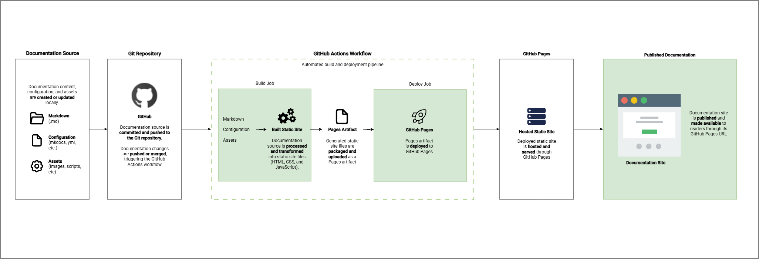
Figure 1 GitHub Actions and GitHub Pages Workflow Model
  - Source Material
The folliwng links to the original public documentation/repository.

- GitHub - Understanding GitHub Actions
- GitHub - Using custom workflows with GitHub Pages
- GitHub - Configuring a publishing source for GitHub Pages

