OpenTelemetry Demo System Architecture
High-Level View of Application Services, Telemetry Collection, and Observability
Visual Documentation Case Study

PREPARED BY: | Jovi Sarmiento
CREATED ON: | DD Month YYYY  (Updated on DD Month YYYY)
VERSION: | Version XX

Table of Contents

1. Overview 1
2. Case Study Fields 2
2.1. Source & Context 2
2.2. Communication Problem 2
2.3. Audience 3
2.4. Design Decisions 3
2.5. Visualization 4
2.6. Source Material 4

List of Figures

Figure 1 OpenTelemetry Demonstration 4

List of Tables

Table 1 Case Study Fields 2

Version History

Rev # | System Version | Description | Author | Date | Reviewer | Date
1.0 |  | Initial document publication | J. Sarmiento

- Overview
This visual documentation case study demonstrates how complex technical information can be analyzed, structured, and translated into a purposeful visualization. It presents the context and source material behind the visualization, the communication problem it addresses, the intended audience, and the design decisions used to determine its scope, structure, and level of detail.
The case study includes the resulting visualization and identifies the source material used to understand and represent the subject.
- Case Study Fields
Each case study follows a consistent structure to document the context, communication need, intended audience, visualization approach, and supporting references behind the resulting visual solution.
Table 1 Case Study Fields
Source Field | Description
Source & Context | What information or system was studied and where the visualization originated
Communication Problem | What aspect of the information is difficult to understand or needs clarification
Audience | Who the visualization is intended to help
Design Decisions | Why a particular diagram type, scope, structure, and level of detail were selected
Visualization | The resulting visual solution
Source Material | The authoritative references used to understand and verify the subject
  - Source & Context
This visualization is based on the OpenTelemetry Demonstration, a distributed microservice application designed to demonstrate OpenTelemetry instrumentation and observability in a production-like environment.
The application contains services implemented in multiple programming languages that communicate using gRPC and HTTP.
  - Communication Problem
The complete demo contains numerous application and observability components, making the architecture potentially difficult for a newcomer to interpret. The visualization provides a simplified overview of the major functional groups, key service relationships, and the connection between application services and observability infrastructure.
  - Audience
Developers and technical team members who are encountering the OpenTelemetry Demo architecture for the first time.
  - Design Decisions
A Component Architecture Diagram is selected to show the major system components their functional groupings, and how do they interact.
The visualization emphasizes system structure, component boundaries, and the relationships between major services. Related microservices are grouped into functional areas to support a high-level understanding of the architecture.
To maintain focus on the primary architecture, the visualization intentionally omits:
- Detailed instrumentation configuration
- Feature-flag scenarios
- Testing components
- Lower-level service interactions
- Other implementation details not required to understand the primary architecture
  - Visualization
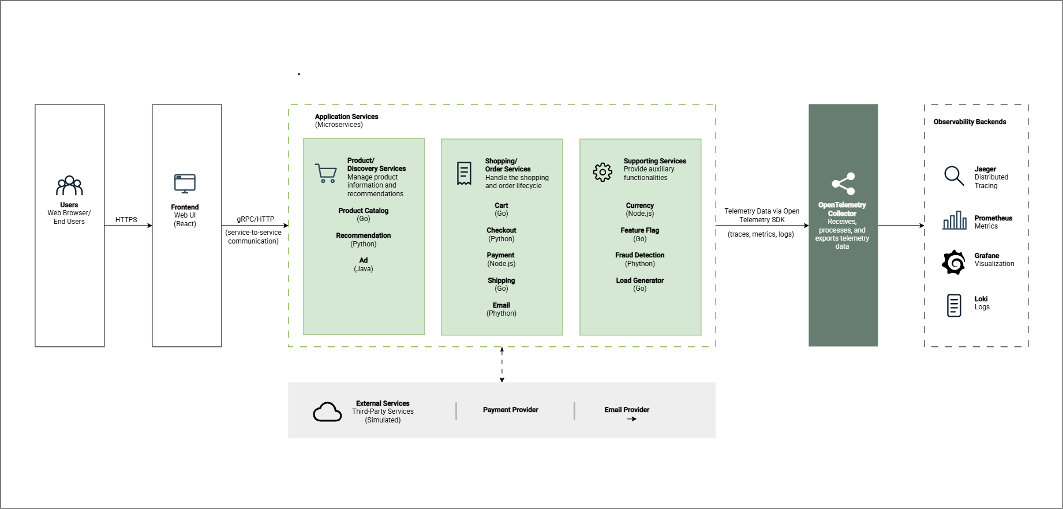
Figure 1 OpenTelemetry Demonstration
  - Source Material
The following are the links to the original public documentation/repository.
- OpenTelemetry Demo - Architecture
- OpenTelemetry Demo - Services
- OpenTelemetry Demo - Architecture Requirements

