GitHub's Documented Pull Request Workflow
Contributor, Review, Revision, and Merge Process
Visual Documentation Case Study

PREPARED BY: | Jovi Sarmiento
CREATED ON: | DD Month YYYY  (Updated on DD Month YYYY)
VERSION: | Version XX

Table of Contents

1. Overview 1
2. Case Study Fields 2
2.1. Source & Context 2
2.2. Communication Problem 2
2.3. Audience 3
2.4. Design Decisions 3
2.5. Visualization 4
2.6. Source Material 5

List of Figures

Figure 1 GitHub's Documented Pull Request Workflow 4

List of Tables

Table 1 Case Study Fields 2

Version History

Rev # | System Version | Description | Author | Date | Reviewer | Date
1.0 |  | Initial document publication | J. Sarmiento

- Overview
This visual documentation case study demonstrates how complex technical information can be analyzed, structured, and translated into a purposeful visualization. It presents the context and source material behind the visualization, the communication problem it addresses, the intended audience, and the design decisions used to determine its scope, structure, and level of detail.
The case study includes the resulting visualization and identifies the source material used to understand and represent the subject.
- Case Study Fields
Each case study follows a consistent structure to document the context, communication need, intended audience, visualization approach, and supporting references behind the resulting visual solution.
Table 1 Case Study Fields
Source Field | Description
Source & Context | What information or system was studied and where the visualization originated
Communication Problem | What aspect of the information is difficult to understand or needs clarification
Audience | Who the visualization is intended to help
Design Decisions | Why a particular diagram type, scope, structure, and level of detail were selected
Visualization | The resulting visual solution
Source Material | The authoritative references used to understand and verify the subject
  - Source & Context
This visualization is based on GitHub's documented pull request workflow. Pull requests provide a collaborative process for proposing, reviewing, discussing, validating, and merging changes before they become part of the target branch.
  - Communication Problem
The documented workflow involves activities performed by both the change author and the reviewer, together with the repository-level actions and checks.
The visualization is intended to make the sequence of activities, responsibilities, review outcomes, and feedback loop easier to understand.
  - Audience
New team members who understand the basic Git concepts but are unfamiliar with collaborative pull request workflows in GitHub.
  - Design Decisions
A Cross-Functional Flowchart is selected to show how activities move between the contributor, GitHub, and reviewer throughout the pull request process. The visualization shows who does what, and emphasizes activities, responsibilities, handoffs, and the primary review-and-revision cycle.
- Stacked pull requests
- Merge conflicts
- Auto-merge
- Branch protection configuration
- Repository-specific rules
  - Visualization
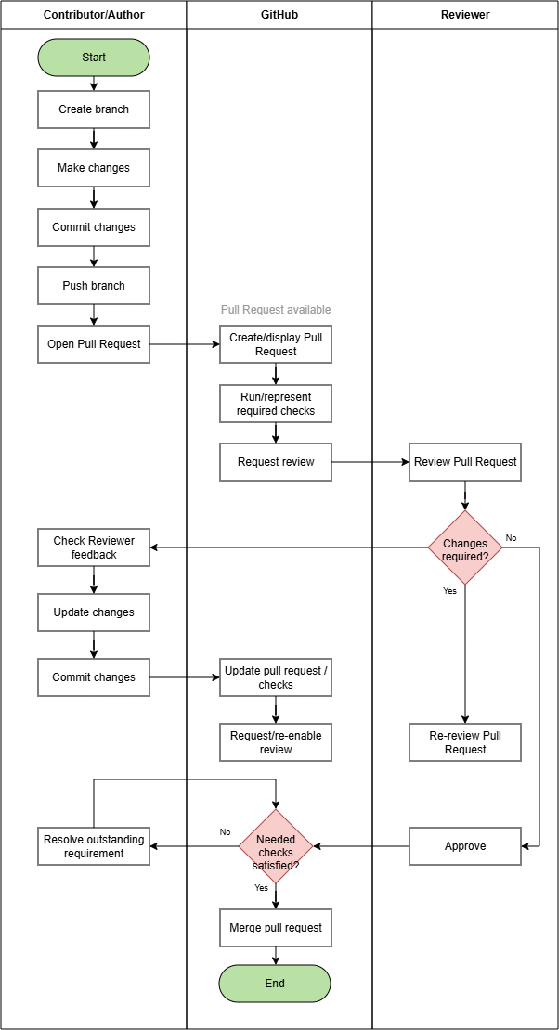
Figure 1 GitHub's Documented Pull Request Workflow
  - Source Material
The following are the links to the original public documentation/repository:
- GitHub - About pull requests
- GitHub - Giving reviews

