Northwind Core Order Data Model
Entity Relationships Supporting the Order-Processing Domain
Visual Documentation Case Study

PREPARED BY: | Jovi Sarmiento
CREATED ON: | DD Month YYYY  (Updated on DD Month YYYY)
VERSION: | Version XX

Table of Contents

1. Overview 1
2. Case Study Fields 2
2.1. Source & Context 2
2.2. Communication Problem 2
2.3. Audience 3
2.4. Design Decisions 3
2.5. Visualization 4
2.6. Source Material 4

List of Figures

Figure 1 Northwind Core Order Data Model 4

List of Tables

Table 1 Case Study Fields 2

Version History

Rev # | System Version | Description | Author | Date | Reviewer | Date
1.0 |  | Initial document publication | J. Sarmiento

- Overview
This visual documentation case study demonstrates how complex technical information can be analyzed, structured, and translated into a purposeful visualization. It presents the context and source material behind the visualization, the communication problem it addresses, the intended audience, and the design decisions used to determine its scope, structure, and level of detail.
The case study includes the resulting visualization and identifies the source material used to understand and represent the subject.
- Case Study Fields
Each case study follows a consistent structure to document the context, communication need, intended audience, visualization approach, and supporting references behind the resulting visual solution.
Table 1 Case Study Fields
Source Field | Description
Source & Context | What information or system was studied and where the visualization originated
Communication Problem | What aspect of the information is difficult to understand or needs clarification
Audience | Who the visualization is intended to help
Design Decisions | Why a particular diagram type, scope, structure, and level of detail were selected
Visualization | The resulting visual solution
Source Material | The authoritative references used to understand and verify the subject
  - Source & Context
This visualization is based on Microsoft's Northwind sample database. The exercise focuses on the portion of the schema supporting customers, orders, order details, products, and product classification rather than documenting the complete database.
  - Communication Problem
A complete database schema can contain more information than a reader needs when trying to understand a specific business domain. This visualization isolates the core entities involved in order processing and shows how customer orders connect to individual products and supporting product information.
  - Audience
Developers, technical analysts, and documentation professionals who need a high-level understanding of the Northwind order data model.
  - Design Decisions
An Entity Relationship Diagram (ERD) is selected to show the entities relevant to the Northwind order-processing domain and how they relate to one another. The visualization emphasizes data structure and relationships through primary keys, foreign keys, representative attributes, and cardinality.
To maintain focus on the selected domain, the visualization intentionally omits:
- Entities outside the core order-processing scope
- Attributes that do not materially contribute to understanding the selected relationships
- Other database implementation details not required for a high-level understanding of the data model
  - Visualization
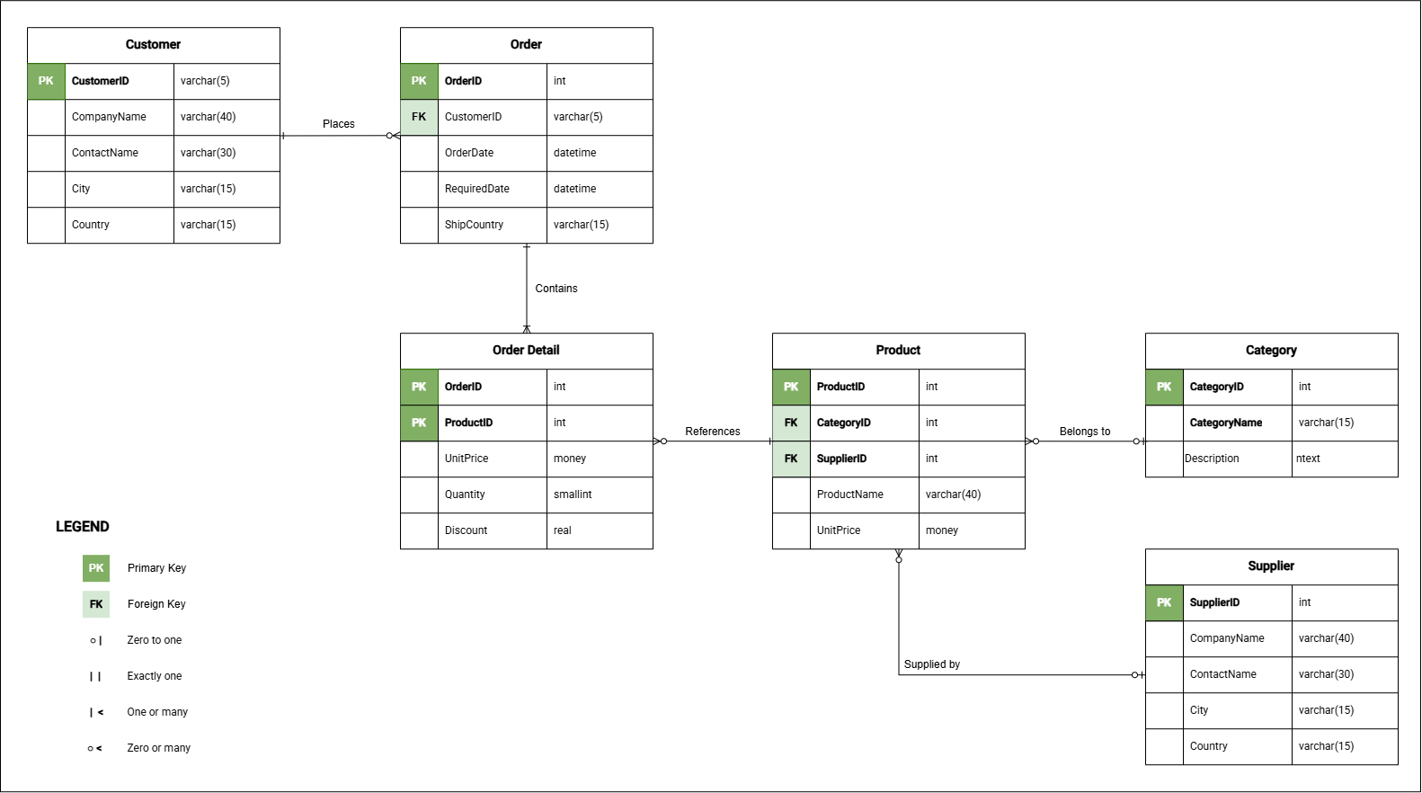
Figure 1 Northwind Core Order Data Model
  - Source Material
The following are the links to the original public documentation/repository.
- Microsoft SQL Server Samples - Northwind and pubs
- Northwind database creation script

