### **Task 1: Create a storage account**

In this task, we will create a new storage account.

Sign in to the Azure portal at [Azure portal (https://portal.azure.com)](https://portal.azure.com/" \t "https://docs.microsoft.com/en-us/learn/modules/define-core-azure-services-products/az-portal).

From the ****All services**** blade, search for and select ****Storage accounts****, and then click ****+ Add****.

On the ****Basics**** tab of the ****Create storage account**** blade, fill in the following information (replace ****xxxx**** in the name of the storage account with letters and digits so that the name is globally unique). Leave the defaults for everything else.

| **TABLE 1** | |
| --- | --- |
| **Setting** | **Value** |
| Subscription | ****Choose Concierge Subscription**** |
| Resource group | ****[sandbox resource group name]**** |
| Storage account name | ****storageaccountxxxx**** |
| Location | ****(US) East US**** |
| Performance | ****Standard**** |
| Account kind | ****StorageV2 (general purpose v2)**** |
| Replication | ****Locally redundant storage (LRS)**** |
| Access tier (default) | ****Hot**** |
|  |  |

Click ****Review + Create**** to review your storage account settings and allow Azure to validate the configuration.

Once validated, click ****Create****. Wait for the notification that the account was successfully created.

From the Home page, search for and select ****Storage accounts**** and ensure your new storage account is listed.

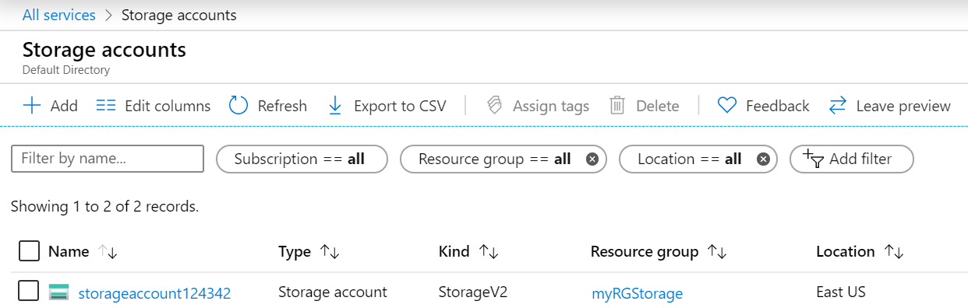

### **Task 2: Work with blob storage**

In this task, we will create a Blob container and upload a blob file.

Click the name of the new storage account, scroll to the ****Blob service**** section, and then click ****Containers****.

Click ****+ Container**** and complete the information. Use the Information icons to learn more. When done click ****Create****.

| **TABLE 2** | |
| --- | --- |
| **Setting** | **Value** |
| Name | ****container1**** |
| Public access level | ****Private (no anonymous access)**** |
|  |  |

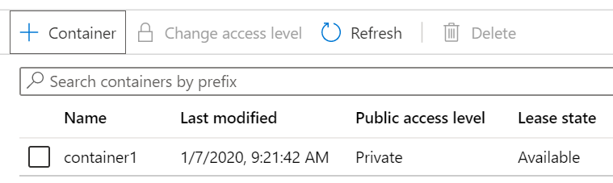

Click the ****container1**** container, and then click ****Upload****.

Browse to a file on your local computer.

**Note**

You can create an empty .txt file or use any existing file. Consider chooosing a file of a small size to minimize the upload time.

Click the ****Advanced**** arrow, leave the default values (but review the available options), and then click ****Upload****.

**Note**

You can upload as many blobs as you like in this way. New blobs will be listed within the container.

Once the file is uploaded, right-click on the file and notice the options (including View/edit, Download, Properties, and Delete).

If you have the free time, review the options on the storage account blade for Files, Tables, and Queues.

### **Task 3: Monitor the storage account**

If needed, return to the storage account blade and click ****Diagnose and solve problems****.

Explore some of the most common storage problems. Notice there are multiple troubleshooters.

On the storage account blade, scroll down to the ****Monitoring**** section and click ****Insights (preview)****. Notice there is information on Failures, Performance, Availability, and Capacity. Your information will be different.

