**HIGH LEVEL OVERVIEW OF AZURE ACTIVE DIRECTORY**

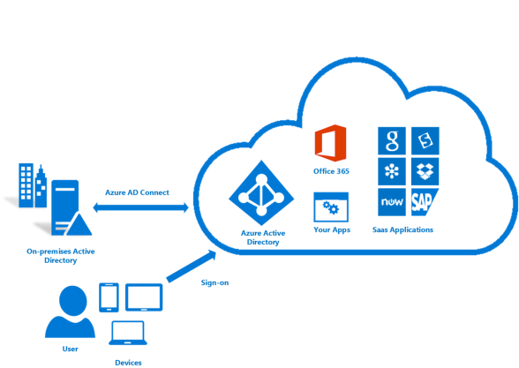

Reduces the hassle of having multiple User IDs/Passwords that have to be managed by the system admin.

WITHOUT AZURE AD

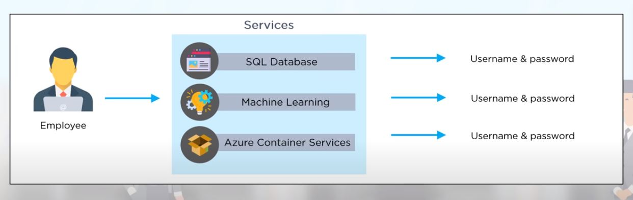

WITH AAD

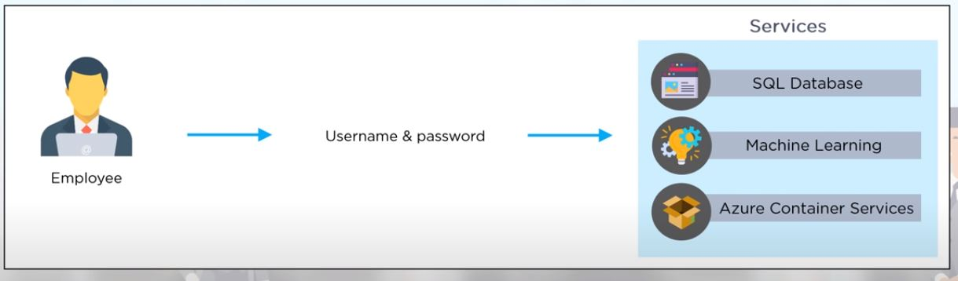

WORKFLOW OF AZURE AD

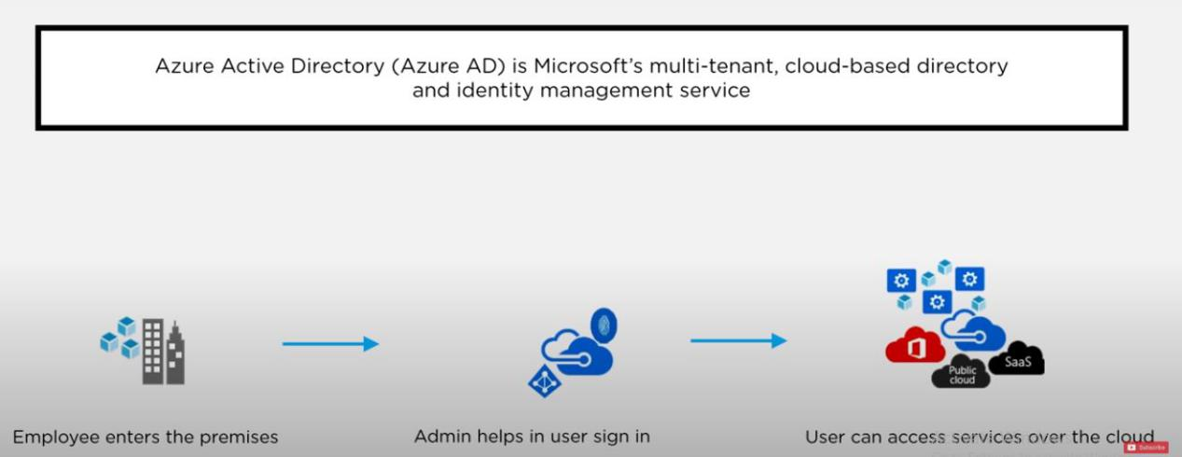

**CONNECTING TO SALESFORCE OBJECTS FROM PBI**

We can connect to the salesforce data from power bi to make reports that can help gain insights into data and assist in taking better decisions

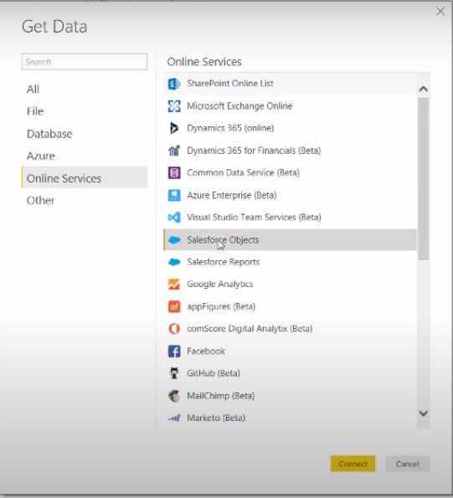

**ALERTS IN POWER BI**

When a report has been published in Power BI we might want to notify the user with certain alerts when encountered certain circumstances

In such a case Alerts come into play

Eg.

If we want to send a slack notification when a card of sales has crossed a certain threshold we can setup an alert to notify the user of the change

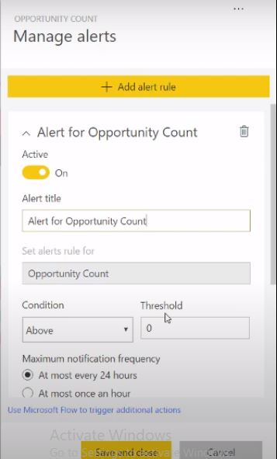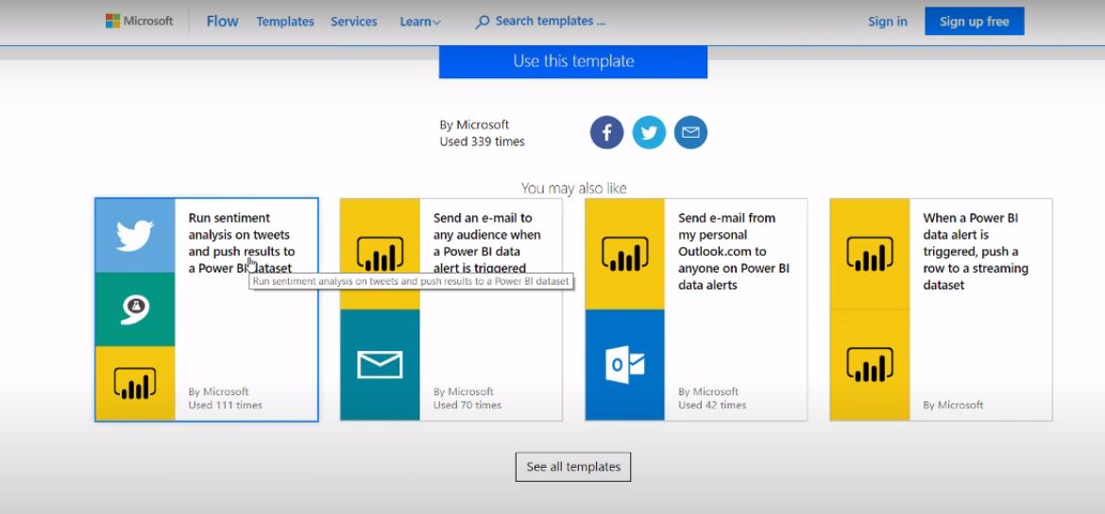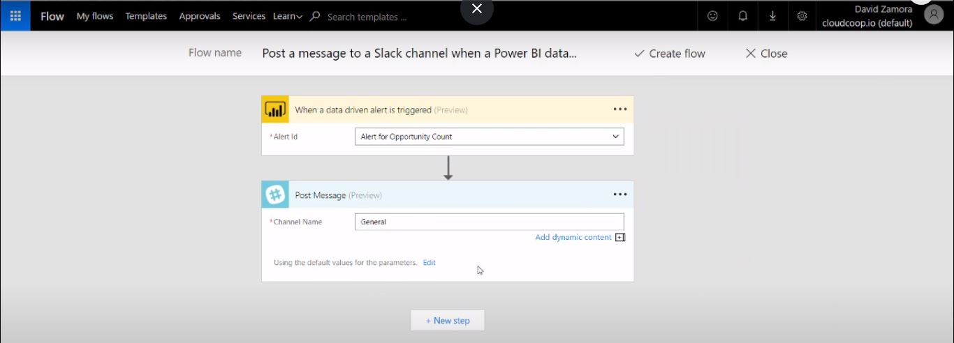

WORKFLOW OF AAD+PBI+SF

