TABLEAU

Source:udemy tableau A-Z course

Generally in tableau measures are aggregated and dimensions specify level of granularity

**To highlight only one feature** on the chart go to the toolbar where the feature or dimension is placed and click the 1st button on the right now only the category which is selected is highlighted

**For creating hierarchies:**

Take a feature and push it onto the other it creates a new feature with a hierarchy

Eg.Country/State/City

For creating calculated value

Right click on a feature and go onto create and select the category calculated value now create the formula and click ok the new feature will be created

**To apply a filter across all the worksheets in a dashboard:**

go to the worksheet already using this filter and click ‘apply to worksheets’ and select ‘all using related data source’

**To create dashboard**

1. click on toolbar press ‘new dashboard’
2. Now drag the sheets to be displayed onto the dashboard
3. The filters that are applied to all worksheets used to control the display for all the sheets on the dashboard,altering the all worksheets filter a change can be seen on all the sheets eg.the year filter is applied for all sheets now on the dashboard when the year filter is altered a change is observed in both the map and also the scatter plot

**To use a sheet as filter:**

1. go to the sheet on dashboard click on use as filter from the dropdown menu when a sheet is selected
2. On clicking the ‘use as filter’ we can use the sheet on which it is applied to control the other sheets in the dashboard

Eg.if use as filter is applied to map in the dashboard selecting a location on the map will help us to see changes for that particular location in the scatter plot sheet

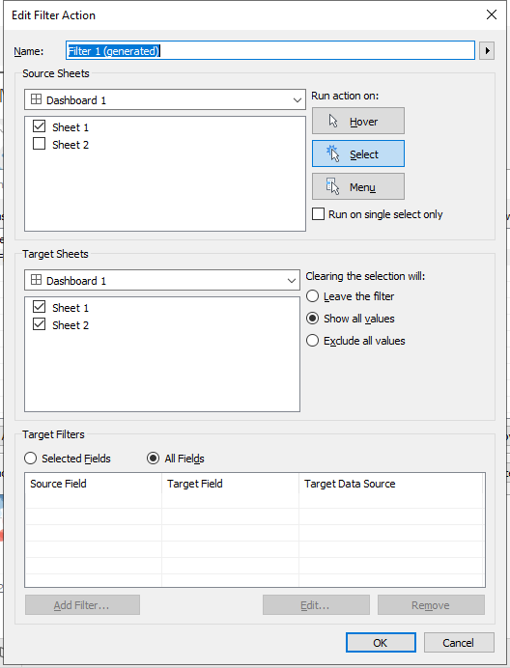

Method2

1. click on dashboard
2. Press actions
3. Click add action
4. Give it a name
5. Select source sheet I.e the sheet to be used as filter and
6. Run action,suggested:select
7. Select the target sheets I.e sheets to be affected by the source when used as filter and trigger an action

**To select multiple values to trigger an action:**

Select a point on the source map,hold ctrl button and select another point,now the target sheet would show us the results of both the selected entities

Filtering vs Highlighting

Filtering actually filters the data when a object is selected in the source sheet the rows of data related to the selected object is kept and rest discarded,target sheet is constructed based on the filtered data obtained from the source sheet

Whereas in highlighting the above process doesnt occur in the background rather when a object is selected in the source sheet it is highlighted and all other become transparent therefore in the target sheet only those points which belong to the selected product from the source are highlighted and others become transparent,whereas as in filtering a new target sheet is created altogether

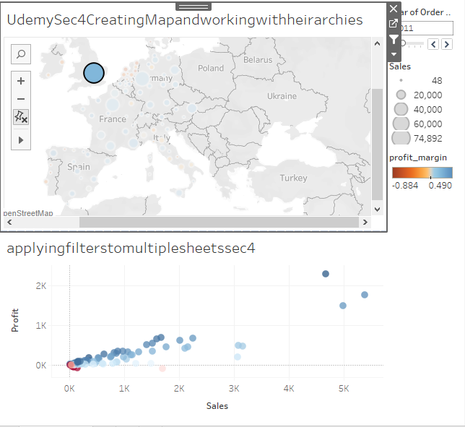

**filtering**

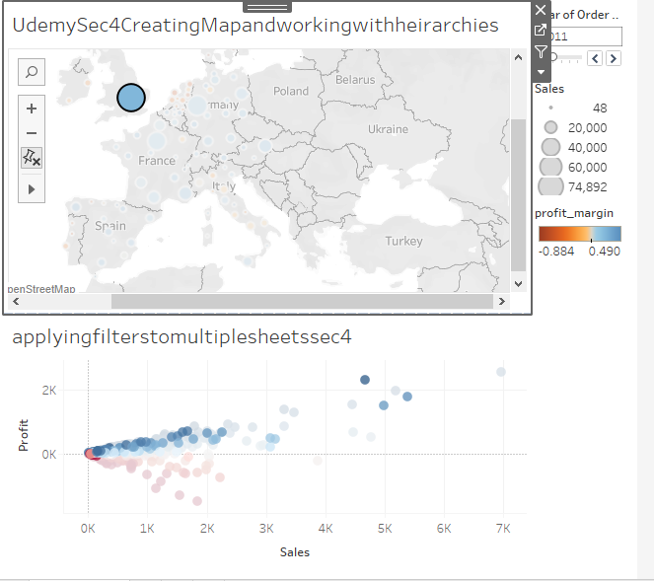

**Highlighting**

**Section5**

**Data Joins vs Data blending**

Blending used in 2 cases:

1. when join cant be used
2. When the data sets to be joined are at varying level of granularity
3. When the dataset is from different sources eg.one dataset is from xlsx and other is sql in that case blending is used

**How to achieve this**

1. establish new connection
2. Now drag a set of data into the dragspace
3. Now click on tableau symbol
4. Again select the same table but now with a different dataset
5. Now tableau finds a relation between the two sheets

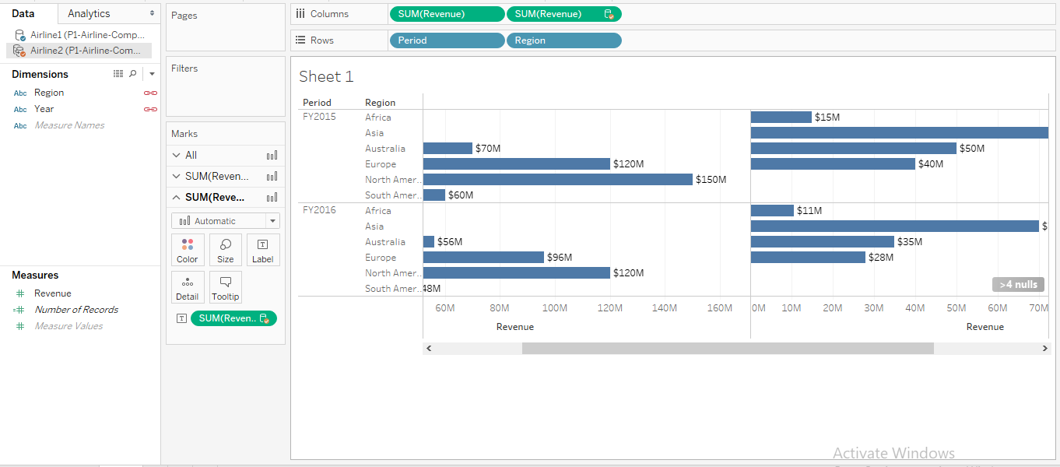

The red symbol next to any feature symbolizes that the relation between two datasets is established

**How to establish a custom relation between two features of different dataset:**

1. navigate to the toolbar,click Data
2. Select edit relationships

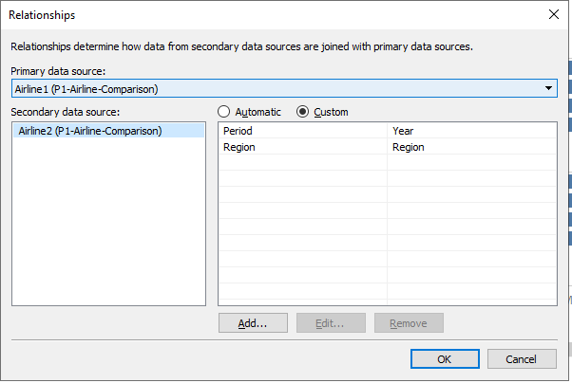

1. click on custom
2. Now press add
3. All features from every dataset is displayed
4. Now from the displayed features select one feature from each dataset and click ‘ok’ new relation between two different features from two different dataset is established

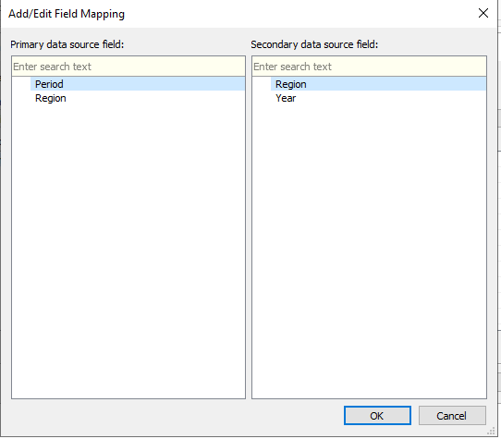

Note:

Every entity marked with an orange symbol is secondary

Note:

**Data blending is generally a left outer join**

**Note:**

**To create the dual axis right click on the graph to be merged and click dual axis now the graph with dual axis have been merged to sync them right click on axis then press synchronize axis**

**To pivot the columns:**

1. Select all the col that are to be pivoted
2. Right click and press pivot
3. Pivoted rows are obtained as output

Before pivoting the cols that are selected for pivoting

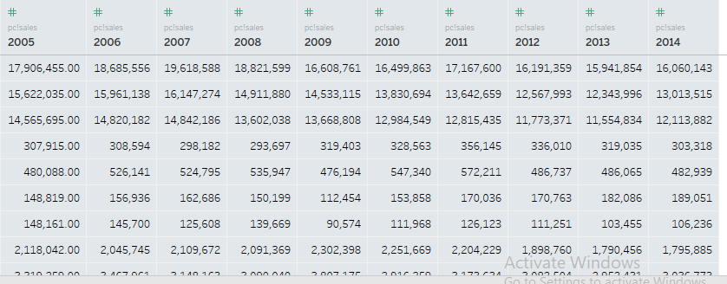

after pivot

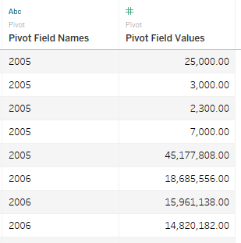

Basically pivot is used to join multiple cols of dataset into a single valued col bearing all the vals from diff cols

**Splitting a col into multiple cols**

1. select the col you want to split
2. Right click on the col and then press custom split
3. Now specify the identifier at which you want to split
4. Click ok the single col data is split into multiple col

Eg.splitting the name into 1st and last name eg.Mani Ratna can be split into Mani in one col and Ratna in another the words are split by space

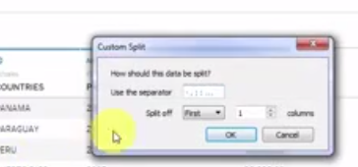

***SECTION 8***

***CUSTOM TERRITORIES***

**To create custom territories :**

1. select one state
2. Hold on control and select the rest of the states you want to group
3. Now right click and click on group and select all dimension
4. Now all the states or regions you have selected in step2 become into a new region forming a custom territory altogether irrespective of being discrete or continuous

Before custom territory

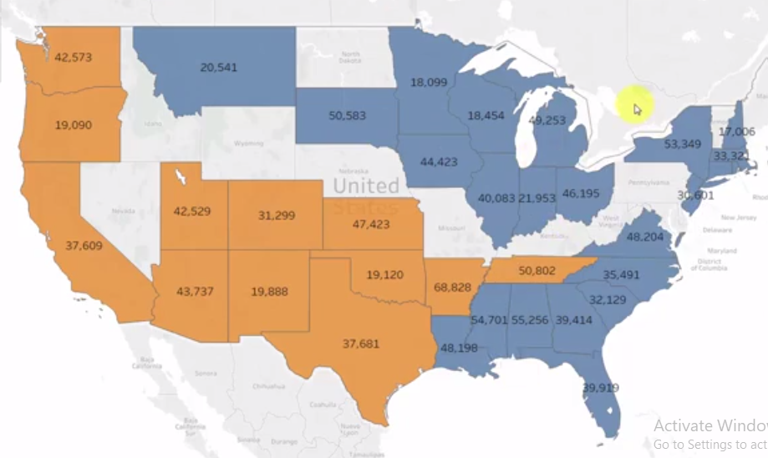

**Creating group**

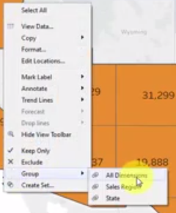

**After custom territory**

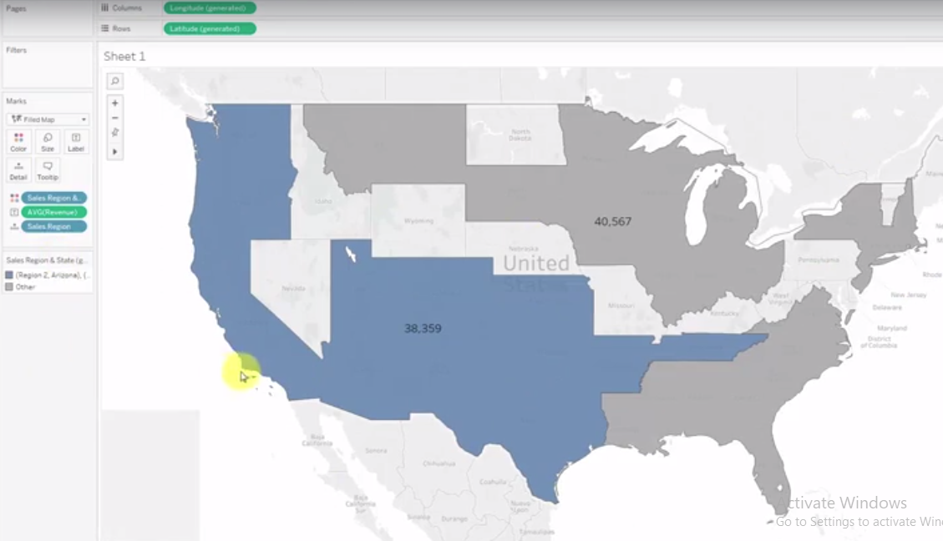

**To add a description to the label**

1. click on the label icon
2. Select text
3. Align text,change params like font etc.
4. Also add a description to the label

**At the end:**

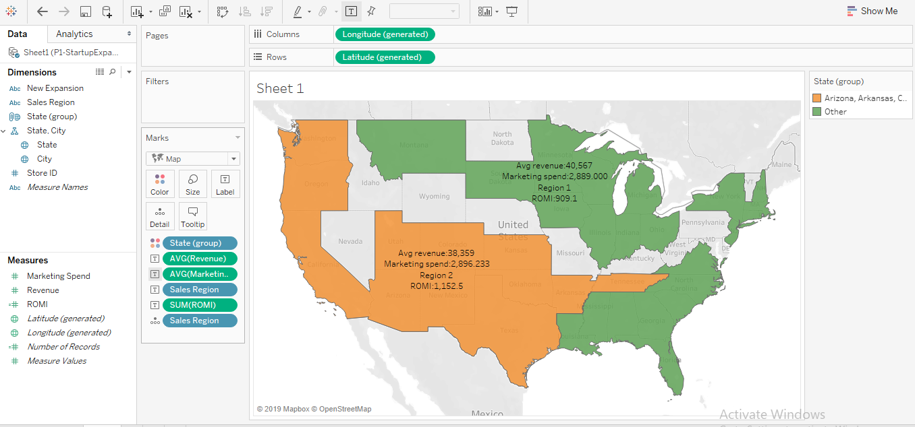

**Highlighter**

1. Drag the feature to be highlighted into detail
2. Now right click and select ‘show highlighter’
3. It gives a legend ,based on values in feature it can be highlighted

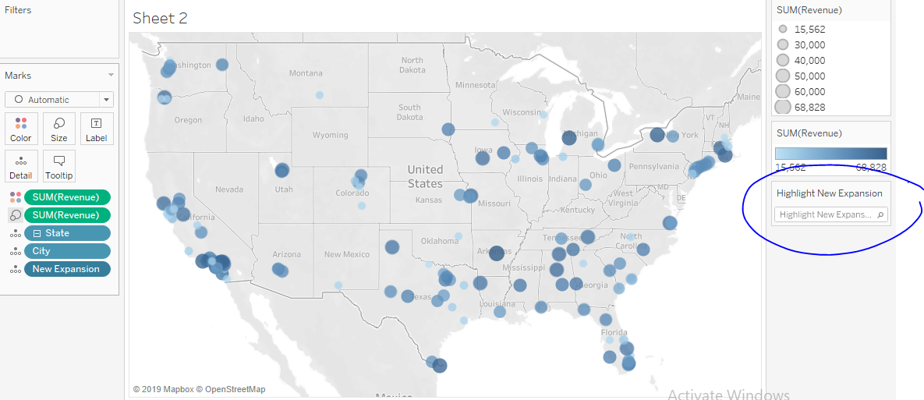

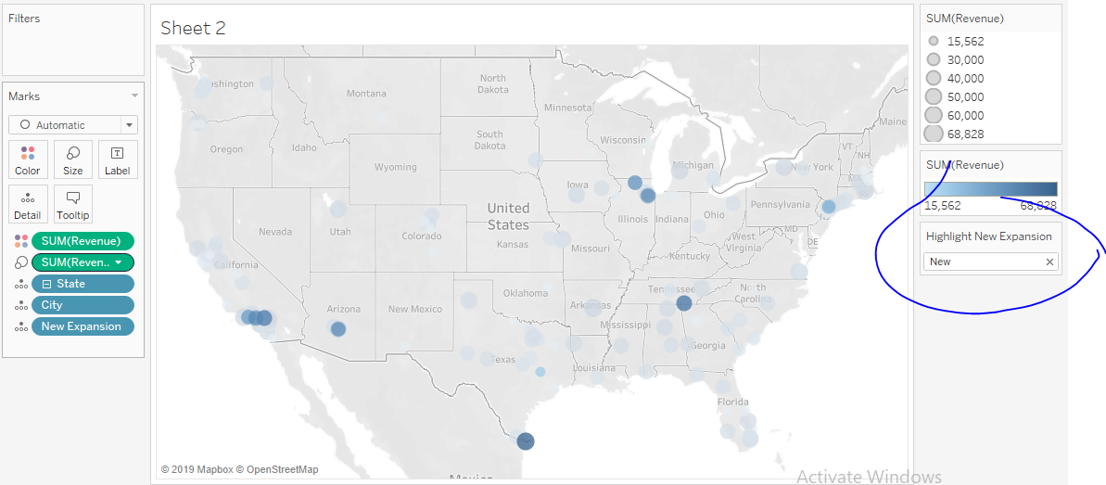

**Clustering**

**To create clusters**

1. go onto the analytics tab on the left
2. Under model we find the word cluster
3. Drag it onto the graph it identifies and creates clusters based on the features graphs uses and clusters differentiated by color

