MORE
Members

Gallery

Alumni Family

Club Activities

Resources

Contact

Members
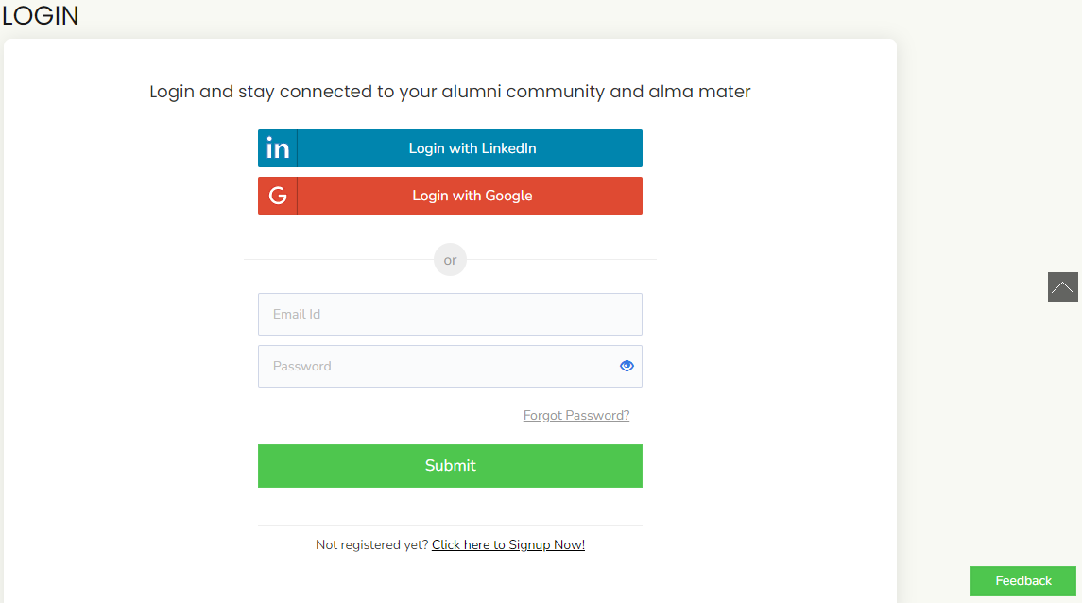

Gallery

Alumni Family
Family is an integral part of any individual. Members apart, families are equally important to ensure active participation by our members in the events and activities of the Association. When families are involved, we believe the involvement of the members will grow much deeper in one's association in meeting the deliberations of the Association. While the Institute can offer little in this area, the Association can certainly fill this gap with much fun, fairness, and fancy. Hence this page is exclusively allotted to the families of the members where they are welcome to showcase their involvement in our parallel causes relating to the spread of education to the needy, underprivileged, and such similar areas of interest. Such stories could be related to achievements by the members' spouse, children in academics, sports, talents, and other areas of interest. However, the Association reserves the right to screen based on the contents before placing it on our portal.

Club Activities
Social Club (Need to Link with Social Club Page)
Photography Club (Need to Link with Photography Club Page)
Sports & Fitness Club ((Need to Link with Sports & Fitness Club Page)
Trekking & Adventure Sports Club (Need to Link with T & A Sports Club Page)
Talents Club (Need to Link with Talents Club Page)

Resources

- Bye-Laws (Need to link Bye-Laws Page)
- Balance Sheets (Need to link Balance Sheets Page)
- AGM Minutes (Need to link AGM Page)

Contact
General Secretary
Cotton Collegiate Alumni Association,
Cotton Collegiate Govt. H.S. School Campus,
Guwahati - 781001

Work Timings
Monday to Friday : 10.30 A.M. to 5.30 P.M.
Saturday : 10.30 A.M. to 1.30 P.M.
Telephone:
E-mail: cottoncollegiatealumni.org | alumni.collegiate@gmail.com

