McDonald's Nutrition Analysis
Diagnostic Analysis Report (CDACL-004 Fast Food Analysis)
Prepared by: Sauravi Sarode
Batch / Team: PTID-CDA-SEP-26-11277
Date: 11-10-2026
Tool: MySQL and Power BI

1. Introduction

1.1 Objective
This project analyses the nutrition of menu items in a fast-food dataset covering 8 restaurant chains. McDonald's was chosen as the company of focus. The goal is not only to describe the numbers but to explain why they look the way they do (diagnostic analysis), and to give data-driven recommendations.

1.2 Dataset Overview
Source: MySQL database, Table: food
- Total records: 512 menu items across 8 restaurants (511 after removing duplicates); McDonald's has 57 items
- Key fields: restaurant, item, calories, calories from fat, total fat, saturated fat, trans fat, cholesterol, sodium, carbohydrates, fiber, sugar, protein, vitamin A, vitamin C, calcium

1.3 Tools Used
- MySQL: data source and querying
- Power BI: data cleaning, calculated columns, dashboard and chart visualization
- Microsoft Word / PDF: reporting

1.4 Data Cleaning and Limitations
- Removed the columns satish (empty), age (all zeros) and salad (every value was "Other").
- Removed 1 duplicate rows. Replaced the text value "NA" with null in fiber, protein, vitamin A, vitamin C and calcium, and set these columns to numeric types. Blanks were kept as blanks, not replaced with 0.
- Created new columns: Calorie Category (Low under 300, Medium 300 to 600, High over 600), Is Salad (from the item name) and Protein per 100 Cal.
- The dataset has no price column, so the average price in the project brief cannot be analysed. Nutrition measures are used instead. There are also no portion weights or sales figures.

Power BI – Dashboard and chart visualization (restaurant filter set to McDonald's).

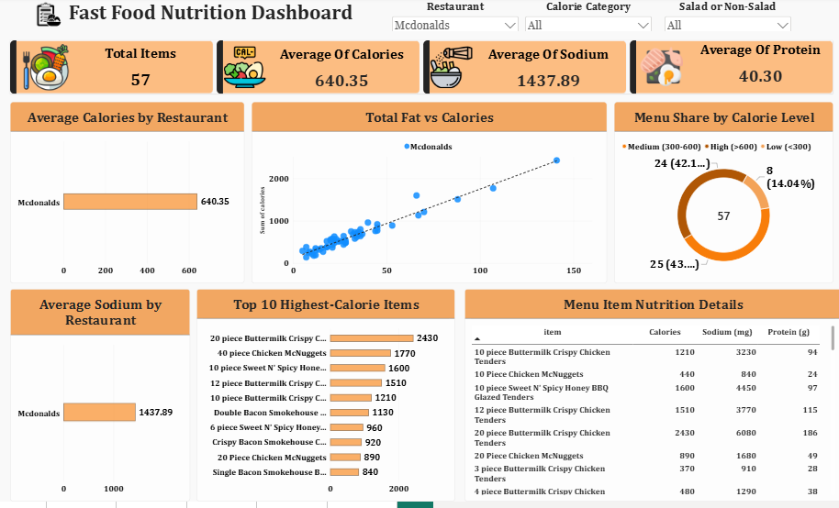

2. Key Performance Indicators (KPIs)
Total Items  57 | Average Calories  640.35 | Average Sodium  1,437.89 mg | Average Protein  40.30 g | High-Calorie Items  42.1% | Max Calories  2,430
Dashboard KPIs:

2.1 Supporting Notes
Total Items counts all McDonald's menu items in the table (57). Average Calories, Average Sodium and Average Protein are calculated per item across these 57 items. High-Calorie Items (42.1%) is the share of items above 600 calories (24 of 57). Max Calories (2,430) is the 20-piece Buttermilk Crispy Chicken Tenders. For comparison, the average across all chains is about 531 calories, 1,247 mg sodium and 28 g protein per item, so McDonald's items are heavier and saltier but much higher in protein.

3. Charts & Visualizations

3.1 Top 10 and Bottom 10 Items by Calories (Tables)
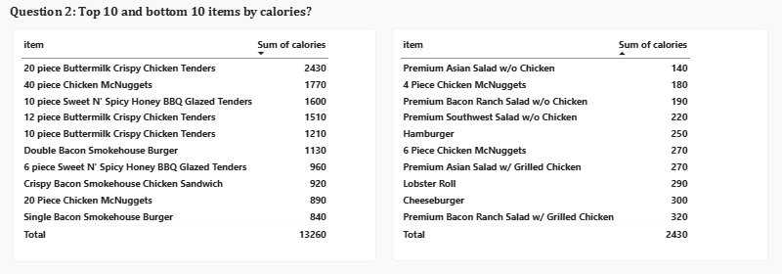
Insight: Calories range from 140 to 2,430. The highest items are the 20-piece Buttermilk Crispy Chicken Tenders (2,430), 40-piece Chicken McNuggets (1,770), 10-piece Sweet N' Spicy Honey BBQ Glazed Tenders (1,600), 12-piece Buttermilk Crispy Chicken Tenders (1,510) and 10-piece Buttermilk Crispy Chicken Tenders (1,210). These are multi-piece sharing portions, breaded and fried, listed as a single item. The lightest items are the Premium Asian Salad without Chicken (140), 4 Piece Chicken McNuggets (180) and Premium Bacon Ranch Salad without Chicken (190).

3.2 Menu Share by Calorie Level (Donut Chart)
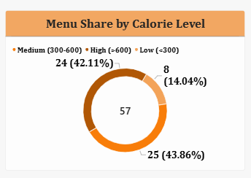
Insight: Of 57 McDonald's items, 8 (14.0%) are low calorie, 25 (43.9%) are medium calorie and 24 (42.1%) are high calorie (over 600). Nearly half of the menu is high calorie because it is built mainly around burgers, sandwiches and fried chicken, with few light options.

3.3 Sodium and Saturated Fat (Tables)
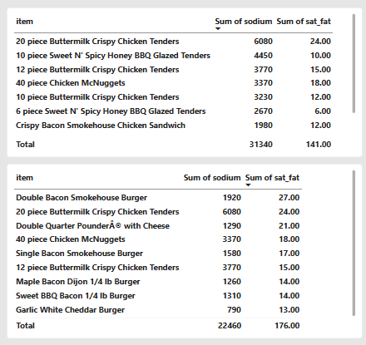
Insight: The 20-piece tenders also have the highest sodium at 6,080 mg, followed by the 10-piece Sweet N' Spicy Honey BBQ Glazed Tenders (4,450 mg) and the 12-piece Buttermilk Crispy Chicken Tenders (3,770 mg). Six items exceed 2,300 mg, the commonly cited daily limit, and 19 items exceed 1,500 mg. For saturated fat, the top items are the Double Bacon Smokehouse Burger (27 g), 20-piece tenders (24 g), Double Quarter Pounder with Cheese (21 g), 40-piece McNuggets (18 g) and Single Bacon Smokehouse Burger (17 g). Breading, sauces, cheese and processed meat drive sodium, while double patties, bacon and cheese drive saturated fat.

3.4 Salads vs Non-Salads (Bar Chart)
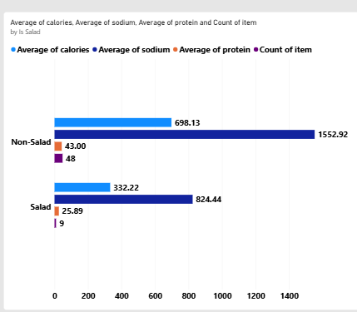
Insight: McDonald's has 9 salads and 48 non-salad items. Salads average 332 calories, 824 mg sodium and 26 g protein, while non-salad items average 698 calories, 1,553 mg sodium and 43 g protein. Salads replace buns, fries, fried coatings and cheese with vegetables, so calories and sodium are roughly halved, and protein is lower because there is less meat.

3.5 Protein per 100 Calories (Table)
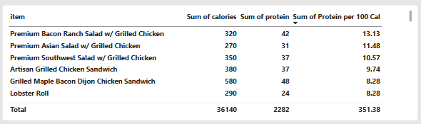
Insight: The best items for protein per calorie are the Premium Bacon Ranch Salad with Grilled Chicken (13.13, with 42 g protein for 320 calories), Premium Asian Salad with Grilled Chicken (11.48), Premium Southwest Salad with Grilled Chicken (10.57), Artisan Grilled Chicken Sandwich (9.74), and the Grilled Maple Bacon Dijon Chicken Sandwich and Lobster Roll (8.28 each). Grilled chicken is lean protein and avoids the breading and frying that add calories without adding protein.

3.6 Total Fat vs Calories (Scatter Chart)
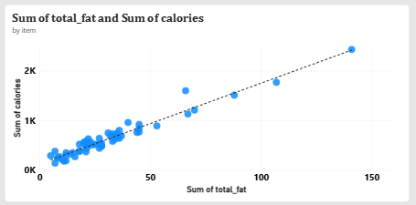
Insight: The points rise tightly along the trend line, showing that calories increase strongly with total fat (correlation about 0.97). Fat has 9 calories per gram versus 4 for carbohydrates and protein, so fatty items gain calories quickly.

3.7 Sodium vs Calories (Scatter Chart)
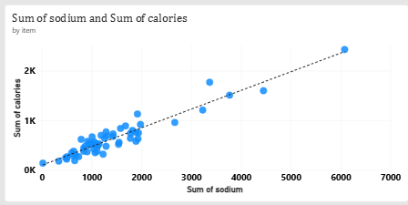
Insight: Calories also rise strongly with sodium (correlation about 0.95), and with protein (about 0.95). Meat-heavy, fried and cheesy items bring fat, salt and protein together, so these measures increase at the same time. This shows a relationship, not proof of cause.

4. Insights & Findings

4.1 Portion Size
The highest-calorie items are large sharing portions listed as one item, mainly fried chicken pieces. These pull the average to 640 calories, while single-serve items such as the Hamburger (250) and Cheeseburger (300) are far lower. Averages should therefore be read with sharing portions in mind.

4.2 Sodium
Sodium is very high, especially in fried chicken items. The 20-piece tenders contain 6,080 mg, more than double the commonly cited daily limit, and 19 of 57 items exceed 1,500 mg. The reasons are breading, sauces, cheese and processed meat, multiplied by large portions.

4.3 Saturated Fat
Saturated fat peaks in multi-patty burgers (up to 27 g in the Double Bacon Smokehouse Burger), even where their calories are lower than the largest chicken platters. An item can therefore be a high-risk choice for saturated fat without being the highest in calories, so sodium, saturated fat and calories should be judged separately.

4.4 Salads
Salads average 332 calories against 698 for other items, and about half the sodium. Toppings and dressings still matter, but choosing a salad cuts calories and sodium by more than half.

4.5 Protein Value
Grilled chicken salads and sandwiches give the most protein for their calories (up to 13.13 g per 100 calories). McDonald's has the highest average protein of any chain in this dataset (about 40 g per item), partly because of its large meat portions.

4.6 Fat as the Driver of Calories
Calories follow fat very closely (correlation about 0.97), with sodium and protein close behind (about 0.95 each). Reducing fat in an item is the most direct way to reduce its calories, and because sodium and fat move together, lowering one often lowers the other.

4.7 Menu Balance
Only 8 of 57 items (14.0%) are low calorie, while 24 (42.1%) are above 600 calories. Customers have limited light choices, and nearly one item in two is a heavy option.

5. Recommendations
- Separate sharing portions from single servings: show sharing items apart on menus and in nutrition reports so averages are not distorted.
- Show sodium warnings: flag items above 1,500 mg, since 19 of 57 items exceed this level and 6 exceed 2,300 mg.
- Promote grilled options: grilled chicken salads and sandwiches give the best protein per calorie and avoid breading and frying.
- Add more light items: only 8 of 57 items are under 300 calories, so a wider range of light choices would improve balance.
- Reduce fat in multi-patty burgers: a lighter cheese or sauce option would lower both calories and saturated fat.
- Collect price and sales data: this would connect nutrition to what customers actually buy and pay, which the current dataset cannot show.

6. Conclusion
McDonald's menu ranges from a 140-calorie salad to a 2,430-calorie sharing platter. The extremes come from large, fried, breaded portions, while the lightest and most nutritious choices are salads and grilled chicken items. Calories follow fat very closely, and sodium and saturated fat are concentrated in the same heavy items. With clearer labelling and more light options, customers could make healthier choices without losing variety. A limitation of this analysis is the lack of price and sales data, which would allow a deeper look at what customers choose.

