HR Analytics
Capstone Project Analysis Report (PRDA-03)
Prepared by: Sauravi Sarode
Batch / Team: PTID-CDA-SEP-26-11277
Date: 30-09-2026

1. Introduction

1.1 Objective
This project analyses the company's HR dataset to understand workforce composition, diversity, hiring trends, and attrition, and to provide data-driven recommendations to HR leadership.

1.2 Dataset Overview
Source: MySQL database - project_hr_analytics, Table: HR
- Total records: 22,214 employees
- Key fields: employee ID, name, birthdate, age, gender, race, department, job title, location (remote/HQ), hire date, termination date, city, state

1.3 Tools Used
- MySQL - data querying and KPI calculation
- Power BI - dashboard and chart visualization
- Microsoft Word / PDF – reporting

Power BI – Dashboard and chart visualization.

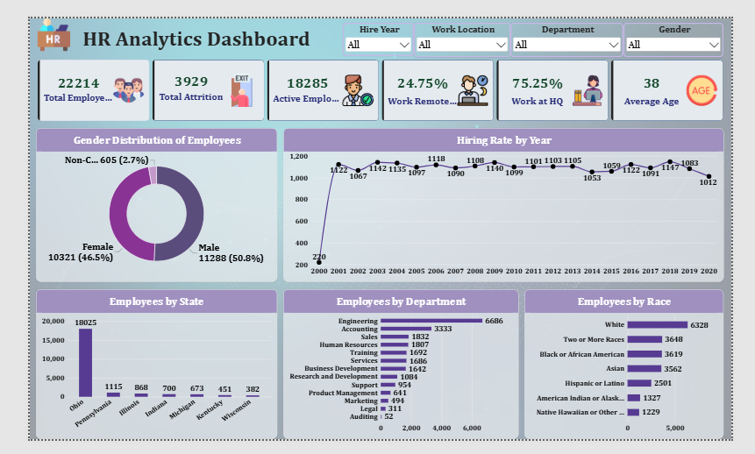

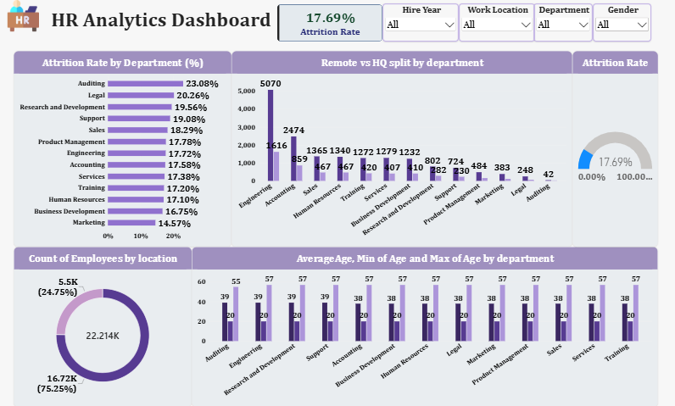

2. Key Performance Indicators (KPIs)
Total Employees  22,214 | Total Attrition  3,929 | Active Employees  18,285 | Remote (%)  24.75% | HQ (%)  75.25% | Average Age  38 yrs

Dashboard KPIS:

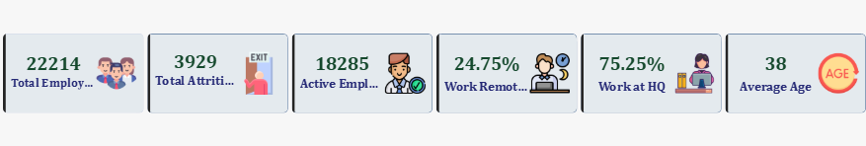

2.1 Supporting Notes
Total Employees represents all records in the HR table. Active Employees excludes anyone with a termination date on file. Total Attrition (3,929) represents employees who have left the company, giving an overall attrition rate of 17.69% (3,929 / 22,214). The Remote/HQ split and Average Age are calculated across the full employee base.

3. Charts & Visualizations

3.1 Hiring Rate by Year (Line Chart)
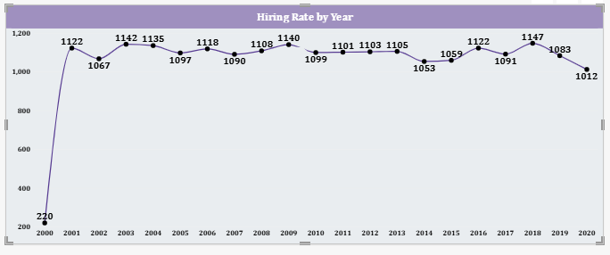
Insight: Hiring was minimal in 2000 (220 hires, likely the first partial year of records) before stabilizing to a consistent range of roughly 1,050-1,150 hires per year from 2001 through 2019. Hiring peaked in 2018 at 1,147 employees. 2020 shows a dip to 1,012 hires, which may reflect either a genuine slowdown or an incomplete final year of data. Overall, the hiring rate has been remarkably steady over two decades rather than showing strong growth or decline.

3.2 Gender Split (Donut Chart)
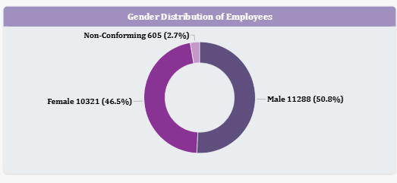
Insight: The workforce is fairly balanced by gender: Male employees make up 50.8% (11,288), Female employees make up 46.5% (10,321), and Non-Conforming employees make up 2.7% (605). There is no significant gender imbalance at the company-wide level.

3.3 Headcount by State (Bar Chart)
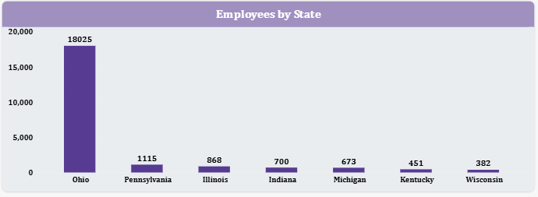
Insight: Employee presence is heavily concentrated in Ohio, which accounts for 18,025 employees (about 81% of the entire workforce). All other states are minor by comparison: Pennsylvania (1,115), Illinois (868), Indiana (700), Michigan (673), Kentucky (451), and Wisconsin (382). This indicates a strong geographic dependency on a single state.

3.4 Headcount by Department (Bar Chart)
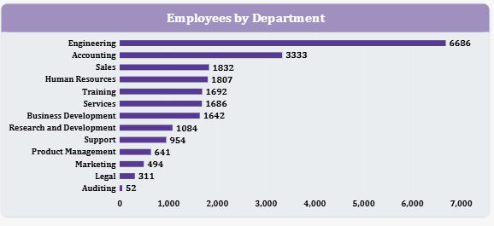
Insight: Engineering is by far the largest department at 6,686 employees (30.1% of the workforce), followed by Accounting (3,333), Sales (1,832), Human Resources (1,807), Training (1,692), and Services (1,686). Auditing is the smallest department at just 52 employees, followed by Legal (311) and Marketing (494).

3.5 Headcount by Race (Bar Chart)
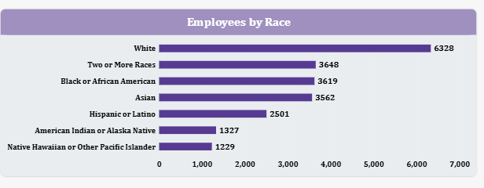
Insight: Racial representation is reasonably distributed: White employees are the largest single group at 6,328 (28.5%), followed by Two or More Races (3,648), Black or African American (3,619), Asian (3,562), Hispanic or Latino (2,501), American Indian or Alaska Native (1,327), and Native Hawaiian or Other Pacific Islander (1,229). No single group holds an overwhelming majority of the workforce, which reflects a reasonably diverse company-wide profile.

3.6 Attrition Rate by Department (Bar Chart)
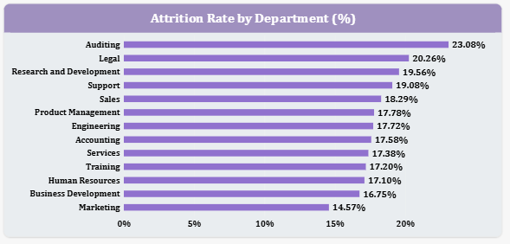
Insight: Auditing has the highest attrition rate at 23.1%, followed by Legal (20.3%) and Research and Development (19.6%). Marketing has the lowest attrition rate at 14.6%. Note that Auditing's high percentage is based on a very small department (52 employees total), so a handful of departures produces a large percentage swing - this should be read with that caveat rather than treated as a large-scale trend.

3.7 Average, Minimum & Maximum Age by Department (Bar Chart)
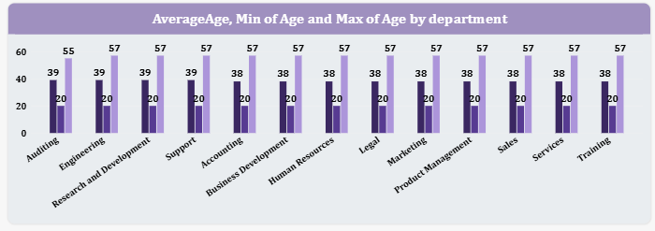
Insight: Average age is nearly uniform across departments, ranging narrowly from 38 to 39 years. The minimum (20) and maximum (57) ages are also consistent across nearly every department. This indicates age is evenly distributed throughout the company rather than concentrated in specific teams, so there is no single department carrying a disproportionate retirement risk.

4. Insights & Findings

4.1 Workforce Composition
The company employs 22,214 people in total, of whom 18,285 (82.3%) are currently active and 3,929 (17.7%) have left. The workforce is split 75.25% HQ-based and 24.75% Remote, showing the company is still predominantly office-centric despite a meaningful remote presence.

4.2 Age & Generational Mix
The average employee age is 38, and this holds consistently across departments (38-39 years). The age range of 20-57 is also consistent company-wide, meaning there is no single department at elevated retirement risk - succession planning should be considered as a company-wide initiative rather than department-specific.

4.3 Hiring Trends
Hiring has been stable for two decades, holding in the 1,050-1,150 range per year since 2001, aside from a low starting point in 2000 (220) and a slight dip in the most recent year, 2020 (1,012). There is no evidence of an aggressive growth phase or a hiring freeze - the pattern instead suggests steady, planned replacement-level hiring.

4.4 Gender Diversity
The company-wide gender ratio is close to even: 50.8% Male, 46.5% Female, 2.7% Non-Conforming. This is a healthy balance overall. Department-level gender breakdowns were not part of the current dashboard build - a recommended next step would be adding a Department slicer to the Gender chart to check whether this balance holds within each team, particularly in Engineering given its size.

4.5 Geographic Spread
Ohio accounts for roughly 81% of the entire workforce (18,025 of 22,214 employees), making it a significant single point of geographic concentration. All other states each represent under 5% of headcount. This creates meaningful exposure to local labor-market conditions, cost-of-living changes, or regional disruptions in Ohio specifically.

4.6 Department & Role Structure
Engineering (30.1%) and Accounting (15%) together account for nearly half the company's headcount, while Auditing (0.2%), Legal (1.4%), and Marketing (2.2%) are comparatively very small. This is a fairly top-heavy structure concentrated in two departments, which may be appropriate for the business model but is worth confirming against staffing targets.

4.7 Racial/Ethnic Diversity
Company-wide racial representation is reasonably diverse, with no group exceeding 29% of the total workforce. White employees are the largest group (28.5%), closely followed by Two or More Races (16.4%), Black or African American (16.3%), and Asian (16%). Department-level diversity breakdowns were not built into the current dashboard and would require an additional drill-down view to confirm this balance holds within each team.

4.8 Attrition
Overall attrition stands at 17.69% (3,929 of 22,214 employees). Auditing (23.1%), Legal (20.3%), and Research and Development (19.6%) show the highest attrition rates, while Marketing (14.6%) shows the lowest. Auditing's rate should be interpreted cautiously given its very small headcount (52 employees), where even 2-3 departures significantly moves the percentage.

5. Recommendations
- Review retention in Auditing (23.1%), Legal (20.3%), and R&D (19.6%) — all three run meaningfully above the 17.69% company attrition average. Start with exit interviews and a workload/compensation review in each. Note: Auditing's rate is based on a small team (52 employees), so while it's the highest percentage, a couple of additional hires or departures could shift it significantly — worth confirming the trend holds as headcount grows.
- Address geographic concentration risk: with 81% of the workforce based in Ohio, the company is exposed to local labor-market and cost pressures. Recommend evaluating expanded remote hiring or a second regional hub to diversify geographic exposure.
- Expand remote work options: only 24.75% of employees currently work remotely. Given the company already supports remote work, consider piloting broader remote eligibility to widen the talent pool beyond Ohio and reduce single-location dependency.
- Investigate Engineering and Accounting's outsized share of headcount: together these two departments hold 45% of all employees. Recommend confirming this concentration aligns with strategic staffing plans rather than being an artifact of historical hiring patterns.
- Maintain and monitor diversity metrics: current gender and racial diversity are both well-balanced company-wide. Recommend adding department-level slicers to the dashboard to confirm this balance holds within each team, particularly the largest ones (Engineering, Accounting).

6. Conclusion
The analysis shows a large (22,214-employee), demographically balanced workforce with steady hiring patterns over the past two decades and an overall attrition rate of 17.69%. The two most significant structural findings are the company's heavy geographic concentration in Ohio (81% of staff) and elevated attrition in the Legal and Research & Development departments. Addressing geographic risk and targeted retention in these departments represent the highest-priority actions for HR leadership going forward.

