IST769 Kafka and KSQL
Your Name: Tajudeen Abdulazeez
Your SUID: 69687-7373-0
Your Email: toabdula@syr.edu
Date Due:
Homework #: 10

- Write KSQL to create a stream named weblogs from the JSON keys in the weblogs Kafka topic. Make sure to set the TIMESTAMP property to the timestamp from the stream.
CREATE STREAM weblogs2 (timestamp bigint,browser varchar, OS varchar, uri varchar, user varchar )
with (kafka_topic='weblogs', value_format='json', timestamp='Timestamp');
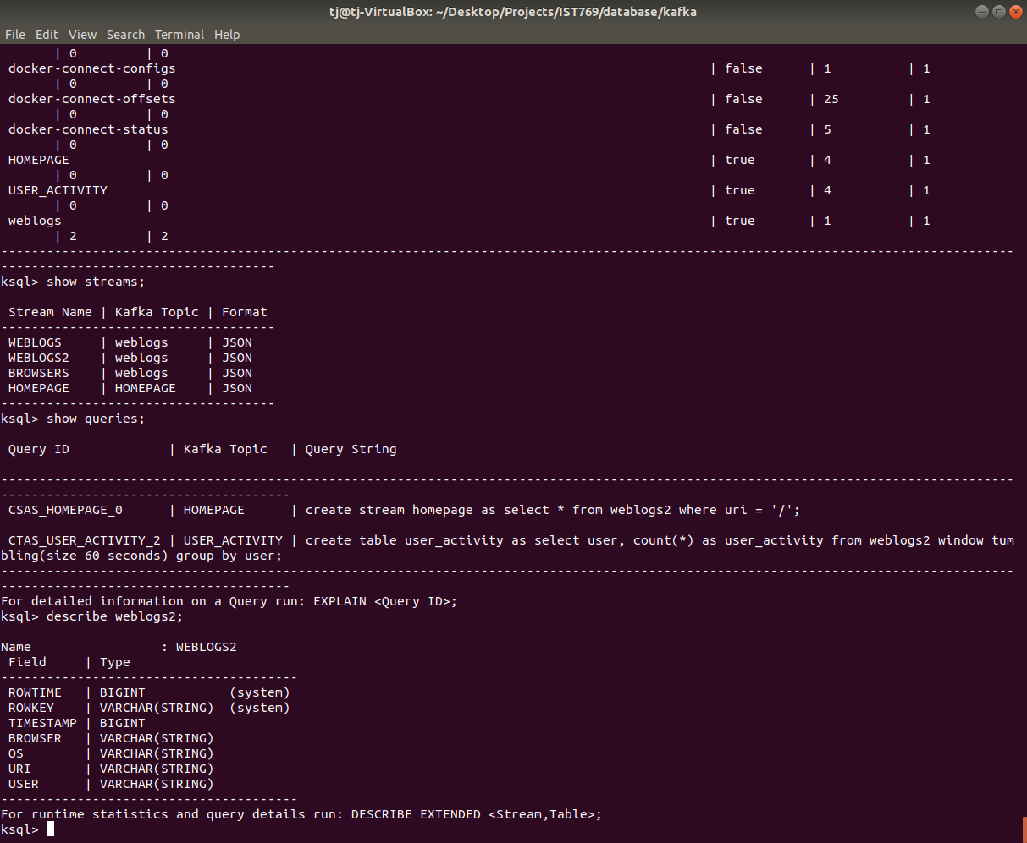
- Write a KSQL statement create a persistent stream/table called homepage which only displays visitors to the root of the website (/). It should display all columns from the weblogs stream.
create stream homepage as select * from weblogs2 where uri = '/';

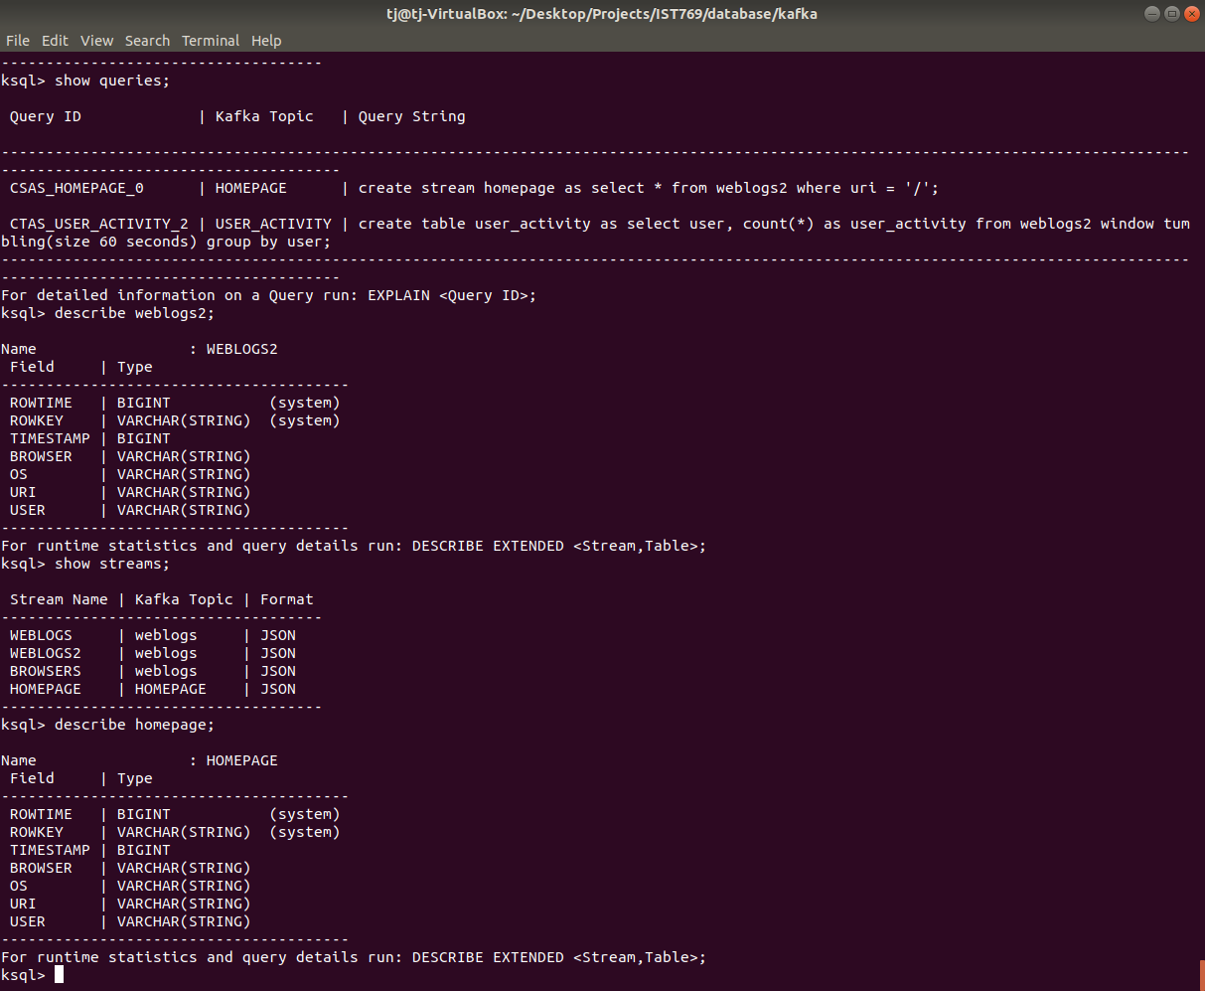

- Write a KSQL statement to count operating systems users (os) in 60 second windows. After 60 seconds, the counter should reset, and counts should begin again.

select os, count(user) as number_of_users from weblogs2 window tumbling(size 60 seconds) group by os;

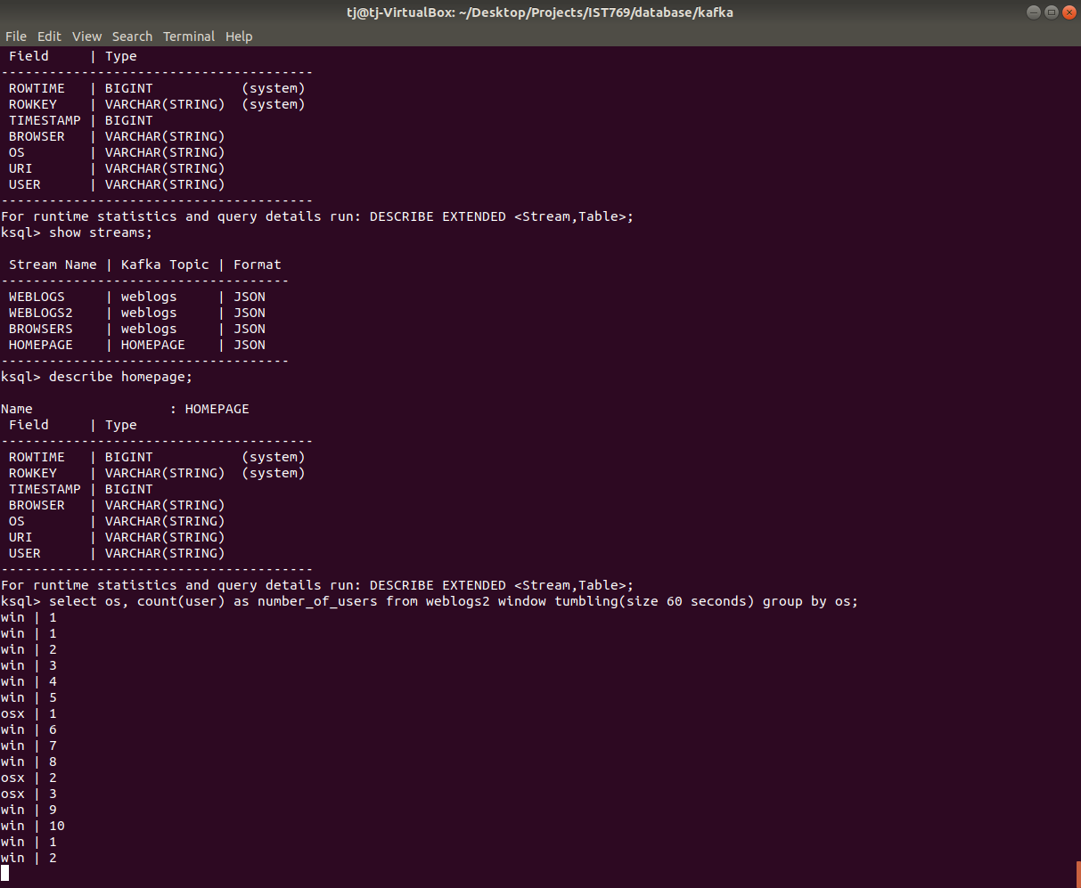

- Write a KSQL persistent stream/table called user_activity which will display a count of user activity on the website within 1-minute sessions.

Create table user_activity as select user, count(*) as user_activity from weblogs2 window tumbling(size 60 seconds) group by user;

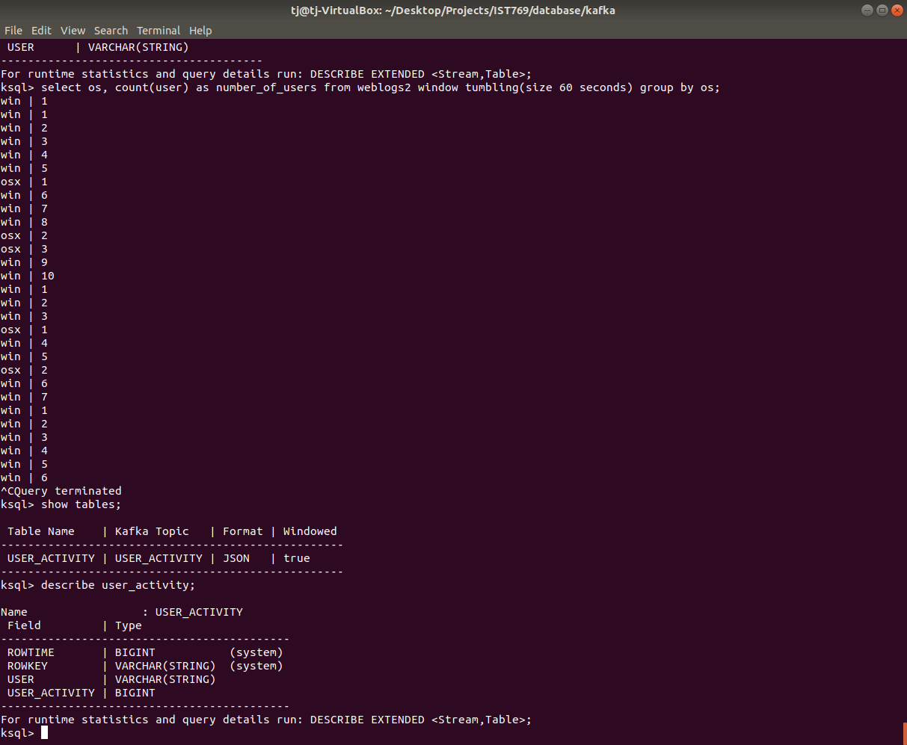

- Write a KSQL statement to display users who have more than 1 pages of activity in a 1-minute session.
Select * from user_activity where user_activity > 1;
