1. **MONGODB SAMPLE COMMANDS**

-Command to check database present

>show dbs

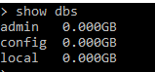

In the below example we will create a sample customer database for telecom operator

-To create a database



-To check if the database is created

> db



- Inserting document to collection

- Let us insert details of customers for a telecom operator

Format for the collection

{

msisdn : value,

imsi : value,

name : value ,

address :

{

street : value,

area : value

pin : value

},

pack :

{

data : value,

call : value,

sms :value

},

Subscription:

{

callertune:

{

Hindi: value,

English: value,

},

Netflix:value

}

}

- ***inserting the customer data***

1.

> db.customer.insert ({

msidn: "9197464646464",

imsi: "313460000000001",

address: {

street: "38 alfred street",

area: "donegal pass",

pin: "560037"

},

pack: {

data: "2 GB per day",

call: "unlimited",

sms: "100 sms per day"

},

subscription: [{

callertune: {

Hindi: "yes",

english: "no"

},

netflix: "yes"

}]

})

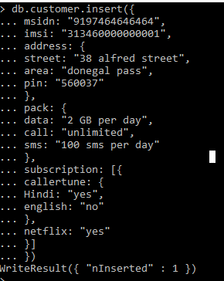

2.

db.customer.insert({

msidn: "9197464646312",

imsi: "313460000030001",

address: {

street: "38 alfred street",

area: "donegal pass",

pin: "560037"

},

pack: {

data: "2 GB per day",

call: "unlimited",

sms: "100 sms per day"

},

subscription: [{

callertune: {

Hindi: "no",

english: "no"

},

netflix: "no"

}]

})

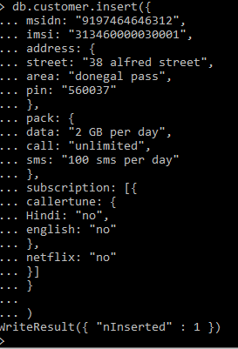

3.

> db.customer.insert({

msidn: "9197464546312",

imsi: "313460300030001",

address: {

street: "38 alfred street",

area: "donegal pass",

pin: "560037"

},

pack: {

data: "0 GB per day",

call: "unlimited",

sms: "53 sms per day"

},

subscription: [{

callertune: {

Hindi: "no",

english: "no"

},

netflix: "no"

}]

})

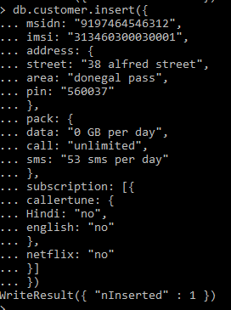

4.

db.customer.insert({

msidn: "9197464646434",

imsi: "313460000000011",

address: {

street: "42 university street",

area: "queen square",

pin: "560092"

},

pack: {

data: "3 GB per day",

call: "unlimited",

sms: "1700 sms per day"

},

subscription: [{

callertune: {

Hindi: "yes",

english: "no"

},

netflix: "yes"

}]

})

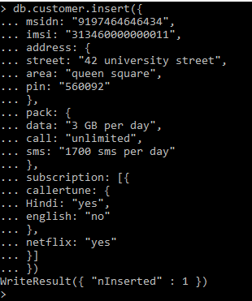

5.

db.customer.insert({

msidn: "9197464641953",

imsi: "313460000000011",

address: {

street: "42 university street",

area: "queen square",

pin: "560092"

},

pack: {

data: "3 GB per day",

call: "unlimited",

sms: "1700 sms per day"

},

subscription: [{

callertune: {

Hindi: "yes",

english: "no"

},

netflix: "yes"

}]

})

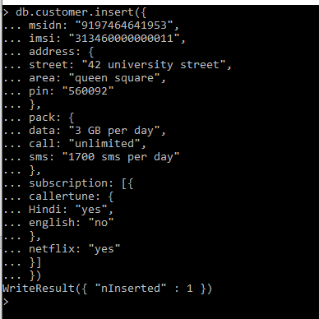

6.

db.customer.insert({

msidn: "9197464646475",

imsi: "313460000000011",

address: {

street: "42 university street",

area: "queen square",

pin: "560092"

},

pack: {

data: "1 GB per day",

call: "unlimited",

sms: "1700 sms per day"

},

subscription: [{

callertune: {

Hindi: "yes",

english: "no"

},

netflix: "no"

}]

})

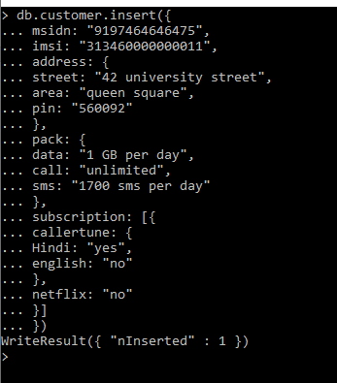

7.

db.customer.insert({

msidn: "9197464646434",

imsi: "313460000000011",

address: {

street: "42 university street",

area: "queen square",

pin: "560092"

},

pack: {

data: "2 GB per day",

call: "unlimited",

sms: "1700 sms per day"

},

subscription: [{

callertune: {

Hindi: "no",

english: "yes"

},

netflix: "yes"

}]

})

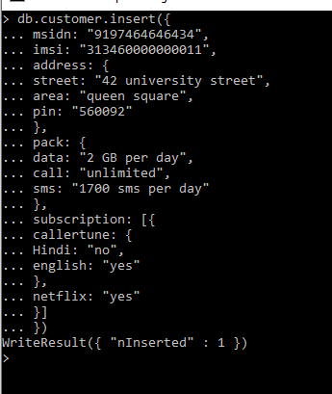

8.

db.customer.insert({

msidn: "91974644546434",

imsi: "313460560000011",

address: {

street: "34,stormont road",

area: "college cour",

pin: "560066"

},

pack: {

data: "2 GB per day",

call: "unlimited",

sms: "1700 sms per day"

},

subscription: [{

callertune: {

Hindi: "no",

english: "yes"

},

netflix: "yes"

}]

})

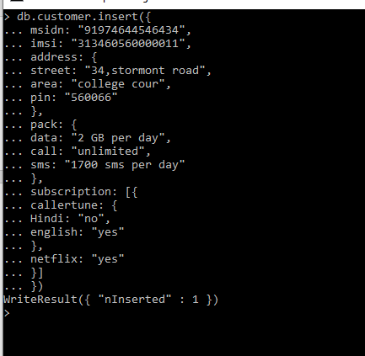

9.

db.customer.insert({

msidn: "919746443434",

imsi: "313460560300011",

address: {

street: "34,stormont road",

area: "college cour",

pin: "560066"

},

pack: {

data: "1 GB per day",

call: "unlimited",

sms: "170 sms per day"

},

subscription: [{

callertune: {

Hindi: "no",

english: "yes"

},

netflix: "yes"

}]

})

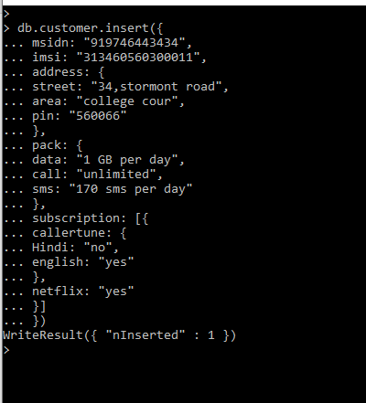

10.

db.customer.insert({

msidn: "919746412434",

imsi: "313460560340011",

address: {

street: "34,stormont road",

area: "college cour",

pin: "560066"

},

pack: {

data: "5 GB per day",

call: "unlimited",

sms: "unlimited"

},

subscription: [{

callertune: {

Hindi: "no",

english: "yes"

},

netflix: "yes"

}]

})

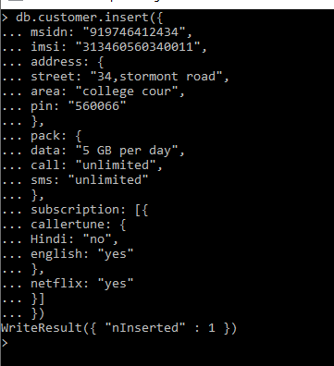

-Command to check for the values inserted

> db.customer.find()

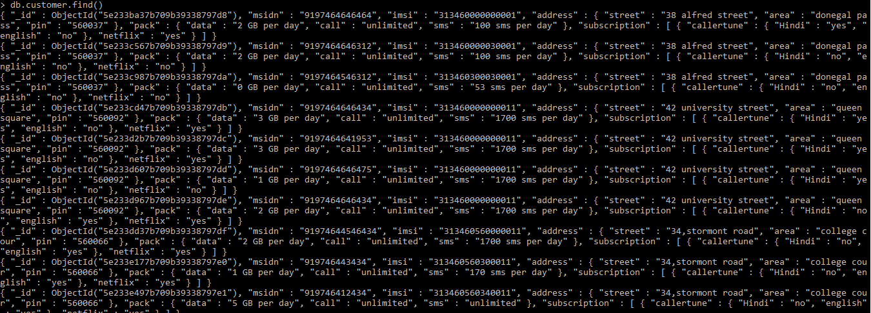

> db.customer.find({msidn:"919746412434"}).forEach(printjson)

**Output:**

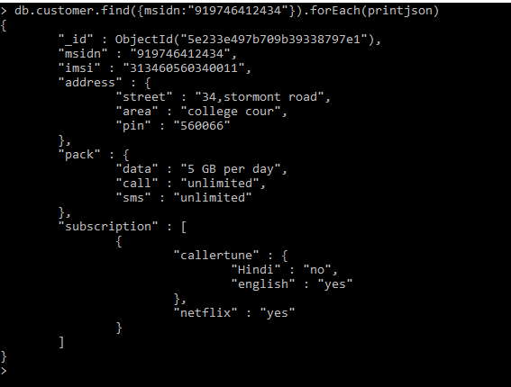

-Limiting the result of the query

> db.customer.find().limit(1)



* Find the customer who are subscribed to callertune Hindi

> db.customer.find({"subscription.callertune.Hindi":"yes"}).forEach(printjson)

**Output:**

> db.customer.find({"subscription.callertune.Hindi":"yes"}).forEach(printjson)

{

"_id" : ObjectId("5e233ba37b709b39338797d8"),

"msidn" : "9197464646464",

"imsi" : "313460000000001",

"address" : {

"street" : "38 alfred street",

"area" : "donegal pass",

"pin" : "560037"

},

"pack" : {

"data" : "2 GB per day",

"call" : "unlimited",

"sms" : "100 sms per day"

},

"subscription" : [

{

"callertune" : {

"Hindi" : "yes",

"english" : "no"

},

"netflix" : "yes"

}

]

}

{

"_id" : ObjectId("5e233cd47b709b39338797db"),

"msidn" : "9197464646434",

"imsi" : "313460000000011",

"address" : {

"street" : "42 university street",

"area" : "queen square",

"pin" : "560092"

},

"pack" : {

"data" : "3 GB per day",

"call" : "unlimited",

"sms" : "1700 sms per day"

},

"subscription" : [

{

"callertune" : {

"Hindi" : "yes",

"english" : "no"

},

"netflix" : "yes"

}

]

}

{

"_id" : ObjectId("5e233d2b7b709b39338797dc"),

"msidn" : "9197464641953",

"imsi" : "313460000000011",

"address" : {

"street" : "42 university street",

"area" : "queen square",

"pin" : "560092"

},

"pack" : {

"data" : "3 GB per day",

"call" : "unlimited",

"sms" : "1700 sms per day"

},

"subscription" : [

{

"callertune" : {

"Hindi" : "yes",

"english" : "no"

},

"netflix" : "yes"

}

]

}

{

"_id" : ObjectId("5e233d607b709b39338797dd"),

"msidn" : "9197464646475",

"imsi" : "313460000000011",

"address" : {

"street" : "42 university street",

"area" : "queen square",

"pin" : "560092"

},

"pack" : {

"data" : "1 GB per day",

"call" : "unlimited",

"sms" : "1700 sms per day"

},

"subscription" : [

{

"callertune" : {

"Hindi" : "yes",

"english" : "no"

},

"netflix" : "no"

}

]

}

>

1. **Importing csv file to mongodb**

-For this example I have taken the csv file from Kaggle <https://www.kaggle.com/abhinav89/telecom-customer/data>

Below is the command to import the csv file to mongodb

>mongoimport --type=csv -d customer_db -c churn --headerline --file="G:\techm_machine_learning\Telecom_customer churn.csv"

**Output:**

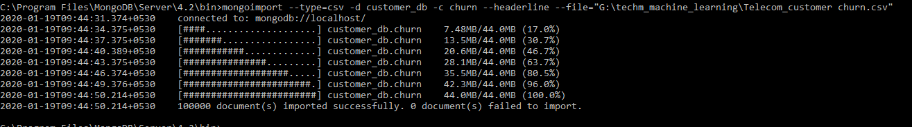

-Verify if the collection is created and documents are inserted

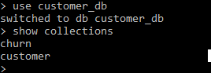

> db.churn.find().limit(1)

