How to re-protect and Failback

Secondary/DR Location/ Failover already done in to this location

RG Name: **ASRAutomationRecovery-RG**

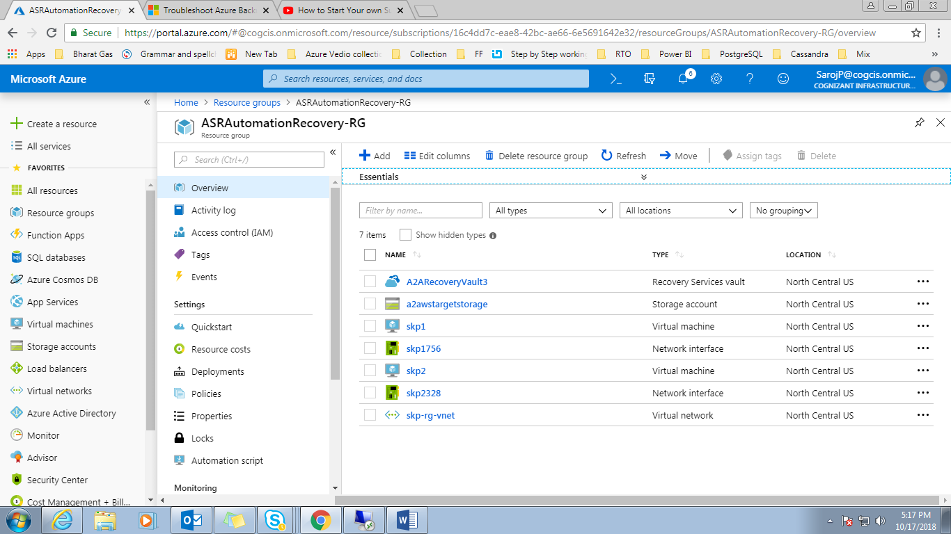

Primary Location/From where took the replicated items

RG Name: **skp-rg**

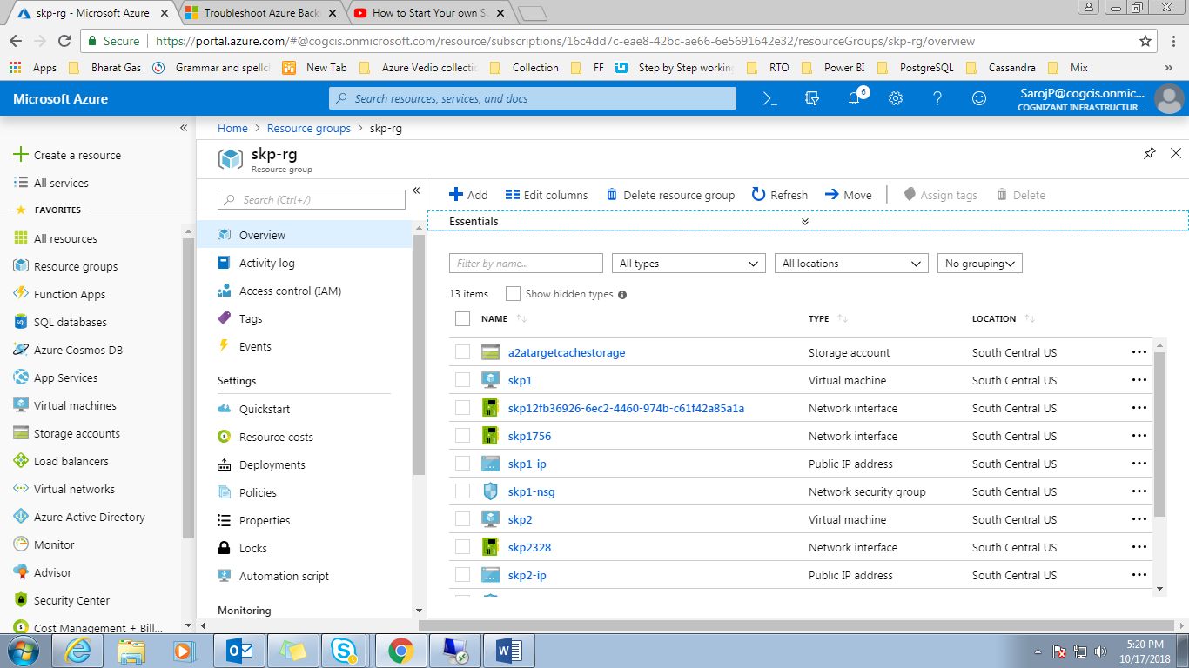

Set 3 items in Config file

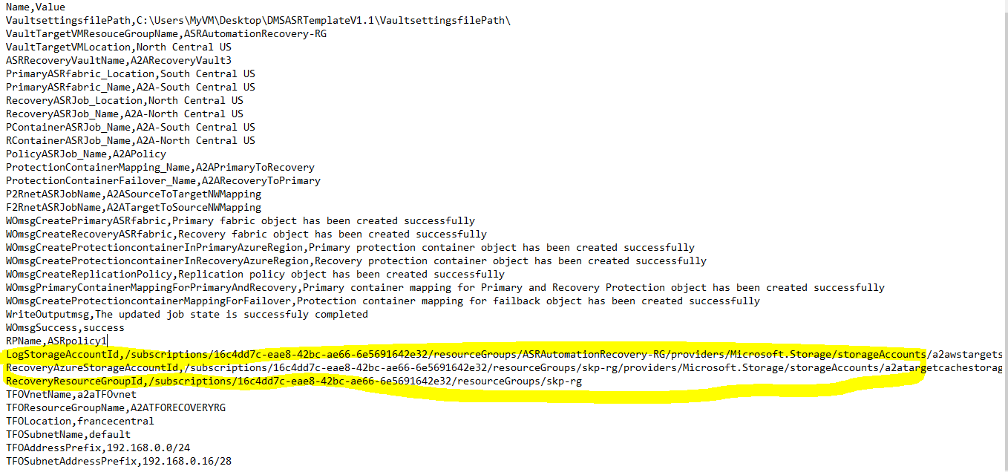

Right part

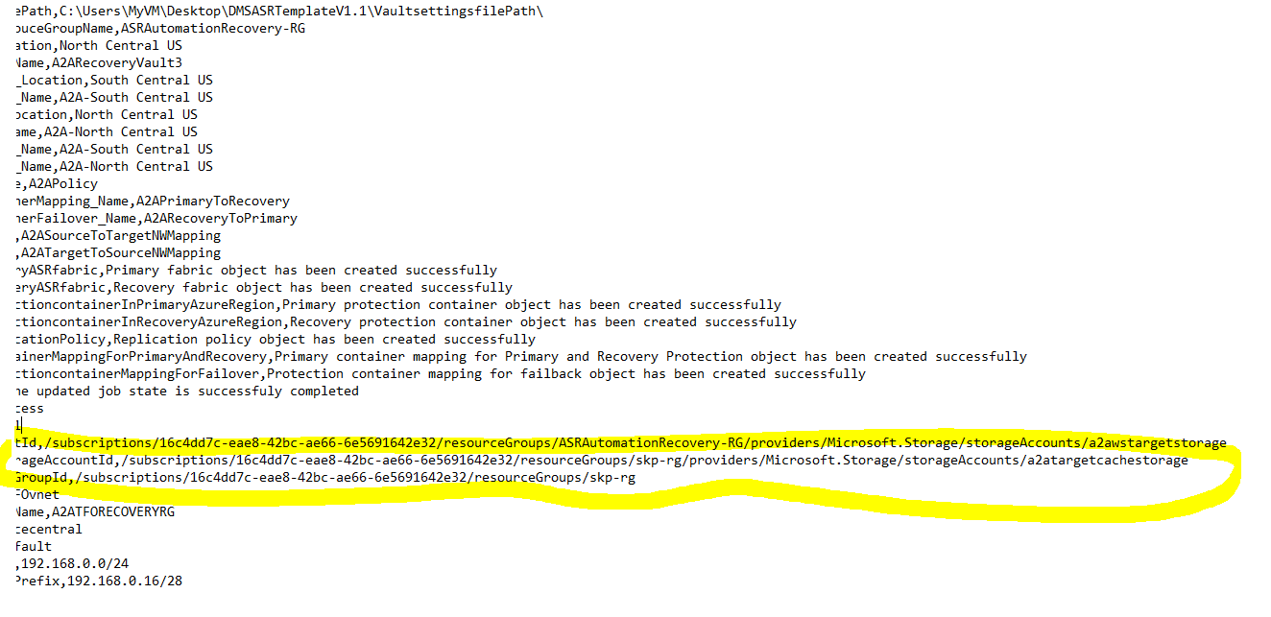

Powershellcode:

Run Code in two times, 1st half first then 2nd half

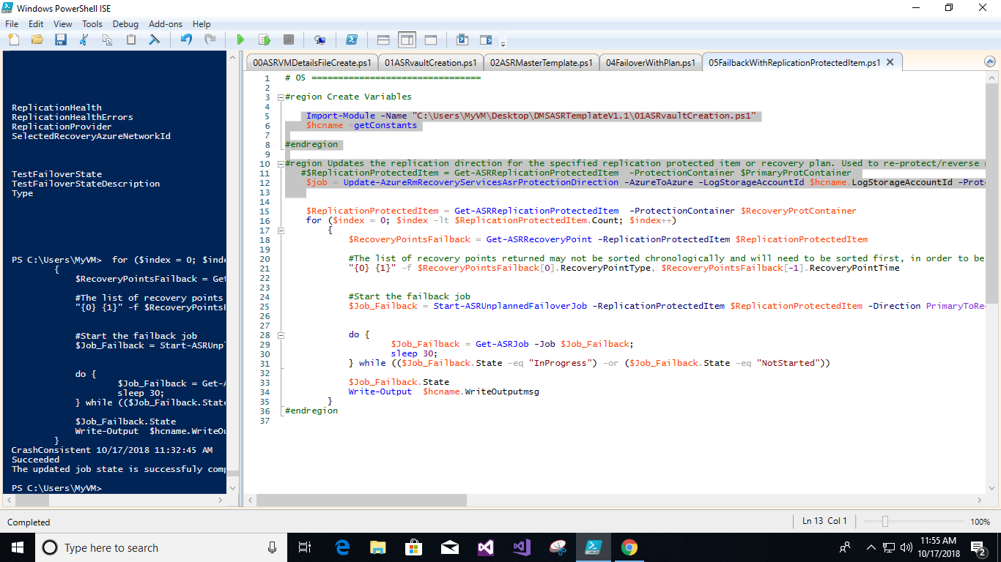

First half reprotect the items and it will take time to reprotect and synchronization

Then start failback