Name: Saroj Kumar Dash

Course: ECE-6310

Course Name: Intro to Computer Vision

Lab#1 – Convolution, separable filters, sliding windows

Problem Statement:

To implement 3 version of 7x7 mean filters.

Version 1 :- with basic 2d convolution

Version 2 :- with separable filters(1x7 and 7x1)

Version 3 :- with separable and sliding window

Solution Version 1:-- with basic 2d convolution

I made two separate function to separate the kernel multiplication.Image is a class that I have created to manage the data structure of the image rows, cols and pixels which reduces the number of arguments to pass to the methods.

Code:-

//Separated kernel multiplication operation

int kernel2dConv(image &iImg,int iCol,int iRow){

int r,c,sum=0;

int outPixel = 0;

int ker[7][7] = { //Now using a mean filter but later we can use any filter here

{1,1,1,1,1,1,1},

{1,1,1,1,1,1,1},

{1,1,1,1,1,1,1},

{1,1,1,1,1,1,1},

{1,1,1,1,1,1,1},

{1,1,1,1,1,1,1},

{1,1,1,1,1,1,1}};

int kSize = 7;

unsigned char *pInPixels = iImg.getPixels();

for( r=-(kSize/2); r<=(kSize/2); r++)

for(c=-(kSize/2); c<=(kSize/2); c++)

sum += (pInPixels[(iRow+r)*iImg.getCols() + (iCol+c)]*ker[c+(kSize/2)][r+(kSize/2)]);

outPixel = sum/(kSize*kSize);

return outPixel;

}

//do the main convolution operation here whoever uses this method should delete the returned pointer

//this method is clocked in main()

unsigned char *convolveSimple(image &iImg){

unsigned char *opPixels = NULL;

int r,c;

int sum;

opPixels = new unsigned char[iImg.getRows() * iImg.getCols()];

//Do convolve operation here

for(r=3; r< (iImg.getRows()-3); r++)

for(c=3 ; c<(iImg.getCols()-3); c++)

opPixels[r*iImg.getCols()+c] = (unsigned char)kernel2dConv(iImg,c,r);

return opPixels;

}

Output:-

Generates a smoothed output image named, **out.ppm**, which is a smoothed version of input image bridge.ppm. Which looks as below:-

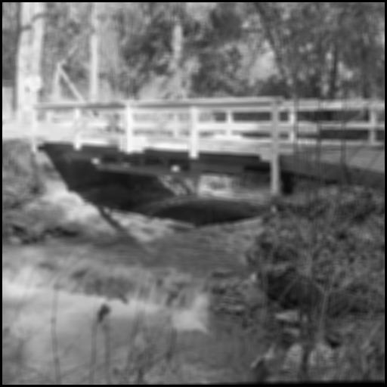

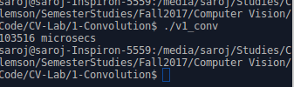

Time Clocked is :- **103516 microsecs**

I have taken observation by measuring the time taken by the function convolveSimple().

Solution Version 2 :- with separable filters(1x7 and 7x1)

Code:

//Convolves a 1x7 kernel horizontally //@return: outPixSum : sum of kernel operation for the mean filter

int kernelSepHor(image &iImg,int iCol,int iRow){

int r,c,kSize = 7;

int outPixSum = 0;

int kerR[7] = {1,1,1,1,1,1,1};

int sum =0,temp =0;

unsigned char *pInPixels = iImg.getPixels();

// horizontal convolution

for( c=-(kSize/2); c<=(kSize/2); c++)

sum += pInPixels[(iRow)*iImg.getCols()+(iCol+c)]*kerR[c+(kSize/2)];

outPixSum = sum;

//std::cout<<outPixSum<<" "<<iCol<<" "<<iRow<<std::endl;

return outPixSum;

}

//Convolves a 7x1 kernel vertically

//@return: outPixSum : sum of kernel operation for the mean filter

int kernelSepVer(unsigned int *&pInPixels,int iCol,int iRow,int iW,int iH){

int r,c,kSize = 7;

int outPixSum = 0;

int kerR[7] = {1,1,1,1,1,1,1};

int sum =0,temp =0;

// vertical convolution

for( r=-(kSize/2); r<=(kSize/2); r++)

sum += pInPixels[((iRow+r)*iW)+(iCol)]*kerR[r+(kSize/2)];

outPixSum = sum;

//std::cout<<outPix<<" "<<iCol<<" "<<iRow<<std::endl;

return outPixSum;

}

//do the main convolution operation here whoever uses this method should release the returned pointer.

//this function is time clocked

unsigned char *convolveImage(image &iImg){

unsigned char *opPixels = NULL;

unsigned int *tmpPixels = NULL;

int r,c,kSize = 7;

int sum;

//allocate memory for the out Pixel pointer

opPixels = new unsigned char[iImg.getRows() * iImg.getCols()];

tmpPixels = new unsigned int[iImg.getRows() * iImg.getCols()];

//Do horizontal convolution, output stored in a temporary array

for(r=0; r<iImg.getRows(); r++)

for(c=3 ; c<(iImg.getCols()-3); c++)

tmpPixels[r*iImg.getCols()+c] = kernelSepHor(iImg,c,r);

//Do vertical convolution

for(c=3; c<(iImg.getRows()-3); c++)

for(r=3 ; r<(iImg.getCols()-3); r++)

opPixels[r*iImg.getCols()+c] =

(unsigned char)(kernelSepVer(tmpPixels,c,r,iImg.getCols(),iImg.getRows())/(kSize*kSize));

delete(tmpPixels);

return opPixels;

}

**Output:-**

Generates a smoothed output image named, **outv2.ppm**, which is a smoothed version of input image **bridge.ppm**.

Which looks as below:-



**Output Validation:-**

Linux version of diff on **out.ppm** and **outv2.ppm** proves both the files are equal.

*My machine result:-*

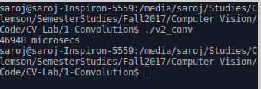

**Time Clocked:- 46948 microsecs**

**Solution Version 3 :- with separable and sliding window**

Code:

//Kernel sliding window algorithm //a 1x7 filter is slided horizontally in the image

int kernelSepSlideWinhor(image &iImg,int iCol,int iRow){

int outPixSum=0;

static int prev1stColSum = 0,prevSum = 0;

int sum = 0;

unsigned char *pInPixels = iImg.getPixels();

//kernel separable details

int ker[7] = {1,1,1,1,1,1,1};

int kSize = 7;

//first pixel of the row, iCol = 3

if( (kSize/2) == iCol){

//Compute the full kernel and save the prev1stColSum and the prevSum

for( int c=-(kSize/2); c<=(kSize/2); c++)

{

//we increment horizontally

sum += (pInPixels[(iRow)*iImg.getCols() + (iCol+c)]*ker[c+(kSize/2)]);

if((c+(kSize/2) == 0)) //saving the first convolved value

prev1stColSum = sum;

}

//save the prevSum

prevSum = sum;

}//not a first pixel of the row, iCol!=3

else{

int lastColSum=0,nb1stColSum=0;

//Compute the last col sum, lastColSum

lastColSum = pInPixels[iRow*(iImg.getCols()) + (iCol+(kSize/2))];

nb1stColSum = pInPixels[iRow*(iImg.getCols()) + (iCol-(kSize/2))];

//compute sum, sum = prevSum - prev1stColSum + lastColSum & save values for next iteration

sum = prevSum - prev1stColSum + lastColSum;

prevSum = sum;

prev1stColSum = nb1stColSum;

}

outPixSum = sum;

return outPixSum;

}

//kernel separable filter applied vertically //a 7x1 filter is slided vertically in the image

int kernelSepSlideWinVer(unsigned int *&pInPixels,int iCol,int iRow,int imgWidth,int imgHeight){

int outPixSum=0;

static int prev1stRowSum,prevSum;

int sum = 0;

//unsigned char *pInPixels = iImg.getPixels();

//kernel separable details

int ker[7] = {1,1,1,1,1,1,1};

int kSize = 7;

//first pixel of the row, iCol = 3

if( (kSize/2) == iRow){

//Compute the full kernel and save the prev1stRowSum and the prevSum

for( int r=-(kSize/2); r<=(kSize/2); r++)

{

sum += (pInPixels[(iRow+r)*imgWidth + (iCol)]*ker[r+(kSize/2)]);

if((r+(kSize/2)) == 0)

prev1stRowSum = sum; //which is the first convolved value

}

//save the prevSum

prevSum = sum;

}//not a first pixel of the row, iCol!=3

else{

int lastRowSum=0,nb1stRowSum=0;

//Compute the last col sum, lastRowSum

lastRowSum = pInPixels[((iRow+(kSize/2))*(imgWidth)) + (iCol)];

nb1stRowSum = pInPixels[((iRow-(kSize/2))*(imgWidth)) + (iCol)];

//compute sum, sum = prevSum - prev1stRowSum + lastRowSum

sum = prevSum - prev1stRowSum + lastRowSum;

prevSum = sum;

prev1stRowSum = nb1stRowSum;

}

outPixSum = sum;

return outPix;

}

//do the main convolution operation here we will clock this function

//whoever uses this method should release the returned pointer

unsigned char *convolveImage(image &iImg){

unsigned char *opPixels = NULL;

unsigned int *tmpPixels = NULL;

int kSize = 7;

int r,c;

int sum;

//allocate memory for the out Pixel pointer

opPixels = new unsigned char[iImg.getRows() * iImg.getCols()];

tmpPixels = new unsigned int[iImg.getRows() * iImg.getCols()];

//Do convolve operation horizontally

for(r=0; r<(iImg.getRows()); r++) //rows will be the same here

for(c=3 ; c<(iImg.getCols()-3); c++)

tmpPixels[r*iImg.getCols()+c] = kernelSepSlideWinhor(iImg,c,r);

//Do convolve operation vertically

for(c=3; c<(iImg.getRows()-3); c++) //rows will be the same here

for(r=3 ; r<(iImg.getCols()-3); r++)

opPixels[r*iImg.getCols()+c] = (unsigned char)(kernelSepSlideWinVer(tmpPixels,c,r,

iImg.getCols(),iImg.getRows())/(kSize*kSize));

delete(tmpPixels);

return opPixels;

}

**Output for version 3:-**

Generates a smoothed output image named, **outv3.ppm**, which is a smoothed version of input image **bridge.ppm**.

Which looks as below:-



**Output Validation:-**

Linux version of diff on **out.ppm** and **outv2.ppm** proves both the files are equal. Diff on **out.ppm** and **outv3.ppm** says both are equal. Diff on **outv2.ppm** and **outv3.ppm** is also successful.

*My machine result:-*

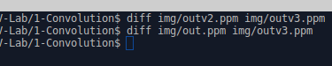

**Time Clocked:- 25161 microsecs**

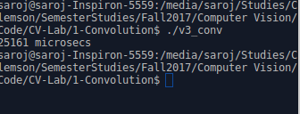

**Conclusion:-**

|  |  |  |
| --- | --- | --- |
|  | Time Taken(µs) | %time taken vs V1 |
| 2dConvV1(basic 2d Convolve) | **103516** | 0 |
| 2d ConvV2(kernel Separable) | **46948** | 54% |
| 2d ConvV3  (separable + sliding Window) | **25161** | 75% |

Thus we can observe that the version is 75% more efficient i.e. takes .25 times of the basic 2d Convolution algorithm. Therefore a combination of separable and sliding window operation is the most efficient way for the convolution operation on the image.