Lab#3 – Letters

Course Name: Intro to Computer Vision

Course: ECE-6310

Name: Saroj Kumar Dash

**Problem Statement:**

To implement thinning, branchpoint and endpoint detection to recognize letters in an image of text

**Solution: -**

For the solution of the problem I built upon my code in my previous lab.

**Preparation for my operation in the images:**

I used my code to read the below images and store in a class named image for further use or operations in the future,

* msf_e.ppm 🡪 to use our previous algorithm to detect the initial detection of the matching images
* parenthood.ppm 🡪 To use it to do all our operations
* parenthood_gt.txt 🡪 To read it for our ground truth computation, I stored this in vector of points and the ground truth character value.

I loop through all the threshold values, iT is starting from 0 to 255. For each threshold value I compare the pixel value in the msf_e.ppm if the value of a pixel at a location r,c is greater than the iT then I consider the pattern ‘e’ to be detected or else I continue in my logic.

**Cropping and Thresholding of the image:**

For every ground-truth coordinates I draw a 9x15 window around the coordinate in the original image and make it a binary image using a threshold value, where all pixels that are greater than the threshold value are made 255 and below the threshold value is made 0. It is said to crop the image from the main image, I instead changed the value in the original image. The cropped and threshold separated binary image appeared as below.

My Modified image with all the detected letters after thresholding it:-

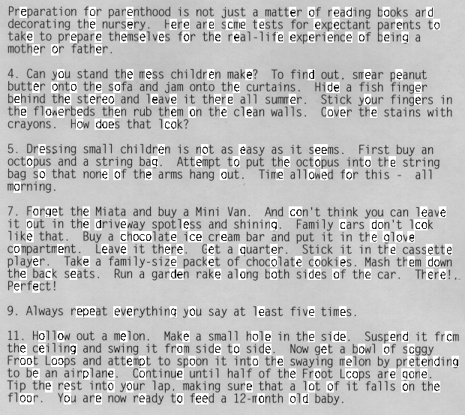

**The Thinning algorithm:**

For a better edge recognizing algorithm we need to thin the thick sections of the detected image. Since we have a binary image now so thinning the image will improve the detection a lot in finding the number of end points and branch points in the image. For thinning I used the ground-truth coordinates obtained to make a window in the original image at which we can use the thinning algorithm (used from class notes). The output of this operation is shown below in the image.

The marking of pixels image condition:-

//the thinning condition to mark the pixel location

if((1 == nbE2NE) && ((3<=nbE)&&(7>=nbE)) && ( N | E | (W&S) )) {

struct point p;

p.c = c;

p.r = r;

vErasePoints.push_back(p);

}

My Modified code screenshot with all the letters that were thinned: -

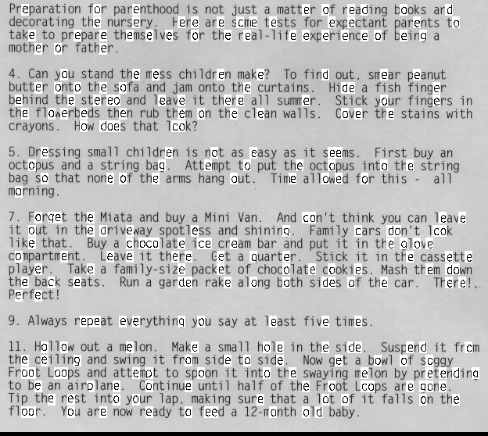

**Edge Properties of the thinned image:**

Next was to find the important pixels in the thinned structure which are the endpoints. I found the 8 neighbor pixels of the pixel of operation (i.e. only edge pixels or whose value was 0) and then checked for edge to non-edge transitions. The most important thing I think was to count the edge to non-edge pixel transition in a clockwise operation. Then using it to calculate the end and branch points in the image, below was my operation to do this.

To count the edge to non-edge transition: -

nbr = getNeighBors(img,c,r);

for(int i=0;i<8;i++){

//count edge to non-edge

if( (nbr[i]==0) && (nbr[i+1]==255))

nb_E2NE+=1;

}

To count the branch point and endpoint in our analysis window:-

if( 1 == nb_E2NE)

nb_ep+=1;

if( 2 < nb_E2NE)

nb_bp+=1;

To check for our letter ‘e’ I check for 1 ep and 1 branchpoint in the analysis window or letter:-

if((nb_bp ==1) && (nb_ep==1))

isE = true;

Since it’s a grey scale image the edge point and branch point could not colored. So I plotted the pixel value and changed the values of edge pixels to 1 and branchpoint pixels to 2. Below is a screenshot of the debug program that I have run. The below dump is of an ‘e’ window at gorundTruth location 139,357. Code is present in Appendix for reference.:-

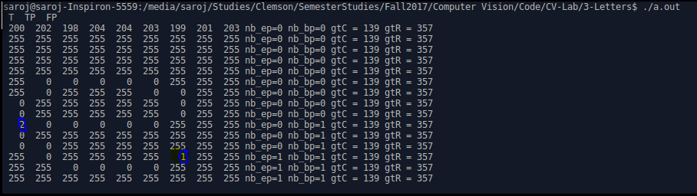

**Plotting my TP and FP counts for my ROC curve: -**

I missed some TP values as the size of the window that I took brought some of the side image data too, but with the missing data and the data that I obtained the ROC curve that I obtained was steeper than my previous lab, thus using this algorithm the letter detection improved. By my observation the TP and FP were optimized at a point of **threshold = 202** which is highlighted in my table.

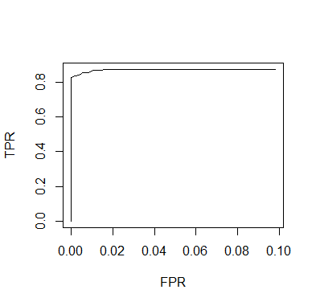

In normalized values of TPR and FPR values: -

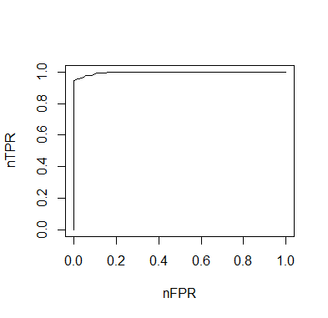

Below are my TP and FP values using my detection method:-

|  |  |  |  |  |  |  |  |  |  |  |  |  |  |  |  |  |  |  |  |  |  |  |  |  |  |  |
| --- | --- | --- | --- | --- | --- | --- | --- | --- | --- | --- | --- | --- | --- | --- | --- | --- | --- | --- | --- | --- | --- | --- | --- | --- | --- | --- |
| T | TP | | FP | |  | | T | | TP | FP |  | T | TP | FP |  | T | TP | FP |  | T | TP | FP |  | T | TP | FP |
| 0 | 143 | | 114 | |  | | 41 | | 143 | 114 |  | 81 | 143 | 114 |  | 121 | 143 | 114 |  | 161 | 143 | 114 |  | 201 | 142 | 21 |
| 1 | 143 | | 114 | |  | | 42 | | 143 | 114 |  | 82 | 143 | 114 |  | 122 | 143 | 114 |  | 162 | 143 | 114 |  | 202 | 142 | 16 |
| 2 | 143 | | 114 | |  | | 43 | | 143 | 114 |  | 83 | 143 | 114 |  | 123 | 143 | 114 |  | 163 | 143 | 114 |  | 203 | 141 | 14 |
| 3 | 143 | | 114 | |  | | 44 | | 143 | 114 |  | 84 | 143 | 114 |  | 124 | 143 | 114 |  | 164 | 143 | 114 |  | 204 | 140 | 12 |
| 4 | 143 | | 114 | |  | | 45 | | 143 | 114 |  | 85 | 143 | 114 |  | 125 | 143 | 114 |  | 165 | 143 | 114 |  | 205 | 140 | 9 |
| 5 | 143 | | 114 | |  | | 46 | | 143 | 114 |  | 86 | 143 | 114 |  | 126 | 143 | 114 |  | 166 | 143 | 114 |  | 206 | 139 | 8 |
| 6 | 143 | | 114 | |  | | 47 | | 143 | 114 |  | 87 | 143 | 114 |  | 127 | 143 | 114 |  | 167 | 143 | 114 |  | 207 | 139 | 7 |
| 7 | 143 | | 114 | |  | | 48 | | 143 | 114 |  | 88 | 143 | 114 |  | 128 | 143 | 114 |  | 168 | 143 | 114 |  | 208 | 138 | 6 |
| 8 | 143 | | 114 | |  | | 49 | | 143 | 114 |  | 89 | 143 | 114 |  | 129 | 143 | 114 |  | 169 | 143 | 114 |  | 209 | 137 | 2 |
| 9 | 143 | | 114 | |  | | 50 | | 143 | 114 |  | 90 | 143 | 114 |  | 130 | 143 | 114 |  | 170 | 143 | 112 |  | 210 | 136 | 0 |
| 10 | 143 | | 114 | |  | | 51 | | 143 | 114 |  | 91 | 143 | 114 |  | 131 | 143 | 114 |  | 171 | 143 | 111 |  | 211 | 136 | 0 |
| 11 | 143 | | 114 | |  | | 52 | | 143 | 114 |  | 92 | 143 | 114 |  | 132 | 143 | 114 |  | 172 | 143 | 110 |  | 212 | 134 | 0 |
| 12 | 143 | | 114 | |  | | 53 | | 143 | 114 |  | 93 | 143 | 114 |  | 133 | 143 | 114 |  | 173 | 143 | 108 |  | 213 | 133 | 0 |
| 13 | 143 | | 114 | |  | | 54 | | 143 | 114 |  | 94 | 143 | 114 |  | 134 | 143 | 114 |  | 174 | 143 | 108 |  | 214 | 129 | 0 |
| 14 | 143 | | 114 | |  | | 55 | | 143 | 114 |  | 95 | 143 | 114 |  | 135 | 143 | 114 |  | 175 | 143 | 104 |  | 215 | 129 | 0 |
| 15 | 143 | | 114 | |  | | 56 | | 143 | 114 |  | 96 | 143 | 114 |  | 136 | 143 | 114 |  | 176 | 143 | 101 |  | 216 | 126 | 0 |
| 16 | 143 | | 114 | |  | | 57 | | 143 | 114 |  | 97 | 143 | 114 |  | 137 | 143 | 114 |  | 177 | 143 | 98 |  | 217 | 124 | 0 |
| 17 | 143 | | 114 | |  | | 58 | | 143 | 114 |  | 98 | 143 | 114 |  | 138 | 143 | 114 |  | 178 | 143 | 96 |  | 218 | 119 | 0 |
| 18 | 143 | | 114 | |  | | 59 | | 143 | 114 |  | 99 | 143 | 114 |  | 139 | 143 | 114 |  | 179 | 143 | 93 |  | 219 | 118 | 0 |
| 19 | 143 | | 114 | |  | | 60 | | 143 | 114 |  | 100 | 143 | 114 |  | 140 | 143 | 114 |  | 180 | 143 | 88 |  | 220 | 116 | 0 |
| 20 | 143 | | 114 | |  | | 61 | | 143 | 114 |  | 101 | 143 | 114 |  | 141 | 143 | 114 |  | 181 | 143 | 81 |  | 221 | 113 | 0 |
| 21 | 143 | | 114 | |  | | 62 | | 143 | 114 |  | 102 | 143 | 114 |  | 142 | 143 | 114 |  | 182 | 143 | 79 |  | 222 | 109 | 0 |
| 22 | 143 | | 114 | |  | | 63 | | 143 | 114 |  | 103 | 143 | 114 |  | 143 | 143 | 114 |  | 183 | 143 | 75 |  | 223 | 102 | 0 |
| 23 | 143 | | 114 | |  | | 64 | | 143 | 114 |  | 104 | 143 | 114 |  | 144 | 143 | 114 |  | 184 | 143 | 72 |  | 224 | 97 | 0 |
| 24 | 143 | | 114 | |  | | 65 | | 143 | 114 |  | 105 | 143 | 114 |  | 145 | 143 | 114 |  | 185 | 143 | 68 |  | 225 | 96 | 0 |
| 25 | 143 | | 114 | |  | | 66 | | 143 | 114 |  | 106 | 143 | 114 |  | 146 | 143 | 114 |  | 186 | 143 | 68 |  | 226 | 91 | 0 |
| 26 | 143 | | 114 | |  | | 67 | | 143 | 114 |  | 107 | 143 | 114 |  | 147 | 143 | 114 |  | 187 | 143 | 64 |  | 227 | 88 | 0 |
| 27 | 143 | | 114 | |  | | 68 | | 143 | 114 |  | 108 | 143 | 114 |  | 148 | 143 | 114 |  | 188 | 143 | 59 |  | 228 | 80 | 0 |
| 28 | 143 | | 114 | |  | | 69 | | 143 | 114 |  | 109 | 143 | 114 |  | 149 | 143 | 114 |  | 189 | 143 | 55 |  | 229 | 74 | 0 |
| 29 | 143 | | 114 | |  | | 70 | | 143 | 114 |  | 110 | 143 | 114 |  | 150 | 143 | 114 |  | 190 | 143 | 52 |  | 230 | 67 | 0 |
| 30 | 143 | | 114 | |  | | 71 | | 143 | 114 |  | 111 | 143 | 114 |  | 151 | 143 | 114 |  | 191 | 143 | 47 |  | 231 | 62 | 0 |
| 31 | 143 | | 114 | |  | | 72 | | 143 | 114 |  | 112 | 143 | 114 |  | 152 | 143 | 114 |  | 192 | 143 | 45 |  | 232 | 59 | 0 |
| 32 | 143 | | 114 | |  | | 73 | | 143 | 114 |  | 113 | 143 | 114 |  | 153 | 143 | 114 |  | 193 | 143 | 43 |  | 233 | 52 | 0 |
| 33 | 143 | | 114 | |  | | 74 | | 143 | 114 |  | 114 | 143 | 114 |  | 154 | 143 | 114 |  | 194 | 143 | 40 |  | 234 | 47 | 0 |
| 34 | 143 | | 114 | |  | | 75 | | 143 | 114 |  | 115 | 143 | 114 |  | 155 | 143 | 114 |  | 195 | 143 | 38 |  | 235 | 42 | 0 |
| 35 | 143 | | 114 | |  | | 76 | | 143 | 114 |  | 116 | 143 | 114 |  | 156 | 143 | 114 |  | 196 | 143 | 32 |  | 236 | 40 | 0 |
| 36 | 143 | | 114 | |  | | 77 | | 143 | 114 |  | 117 | 143 | 114 |  | 157 | 143 | 114 |  | 197 | 143 | 30 |  | 237 | 38 | 0 |
| 37 | 143 | | 114 | |  | | 78 | | 143 | 114 |  | 118 | 143 | 114 |  | 158 | 143 | 114 |  | 198 | 143 | 28 |  | 238 | 34 | 0 |
| 38 | 143 | | 114 | |  | | 79 | | 143 | 114 |  | 119 | 143 | 114 |  | 159 | 143 | 114 |  | 199 | 143 | 26 |  | 239 | 30 | 0 |
| 39 | 143 | | 114 | |  | | 80 | | 143 | 114 |  | 120 | 143 | 114 |  | 160 | 143 | 114 |  | 200 | 142 | 21 |  | 240 | 28 | 0 |
| 40 | 143 | | 114 | |  | |  | |  |  |  |  |  |  |  |  |  |  |  |  |  |  |  |  |  |  |
| T | | TP | | FP | |
| 241 | | 24 | | 0 | |
| 242 | | 23 | | 0 | |
| 243 | | 20 | | 0 | |
| 244 | | 16 | | 0 | |
| 245 | | 13 | | 0 | |
| 246 | | 11 | | 0 | |
| 247 | | 8 | | 0 | |
| 248 | | 6 | | 0 | |
| 249 | | 5 | | 0 | |
| 250 | | 1 | | 0 | |
| 251 | | 1 | | 0 | |
| 252 | | 1 | | 0 | |
| 253 | | 1 | | 0 | |
| 254 | | 1 | | 0 | |
| 255 | | 0 | | 0 | |

Appendix for Code:-

void cropAndThreshold_9x15(image &inImg,int ix,int iy){

//unsigned char *pOutCropPixels = new unsigned char[9*15];

int ix0,ixn,iy0,iyn;

ix0 = ix-(9/2)-1;

ixn = ix+(9/2);//+1;

iy0 = iy-(15/2);//-1;

iyn = iy+(15/2);//+1;

int T = 128;

unsigned char **ppImgPix = inImg.getppPixels();

int cnt = 0;

for(int r=iy0;r<=iyn;r++){

for(int c=ix0;c<=ixn;c++){

//edgecases

if((c==ix0) || (c==ixn) || (r==iy0) || (r==iyn))

ppImgPix[r][c] = 255;

if(ppImgPix[r][c] > T)

ppImgPix[r][c] = 255;

else

ppImgPix[r][c] = 0;

}

}

}

unsigned char *getNeighBors(image &img,int c,int r){

unsigned char *nbr = new unsigned char[9];

int cnt = 0;

int i =0;

unsigned char **ppPixels = img.getppPixels();

for(i = c-1;i<=(c+1);i++)

nbr[cnt++] = ppPixels[r-1][i];

nbr[cnt++] = ppPixels[r][c+1];

for(i = c+1;i>=(c-1);i--)

nbr[cnt++] = ppPixels[r+1][i];

nbr[cnt++] = ppPixels[r][c-1];

nbr[cnt++] = ppPixels[r-1][c-1];

return nbr;

}

void thinning(image &img,int gtc,int gtr){

//thinning has to be done for single pixel wide components

int ic0,icn,ir0,irn;

ic0 = gtc-(9/2);

icn = gtc+(9/2);

ir0 = gtr-(15/2);

irn = gtr+(15/2);

unsigned char **ppImgPix = img.getppPixels();

std::vector<struct point> vErasePoints;

int c =0;

//loop through the thresholded image

do{

//erase the marked points

for(int ithP=0;ithP < vErasePoints.size(); ithP++){

//erase here by making them 255

ppImgPix[vErasePoints[ithP].r][vErasePoints[ithP].c] = 255;

}

if(vErasePoints.size()) vErasePoints.clear();

for(int r=ir0;r<=irn;r++){

for(int c=ic0;c<=icn;c++){

//Pass through the image looking at each pixel with value 0 i.e. edge pixels

if( 0 == ppImgPix[r][c]){

//check for erasure

unsigned char *nbr = getNeighBors(img,c,r);

int nbE2NE = 0;

int N=0,E=0,W=0,S=0;

int nbE = 0;

//check for all edge to non-edge transition

for(int i =0;i<8;i++){

if( (nbr[i]==0) && (nbr[i+1]==255))

nbE2NE+=1;

//get neighbors

if( (i == 1) && (nbr[i]==255)) N=1;

if( (i == 3) && (nbr[i]==255)) E=1;

if( (i == 5) && (nbr[i]==255)) S=1;

if( (i == 7) && (nbr[i]==255)) W=1;

//get number of edge neighbors

if( 0 == nbr[i])

nbE+=1;

}

//the thinning condition to mark the pixel location

if( (1 == nbE2NE) && ((3<=nbE)&&(7>=nbE)) && ( N | E | (W&S) )) {

struct point p;

p.c = c;

p.r = r;

vErasePoints.push_back(p);

}

delete nbr;

}

}

}

}while(vErasePoints.size());

return;

}

bool is_e_detected(image &img,int gtC,int gtR){

bool isE = false;

int nb_E2NE=0;

int nb_ep=0,nb_bp=0;

int ic0,icn,ir0,irn;

ic0 = gtC-(9/2);

icn = gtC+(9/2);

ir0 = gtR-(15/2);

irn = gtR+(15/2);

unsigned char *nbr = NULL;

for(int r=ir0;r<=irn;r++){

for(int c=ic0;c<=icn;c++){

//printf("%4d ",(img.getppPixels())[r][c]);

if( 255 == (img.getppPixels())[r][c]) continue;

nbr = getNeighBors(img,c,r);

for(int i=0;i<8;i++){

//count edge to non-edge

if( (nbr[i]==0) && (nbr[i+1]==255))

nb_E2NE+=1;

}

if( 1 == nb_E2NE)

nb_ep+=1;

if( 2 < nb_E2NE)

nb_bp+=1;

nb_E2NE=0;

delete nbr;

}

}

if((nb_bp ==1) && (nb_ep==1))

isE = true;

return isE;

}