git init

git remote add origin [git@github.com:saroj3454/testclient1.git](mailto:git@github.com:saroj3454/testclient1.git)

git status

git add .

git commit –m ”jocommit likhibar achi”

git status (add heigiki nahi)

generate( ssh-keygen -t rsa -b 4096 -C "sarojsahoo41@gmail.com"

)

Enter enter

Cat (gote commanf)

cat /c/Users/LENOVO/.ssh/id_rsa.pub

code copy past kargiri

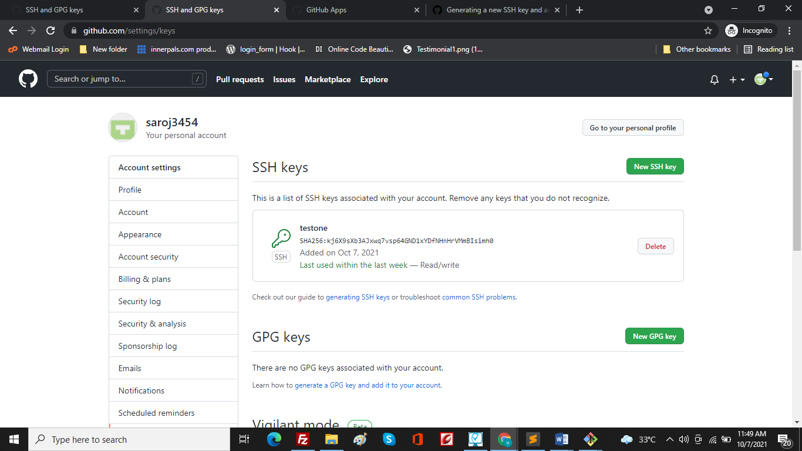

git push origin master

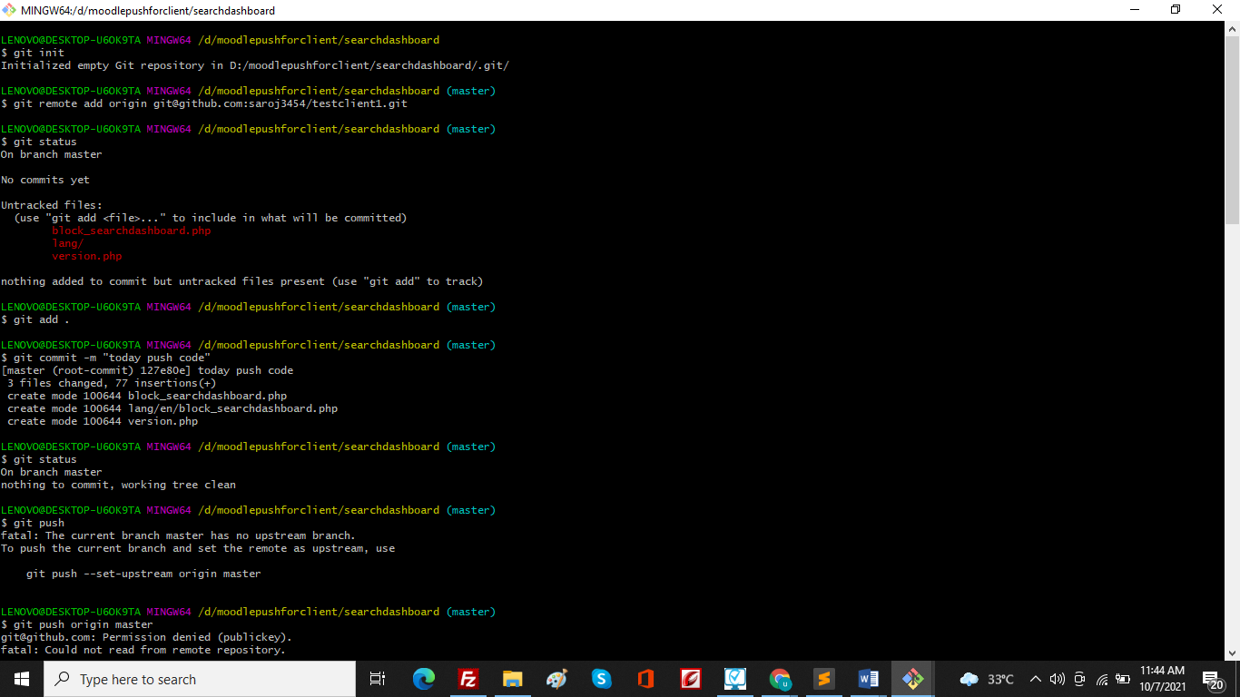

Second time add code pane

git status

git add .

git commit –m ”jocommit likhibar achi”

git status

git push origin master

