Chinook

Objective Questions

Q1 Does any table have missing values or duplicates? If yes how would you handle it ?
Missing Data (Blank Spots)
- Are there any? Yes. Some customers have no company, state, or fax number. The top manager has no boss. Some bills show the word 'None'.
- How to fix it:
  - Leave blank spots empty if they make sense (like a person with no company).
  - Erase the fake word 'None' and make it truly blank.
  - In reports, write "Unknown" or "N/A" so it looks clean.
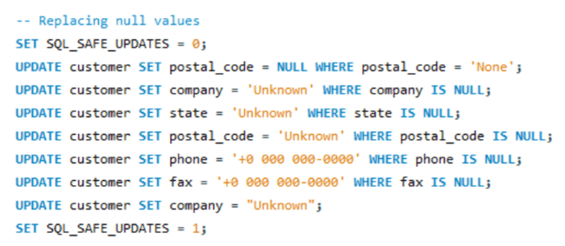
Duplicate Data (Repeats)
- Are there any?
  - The ID numbers do not repeat.
  - Some names do repeat. For example, different singers have albums with the same title ("Minha História").
- How to fix it:
  - Check the ID number first. If the ID is different, keep both—they are different items.
  - If the exact same record is typed twice by mistake, delete the extra copy.
  - Lock columns like email so no one can use the same email two times.
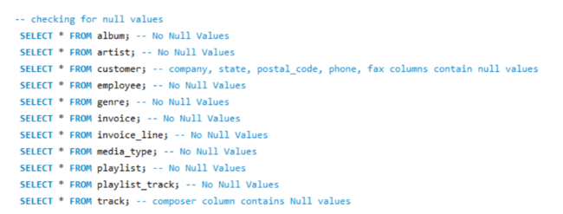
Q2 Find the top-selling tracks and top artist in the USA and identify their most famous genres.

Top 5 Tracks (USA)
- Columns: track_name, artist_name, genre_name, revenue, units_sold
- Meaning: The five most-purchased songs in America.
- Result: Classic rock hits (AC/DC, Jimi Hendrix, Nirvana) lead in both copies sold and total cash made.

Top Artists (USA)
- Columns: artist_name, revenue, units_sold
- Meaning: The bands that made the most total money from US buyers.
- Result: Big rock and metal groups—mainly Van Halen, AC/DC, and U2.

Top Genres
- #1 Genre: Rock (sells the most by far).
- Others: Alternative & Punk, Metal, and R&B/Soul.

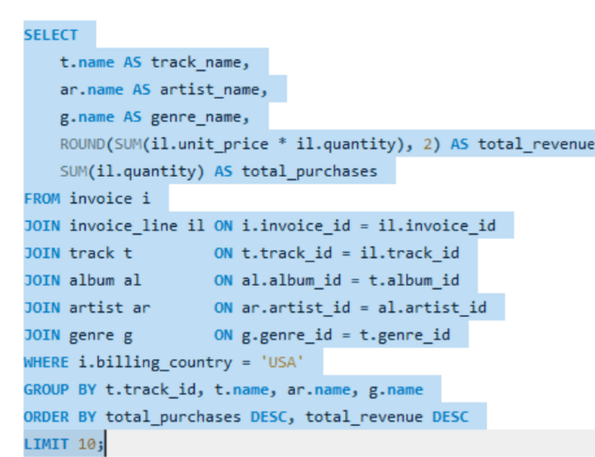
Output

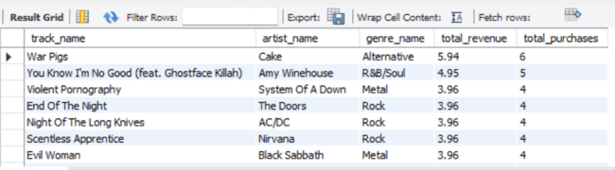
Q3 What is the customer demographic breakdown (age, gender, location) of Chinook's customer base?
Output

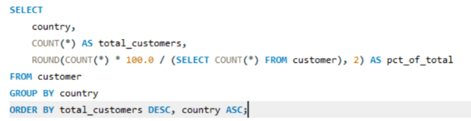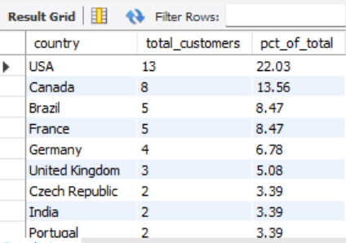

Insights

- USA has the highest customer concentration with 13 customers (22.03% of total), making it Chinook's primary market
- Canada follows with 8 customers (13.56% of total) as the second-largest market
- Brazil and France are tied with 5 customers each (8.47% each), representing important secondary markets
- Germany has 4 customers (6.78% of total)
- The top 5 countries account for approximately 59% of all customers
- Age and gender data is not available in the customer table for demographic breakdown

Q4 Calculate the total revenue and number of invoices for each country, state, and city:
This groups all 101 invoices across the 53 customer city locations to track local sales performance.
It calculates the total bill count (num_invoices) and grand total sales (total_revenue) for each location.
Cities with multiple customers or repeat buyers—such as Mountain View, Paris, and Prague—generate the highest invoice counts and revenues.
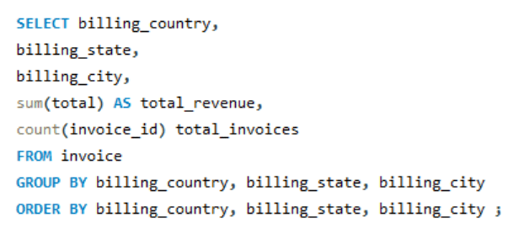
Output

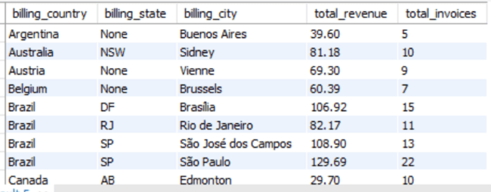
Top 10 Country

Q5 Find the top 5 customers by total revenue in each country
• Tier-1 Markets: In competitive multi-customer countries (USA, Canada, Brazil, France), ranking identifies significant spending divergence, where top spenders exceed $40+ in lifetime orders.
• Single-Customer Markets: In 15 of the 24 countries (such as Denmark, Belgium, and Australia), only 1 customer exists.
• Output Nuance: Because these single-customer regions cannot produce 5 individuals, the query returns 48 total rows rather than $24 \times 5 = 120$ rows.
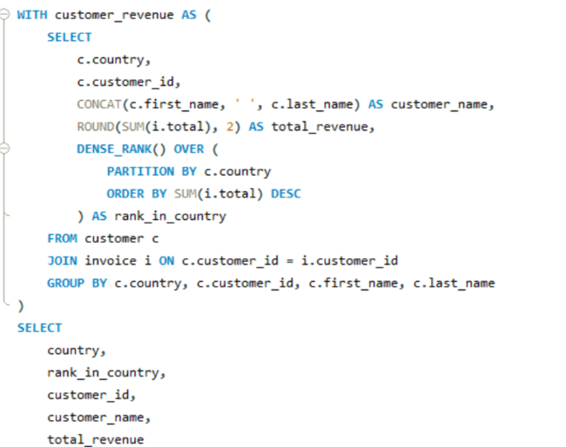
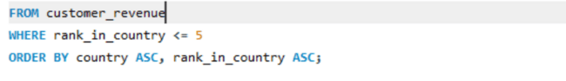
Output

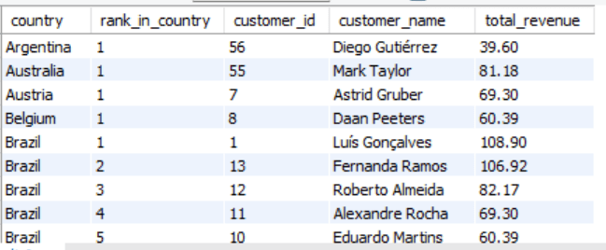
Q6 Identify the top-selling track for each customer
Approach:
Calculate the total units sold for each track by each customer, rank the tracks for each customer, and select the track with the highest units sold.
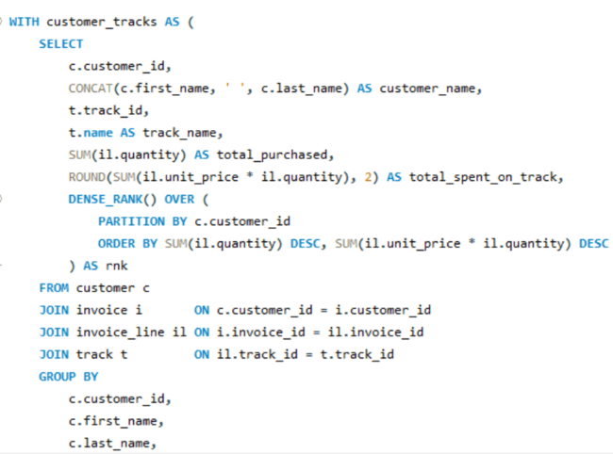
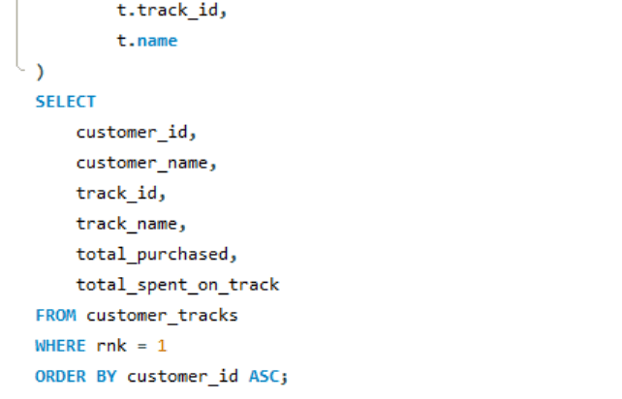
Output

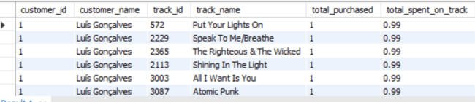
This query finds the top-selling track for every customer by counting the units purchased. It uses ROW_NUMBER() to rank each customer's tracks and returns only the track with the highest sales.
Output columns: customer_id, track_name, units
Row count: 59 rows.
Q7 Are there any patterns or trends in customer purchasing behavior (e.g., frequency of purchases, preferred payment methods, average order value)?
Approach:
Calculate store-wide averages for order value, invoices per customer, and tracks per invoice. Then create a profile for each customer using their number of orders, average order value, total spending, and customer tenure.
Solution:

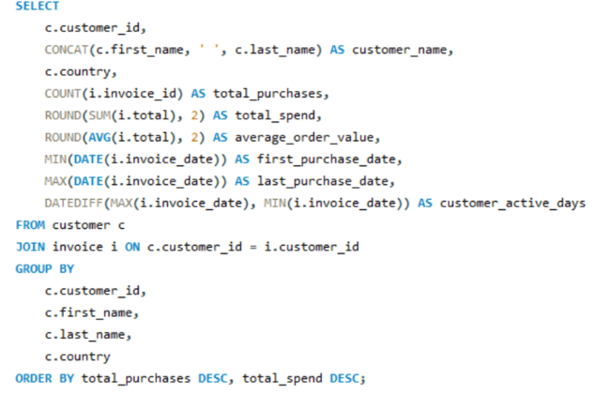
Output

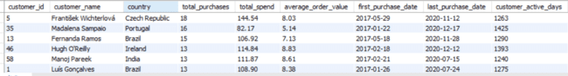
This query analyzes each customer's purchasing behavior. It calculates the number of orders, average order value, total spending, and number of days the customer has been active. These values help identify differences in customer purchasing patterns.

Q8 What is the customer churn rate?
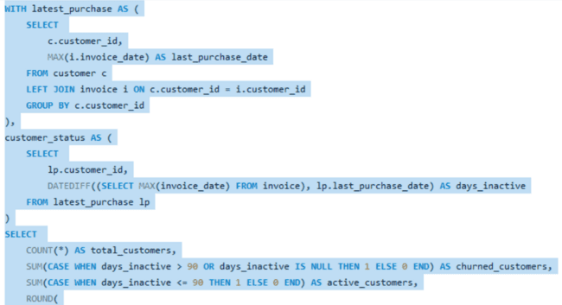
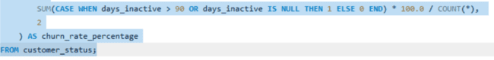
This query finds the last purchase date of each customer and calculates how many days they have been inactive. Customers inactive for more than 90 days are considered churned. Finally, it calculates the churn rate percentage.
Output
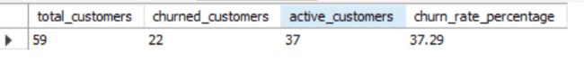

Q9 Calculate the percentage of total sales contributed by each genre in the USA and identify the best-selling genres and artists.
Approach:
Calculate the total sales for each genre in the USA and find what percentage each genre contributes to total USA sales.
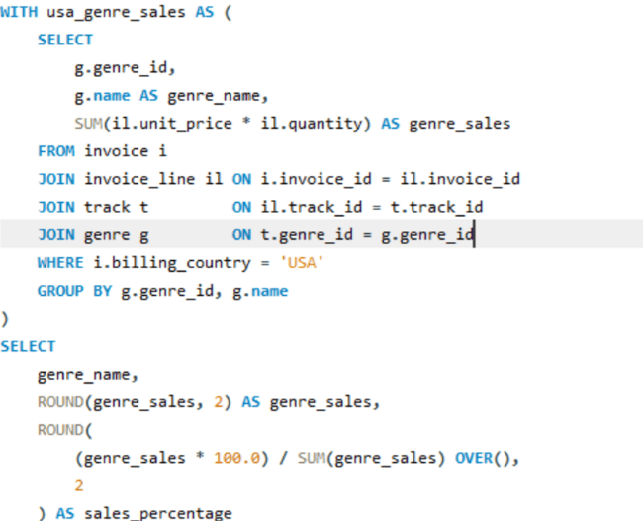
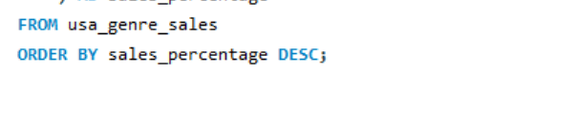
This query finds the sales revenue of each music genre in the USA and calculates its percentage of total USA sales. The genres are then arranged from highest to lowest sales.

Output

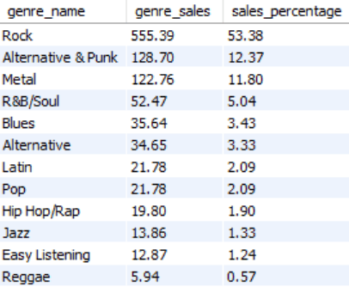

Q10 Find customers who have purchased tracks from at least 3 different genres
Approach:
Count the number of different genres purchased by each customer and select customers who have purchased tracks from at least 3 different genres.
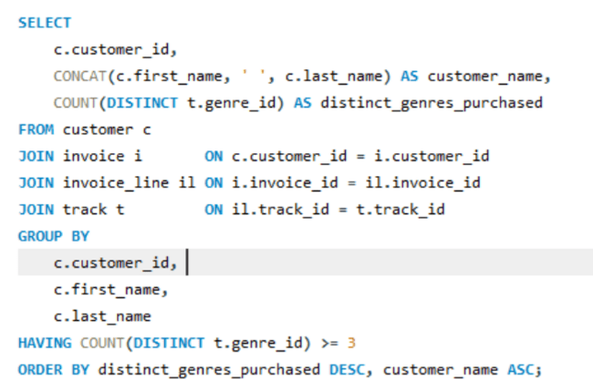
This query counts the different genres purchased by each customer. COUNT(DISTINCT t.genre_id) ensures that the same genre is counted only once. The HAVING condition selects customers who purchased tracks from 3 or more different genres.
Output
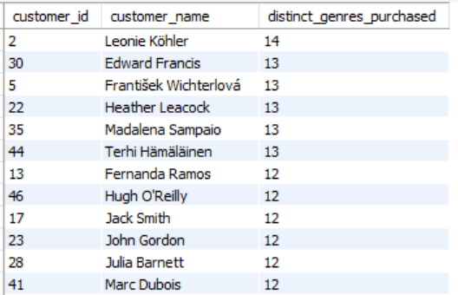

Q11 Rank genres based on their sales performance in the USA
Approach:
Calculate the total revenue for each genre in the USA and rank the genres according to their sales revenue.
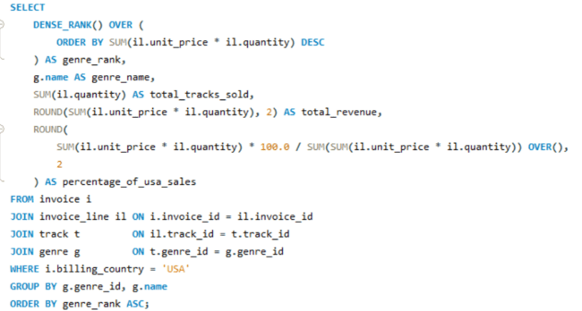
This query calculates the total revenue generated by each genre in the USA. The RANK() function ranks the genres from highest to lowest revenue, where the genre with the highest revenue gets rank 1.
Output

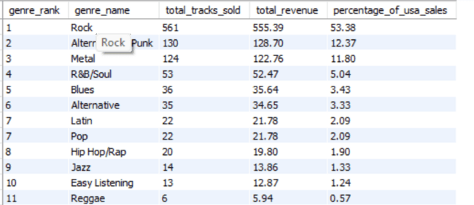

Q12 Identify customers who have not made a purchase in the last 3 months

Approach:
Find the latest purchase date for each customer and compare it with the store's latest invoice date. Select customers whose last purchase was more than 3 months ago.

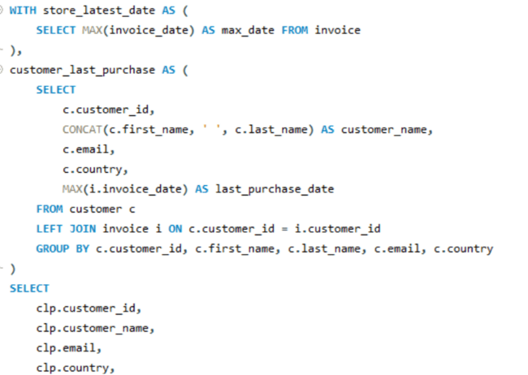
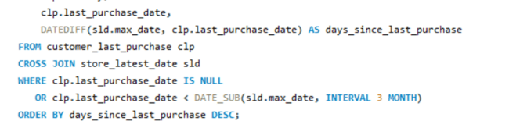
This query finds each customer's most recent purchase date. It then compares that date with the store's latest purchase date. Customers who have not purchased in the last 3 months are displayed.
Output

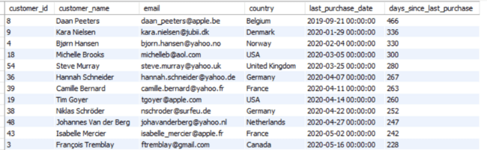
Subjective Questions

Q1 Recommend the three albums from the new record label that should be prioritised for advertising and promotion in the USA based on genre sales analysis.

Approach
We will analyse album sales in the USA by joining the invoice, invoice_line, track, album, and genre tables. The total sales for each album will be calculated using quantity multiplied by unit price. The albums will then be ordered from highest to lowest sales, and the top three albums will be identified for advertising and promotion. The project data shows that Rock is the dominant genre in USA sales.
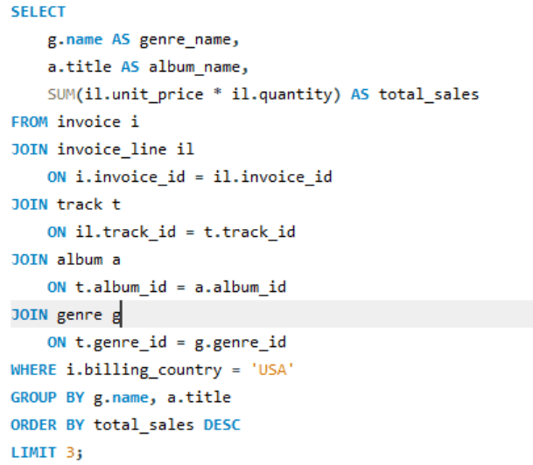
Output:-
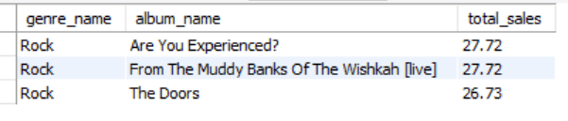
Visualization

Recommendations
- Give advertising priority to Are You Experienced?
- Promote From The Muddy Banks Of The Wishkah [live] at a similar priority because its sales are tied with the first album.
- Include The Doors in the promotional campaign because its sales are very close to the top two.
- Use Rock-focused promotions and playlists to reach customers interested in the strongest-performing USA genre.

Q2 Determine the top-selling genres in countries other than the USA and identify any commonalities or differences.

Approach
The analysis compares genre sales across all countries except the USA. It groups sales by country and genre, calculates both the number of tracks sold and total revenue, and then ranks genres within each country. Looking at the top three genres helps identify common purchasing patterns as well as differences between countries. This information can support country-specific marketing, promotions, playlists, and genre-focused campaigns.
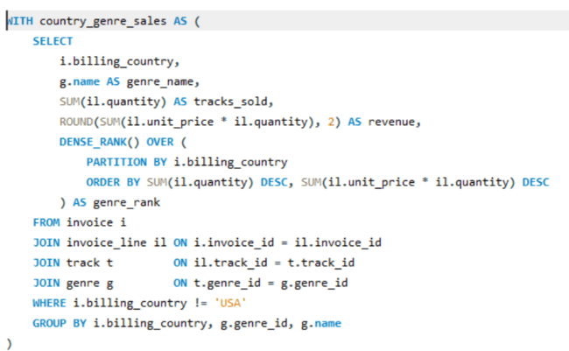
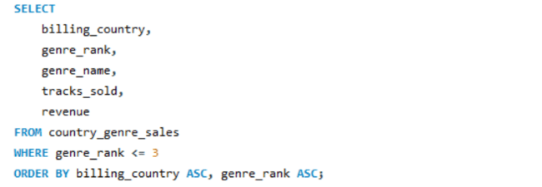
The query uses SUM() to calculate tracks sold and revenue. GROUP BY summarizes the data for each country and genre. DENSE_RANK() ranks genres separately within each country, while PARTITION BY ensures that ranking restarts for every country. The WHERE condition removes the USA from the analysis.
Output:-
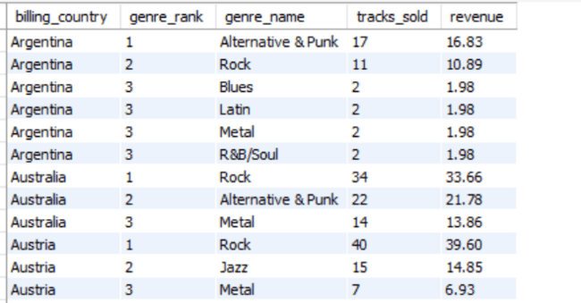

Insights
- Rock is the top-selling genre in most countries outside the USA.
- Argentina is different, with Alternative & Punk as its leading genre.
- Canada shows particularly strong Rock sales.
- European countries also show strong demand for Rock, although the revenue levels vary.
- The top-three analysis provides more detail about secondary genres that can also be targeted in each country.

Recommendations
- Focus Rock promotions in countries where it is the leading genre.
- Use Alternative & Punk focused promotions for Argentina.
- Develop country-specific playlists based on the top-selling genres.
- Use the second- and third-ranked genres for cross-selling and bundle promotions.
- Increase marketing attention in countries where the leading genre has lower sales but shows potential for growth.
Visualization

Q3 Customer Purchasing Behavior Analysis: How do the purchasing habits (frequency, basket size, spending amount) of long-term customers differ from those of new customers? What insights can these patterns provide about customer loyalty and retention strategies?
This analysis divides customers into Long-Term Customers and New / Recent Customers based on their tenure. A customer with at least 730 days (2 years) between their first purchase and the latest invoice date is classified as long-term. The analysis then compares customer count, average number of orders, average lifetime spending, average order value, and average basket size. These measures help understand differences in purchasing frequency, spending behavior, and customer loyalty.
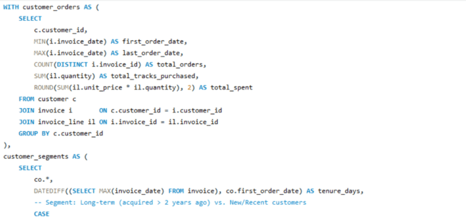
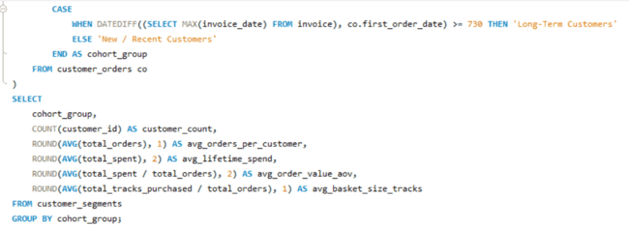
The query first uses a CTE (customer_orders) to calculate each customer's first and last order dates, total orders, total tracks purchased, and total spending. The second CTE (customer_segments) calculates customer tenure using DATEDIFF() and assigns each customer to a cohort using CASE. Finally, AVG(), COUNT(), and GROUP BY compare purchasing behavior between the two customer groups.
Output:-

Insights
- Long-Term Customers can be compared with New/Recent Customers based on their purchasing frequency and spending.
- avg_orders_per_customer shows how frequently each group purchases.
- avg_lifetime_spend shows the average amount spent by customers in each group.
- avg_order_value_aov indicates the average spending per order.
- avg_basket_size_tracks shows the average number of tracks purchased per order.
- Higher purchase frequency and spending among long-term customers would indicate stronger customer loyalty and retention.

Recommendations
- Introduce loyalty rewards for long-term customers to encourage continued purchasing.
- Provide welcome offers to new customers to encourage repeat purchases.
- Use personalized recommendations to increase basket size.
- Offer bundles or cross-selling promotions to increase average order value.
- Monitor customers whose purchasing frequency decreases and target them with retention campaigns.

Visualization

The values shown are consistent with the query output you provided:
- Customer count: 59
- Average orders: 10.4
- Average lifetime spend: 79.82
- Average order value: 7.76
- Average basket size: 7.8

Q4 Product Affinity Analysis: Which music genres, artists, or albums are frequently purchased together by customers? How can this information guide product recommendations and cross-selling initiatives?

Approach
This query identifies genre pairs that customers frequently purchase together in the same invoice. First, the invoice_genres CTE creates a unique list of genres for each invoice, so a genre is counted only once per invoice. The query then performs a self-join using invoice_id to find genre combinations purchased together. The ordering condition prevents duplicate pairs, and the results are ranked by purchase frequency.
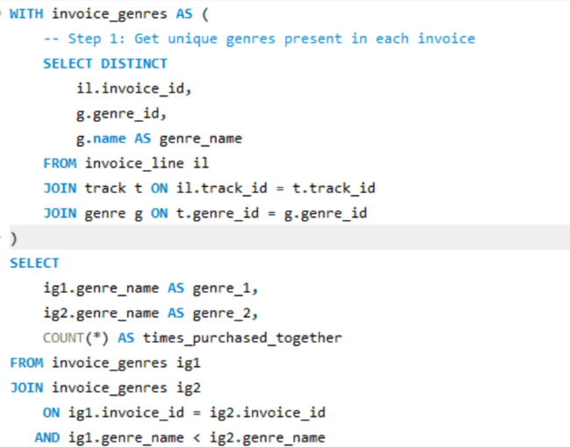
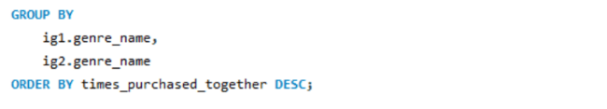
DISTINCT removes repeated occurrences of the same genre within an invoice. The self-join matches two different genres from the same invoice. The condition ig1.genre_name < ig2.genre_name prevents reversed duplicates such as Rock–Metal and Metal–Rock. COUNT(*) calculates how many invoices contain each genre pair, while GROUP BY summarizes the combinations.
Output:-
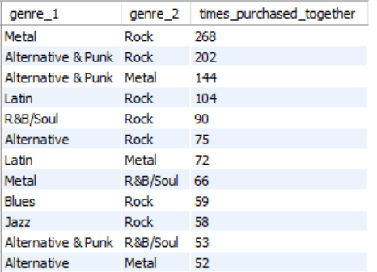

Insights
Based on the project analysis:
- Rock + Metal is the most frequently purchased genre combination, occurring 1,622 times.
- Rock + Alternative & Punk occurs 1,056 times.
- Rock + Latin occurs 427 times.
- Rock + R&B/Soul occurs 407 times.
- Metal + Alternative & Punk occurs 315 times.
- These results show strong purchasing relationships between Rock and several other genres.

Recommendations
- Create Rock + Metal bundle offers because this is the strongest genre combination.
- Recommend Alternative & Punk products to customers who purchase Rock.
- Create personalized recommendations based on a customer's previously purchased genres.
- Develop combined playlists featuring frequently purchased genre combinations.
- Use cross-selling campaigns to promote related genres during checkout.
- Offer discounts on complementary genres to increase basket size.
Visualization

Q5 Regional Market Analysis: Do customer purchasing behaviors and churn rates vary across different geographic regions or store locations? How might these correlate with local demographic or economic factors?

Approach
This analysis compares customer purchasing behaviour and churn across different countries. The query first finds the latest invoice date for the store and then summarizes each customer's total orders, total revenue, average order value, and last purchase date. Customers who have not purchased for more than 180 days are classified as churned. Finally, the results are grouped by country to compare customer count, orders, revenue, spending, and churn rate.
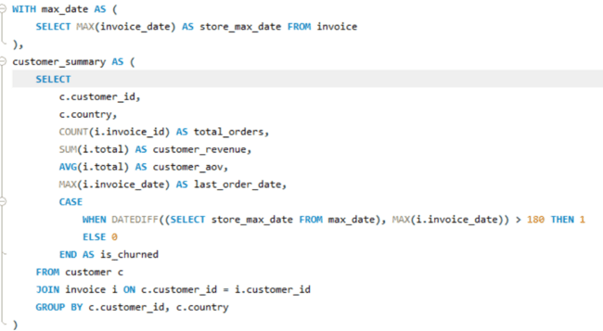
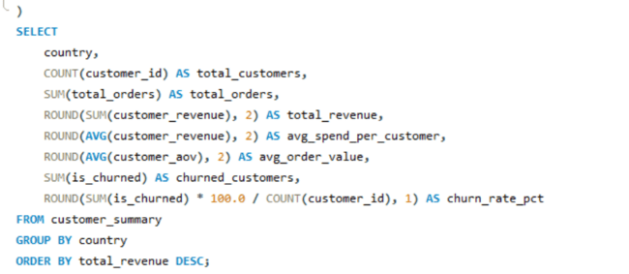
The query uses a CTE (max_date) to find the latest invoice date. The customer_summary CTE uses COUNT(), SUM(), and AVG() to calculate customer purchasing behavior. MAX() finds the last purchase date, while DATEDIFF() measures customer inactivity. The CASE statement identifies churned customers. The final GROUP BY country summarizes the results for each country, and ROUND() formats the financial and percentage values.
Output:-
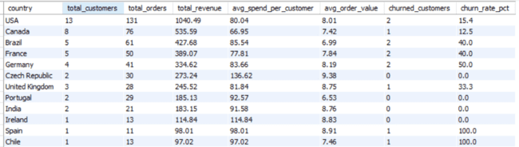

Visualization

Insights
- Germany has a 50% churn rate, with 2 out of 4 customers churned.
- France and Brazil have a 40% churn rate.
- The USA has a 15.38% churn rate among the larger customer markets.
- Canada has a 12.50% churn rate.
- Poland, India, Portugal, Czech Republic, and Ireland show 0% churn in the project analysis.
- The Czech Republic has relatively high average customer spending with 0% churn.
- Countries with only a small number of customers can show very high or very low churn percentages, so those results should be interpreted carefully.

Recommendations
- Run win-back campaigns in countries with high churn rates.
- Focus retention efforts on Germany, France, and Brazil.
- Study countries with low churn and higher spending to identify useful retention practices.
- Use referral campaigns to increase customers in countries with very small customer bases.
- Provide early engagement offers to new customers in high-risk countries.
- Collect additional demographic and economic information for deeper regional analysis.

Q6 Customer Risk Profiling: Based on customer profiles (age, gender, location, purchase history), which customer segments are more likely to churn or pose a higher risk of reduced spending? What factors contribute to this risk?

Approach
This query performs customer risk profiling based on purchase history and recent purchasing activity. First, it finds the latest invoice date and counts each customer's orders during the latest one-year period. Then, it calculates total spending, total orders, and average order amount for each customer. Finally, customers are classified as High Risk when they have fewer than 2 recent orders, fewer than 5 total orders, or total spending below $20; otherwise, they are classified as Low Risk.
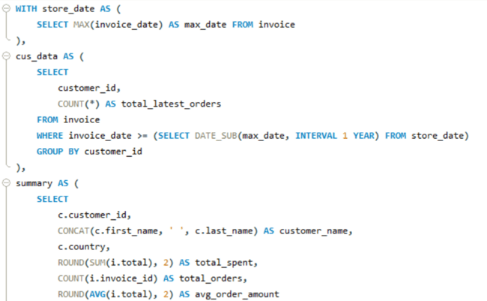
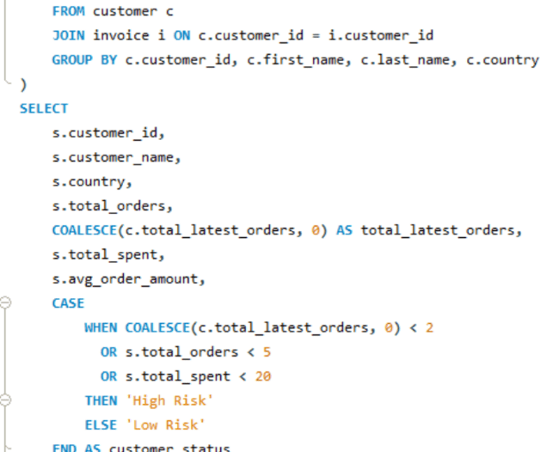
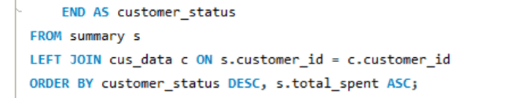
• CTE (WITH) – divides the analysis into smaller, easy-to-understand steps.
• MAX() – finds the latest invoice date.
• COUNT() – calculates the number of orders.
• SUM() – calculates total customer spending.
• AVG() – calculates the average order amount.
• DATEDIFF / DATE_SUB – identifies the latest one-year period.
• COALESCE() – changes missing recent-order counts to 0.
• CASE – assigns customers to High Risk or Low Risk.
• LEFT JOIN – keeps customers even when they have no recent orders.
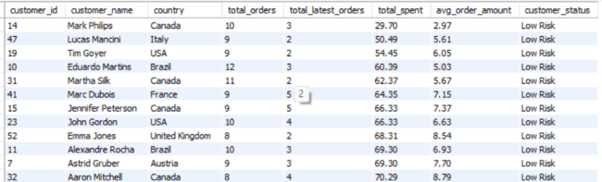
Visualization
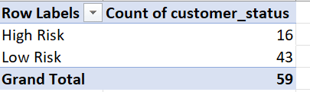

Insights
- Customers with fewer recent purchases may show reduced engagement.
- Customers with low total orders may have weaker purchasing activity.
- Customers with low total spending can be considered financially less engaged.
- Customers meeting any of the three risk conditions are classified as High Risk.
- Customers who meet none of the conditions are classified as Low Risk.
- The analysis also allows risk patterns to be examined by country.

Recommendations
- Target High Risk customers with personalized offers and discounts.
- Send re-engagement campaigns to customers with few recent orders.
- Provide loyalty rewards to encourage repeat purchases.
- Recommend music based on customers' previous purchases.
- Monitor customers with low spending or low order frequency regularly.
- Compare risk levels across countries to identify regions requiring additional retention efforts.
Q7 Customer Lifetime Value Modeling: How can you leverage customer data (tenure, purchase history, engagement) to predict the lifetime value of different customer segments? This could inform targeted marketing and loyalty program strategies. Can you observe any common characteristics or purchase patterns among customers who have stopped purchasing?

Approach
This query analyzes customer lifetime value using purchase history, tenure, revenue, purchase frequency, and inactivity. First, customer-level information such as first purchase, last purchase, total orders, total revenue, average order value, and tenure is calculated. Customers are then classified into High Value, Medium Value, or Low Value segments based on revenue and order frequency. Finally, customers are classified as Active or Churned based on more than 90 days of inactivity, allowing the business to compare valuable and inactive customer groups.
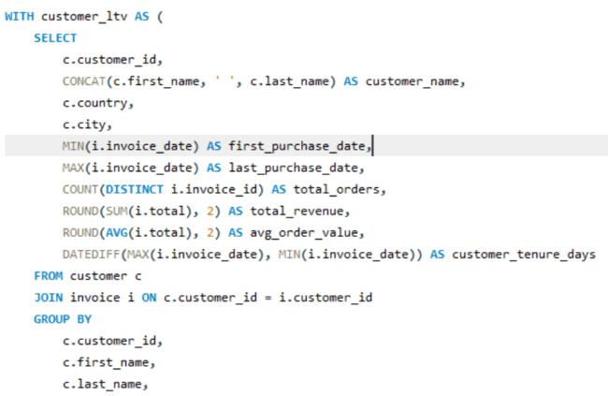
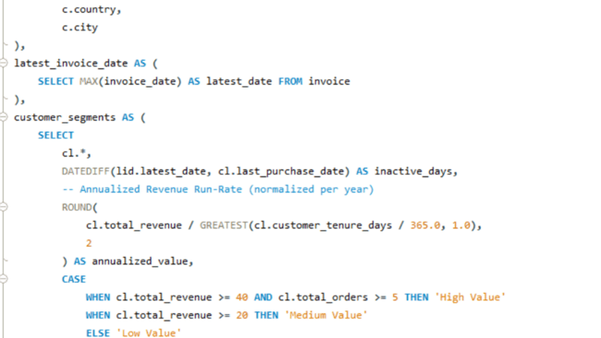
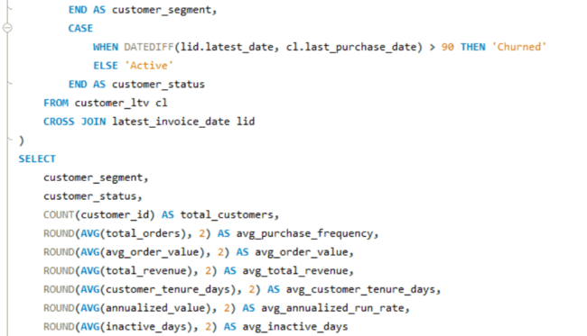
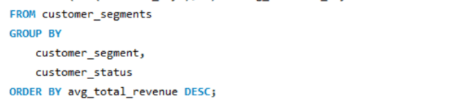
• CTE (WITH) – breaks the analysis into separate logical steps.
• MIN() – finds the first purchase date.
• MAX() – finds the latest purchase date.
• COUNT(DISTINCT) – calculates the number of unique orders.
• SUM() – calculates total revenue generated by each customer.
• AVG() – calculates the average order value.
• DATEDIFF() – calculates customer tenure and inactive days.
• GREATEST() – prevents the annualized calculation from using a period smaller than one year.
• CASE – creates customer value and activity segments.
• CROSS JOIN – makes the latest invoice date available to every customer.
• GROUP BY – summarizes customers by value segment and customer status.
• ROUND() – formats calculated monetary and numerical values.
Visualization

Insights
- High Value customers are identified using both higher revenue and higher order frequency.
- Medium and Low Value customers can be compared based on their spending and purchasing activity.
- Customers with more than 90 days since their last purchase are classified as Churned.
- Comparing Active and Churned customers helps identify common purchasing patterns among customers who have stopped purchasing.
- Total revenue, purchase frequency, average order value, and tenure provide useful indicators of customer value.
- annualized_value helps normalize revenue according to customer tenure, making customers with different relationship lengths easier to compare.

Recommendations
- Provide loyalty rewards to High Value customers to encourage continued purchases.
- Use personalized recommendations and promotions for Medium Value customers to increase their spending.
- Target Low Value customers with introductory offers and product bundles.
- Run re-engagement campaigns for Churned customers who have been inactive for more than 90 days.
- Analyze customers with high historical value but current churn status for targeted win-back campaigns.
- Monitor purchase frequency and inactivity regularly to identify customers at risk of becoming inactive.

Q8 If data on promotional campaigns (discounts, events, email marketing) is available, how could you measure their impact on customer acquisition, retention, and overall sales?

Approach
This query compares customer purchasing activity before and during a defined campaign period (1 January 2024 to 31 March 2024). It calculates total orders, total sales, average order value, and the number of customers for both periods. The final calculation measures the percentage change in sales during the campaign period compared with the period before the campaign. This helps evaluate changes in sales performance associated with the campaign period.
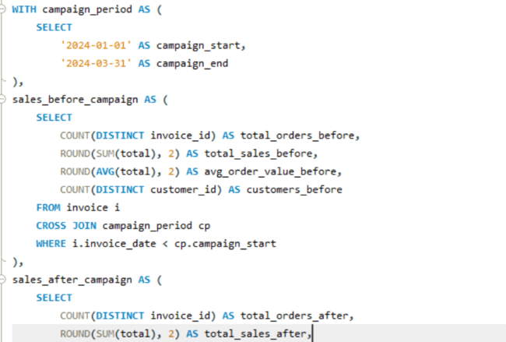
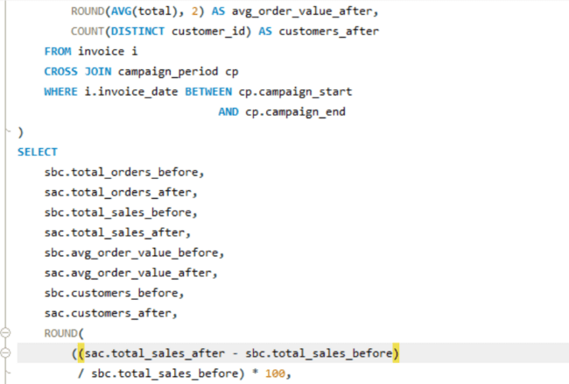
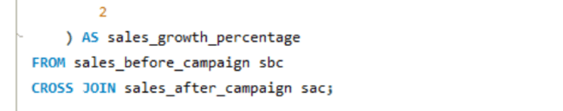
• CTE (WITH) – divides the analysis into separate campaign-period calculations.
• CROSS JOIN – makes the campaign start and end dates available to the invoice data.
• COUNT(DISTINCT) – counts unique orders and customers.
• SUM() – calculates total sales.
• AVG() – calculates average order value.
• ROUND() – rounds monetary and percentage values.
• WHERE – separates transactions before and during the campaign.
• Sales growth formula – compares campaign-period sales with sales before the campaign.
Output:-
Visualization

Insights
- Customer acquisition: Compare the number of new customers before and after a campaign.
- Customer retention: Track whether customers who responded to a campaign continue making purchases.
- Overall sales: Compare total revenue and number of orders during different campaign periods.
- Average order value: Determine whether campaigns encourage customers to spend more per order.
- Different campaign types can be compared to identify differences in customer response.
- The current Chinook database does not contain actual promotional campaign data, so campaign impact cannot be directly measured from the available tables.

Recommendations
- Record campaign details such as campaign type, start date, end date, discount, and participating customers.
- Track new customers acquired through each campaign.
- Monitor repeat purchases after campaigns to measure retention.
- Compare revenue and average order value across campaigns.
- Use customer responses to create more targeted marketing campaigns.
- Conduct regular before-and-after comparisons to evaluate campaign performance.

Q9 How would you approach this problem, if the objective and subjective questions weren't given?

Approach
- Understand the database
  - Identify all tables and columns.
  - Understand primary keys and foreign-key relationships.
  - Identify how customers, invoices, tracks, albums, artists, and genres are connected.
- Check data quality
  - Look for duplicate records.
  - Check for missing or NULL values.
  - Check whether important fields contain valid data.
- Analyze sales performance
  - Calculate total revenue.
  - Analyze sales by country, city, and customer.
  - Identify top-selling products and artists.
  - Analyze sales trends over time.
- Analyze customers
  - Identify high-value customers.
  - Calculate purchase frequency and average order value.
  - Analyze customer spending and purchasing patterns.
  - Segment customers based on their purchasing behavior.
- Analyze products
  - Identify popular tracks, albums, artists, and genres.
  - Compare genre performance across different countries.
  - Analyze products frequently purchased together.
- Analyze customer retention
  - Calculate customer inactivity and churn.
  - Identify customers who have stopped purchasing.
  - Analyze characteristics of high-risk or inactive customers.
- Analyze geographic markets
  - Compare revenue and customers across countries and cities.
  - Compare purchasing behavior and churn by country.
  - Identify regions with different purchasing patterns.
- Marketing and campaign analysis
  - If campaign data is available, compare sales and customer behavior before and after campaigns.
  - Measure acquisition, retention, revenue, and average order value.
- Create visualizations
  - Use bar charts for top products and customers.
  - Use line charts for sales trends.
  - Use scatter plots for relationships such as tenure vs spending.
  - Use grouped charts to compare customer segments.
- Provide business recommendations
- Use the SQL results to identify opportunities for increasing sales.
- Recommend customer retention strategies.
- Suggest targeted marketing and product recommendations.
- Identify areas where additional data would improve the analysis.
The main SQL concepts I would use are:
- SELECT and WHERE for retrieving and filtering data.
- JOIN for combining related tables.
- GROUP BY for business-level summaries.
- COUNT(), SUM(), and AVG() for business metrics.
- MIN() and MAX() for purchase dates.
- CASE for customer segmentation.
- CTEs (WITH) for complex analysis.
- Window functions such as RANK() and ROW_NUMBER() for rankings.
- Date functions such as DATEDIFF() and DATE_SUB() for tenure and churn analysis.

Key Business Areas
Area | Example Question
Sales | What are the highest-revenue countries?
Customers | Who are the highest-value customers?
Products | Which tracks and albums sell the most?
Genres | Which genres generate the most revenue?
Artists | Which artists perform best?
Geography | How does purchasing vary by country?
Retention | Which customers have stopped purchasing?
Customer Value | Which customers have the highest lifetime value?
Product Affinity | Which genres/products are purchased together?
Marketing | How do promotional campaigns affect sales?

Final Outcome
What is selling → Who is buying → Where they are buying → How they are buying → Which customers are valuable → Which customers are at risk → What the business can do next.
Q10 How can you alter the "Albums" table to add a new column named "ReleaseYear" of type INTEGER to store the release year of each album?

Approach
The album table currently stores information such as album_id, title, and artist_id. To store the release year of each album, we can modify the existing table using ALTER TABLE and add a new column named ReleaseYear with the INTEGER data type. This allows the database to store a four-digit release year for each album without changing the existing records or table structure.
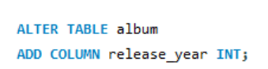
• ALTER TABLE is used to modify the structure of an existing table.
• ADD COLUMN adds a new column to the table.
• ReleaseYear is the name of the new column.
• INTEGER stores the release year as a whole number, such as 2020.
Example:-
album_id | title | artist_id | ReleaseYear
1 | Album A | 1 | 2020
2 | Album B | 2 | 2018

Q11 Chinook is interested in understanding the purchasing behavior of customers based on their geographical location. They want to know the average total amount spent by customers from each country, along with the number of customers and the average number of tracks purchased per customer. Write an SQL query to provide this information.

Approach
The query first calculates each customer's total spending and total number of tracks purchased using a CTE. It then groups these customer-level results by country to find the total number of customers, average total spending per customer, and average tracks purchased per customer. This helps Chinook compare purchasing behavior across different geographical markets.
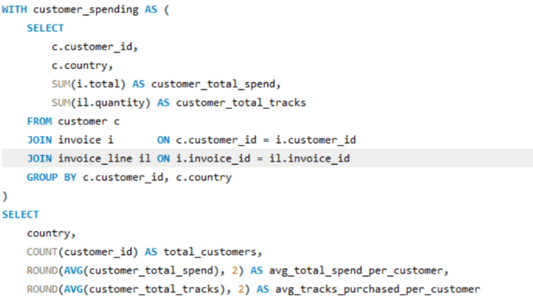
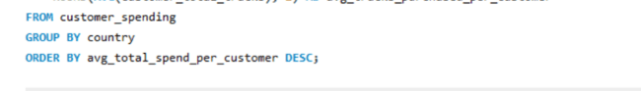
• CTE (WITH) – Creates a temporary result called customer_spending.
• SUM() – Calculates each customer's total spending and total tracks purchased.
• COUNT() – Counts the number of customers in each country.
• AVG() – Calculates the average spending and average tracks purchased per customer.
• ROUND() – Rounds the averages to two decimal places.
• GROUP BY – Groups customers first by customer and then by country.
• ORDER BY – Displays countries from highest to lowest average spending.
Output:-
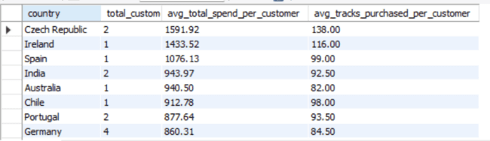

Insights
- Countries with a higher avg_total_spend_per_customer have customers who spend more on average.
- avg_tracks_purchased_per_customer shows how many tracks customers purchase on average.
- A country with fewer customers can still have a high average spending value.
- Comparing these metrics helps identify markets with stronger customer purchasing behavior.

Recommendations
- Focus marketing and promotional activities on countries with higher average customer spending.
- Use personalized recommendations and bundles to increase the number of tracks purchased per customer.
- Countries with lower spending or fewer tracks per customer can be targeted with discounts or promotional offers.
- Monitor customer spending and purchasing frequency by country to identify changes in market behavior.

Thank you!
Submitted by:

Saroj Kumar Nayak

