**Sales Form**

**Database Design (ER Diagram):**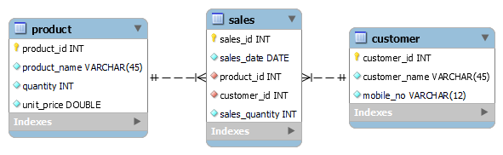

**Form Design:**

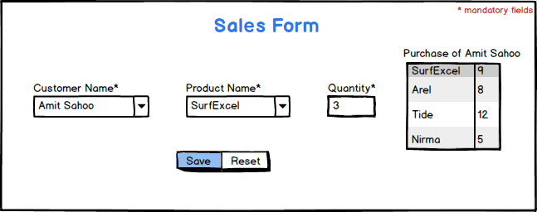

**Description:**

Create a database design as shown in above ER-Diagram. Insert 5 records each to product table and customer table from database side.

While form loading customer name drop-down list must be populated with all 5 customers and product name drop-down list must be populated with all 5 products. Upon selecting any customer name, purchase table for that customer will be displayed as shown in above image. Purchase table contains two columns i.e. product name and total number of purchase done by the customer for each product. Make sure, if total number of purchase for any product is 0, that product must not be displayed. Chose product name, fill quantity, and save the form data in sales table where sales_date is current system date. Required quantity must be deducted from product table.

**Validations:**

* One product name must be selected
* Quantity must be a positive number and required quantity must be available in product table.
* One customer name must be selected.