**Git :-** Version control systems is a tool that help track changes in code.

* To track the history
* Popular, It is free and open source.
* Fast & scalable
* To collaborate

**GitHub :** Website that allows developers to “store and manage” their code using Git.

* Developers can upload their whole code
* And do changes their itself.
* Even in resume, we can add the link of project.
* Add our projects in the form of folder/repository.
* We can see other developers code and add them at your side and make changes.

https://github.com

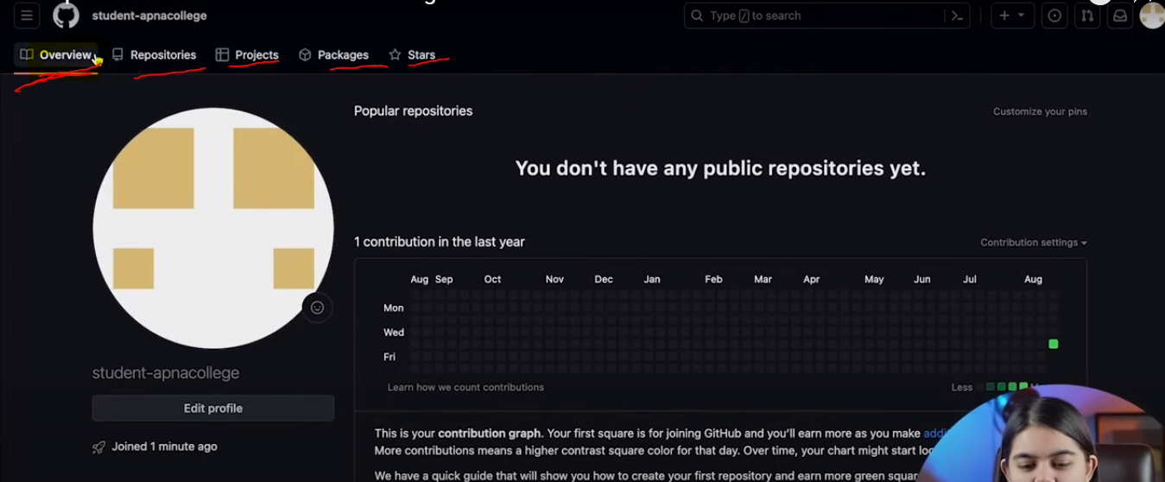

ReadMe file -> stores project information, its name, How to use the project, Its features, why we have created this project.

**Steps**

1. We add the changes and then do commit(It means it is saved in repo)(Add --- > Commit)

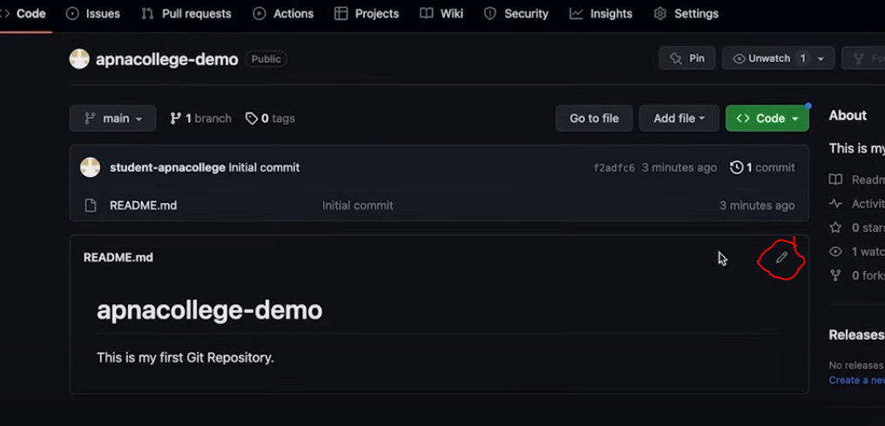

|  |  |
| --- | --- |
| **Output** | **Edited file** |
|  |  |
|  |  |

Setting up Git :->

1. Download Visual studio code
2. Download git bash(windows) (check by using -> git --version)
3. Below command execute on command prompt

