Supplementary File 1

Complete Spatial Transcriptomics Case Studies
Arabidopsis thaliana seedling development and inflamed murine lacrimal gland remodeling

This supplementary document integrates two complete spatial transcriptomics case studies into one continuous, results-guided analysis. Figure and table numbering is continuous across both studies. All numerical values were taken from the supplied final output files, and the biological interpretations were written at the spatial bin or spot level supported by those outputs.
Interpretive scope. Each case study represents one tissue section. The analyses establish spatially organized transcriptional domains within the analyzed section, but they do not provide replicate-supported population-level inference. Visium HD bins and Visium spots are capture units rather than automatically segmented single cells.
Supplementary Table S1. Overview of the two spatial transcriptomics case studies.
Case study | Platform and reference | Analysis unit | Retained units | Central biological question | Downstream analyses
Arabidopsis seedling | 10x Genomics Visium HD 3′; TAIR10 | 8 µm capture bin | 1,516 bins | Can bin-level spatial expressions recover seedling tissue domains and their metabolic/developmental programs? | QC, log normalization, marker validation, PCA/UMAP/clustering, marker discovery, Moran’s I SVGs, pairwise DE, ORA/GSEA, distance-based GAMs
Inflamed lacrimal gland | Visium section; Case_1 / NOD.H-2b_1 | Visium spot | 1,516 spots | Is the section organized as a mosaic of epithelial-secretory, antigen-presenting, lymphoid, and humoral niches? | QC, SCTransform, PCA/UMAP/clustering, marker discovery, GO enrichment, module scoring, SVGs, neighborhood mixing, 2D GAMs, STdeconvolve
Note. The retained units are independent capture locations within one section, not biological replicates.

General analytical framework
Both workflows followed the same analytical logic: quality control, normalization, dimension reduction, graph-based clustering, marker discovery, spatial validation, and biological interpretation. The plant case study then emphasized tissue-domain differential expression, pathway analysis, and distance from a developmental organizer. The lacrimal gland case study emphasized biological program scoring, neighborhood mixing, two-dimensional spatial gradients, spatially variable genes, and reference-free latent topic deconvolution.
Seurat functions were used for data handling, normalization, clustering, marker testing, and spatial visualization. Functional enrichment used clusterProfiler, continuous spatial trends were modeled with generalized additive models, and the lacrimal gland section was additionally analyzed with STdeconvolve. Adjusted P values were interpreted using Benjamini-Hochberg correction where applicable. Because both datasets contain one section, spot- or bin-level tests are treated as descriptive and exploratory rather than as substitutes for biological replication.

Part I. Arabidopsis thaliana seedling analyzed with Visium HD

1. Biological rationale and research question
Early seedling establishment requires spatial coordination of photosynthesis, reserve mobilization, cell-wall remodeling, root growth, vascular transport, and meristem maintenance. Conventional bulk RNA sequencing averages across these compartments, while dissociation-based single-cell workflows can disrupt spatial architecture and may introduce tissue-processing artifacts. This case study asked whether a standard Seurat workflow applied directly to 8 µm Visium HD bins could reconstruct anatomically coherent tissue domains across an intact Arabidopsis seedling and recover pathway signatures consistent with the known metabolic and developmental roles of those domains.
The sample analyzed was the publicly available 10x Genomics Visium HD 3′ Arabidopsis thaliana seedling dataset processed against TAIR10. The 8 µm output was selected because it provides a practical compromise between the sparsity of 2 µm bins and the lower spatial resolution of 16 µm aggregation (10x Genomics, 2025; Satija Lab, 2025).

2. Dataset, quality control, and normalization
Supplementary Table S2. Dataset characteristics and quality-control outcome for the Arabidopsis Visium HD case study.
Metric | Value
Dataset | Visium HD 3′ Spatial Gene Expression: Arabidopsis thaliana seedling
Reference genome | TAIR10
Analysis resolution | 8 µm bins
Total sequencing reads | 141,748,868
Sequencing saturation | 98.1%
Raw 8 µm bins | 7,356
On-tissue bins | 7,214
Mean genes per on-tissue bin | 105.9
Mean UMIs per on-tissue bin | 138.0
Bins retained after nCount > 100 and nFeature > 50 | 1,516
Genes retained after removing zero-expression genes | 17,852
The raw object contained 31,109 features across 7,356 8 µm bins. After removing bins with zero counts and retaining bins with more than 100 UMIs and more than 50 detected genes, 1,516 bins remained. Genes with zero expression across all retained bins were removed, leaving 17,852 detected genes. Counts were log-normalized with a scale factor of 10,000.
obj <- Load10X_Spatial(data.dir = data_dir, bin.size = 8)
obj <- subset(obj, nCount_Spatial.008um > 100 & nFeature_Spatial.008um > 50)
counts <- GetAssayData(obj, assay = "Spatial.008um", layer = "counts")
obj <- obj[rowSums(counts) > 0, ]
obj <- NormalizeData(obj, normalization.method = "LogNormalize", scale.factor = 10000)
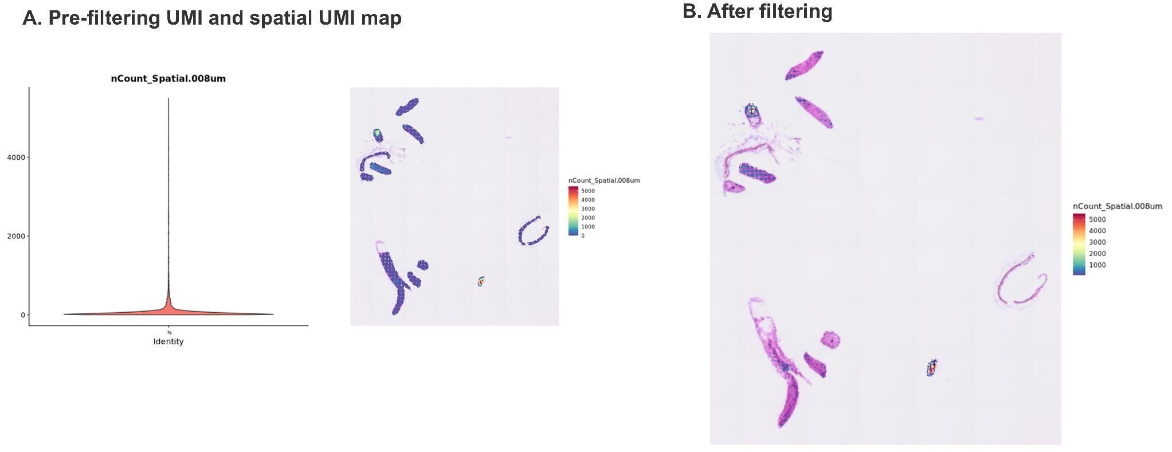
Supplementary Figure S1. Quality control of the Arabidopsis Visium HD dataset. (A) Pre-filtering UMI distribution and spatial UMI map. (B) Spatial UMI distribution after filtering. The final object retained 1,516 higher-complexity 8 µm bins.
Biological Interpretation. Filtering concentrated the analysis on bins with stronger transcript recovery, but it also reduced spatial coverage from 7,214 on-tissue bins to 1,516 retained bins. All subsequent spatial maps should therefore be interpreted as high confidence but deliberately sparse representations of the seedling section.
Supplementary Table S3. Core analysis parameters for the Arabidopsis case study.
Analysis step | Parameterization | Rationale or interpretation
Input | Load10X_Spatial(..., bin.size = 8) | 8 µm balances sparsity and spatial resolution
QC | nCount > 100; nFeature > 50 | Applied after removal of zero-count/off-tissue bins
Normalization | LogNormalize; scale.factor = 10,000 | Per-bin library-size normalization
Variable features | VST; 3,000 genes | Features used for dimension reduction
PCA/neighbors | 50 PCs calculated; PCs 1-15 used | PC range extended modestly beyond elbow
Clustering | Louvain; resolution = 0.5 | Seven graph-based domains
Marker testing | Wilcoxon rank-sum; positive markers | Annotation used markers, atlas evidence, and spatial position
SVG detection | Moran’s I | Independent of cluster labels
DE | Wilcoxon; min.pct = 0.10; logfc.threshold = 0.25 | Adjusted P values interpreted separately from output-row counts
ORA | GO BP; BH correction; detected-gene universe | 17,852 detected genes used as the initial universe
GSEA | Pre-ranked by avg_log2FC | Used for three biologically targeted contrasts
Gradient modeling | GAM: expression ~ s(distance from SAM, k = 4) | Restricted to a physically connected shoot-axis fragment

3. Independent marker validation, clustering, and tissue-domain annotation
Before unsupervised clustering, PHB and ERL2 were mapped as independently documented shoot-meristem markers. Their localized spatial expression provided an orthogonal check that the bin coordinates and normalized expression matrix retained anatomical signal. The object was then processed using 3,000 variable genes, z-score scaling, principal component analysis, a shared-nearest-neighbor graph based on PCs 1-15, Louvain clustering at resolution 0.5, and UMAP.
obj <- FindVariableFeatures(obj, selection.method = "vst", nfeatures = 3000)
obj <- ScaleData(obj)
obj <- RunPCA(obj, npcs = 50)
obj <- FindNeighbors(obj, dims = 1:15)
obj <- FindClusters(obj, resolution = 0.5)
obj <- RunUMAP(obj, dims = 1:15)
Seven graph-based clusters were resolved and annotated by combining top positive markers, TAIR expression evidence, and physical position in the seedling section. This triangulation was essential because a cluster number has no intrinsic biological meaning and can change when clustering parameters change.
Supplementary Table S4. Arabidopsis spatial clusters, final tissue-domain annotations, and representative markers.
Cluster | Tissue-domain annotation | Representative markers | Dominant biological interpretation
0 | Cotyledon | CAB1, RBCS1A, LHB1B2, LHCB3, PSAL | Photosynthesis and light-harvesting program
1 | Germinating seed | ICL, MLS, PCK1, PORA, PORB | Reserve mobilization, glyoxylate cycle, and establishment metabolism
2 | Root elongation zone | AGP31, BGLU21, EXPA9, EXPA14, EXT3 | Cell-wall remodeling and elongation-associated program
3 | Root | EXT3, UCC2, AGP4, XYP2, LAX3 | Root structural, transport, and cell-wall-associated program
4 | Meristematic tissue | GRP4, NOP10, HDA3, DI21, ROC2 | Highly distinct proliferative/meristematic transcriptional state
5 | Hypocotyl | ACO2, AGP12, SIAR1, XCP2, WAT1 | Axis and vascular/transport-associated program
6 | Shoot apical meristem (SAM) | CYP78A5, ERL2, AFO, ANT, GRF5 | Shoot-organizer and organ-initiation program
Note. Annotations are bin-level tissue domains. They are not single-cell labels because an 8 µm capture bin may contain a cell fraction, one cell, or material from neighboring cells.
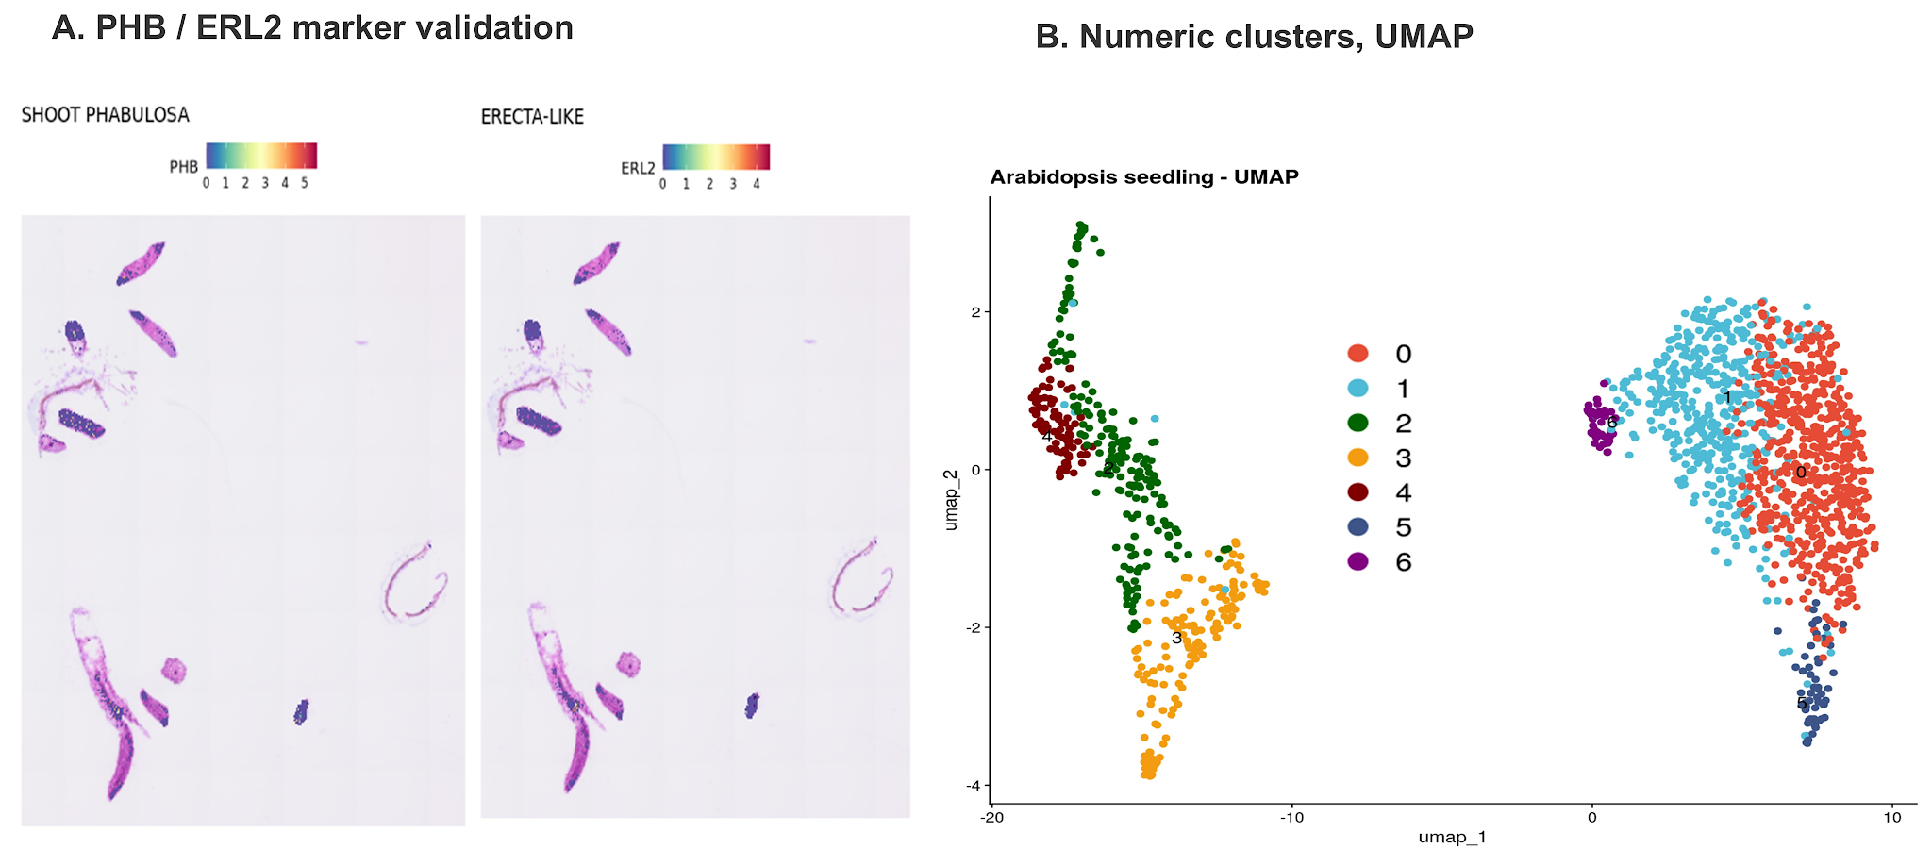

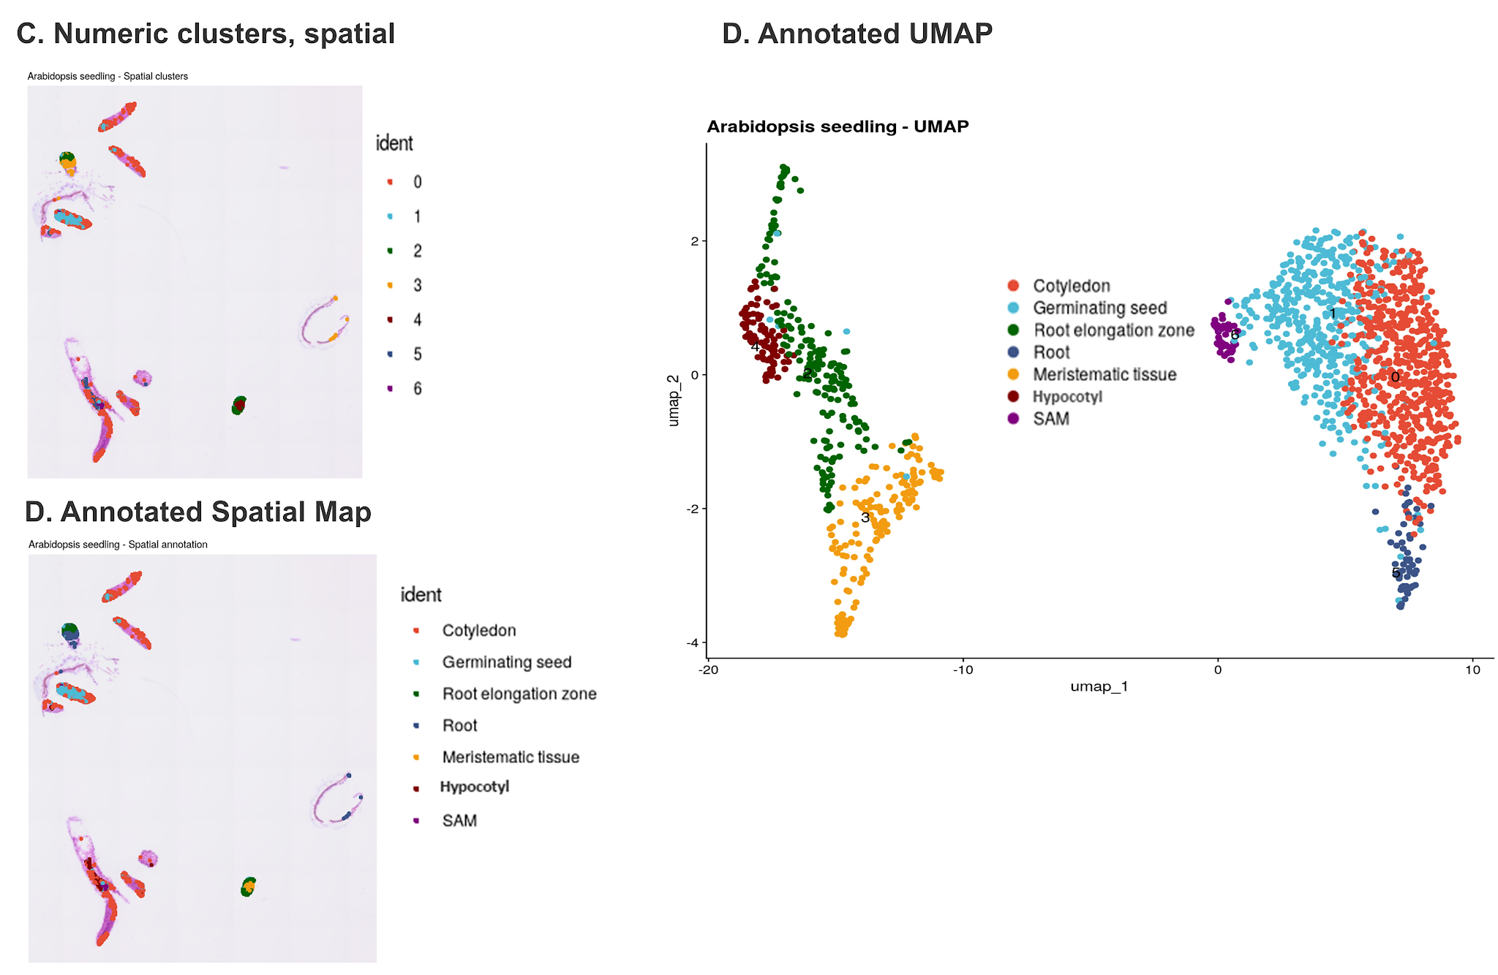
Supplementary Figure S2. Marker validation and unsupervised domain recovery in the Arabidopsis seedling. (A) Spatial expression of PHB and ERL2. (B) UMAP of seven numeric clusters. (C) Spatial localization of numeric clusters. (D) UMAP after biological annotation. (E) Spatial map after biological annotation.
Biological Interpretation. The concordance between marker expression, transcriptional clustering, and anatomical position supports a seven-domain model spanning photosynthetic shoot tissue, germinating seed tissue, root compartments, hypocotyl, meristematic tissue, and the shoot apical meristem. The recovery of these domains without image-based cell segmentation demonstrates that bin-level Visium HD data can preserve organ-scale developmental organization in a plant section.

4. Cluster markers and spatially variable genes
Positive cluster markers were identified with the Wilcoxon rank-sum test and summarized in a heatmap. Spatially variable genes were ranked with Moran’s I, which measures whether similar expression values occur near one another more often than expected under spatial randomness. The top spatially variable genes included structural and developmental markers such as EXT3, AGP31, XYP2, GRP4, and AFO. All top 20 spatially variable genes were also recovered among cluster marker genes in the supplied analysis.
markers <- FindAllMarkers(obj, assay = "Spatial.008um", only.pos = TRUE)
obj <- FindSpatiallyVariableFeatures(
obj, assay = "Spatial.008um", features = VariableFeatures(obj),
selection.method = "moransi"
)
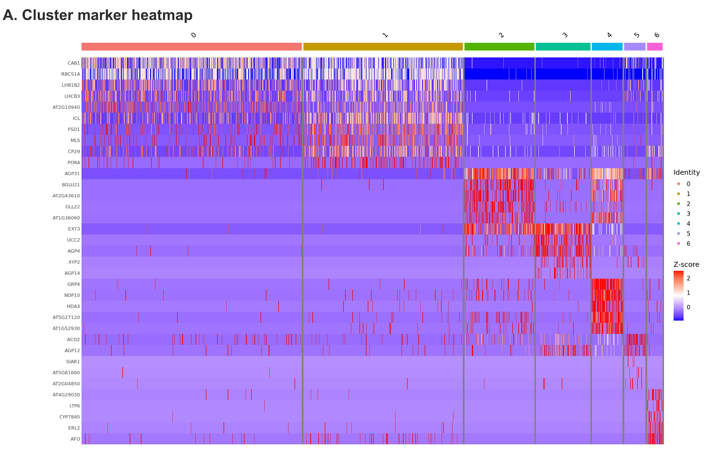
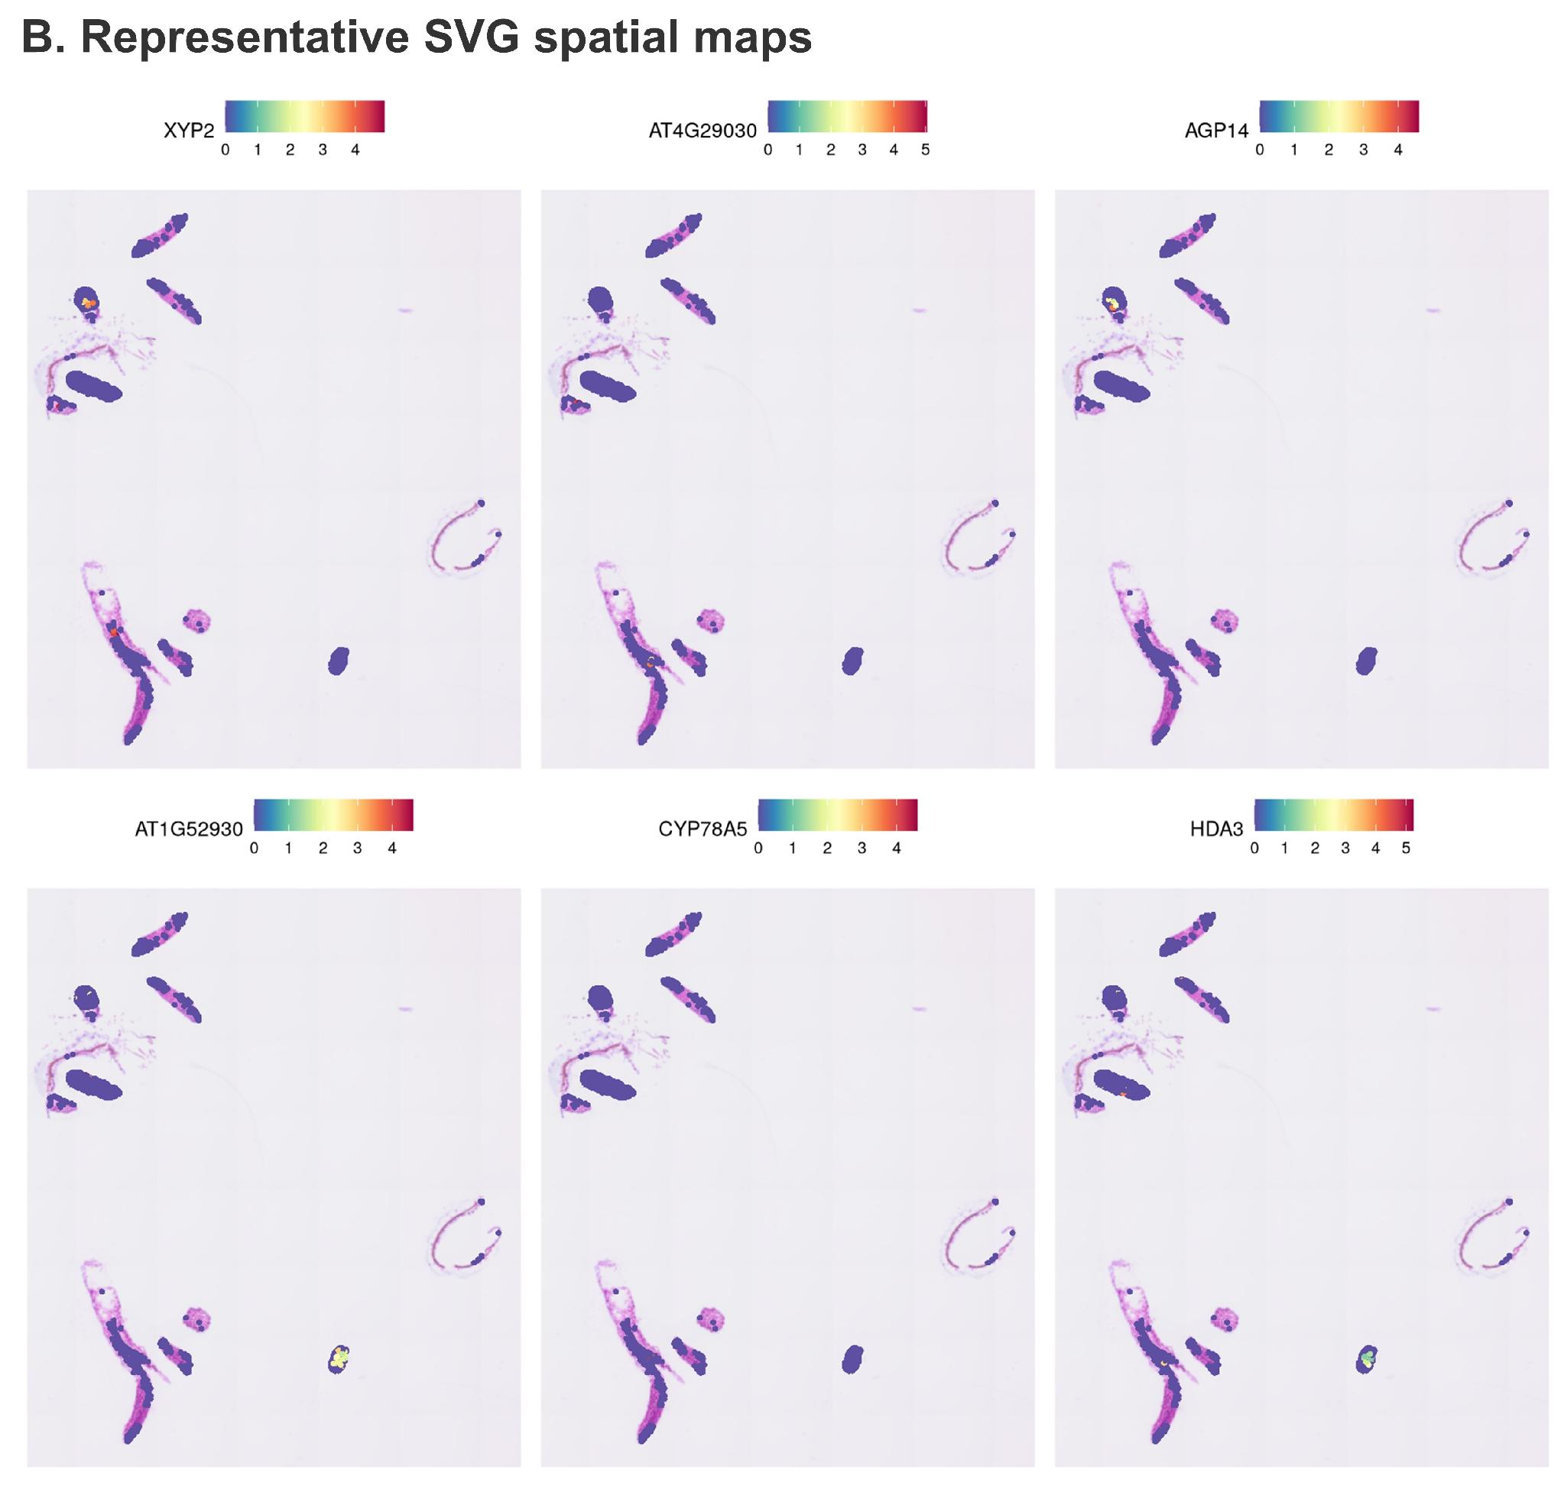
Supplementary Figure S3. Cluster markers and representative spatially variable genes in the Arabidopsis seedling. (A) Heatmap of the leading cluster marker genes. (B) Spatial maps of six representative genes from the ranked spatially variable gene set.
Biological Interpretation. Cluster markers and label-independent spatial statistics converged on the same tissue organization. This agreement is an internal validation because cluster assignment and Moran’s I ranking use different analytical criteria. Root-associated cell-wall genes, shoot photosynthesis genes, and SAM-associated developmental regulators each occupied anatomically coherent regions.

5. Targeted differential expression between tissue domains
Eight biologically motivated contrasts were evaluated rather than performing an exhaustive all-by-all comparison. The raw FindMarkers output files contain genes that passed the algorithm’s default expression and fold-change prefilters (|log2FC| > 0.25). Consequently these returned row counts are not equivalent to multiple-testing-corrected differential expression. Supplementary Table S5 explicitly separates the number of rows returned from the number of statistically significant genes meeting Benjamini-Hotchberg adjusted P < 0.05 (and |avg_log2FC| > 0.25). This differential expression analysis is provided strictly for descriptive and exploratory purposes within this single-section dataset (n=1). Because the same expression matrix was utilized for both spatial cluster identification and differential gene expression analysis, leading to circular statistical inference or double dipping, datasets with true biological replicates should instead implement a pseudobulk workflow across independent replicates (Ospina et al., 2024; Squair et al., 2021).
Supplementary Table S5. Targeted Arabidopsis differential-expression contrasts.
Comparison | Rows returned by FindMarkers | Adjusted-P significant genes | Positive / negative significant genes | Supplied output
Cotyledon vs. germinating seed | 330 | 214 | 1 / 213 | DE_cotyledon_vs_germinating.csv
Cotyledon vs. hypocotyl | 212 | 35 | 3 / 32 | DE_cotyledon_vs_hypocotyl.csv
Root vs. hypocotyl | 1,304 | 47 | 39 / 8 | DE_Root_vs_hypocotyl.csv
Root vs. root elongation zone | 1,652 | 118 | 35 / 83 | DE_Root_vs_REZ.csv
Root vs. meristematic tissue | 5,462 | 1747 | 43/1704 | DE_Root_vs_MT.csv
Root elongation zone vs. meristematic tissue | 4,974 | 1,409 | 7 / 1,402 | DE_REZ_vs_MT.csv
SAM vs. meristematic tissue | 5,354 | 364 | 12 / 352 | DE_SAM_vs_MT.csv
SAM vs. cotyledon | 861 | 523 | 521 / 2 | DE_SAM_vs_cot.csv
Note. Positive fold change corresponds to the first tissue in each contrast.
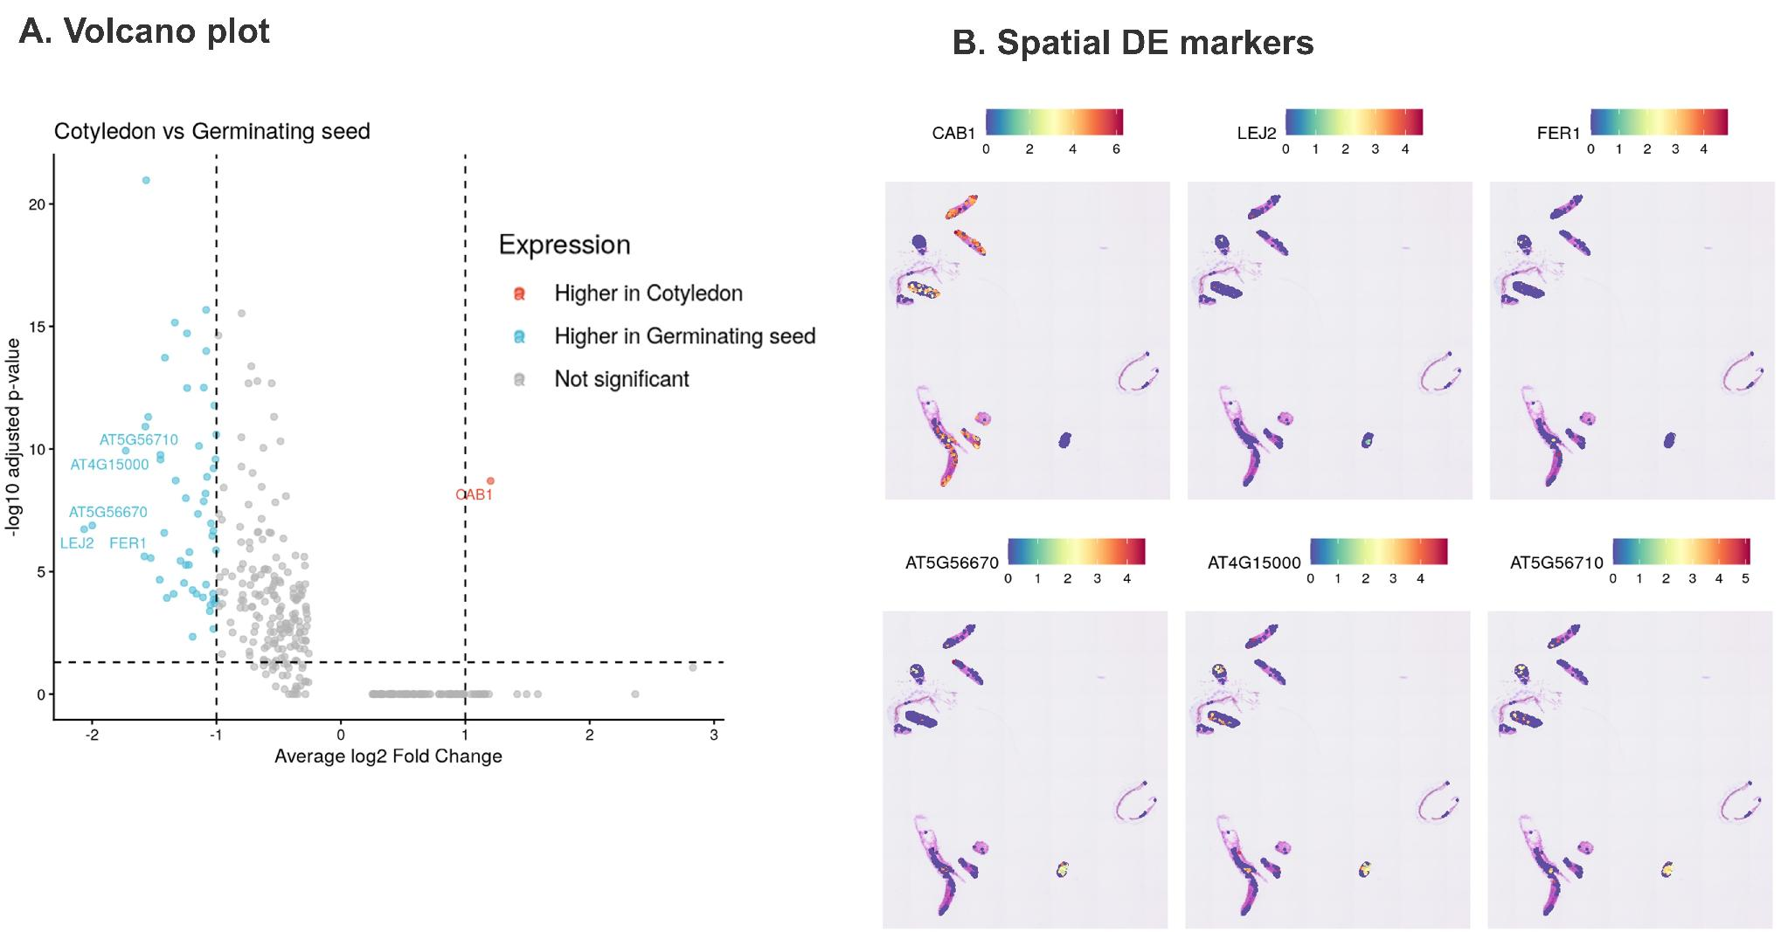
Supplementary Figure S4. Representative differential-expression analysis for cotyledon versus germinating seed. (A) Volcano plot showing effect size and adjusted Interpretation. (B) Spatial expression maps of leading genes from the contrast.
Biological Interpretation. The contrast separates a photosynthetically active cotyledon program from a germination-associated metabolic program. Spatial visualization is important because it verifies that large fold changes correspond to coherent anatomical domains rather than isolated bins or slide-wide technical gradients.

6. Functional enrichment and pathway-level interpretation
Two complementary enrichment strategies were used. Over-representation analysis tested thresholded cluster marker lists against GO Biological Process categories using the detected-gene universe. Pre-ranked GSEA used the full ordered differential-expression statistics to identify pathways enriched toward either side of a contrast without imposing a Interpretation cutoff on individual genes. Redundant GO terms were reduced before visualization.
Supplementary Table S6. Selected pre-ranked GSEA results from the Arabidopsis case study.
Contrast | GO biological process | NES | Adjusted P | Enriched direction
Cotyledon vs. germinating seed | Photosynthesis, light reaction | 3.590 | 6.20 × 10⁻9 | Cotyledon
Cotyledon vs. germinating seed | Response to stimulus | 2.299 | 1.09 × 10⁻5 | Cotyledon
Cotyledon vs. hypocotyl | Metabolic process | 1.879 | 2.75 × 10⁻3 | Cotyledon
Cotyledon vs. hypocotyl | Photosynthesis | 1.873 | 2.04 × 10⁻2 | Cotyledon
Cotyledon vs. hypocotyl | Transport | −1.972 | 4.19 × 10⁻2 | Hypocotyl
SAM vs. cotyledon | Shoot system development | 2.062 | 3.63 × 10⁻4 | SAM
SAM vs. cotyledon | Flower development | 1.977 | 3.10 × 10⁻3 | SAM
SAM vs. cotyledon | Photosynthesis, light harvesting in photosystem I | −3.248 | 4.77 × 10⁻9 | Cotyledon
SAM vs. cotyledon | Response to light stimulus | −2.920 | 4.77 × 10⁻9 | Cotyledon
Note. A positive normalized enrichment score indicates enrichment toward the first tissue in contrast. A negative score indicates enrichment toward the second tissue.
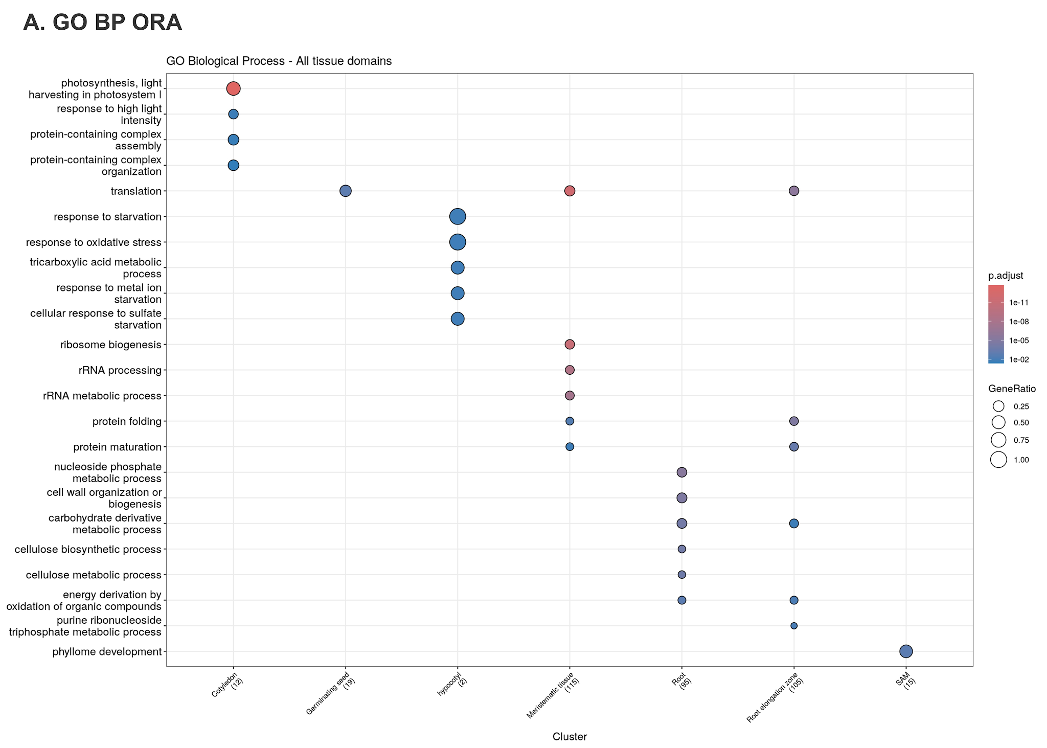
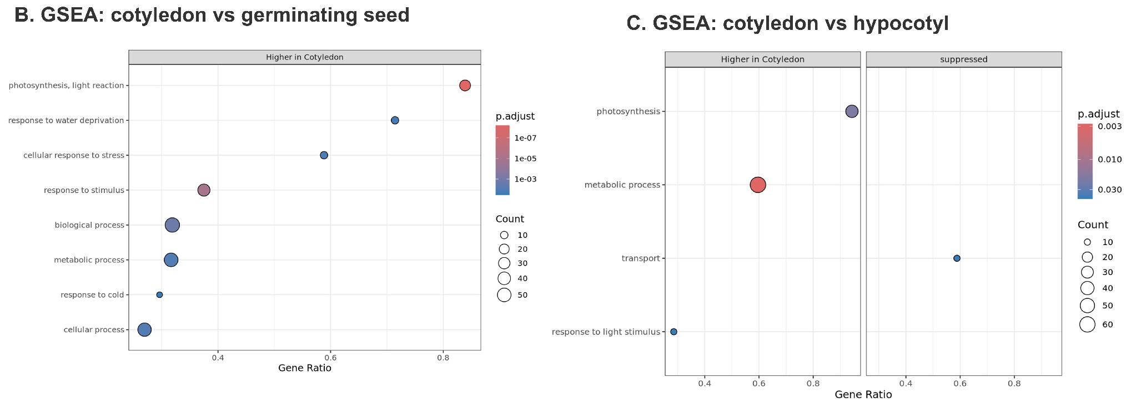

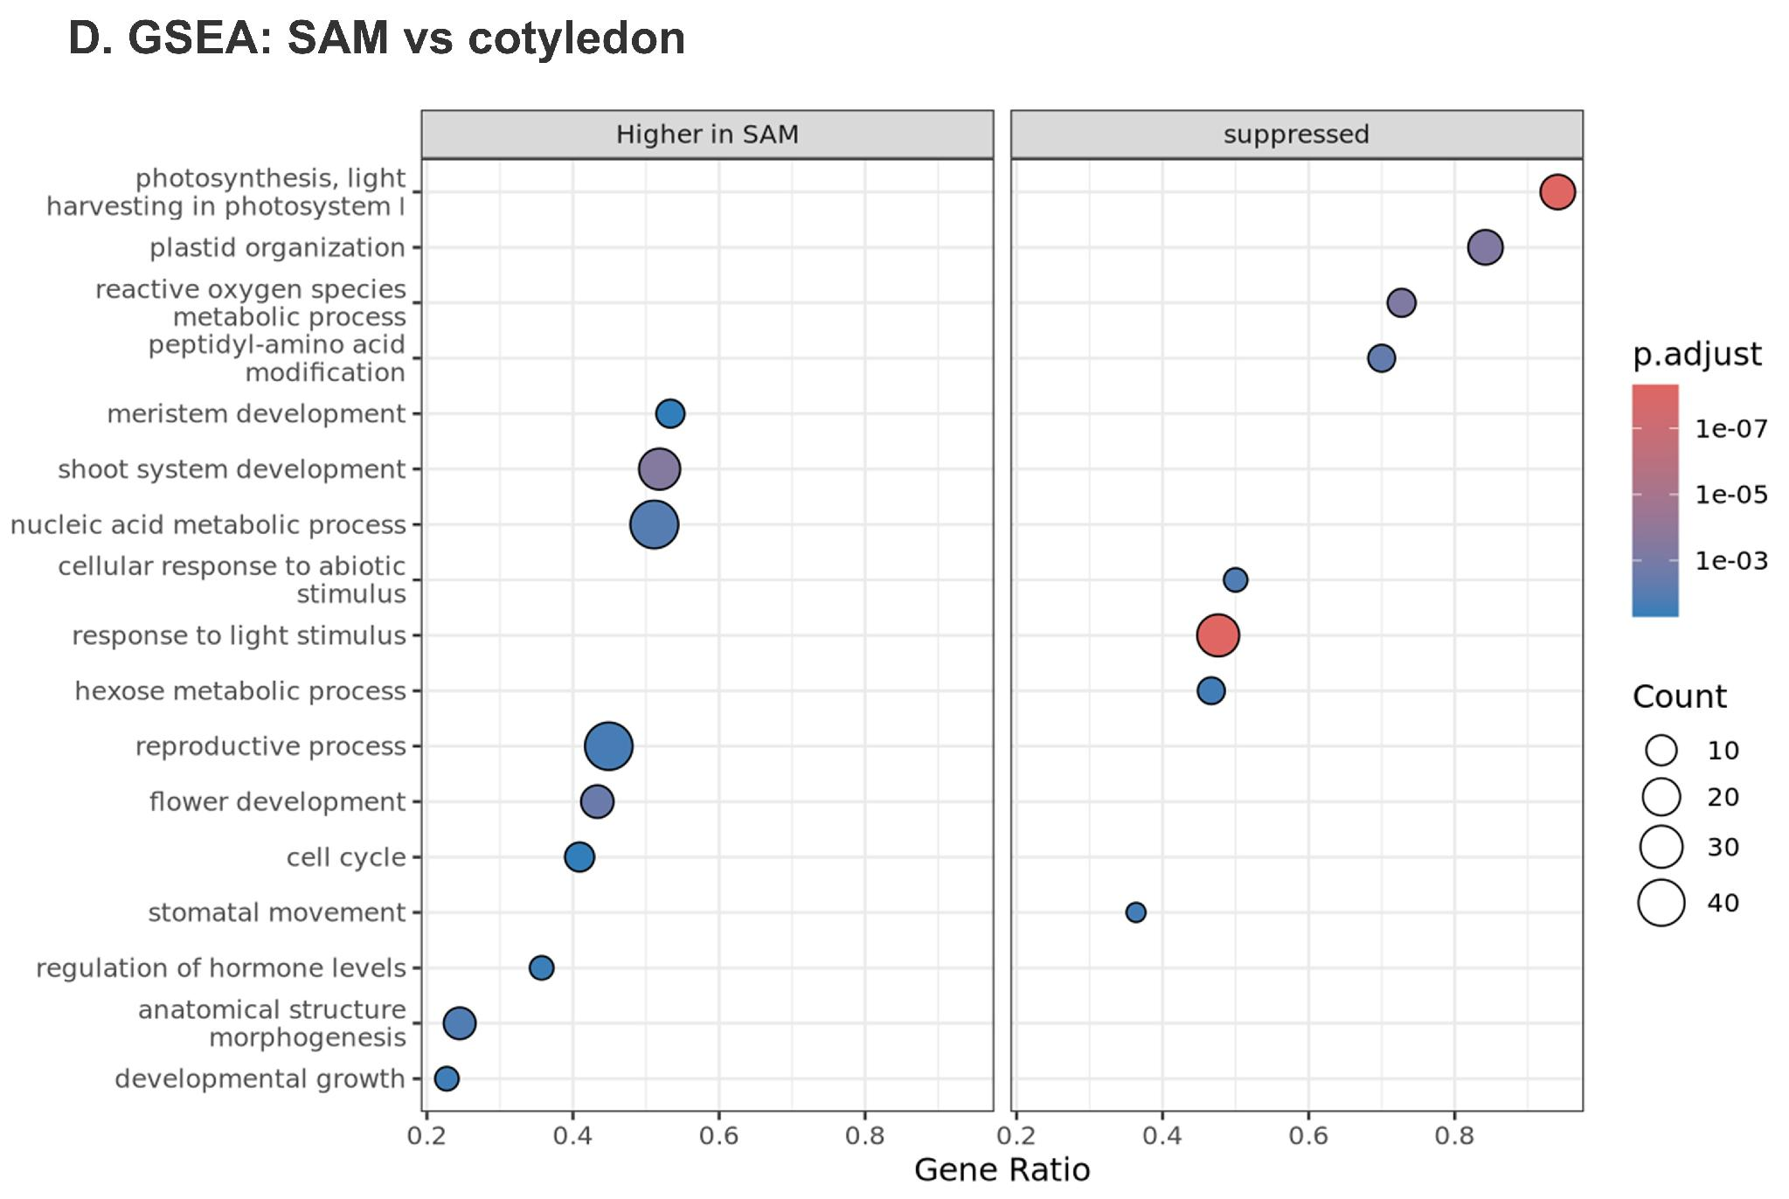
Supplementary Figure S5. Functional enrichment across Arabidopsis tissue domains. (A) GO Biological Process over-representation analysis across the seven annotated domains. (B) GSEA for cotyledon versus germinating seed. (C) GSEA for cotyledon versus hypocotyl. (D) GSEA for SAM versus cotyledon.
Biological Interpretation. The pathway results recapitulate the developmental logic of the seedling. Cotyledon bins were enriched for photosynthesis, plastid organization, light response, and light harvesting. SAM bins were enriched for shoot system development, organogenesis, reproductive development, and meristem-associated programs. Hypocotyl bins were relatively enriched for transport, consistent with their axial and conductive role.

7. Spatial mapping of representative tissue markers
One representative marker was selected for each annotated domain: CAB1 for cotyledon, ICL for germinating seed, EXPA9 for root elongation zone, EXT3 for root, GRP4 for meristematic tissue, XYP2 for hypocotyl, and CYP78A5 for SAM. These maps provide a direct visual summary of the inferred body plan.
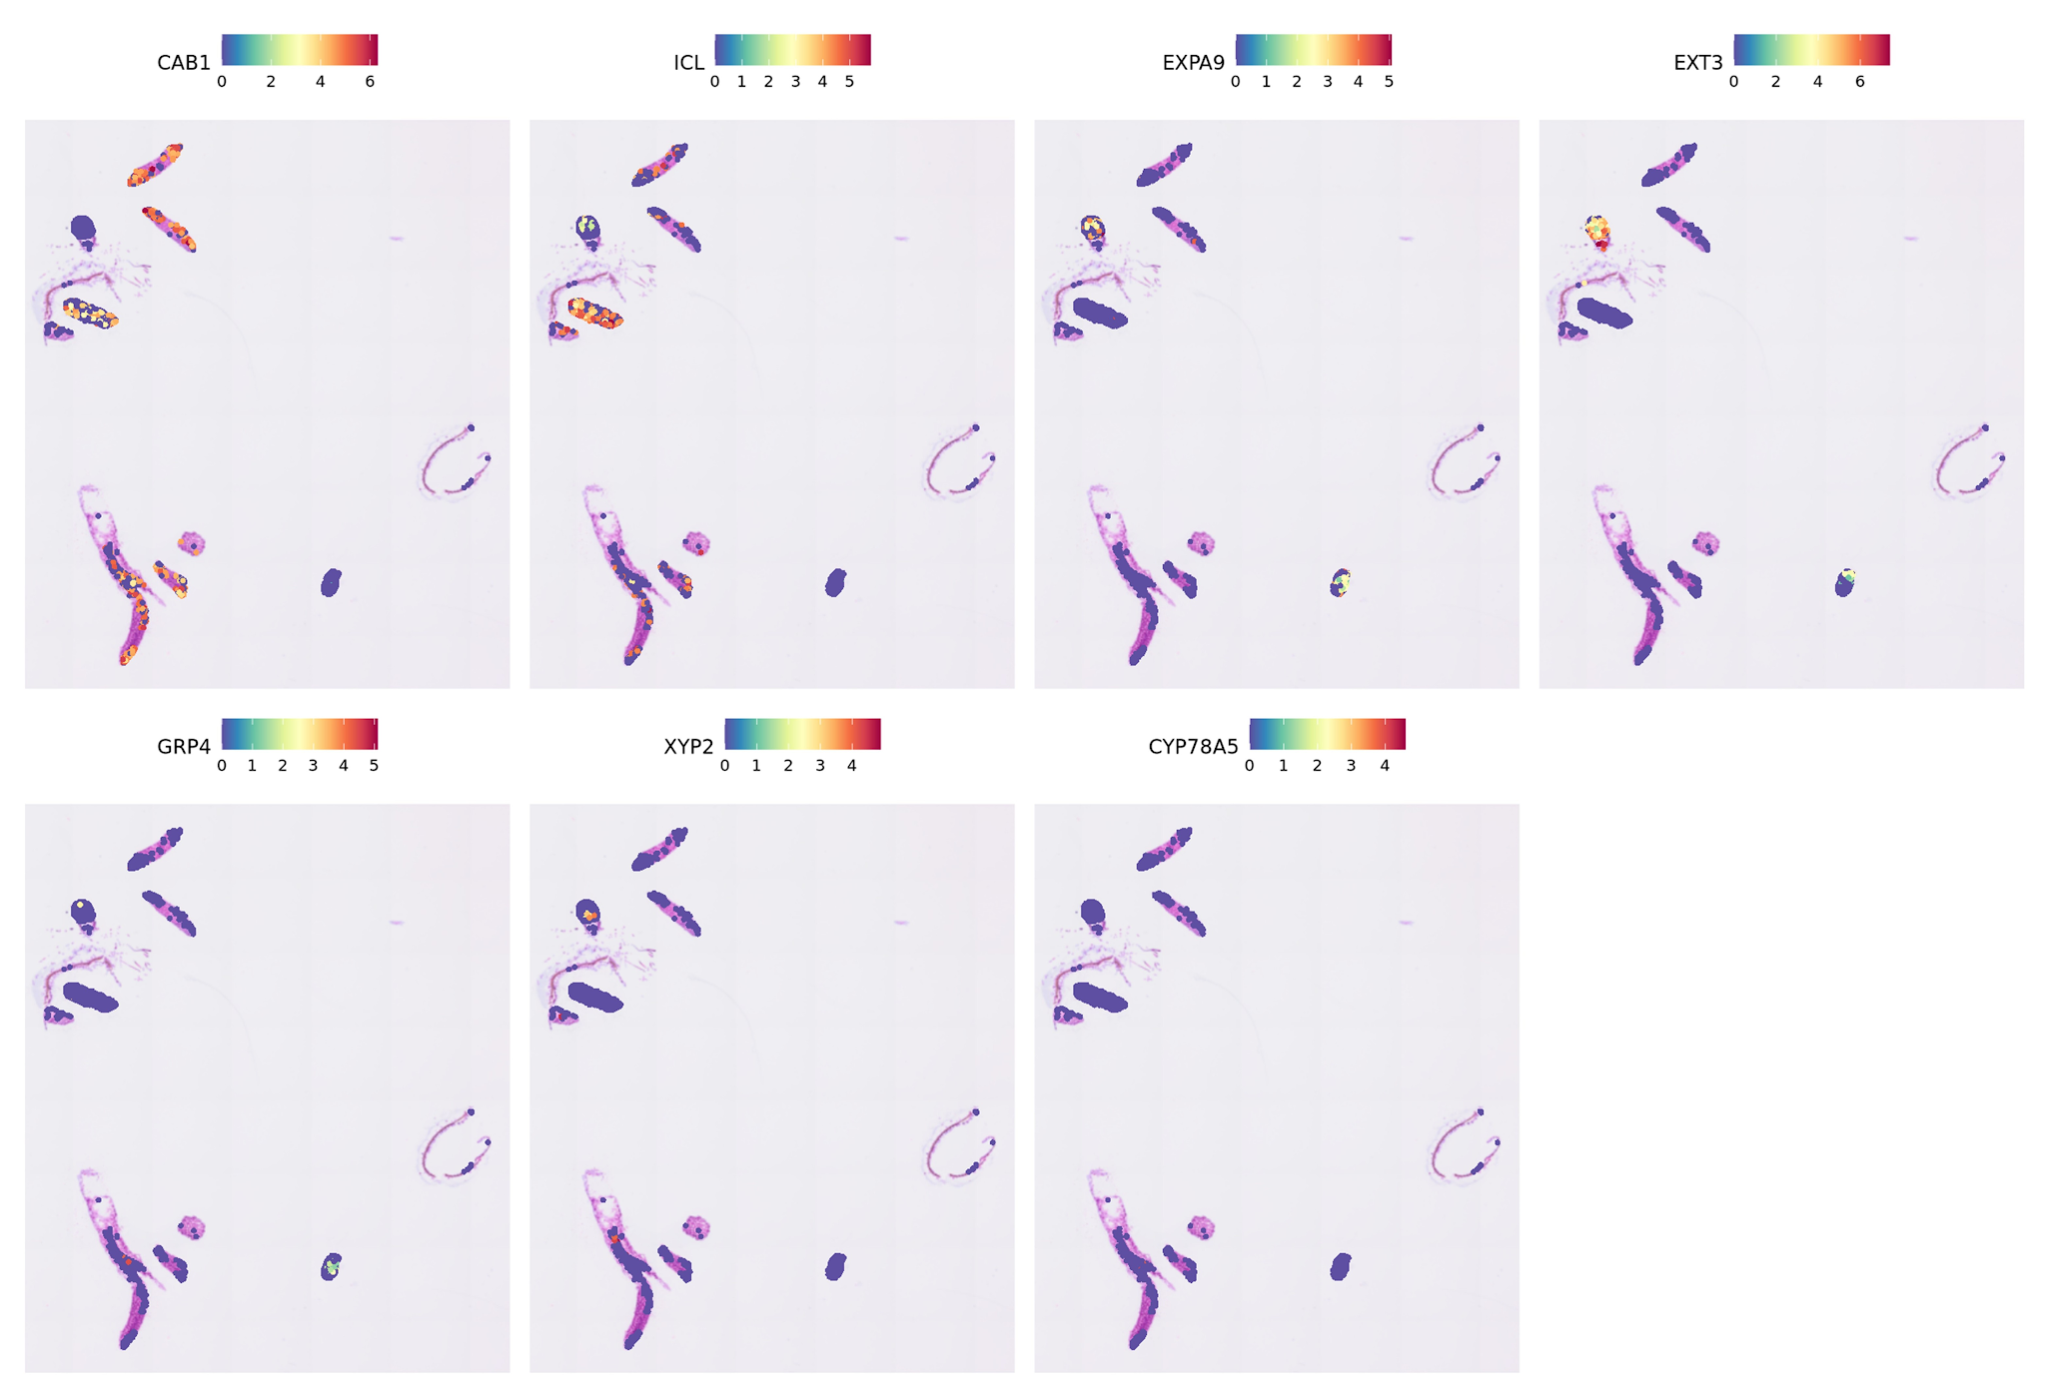
Supplementary Figure S6. Spatial expression of representative markers for the seven Arabidopsis tissue domains. Each panel shows one marker selected from the final annotation evidence.
Biological Interpretation. The composite demonstrates that the cluster annotations are supported by spatially restricted gene expression rather than only by separation in UMAP space. The markers collectively reconstruct the shoot, root, transition, and organizer regions of the seedling.

8. Spatial gradients along the shoot developmental axis
The seedling section contained several physically disconnected tissue fragments. To prevent unrelated fragments from being combined into a single distance model, bins were first partitioned by physical x-y proximity. A connected fragment containing cotyledon, germinating seed, hypocotyl, and SAM were isolated. This fragment contained 213 bins, including 38 SAM bins.
Distance was calculated from the SAM centroid and gene expression was modeled with a one-dimensional smooth. The mean distances followed the expected order: SAM, 69.2 units; germinating seed, 199 units; cotyledon, 413 units; and hypocotyl, 542 units. AFO, ANT, and CYP78A5 showed strong localization near the SAM, whereas CAB1 lacked a significant smooth relationship with distance from the SAM centroid (P = 0.135). ANT was strongly higher in SAM than cotyledon (average log2 fold change 11.62; adjusted P = 8.1 × 10⁻26) and retained a significant distance-associated smooth (P = 0.00026; 9.6% deviance explained).
piece1 <- expr_data[expr_data$piece == "1", ]
sam_centroid <- colMeans(piece1[piece1$cluster == "SAM", c("x", "y")])
piece1$dist_from_SAM <- sqrt((piece1$x - sam_centroid[1])^2 +
(piece1$y - sam_centroid[2])^2)
fit <- mgcv::gam(expression ~ s(dist_from_SAM, k = 4), data = piece1)
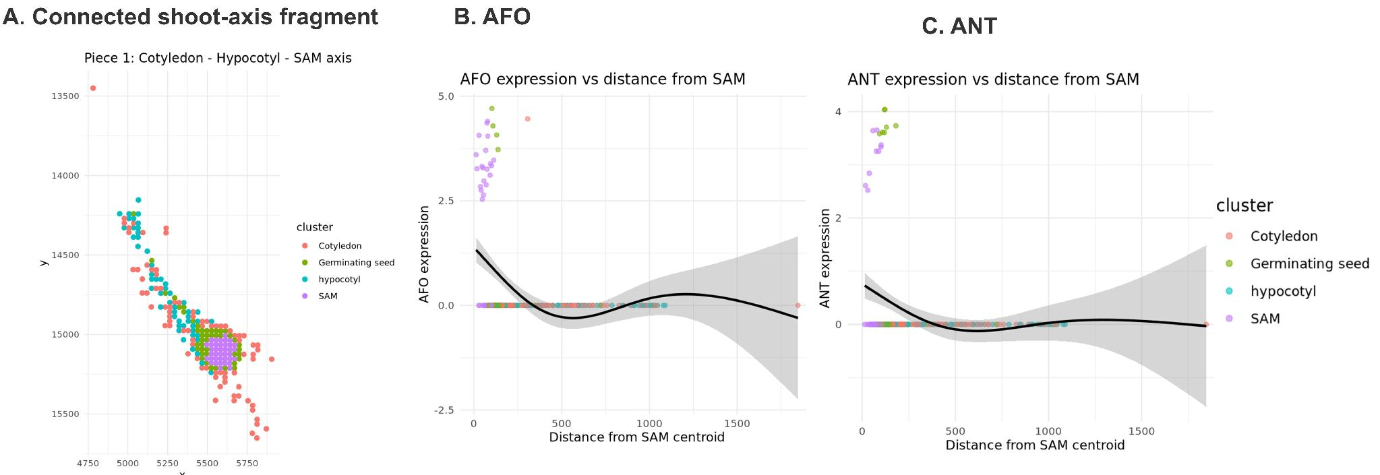
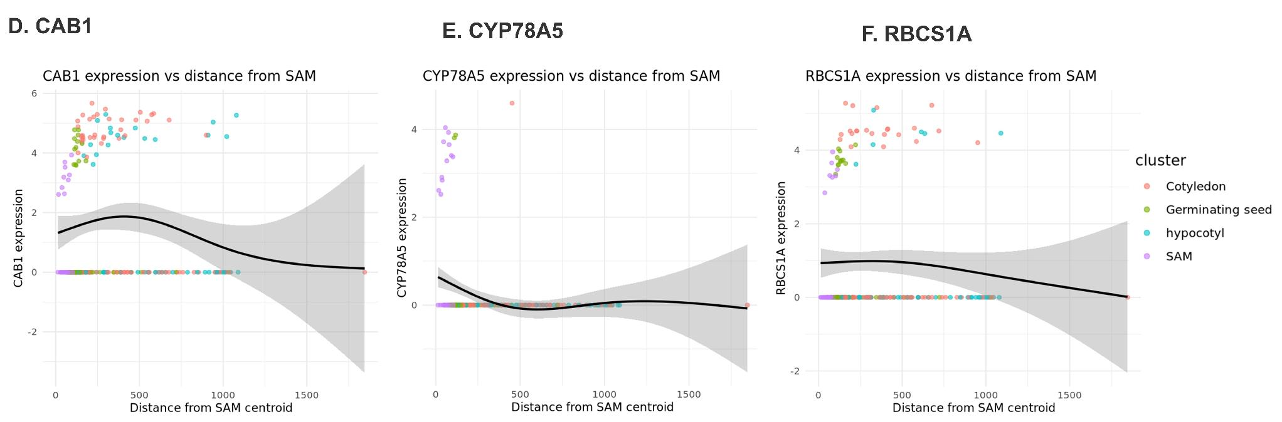
Supplementary Figure S7. Distance-based modeling along a connected Arabidopsis shoot-axis fragment. (A) The physically connected fragment used for modeling. (B-F) Generalized additive model fits for AFO, ANT, CAB1, CYP78A5, and RBCS1A as functions of distance from the SAM centroid.
Biological Interpretation. The gradient models distinguish organizer-restricted identity genes from photosynthetic genes. SAM regulators are sharply concentrated near the organizer, whereas CAB1 and RBCS1A reflect local photosynthetic state and do not behave as simple monotonic developmental gradients. This distinction is not captured by categorical clustering alone.

9. Arabidopsis case-study conclusion and limitations
The analysis recovered seven anatomically coherent tissue domains and linked them to expected photosynthetic, germination, cell-wall, transport, and meristematic programs. Marker validation, cluster markers, spatially variable genes, pathway enrichment, and distance modeling provided independent lines of support for the final interpretation.
- Stringent bin filtering improved transcript complexity but reduced spatial completeness from 7,214 on-tissue bins to 1,516 retained bins.
- The workflow remained bin-based because plant morphology and cell-wall-associated image background limited reliable animal-trained segmentation.
- One section cannot establish biological variability across seedlings or experimental conditions.
- Differential-expression P values treat bins as analytical units and should not be interpreted as replicate-supported organism-level inference.
- The fragmented capture layout required physical-fragment isolation before meaningful distance modeling.

Part II. Inflamed murine lacrimal gland analyzed with Visium

10. Biological rationale and research question
The lacrimal gland is an exocrine tissue that supports tear-film production and ocular-surface homeostasis. In inflammatory dry-eye and Sjögren-like contexts, glandular epithelium can be remodeled by antigen-presentation, lymphoid, plasma-cell, stromal, and humoral programs (Conrady et al., 2016; Craig et al., 2017). This case study asked whether one inflamed lacrimal gland section was organized as sharply separated immune and glandular compartments or as a local mosaic of interacting epithelial-secretory and immune-associated transcriptional territory.
Primary conclusion. The analyzed section is best described as a spatial mosaic. Secretory epithelial domains, a secretory-interface stress domain, an antigen-presentation and lymphoid-activation domain, and a plasma-cell/humoral-complement domain are interspersed and frequently adjacent.

11. Quality control and normalization
Three standard spot-level metrics were evaluated: total transcript counts, detected genes, and mitochondrial percentage. Spots were retained when nFeature_Spatial was at least 200, nCount_Spatial was at least 500, and percent.mt was no greater than 5. This removed 14 of 1,530 spots and retained 1,516 spots for downstream analysis.
Supplementary Table S7. Quality-control summary for the lacrimal gland section.
Stage | Spots | Median counts | Median features | Median percent.mt (%) | Mean counts | Mean features | Mean percent.mt (%)
Before filtering | 1,530 | 26,411.5 | 1,848.5 | 0.1310 | 28,789.84 | 1,795.33 | 0.1470
After filtering | 1,516 | 26,648.0 | 1,856.5 | 0.1304 | 29,049.47 | 1,810.48 | 0.1462
Note. percent.mt is reported in percentage units because it was calculated with Seurat PercentageFeatureSet.
obj[["percent.mt"]] <- PercentageFeatureSet(obj, pattern = "^mt-")
obj <- subset(
obj,
subset = nFeature_Spatial >= 200 & nCount_Spatial >= 500 & percent.mt <= 5
)
obj <- SCTransform(obj, assay = "Spatial", return.only.var.genes = FALSE)
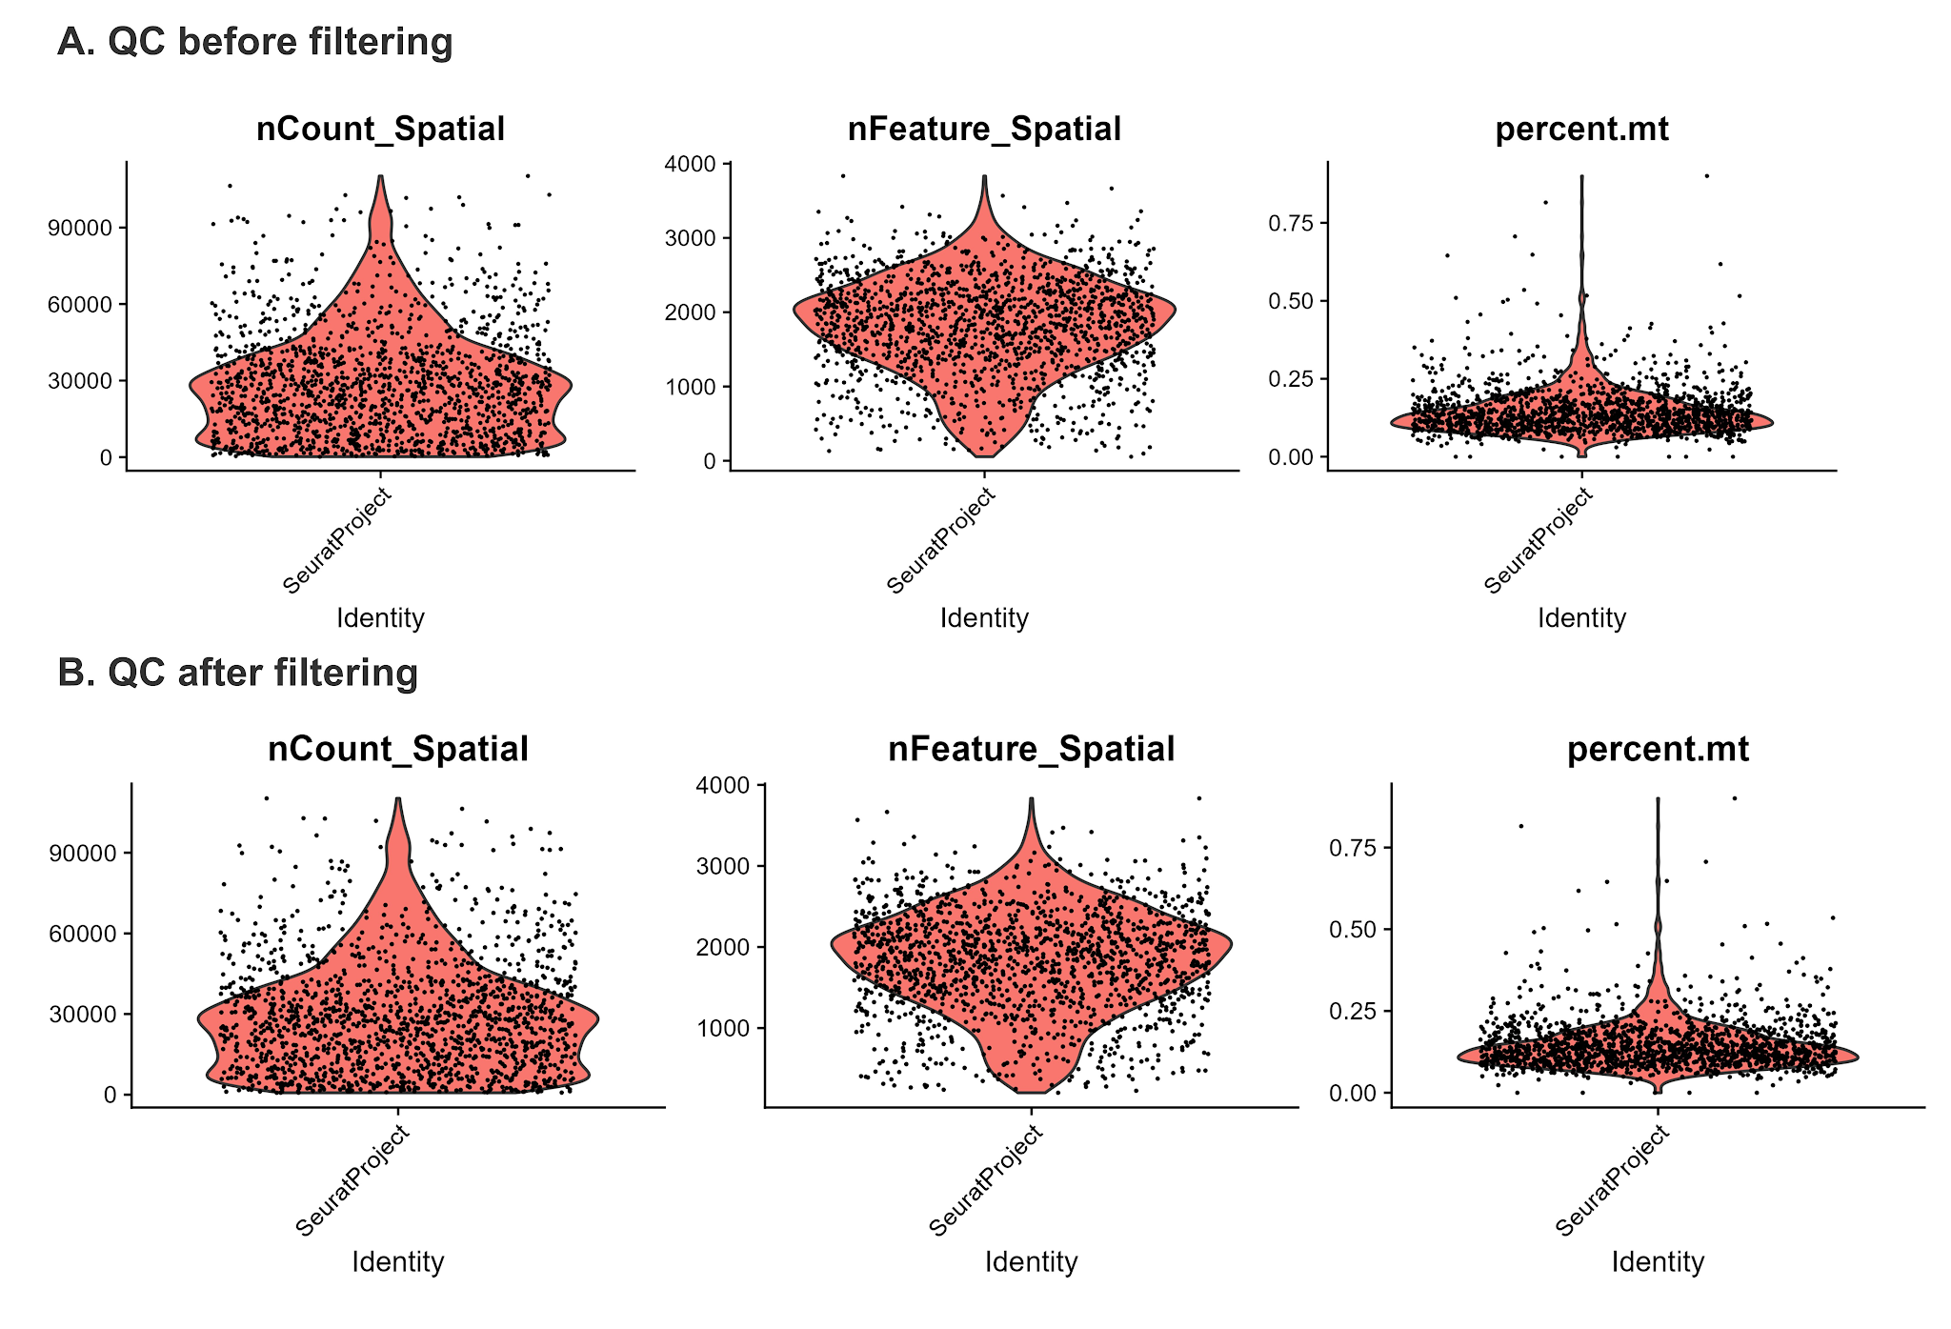
Supplementary Figure S8. Quality-control distributions in the lacrimal gland section. (A) nCount_Spatial, nFeature_Spatial, and percent.mt before filtering. (B) The same metrics after filtering.
Biological Interpretation. The removal of only 14 spots indicates that the section had broadly adequate transcript recovery. Similar pre- and post-filtering medians show that filtering removed a small number of low-quality or extreme spots without changing the central distribution of the dataset.
Supplementary Table S8. Core analysis parameters for the lacrimal gland case study.
Analysis step | Parameterization | Rationale or interpretation
QC | nFeature_Spatial ≥ 200; nCount_Spatial ≥ 500; percent.mt ≤ 5 | Retained 1,516 of 1,530 spots
Normalization | SCTransform; return.only.var.genes = FALSE | Regularized negative-binomial normalization
PCA/UMAP | 50 PCs calculated; dimensions 1-30 used | Transcriptional similarity visualization
Clustering | Graph-based; resolution = 0.45 | Five spot-level transcriptional domains
Markers | PrepSCTFindMarkers + Wilcoxon; min.pct = 0.10; logFC ≥ 0.25 | Positive marker genes
Module scoring | AddModuleScore | Curated epithelial, immune, metabolic, and stress programs
Neighborhoods | Native Visium array adjacency; distance-limited graph sensitivity | Continuous local-mixing fraction and binary interface sensitivity across clustering resolutions
Spatial gradients | 2D GAM: value ~ s(x, y), REML | Deviance explained used as spatial-structure summary
SVGs | Moran’s I ranking | Cluster-independent spatial patterning
Deconvolution | STdeconvolve; eight reference-free topics | Latent transcriptional topics, not definitive cell counts

12. Dimension reduction, clustering, and domain annotation
SCTransform-normalized expression was analyzed with 50 principal components, dimensions 1-30 for UMAP and nearest-neighbor graph construction, and graph-based clustering at resolution 0.45. Five spot-level transcriptional domains were recovered. The final spot counts in Supplementary Table S9 were calculated from the supplied cluster_spot_counts_NOD_1.csv output.
obj <- RunPCA(obj, npcs = 50)
obj <- RunUMAP(obj, reduction = "pca", dims = 1:30)
obj <- FindNeighbors(obj, reduction = "pca", dims = 1:30)
obj <- FindClusters(obj, resolution = 0.45)
Supplementary Table S9. Lacrimal gland spatial-domain sizes, working annotations, and representative markers.
Cluster | Spots | Percent of spots | Working transcriptional-domain annotation | Representative markers
0 | 418 | 27.57% | Inflamed secretory-interface epithelial domain | 2310057J18Rik, Igha, Pigr, Aqp8, Hp, Esp15, Esp6, Ltf, P4hb, Bhlha15
1 | 394 | 25.99% | Car6/secretoglobin-rich epithelial-secretory domain | Scgb2b11, Car6, Cthrc1, Gm43674, Rell1, Esp31, Scgb2b19, Scgb2b12, Scgb2b17, Scgb1b3
2 | 269 | 17.74% | Second secretoglobin/Mup5 epithelial domain | Mup5, A4gnt, Scgb1b27, Esp3, Scgb2b17, Scgb2b12, Esp24, Scgb2b3, Scgb2a2, Esp31
3 | 267 | 17.61% | Antigen-presentation and lymphoid-activation domain | Ccl5, Slamf6, Ighd, H2-Ob, Cd19, Cd79a, Cd79b, Cd74, H2-Eb1, H2-Aa, Ccl19
4 | 168 | 11.08% | Plasma-cell/humoral-complement domain | Iglv1, Ighg1, Slpi, Igkc, Jchain, Mzb1, Iglc1, Ighg2b, Ighm, C3
Note. The labels summarize mixed spot-level programs. They should not be interpreted as pure cell-type identities.
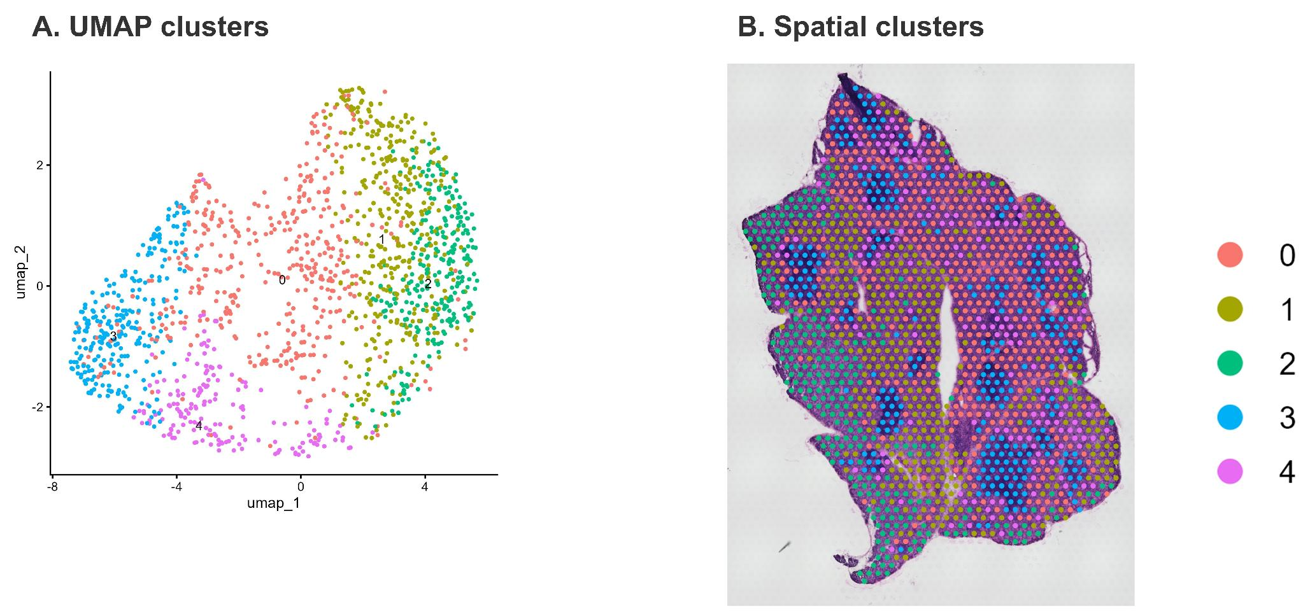
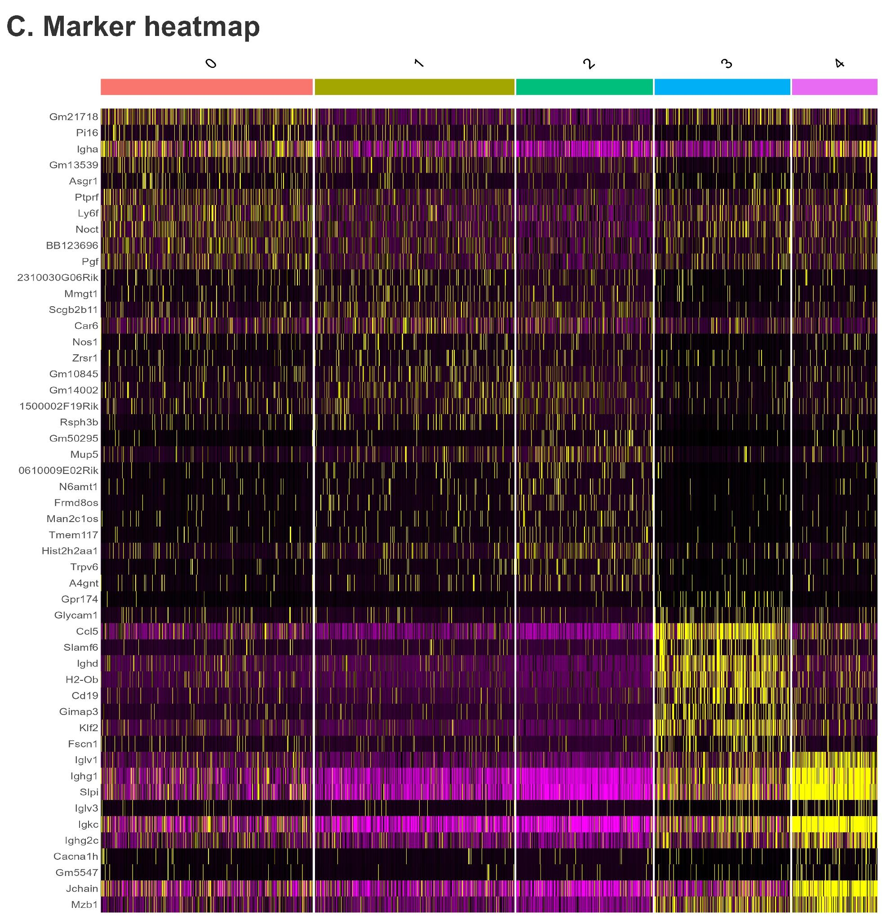
Supplementary Figure S9. Unsupervised clustering of the lacrimal gland section. (A) UMAP of five Seurat clusters. (B) Spatial localization of the same clusters. (C) Heatmap of leading cluster marker genes.
Biological Interpretation. The UMAP resolves five transcriptional states, while the tissue map shows that those states are spatially interleaved. Clusters 0-2 form related epithelial-secretory territories, cluster 3 carries a strong antigen-presentation and lymphoid program, and cluster 4 carries a plasma-cell and humoral-complement program.

13. Marker-gene programs and functional enrichment
Cluster markers were identified after SCT marker preparation using the Wilcoxon rank-sum test. The three epithelial domains were distinguishable despite sharing secretoglobin and epithelial genes. Cluster 0 combined Pigr, Aqp8, Ltf, Hp, P4hb, Bhlha15, and other secretory-defense or stress-handling genes. Cluster 1 was enriched for Car6 and secretoglobin genes. Cluster 2 carried a second secretoglobin/Mup5-associated program. Cluster 3 was marked by Cd74, H2-Eb1, H2-Aa, Cd19, Cd79a, Ccl5, Ccl19, and related lymphoid genes. Cluster 4 was enriched for Igkc, Jchain, Mzb1, immunoglobulin chains, C3, and other humoral-effector genes.
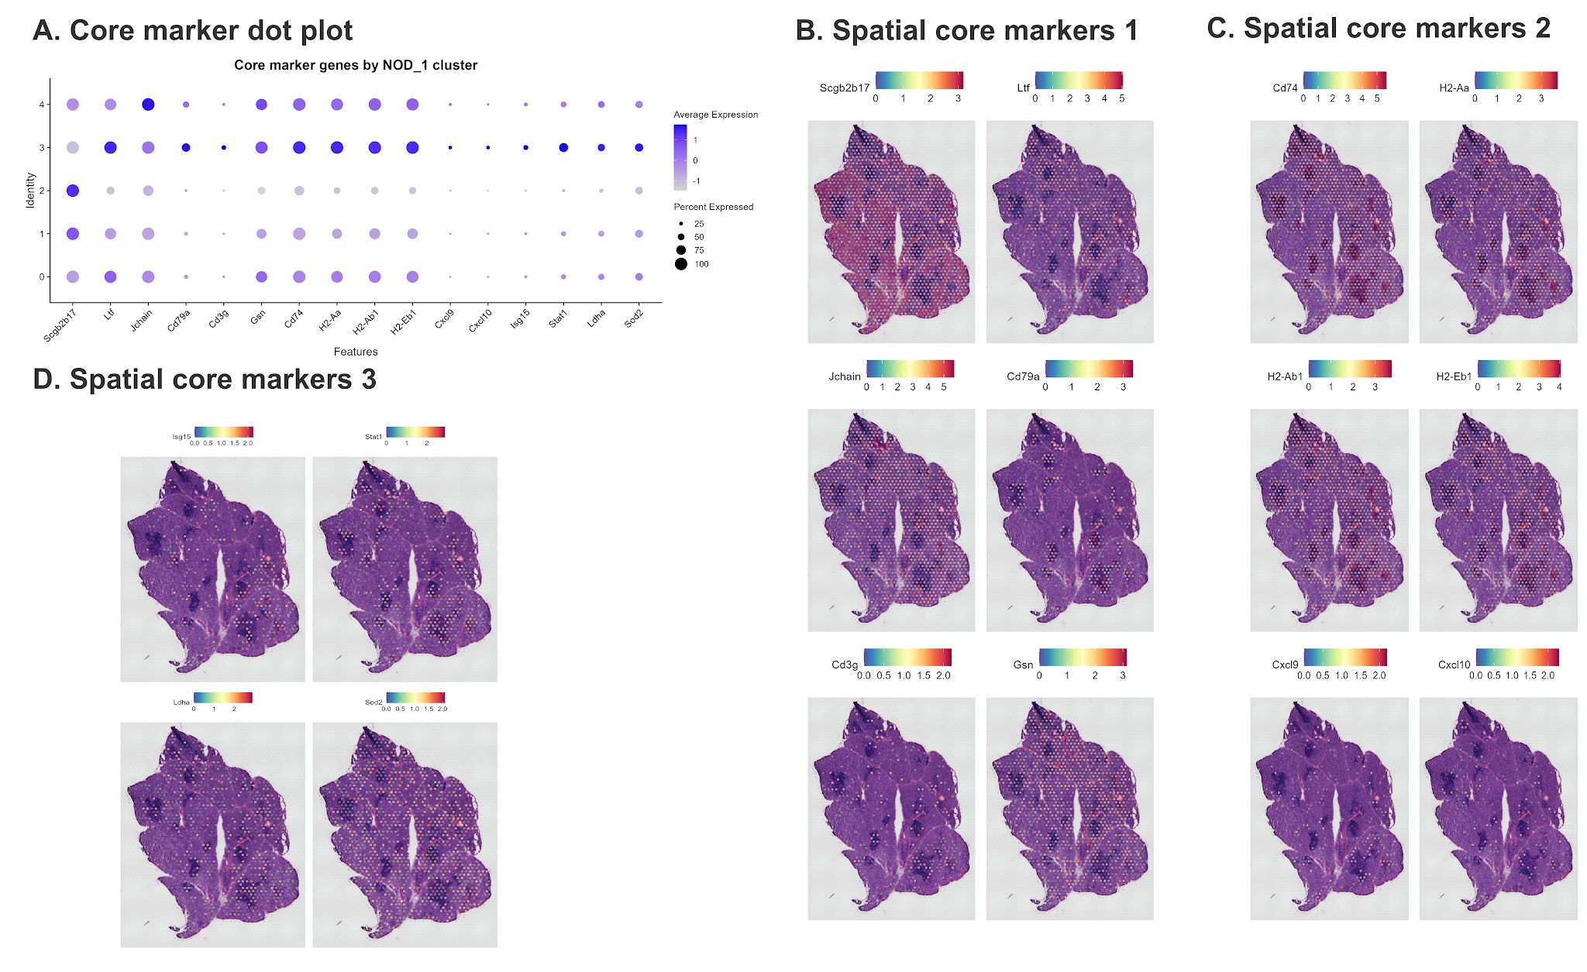
Supplementary Figure S10. Marker-gene expression and spatial localization in the lacrimal gland. (A) Dot plot of selected epithelial, secretory, antigen-presentation, lymphoid, humoral, metabolic, and stress-associated genes. (B-D) Spatial maps of the same marker panel in three image groups.
Biological Interpretation. Marker expression demonstrates that the glandular compartment is transcriptionally heterogeneous rather than uniform. Secretoglobin-rich epithelial regions coexist with an Ltf/Pigr-associated defense interface, an MHC class II-rich lymphoid region, and an immunoglobulin/Jchain-rich humoral region.
GO Biological Process enrichment was interpreted conservatively and used only when it agreed with the corresponding marker and spatial evidence. Cluster 0 showed endoplasmic-reticulum stress and mucosal immune programs, cluster 3 showed leukocyte and lymphocyte activation programs, and cluster 4 showed classical complement and immunoglobulin-mediated humoral programs.
Supplementary Table S10. Representative GO Biological Process enrichment results concordant with the lacrimal gland domain annotations.
Domain | GO biological process | Gene ratio | Fold enrichment | Adjusted P
0: secretory interface | ER unfolded protein response | 4/34 | 34.79 | 3.33 × 10⁻3
0: secretory interface | Mucosal immune response | 3/34 | 50.45 | 3.56 × 10⁻3
0: secretory interface | Response to ER stress | 5/34 | 13.05 | 3.56 × 10⁻3
3: antigen presentation/lymphoid | Leukocyte proliferation | 110/1,154 | 6.44 | 5.30 × 10⁻55
3: antigen presentation/lymphoid | Mononuclear cell proliferation | 104/1,154 | 6.76 | 3.17 × 10⁻54
3: antigen presentation/lymphoid | Lymphocyte proliferation | 101/1,154 | 6.70 | 3.00 × 10⁻52
4: plasma/humoral | Complement activation, classical pathway | 10/77 | 77.71 | 9.85 × 10⁻14
4: plasma/humoral | Humoral response mediated by circulating immunoglobulin | 10/77 | 56.64 | 1.55 × 10⁻12
4: plasma/humoral | B-cell-mediated immunity | 14/77 | 17.33 | 1.93 × 10⁻11
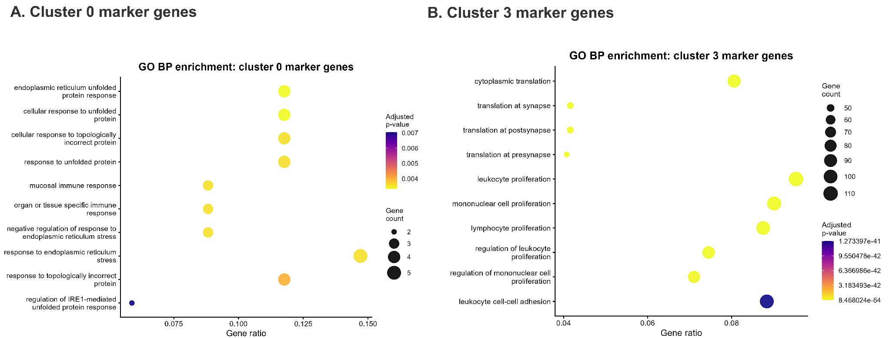

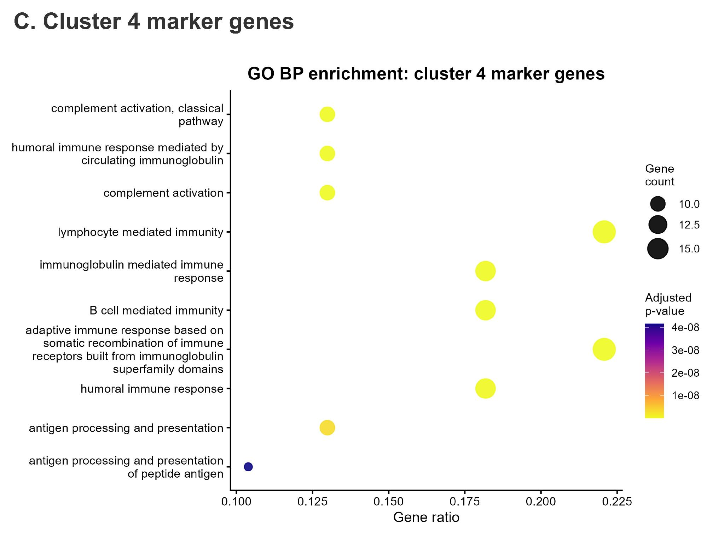
Supplementary Figure S11. Representative GO Biological Process enrichment. (A) Cluster 0, the inflamed secretory-interface domain. (B) Cluster 3, the antigen-presentation and lymphoid-activation domain. (C) Cluster 4, the plasma-cell/humoral-complement domain.
Biological Interpretation. The enrichment results connect spot-level marker patterns to broader biological processes. Secretory-interface spots show protein-folding and mucosal-defense stress, antigen-presentation spots show lymphocyte proliferation and activation, and plasma/humoral spots show classical complement and immunoglobulin-mediated immunity.

14. Biological program scoring
Curated gene sets were summarized with Seurat AddModuleScore to compare coordinated program activity across clusters and tissue space. The scored programs represented epithelial-secretory, antigen-presentation, B-cell/plasma-cell, T-cell, myeloid/stromal, interferon-chemokine, core-metabolism, lipid-metabolism, and oxidative-stress activity.
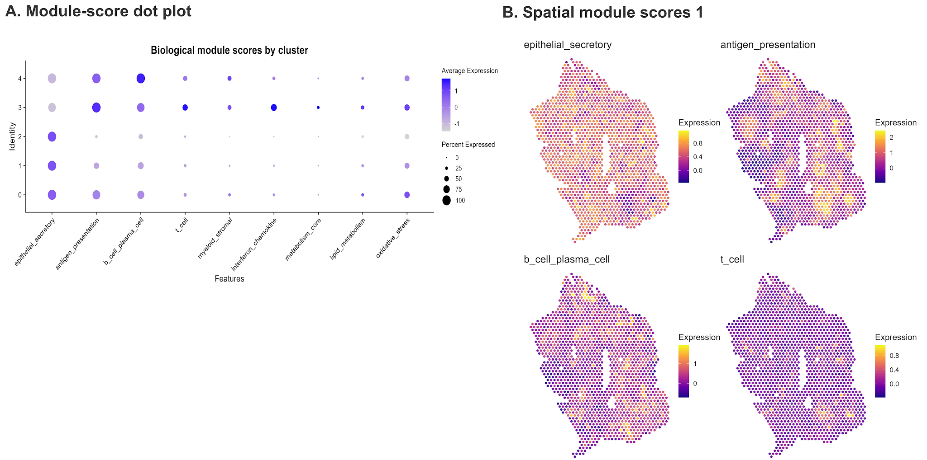
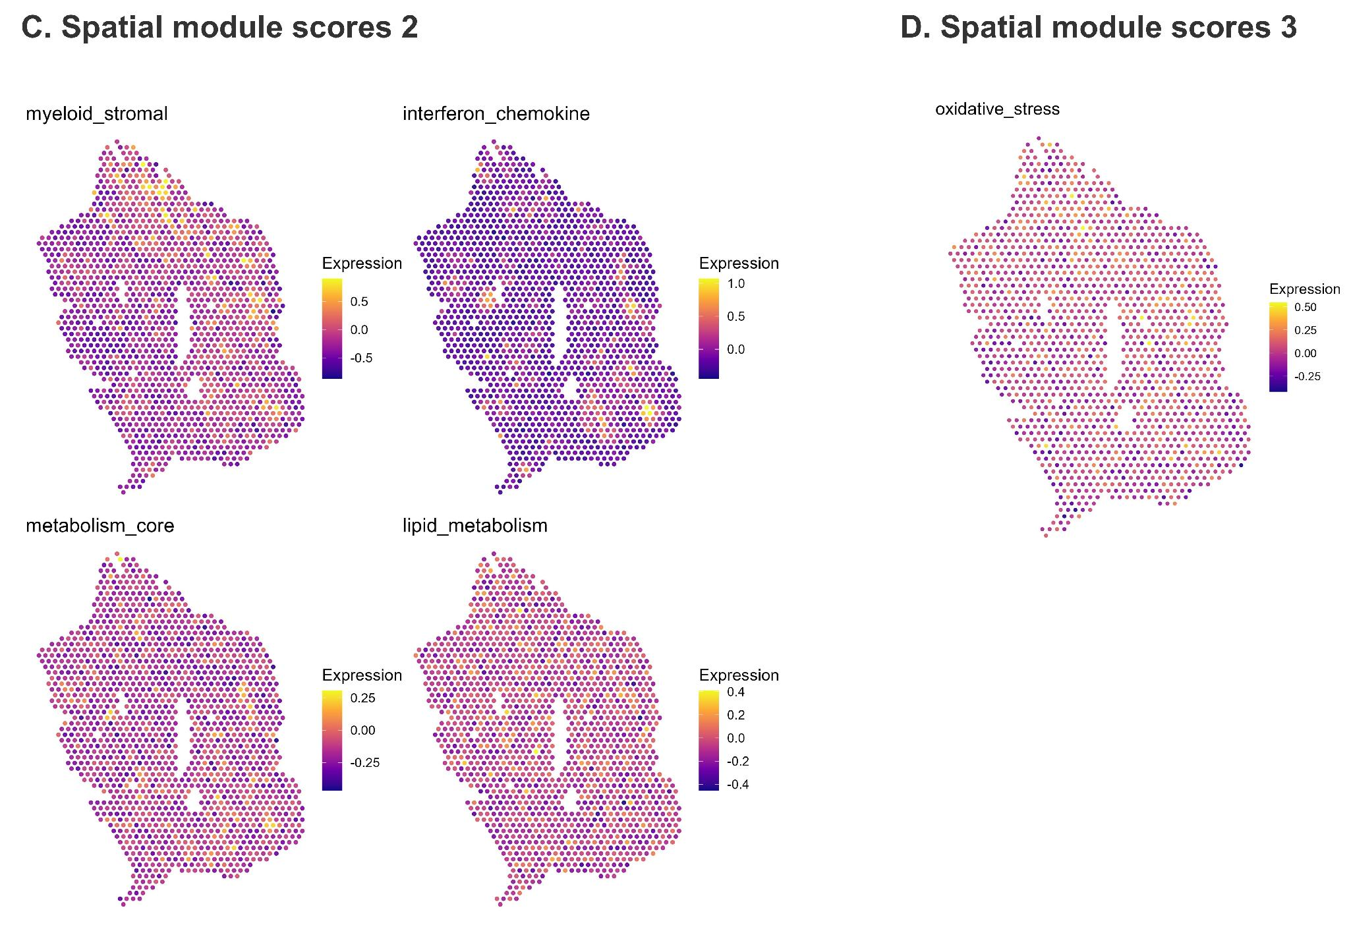
Supplementary Figure S12. Biological program scores in the lacrimal gland. (A) Dot plot of module scores across Seurat clusters. (B-D) Spatial maps of epithelial-secretory, antigen-presentation, B-cell/plasma-cell, T-cell, myeloid/stromal, interferon-chemokine, metabolism, lipid-metabolism, and oxidative-stress scores.
Biological Interpretation. Module scores reinforce the marker-based domain assignments and reveal that immune and secretory programs are distributed as overlapping fields. The analysis does not support a simple binary division into immune versus glandular tissue. Instead, immune-associated programs are embedded within and adjacent to secretory regions.

15. Spatially variable genes
Moran’s I was used to rank genes by spatial autocorrelation independently of the Seurat cluster labels. The leading genes included secretoglobins, epithelial-defense genes, antigen-presentation genes, immunoglobulin genes, and highly expressed structural or translational genes. Supplementary Table S11 lists the top 20 supplied genes.
Supplementary Table S11. Top 20 spatially variable genes in the lacrimal gland section.
Rank | Gene | Curated broad category | Interpretive summary
1 | Scgb2b3 | other or unannotated | Spatially organized gene not assigned to curated program
2 | 2310057J18Rik | other or unannotated | Spatially organized gene not assigned to curated program
3 | Scgb2a2 | other or unannotated | Spatially organized gene not assigned to curated program
4 | Apoe | other or unannotated | Spatially organized gene not assigned to curated program
5 | Slpi | other or unannotated | Spatially organized gene not assigned to curated program
6 | Scgb1b3 | other or unannotated | Spatially organized gene not assigned to curated program
7 | Mucl2 | other or unannotated | Spatially organized gene not assigned to curated program
8 | Esp15 | other or unannotated | Spatially organized gene not assigned to curated program
9 | Scgb2b17 | epithelial secretory | Spatially patterned epithelial or secretory signal
10 | Gm5938 | other or unannotated | Spatially organized gene not assigned to curated program
11 | Cd74 | antigen presentation | Spatially patterned antigen-presentation signal
12 | H2-K1 | other or unannotated | Spatially organized gene not assigned to curated program
13 | Rps27a | other or unannotated | Spatially organized gene not assigned to curated program
14 | Fth1 | other or unannotated | Spatially organized gene not assigned to curated program
15 | Esp31 | other or unannotated | Spatially organized gene not assigned to curated program
16 | Scgb1b2 | other or unannotated | Spatially organized gene not assigned to curated program
17 | Rpl4 | other or unannotated | Spatially organized gene not assigned to curated program
18 | Iglc1 | other or unannotated | Spatially organized gene not assigned to curated program
19 | Ighg1 | other or unannotated | Spatially organized gene not assigned to curated program
20 | Fau | other or unannotated | Spatially organized gene not assigned to curated program
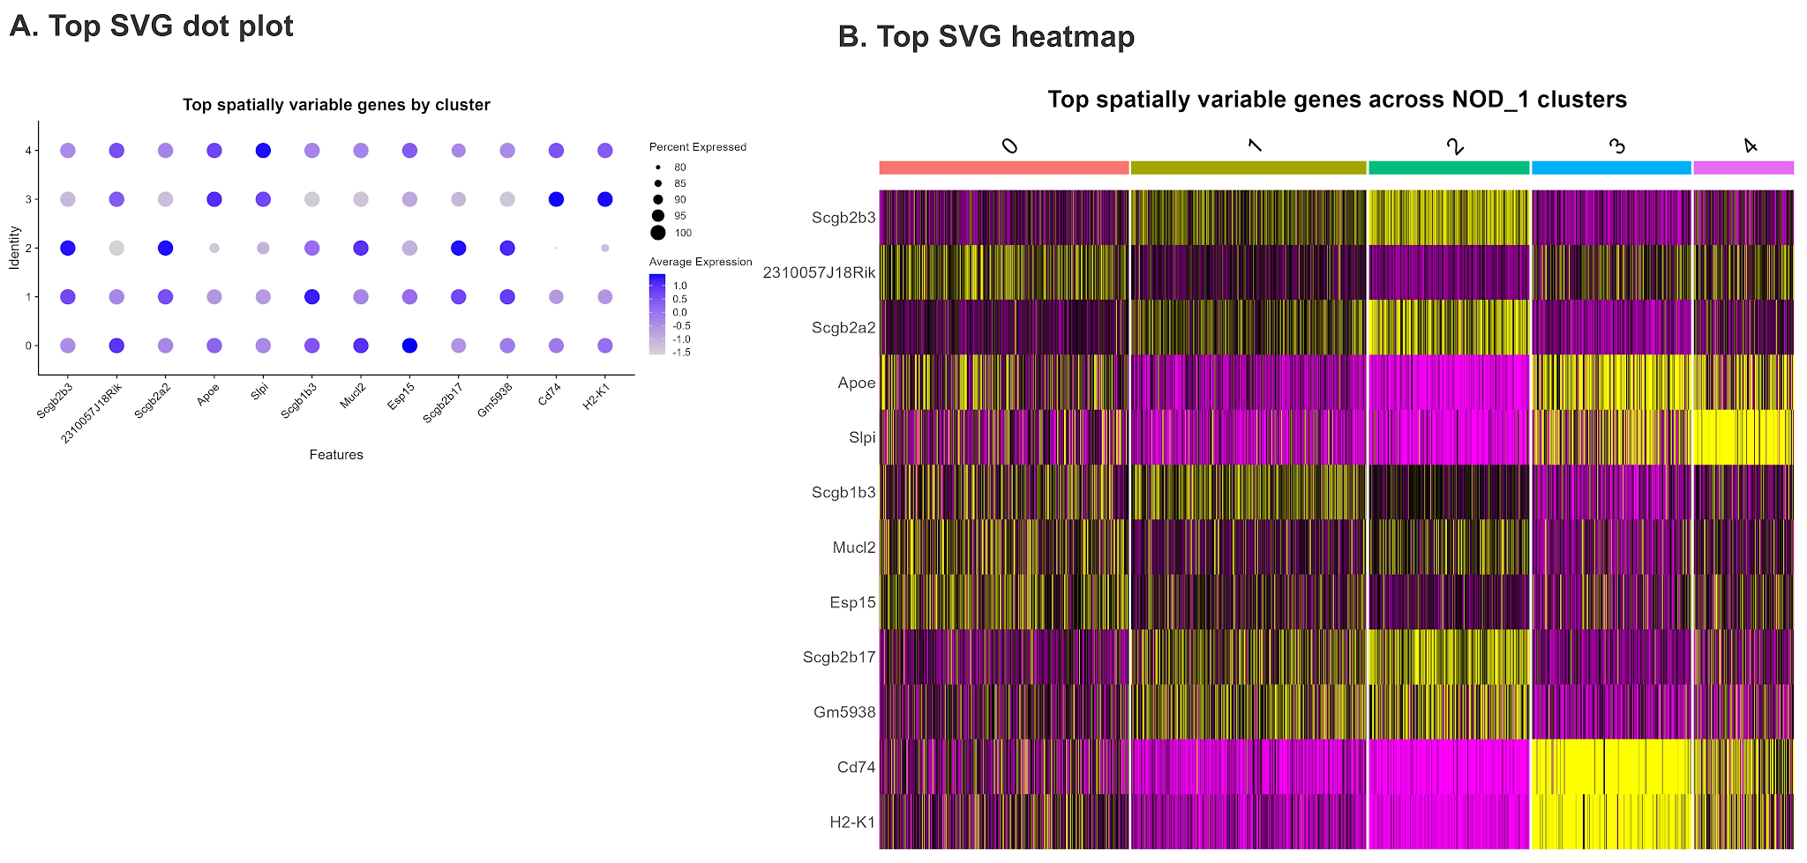
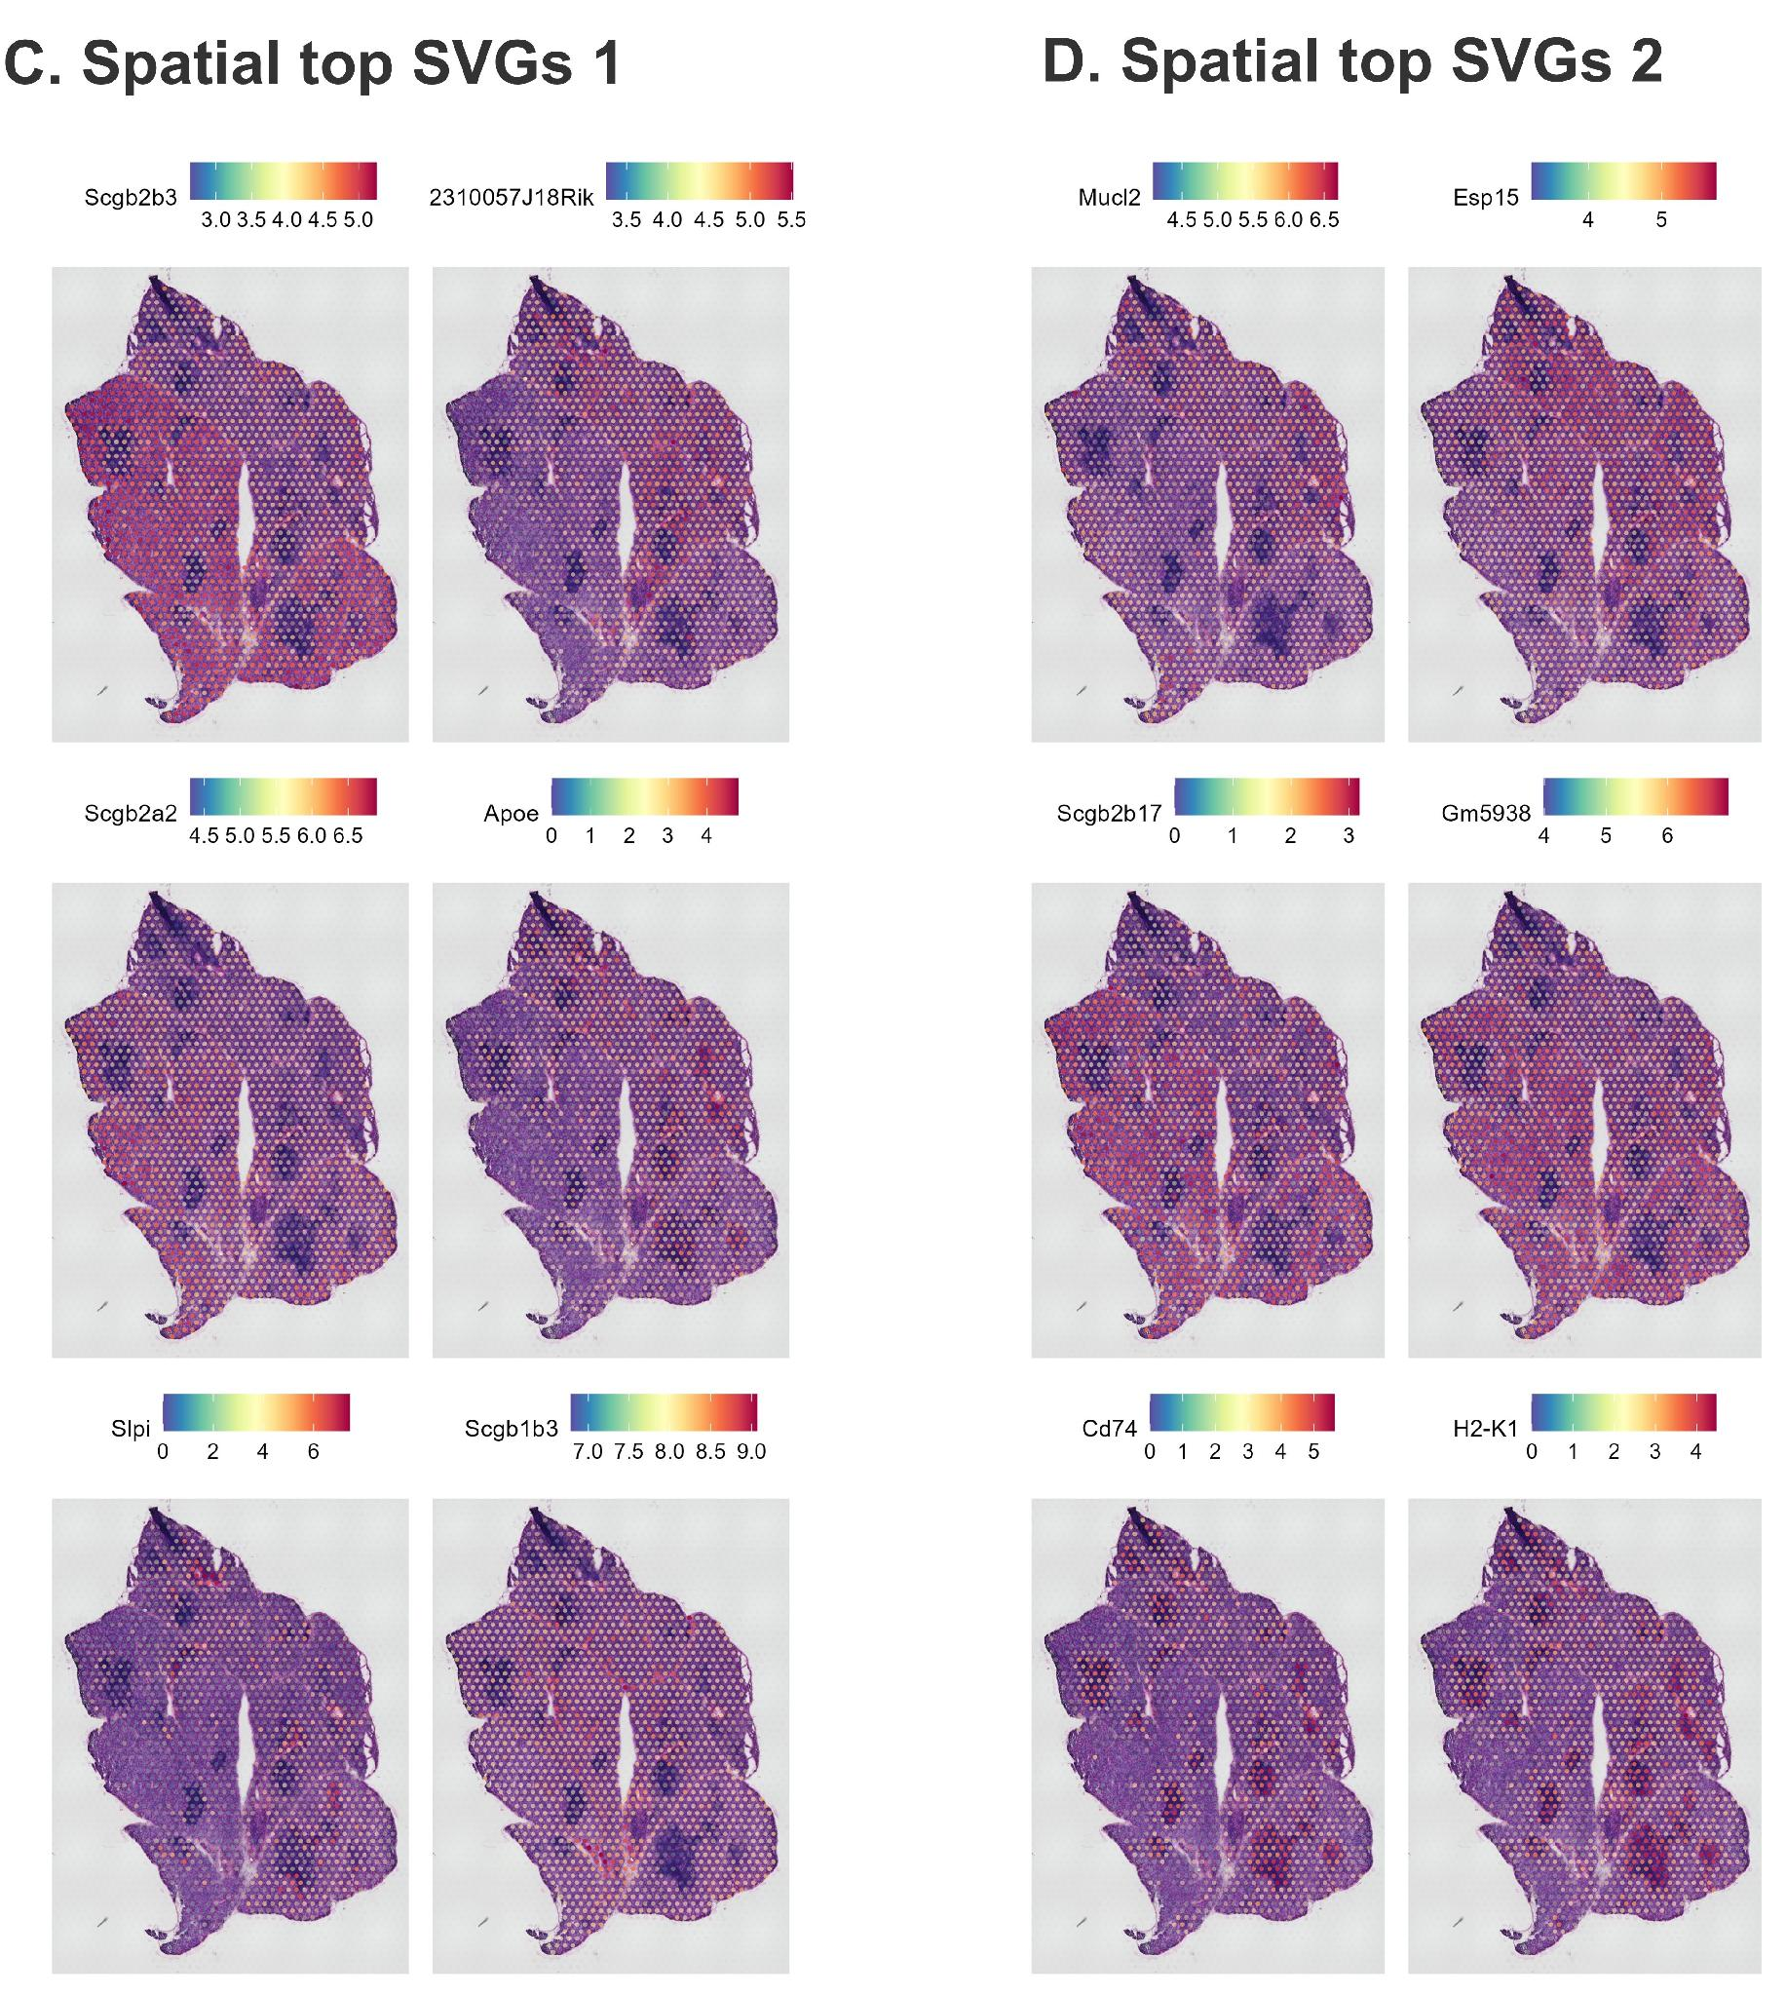
Supplementary Figure S13. Expression patterns of leading spatially variable genes in the lacrimal gland. (A) Dot plot by cluster. (B) Heatmap by cluster. (C-D) Spatial maps of the leading genes.
Biological Interpretation. The spatially variable gene analysis independently recovers the same epithelial-secretory, antigen-presentation, and humoral axes identified by clustering. It also exposes additional spatially organized genes that were not included in the predefined module panels.

16. Native Visium adjacency, local mixing, and sensitivity analysis
Native Visium adjacency was defined from the Space Ranger array coordinates rather than from a generic k-nearest-neighbor search. For the standard staggered Visium array, retained spots were connected only when their array_row/array_col offsets corresponded to one of the six immediate lattice positions: (0, ±2) or (±1, ±1). A non-tissue, missing, or QC-removed position therefore reduced the number of available neighbors and was not replaced by a more distant spot. This follows the Space Ranger array-coordinate convention for the Visium orange-crate layout (10x Genomics, 2026).
The primary local-coherence statistic was the neighbor-difference fraction, calculated for each spot as the number of available native neighbors assigned to a different cluster divided by the native degree of that spot. The binary label “at least one different neighbor” was retained only as a descriptive interface measure. A stricter sensitivity definition classified a spot as an interface when at least 50% of its available native neighbors belonged to another cluster.
# Native Visium lattice adjacency
offsets <- data.frame(dr = c(0,0,-1,-1,1,1), dc = c(-2,2,-1,1,-1,1))
native_edges <- build_native_visium_edges(boundary_df)
neighbor_diff_fraction <- n_different_neighbors / degree
Supplementary Table S12. Native Visium adjacency, local-mixing statistics, and sensitivity analyses in the lacrimal gland section.
(A) Primary native-array adjacency results at Seurat clustering resolution 0.45.
Group | Spots | Mean native degree | Mean neighbor-difference fraction | ≥1 different native neighbor, n (%) | ≥50% different native neighbors, n (%)
Overall | 1,516 | 5.669 | 0.4613 | 1,288 (84.96%) | 811 (53.50%)
Cluster 0 | 418 | 5.799 | 0.4868 | 393 (94.02%) | 232 (55.50%)
Cluster 1 | 394 | 5.635 | 0.4311 | 339 (86.04%) | 195 (49.49%)
Cluster 2 | 269 | 5.230 | 0.3156 | 168 (62.45%) | 90 (33.46%)
Cluster 3 | 267 | 5.854 | 0.4423 | 222 (83.15%) | 147 (55.06%)
Cluster 4 | 168 | 5.833 | 0.7320 | 166 (98.81%) | 147 (87.50%)
(B) Sensitivity to graph construction.
Graph | Isolated spots | Mean degree | Mean neighbor-difference fraction | ≥1 different-neighbor fraction | ≥50% different-neighbor fraction
Native array adjacency | 0 | 5.6689 | 0.4613 | 84.96% | 53.50%
Distance-limited graph | 0 | 5.6689 | 0.4613 | 84.96% | 53.50%
Note. The distance-limited graph retained links within 1.25× the median native-neighbor spacing (133.09 pixels), giving a cutoff of 166.37 pixels. It reproduced the native graph exactly: edge Jaccard = 1.00, Spearman correlation of spot-level neighbor-difference fractions = 1.00, and agreement for the ≥1-different-neighbor interface label = 100%.
(C) Sensitivity to Seurat clustering resolution using the native adjacency graph.
Resolution | Number of clusters | Mean neighbor-difference fraction | ≥1 different-neighbor fraction | ≥50% different-neighbor fraction
0.30 | 4 | 0.4053 | 82.12% | 45.25%
0.45 | 5 | 0.4613 | 84.96% | 53.50%
0.60 | 7 | 0.5302 | 91.42% | 63.46%
At the primary resolution of 0.45, the 1,516 retained spots had a mean native degree of 5.669 and a mean neighbor-difference fraction of 0.4613. The descriptive ≥1-different-neighbor interface fraction was 84.96%, whereas the stricter ≥50% definition classified 53.50% of spots as interface locations. Cluster 4 showed the greatest local mixing (mean neighbor-difference fraction 0.7320; 87.50% under the ≥50% definition). Graph-construction sensitivity was negligible in this dataset because the native and distance-limited graphs were identical, but local-mixing estimates increased as clustering resolution increased, demonstrating the expected dependence on cluster granularity.

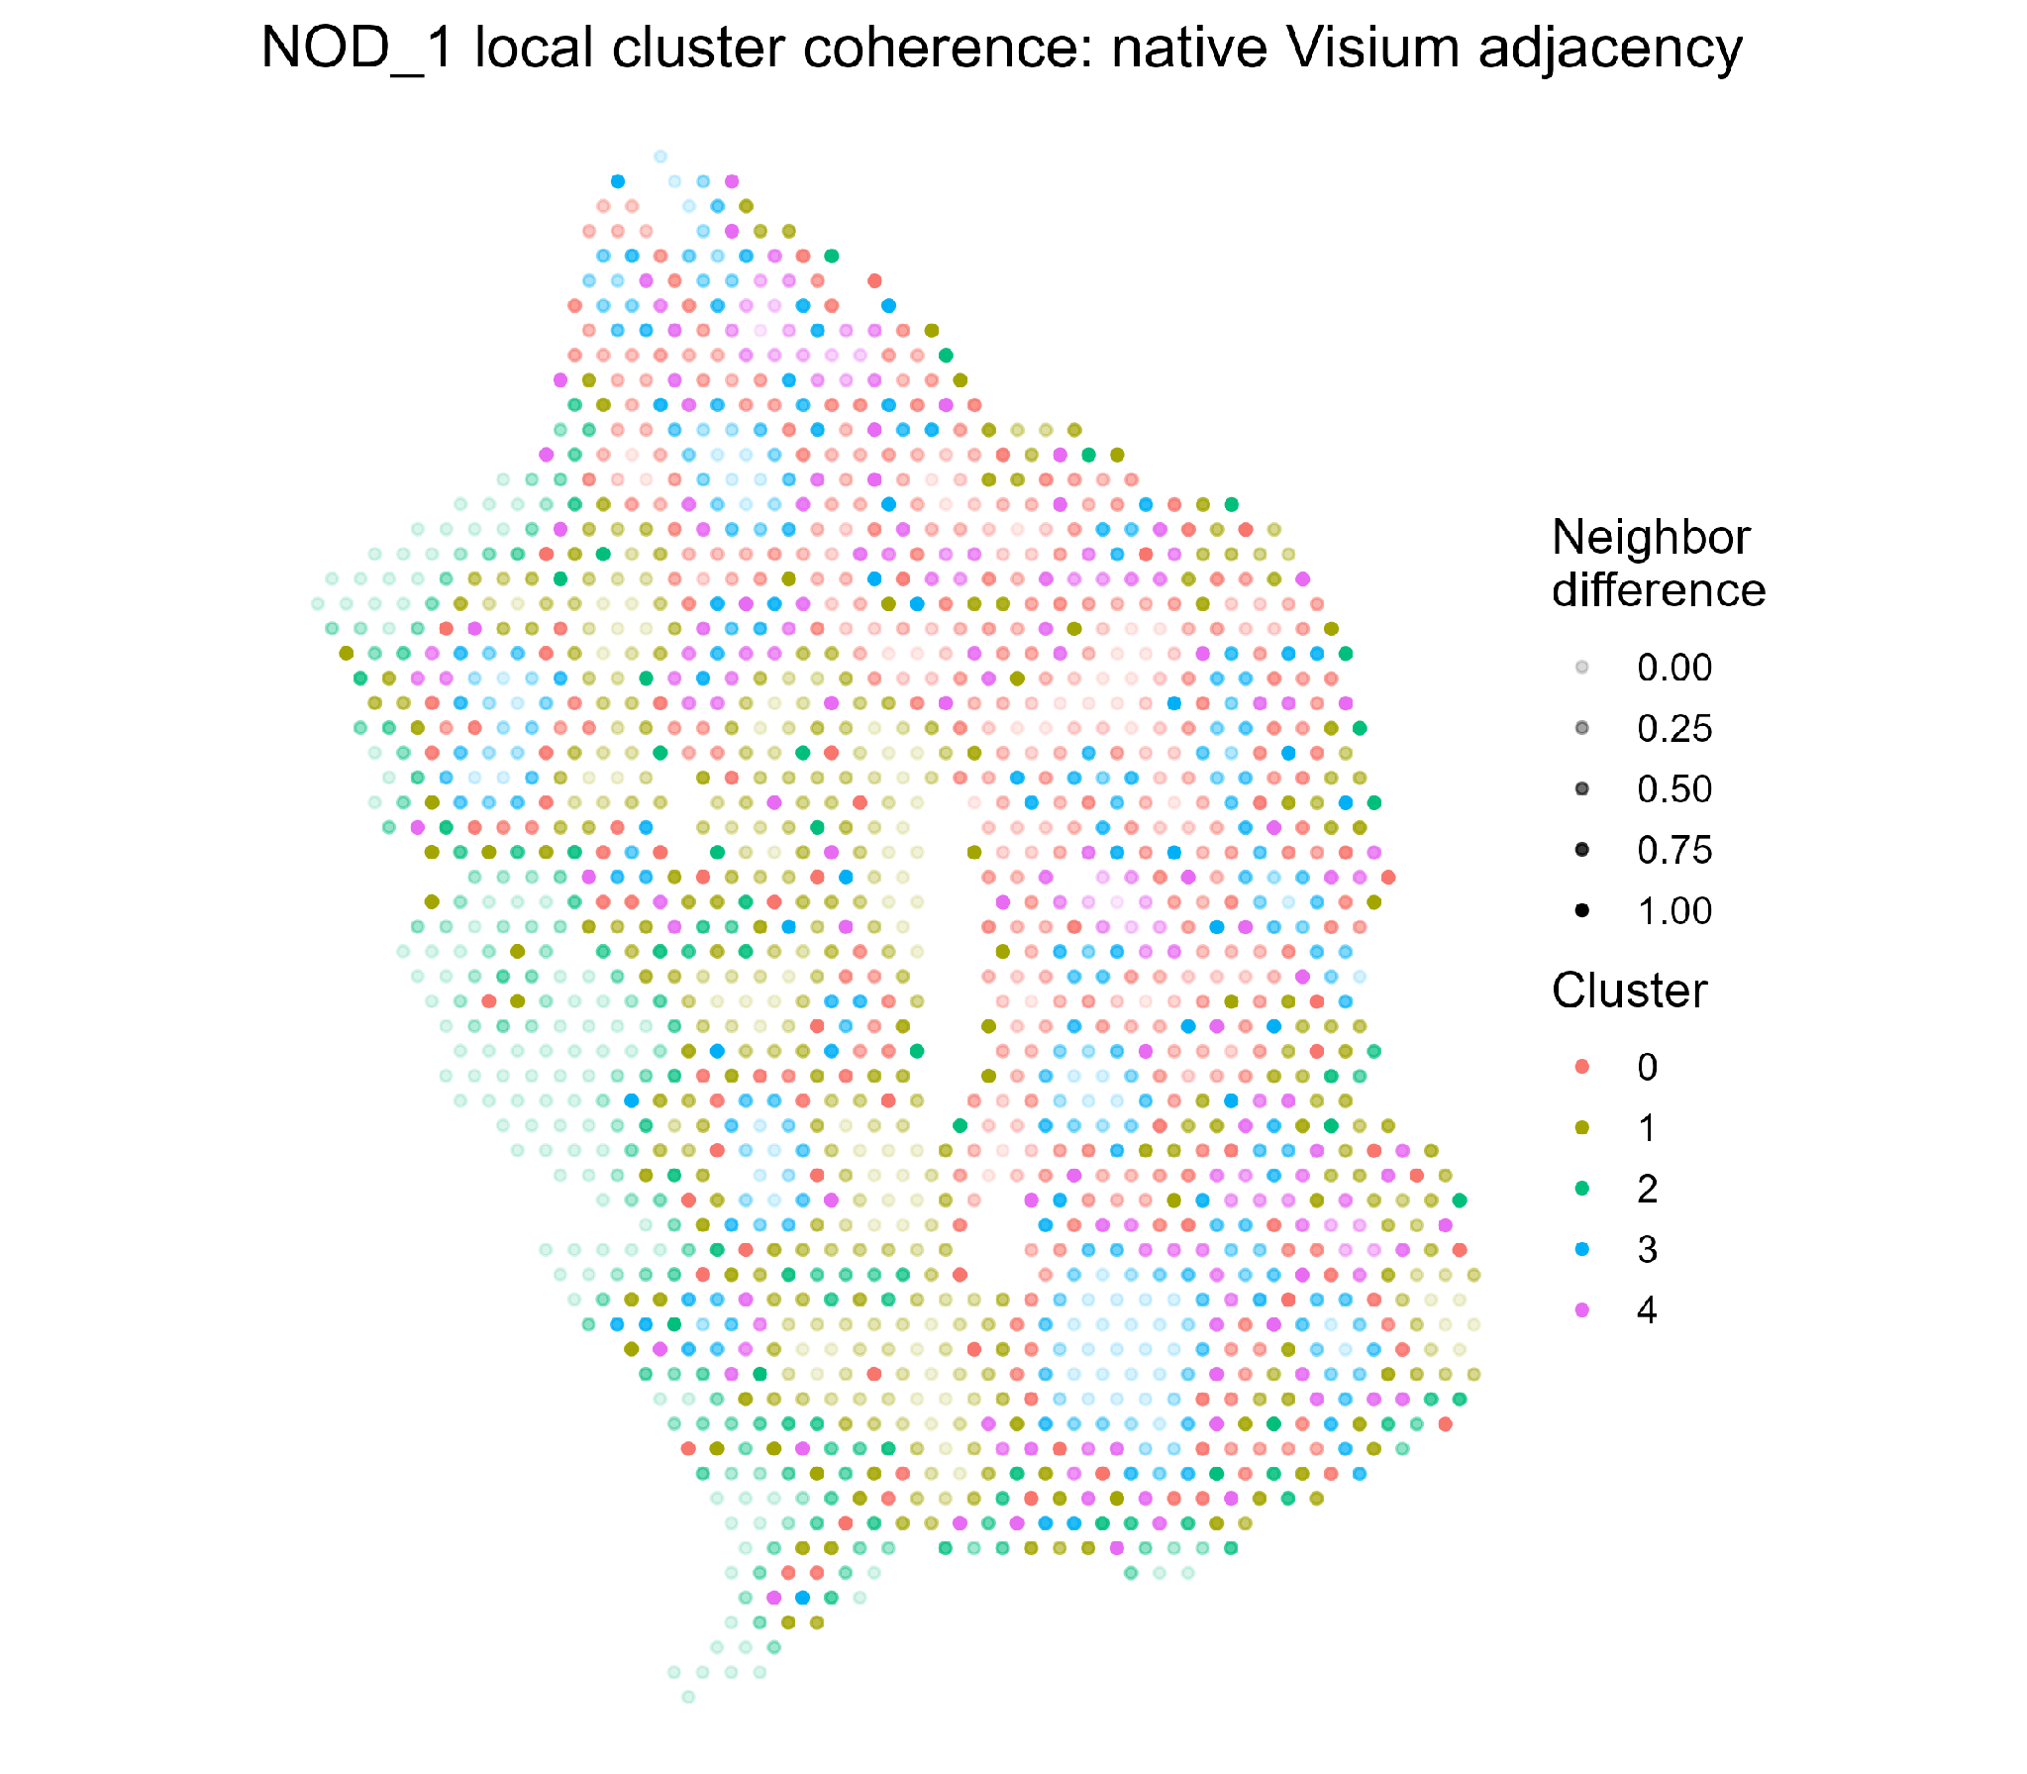
Supplementary Figure S14. Local cluster coherence based on native Visium array adjacency in the lacrimal gland section. Cluster identity is shown by point color, and point opacity encodes the neighbor-difference fraction. Each spot was connected only to retained spots occupying immediate native array positions; missing or filtered positions were not replaced by farther spots.
Biological Interpretation. The continuous map shows broad regions of local agreement together with mixed interfaces between transcriptional domains. The plasma-cell/humoral-complement domain (cluster 4) had the highest local mixing, but interface calls are interpreted descriptively because they depend on the chosen clustering resolution.

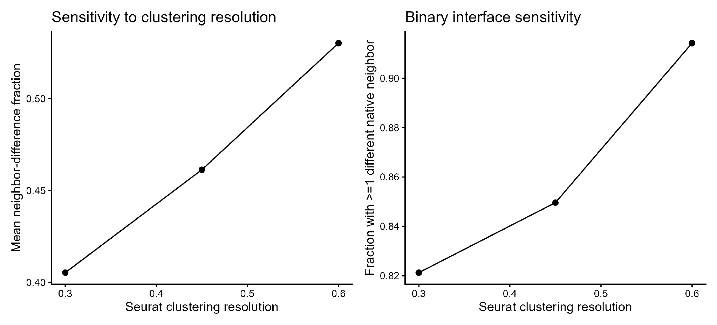
Supplementary Figure S15. Sensitivity of native-adjacency local-coherence measures to Seurat clustering resolution. The analysis was repeated at resolutions 0.30, 0.45, and 0.60, yielding 4, 5, and 7 clusters, respectively. The left panel shows the mean neighbor-difference fraction; the right panel shows the fraction of spots with at least one differently labeled native neighbor.
Biological Interpretation. Both local-mixing summaries increased with cluster resolution, from 0.4053 to 0.5302 for the mean neighbor-difference fraction and from 82.12% to 91.42% for the ≥1-different-neighbor interface fraction. This sensitivity confirms that boundary abundance is partly determined by cluster granularity; therefore, the continuous neighbor-difference fraction and the multi-resolution results should be considered together.

17. Two-dimensional spatial-gradient modeling
Generalized additive models were fitted for selected genes and module scores using tissue x and y coordinates as smooth predictors. Deviance explained summarizes how much variation in each feature was associated with broad spatial position. It does not establish a directional biological gradient or causal relationship.
Supplementary Table S13. Spatial organization of selected lacrimal gland genes and module scores measured by two-dimensional GAMs.
Feature | Deviance explained | Adjusted R²
Cd74 | 49.73% | 0.4747
antigen_presentation_score1 | 47.42% | 0.4508
Scgb2b17 | 39.56% | 0.3724
H2-Eb1 | 39.49% | 0.3697
H2-Aa | 33.76% | 0.3112
b_cell_plasma_cell_score1 | 30.30% | 0.2767
Jchain | 29.57% | 0.2705
Cd79a | 25.02% | 0.2213
interferon_chemokine_score1 | 24.16% | 0.2122
myeloid_stromal_score1 | 21.54% | 0.1945
Ltf | 19.97% | 0.1770
Stat1 | 19.38% | 0.1659
epithelial_secretory_score1 | 19.21% | 0.1673
t_cell_score1 | 18.51% | 0.1577
Gsn | 14.68% | 0.1344
Isg15 | 13.75% | 0.1163
Ldha | 9.38% | 0.0749
Cxcl9 | 6.62% | 0.0517
oxidative_stress_score1 | 6.24% | 0.0519
metabolism_core_score1 | 3.01% | 0.0222
Cxcl10 | 0.83% | 0.0050
Sod2 | 0.67% | 0.0054
lipid_metabolism_score1 | 0.53% | 0.0040
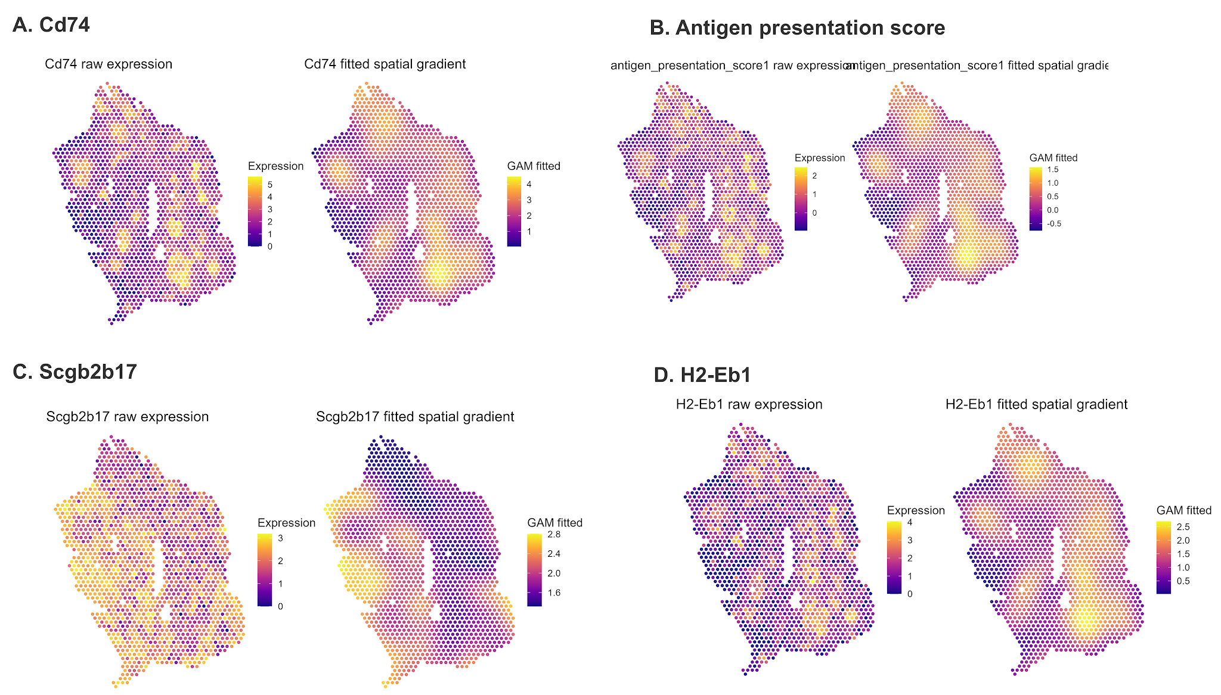
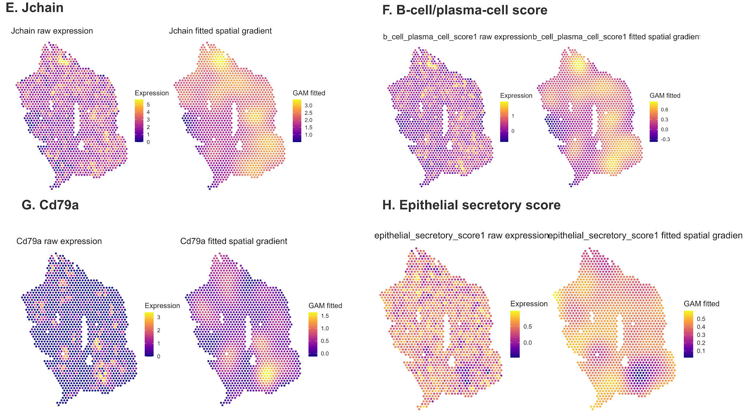
Supplementary Figure S16. Observed and fitted spatial patterns for selected lacrimal gland genes and module scores. (A) Cd74. (B) Antigen-presentation score. (C) Scgb2b17. (D) H2-Eb1. (E) Jchain. (F) B-cell/plasma-cell score. (G) Cd79a. (H) Epithelial-secretory score.
Biological Interpretation. Antigen-presentation features showed the strongest broad spatial organization, followed by secretoglobin and humoral features. Cd74 explained 49.73% of deviance, the antigen-presentation score explained 47.42%, Scgb2b17 explained 39.56%, and H2-Eb1 explained 39.49%. In contrast, core metabolism, oxidative stress, and lipid metabolism were explained only 3.01%, 6.24%, and 0.53%, respectively. The dominant gland-wide axis is therefore immune-secretory rather than broadly metabolic.

19. Lacrimal gland case-study conclusion and limitations
The final analysis supports a spatial mosaic of three related epithelial-secretory states, an antigen-presentation and lymphoid-activation state, and a plasma-cell/humoral-complement state. Marker genes, GO enrichment, module scores, spatially variable genes, neighborhood mixing, spatial GAMs, and latent-topic analysis converge on the same core organization.
- The dataset contains one inflamed section, so the results are exploratory and cannot establish a condition-level effect.
- A Visium spot can contain multiple neighboring cells. Cluster labels and STdeconvolve topics therefore describe mixed transcriptional territories rather than pure cell types.
- Neighborhood statistics remain dependent on clustering resolution. In this section, graph-construction sensitivity was minimal because native-array and 1.25× distance-limited adjacency produced identical edges and local-mixing values.
- GAM deviance explains quantifies broad spatial structure but does not identify causal signaling relationships.
- Curated module panels are intentionally limited and do not cover most spatially variable genes.
- Functional enrichment was interpreted only when it was concordant with current marker and spatial output.

Integrated interpretation across the two case studies
Together, these analyses illustrate how a common computational framework can answer different biological questions in distinct tissue systems. In the Arabidopsis seedling, the dominant signal is anatomical compartmentalization across a whole-organism developmental axis. The analysis resolves photosynthetic, germination, root, hypocotyl, meristematic, and SAM domains and connects them to expected metabolic and developmental pathways. In the inflamed lacrimal gland, the dominant signal is local intermixing. Secretory epithelial, antigen-presentation, lymphoid, plasma-cell, and complement programs form a highly connected mosaic.
The case studies also demonstrate why multiple spatial analyses are necessary. UMAP and clustering identify discrete states; spatial feature plots verify their tissue localization; Moran’s I detect label-independent spatial genes; pathway analysis summarizes coordinated biology; neighborhood statistics quantify local mixing; GAMs test continuous spatial organization; and reference-free topic modeling evaluates whether the same programs recur without fixed cluster boundaries.
General conclusion. Spatial transcriptomics is most informative when categorical domains, continuous spatial structure, local neighborhood relationships, and pathway-level biology are interpreted together. No single plot or statistical test is sufficient on its own.

References
10x Genomics. (2025, October 13). Visium HD 3′ gene expression library, Arabidopsis thaliana (fresh frozen) [Data set].
10x Genomics. (2026). Space Ranger spatial outputs [Software documentation]. 10x Genomics Support. Accessed September 11, 2026.
Conrady, C. D., Joos, Z. P., & Patel, B. C. K. (2016). Review: The lacrimal gland and its role in dry eye. Journal of Ophthalmology, 2016, Article 7542929. doi:10.1155/2016/7542929
Craig, J. P., Nichols, K. K., Akpek, E. K., Caffery, B., Dua, H. S., Joo, C.-K., Liu, Z., Nelson, J. D., Nichols, J. J., Tsubota, K., & Stapleton, F. (2017). TFOS DEWS II definition and classification report. The Ocular Surface, 15(3), 276–283. doi:10.1016/j.jtos.2017.05.008
Hafemeister, C., & Satija, R. (2019). Normalization and variance stabilization of single-cell RNA-seq data using regularized negative binomial regression. Genome Biology, 20, Article 296. doi:10.1186/s13059-019-1874-1
Klepikova, A. V., Kasianov, A. S., Gerasimov, E. S., Logacheva, M. D., & Penin, A. A. (2016). A high resolution map of the Arabidopsis thaliana developmental transcriptome based on RNA-seq profiling. The Plant Journal, 88(6), 1058–1070. doi:10.1111/tpj.13312
Miller, B. F., Huang, F., Atta, L., Sahoo, A., & Fan, J. (2022). Reference-free cell type deconvolution of multi-cellular pixel-resolution spatially resolved transcriptomics data. Nature Communications, 13, Article 2339. doi:10.1038/s41467-022-30033-z
Moran, P. A. P. (1950). Notes on continuous stochastic phenomena. Biometrika, 37(1–2), 17–23. doi:10.1093/biomet/37.1-2.17
Ospina, O.E., Soupir, A.C., Manjarres-Betancur, R. et al. Differential gene expression analysis of spatial transcriptomic experiments using spatial mixed models. Sci Rep 14, 10967 (2024). https://doi.org/10.1038/s41598-024-61758-0
Satija Lab. (2026, May 27). Analysis, visualization, and integration of Visium HD spatial datasets with Seurat [Documentation]. Seurat.
Stuart, T., Butler, A., Hoffman, P., Hafemeister, C., Papalexi, E., Mauck, W. M., III, Hao, Y., Stoeckius, M., Smibert, P., & Satija, R. (2019). Comprehensive integration of single-cell data. Cell, 177(7), 1888–1902.e21. doi:10.1016/j.cell.2019.05.031
Subramanian, A., Tamayo, P., Mootha, V. K., Mukherjee, S., Ebert, B. L., Gillette, M. A., Paulovich, A., Pomeroy, S. L., Golub, T. R., Lander, E. S., & Mesirov, J. P. (2005). Gene set enrichment analysis: A knowledge-based approach for interpreting genome-wide expression profiles. Proceedings of the National Academy of Sciences of the United States of America, 102(43), 15545–15550. doi:10.1073/pnas.0506580102
Squair, J.W., Gautier, M., Kathe, C. et al. Confronting false discoveries in single-cell differential expression. Nat Commun 12, 5692 (2021). https://doi.org/10.1038/s41467-021-25960-2
The Arabidopsis Information Resource. (n.d.). TAIR: The Arabidopsis Information Resource [Database]. Retrieved July 12, 2026.
Wood, S. N. (2017). Generalized additive models: An introduction with R (2nd ed.). Chapman & Hall/CRC. doi:10.1201/9781315370279
Wu, T., Hu, E., Xu, S., Chen, M., Guo, P., Dai, Z., Feng, T., Zhou, L., Tang, W., Zhan, L., Fu, X., Liu, S., Bo, X., & Yu, G. (2021). clusterProfiler 4.0: A universal enrichment tool for interpreting omics data. The Innovation, 2(3), Article 100141. doi:10.1016/j.xinn.2021.100141
Yu, G., Wang, L.-G., Han, Y., & He, Q.-Y. (2012). clusterProfiler: An R package for comparing biological themes among gene clusters. OMICS: A Journal of Integrative Biology, 16(5), 284–287. doi:10.1089/omi.2011.0118

