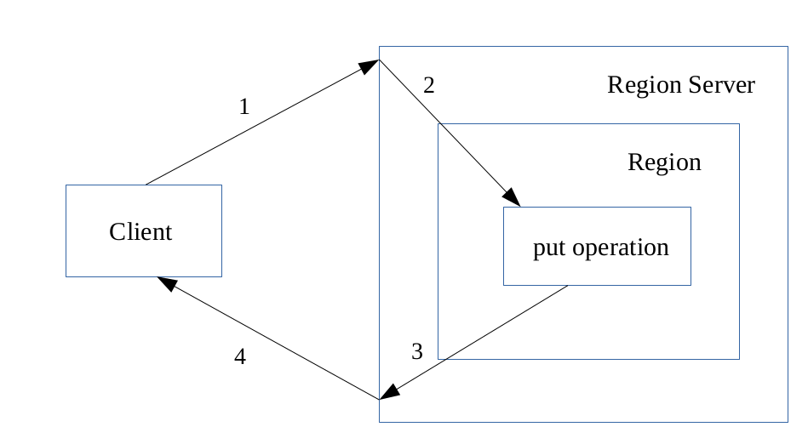

Fig(a): Life cycle of put request

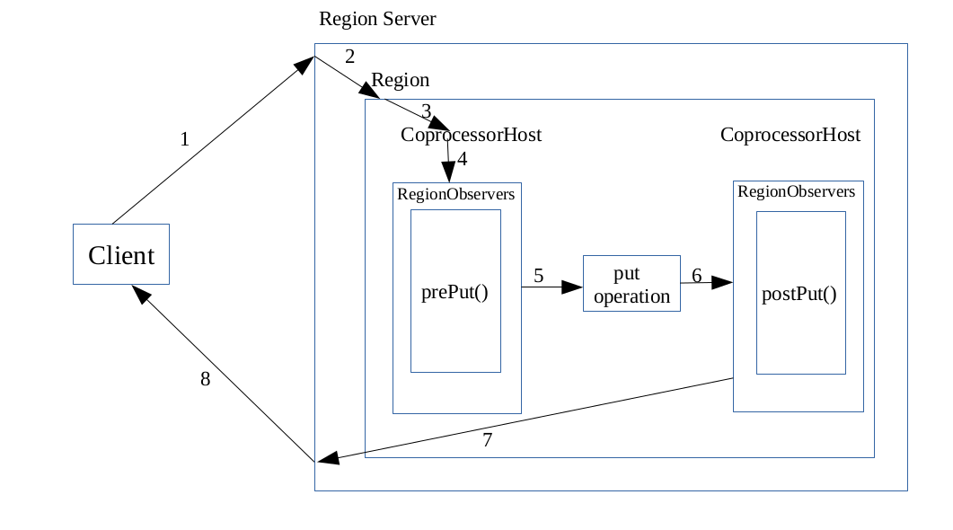
Fig(b): Life cycle of put request with observer coprocessor

