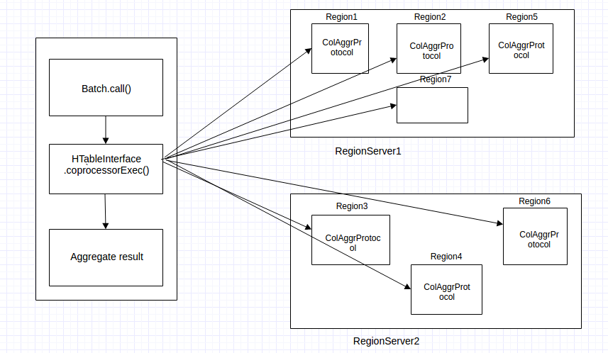
Figure: EndPoint Coprocessor

