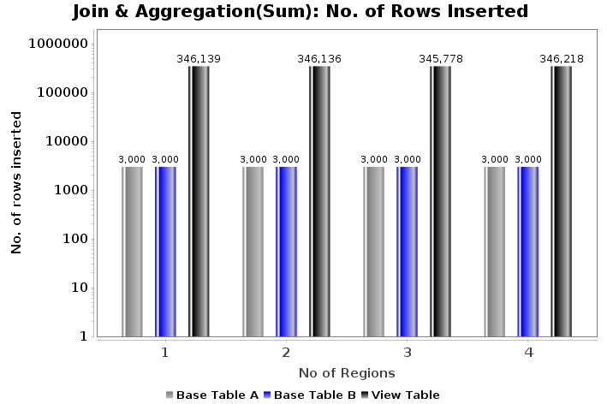
Fig(a): Rows Inserted k-fk join

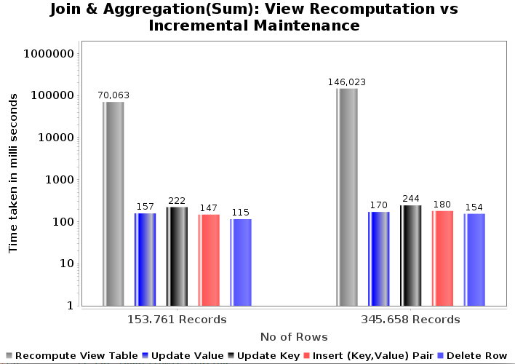

Fig(b): View Recomputaion vs Maintenance

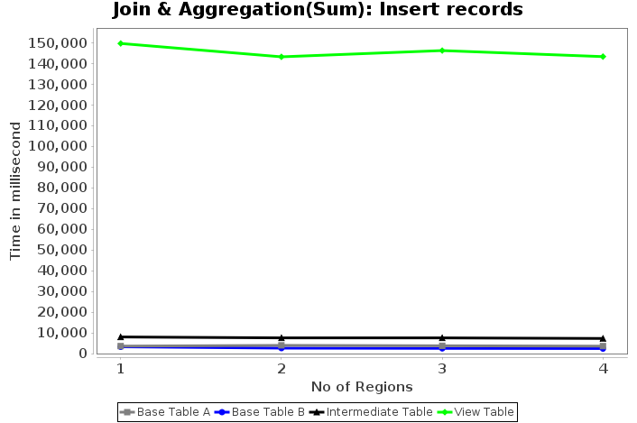
Fig(c): Insert Records

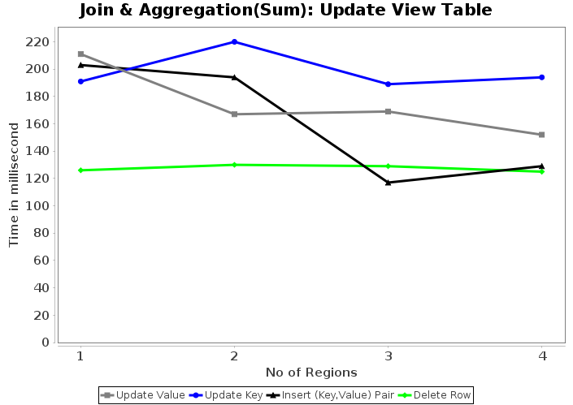
Fig(d): Update View Table

