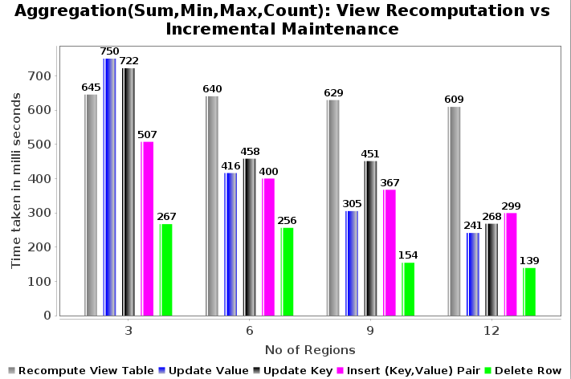
Fig(a): View Re-computation vs Maintenance

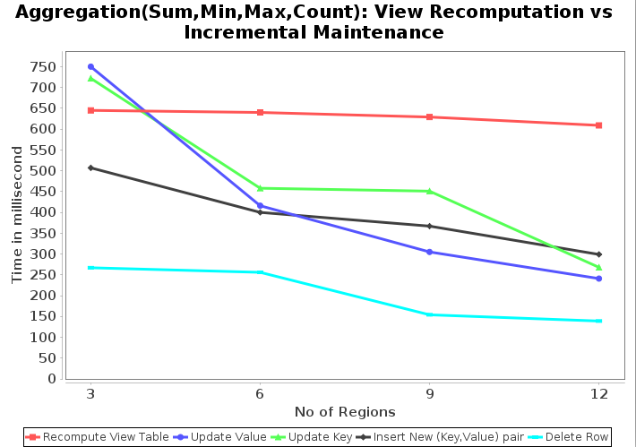

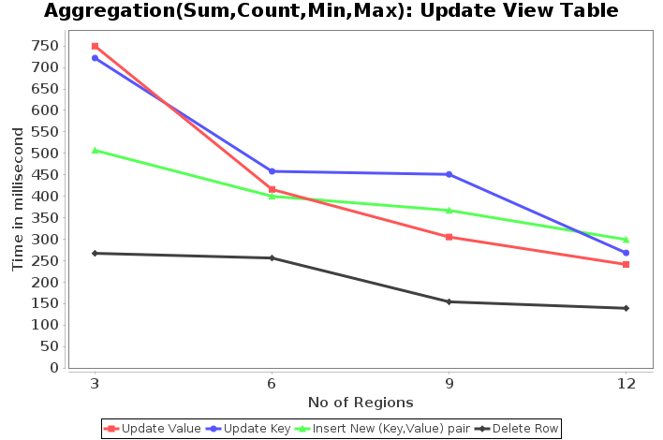

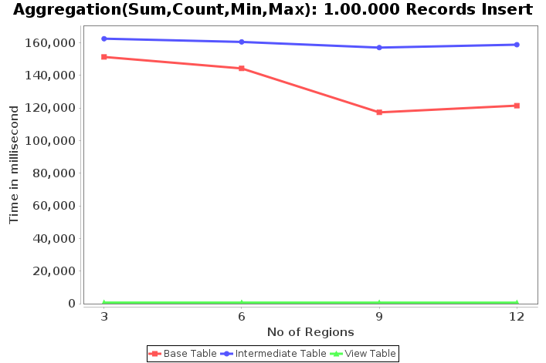
Fig(c): Insert 1.00.000 records

Fig(b): Re-computation vs Maintenance: Line Chart
Fig(d): Update view tables incrementally

