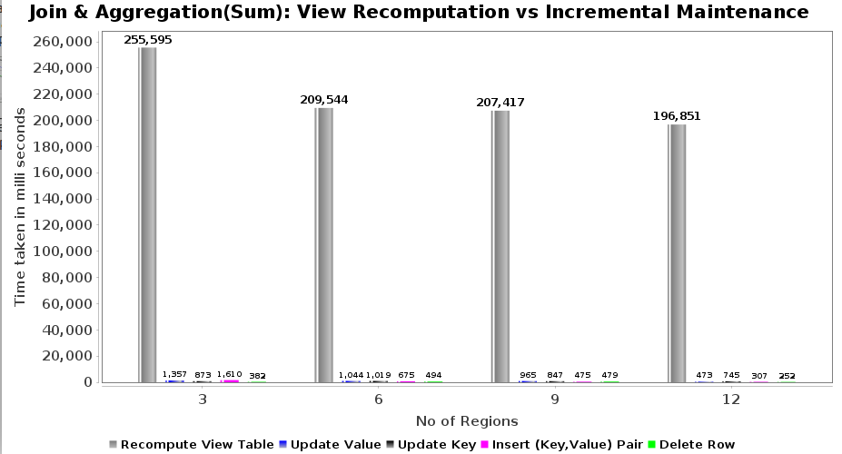

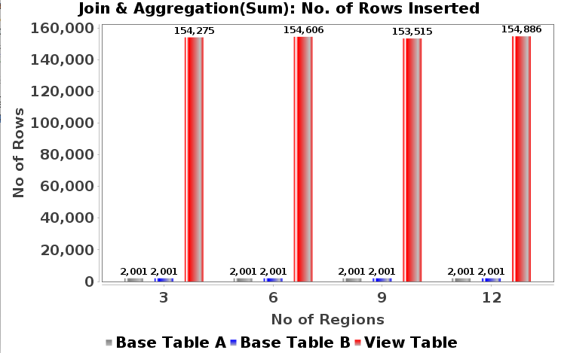
Fig(b): No of rows inserted (k-fk join)
Fig(c): Insert records (k-fk join) Line chart
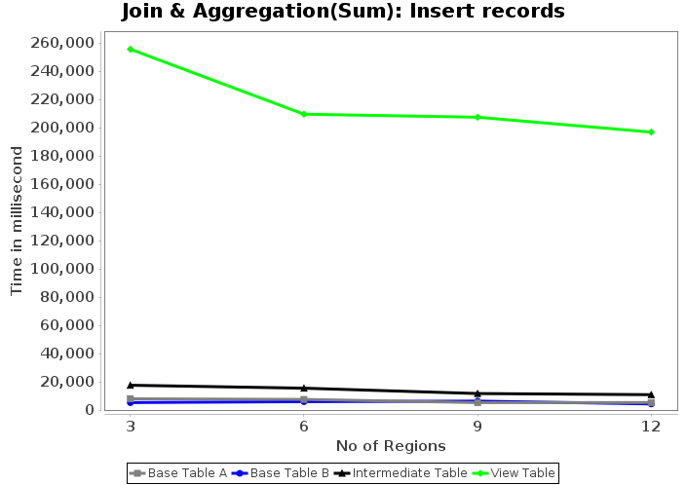
Fig(a): View Re-computation vs Incremental Maintenance
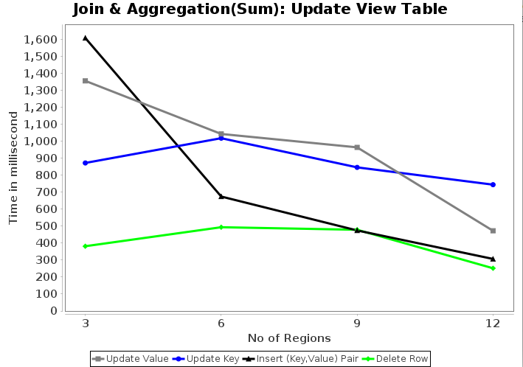
Fig(d): Update View Table

