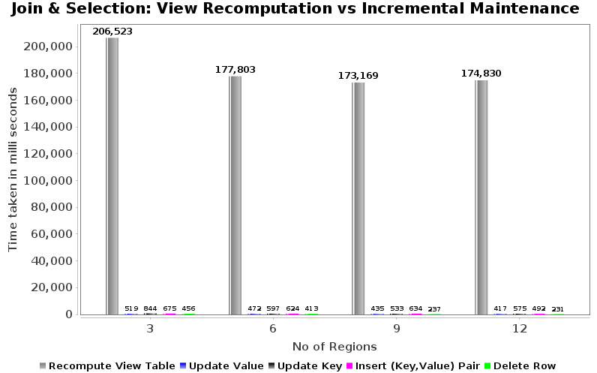
Fig(a): View Re-computation vs Incremental Maintenance
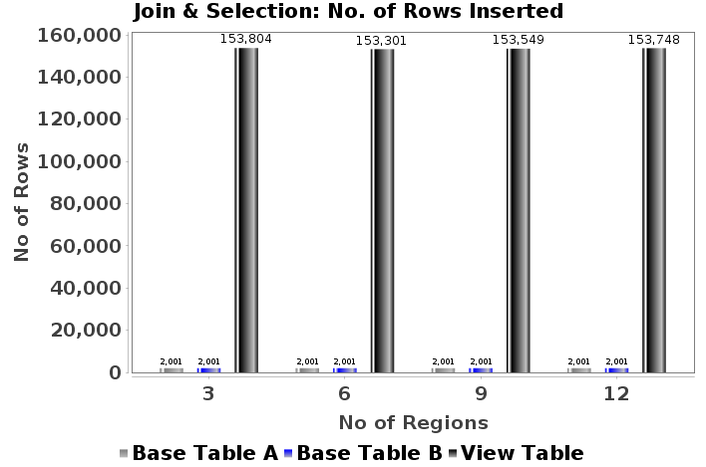

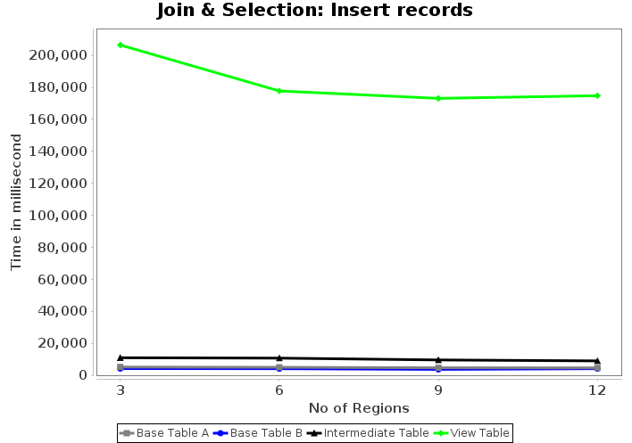
Fig(c): Insert Records (k-fk join) Line Chart

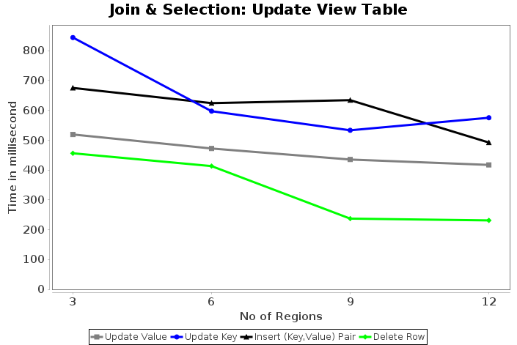
Fig(b): No of Rows Inserted (k-fk join)
Fig(d): Update View Tables

