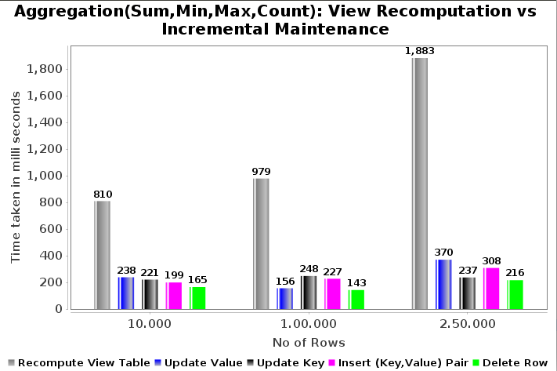

Fig(a): Recomputation vs Incremental Maintenance

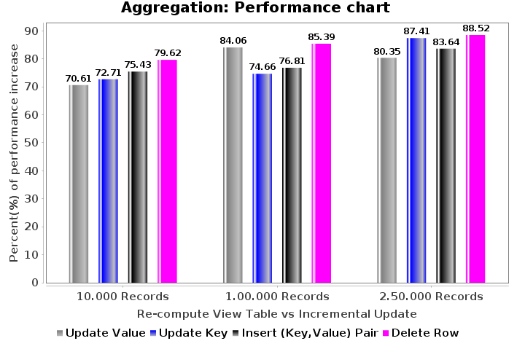

Fig(b): Aggregation Performance Chart

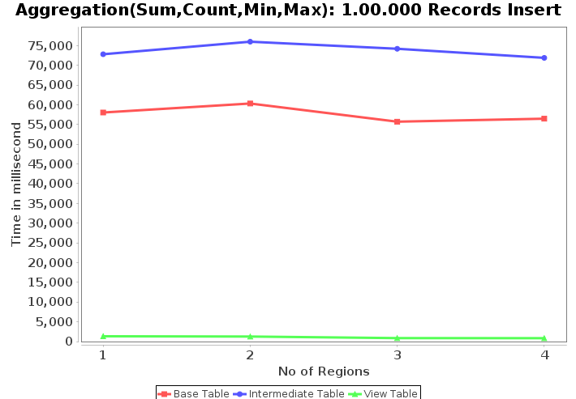
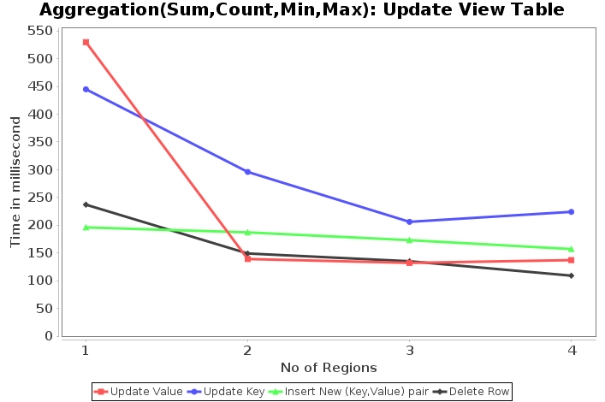
Fig(c): Insert records

Fig(d): Update View Table

