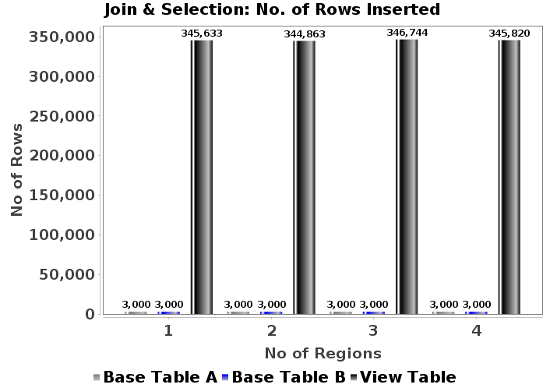
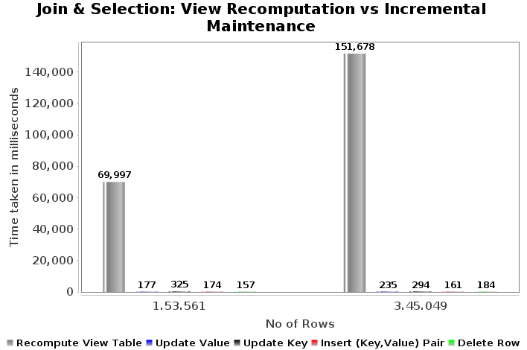
Fig(a): Rows Inserted using k-fk joins

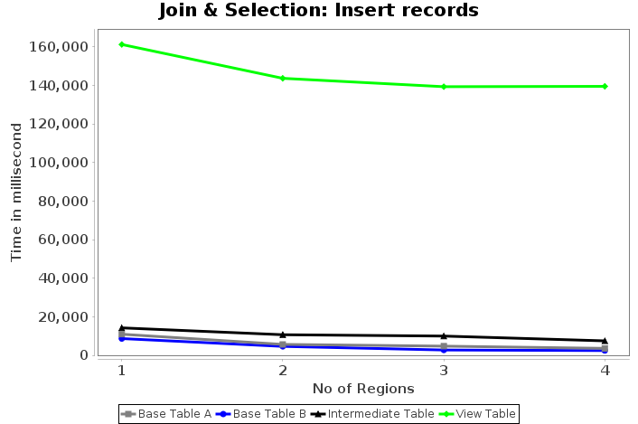

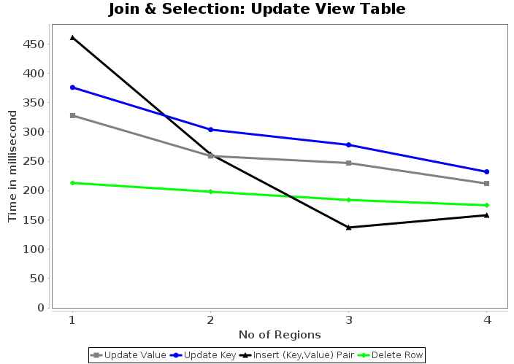

Fig(b): View Re-computation vs Maintenance
Fig(c): Insert records
Fig(d): Update View Tables

