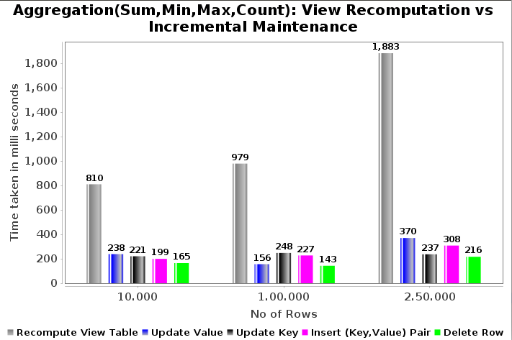
Fig(a): Recomputation vs Incremental Maintenance

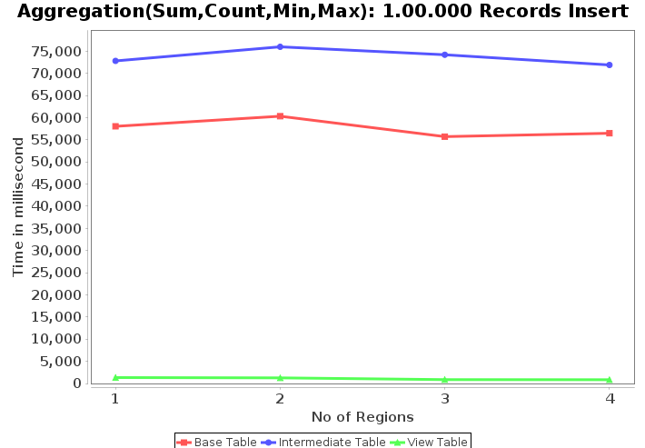

Fig(b): Insert records
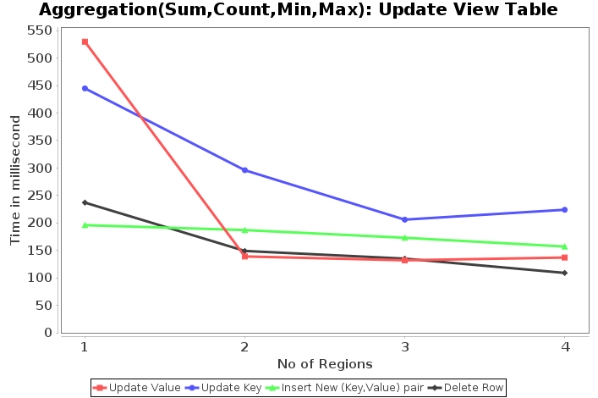

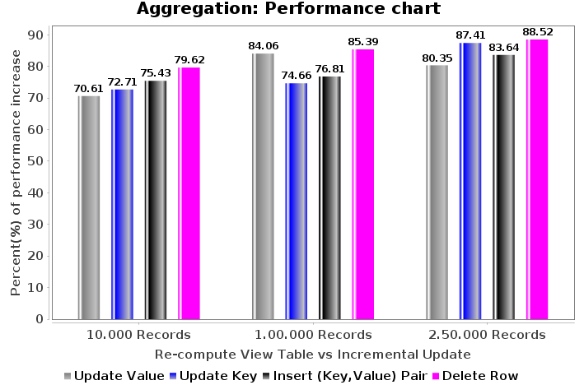
Fig(d): Aggregation Performance Chart

Fig(c): Update View Table

