Employee User Guide & Demo Document
Leave & Staff Movement System

1. Dashboard Overview
When you log in, you will land on your personal Dashboard. It serves as your command center and contains:
- Leave Balance Card: Displays your total remaining leave days (e.g., Annual Leave, Sick Leave) for the current fiscal year.
- Monthly Calendar: A visual calendar displaying your scheduled leaves, public holidays, and attendance request statuses.
- Quick Action Buttons: Directly apply for a leave, attendance correction, or log a staff movement.

2. Managing Your Leaves

Applying for a Leave
- Click Apply Leave in the sidebar or dashboard.
- Select the Leave Type (e.g., Annual Leave, Casual Leave).
- Select the Start Date and End Date (AD dates, which automatically show their Nepalese Calendar BS equivalent).
- Input your Reason and submit.

Cancelling a Leave
- If a leave request is still Pending, you can cancel it at any time from the My Leaves tab.
- If a leave request has been Approved, you can still cancel it as long as the start date has not passed. Once cancelled, your leave balance is automatically refunded.

Exporting to PDF
For approved leaves, click the Export PDF button next to the request. This downloads a formal, print-ready PDF form which you can print for physical signing and filing.

3. Attendance Corrections & Holiday Work
Sometimes you might forget to log in/out, or need to work on a public holiday/weekend. You can request corrections for these days:
- Attendance Correction: Use this to request a correction for a past date when your attendance was missed or incorrect.
- Holiday Work Request: If you are scheduled to work on an official holiday, submit this request to document it.
[NOTE] Once your manager approves an Attendance or Holiday Work request, you can download a printable single-page request PDF form matching physical company documentation for physical signing.

4. Staff Movements (Field & Client Visits)
The Staff Movement tab allows you to log client visits, AMCs, document deliveries, or goods pickups.
Staff Movement Life Cycle Flowchart:
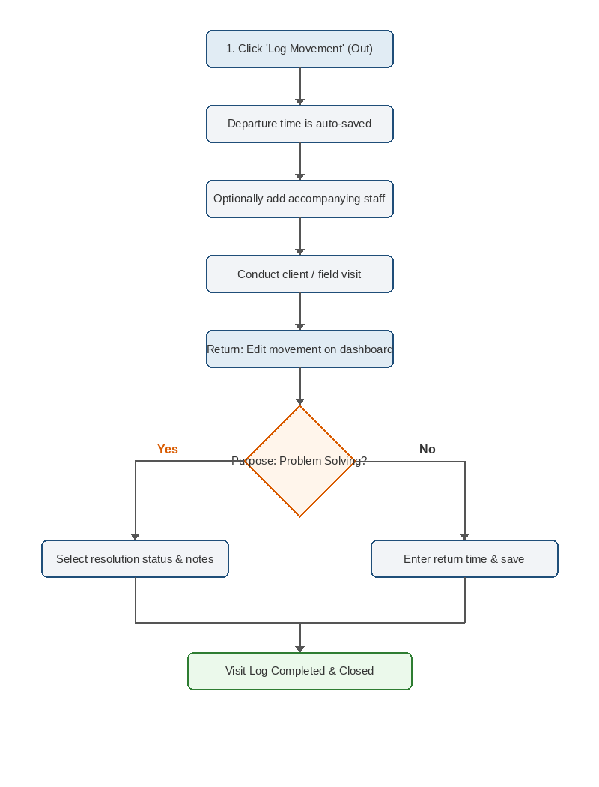

Step 1: Logging Your Departure (Heading Out)
- Go to the Staff Movement page.
- Select the Date (defaults to today).
- Specify the Client / Location (e.g. ABC Tech Office).
- Select the Purpose (e.g. Problem solving, AMC, Goods pickup).
- If accompanying other team members, select them under Assist(s).
- Click Log Movement. Your departure time (out_time) is automatically captured using the server clock.

Step 2: Logging Your Return (Back in Office)
- When you return, click Edit next to your active movement record.
- Enter your Return Time (must be later than your departure time and cannot be in the future).
- For Problem Solving Visits: You must specify the Resolution Status (Solved or Not Solved) and enter a brief description of the outcome.
- If you logged assistants:
- You can check Still out for assistants who haven't returned yet, allowing you to log your return independently.
- You can input separate return times for assistants if they returned at different times.
- Click Update to close the movement log.

5. System Rules & Safety Guards
[SAME-DAY CORRECTION WINDOW] You can only edit your own movement records (e.g. recording return times) on the same day the movement occurred. After midnight, the record is locked, and only a System Administrator or Manager can make corrections.

[NO OVERLAPPING MOVEMENTS] You cannot log a new movement if you (or any of your selected assistants) are currently marked as 'out' on another unresolved movement for that date. You must enter your return time for the previous trip before heading out on a new one.

