DEMO 200: Introduction to Circuit Analysis (fictional example)
Lecture 5 notes, January 15, 2026
Topics: series RC circuit, first-order differential equation, time constant, step response, discharging, RC vs RL comparison.
Sources
File | Range used | Role
example-deck.pdf | Slides 1 to 6 | Slide images, slide text, notation

How to use these notes
- Each page shows a slide on the left and the notes for that slide on the right, in the order things happened in class.
- When a slide's notes run long, the slide repeats on the next page marked (continued).
- Group work, videos, presentations and discussions have their own headed blocks where they happened.
- Each topic ends with a Topic wrap-up beside its last slide: how to recognize the problem, numbered steps, a check, and a worked example.
- Ink: red marks the professor's emphasis (the boxed equation on slide 2); green on slide 3 is part of the slide.
- Examples are the professor's own unless marked constructed.
- Amber boxes = flagged as important (exam, homework, repeated or stressed).
- BOLD RED CAPITALS = something that could not be made out or confirmed, or where what was said differed from the slide, ending with the AI notetaker's best guess where one applies. All of them are also listed under Open questions at the end.
- The contents page fills in when the file is opened in Word; if it looks blank, press Ctrl+A then F9.

Contents
Press Ctrl+A then F9 to fill in the contents.

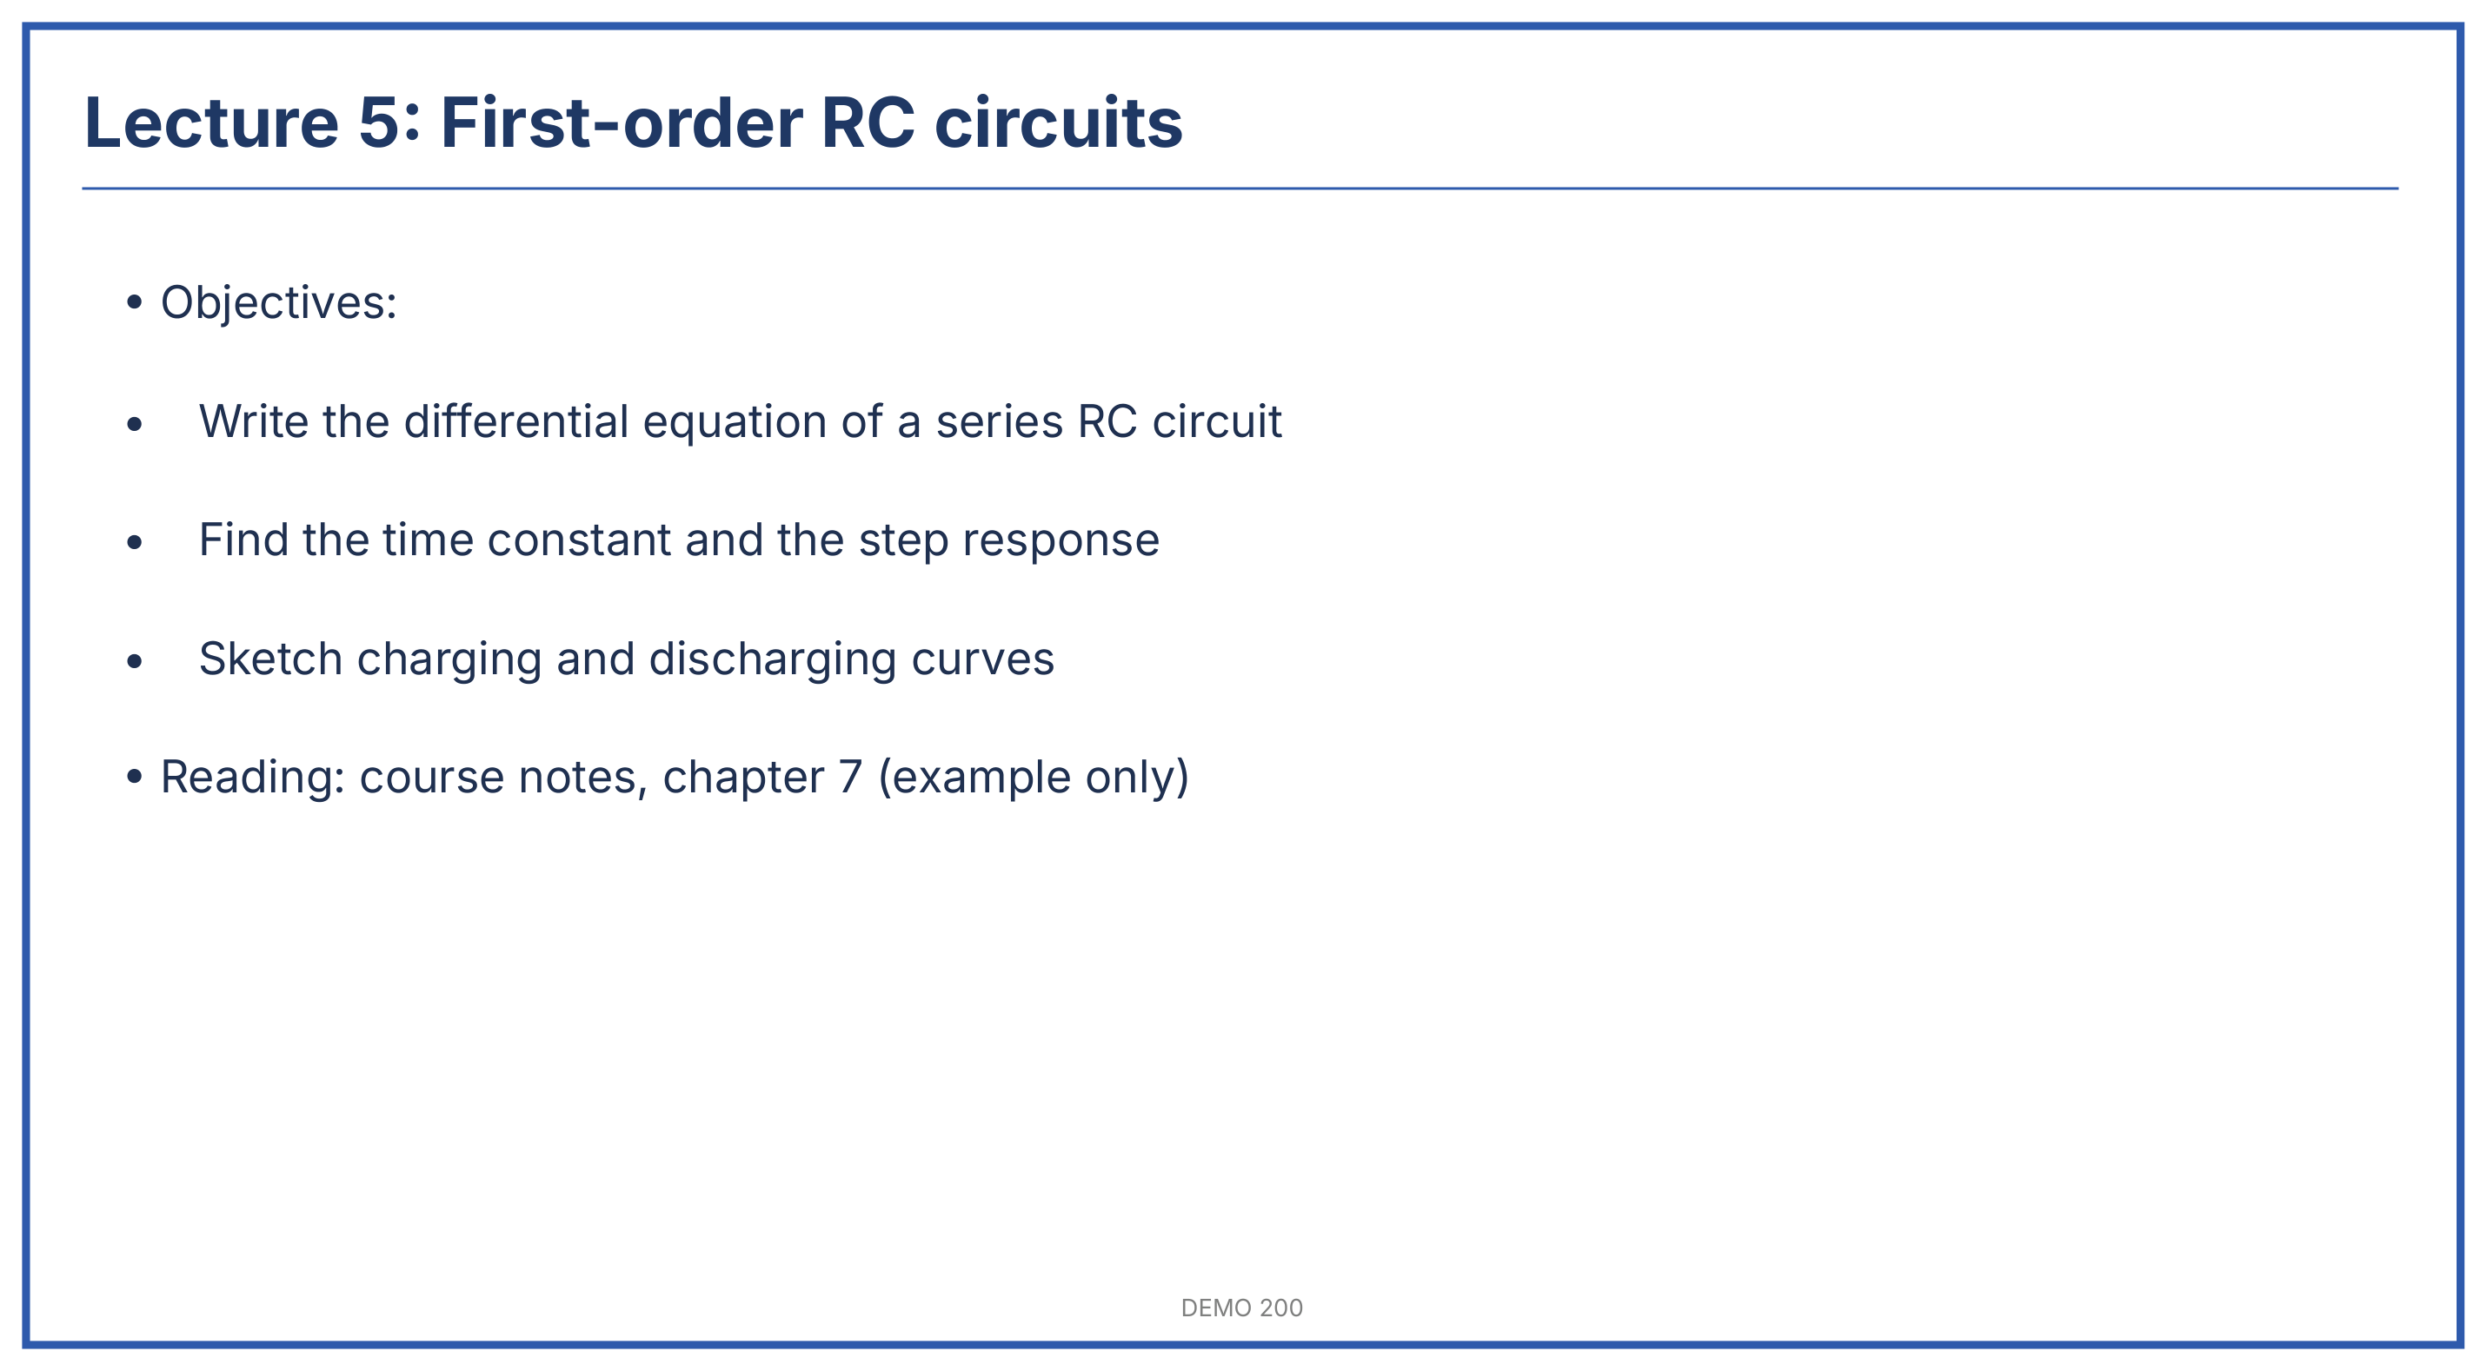  Slide 1 of 6 | Slide 1: First-order RC circuits  What it is: Start of the unit on circuits with one energy-storage element. Today: the series RC circuit.  Announcements  - Assignment 3 is due next Friday. It covers today's material.  - Office hours move to Thursday this week.  - Objectives read from the slide: write the circuit's differential equation, find the time constant and step response, sketch charging and discharging.  - The professor said the whole unit builds on one equation, so it is worth getting comfortable with it today.  - Reading on the slide is reference only; it was not discussed.

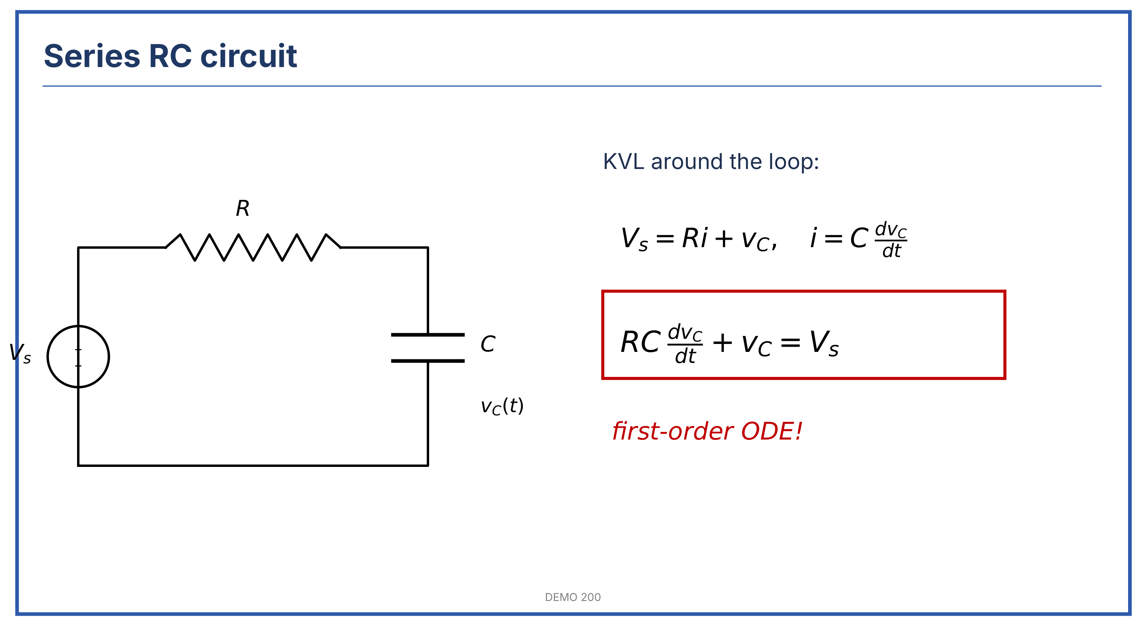  Slide 2 of 6 | Slide 2: Series RC circuit  What it is: A source, a resistor and a capacitor in one loop. Applying KVL gives a first-order differential equation.  - Walk around the loop with KVL: the source voltage equals the resistor drop plus the capacitor voltage.  $$V_{s}=Ri+v_{C}$$  - The capacitor current depends on how fast its voltage changes:  $$i=C\frac{dv_{C}}{dt}$$  $V_{s}$ = source voltage (V); $R$ = resistance (Ω); $C$ = capacitance (F); $v_{C}$ = capacitor voltage (V); $i$ = loop current (A)  - Substitute $i$ into the KVL equation:  $$RC\frac{dv_{C}}{dt}+v_{C}=V_{s}$$

Slide 2 of 6 (continued) | Slide 2 (continued)  - The professor boxed this in red and called it "the equation for the whole unit". It is first order because only the first derivative appears.  ⚠ WILL BE ON EXAM: Deriving the RC differential equation from KVL. Professor: "You will write this on the midterm, guaranteed." Boxed in red on the slide.  - Class question: why not just use Ohm's law on the capacitor? Answer given: a capacitor has no resistance value; its current depends on the rate of change of voltage, not the voltage itself.  Watch out. Keep the passive sign convention: current entering the + terminal of the capacitor. A flipped sign gives a growing exponential, which is not physical.

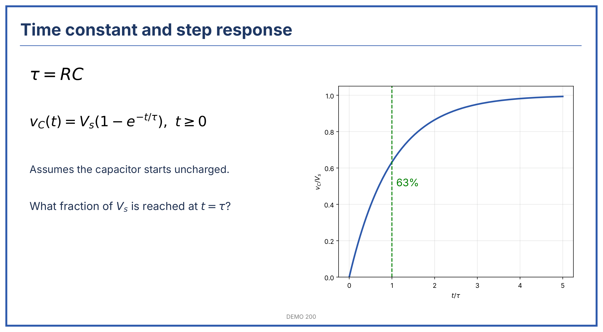  Slide 3 of 6 | Slide 3: Time constant and step response  What it is: Solving the equation for a step input from an uncharged capacitor.  - Define the time constant $τ=RC$ (units: Ω·F = seconds).  $$v_{C}\left(t\right)=V_{s}\left(1−e^{−t/τ}\right), t≥0$$  - Valid only when the capacitor starts uncharged and the source switches on at $t=0$.  - The slide asks what fraction of $V_{s}$ is reached at $t=τ$. Answer given in class: $1−e^{−1}≈0.632$, so about 63%.  - The professor stressed reading the graph in units of $τ$, not seconds: the curve always has the same shape.  On the slide: The green dashed line marks $t=τ$; the curve is plotted against $t/τ$, so it fits any RC circuit.

Slide 3 of 6 (continued) | Slide 3 (continued)  ⚠ REPEATED 3 TIMES: 63% at one time constant. Said here, again when slide 3 came back, and in the end-of-class recap.  UNCLEAR IN LECTURE: ONE EXAMPLE VALUE FOR $R$ COULD NOT BE MADE OUT. AI NOTETAKER'S BEST GUESS: 10 kΩ, SINCE THE RESULT GIVEN WAS $τ=1$ ms WITH $C=100$ nF.

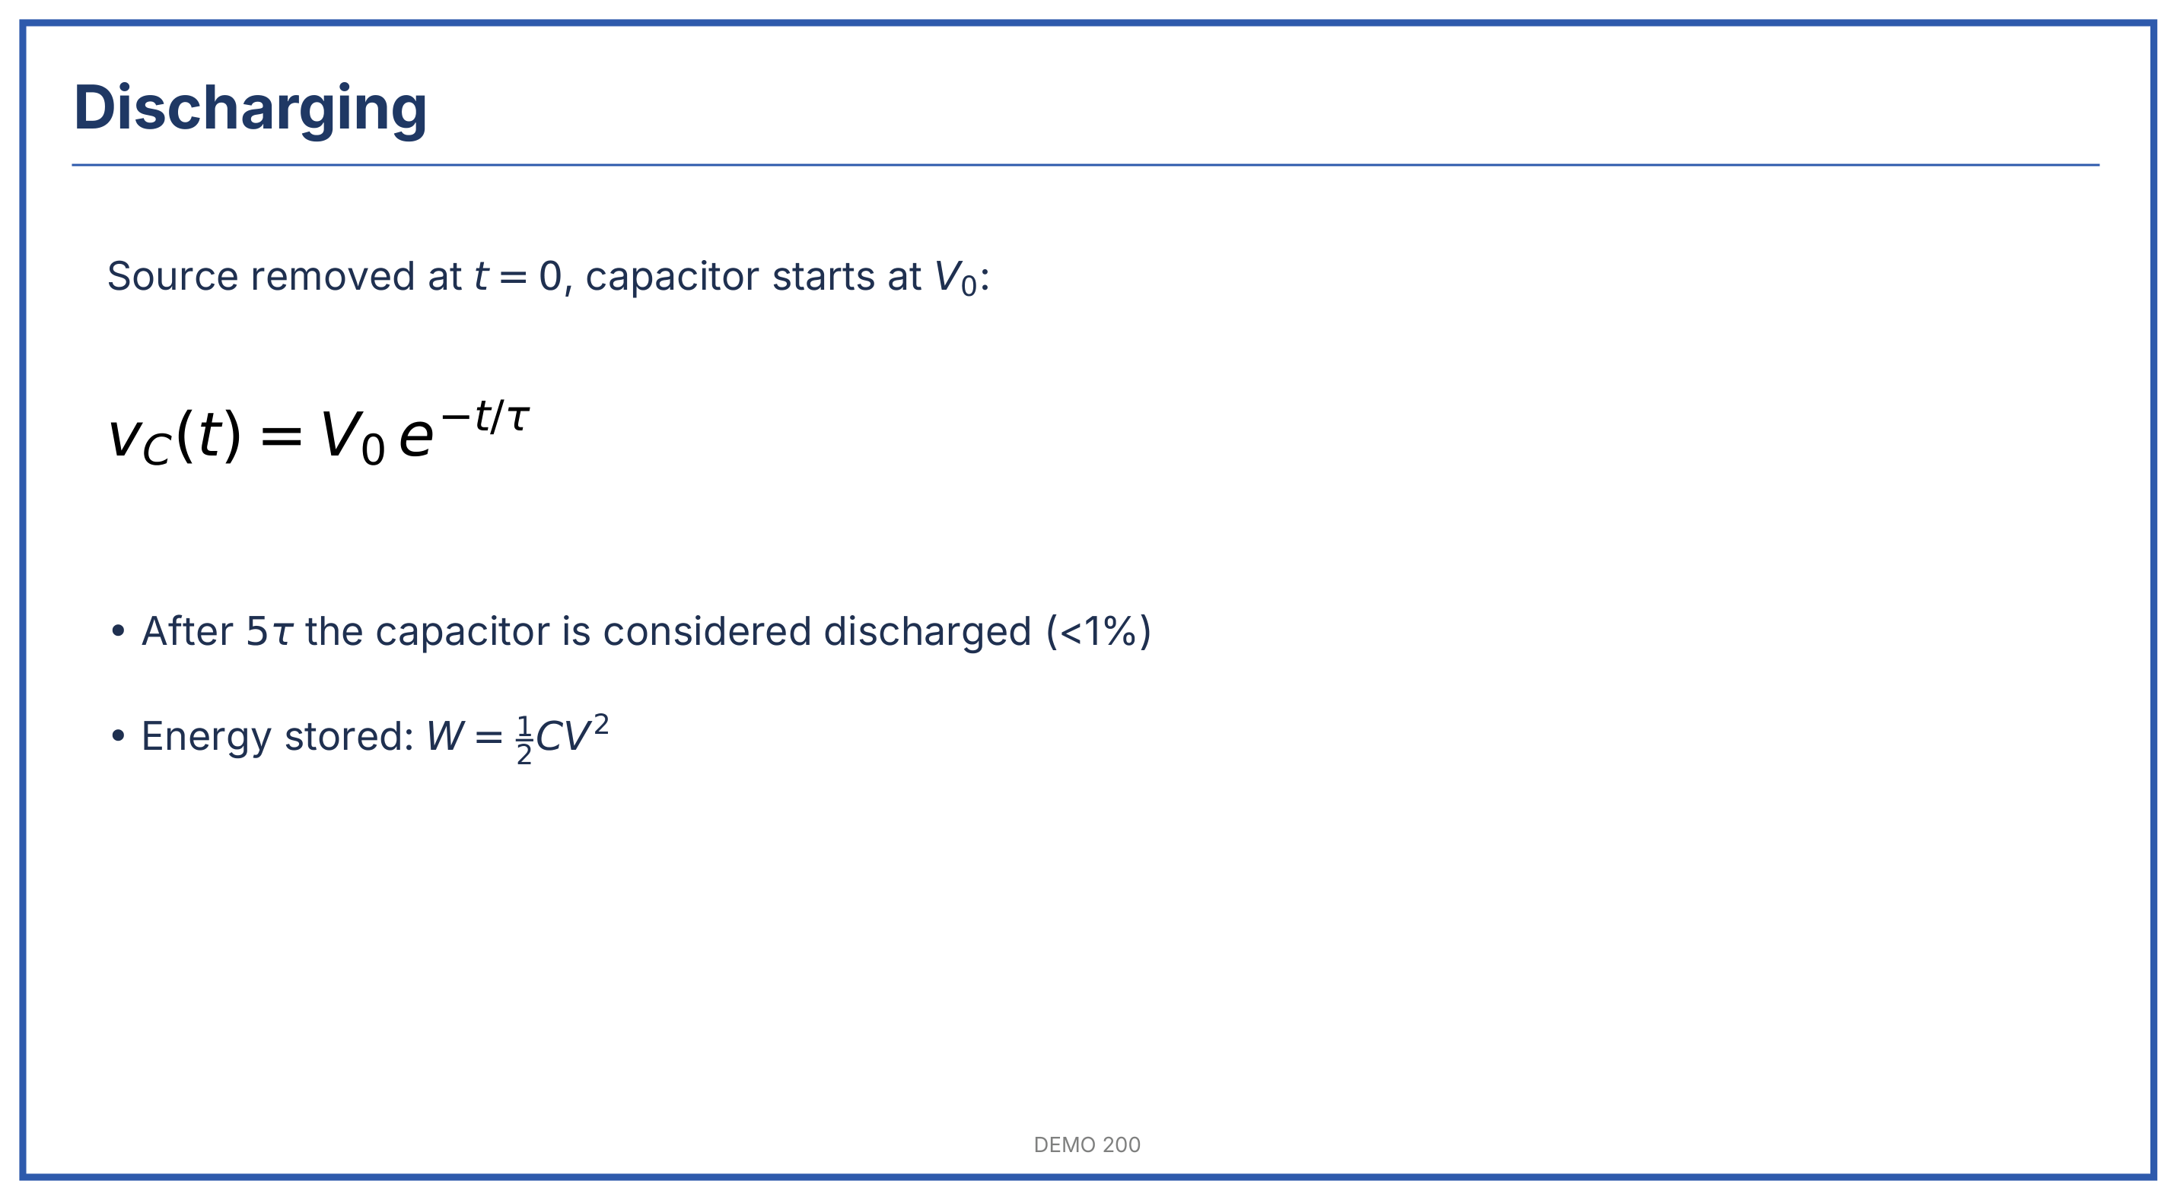  Slide 4 of 6 | Slide 4: Discharging  - With the source removed at $t=0$ and the capacitor starting at $V_{0}$, the voltage decays:  $$v_{C}\left(t\right)=V_{0}e^{−t/τ}$$  - Why $5τ$: the professor showed that $e^{−5}≈0.0067$, so less than 1% of the starting voltage is left. Engineers treat that as fully discharged. After $3τ$ about 5% is still left, which is not small enough.  - Energy stored in the capacitor: $W=\frac{1}{2}CV^{2}$ (joules). The professor called it "the same form as kinetic energy".  SLIDE AND LECTURE DISAGREE: "AFTER $4τ$" WAS SAID ONCE; THE SLIDE AND THE REST OF CLASS USE $5τ$. THESE NOTES FOLLOW THE SLIDE.

Slide 3 of 6 | Slide 3: Time constant and step response (back to it)  - The professor went back to slide 3 to compare charging and discharging side by side: charging rises to 63% in one $τ$; discharging falls to 37% in one $τ$.  - Both curves are "mirror images" with the same time constant.  Topic wrap-up: RC step response  Recognize it: "find $v_{C}\left(t\right)$", "how long until the capacitor is charged?", a switch closing on an RC circuit at $t=0$.  - Check the initial capacitor voltage (zero, or $V_{0}$).  - Find $τ=RC$ using the resistance seen by the capacitor.  - Write $v_{C}\left(t\right)=V_{final}+\left(V_{initial}−V_{final}\right)e^{−t/τ}$.  - Substitute the time asked for, or solve for $t$.

Slide 3 of 6 (continued) | Slide 3 (continued)  Check: $τ$ comes out in seconds; $v_{C}$ starts at the initial value and settles at the final value.  Example (constructed): $R=10$ kΩ, $C=100$ nF, $V_{s}=5$ V, uncharged: $τ=1$ ms, and at $t=2$ ms, $v_{C}=5\left(1−e^{−2}\right)≈4.32$ V.  Capacitor charged at t=0?  |  +-----+------+  no yes  | |  Charging: Source still  Vs(1-e^-t/T) connected?  no: V0 e^-t/T

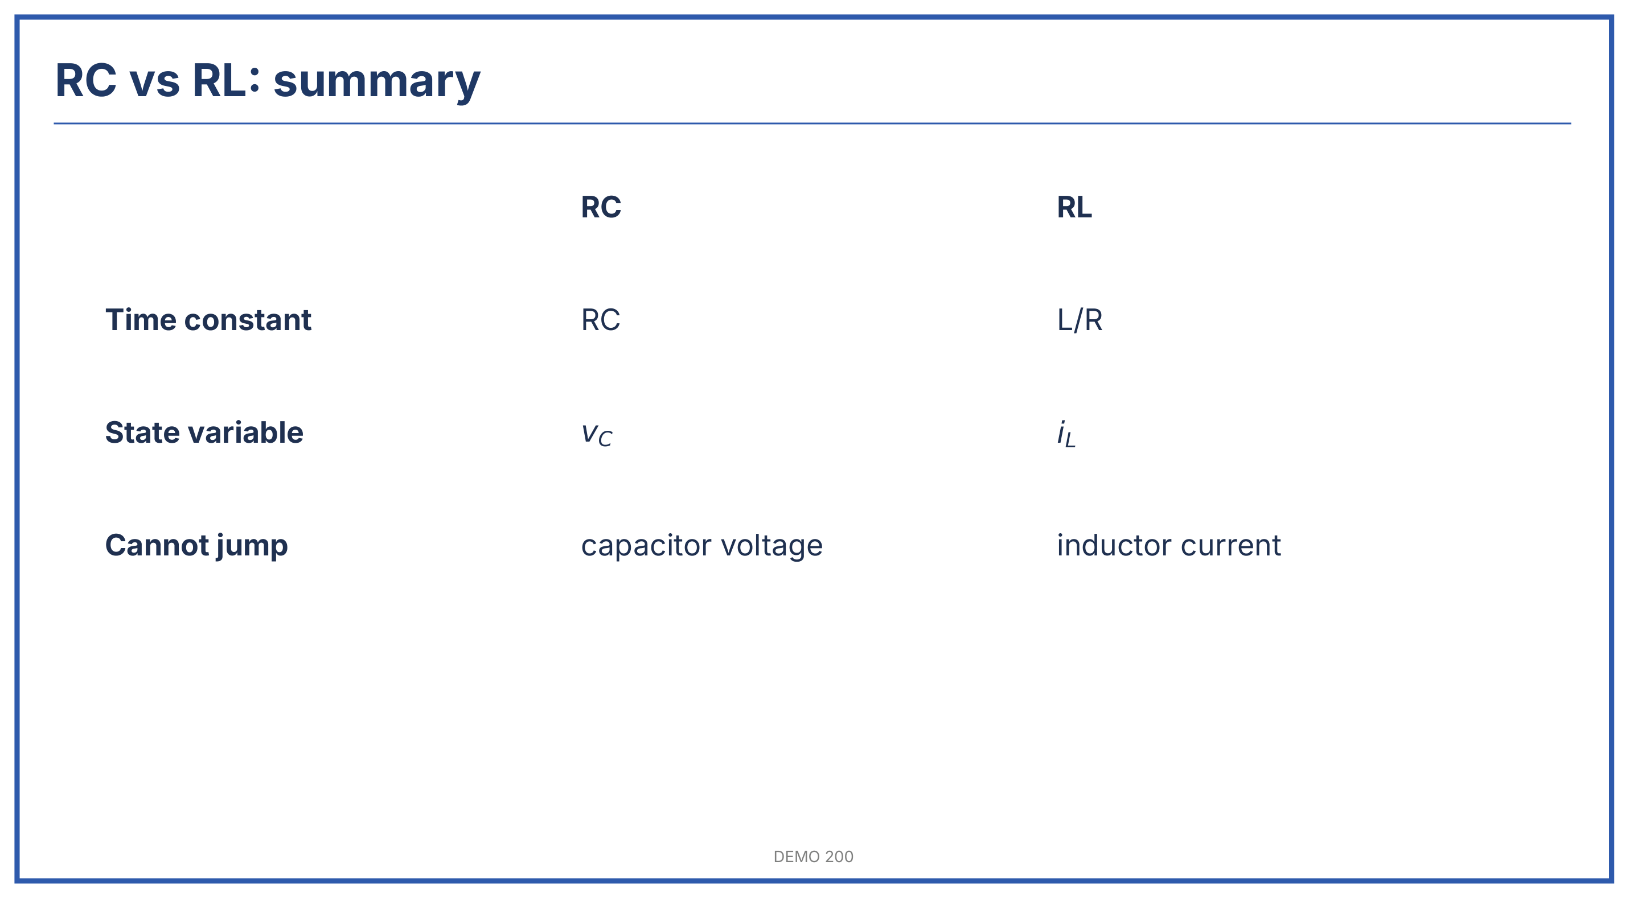  Slide 5 of 6 | Slide 5: RC vs RL summary  What it is: Side-by-side comparison of the two first-order circuits.  - Same equation shape for both; only the time constant and the state variable change.  - The quantity that cannot jump is the one that stores energy: capacitor voltage, inductor current.  - RL details come next class; the professor said only the time constant $L/R$ is needed today.

Slide 5 (continued)
Property | RC circuit | RL circuit | Why it matters
Time constant | $τ=RC$ | $τ=L/R$ | Sets the speed of the response
State variable | $v_{C}$ | $i_{L}$ | Continuous at the switching instant
Energy stored | $\frac{1}{2}CV^{2}$ | $\frac{1}{2}LI^{2}$ | Explains why it cannot jump
Long-time behaviour | Open circuit | Short circuit | Use for final values

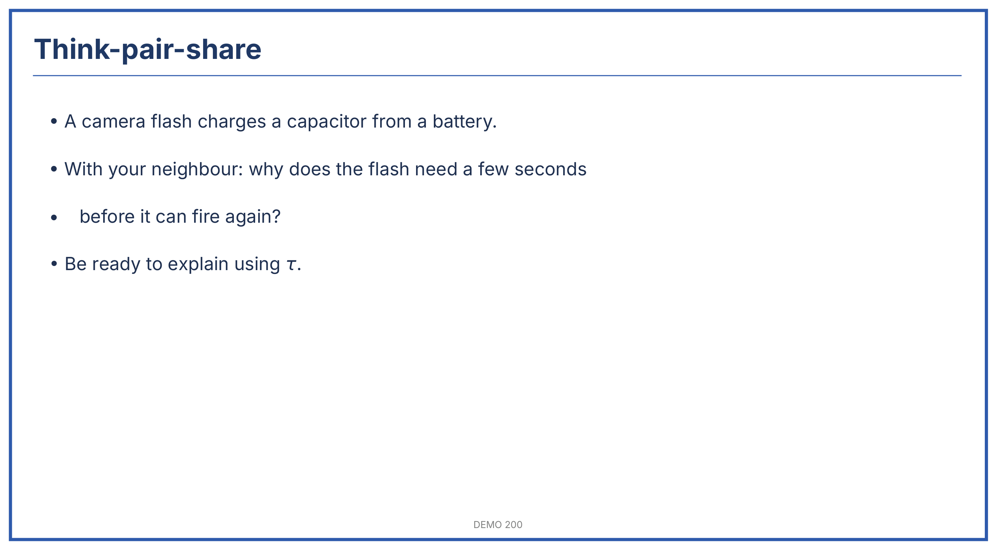  Slide 6 of 6 | Slide 6: Think-pair-share  Think-pair-share  Focus: Why a camera flash needs a few seconds between shots  - Small-group discussion: pairs pointed out that the flash capacitor charges through a resistance from a small battery, so the charging current is limited.  - Whole-class discussion: the class linked the wait to $τ$: the flash is ready after a few time constants. A large capacitor gives a bright flash but a long $τ$.  Kept coming back to: the trade-off between flash brightness (large $C$) and waiting time (large $RC$).

Video: Capacitor charging demo | Video shown in class  Video  Focus: Video: "Capacitor charging demo", an oscilloscope trace of an RC circuit  - The trace showed the charging curve rising quickly, then levelling off, matching slide 3.  - Changing $R$ on the bench stretched the curve in time without changing its shape.
  Video: Capacitor charging demo

Marked as important
Item | Why flagged | Slide
Derive $RC dv_{C}/dt+v_{C}=V_{s}$ from KVL | Professor: "on the midterm, guaranteed" + boxed in red on the slide (both sources) | Slide 2
63% of the final value at $t=τ$ | Repeated three times in class and marked on the slide's graph (both sources) | Slide 3

Cheat sheet, copy-ready
First-order RC circuit
Use when: "find $v_{C}\left(t\right)$", "time constant", a switch opens or closes on an RC circuit
$$RC\frac{dv_{C}}{dt}+v_{C}=V_{s}$$
$$τ=RC$$
$$v_{C}\left(t\right)=V_{f}+\left(V_{i}−V_{f}\right)e^{−t/τ}$$
Valid for $t≥0$ after one switching event; $V_{i}$ = value just before, $V_{f}$ = long-time value.
- At $t=τ$: 63% of the change done; at $5τ$: over 99%.
Solve: initial value, final value (capacitor = open circuit), $τ$ from the resistance seen by $C$, then substitute.
Trap: use the resistance seen by the capacitor, not the total circuit resistance.
RL comparison
Use when: an inductor instead of a capacitor, "current cannot change instantly"
$$τ=L/R$$
- State variable $i_{L}$; long-time inductor = short circuit.
Trap: $τ=L/R$, not $LR$.
Common traps (all topics)
- Capacitor voltage and inductor current cannot jump; the other quantities can.
- Read graphs in units of $τ$.

Open questions
SLIDE 3: UNCLEAR IN LECTURE: ONE EXAMPLE VALUE FOR $R$ COULD NOT BE MADE OUT. AI NOTETAKER'S BEST GUESS: 10 kΩ, SINCE THE RESULT GIVEN WAS $τ=1$ ms WITH $C=100$ nF.
SLIDE 4: SLIDE AND LECTURE DISAGREE: "AFTER $4τ$" WAS SAID ONCE; THE SLIDE AND THE REST OF CLASS USE $5τ$. THESE NOTES FOLLOW THE SLIDE.

