LandAlert - Technology Stack & Architecture

SIH Problem ID: SIH26001
Title: AI-Based Early Warning and Landslide Risk Monitoring System in NER

1. Technology Stack
LandAlert uses a three-tier architecture with the following technologies:

1.1 Frontend (Presentation Layer)
Technology | Version / Detail | Purpose
Next.js | React Framework | Server-side rendering, routing, API proxy
React | UI Library | Component-based user interface
TypeScript | Type Safety | Static typing for reliability
Tailwind CSS | Utility-First CSS | Responsive design, styling
Leaflet + React-Leaflet | Map Library | Real OpenStreetMap with markers

1.2 Backend (API Layer)
Technology | Version / Detail | Purpose
Python | Programming Language | Backend logic, ML integration
FastAPI | Web Framework | REST API with auto-docs, async support
Uvicorn | ASGI Server | Production-grade API server

1.3 Machine Learning (Intelligence Layer)
Technology | Version / Detail | Purpose
scikit-learn | ML Library | Model training, prediction, metrics
HistGradientBoosting | Algorithm | Tree-based boosting classifier
pandas | Data Processing | Dataset loading, manipulation
joblib / pickle | Serialization | Model save/load

1.4 Data Sources
Technology | Version / Detail | Purpose
NASA Landslide Catalog | Historical Events | 1,773 landslide records for NE India
IMD Rainfall Data | Rainfall | Monthly rainfall by subdivision (1901-2015)
SRTM 90m (via Open-Elevation) | Terrain | Elevation and slope for 441 coordinates
NASA POWER | Temperature | Daily 2m temperature data

2. Architecture Overview
LandAlert follows a three-tier architecture pattern: Presentation (Frontend), Business Logic (Backend API + ML Engine), and Data (Datasets + Model). The tiers communicate through REST API calls.

2.1 Architecture Diagram
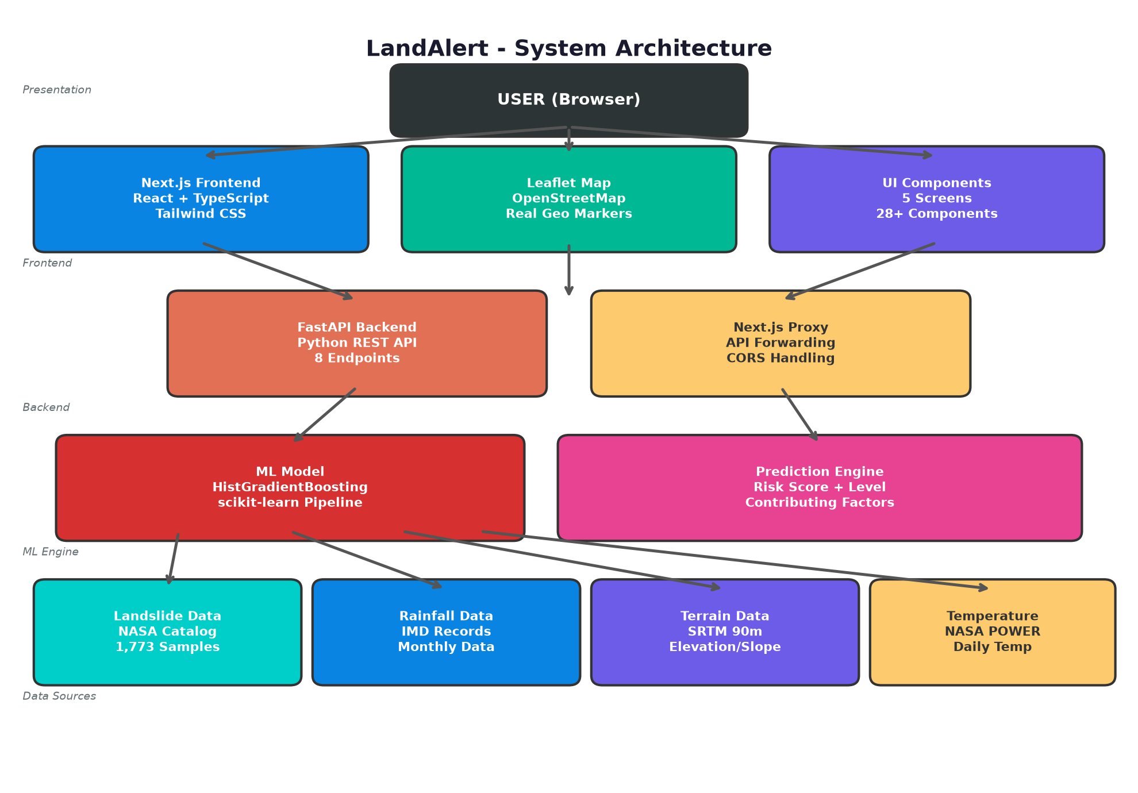

3. How Technologies Work Together

3.1 Data Flow: User Search to Risk Prediction
Step 1 - User Action: User types a location in the search bar (e.g., "Meghalaya").
Step 2 - Frontend Request: Next.js frontend sends the search term to the FastAPI backend via the API proxy.
Step 3 - Backend Processing: FastAPI matches the location to a district, retrieves terrain data (elevation, slope), rainfall, and temperature.
Step 4 - ML Prediction: Backend passes the 9 features (lat, lon, month, temp, monsoon, rainfall, elevation, slope, state) to the HistGradientBoosting model.
Step 5 - Risk Calculation: Model returns a probability score (0-100%). Backend maps it to a risk level (Low/Moderate/High/Very High) and generates contributing factor explanations.
Step 6 - Response: Backend sends back: risk score, risk level, contributing factors, terrain data, and explanation text.
Step 7 - Frontend Display: React components render the risk score, factor bars, map marker, hazard chain, and alert status.

3.2 Component Interaction
The Next.js app serves as a single-page application with client-side routing. When the user navigates between Dashboard, Risk Map, Analytics, Alerts, and Methodology screens, React handles the rendering without full page reloads. The Leaflet map component loads dynamically to avoid server-side rendering issues.
The FastAPI backend runs as a separate process on port 8000. Next.js proxies API requests to the backend using next.config.mjs rewrite rules. This avoids CORS issues during development. The ML model is loaded once at API startup and kept in memory for fast predictions.

3.3 Model Pipeline
The ML model is a scikit-learn Pipeline stored as a dictionary with a "pipeline" key. During training (ml/add_terrain.py), the pipeline handles feature preprocessing and classification. During prediction, the API loads the pipeline, constructs a feature vector, and calls model.predict_proba() to get the landslide probability. Feature importances are precomputed and stored in model_meta.json for the explainability module.

3.4 Map Integration
The Leaflet map uses OpenStreetMap tiles (free, no API key required). State coordinates are defined in a STATE_GEO constant. Each state gets a color-coded circle marker based on its risk level. Clicking a marker selects the state and shows details in a side panel with elevation, slope, and risk factors from the ML API.

3.5 Alert System
The backend generates alerts for states with High or Very High risk levels. Alerts include severity, state name, risk score, and a cascading hazard note. The frontend displays alerts in a filterable list with expandable detail panels. The sidebar shows a live alert count badge.

4. Key Files
File | Purpose
ml_api.py | FastAPI backend server with 8 endpoints
ml_model/rf_landslide_model.pkl | Trained HistGradientBoosting model
ml_model/model_meta.json | Model metrics and feature importances
ml/add_terrain.py | Training script with terrain features
components/screens/*.tsx | 5 UI screens (Dashboard, Map, Analytics, Alerts, Methodology)
components/leaflet-map.tsx | Real Leaflet/OpenStreetMap component
lib/ml-api.ts | Frontend API client with TypeScript types
datasets/ne_india_landslide_enriched.csv | Main training dataset
datasets/ne_terrain_lookup.csv | Elevation/slope lookup (441 coordinates)
Rainfall_Data_LL.csv | IMD rainfall data by subdivision

5. Summary
LandAlert combines a modern React/Next.js frontend with a Python/FastAPI backend and scikit-learn ML model to deliver landslide risk predictions for North-East India. The system processes historical landslide data, rainfall, terrain, and temperature to generate risk scores with explainable factors. The architecture is modular, allowing independent scaling of frontend, API, and ML components.

